Exercise 5)

Changes to calc.p4:

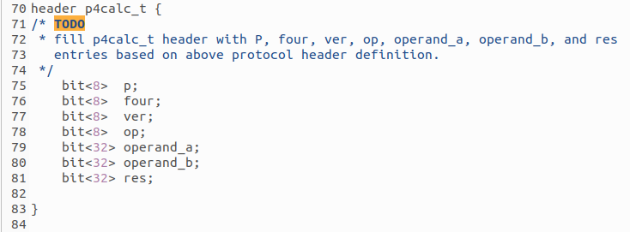
I filled in the header with these bit sizes because p, four, ver and op are 2 digit hexadecimal numbers so they are 8 bits.

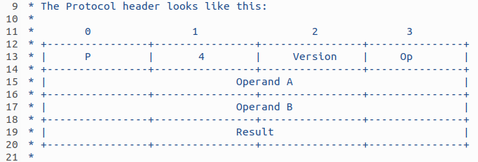

operand_a, operand_b and result are 4 times the length of p, four, ver and op so they must be 32 bits each.

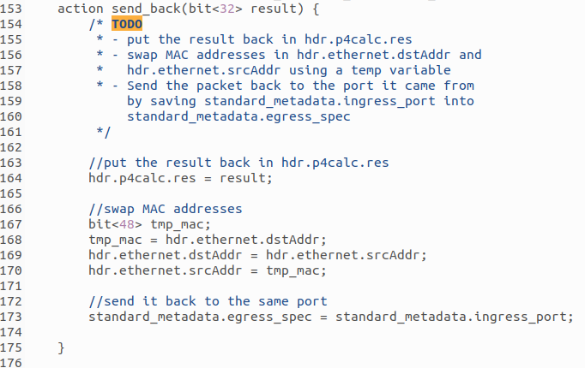

I stored result into the res variable we made earlier by using its location hdr.p4calc.res

I swapped the mac address by first defining a temporary variable with the same length as a mac address (6 2-digit hexadecimal numbers so 6 x (2 x 4) so 48 bits).

I sent the packet back to the same port as instructed.

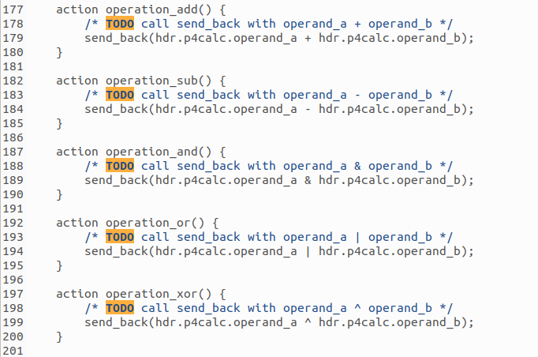

I used the send_back action by replacing the parameter with the appropriate operation of operand_a and operand_b.

Changes to calc.p4:

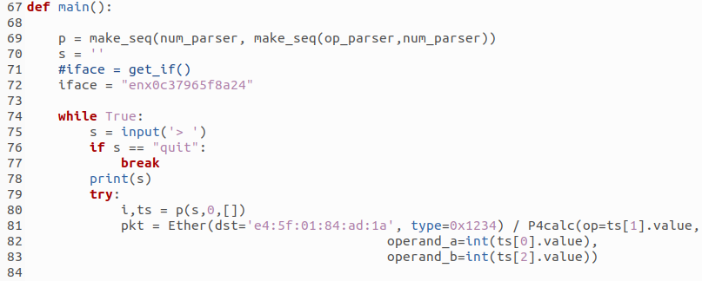
I changed the interface name to the interface of the lab machine because it runs calc.py

I changed the destination mac address of the packet to the mac address of the Raspberry PI because the lab machine will send packets to the Raspberry PI so it can get the relevant packets back from calc.p4

Example inputs:

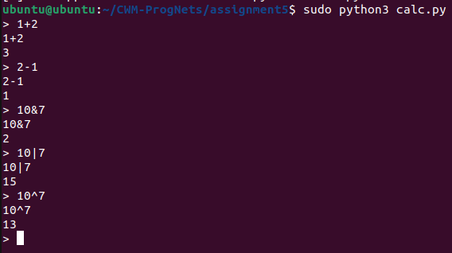
All of the outputs are as expected.

Link to directory:
https://github.com/VKing15/CWM-ProgNets.git

