**Documentation of Lab Integration Kit (lik-release-0.5.0)**

The UI Toolkit consists of the Virtual Labs User Interface Template version 1.0. The toolkit also contains helper scripts that extract the content of labsto UI 1.0 Template. The objective of using UI 1.0 Toolkit is to standardize the formats of all labs according to the UI 1.0 Template.

This procedure is for Ubuntu OS.

**Installation of Lab Integration Kit**

**Run the scripts with super user (su)**

**1.** Open the terminal. Update the OS by running the following command.

**Command:**

**sudo apt-get update**

**2.** After update is complete, run the config.sh script which is located in lik-release-0.5.0/ui-1.0-toolkit/scripts/ubuntu-scripts/config.sh

**Command:**

**cd lik-release-0.5.0/ui-1.0-toolkit/scripts/ubuntu-scripts/**

**./config.sh**

**3.** After installing config.sh, run the initialize.sh script which is also located in the same folder (lik-release-0.5.0/ui-1.0-toolkit/scripts/ubuntu-scripts/).

**Command:**

**cd lik-release-0.5.0/ui-1.0-toolkit/scripts/ubuntu-scripts/**

**./initialize.sh**

**4.** After running initialize.sh script, a build folder is created inside the template folder and at var/www/html/build which is a deployable folder.

**Porting of labs into LIK template format**

The LIK format contains pre-designed template to maintain the uniformity and standardize the formats of all labs.

To write the content (aim, theory, procedure etc.) of the experiment, follow the below mentioned procedure.

1. Go to lik-release-0.5.0/ui-1.0-toolkit/src/template/src/lab
2. Open the content.html in the editor. This is the main page which contains the introduction of the lab and list of experiments.

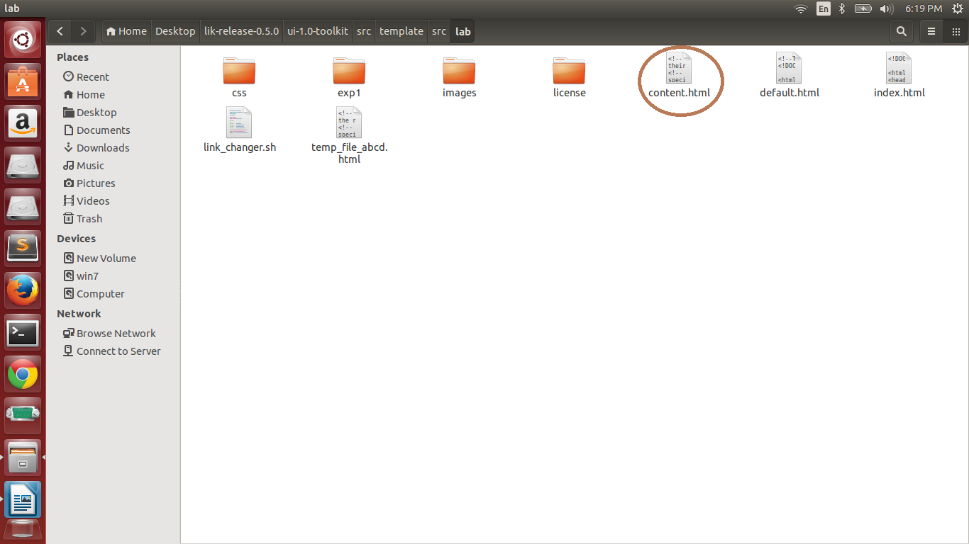

**3.**  Replace the dummy content with the actual content.

Replace the Test Lab with the actual lab name in the **title and header tag.**

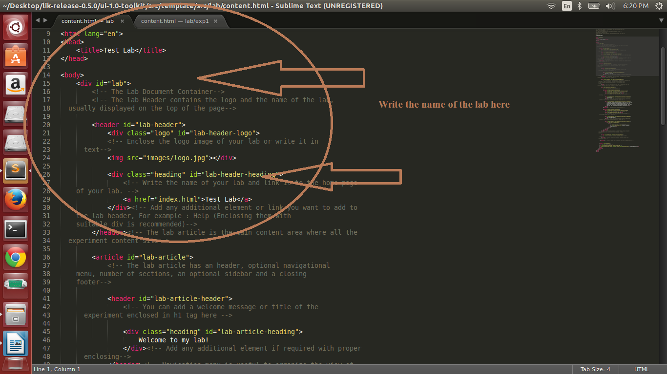

Give the introduction of the lab in the introduction section.

**4.** The list of experiments section contains links of the experiments which the perticular lab contains.

Add the links of the experiments in the list item tag.

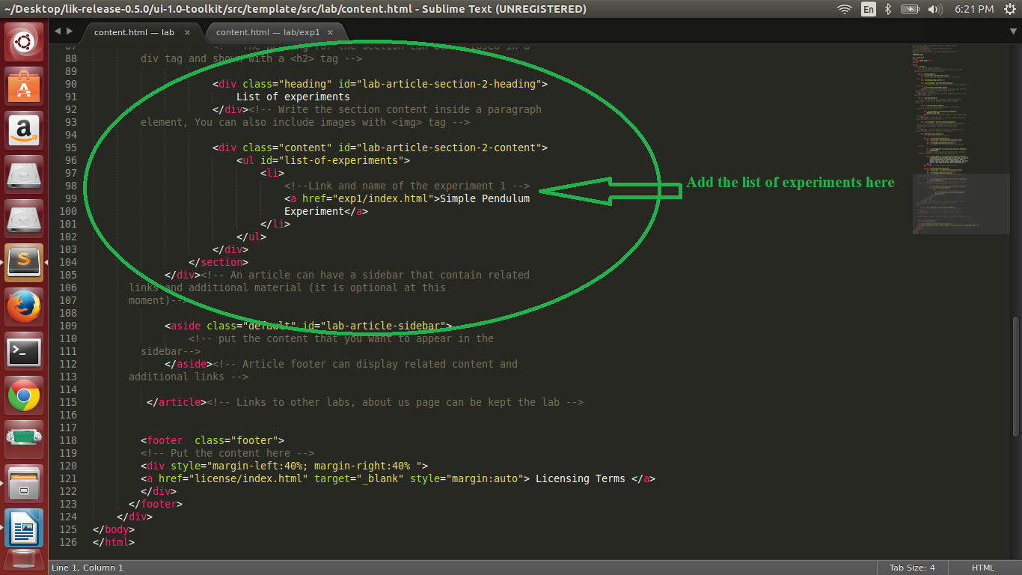

To edit the content (aim, theory, procedure etc.) of the experiment,

**1.** Go to lik-release-0.5.0/ui-1.0-toolkit/src/template/src/lab

**2.** There id a folder named exp1. This folder represents on experiment. That means has the content of one experiment. If you have more than one experiment in the lab then copy and paste the exp1 folder equal to number of experiments. (Suppose there are 10 experiments in the lab then paste the exp1 folder 10 times). Name the folders according to name of the experiments.

**3.** Now go to exp1 folder and in editor open content.html.

**4.** Replace the dummy content with the actual experiment content.

**5.**  The code contains multiple section tags. Each section tag represents one tab i.e first tab represents **Aim**, second tab represents **Theory** and so on.

So, aim of the experiment is to be written inside AIM section tag, theory of the experiment is to be written inside THEORY section tag and so on.

You can add or remove section tags according to your need.

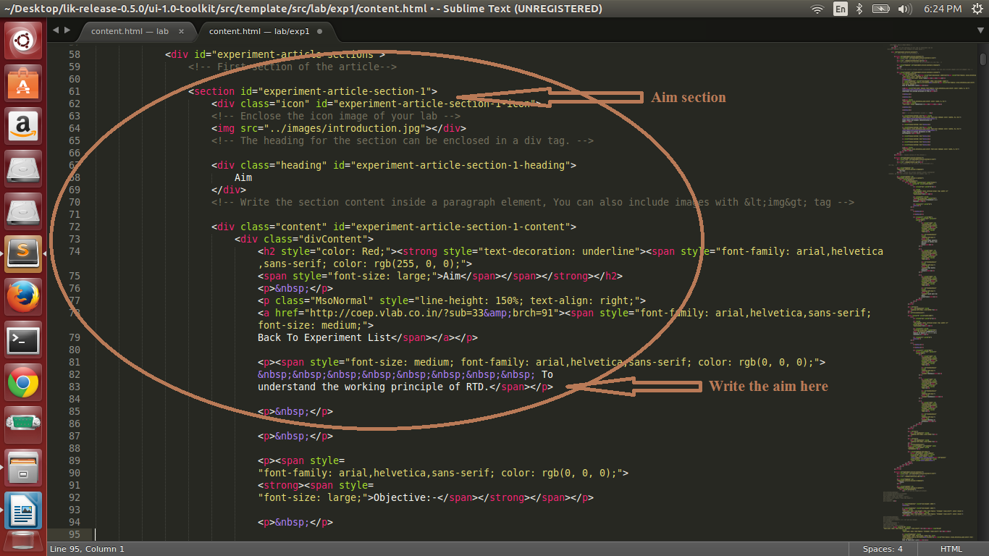

To see the changes in template on browser, save the code and then in terminal run initialize.sh script.

**Command:**

**./initialize.sh**

All changes are committed in var/www/html/build folder also that is deployable folder.

