# Exercises: Inheritance

Problems for exercise and homework for the [Python OOP Course @SoftUni](https://softuni.bg/courses/python-oop). Submit your solutions in the SoftUni judge system at <https://judge.softuni.bg/Contests/1941>

## Person

You are asked to model an application for storing data about people. You should be able to have a Person and a Child. The child derives from the person. Every person has public attributes **name** and **age**. Your task is to model the application.

Create a **Child** class that inherits **Person** and has the same constructor definition. However, do not copy the code from the **Person** class - **reuse the Person class's constructor**.

## Players and Monsters

Your task is to create the following game hierarchy:

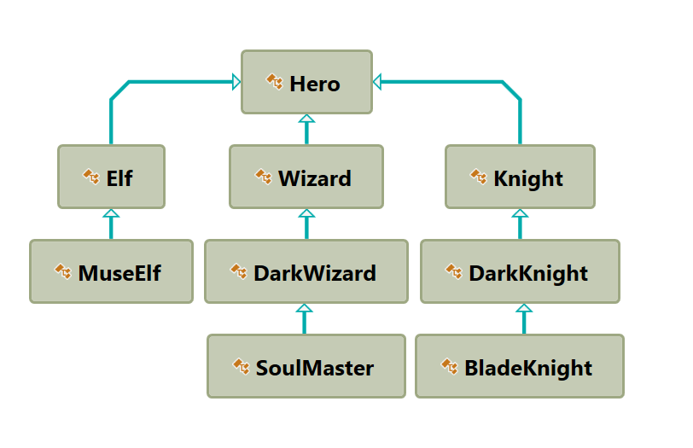

Create a class Hero. It should contain the following:

* A constructor, which accepts:
  + **username – string**
  + **level – number**
* The following attributes:
  + **username - string**
  + **level – number**
* **__repr__()** method

Hint: Override **__repr__()** of the base class so it returns: **"{name} of type {class_name} has level {level}"**

## Need for Speed

Create the following **hierarchy** with the following **classes**: 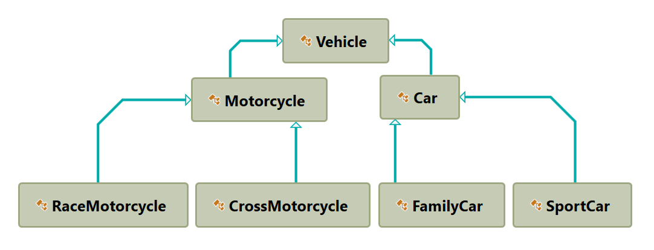

Create a base class Vehicle. It should contain the following attributes:

* **DEFAULT_FUEL_CONSUMPTION – float (constant)**
* **fuel_consumption – float**
* **fuel – float**
* **horse_power – int**
* A public constructor which accepts (fuel, horse_power) and **set** the **default fuel consumption** on the attribute fuel_consumption

The class should have the following methods:

* **drive(kilometers)**
  + The **drive** method should have a functionality to reduce the **fuel** based on the travelled kilometers and fuel consumption. Keep in mind that you can drive the vehicle only if you have enough fuel to finish the driving.

The default fuel consumption for **Vehicle** is 1.25.Some of the classes have different default fuel consumption:

* **SportCar – DEFAULT_FUEL_CONSUMPTION = 10**
* **RaceMotorcycle – DEFAULT_FUEL_CONSUMPTION = 8**
* **Car – DEFAULT_FUEL_CONSUMPTION = 3**