Problem: What is SAR?

Answer: SAR stands for synthetic aperture radar. It is a type of data collection with the following key aspects:

- Active: The sensor produces its own energy (e.g. microwaves) and then records the amount of that energy reflected back after interacting with the earth. It is opposed to "passive" where the sensor
relies on an external source of energy (light) to record the information. Google Earth is an example of passive sensor.

- Microwave: the wavelengths used in sar go from cms to meters. The nature of microwaves allows to penetrate through obstacles like a clouds, and get information from the earth surface, regardless it
is day or night.

- Coherent: basically means that because you have a sensor, and you have a signal which you know, you can calculate the phase of the signal.

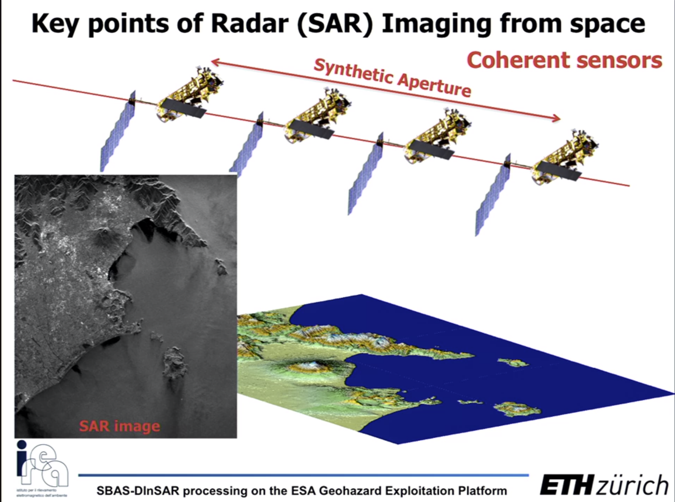

*Note: it is called Synthetic aperture because the antenna of the satellite receives a sequence of acquisitions that are combined to simulate a much larger antenna. Keep in mind that spatial
resolution of radar data is directly related to the ratio of the sensor wavelength to the length of the sensor antenna. For a given wavelength, the longer the antenna, the higher the spatial
resolution. From a satellite in space operating at a wavelength of about 5 cm (C-band radar), in order to get a spatial resolution of 10 m, you would need a radar antenna about 4250 m long, which is impractical :)

######################################

What is an interferogram?

Answer: Let's say you have two SAR images taken in two different times: t1 and t2. If you combine the two images, since they are coherent signals you can obtain the difference between their phases and
that's known as interferogram.

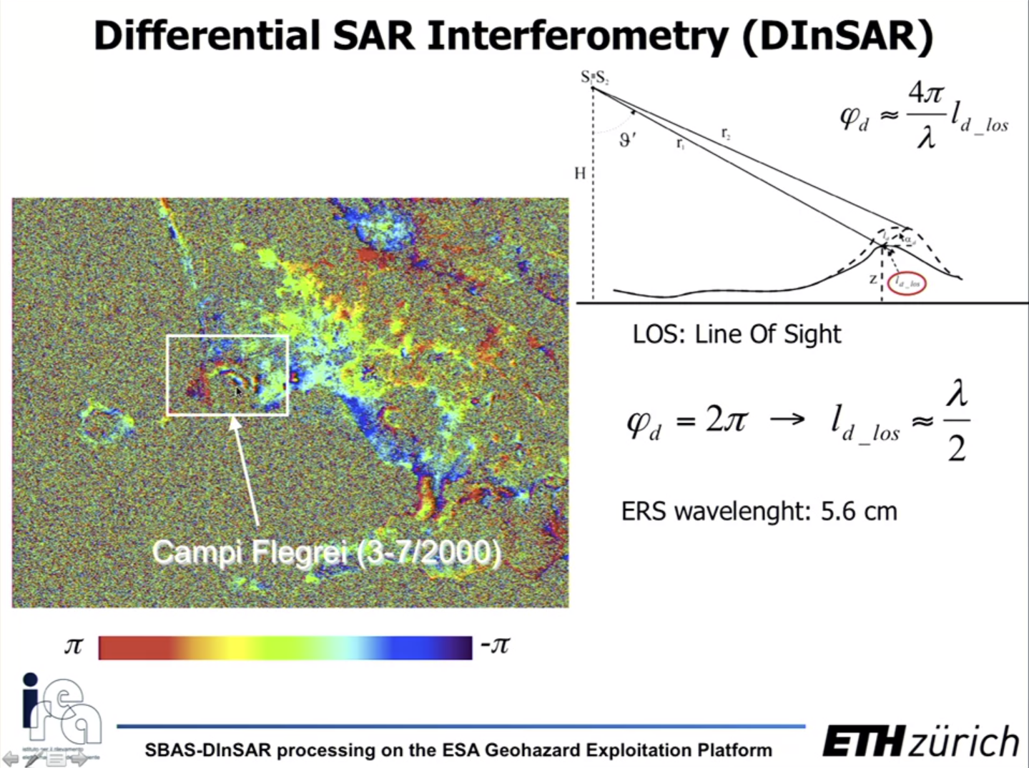

<<<<< Important: ld_loss is measured in the line of sight (LOS) of the sensor. ld_loss, it is not vertical, horizontal, east, west or whatever....>>>>>>>>>

Nonetheless, it is possible to translate the desplacement ld_loss in LOS to more conventional system or coordinates (e.g. N, S, W and E)

The color codings appearing in the interferogram are called fringes. The interferogram representes the difference between sar1 and sar2 using complex numbers, therfore we use a pi to -pi (radians) domain to retrieve phase.

Everytime we see a color cycle going from red (pi) to purple (-pi) alternating, this corresponds to the wavelength of the sensor we are working with, for example 5.6 cm. So we can
convert from radians to centimeters. A complete cycle is the same as fringe.

Example: t1 is 03-2000 and t2 is 07-2000. We obtain the interferogram of both images and in the volcano zone, from the center to the border we observe approximately 2 fringes or complete cycles, given that wavelength is 5.6 cm Calculate how many centimeters the volcano displaced from t1 to t2.

Solution:

ld_loss = (λ / 2) * num of cycles = (5,6 / 2) * 2 = 5,6cm

##############################

Problem What is phase unwrapping operation?

Solution: It is counting the number of fringes considering that one wrapped phase is in the -pi, to pi domain. Once you have counted the number of fringes you do the operation displayed below.
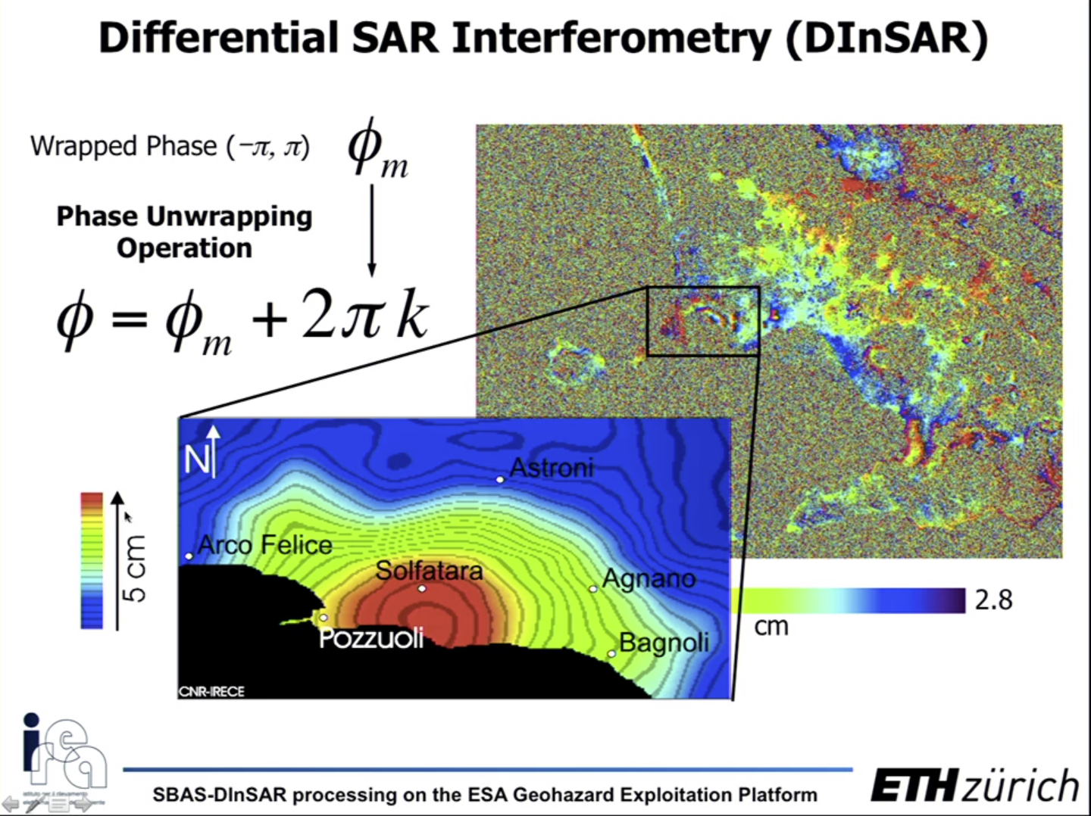
AAAAAAAAAAAAAAAAAAAAAAAAAAAAAAAAAAAAAAAAAAAAAAAAAAAAAAAAAAAAAAAAAAAAAAAAAAAAAAAAAAAAAAA

With this operation you get the unwrapped phase which is no longer restricted to -pi, pi domain, but in can be instead expressed in cm.

In real life, to obtain an interferogram you don’t have only different time of data acquisition, but also your satellites are moving in different orbital paths (whose distance is called baseline), therefore it is more complex to calculate the difference in phase to generate the interferogram.

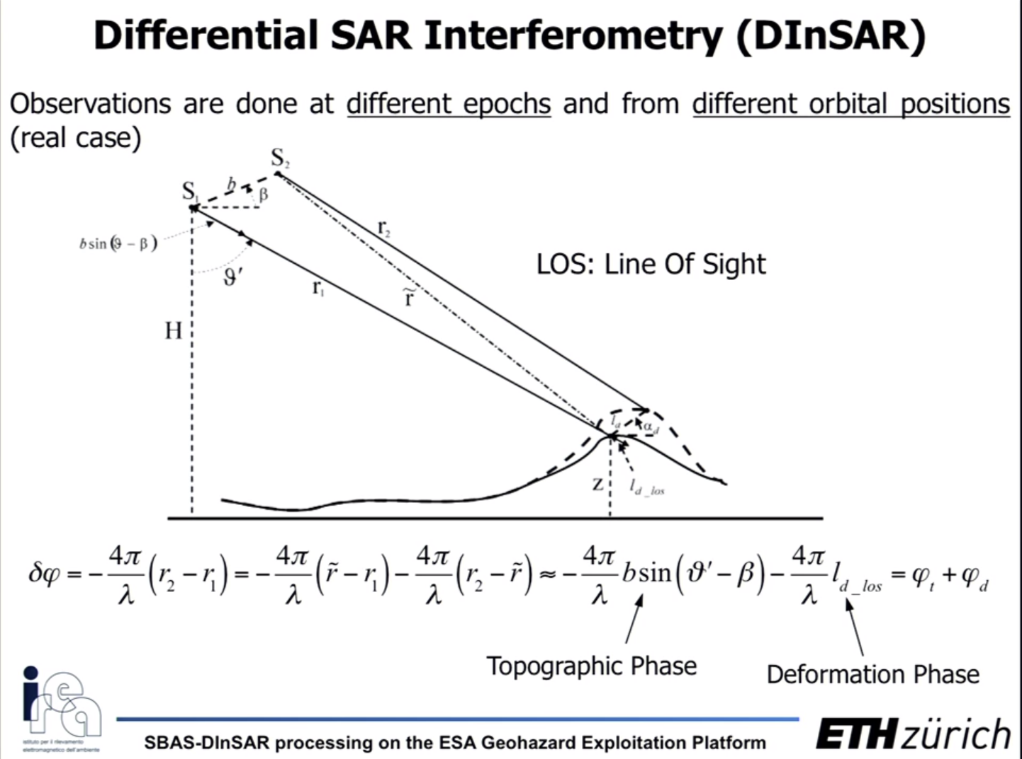

######################################

What is a coherence map?

Solution: It a measure of the quality of your phases. It goes from 0 (full noise, for example black) to 1 (not noise, for example white).

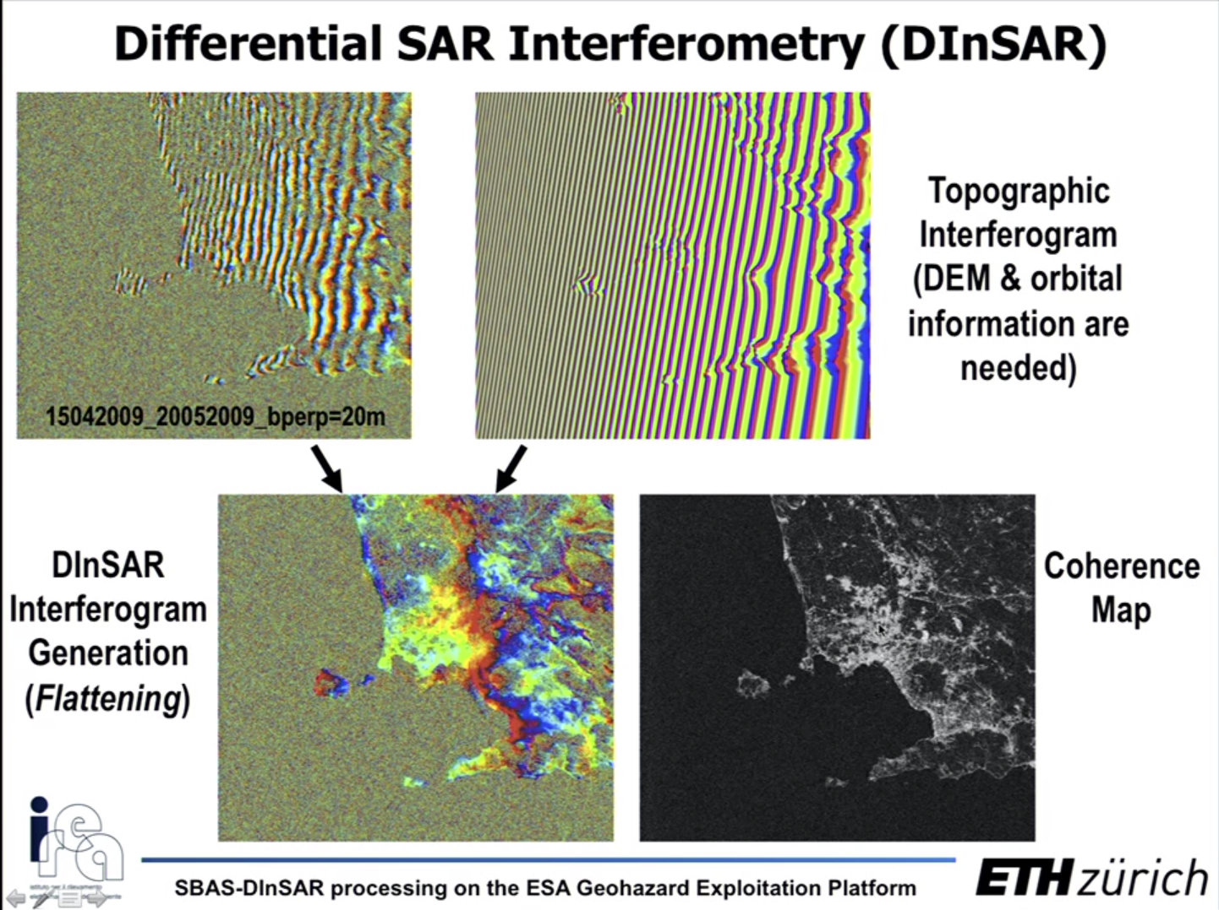

See example above at the bottom right.

We want to avoid big baselines, because they introduce too much noise (decorrelation efects) and topography contributions to our interferogram. The baseline can be physical: the distance between to orbital paths and also temporal: the same scene captured from the same orbital path, but with a long time in between recorded sar images: t2 >> t1 maybe something like years in between t2 and t1 (the scene can change a lot in between one and the other)

What techniques can be used to measure deformations in time series?

Solution: you can use persistent scatters and small baseliine

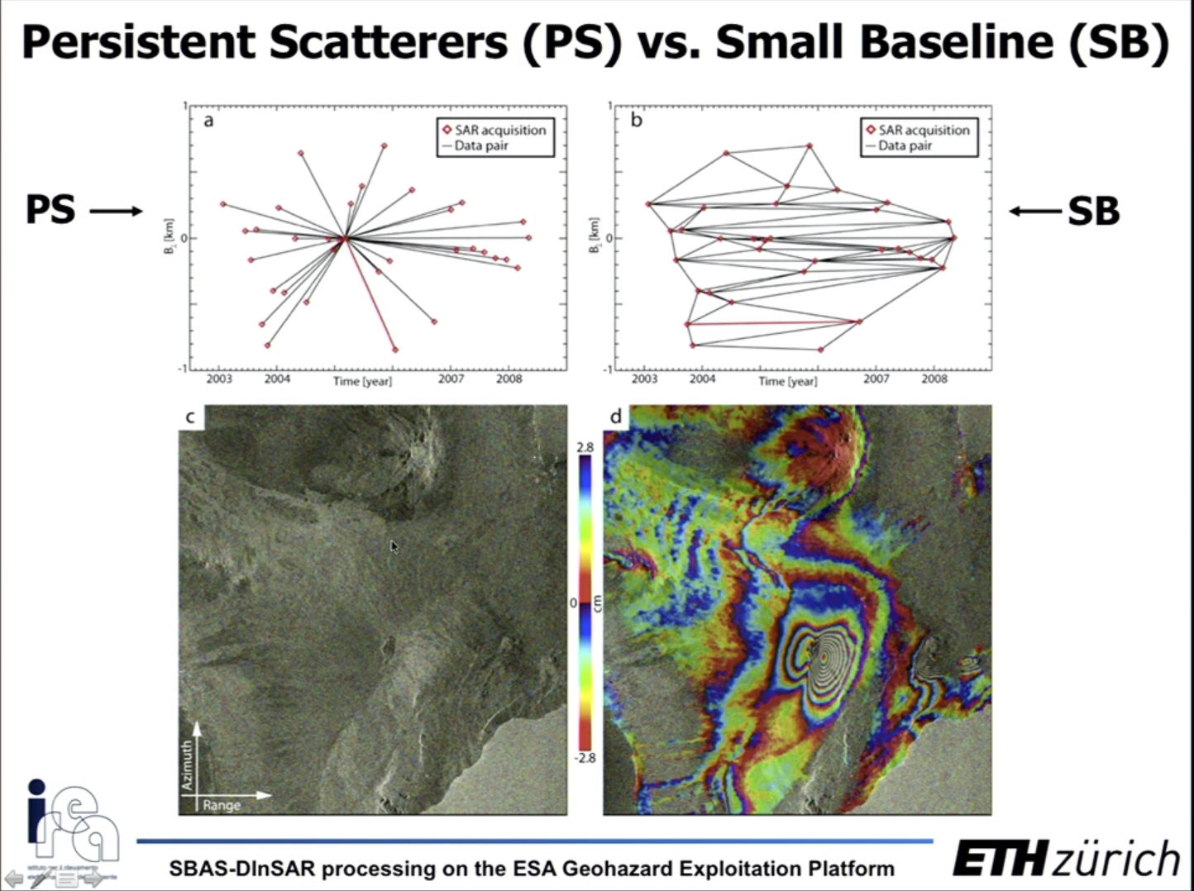

PS:persistent scatters, exploit particular points that have certain statistical properties that made them more or less “fixed” in different time series of sar images.

SB (small baseline) uses conventional interferograms with small baseline to process the movements along time series.

Let’s focus on explaining what is the key ideas behind SB and its application to time series through the SBAS algorithm.

We start with a distribution of acquisition sar images with respect to the perpendicular baseline and the time.
distr
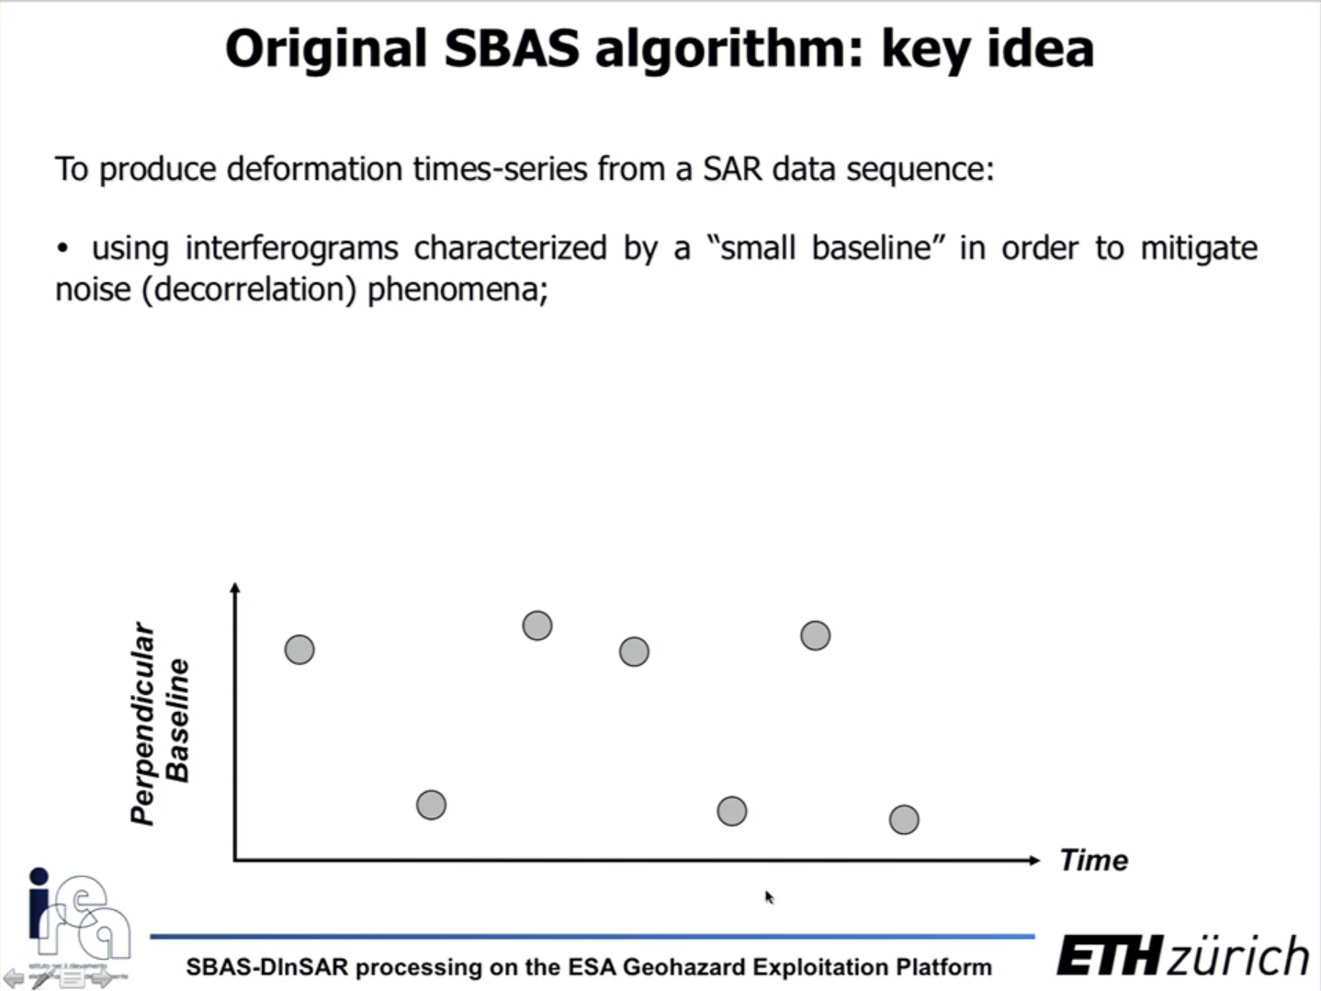
And you can combine the acquisitions on pairs based on maximum baseline threshold and then you generate the corresponding interferograms.

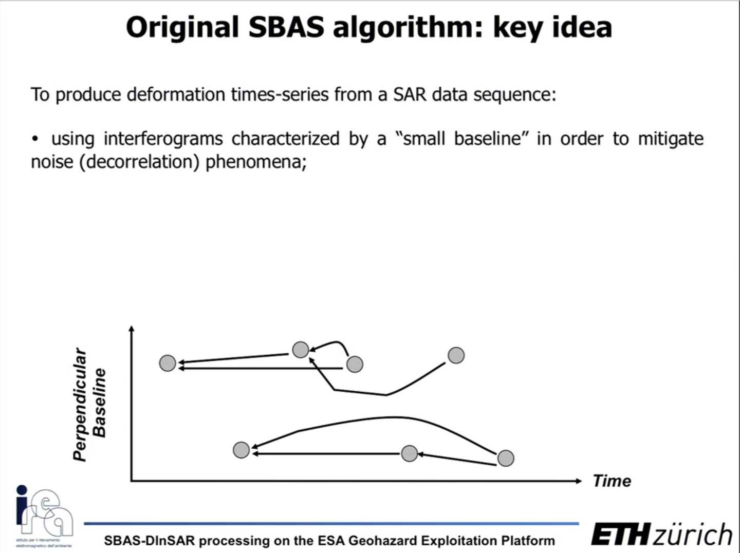

Then it is possible to generate a subset of sar data separated by large baselines.

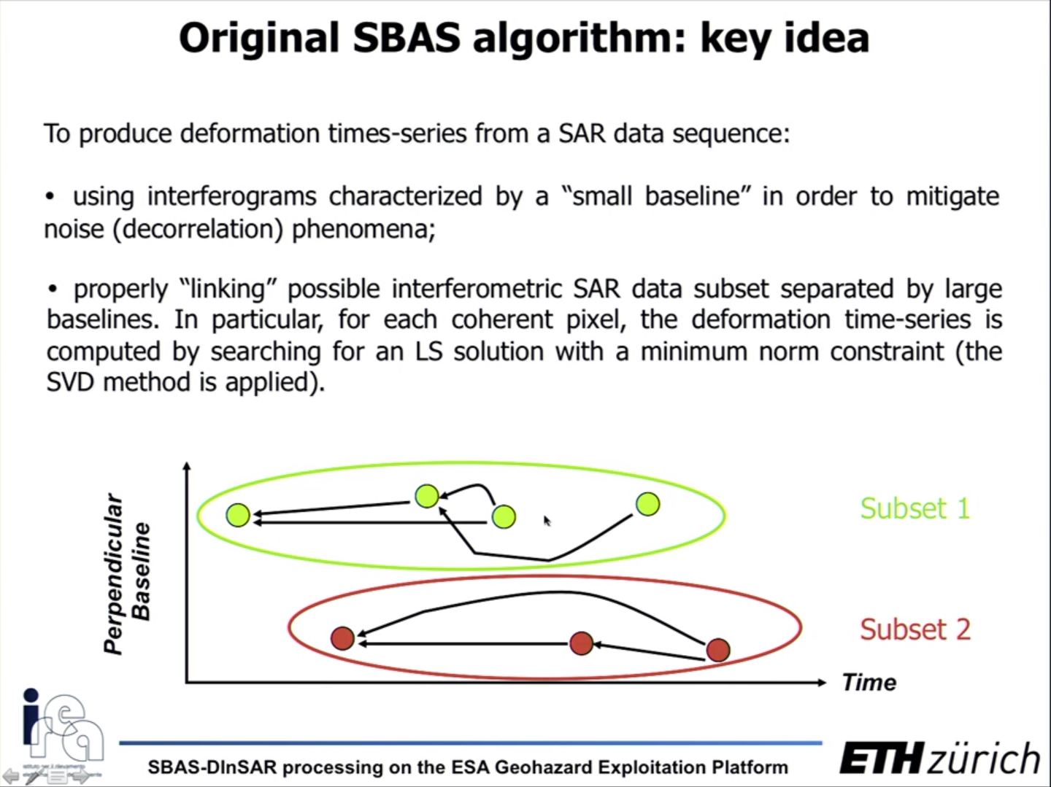

LS: least square
SVD: singular value decomposition

The main constraint is to put a minimum norm of the velocity among the acquisition.

The mathematical formulation of the sbas algorithm is the following:
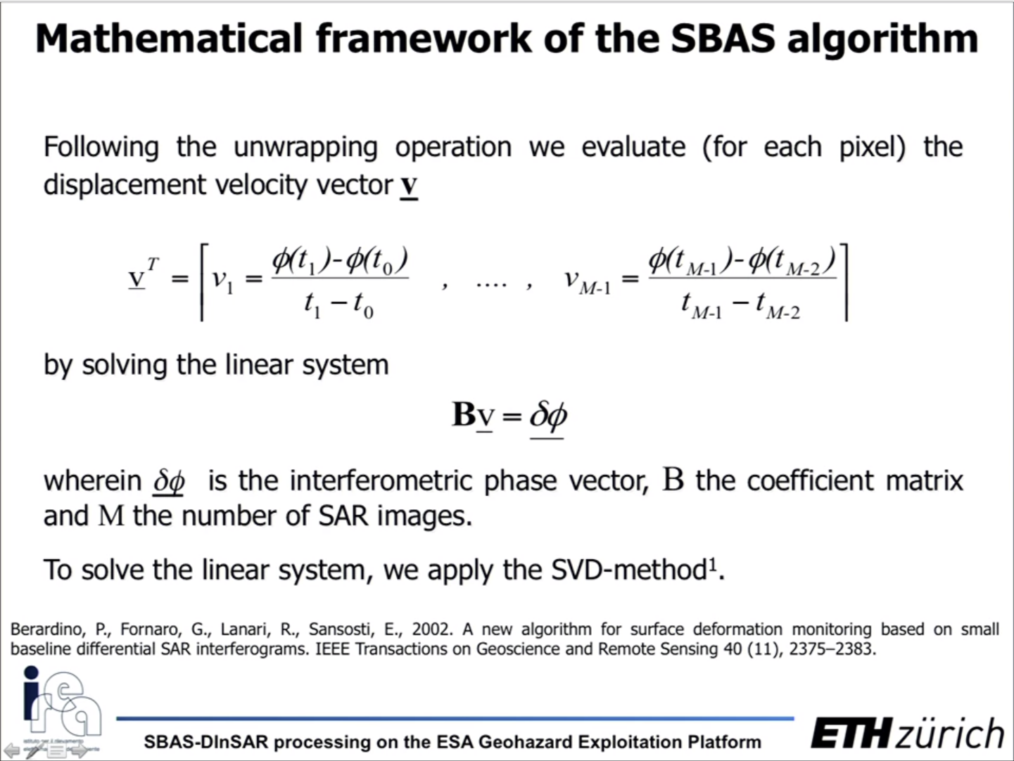

The flow-work of how the sbas algorithm work is the following:

1) You start with some interferograms that you compute at small baseline
2) You do the unwrapping operation
3) For each pixel you evaluate the displacemente velocity vector
4) You get the mean deformation velocity per each point

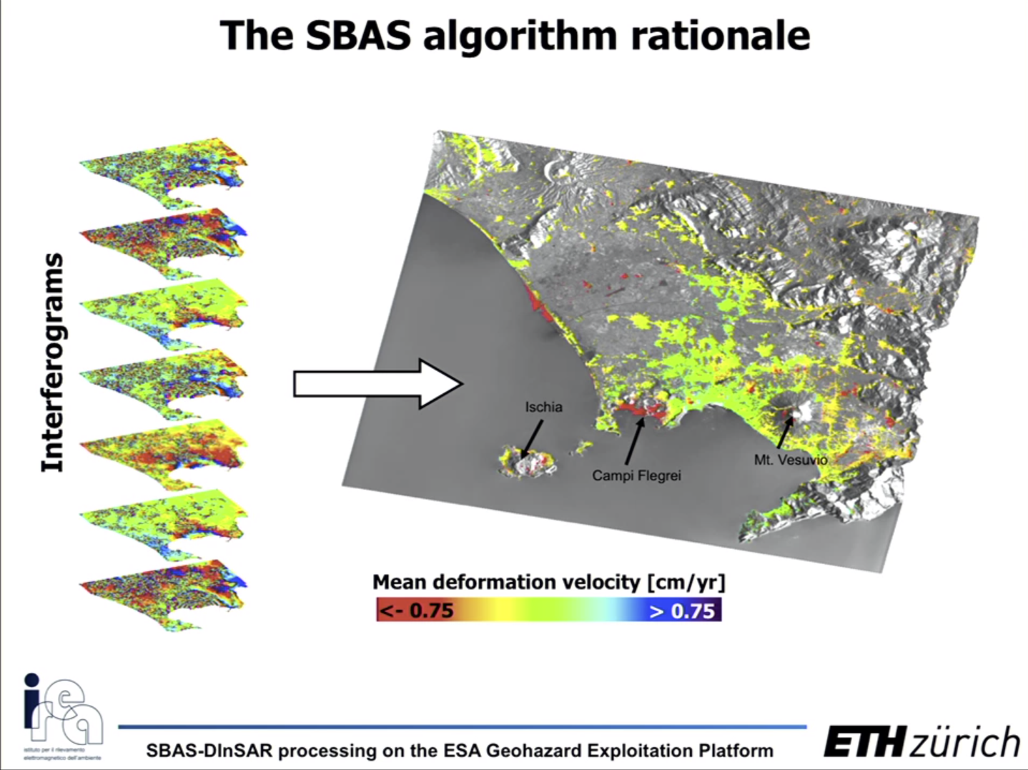

In the image below the small chart in the top right, each triangle represent one sar acquisition with respect to the displacement and the time.

Keep in mind that this can only be done with coherent points, in the other words, points that have a good signal according to the coherence matrix. You can’t have the time series of the whole area.

Previously, we explained how the unwrapping operation happens when we have a single sar image. In that situation, we can calculate the displacement for a single inteferogram in between to times: t1 and t2. Now because we have a data stack of several interferograms we are able to plot a time series and find trends.

With the time series you can perform a linear fitting of the time series points and obtain the mean deformation velocity.

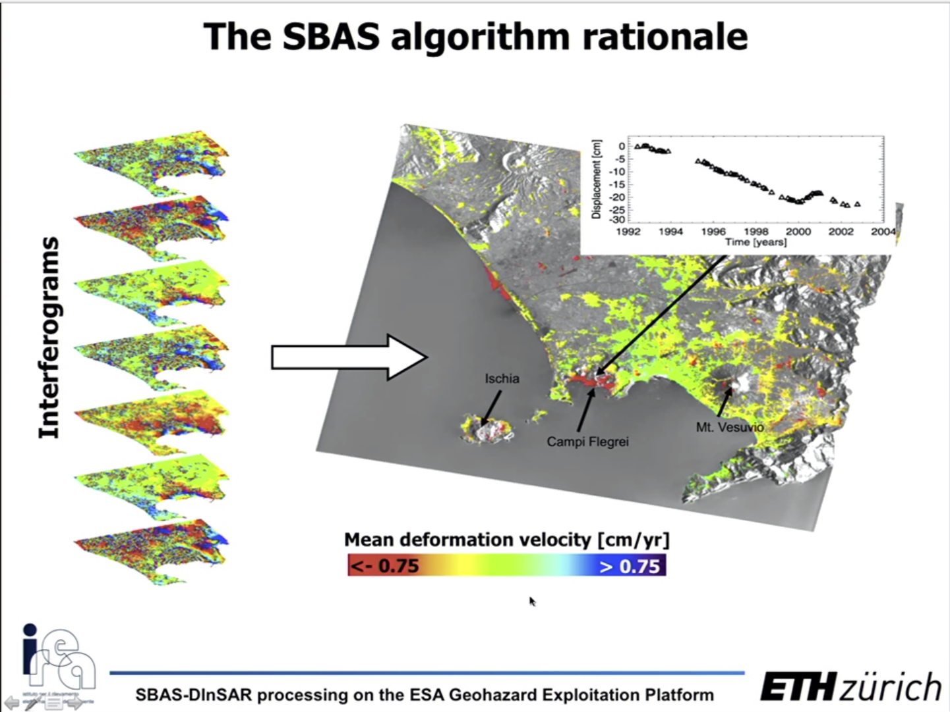

Another example:

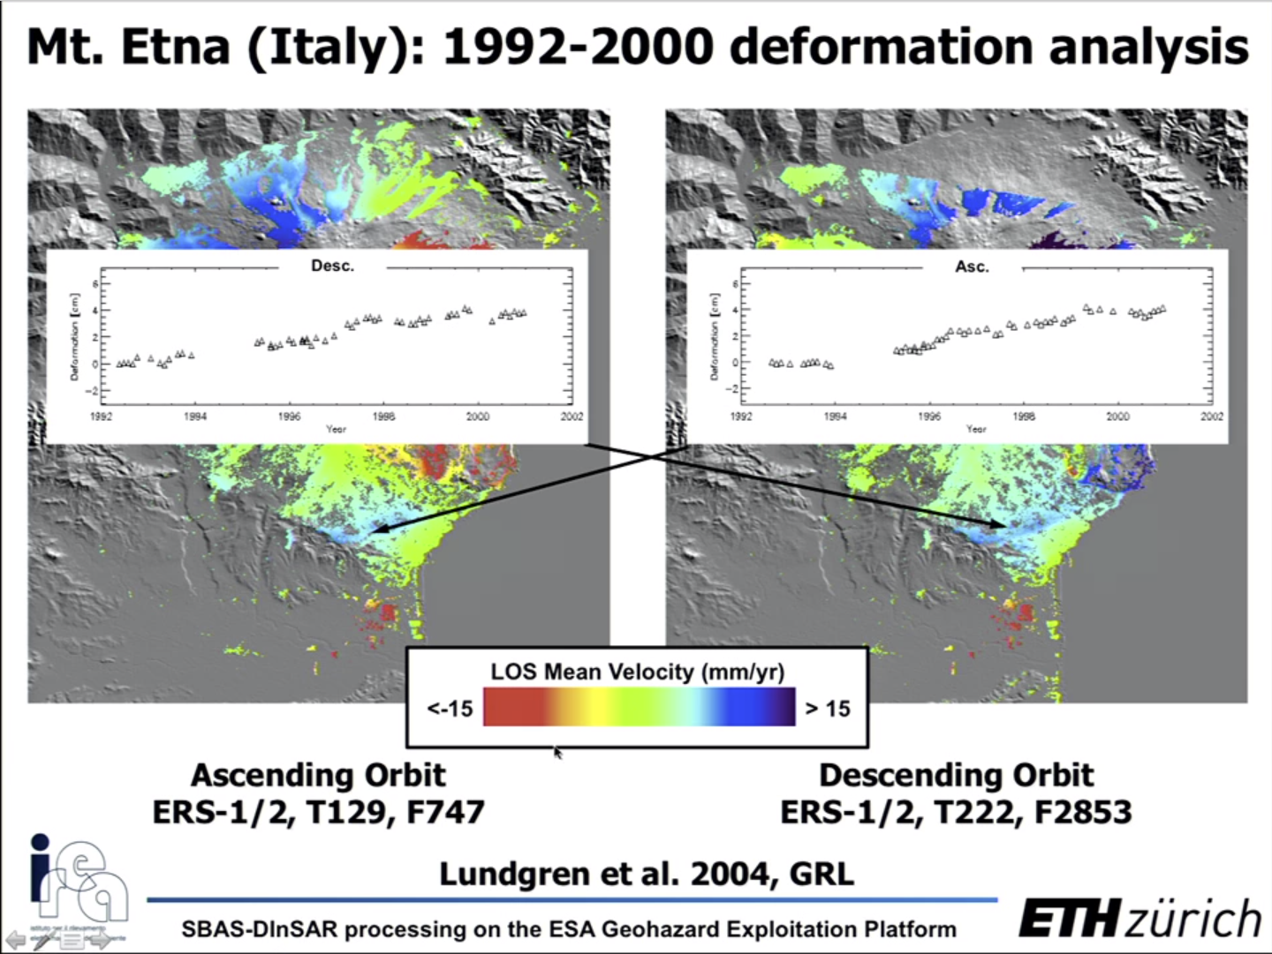

Remeber the displacement is measured in the LOS. You can combine the displacement measured in the ascending (towards the north pole) and descending orbits (towards the south pole) to obtain the displacement in more conventional directions:

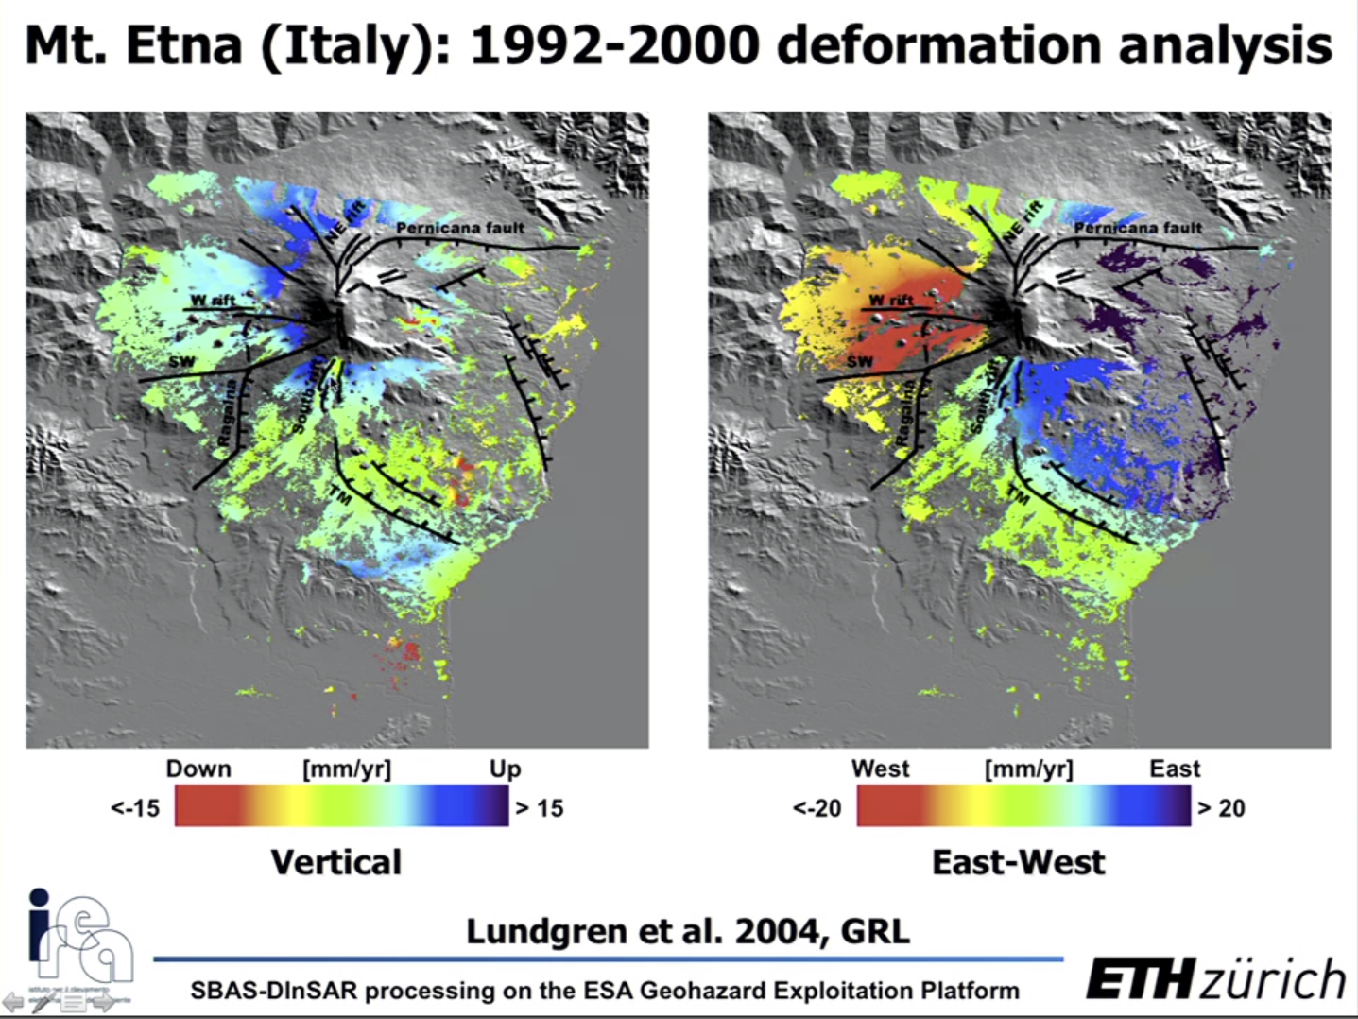

aaaa

