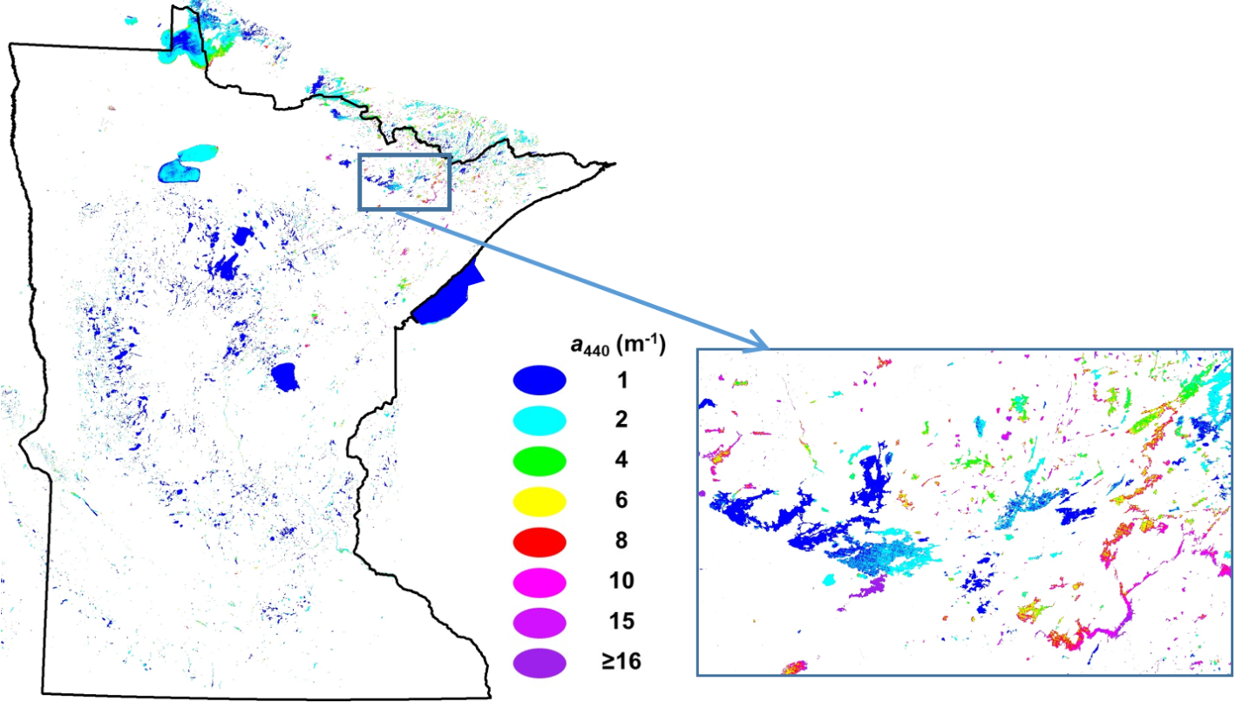

**Figure A1.** CDOM 2015 pixel-level map with blowup of the Ely lakes area.

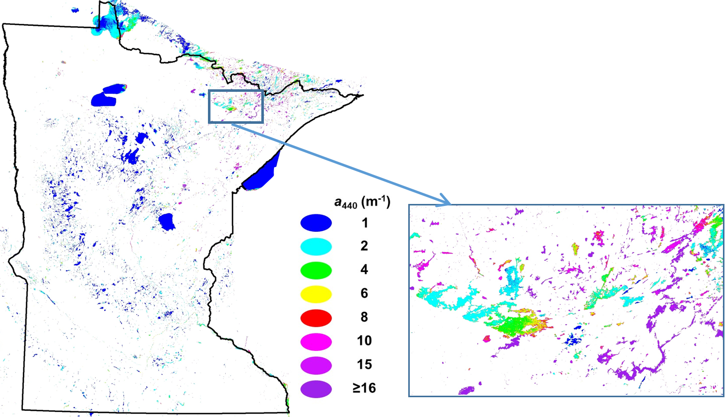

**Figure A2.** CDOM 2016-17 pixel-level map with blowup of the Ely lakes area.

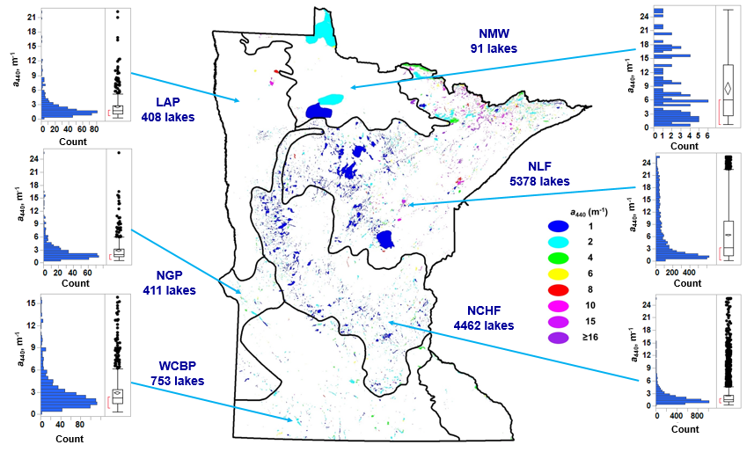

**Figure A3.** Minnesota 2015 and 2016 mean CDOM distribution for all measured waterbodies by ecoregion.

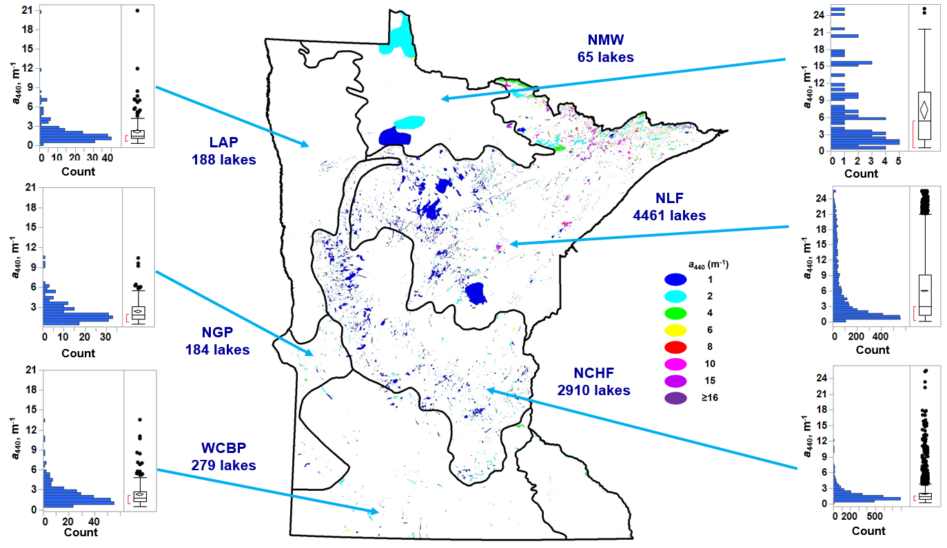

**Figure A4.** Minnesota 2015 and 2016 mean CDOM distribution for lakes and reservoirs (without open-water wetlands) by ecoregion.

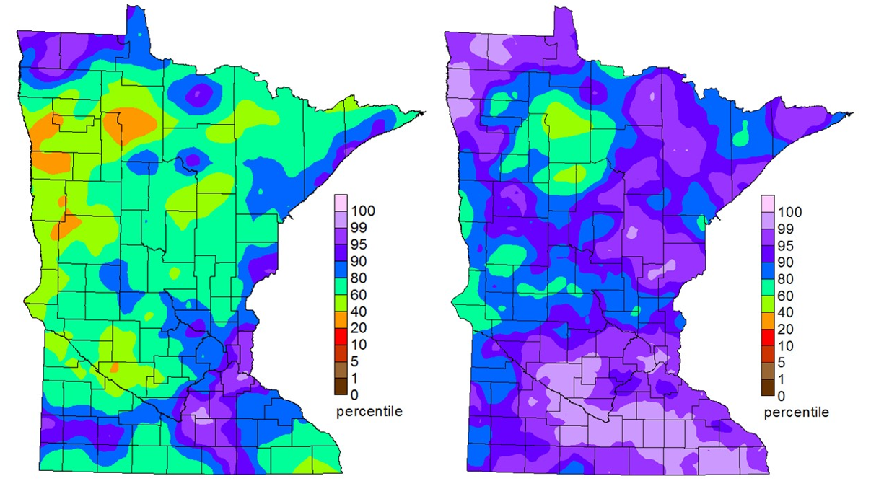

**Figure A5**. Historical precipitation ranking maps for 2015 and 2016 respectively from the Minnesota Department of Natural Resources State Climatology Office.