MID-SEMESTER REPORT
Hybrid epithelial/mesenchymal cells on the archetype geometry of breast cancer
Student: Vedashree Mahajan, ID f20220216
Institution: BITS Pilani, K K Birla Goa Campus
Course: First Degree Thesis, Semester I, 2026–27
Supervisor: Dr. Mohit Kumar Jolly, Department of Bioengineering, Indian Institute of Science
Period covered: 10 August 2026 – 4 October 2026

Abstract
This project asks whether hybrid epithelial/mesenchymal (E/M) cells behave as generalists in the interior of a task trade-off simplex, with fully epithelial and fully mesenchymal cells at the corners. I first reproduced the published archetype analysis of small-cell lung cancer. The same method finds no significant simplex in the full transcriptome of breast or glioblastoma cell lines. On the 206-gene KS epithelial/mesenchymal signature, however, 63 breast cell lines do form a significant triangle. A large tumor single-cell atlas (Pal et al., 84,602 cells) mostly falls outside that triangle: only 13.3% of its cells are inside. When the triangle is fitted on the tumor cells instead, the cell lines and a second tumor atlas fall inside it (78–96%).
The three corners of the tumor-fitted triangle are an epithelial program, a mesenchymal program, and a third vertex enriched for triple-negative cells. Hybrid cells are not the interior class. In the Pal atlas they concentrate at the third vertex, which is dominated by one patient. In an independent tumor atlas they lie along an edge rather than at a corner. The working conclusion is that, for this signature, cell lines are the wrong host for the simplex, and hybrid E/M is not in general the Pareto generalist.

1. Introduction and aim
Tumors have to carry out several tasks at once, and no single cell state can do all of them well. Hausser et al. (2019) formalised this as Pareto Task Inference: if tasks trade off against each other, cells should lie inside a low-dimensional polytope. Specialists sit near the vertices, each excelling at one task, while generalists sit in the interior and do a little of everything.
Groves et al. (2022) showed that this is more than a picture in small-cell lung cancer (SCLC). SCLC cell lines form a significant five-vertex simplex, the known subtypes sit on its vertices, and tumors occupy the same shape. The question I brought to this thesis is the epithelial–mesenchymal version of that result in breast cancer. Cells at the epithelial and mesenchymal extremes should be specialists. Hybrid E/M cells, which are known to be plastic, should be the generalists in the middle.
Hypothesis. Hybrid E/M cells lie in the interior of the simplex; fully epithelial and fully mesenchymal cells lie at its vertices.
The work in this period was organised as a sequence of tests, each of which exists because the previous one was not enough. The sections below follow that order.

2. Methods

2.1 Pareto Task Inference
I implemented the analysis in Python. It consists of principal component analysis, principal convex hull analysis (PCHA) to place the archetypes, a t-ratio (the volume of the fitted polytope relative to that of the convex hull of the data) whose significance is tested by permutation, and projection of new samples into a frozen simplex using barycentric weights. A sample counts as inside the simplex when all of its weights are non-negative.

2.2 Datasets
Table 1. Datasets used.
Dataset | Samples | Use in this report
Groves SCLC cell lines | 120 lines | Method check; reproduction of the published analysis
DepMap invasive breast carcinoma | 63 lines | Transcriptome-wide fit; KS-restricted fit (cell-line host)
DepMap glioblastoma | 54 lines | Control; TCGA tumors projected in
Pal et al., GSE161529 | 84,602 tumor cells | Tumor-atlas host; archetypes fitted here
Wu et al., GSE176078 | 24,162 tumor cells | Second tumor atlas; projected, never refitted
GSE173634 | 35,271 cell-line cells | Single-cell cell-line data; projected, never refitted

Single-cell data were imputed with MAGIC before projection. Glioblastoma, and a separate rebuild of a lung-premalignancy archetype figure, serve as controls and methods checks and are not part of the main result.

2.3 Gene signature
Epithelial and mesenchymal state was scored with the 206-gene KS signature of Tan et al. (2014). For comparison, a short PAM50 gene list was also tried.

2.4 Two labels for every sample
Each sample received two independent labels. The first comes from the gene score and says what the cell looks like; the second comes from archetype geometry and says where it sits.
- Hybrid (gene score). Both the KS epithelial score and the KS mesenchymal score are in the top quartile of the sample’s own dataset. Remaining samples are called epithelial, mesenchymal or intermediate from the mesenchymal-minus-epithelial score, split at the 33rd and 67th percentiles.
- Specialist (geometry). After clipping negative weights to zero and renormalising, the largest archetype weight exceeds the second largest by at least 0.35. Every other sample is interior, which includes edges and the centroid. In the text I use “generalist” for this interior class.

3. Results

3.1 The method reproduces the published SCLC result
Before pointing the method at a new question, I needed to know that it could reproduce a known one. On the Groves SCLC data the t-ratio at five archetypes is 0.107, matching the paper. With 1,000 permutations the smallest significant number of archetypes is five, which is the published choice. From this point on, a new dataset could produce a biological result rather than a coding one.
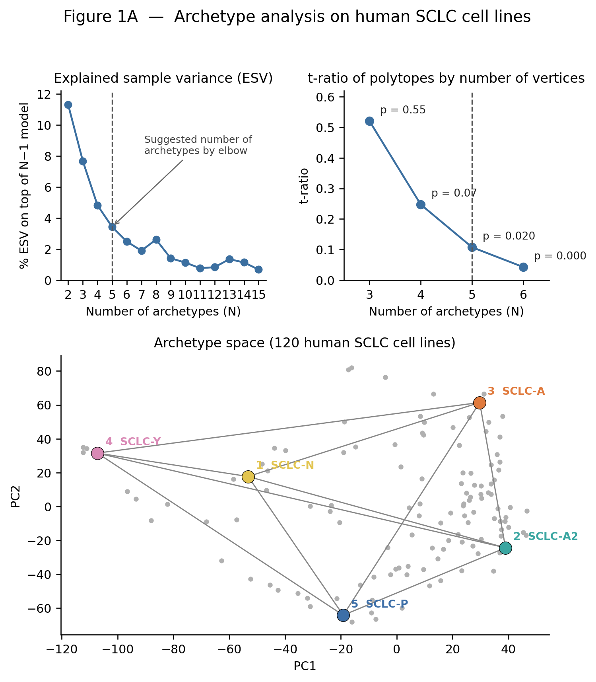
Figure 1. Archetype analysis of 120 human SCLC cell lines: explained variance, t-ratio by number of vertices, and the five-vertex simplex.

3.2 The transcriptome-wide fit does not generalise
The obvious next step was to run the same pipeline on 63 invasive breast carcinoma cell lines using the full transcriptome. There is no significant simplex: the elbow suggests four archetypes, but the best p-value is 0.082. TCGA tumors do not fall inside that shape. Glioblastoma, run as a second test in a cleaner statistical setting (54 lines, with TCGA tumors projected in), also has no significant number of archetypes. The method is therefore able to say no. The failure is not that breast cancer has no geometry; it is that the geometry is not the whole transcriptome of cell lines.

3.3 The KS signature gives a triangle
Restricting to the 206 KS genes, the same 63 lines support a triangle with a t-ratio of 0.587 (p = 0.022, 500 permutations). Basal and luminal lines separate toward different vertices, and HER2 does not receive a vertex of its own. A short PAM50 list does not reproduce this, so the signal comes from the EMT signature. This is the first positive breast result, and it is still a cell-line result.
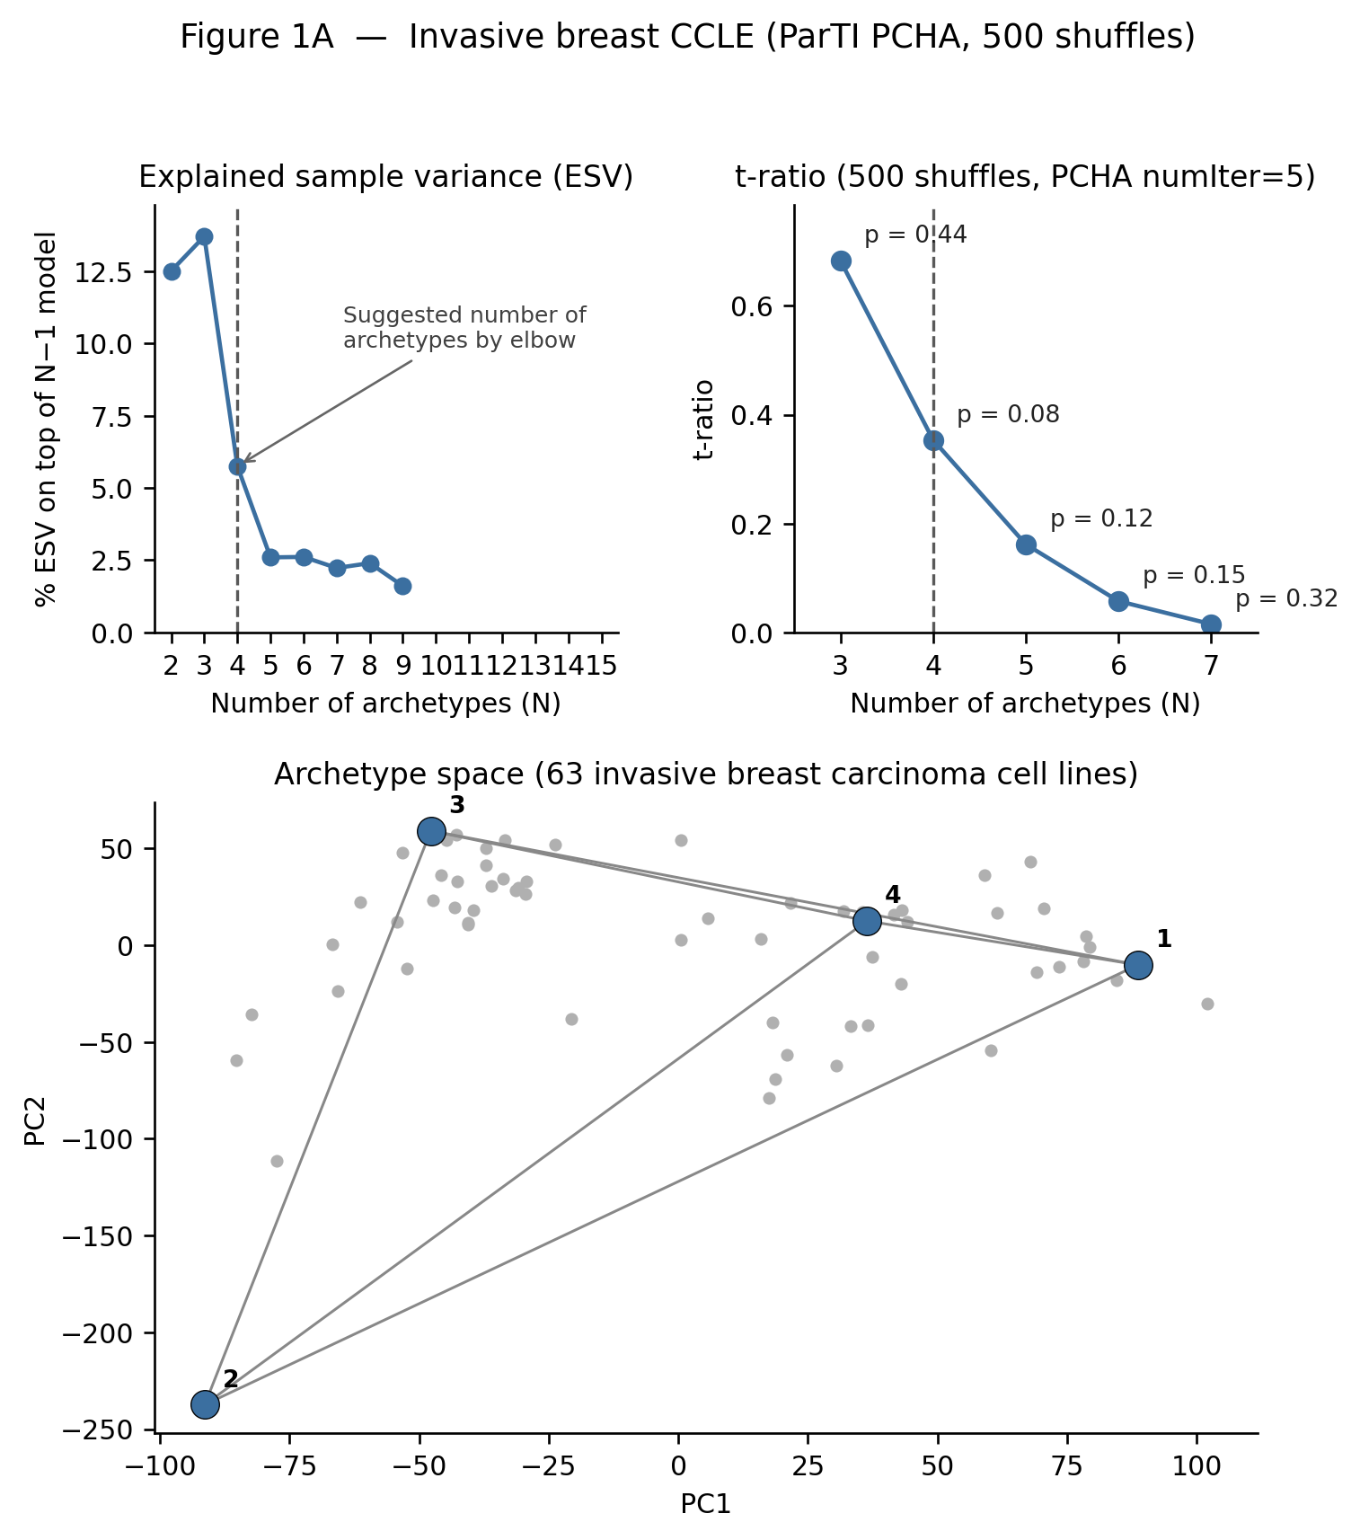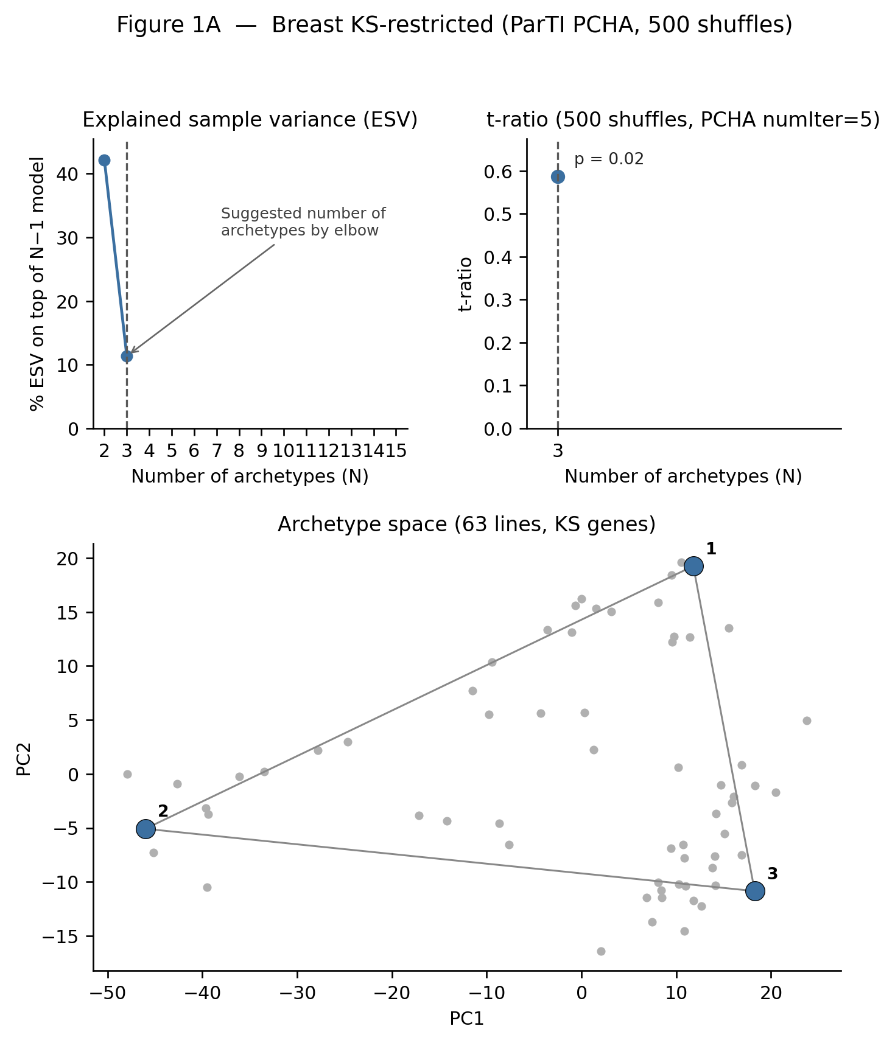
Figure 2. Left: 63 breast cell lines, full transcriptome (best p = 0.082). Right: the same lines restricted to the KS genes (k = 3, p = 0.022).

3.4 The host of the simplex matters
Three single-cell datasets were projected into the cell-line triangle after MAGIC imputation. Cell-line single cells (GSE173634) and the Wu tumor atlas fall partly inside it, about half of the cells. The Pal atlas does not: 13.3% of its 84,602 epithelial cells are inside. If the cell-line triangle were the tumor geometry, Pal should have behaved like Wu.
I therefore reversed the fit. Archetypes were estimated on Pal (GSE161529), and the other datasets were projected into that frozen triangle without refitting. They now fall mostly inside, while Pal remains mostly outside the cell-line triangle.
Table 2 sets out exactly which dataset defines each triangle and which datasets are only projected into it. In both cases the same 206 KS genes and k = 3 are used, and no guest dataset is ever refitted.
Table 2. Host and guest datasets for the two triangles.
Triangle | Fitted on (host) | Projected, not refitted (guests) | Shown in
Cell-line triangle | 63 DepMap breast lines | Pal (84,602 cells), Wu (24,162 cells), GSE173634 (35,271 cells), after MAGIC | Figure 3
Tumor triangle | Pal GSE161529 tumor cells | DepMap lines (63), Wu, GSE173634 | Figure 4

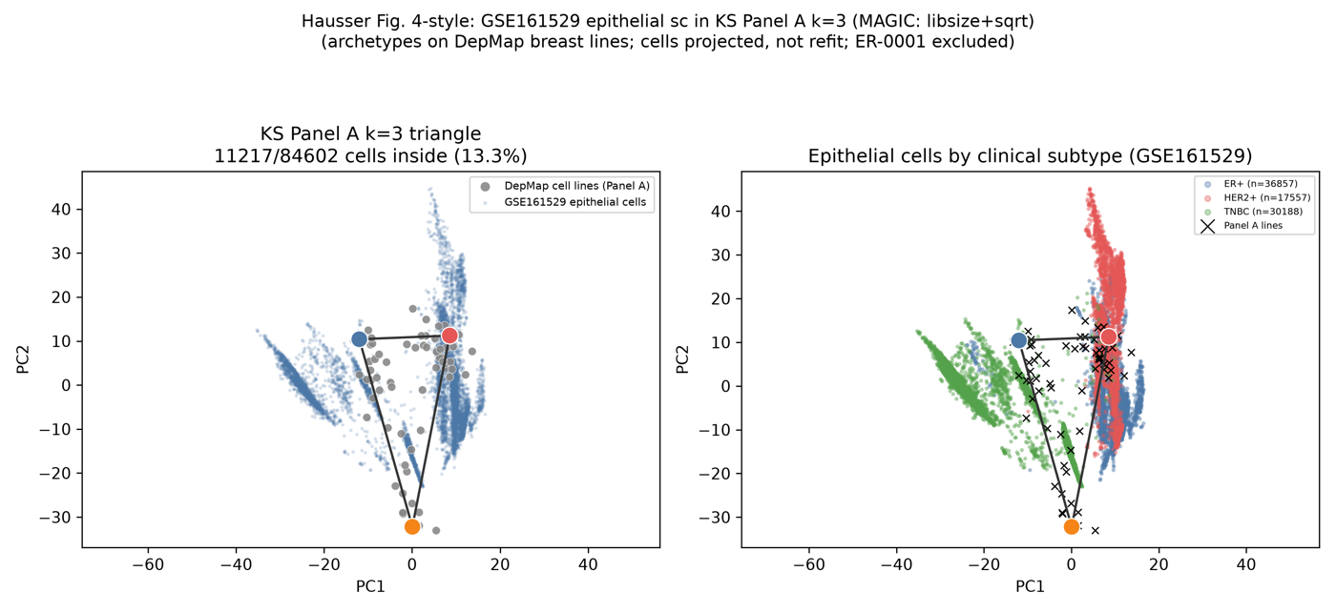
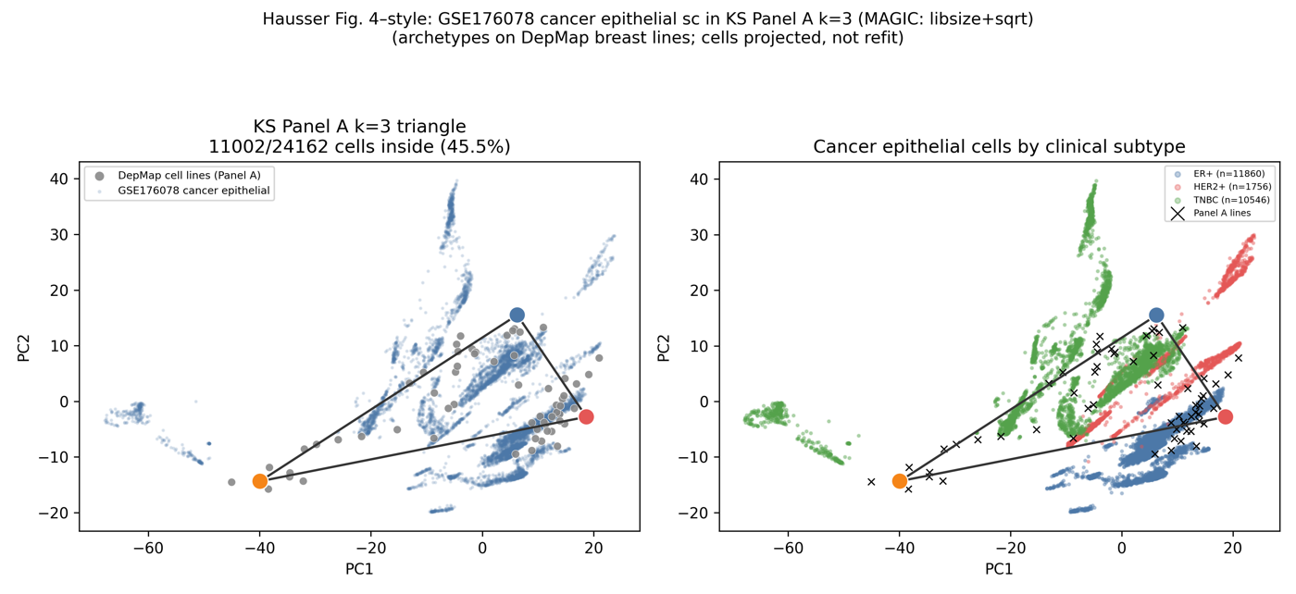
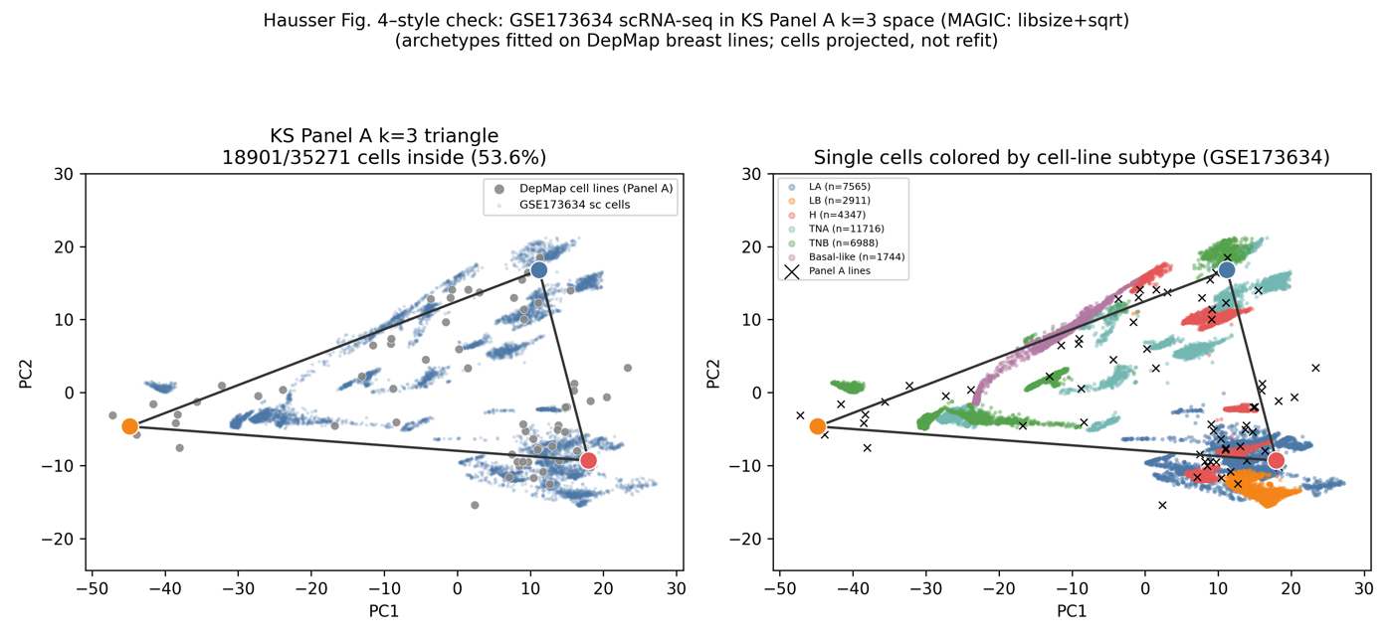
Figure 3. Cell-line host. The triangle is fitted on the 63 DepMap breast lines (grey points) and each single-cell dataset is projected in. Rows: Pal (13.3% inside), Wu (45.5%) and GSE173634 (53.6%). Left panels show the cells against the triangle; right panels colour the same cells by clinical or cell-line subtype.
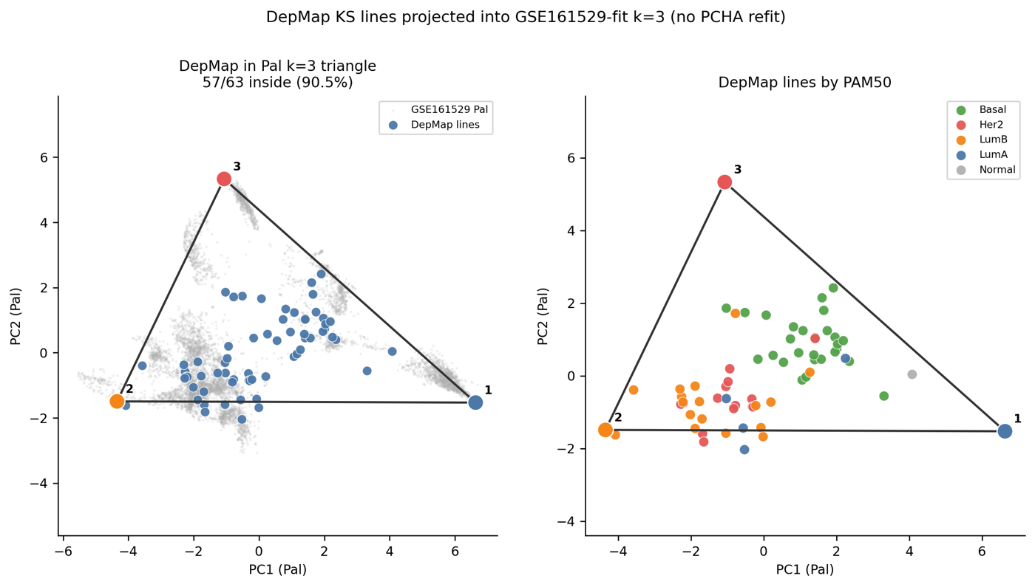
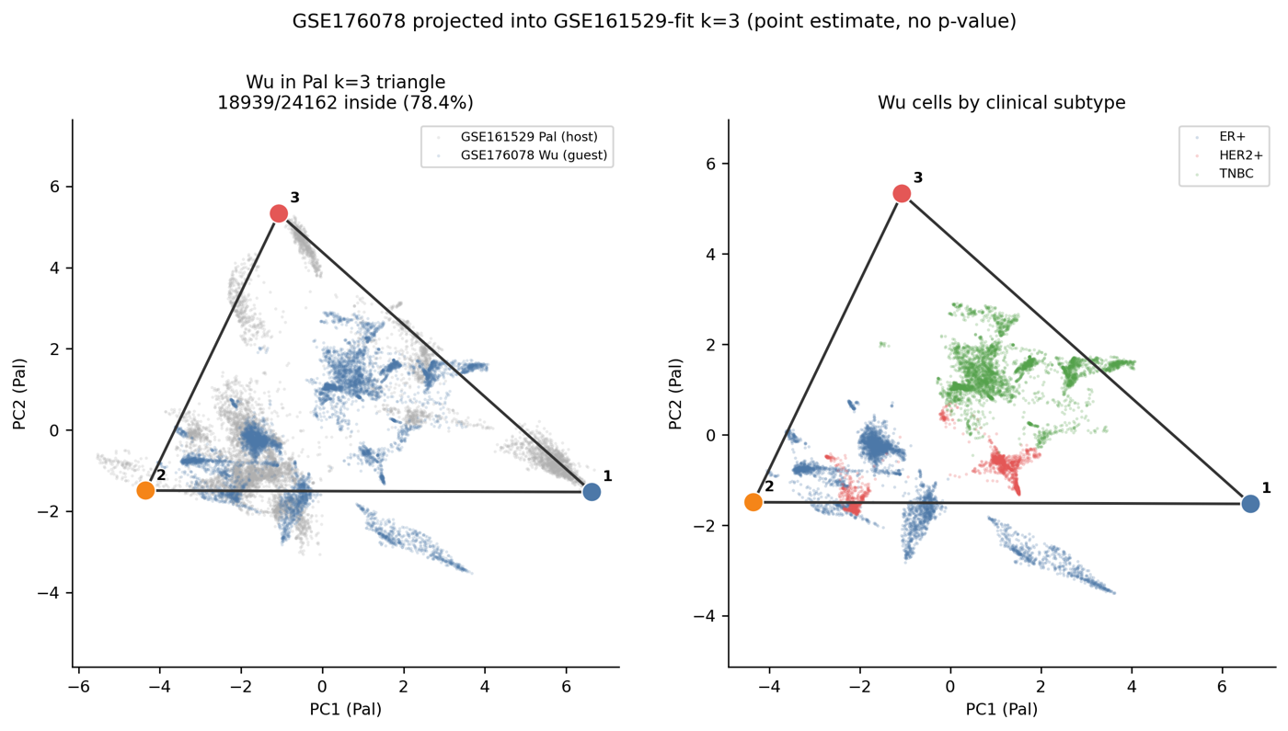
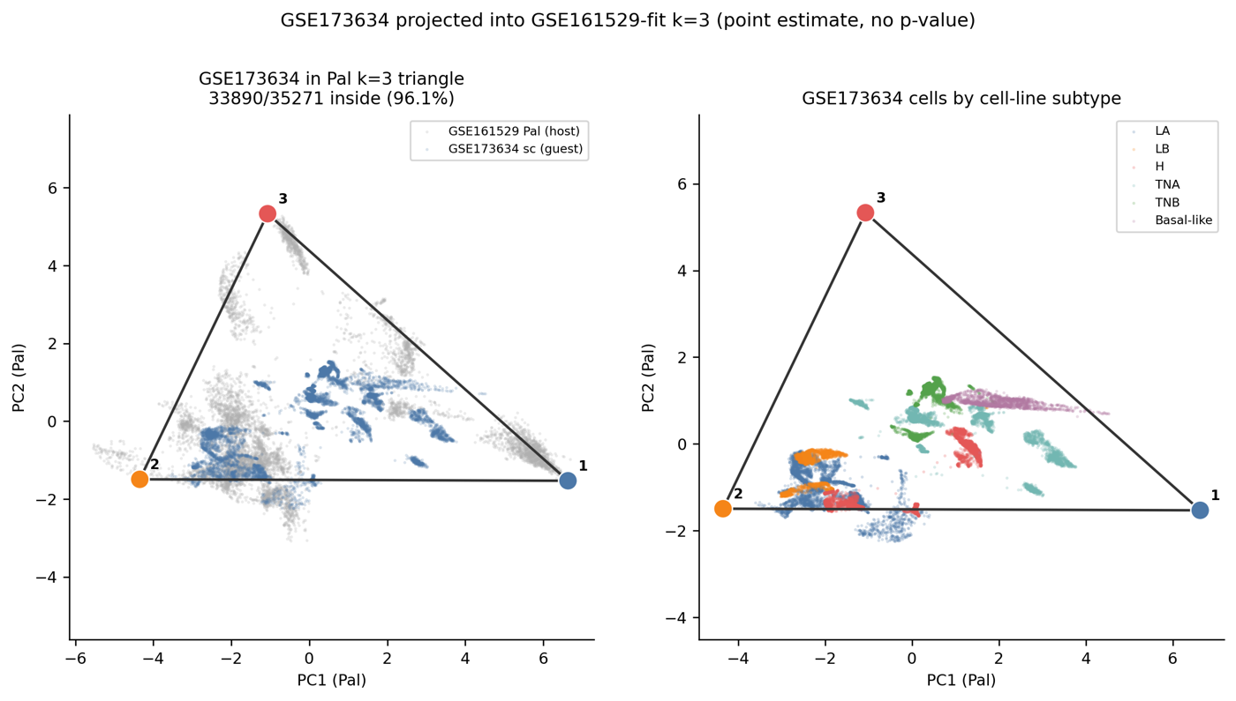
Figure 4. Tumor host. The triangle is fitted on Pal tumor cells (grey) and the other datasets are projected in. Rows: DepMap lines (57 of 63 inside, 90.5%), Wu (78.4%) and GSE173634 (96.1%). Right panels colour the guests by PAM50 or clinical subtype.
Table 3. Fraction of samples inside each k = 3 triangle.
Dataset | n | Inside cell-line triangle | Inside Pal triangle
Pal GSE161529, tumor cells | 84,602 | 13.3% | 75.8%
Wu GSE176078, tumor cells | 24,162 | 45.5% | 78.4%
GSE173634, cell-line cells | 35,271 | 53.6% | 96.1%
DepMap bulk lines | 63 | 52.4% | 90.5%

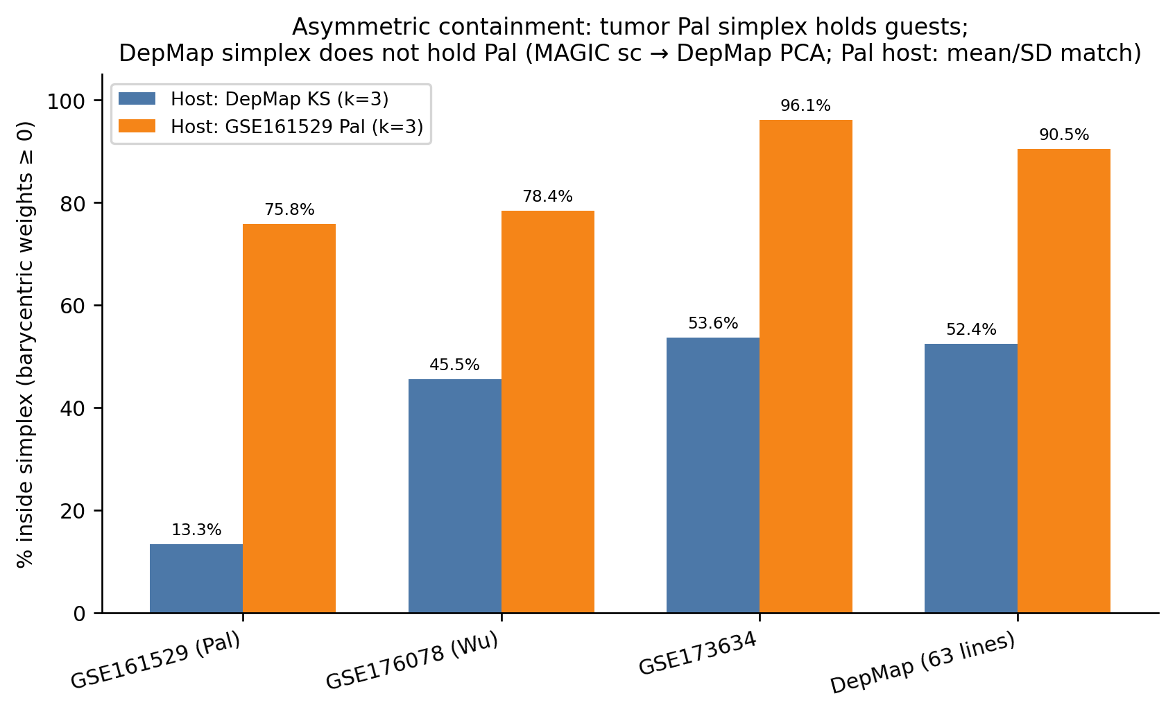
Figure 5. Asymmetric containment. The tumor-fitted triangle holds the guests; the cell-line triangle does not hold Pal.
A four-vertex fit does not contain the other datasets, so the triangle is the working geometry even though the elbow criterion on the cell lines preferred four. On the Pal t-ratio test both k = 3 (t-ratio 0.66) and k = 4 (0.33) beat all 50 permutations. With 50 permutations this means p < 0.02, not a more precise value.
The scientific point is that, for this signature, cell lines are a truncated version of the tumor geometry rather than the geometry that tumors fail to reach. They cover the epithelial side and under-represent the mesenchymal extreme.

3.5 The corners are programs, not the three clinical bins
On the Pal triangle, Arc 2 is a luminal-epithelial program and holds ER+ and HER2+ cells together. Arc 3 is a mesenchymal program driven by VIM and is not a single immunohistochemistry class. Arc 1 is enriched for triple-negative breast cancer (TNBC) but is not a single class either: TNBC splits between Arc 1 and Arc 3, largely by patient. HER2 never receives a vertex. Clinical subtype and EMT task are different partitions of the same cells.
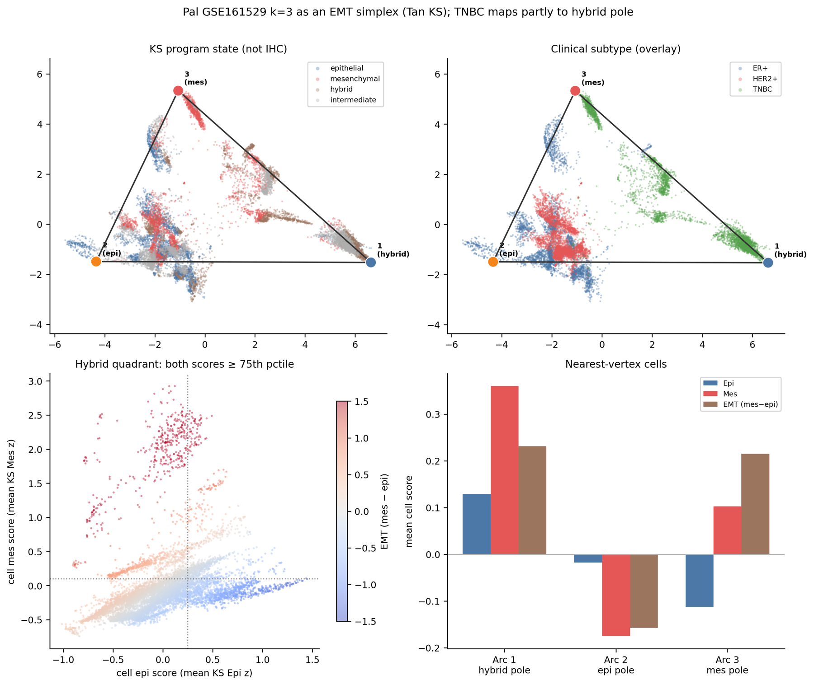
Figure 6. The Pal triangle (k = 3) coloured by KS program state (top left) and clinical subtype (top right). The figure labels Arc 1 as the hybrid pole; Section 3.7 shows why that label needs care.

3.6 Hybrid cells are not the generalists
With both labels in hand, the hypothesis can be tested directly: if hybrid E/M cells are generalists, they should sit in the interior, and the interior should be mostly hybrid.
Table 4. Where hybrid cells sit.
Dataset | Hybrid samples | At a corner | Interior | Median weights (Arc 1, 2, 3)
Pal | 8,719 (10.3%) | 65.6% | 34.4% | 0.68, 0.02, 0.11
Wu | 2,413 (10.0%) | 6.3% | 93.7% | 0.51, 0.11, 0.38
GSE173634 | 65 (0.2%) | 0% | 100% | 0.36, 0.28, 0.37
DepMap | 0 | — | — | no jointly high line

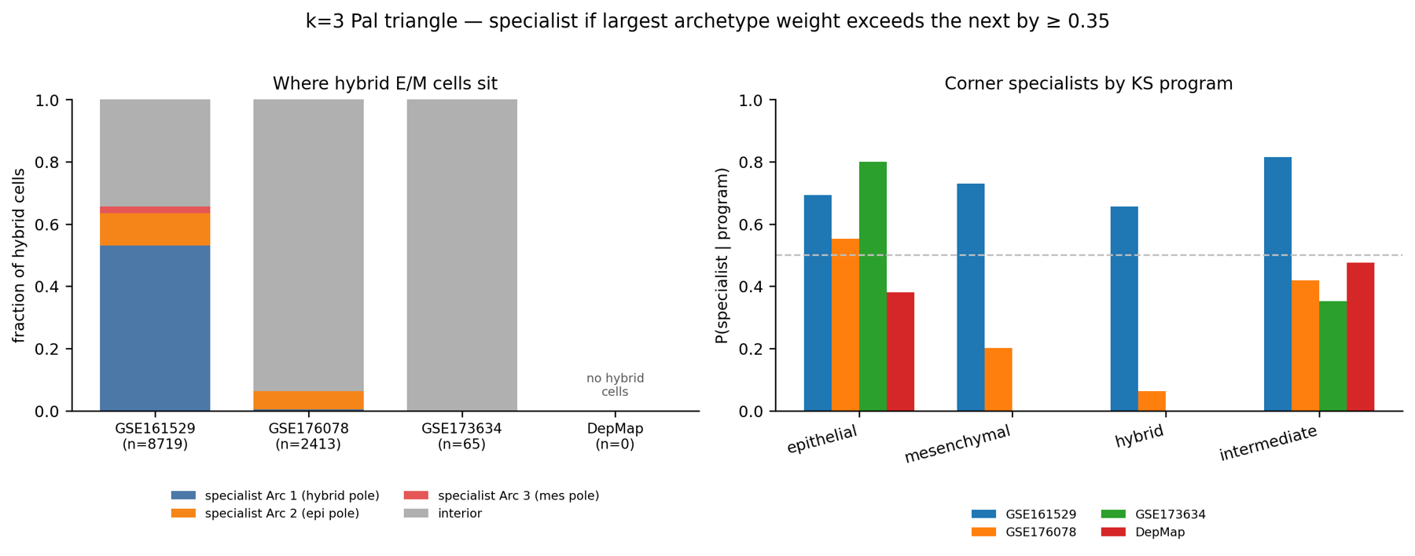
Figure 7. Left: where hybrid E/M cells sit in each dataset. Right: probability of being a corner specialist, by KS program.
The answer differs by dataset, and none of the answers is “interior generalist” in the sense of the hypothesis. In Pal, hybrid cells sit at a corner, Arc 1, and the median purity of 0.52 shows this is not a near miss on the 0.35 cut. In Wu, hybrid cells fail the corner cut but are not at the centre either: their median weights (about 0.51, 0.11 and 0.38) place them on the edge between Arc 1 and the mesenchymal vertex. In GSE173634 they sit at the centroid, and in DepMap no line is jointly high for both scores.
Seen from the other side, the interior is mostly not hybrid. In every dataset, interior samples are mostly epithelial, mesenchymal or intermediate; hybrid is only 13–15% of the interior in the two tumor atlases and essentially absent in the cell-line data. The epithelial samples are the ones that consistently reach a corner. Mesenchymal samples are interior in Wu (79.9%), GSE173634 (100%) and DepMap (100%).

3.7 A patient audit of the hybrid signal
The Pal hybrid corner needs a further check, because single-cell atlases contain very many cells from a small number of patients.
Table 5. Patient and line composition of the hybrid signal.
Dataset | Finding
Pal | 92% of the hybrid cells that are Arc 1 specialists come from one patient, TN-0135 (14,322 cells, all specialists at Arc 1; median weights 0.91, 0.00, 0.08).
Wu | About half of the hybrid cells come from one TNBC patient, CID4515, who does not pass the corner cut (specialist rate 0%).
GSE173634 | All 65 hybrid cells come from one cell line, CAL851.

Hybrid-as-its-own-corner is therefore a Pal result, and inside Pal it is one patient. It does not recur elsewhere: where both gene sets are high in another dataset, the cells are interior, on an Arc 1–Arc 3 edge in Wu and at the centroid in GSE173634.

4. Discussion

4.1 What the results support
The hypothesis that hybrid E/M cells are the interior generalists is not supported as a general rule on this signature. What is supported is a host effect. Archetypes defined on cell lines miss the tumor geometry, in particular the mesenchymal extreme, whereas archetypes defined on a large tumor atlas contain both the cell lines and a second tumor cohort. The reproducible specialist is the epithelial program. Hybrid E/M is sometimes a patient-dominated vertex, sometimes an edge, and sometimes missing.
An apparent hybrid vertex should not be reported as a third task until the dominant patient is removed and the fit is repeated. That is the next experiment.

4.2 What this report does not claim
- It does not claim that PCHA finds a simplex in every cancer. Glioblastoma and the breast transcriptome are counterexamples.
- It does not claim that the Pal p-value is zero. Zero of fifty shuffles means p < 0.02.
- It does not claim that Arc 1 is a hybrid task of TNBC. It says Arc 1 is where one large TNBC patient sits.
- It does not claim that cell lines are useless. It says they are the wrong host for the corners of this signature.

4.3 Limitations
Two limits belong next to the result. The breast and Pal fits used fewer PCHA random starts than the SCLC reproduction, and the Pal permutation test used 50 shuffles. The hybrid call is a within-dataset rank, so hybrid fractions are not directly comparable across cohorts. The specialist cut of 0.35 is a choice; the ordering described above (Pal hybrids at a corner, Wu hybrids on an edge, cell-line hybrids absent) is what the weight vectors show, and a threshold sensitivity table is in the repository. The analysis also depends on MAGIC imputation and the projection recipe, and covers one signature in one disease.

5. Next steps

5.1 The check the claim depends on
The first task is narrow and decisive: refit the Pal triangle without TN-0135, project the held-out cells and the other three datasets into the new triangle, and recompute the specialist table. There are three possible outcomes, and each is reportable.
Table 6. Possible outcomes of the leave-one-patient refit.
Outcome of the refit | Consequence for the thesis
Arc 1 disappears or moves; the epithelial–mesenchymal axis remains | The third corner was a patient. The result becomes an epithelial specialist pole with a mesenchymal interior.
A hybrid-enriched corner returns, shared by several TNBC patients | The third task survives; TN-0135 was an extreme member, not the cause.
The triangle falls apart | The Pal host was not robust. The thesis stops at the host-swap asymmetry and does not claim three tasks.

5.2 Hardening and extending the current analysis
Once the refit is done, four extensions would make the result harder to dispute and more useful.
- Continuous purity. Report archetype-weight purity (largest weight minus second) against the mesenchymal-minus-epithelial score, with the 0.35 cut kept as a sensitivity table rather than a rule.
- A common ruler for “hybrid”. Recompute the double-high call with one set of gene means and standard deviations for all four datasets, to test whether “no hybrid DepMap line” and “10% hybrid Pal cells” survive a shared scale.
- Leave each large patient out in turn. Extending the TN-0135 refit to every major patient shows which corners are stable and which are carried by one individual. Wu stays a guest and is never refitted.
- A second EMT signature. Repeating the host swap with an independent E/M gene set tests whether the asymmetry belongs to biology or to the KS list.
- Clinical association. If the corners survive the refit, test whether corner weights relate to survival and drug response. This is held back until then, since a survival panel on a vertex that is one patient would not help.

5.3 Beyond RNA: methylome and proteome
A longer-term direction is to ask whether other molecular layers agree with the corners found from RNA. The archetype weights give a common coordinate: each sample already has a position in the frozen triangle, so methylation and protein measurements can be related to that position rather than to a discrete label. The datasets named below are candidates; their availability and sample matching still need to be confirmed.
Table 7. Proposed multi-omic extension.
Layer | Candidate data | Question | First test
Methylome | DepMap/CCLE methylation for the 63 breast lines; TCGA-BRCA tumors | Do the epithelial and mesenchymal corners differ in methylation at CDH1, VIM, ZEB1 and miR-200 loci? Is the hybrid state epigenetically distinct? | Regress methylation on archetype weights in the 63 lines
Proteome | DepMap/CCLE proteomics; CPTAC breast tumors | Do E-cadherin and vimentin levels agree with the RNA-defined corners? Does the cell-line truncation also hold at the protein level? | Same 63 lines, then project CPTAC tumors into the frozen Pal triangle

The order matters. Cell lines come first because they need no new cohort: the same 63 lines already have a position in the triangle. Tumor cohorts come second, and only after the leave-one-patient result, so that the multi-omic work is built on a corner structure that has survived the patient check. This extension is planned beyond the thesis itself, as part of the work toward a manuscript.

5.4 Timeline
Table 8. Timeline to the final viva and beyond.
Date | Milestone
By 9 October | Mid-semester report and presentation
October | Leave-one-patient refit; purity-versus-EMT plot; sensitivity table
15 November | Viva II
20 November | Full thesis draft
28 November | Thesis abstract and final report
10–15 December | Final viva
2027 | Methylome and proteome extension; manuscript if the refit supports it

A manuscript in 2027 is realistic only after the leave-one-patient refit. Its core is a biological correction about hosts and hybrid cells; the multi-omic layer would add support for it rather than replace it.

References
1. Hausser, J. et al. Tumor diversity and the trade-off between universal cancer tasks. Nature Communications 10, 5423 (2019).
2. Groves, S. M. et al. Archetype tasks link intratumoral heterogeneity to plasticity and cancer hallmarks in small cell lung cancer. Cell Systems 13, 690–710 (2022).
3. Tan, T. Z. et al. Epithelial-mesenchymal transition spectrum quantification and its efficacy in deciphering survival and drug responses of cancer patients. EMBO Molecular Medicine 6, 1279–1293 (2014).
4. Pal, B. et al. A single-cell RNA expression atlas of normal, preneoplastic and tumorigenic states in the human breast. EMBO Journal 40, e107333 (2021).
5. Wu, S. Z. et al. A single-cell and spatially resolved atlas of human breast cancers. Nature Genetics 53, 1334–1347 (2021).
6. Gambardella, G. et al. A single-cell analysis of breast cancer cell lines to study tumour heterogeneity and drug response (GEO series GSE173634, as used in Sahoo et al., iScience, 2024).

Attendance
Working days present in this period: ____ of ____. Days of leave: ____. I was at IISc for the thesis work and met the supervisor in person and by email throughout the period.

Repository
Figures and tables cited here are in Breast Cancer/figures/ and Breast Cancer/results/ of the project repository (github.com/VM1235/cancer-archetype-analysis). The four-dataset comparison write-up is Breast Cancer/docs/RESULT_compare_four_datasets.md.

