Mermaid alignment

Table of contents

# 1.

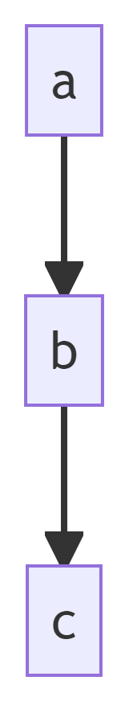

Mermaid diagram