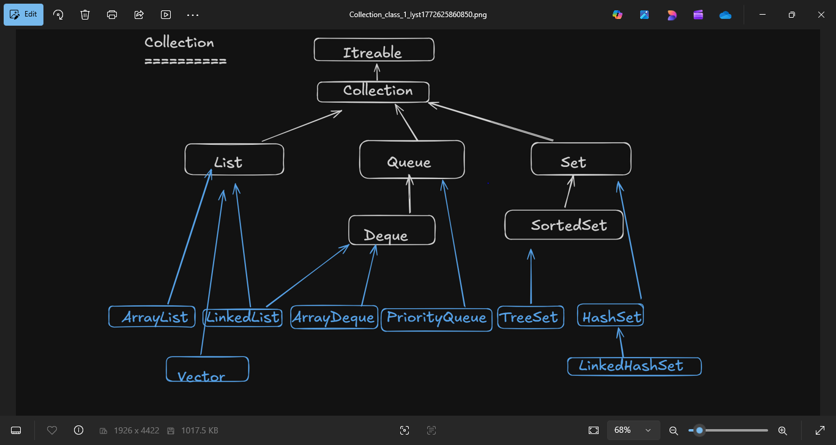

PriorityQue:
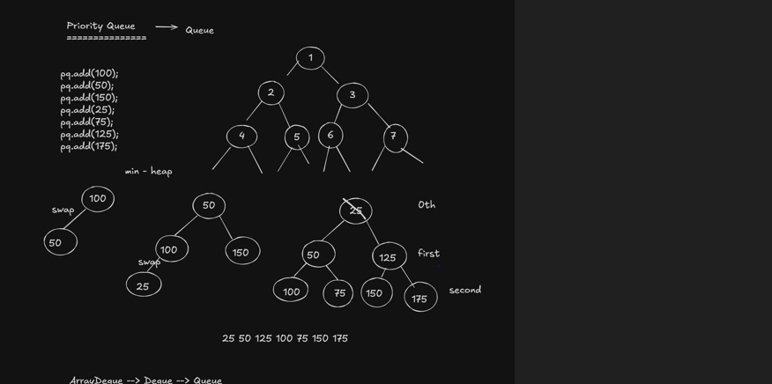
PriorityQueue pq=new PriorityQueue();// min heap ds
pq.add(100);
pq.add(50);

ArrayDeque:

ArrayDeque ad=new ArrayDeque();
ad.add(100);
ad.add(200);
System.out.println(ad);
ad.add(300);
System.out.println(ad);
ad.addFirst(400);

TreeSet:
TreeSet->SortedSet->Set
Set --> Sorted order --> BST --> Red-Black Algo
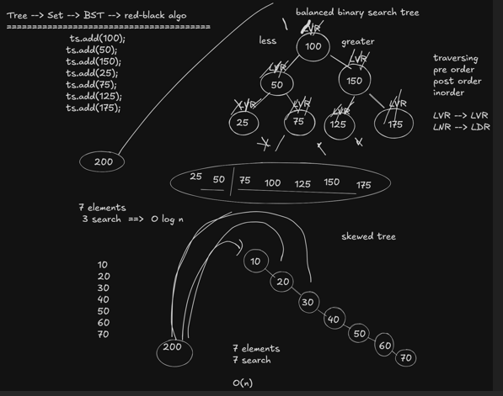
- It will print the output in sorted mannner.
TreeSet ts=new TreeSet();//Set --> Sorted order --> BST --> Red-Black Algo
ts.add(100);
ts.add(50);
ts.add(150);
ts.add(25);
ts.add(75);
ts.add(125);
ts.add(175);
// ts.add(null);exeception
//ts.add(175);duplicate not allowed
System.out.println(ts);
System.out.println(ts.higher(50));
System.out.println(ts.lower(50));
System.out.println(ts.higher(65));
System.out.println(ts.lower(30));
System.out.println("********************");
System.out.println(ts.ceiling(65));
System.out.println(ts.floor(30));
System.out.println(ts.ceiling(50));
System.out.println(ts.floor(50));
System.out.println(ts.headSet(75));
System.out.println(ts.tailSet(75));

ArrayList And LinkedList

Generics
Basically collections will store the hetrogeneous type of data, like w can store integer, string and even object also.
But if we want to specify the collection that we need to add only perticular type of data then we will use generics. Here we will explicitly specify the date type in “<>” brackates and not able to specigy non-primitive data type like(int,char). We need to specify primotive or Wrapper class like (Integer, String or object).
Example :
ArrayList<Integer> ar1=new ArrayList<>;

CollectionUtilClass
There are mainly 2 class are there from which we can use methods for Collection Util class.
Ex: Collection.frequency(cources, “java”);
1.Comparator (If we don’t have acess modify class we can use this).
Comparator will give the inbuild funtion.
2. Comparable(If we t have acess modify class we can use this)

Map
In Java, the Map Interface is part of the java.util package and represents a collection of key-value pairs, where Keys should be unique, but values can be duplicated.
Whenever we want to store data in key-value pair then we will use map.
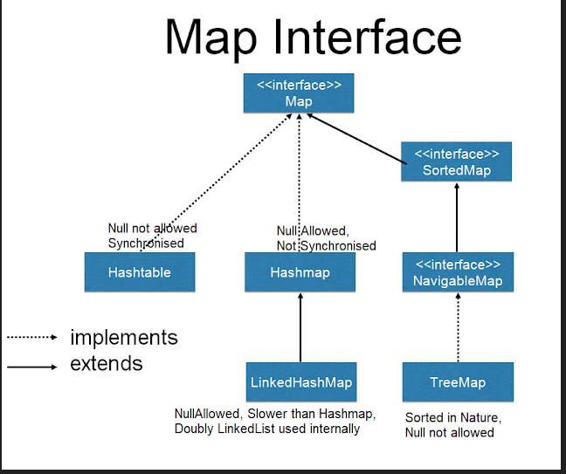

HashMap

HashMap: Duplicates are allowd, no order, null are allowed
LinkedHashMAp: Same like HashMap but it will maintain insertion order.
HashTree: Duplicates and null values are not allowed and it sorts the data.

// * HashMap: Null is allowed ,Null is allowed.
public class HashMap1 {

public static void main(String[] args) {
// TODO Auto-generated method stub
HashMap<Integer,String> h1=new HashMap<>();
// h1.put(key,value );
h1.put(3, "Rohit");
h1.put(4, "Rohit");
h1.put(5, "Aaru");
h1.put(2, "Manu");
h1.put(4, "Rohan"); //Value can be duplicate but key must be uniq
h1.put(null, "Kavya");
h1.put(9, null); //value and key canbe null
System.out.println(h1);

package map;

import java.util.Map.Entry;
import java.util.Collection;
import java.util.HashMap;
import java.util.Iterator;
import java.util.Map;
import java.util.Set;

public class FetchingKeyValue {

public static void main(String[] args) {
// TODO Auto-generated method stub
HashMap map=new HashMap();
map.put(2,"veena");
map.put(3,"manasvi");
map.put(5,"vaval");
map.put(4,"arradhya");
map.put(1,"mahendra");
System.out.println(map);

//Fetching Keys
Set key1=map.keySet();
//System.out.println(itr1);
Iterator itr1=key1.iterator();
while(itr1.hasNext())
{
System.out.println(itr1.next());
}

//Fetching Values
Collection value1=map.values();
Iterator itr2=value1.iterator();
while(itr2.hasNext())
{
System.out.println(itr2.next());
}

//Fetching key and Values
Set kv=map.entrySet();
Iterator itr3=kv.iterator();
while(itr3.hasNext())
{
//System.out.println(itr3.next());
Map.Entry pair=(Entry) itr3.next();
System.out.println("key:"+pair.getKey()+" "+"Value:"+pair.getValue() );

}

}

}

