Recruitment Lifecycle Assistant

AI-Powered Smart Talent Acquisition & Hiring Management Assistant
Idea Submission — KPMG HackNow

1.1 Team Information
Team Name | The Assist Alliance
College / Institution | KSRM College of Engineering
Number of Members | 5
Team Members | V. Mahamadh Basha (Team Lead), K. Gowthami, G. Gowthami, S. Venkata Kalyan, G. Thanusha.
Problem Statement Chosen | 3. Talent Acquisition & Hiring Lifecycle Management

1.2 Problem Statement
Hiring looks simple on paper, but in most organizations it runs through emails, spreadsheets and several unconnected tools. Job requisitions, approvals, applications, interviews, feedback and offers each live in a different place, so recruiters and hiring managers spend more time coordinating than evaluating people.
As application volumes grow, manual resume screening becomes slow and inconsistent. Candidates also need to move through evaluation rounds against clear, predefined criteria, and the final hiring decision has to stay with people, not with a tool.
The core gap
There is no single connected platform that manages the complete hiring lifecycle, from job requisition to candidate selection, offer management and hiring.

What is needed is a centralized, AI-enabled talent acquisition platform that scores candidates against job requirements, applies round cut-offs, automates approvals and communication, and leaves the final decisions with HR and hiring managers.
Where the process breaks down today
Fragmented operations  Emails, spreadsheets and separate tools. Everything is coordinated by hand. | Requisition and approval delays  Manual follow-ups slow down job creation, approval and publishing. | Screening overload  High application volume, manual resume review and no easy way to compare candidates.
Interview coordination  Availability clashes, scattered feedback and manual reminders. | Offer and hiring decisions  Several approvals, offer changes by email and no single history. | Candidate experience  Unclear status, late updates and no visibility across the lifecycle.

Why it matters
Fragmented hiring → manual coordination → delayed decisions → poor visibility → inconsistent candidate experience.

1.3 Key Needs
Need | What the platform must do
Centralized hiring management | Manage jobs, candidates, evaluations, approvals and offers in one platform.
AI-assisted candidate scoring | Analyze candidate details against job requirements and return scores, matched skills and gaps.
Human-controlled selection | HR makes the final shortlist and hiring decisions using AI results and evaluation scores.
Structured evaluation | Run multiple rounds with defined cut-offs and automatic candidate progression.
Interview and feedback management | Schedule interviews against availability and capture interviewer evaluations.
Offer management | Handle offer preparation, approvals, re-quotes and candidate responses.
Automated workflow and communication | Automate approvals, status updates, notifications and follow-ups.
Hiring visibility | Show job status, candidate pipeline, evaluation results and hiring progress on dashboards.
Who is affected
Stakeholder | Role in hiring | Pain today
Student / candidate | Applies, takes the rounds, responds to the offer | Unclear status and late updates
HR | Shortlists, runs rounds, selects the final candidate | Heavy manual screening and coordination
Support Member | Creates and tracks interview tasks | Manual scheduling and follow-ups
Manager | Approves requisitions and offers | Approvals scattered across emails
Head HR | Prepares and re-quotes offers | No controlled offer history
Organization | Owns hiring outcomes | Slow cycles and little visibility

2. Solution Innovation

2.1 Our Approach
The Campus Hiring System is an AI-assisted, human-controlled hiring platform built entirely on ServiceNow. It connects the whole talent acquisition lifecycle in one workflow: job requisition, approval, publishing, candidate application, AI screening, shortlisting, interviews, evaluation, final selection, offer management and hiring.
Repetitive work is automated: approvals, notifications, eligibility checks, interview coordination and offer processing. For every application, the AI compares the candidate with the job description and returns a score, matched skills, skill gaps and a short reason.
The AI never makes the hiring decision. HR reviews its analysis and chooses who moves forward, and any override is recorded with a reason. That keeps the process transparent and under human control.
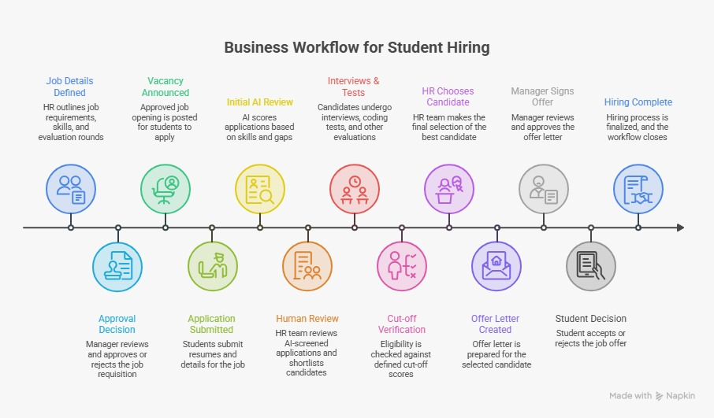

Figure 1: Solution approach at a glance, from requisition to hiring
2.2 Innovation & Differentiation
The main innovation of the solution is not simply using AI for recruitment. It is the combination of AI assistance, workflow automation, and human decision-making within one connected hiring lifecycle.
- AI-Assisted, Human-Controlled Hiring: AI provides candidate scores and insights, while HR retains complete control over shortlisting and final selection.
- Cut-off Based Progression: Candidates automatically progress through evaluation rounds based on predefined cut-off criteria.
- Automated Recruitment Workflow: Approvals, notifications, eligibility checks, interview activities, offer approvals, and status updates are handled through ServiceNow workflows.
- Controlled Offer Management: Offer approvals and re-quotation are handled through a defined workflow with limits and complete history.
- Complete Traceability: Candidate applications, AI analysis, evaluation scores, feedback, approvals, decisions, and offer history remain connected throughout the hiring lifecycle.

Figure 2: End-to-end hiring lifecycle with approvals, cut-offs, the offer re-quote loop and exception paths
Key business rules
AI only scores. HR decides, and the AI ignores name, gender, age and similar personal attributes.
Cut-offs are set at requisition time. Maximum 3 interview rounds and 3 offer re-quotes.
Comments are required on every rejection and override. Duplicate applications are blocked.
No candidate email is sent before Manager confirmation.

2.3 Why This Matters
Who | What they gain
Students / candidates | Simple job discovery and application, a live status tracker, timely notifications and a clear offer response step.
HR and recruiters | Centralized applications, AI-assisted screening, faster shortlisting, automated communication and complete candidate history.
Support Member | Interview tasks and schedules in one place instead of scattered messages.
Hiring managers | Structured approvals, visibility of evaluations and controlled offer approval.
Head HR | One place for offer preparation, offer history and re-quote tracking.
Organization | Standardized, traceable hiring with real-time visibility and better decisions.

2.4 System Architecture

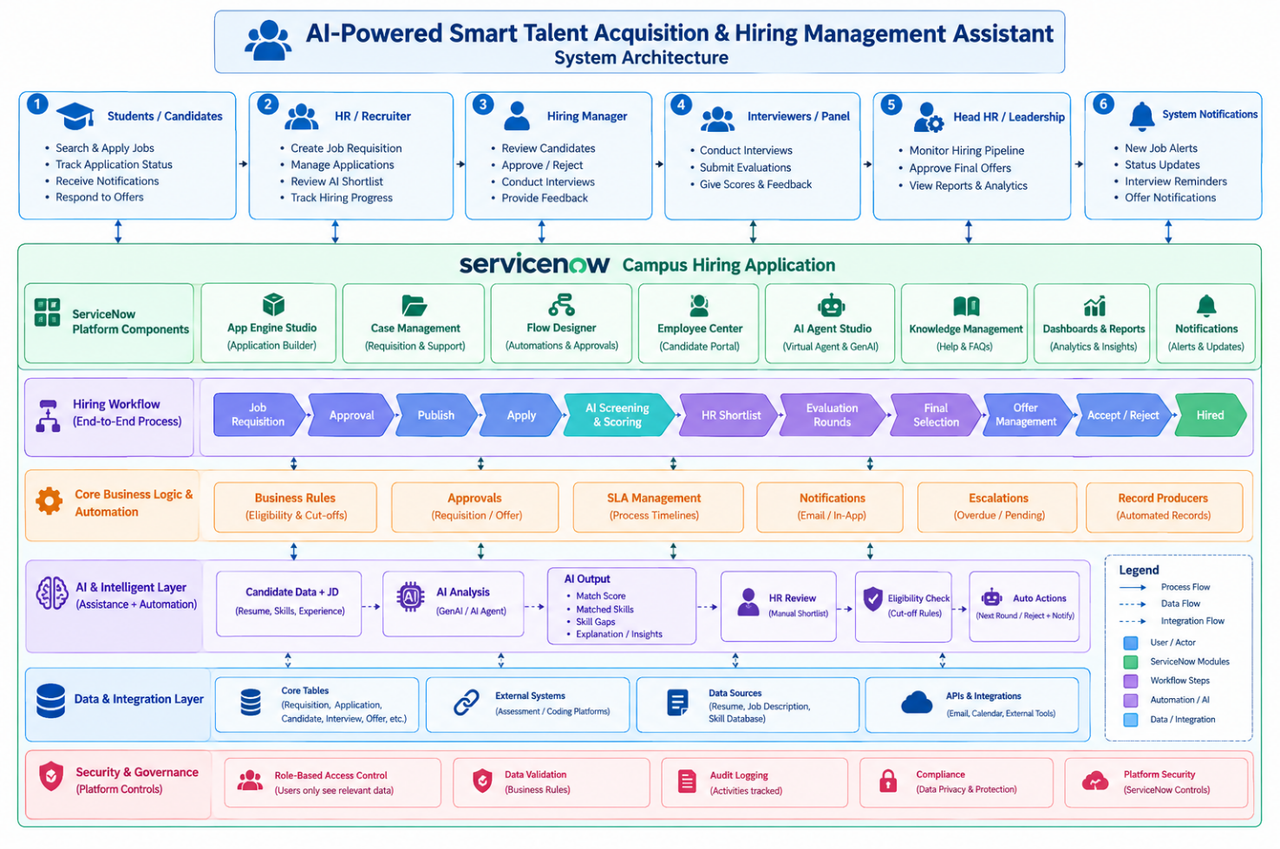3. Implementation & Feasibility

3.1 Technical Stack
Component | Technology / Module
Front-end and back-end elements | Front-end: Employee Center (job listings, apply form, status tracker) and UI Builder pages (HR review, evaluation and offer screens). Back-end: custom tables, Flow Designer, Business Rules and server-side scripts (Script Includes).
ServiceNow modules | App Engine Studio, Service Catalog, Flow Designer, Business Rules, Notifications and Email, UI Builder, Employee Center, Dashboards and Reporting, Generative and Agentic AI
ServiceNow features | Custom tables, requisition catalog item, approvals, scheduled jobs for auto-close and reminders, role-based access, offer letter template, AI scoring agent, reports and dashboards. Optional: Virtual Agent for candidate questions.
High level design | Layered design: users, Employee Center and UI Builder, the scoped hiring application, workflow and Business Rules, AI, then data and analytics (Figure 3).
Supporting tools / languages | JavaScript, Glide APIs, HTML and CSS, update sets for version control. REST APIs are kept for future integrations.

3.2 Project Timeline
The work is split into seven phases so the core hiring workflow is finished first and extra features are layered on afterward. Phases follow their dependencies, and calendar dates follow the official hackathon schedule.
Phase | Implementation | Milestone
Phase 1 | Understand requirements, finalize the hiring workflow, roles, cut-off rules and data structure | Workflow finalized
Phase 2 | Create the scoped application, custom tables, roles and access rules | Data model ready
Phase 3 | Build requisition, Manager approval and job publishing with auto-close | Jobs go live
Phase 4 | Build the apply form, status tracker, AI screening and HR shortlisting | Candidates ranked
Phase 5 | Build interview scheduling, feedback, round scores and cut-off eligibility | Rounds automated
Phase 6 | Build final selection, offer approval, re-quote loop, offer letter and candidate response | Offer to hire works
Phase 7 | Dashboards, testing, bug fixing and demo preparation | Working prototype

Project Timeline:
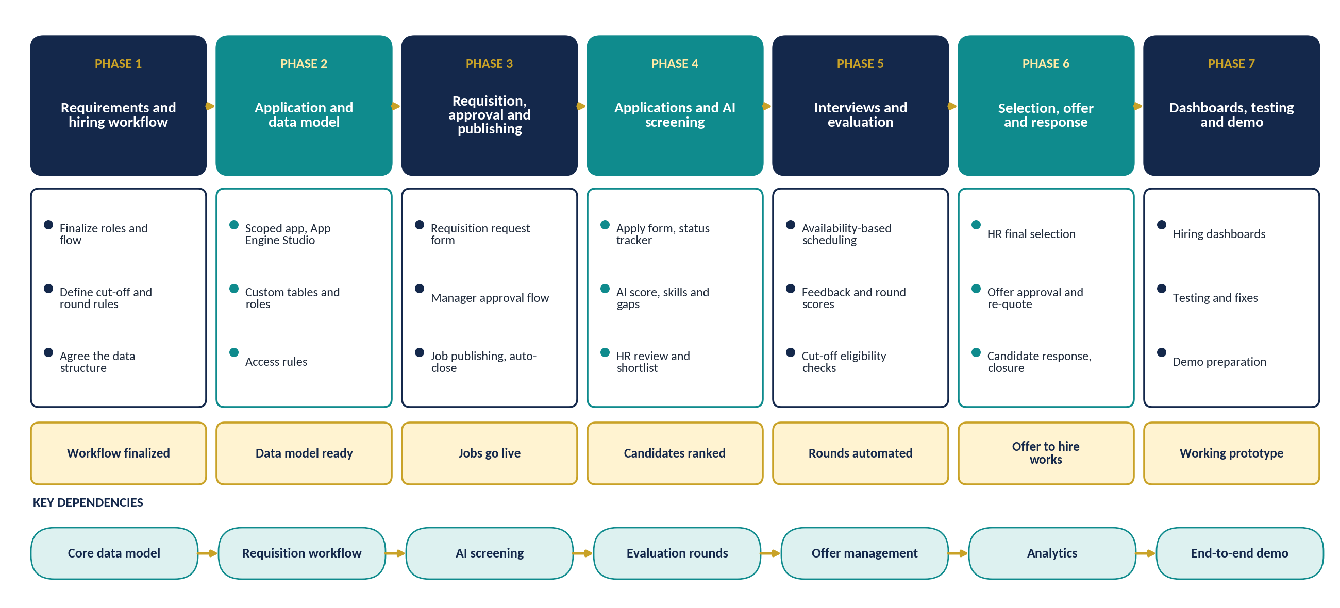
Fig:Project timeline, seven phases with milestones and dependencies
Main dependency: the core data model must be complete before workflows, AI screening and dashboards can be connected. Final milestone: a working end-to-end demo from requisition to hired, with live dashboards.

3.3 Feasibility Assessment
The scope is realistic for the hackathon because everything runs on native ServiceNow capabilities. There is no separate database, workflow engine, notification system or reporting tool to build. The team has ServiceNow CSA and CAD certified experience and has already built a full-stack recruitment platform, so the hiring domain and data model are familiar.
Minimum viable product
Requisition → Approval → Publish → Apply → AI screening → HR shortlist → Interview and evaluation → Final selection → Offer → Candidate response. Dashboards and extra automation are layered on top.

Required resources
- A ServiceNow developer instance with App Engine Studio and Flow Designer.
- Team members with ServiceNow, JavaScript and scripting skills.
- Generative AI capability in the instance, or the rule-based scoring fallback below.
- Sample, anonymized job and candidate data for testing.
Risks and mitigation:
- AI capability limitations: Keep a rule-based scoring fallback.
- Limited hackathon time: Prioritize the core hiring workflow first.
- AI influencing final decisions: Keep AI advisory and HR-controlled.
- Complex workflow exceptions: Enforce rules through Flow Designer and Business Rules.
- Limited sample data: Use sample/anonymized candidate data.
- Offer re-quotation issues: Enforce a maximum of 3 re-quote cycles.

4.Imapct and metrics

4.1 Measurable Outcomes
Success is measured against the manual process during a pilot. These KPIs map directly to the problems described in Section 1.
KPI | What it measures | Expected impact
Shortlisting time | Time for HR to review applications and shortlist | Less manual screening through AI-assisted analysis
Hiring cycle time | Time from requisition to hired | Fewer delays through connected workflows and approvals
Approval turnaround | Time for requisition and offer approvals | Faster decisions through reminders and escalation
Interview scheduling time | Time from shortlist to a scheduled interview | Quicker booking through availability-aware scheduling
Round processing time | Time to evaluate and move candidates between rounds | Faster progression through automatic eligibility checks
Notification coverage | Share of status changes sent automatically | Less manual communication effort
Pending follow-ups | Approvals and tasks that need manual chasing | Fewer, through workflow reminders
Offer acceptance rate | Accepted offers against offers released | Tracked and visible per job
Offer re-quote control | Re-quote cycles per offer | Capped at 3 and fully recorded
Hiring funnel visibility | Applications to shortlist, interview, offer and hire | Real-time pipeline dashboard
Measurement approach: actual improvement percentages will be set by comparing the current manual process with system performance during the pilot. The prototype does not claim improvement results before validation.

4.2 Real-World Applicability
The solution is built on a modular ServiceNow architecture, so it can grow from a hackathon prototype into a production hiring platform without rebuilding the foundation.
Scaling path
- Pilot: start with one department, placement cell or selected recruitment process.
- Scale: extend to more departments, job roles, recruiters and hiring managers.
- Integrate: connect external coding tests, assessment platforms, calendar and HR systems through APIs, so test scores flow into the round record automatically.
- Enhance: add AI interview assistance, post-round summaries and talent pool recommendations.
- Extend: connect successful candidates to onboarding and employee lifecycle processes.
Who benefits: companies, college placement cells and universities, along with their candidates, recruiters, hiring managers and HR heads.

Manager Dashboard:
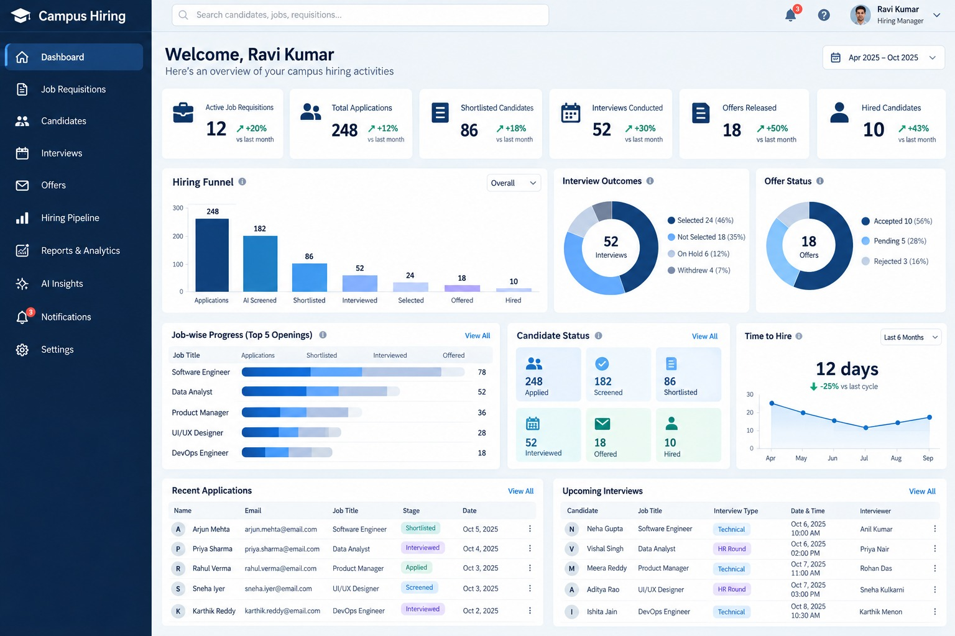
Fig: Manager hiring dashboard (mock-up with illustrative sample data)
5. Team Roles & Expertise

5.1 Role Assignment
Name | Team Lead | Role & Responsibility
V. Mahamadh Basha | Yes | Team Lead and Solution Architect: scoped app, data model, overall coordination, final demo and judge Q&A
K. Gowthami |  | Workflow and Automation Developer: Flow Designer approvals, round progression, offer re-quote loop, notifications
G. Gowthami |  | AI and Hiring Logic Developer: AI scoring agent, cut-off rules, rule-based fallback, post-round summary
S. Venkata Kalyan |  | Employee Center and UI Developer: job listings, apply form, status tracker, review and offer screens
G. Thanusha |  | Dashboards, Testing and Quality: reports and dashboards, test cases, demo rehearsal

5.2 Leadership and Coordination
- Team Leader: [Team Lead name] leads planning, tracks progress against the seven phases and coordinates the final demonstration.
- Skill Mapping: each member takes a focused ServiceNow area: app and data architecture, workflow automation, AI and hiring logic, Employee Center and UI, and QA and analytics.
- Integration: every module plugs into the common hiring lifecycle, so requisition, application, AI analysis, evaluation, selection and offer records stay connected.
- Coordination: short syncs after each milestone: data model complete, core workflow ready, AI and dashboards integrated.

6. Diagrams & Visual Aids

6.1 Core Data Model and AI Analysis
Six connected records carry a candidate from requisition to closure, supported by users, skills, the interview panel, approvals, notifications and job history. The example on the right shows the output HR sees for each application.
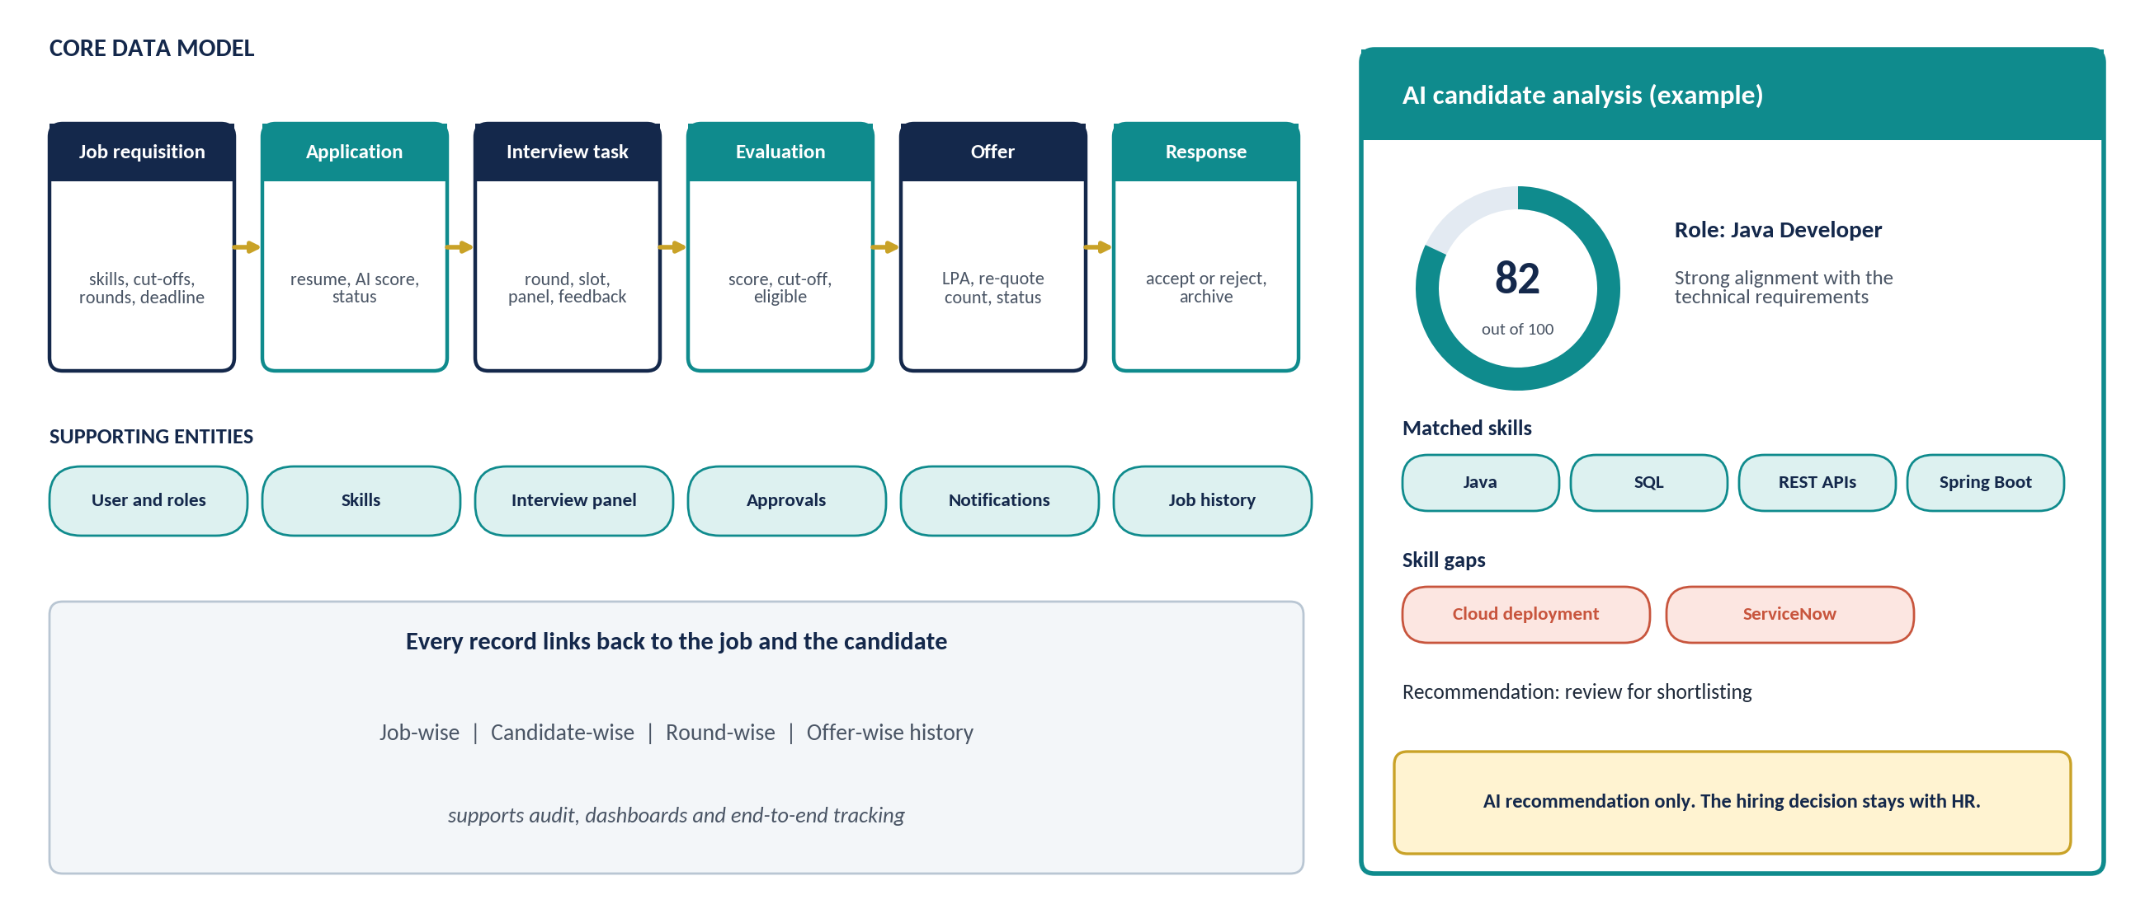
Figure 6: Core data model and an example AI candidate analysis (illustrative)

6.2 Sample Candidate Interaction
Employee Center assistant (optional Virtual Agent)
Student: Can I apply for the Java Developer position?
Assistant: Yes, the Java Developer role is open for applications. It asks for Java, SQL and REST API skills and has a test, a coding round and an interview. You can apply from the job page in Employee Center and follow your status there after submitting.
Later, after applying: the student sees Applied, Screened, Shortlisted and each round as the status tracker updates.
Figure 6: Core data model and an example AI candidate analysis (illustrative)
6.3 End-to-End Workflow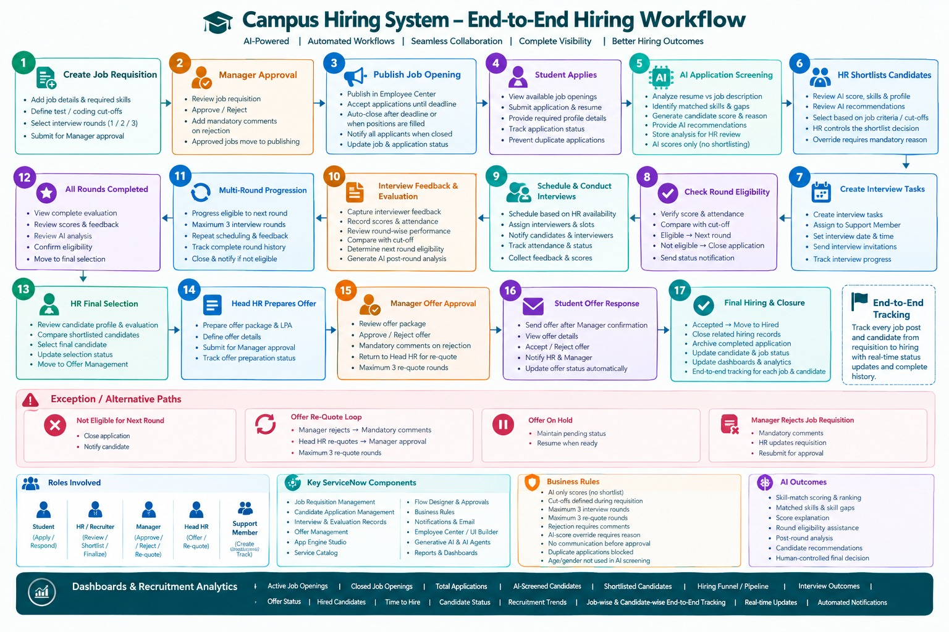

7. References
- ServiceNow Documentation: https://docs.servicenow.com
- ServiceNow Developer Portal: https://developer.servicenow.com
- ServiceNow App Engine Studio documentation
- ServiceNow Flow Designer documentation
- ServiceNow Service Catalog documentation
- ServiceNow Employee Center and UI Builder documentation
- ServiceNow Now Assist and AI Agent documentation
- ServiceNow Dashboards and Reporting documentation

