1.2 Problem Statement
Organizations often manage recruitment activities across multiple tools, emails, and spreadsheets, making it difficult to track the complete hiring lifecycle. Recruiters and hiring managers spend significant time managing job requisitions, candidate applications, evaluation rounds, approvals, interviews, and offers.
As application volumes increase, manual candidate screening and tracking become time-consuming and inconsistent. There is also a need to ensure that candidates progress through evaluation rounds based on defined criteria while keeping final hiring decisions under human control.
Therefore, there is a need for a centralized AI-enabled Talent Acquisition platform that connects the complete hiring lifecycle, from job creation and candidate application to evaluation, selection, approvals, and offer management. The platform should use AI to analyze and score candidates against job requirements, while allowing HR and hiring managers to make the final selection decisions.
Key Needs
- Centralized Hiring Management – Manage jobs, candidates, evaluations, approvals, and offers in one platform.
- AI-Assisted Candidate Scoring – Analyze candidate details against job requirements and provide scores and insights.
- Human-Controlled Selection – HR makes the final shortlist and hiring decisions based on AI-assisted results and evaluation scores.
- Structured Evaluation – Manage multiple hiring rounds with defined cut-offs and candidate progression.
- Interview & Feedback Management – Schedule interviews and capture interviewer evaluations.
- Offer Management – Manage offer preparation, approvals, negotiations, and candidate responses.
- Automated Workflow & Communication – Automate approvals, status updates, notifications, and follow-ups.
- Hiring Visibility – Provide dashboards for job status, candidate pipeline, evaluation results, and hiring progress.

2. Solution Innovation
2.1 My Approach
The Campus Hiring System is an AI-assisted and human-controlled hiring platform built on ServiceNow. It connects the complete recruitment lifecycle, from job requisition and candidate application to evaluation, offer management, and final hiring.
The system centralizes candidate information and automates repetitive recruitment activities such as approvals, notifications, eligibility checks, interview coordination, and offer processing. AI is used to analyze candidate applications against job requirements and provide scores, matched skills, skill gaps, and supporting insights.
However, AI does not make the final hiring decision. HR reviews the AI-generated analysis and manually selects candidates for the next stage. This keeps the recruitment process transparent and human-controlled.
Business Workflow
HR
│
▼
┌─────────────────────┐
│ Create Job │
│ Requisition │
│ • Job details │
│ • Skills │
│ • Round cut-offs │
│ • Evaluation rounds │
└──────────┬──────────┘
▼
┌─────────────────────┐
│ Manager Approval │
│ Approve / Reject │
└──────────┬──────────┘
│ Approved
▼
┌─────────────────────┐
│ Publish Job Opening │
└──────────┬──────────┘
▼
┌─────────────────────┐
│ Student Applies │
│ Resume + Details │
└──────────┬──────────┘
▼
┌─────────────────────┐
│ AI Application │
│ Screening │
│ Score + Skills + Gaps│
└──────────┬──────────┘
▼
┌─────────────────────┐
│ HR Shortlisting │
│ Human Decision │
└──────────┬──────────┘
▼
┌─────────────────────┐
│ Evaluation Rounds │
│ Test / Coding / │
│ Interview │
└──────────┬──────────┘
▼
┌─────────────────────┐
│ Eligibility Check │
│ Based on Cut-off │
└──────┬────────┬─────┘
│ │
Eligible Not Eligible
│ │
▼ ▼
Next Round Close +
│ Notify
▼
┌─────────────────────┐
│ Final HR Selection │
└──────────┬──────────┘
▼
┌─────────────────────┐
│ Offer Preparation │
└──────────┬──────────┘
▼
┌─────────────────────┐
│ Manager Approval │
└──────────┬──────────┘
▼
┌─────────────────────┐
│ Student Accept / │
│ Reject Offer │
└──────────┬──────────┘
▼
┌─────────────────────┐
│ Final Hiring & │
│ Process Closure │
└─────────────────────┘

2.2 How the Solution Works
The workflow can be grouped into five major stages:
1. Job Creation & Approval
HR creates a job requisition by defining the job requirements, required skills, evaluation rounds, and cut-off criteria. The requisition is sent to the Manager for approval before publication.
2. Application & AI Screening
Once published, students apply through Employee Center. The AI analyzes the candidate's profile and resume against the job description and provides a score, matched skills, skill gaps, and explanation.
3. Human Shortlisting & Evaluation
HR reviews the AI analysis and manually shortlists candidates. Shortlisted candidates proceed through the configured evaluation rounds. Scores and feedback are recorded, and the system automatically checks eligibility against the defined cut-offs.
4. Final Selection & Offer
After completing the required rounds, HR makes the final candidate selection. Head HR prepares the offer, followed by Manager approval. If required, controlled re-quotation can be performed within the defined limit.
5. Candidate Response & Closure
The candidate accepts or rejects the offer. The system updates the candidate and job status, closes the completed application, and updates recruitment dashboards and analytics.

2.3 Innovation & Differentiation
The main innovation of the solution is not simply using AI for recruitment. It is the combination of AI assistance, workflow automation, and human decision-making within one connected hiring lifecycle.
AI-Assisted, Human-Controlled Hiring
AI provides candidate scores and insights, while HR retains complete control over shortlisting and final selection.
Cut-off Based Progression
Candidates automatically progress through evaluation rounds based on predefined cut-off criteria.
Automated Recruitment Workflow
Approvals, notifications, eligibility checks, interview activities, offer approvals, and status updates are handled through ServiceNow workflows.
Controlled Offer Management
Offer approvals and re-quotation are handled through a defined workflow with limits and complete history.
Complete Traceability
Candidate applications, AI analysis, evaluation scores, feedback, approvals, decisions, and offer history remain connected throughout the hiring lifecycle.

2.4 System Architecture
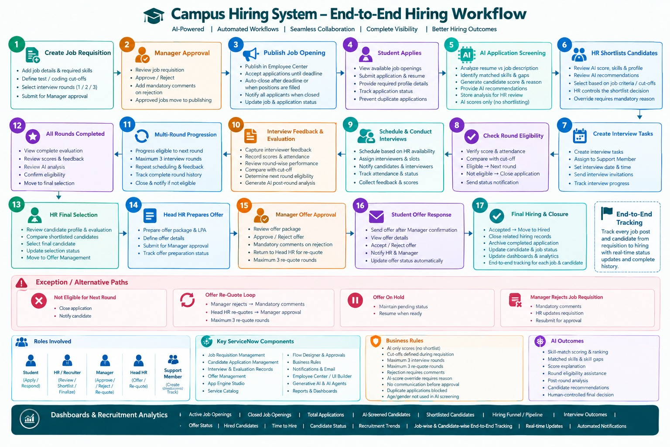
3.1 Technical Stack
Component | Technology / Module
ServiceNow Modules | App Engine Studio, Case Management, Flow Designer, Employee Center, Virtual Agent, AI Agent Studio, Knowledge Management, Notifications, Surveys, Performance Analytics
ServiceNow Features | Custom Tables, Record Producers, Business Rules, Approvals, Reports & Dashboards
Supporting Tools / Languages | Generative AI, AI Agent, JavaScript, Glide APIs, HTML/CSS, REST APIs
Front-end | Employee Center, UI Builder
Back-end | Custom Tables, Flow Designer, Business Rules, Script Includes
3.2 Project Timeline
Keep this as a horizontal 7-phase flow in your document:
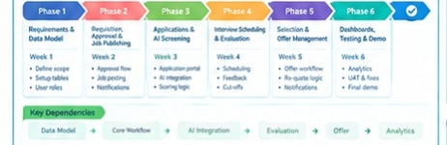
Phase | Implementation
Phase 1 | Understand requirements, finalize hiring workflow and data structure
Phase 2 | Build job requisition, approval and job publishing
Phase 3 | Implement candidate application and AI screening
Phase 4 | Build evaluation rounds, cut-offs and eligibility progression
Phase 5 | Implement interview, feedback and candidate tracking
Phase 6 | Build final selection, offer approval and re-quotation
Phase 7 | Testing, bug fixing, dashboards and final prototype
Timeline Flow
Requirements → Core Application → Hiring Workflow → AI Screening → Evaluation & Interviews → Offer Management → Testing & Demo
3.3 Feasibility Assessment
Minimum Viable Product
Requisition → Approval → Publish → Application → AI Screening → HR Shortlist → Evaluation → Final Selection → Offer Approval → Candidate Response → Hired
Risks & Mitigation
Risk | Mitigation
AI capability limitations | Keep a rule-based scoring fallback
Limited hackathon time | Prioritize the core hiring workflow first
AI influencing final decisions | Keep AI advisory and HR-controlled
Complex workflow exceptions | Enforce rules through Flow Designer and Business Rules
Limited sample data | Use sample/anonymized candidate data
Offer re-quotation issues | Enforce a maximum of 3 re-quote cycles

4. Impact & Metrics
4.1 Measurable Outcomes
The impact of the Campus Hiring System can be evaluated using the following measurable KPIs during a pilot implementation:
KPI | What It Measures | Expected Impact
Shortlisting Time | Time required for HR to review applications and shortlist candidates | Reduce manual screening effort through AI-assisted analysis
Hiring Cycle Time | Time from job requisition to final hiring | Reduce delays through connected workflows and automated approvals
Application Processing | Number of applications processed and tracked through the system | Centralized and structured candidate management
Automated Notifications | Hiring status updates sent automatically | Reduce manual communication effort
Pending Follow-ups | Approvals and activities requiring manual follow-up | Reduce through workflow reminders and automation
Round Processing Time | Time required to evaluate and move candidates between rounds | Faster progression through automated eligibility checks
Candidate Status Visibility | Availability of application and offer status to candidates | Provide end-to-end status tracking
Offer Re-quote Control | Number of re-quotation cycles per offer | Enforce a maximum of 3 re-quote rounds
Hiring Funnel Visibility | Visibility into applications, shortlists, evaluations, offers and hires | Provide real-time recruitment dashboards
Measurement approach: Actual improvement percentages will be established by comparing the current/manual process with system performance during the pilot. The prototype does not claim improvement results before validation.

4.2 Real-World Applicability
The solution is designed to move beyond a hackathon prototype by using a modular ServiceNow architecture that can be extended as recruitment requirements grow.
Scaling Path
Pilot → Department-Level Deployment → Organization-Wide Hiring → Integrated Talent Management
- Pilot: Start with one department, placement cell, or selected recruitment process.
- Scale: Extend the workflow to multiple departments, job roles, recruiters, and hiring managers.
- Integrate: Connect external coding tests, assessment platforms, or other recruitment systems through APIs.
- Enhance: Introduce AI-assisted interview summaries, post-round analysis, and talent-pool recommendations.
- Extend: Connect successful candidates to onboarding and employee lifecycle processes.
Who Benefits?
- Students/Candidates: Centralized application, interview, and offer status.
- HR/Recruiters: Reduced screening and coordination effort.
- Hiring Managers: Structured approvals and candidate evaluation visibility.
- Head HR: Controlled offer management and recruitment insights.
- Organization: Standardized, traceable, and data-driven hiring.
- One Dashboard:
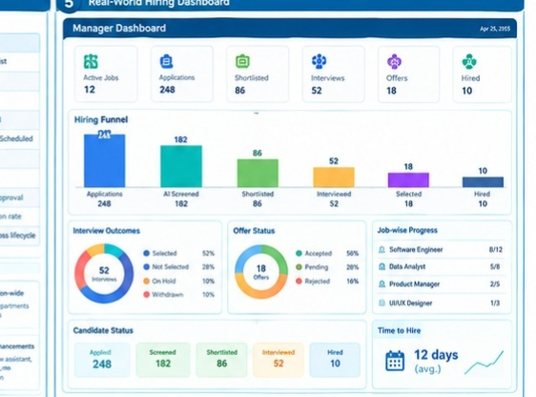

5. Team Roles & Expertise
5.1 Role Assignment
Name | Team Lead | Role & Responsibility
V. Pavan Kumar | Yes | Team Lead & ServiceNow App/Data Architect — App Engine Studio setup, application architecture, custom tables, data modelling, requirement coordination, overall integration, and judge Q&A
S. Sameera | No | Workflow & Automation Developer — Flow Designer, requisition and offer approval flows, candidate progression, interview workflows, notifications, and automation
Y. Madhusudhan Reddy | No | AI & Hiring Logic Developer — Generative AI / AI Agent, candidate screening, skill matching, AI scoring, eligibility logic, and post-round AI insights
B. Anjali | No | Employee Center & UI Developer — Candidate job listings, application experience, application status, offer response interface, and user-facing portal components
[Member 5] | No | QA, Analytics & Reporting Developer — End-to-end testing, evaluation of workflow scenarios, exception-path testing, Reports & Dashboards, data validation, and demo preparation
5.2 Leadership and Coordination
- Team Leader: V. Pavan Kumar leads project planning, coordinates the overall architecture, tracks implementation progress, and manages the final demonstration and judge Q&A.
- Skill Mapping: Each member is assigned to a focused ServiceNow area: App & Data Architecture, Workflow Automation, AI & Hiring Logic, Employee Center & UI, and QA & Analytics.
- Coordination: The team coordinates implementation around the major milestones: application setup → core hiring workflow → AI screening → evaluation & offer management → dashboards and testing.
- Integration: Each module is integrated into the common hiring lifecycle so that requisition, application, AI analysis, evaluation, selection, and offer records remain connected throughout the process.
- 1. Complete Hiring Workflow
- Place this in Section 2: Solution Innovation, after My Approach.
- Show:
- Requisition → Approval → Publish → Apply → AI Screening → HR Shortlist → Evaluation Rounds → Final Selection → Offer → Accept/Reject → Hired
- This gives the judges the immediate understanding of the complete system.

- 2. Core Data Model
- Place this after the Technical Stack / Implementation section.
- Don't show every field. Show only the major connected entities:
- JOB REQUISITION
- │
- ▼
- APPLICATION
- │
- ┌────────────┼────────────┐
- ▼ ▼ ▼
- AI ANALYSIS EVALUATION INTERVIEW
- │ │ │
- └────────────┼────────────┘
- ▼
- FINAL SELECTION
- │
- ▼
- OFFER
- │
- ▼
- CANDIDATE RESPONSE
- This demonstrates that your system is properly connected, rather than being just separate ServiceNow modules.

- 3. AI + Automated Eligibility Decision
- This is probably your strongest innovation visual, so I would definitely include it.
- Show something like:
- Candidate Details
- +
- Job Description
- │
- ▼
- ┌──────────────────────┐
- │ AI SCREENING │
- │ │
- │ Score: 82/100 │
- │ Matched Skills │
- │ Skill Gaps │
- │ Reason / Explanation │
- └──────────┬───────────┘
- ▼
- HR REVIEW
- │
- HR SHORTLISTS
- │
- ▼
- Evaluation Round
- │
- ▼
- Score = 72
- Cut-off = 70
- │
- ┌────┴────┐
- ▼ ▼
- Eligible Not Eligible
- │ │
- ▼ ▼
- Next Round Auto Close
- + Notification

