COLLECTIONS:
Collection is a frame work provided by java. This frame work provide many interfaces and their implemented classes in order to store group of objects in a single entity.

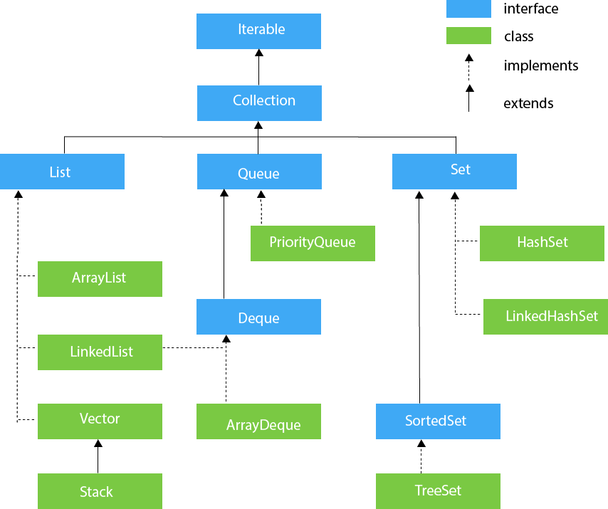
OPERATIONS in collection performed
Creation
Addition
Retriveal
Deletion
Verification
Updation

LIST:
List interface is the child interface of Collection interface. It inhibits a list type data structure in which we can store the ordered collection of objects. It can have duplicate Values.
List interface is implemented by the classes ArrayList, LinkedList, Vector, and Stack.
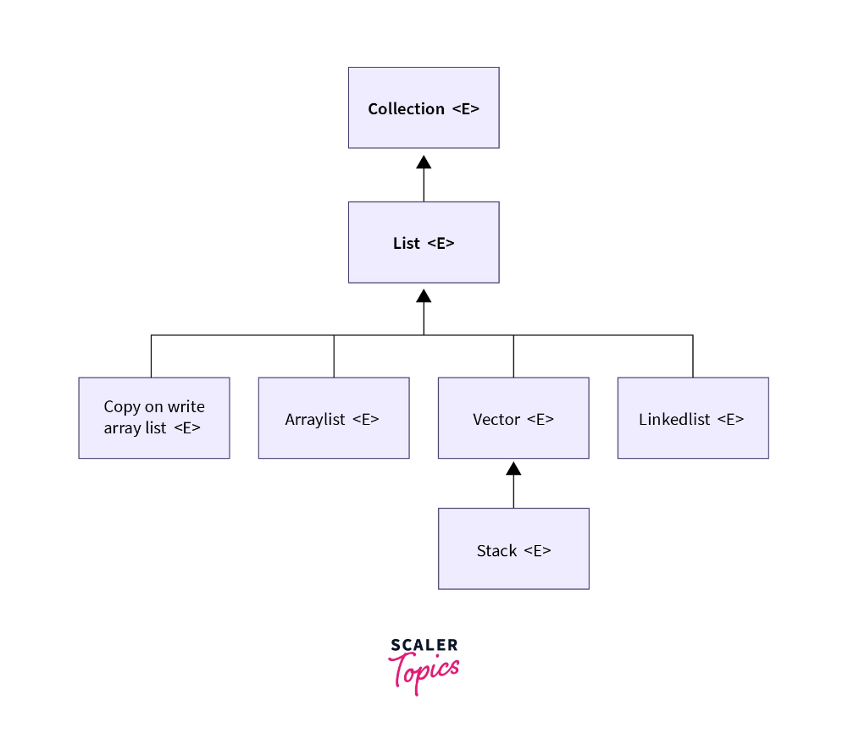
1.ArrayList
The ArrayList class implements the List interface. It uses a dynamic array to store the duplicate element of different data types. The ArrayList class maintains the insertion order and is non-synchronized. The elements stored in the ArrayList class can be randomly accessed. Consider the following example.

import java.util.*;
public class Arraylist {

public static void main(String[] args) {
ArrayList<Integer> a=new ArrayList<>();
a.add(1);
a.remove(1);
a.get(1);
a.set(0,2);
a.contains(1);
System.out.println(a);
}
}

- LinkedList
LinkedList implements the Collection interface. It uses a doubly linked list internally to store the elements. It can store the duplicate elements. It maintains the insertion order and is not synchronized. In LinkedList, the manipulation is fast because no shifting is required.
import java.util.*;
public class linkedList {
public static void main(String[] args) {
LinkedList<Integer> a= new LinkedList<>();
a.add(1);
a.add(2);
a.add(3);
a.add(4);
a.push(6);
a.pollFirst();
a.pollLast();
a.pop();
a.peekFirst();
a.peekLast();
a.peek();
a.reversed();
System.out.println(a);
}
}
- Vector
Vector uses a dynamic array to store the data elements. It is similar to ArrayList. However, It is synchronized and contains many methods that are not the part of Collection framework.
import java.util.Vector;
public class vectors {

public static void main(String[] args) {
Vector v1 = new Vector();
v1.add("ravi");
v1.add("surya");
v1.add(0,"raju");
Vector v2=new Vector();
v2.add("lakshmi");
v2.add("hishita");
System.out.println(v1 );
v1.addAll(v2);
System.out.println(v1 );
System.out.println(v1.get(2));
v1.remove("lakshmi");
System.out.println(v1);
v1.removeAll(v2);
System.out.println(v1);
System.out.println(v1.contains("raju"));
v1.set(1,"king");
System.out.println(v1);
System.out.println(v1.capacity());

}
}
- Stack
The stack is the subclass of Vector. It implements the last-in-first-out data structure, i.e., Stack. The stack contains all of the methods of Vector class and also provides its methods like boolean push(), boolean peek(), boolean push(object o), which defines its properties.
import java.util.*;
public class Stack1 {
public static void main(String[]args) {
Stack<Integer> s= new Stack<>();
s.add(1);
s.add(2);
s.add(3);
s.pop();
s.peek();
System.out.println();
System.out.println(s.pop());
System.out.println(s);
s.push(3);
System.out.println(s);
System.out.println(s.search(2));
}
}
QUEUE:
Queue interface maintains the first-in-first-out order. It can be defined as an ordered list that is used to hold the elements which are about to be processed. There are various classes like PriorityQueue, Deque, and ArrayDeque which implements the Queue interface.
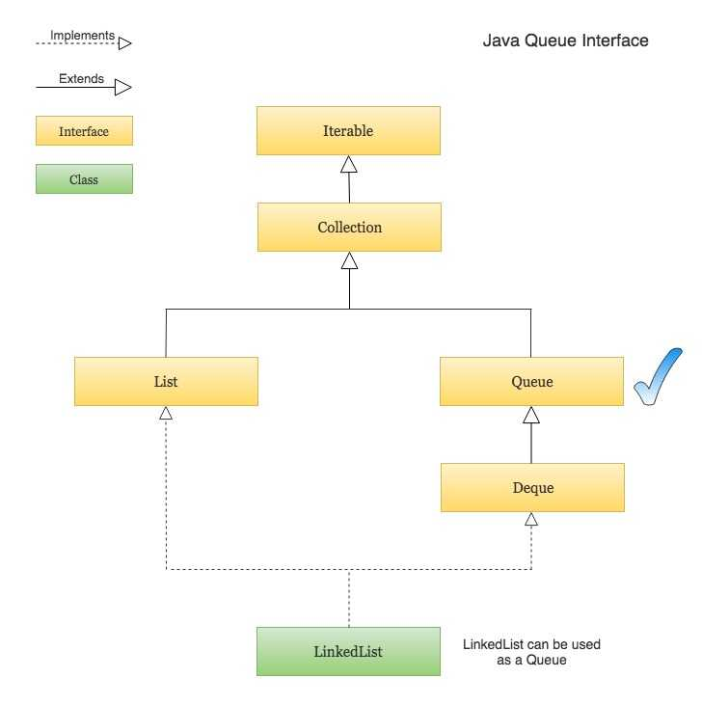
  - PRIORITY QUEUE
The PriorityQueue class implements the Queue interface. It holds the elements or objects which are to be processed by their priorities. PriorityQueue doesn't allow null values to be stored in the queue.
PriorityQueue<Integer> p=new PriorityQueue<>();
p.add(1);
p.offer(5);
p.add(9);
System.out.println(p.poll());
System.out.println(p);
2.deque
Deque interface extends the Queue interface. In Deque, we can remove and add the elements from both the side. Deque stands for a double-ended queue which enables us to perform the operations at both the ends.
package mocketst;
import java.util.*;
public class queee {
public static void main(String[] args) {
Deque<Integer> q= new Qu<>();
q.add(1);
q.addFirst(null);
q.add(6);
q.offer(9);
System.out.println(q);
}
}
3.ARRAY DEQUE
ArrayDeque class implements the Deque interface. It facilitates us to use the Deque. Unlike queue, we can add or delete the elements from both the ends.
ArrayDeque is faster than ArrayList and Stack and has no capacity restrictions.
public static void main(String[] args) {
Deque<Integer> q= new ArrayDeque<>();
q.add(1);
q.addFirst(null);
q.add(6);
q.offer(9);
System.out.println(q);
}
}
SET
Set Interface in Java is present in java.util package. It extends the Collection interface. It represents the unordered set of elements which doesn't allow us to store the duplicate items. We can store at most one null value in Set. Set is implemented by HashSet, LinkedHashSet, and TreeSet.
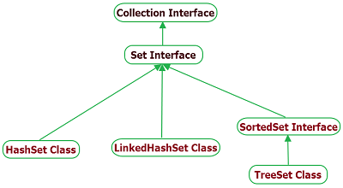
package mocketst;
import java.util.*;
public class setss {
public static void main(String[] args) {
Set<Integer> h=new TreeSet<>();
h.add(63);
h.add(15);
h.add(35);
h.add(35);
new Object();//dummy object
// System.out.println(h.remove(63));
System.out.println(h);
}

}
- Set<data-type> s1 = new HashSet<data-type>();
- Set<data-type> s2 = new LinkedHashSet<data-type>();
- Set<data-type> s3 = new TreeSet<data-type>();
Java Map Interface
A map contains values on the basis of key, i.e. key and value pair. Each key and value pair is known as an entry. A Map contains unique keys.
A Map is useful if you have to search, update or delete elements on the basis of a key.
There are two interfaces for implementing Map in java: Map and SortedMap, and three classes: HashMap, LinkedHashMap, and TreeMap. The hierarchy of Java Map is given below:

A Map doesn't allow duplicate keys, but you can have duplicate values. HashMap and LinkedHashMap allow null keys and values, but TreeMap doesn't allow any null key or value.
package mocketst;
import java.util.*;
import java.util.Map.Entry;
public class haash {

public static void main(String[] args) {
Map<Integer,String> m= new Hashtable<>();
m.put(1,"raju");
m.put(2,"ravui");
m.put(3,"surya");
System.out.println(m);
Set<Integer > keys=m.keySet();
for(Integer key:keys) {
System.out.println(key+" "+m.get(keys));
} Set<Entry<Integer,String>> entries=m.entrySet();
for(Entry<Integer,String> entry:entries) {
System.out.println(keys +" "+keys);
}
}
}
KEY | VALUES
101 | 101,surya,cse,vijayawada
102 | 102,ravi,cse,amaravati
103 | 103,ram,cse,Guntur
104 | 104,hishita,cse,vijayawada

Enumeration:
Used for iterating the legacy collection collection clases.
The legacy clases are hash table , stack, vector.
package mocketst;
import java.util.*;
public class enumers {

public static void main(String[] args) {
Vector<Integer> v= new Vector<>();
v.add(1);
v.add(5);
v.add(6);
v.add(3);
Enumeration<Integer> e=v.elements();
while(e.hasMoreElements()) {
System.out.println(e.nextElement());
}
}

}
Iterator:
package mocketst;
import java.util.*;
public class iteratorss {

public static void main(String[] args) {
ArrayList<Integer> a= new ArrayList<>();
a.add(1);
a.add(2);
a.add(3);
a.add(4);
Iterator<Integer> i=a.iterator();
// while(i.hasNext()) {
// }
i.next();
i.remove();
i.next();
i.remove();
System.out.println(a);
}
}
ListIterators:
package mocketst;
import java.util.*;
public class linkeditteratos {
public static void main(String[] args) {
ArrayList<Integer> a= new ArrayList<>();
a.add(1);
a.add(2);
a.add(3);
a.add(4);
ListIterator<Integer> l=a.listIterator();
while(l.hasNext()) {
System.out.println(l.next());
}
while(l.hasPrevious()) {
System.out.println(l.previous());
}
}
}

