A thread is a lightweight subprocess, the smallest unit of processing. It is a separate path of execution.
Threads are independent. If there occurs exception in one thread, it doesn't affect other threads. It uses a shared memory area.
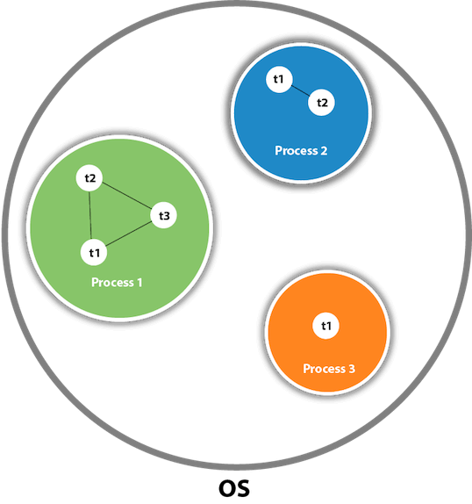
package com.threads;
import java.util.*;
public abstract class Threaadss {

public static void main(String[] args) throws InterruptedException{
employee e=new employee();
managaer m=new managaer();
Thread t1=new Thread(e);
Thread t2=new Thread(m);
t1.start();
t1.sleep(1000);
t2.start();
t1.join();
for(int i=0;i<10;i++) {
System.out.println("hello");
}
for(int i=0;i<20;i++) {
System.out.println("hi");
}
}

}
class employee extends Thread{
public void run() {
//System.out.println("hi");
}
}
class managaer extends Thread{
public void run() {
//S//ystem.out.println("hello");
}
}
METHODS OF CREATING THREAD:
1.EXTENDS
package com.examples;
public class Threaadss {
public static void main(String[] args) throws InterruptedException {
employee e=new employee();
Thread T=new Thread(e);
T.start();
}
}
class employee extends Thread{
public void run(){
}
}
2.IMPLEMENTS
package com.examples;
public class Threaadss {
public static void main(String[] args) throws InterruptedException {
employee e=new employee();
manager m=new manager();
Thread T=new Thread(e);
T.start();
Thread T1=new Thread(m);
T.start();
}
}
class employee extends Thread implements Runnable{
public void run(){
}
}
class manager implements Runnable{
@Override
public void run() {
}
}
3.ANANIMOUS CLASS
package com.examples;
public class Threaadss {
public static void main(String[] args) throws InterruptedException {
Runnable r1=new Runnable() {
public void run() {
}
};
Thread T=new Thread(r1);
T.start();
}
}

4.LAMDA CLASS
package com.examples;
public class Threaadss {
public static void main(String[] args) throws InterruptedException {
Runnable r1 = () -> {
for (int i = 0; i < 10000; i += 100) {
}
};
Thread T=new Thread(r1);
T.start();
}
}

Synchronization in Java is the capability to control the access of multiple threads to any shared resource.
Java Synchronization is better option where we want to allow only one thread to access the shared resource.
package com.threads;
public class Threaadss {
public static void main(String[] args) throws InterruptedException {
Books b = new Books();
Runnable r1 = () -> {
for (int i = 0; i < 10000; i += 100) {
b.incrementBookCount();
}
};
Runnable r2 = () -> {
for (int i = 0; i < 5000; i += 100) {
b.incrementBookCount();
}
};
Runnable r3 = () -> {
for (int i = 0; i < 15000; i += 100) {
b.incrementBookCount();
}
};

Thread t1 = new Thread(r1);
Thread t2 = new Thread(r2);
Thread t3 = new Thread(r3);

t1.start();
t2.start();
t3.start();
t1.join();
t2.join();
t3.join();
System.out.println(b.getBookCount());
}
}

class Books {
private int bookCount = 0;
public void incrementBookCount() {
bookCount += 100;
}
public int getBookCount() {
return bookCount;
}
}

