When you run the program you will see the main window. It must be something like this:

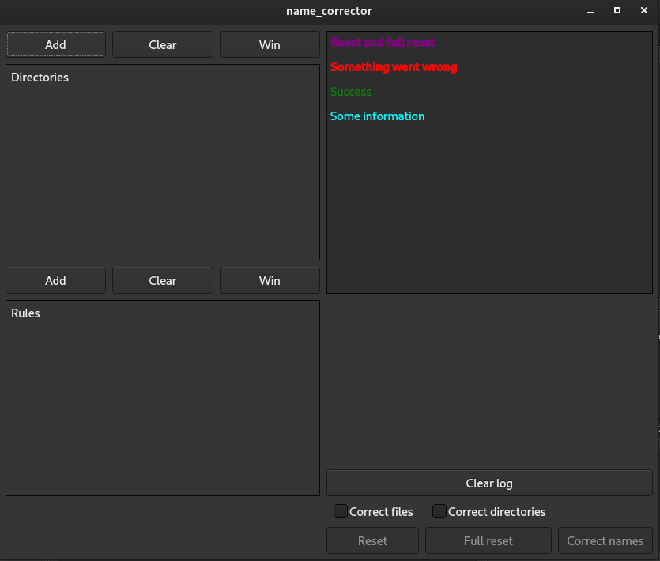
In the left you can see two panels, directories and rules, with three buttons (Add, Clear and Win)
In the right you can see the log-panel, below you can see several buttons and two check-boxes.

To correct names you need select the target directory(-ies), so click the “Add” button above the directory panel. Program must show you a window like this:

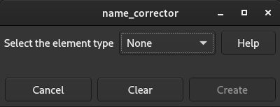

Use the type-combo-box and select the “directory” type, the program must show you something like this:

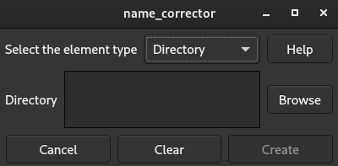

You can use the path-text-box or the Browse button to select the target directory.
If your input incorrect (this directory does not exist), then program draws your attention to that using the red backlighting, else the Create button becomes active, so click it.

Now you can see something like this:

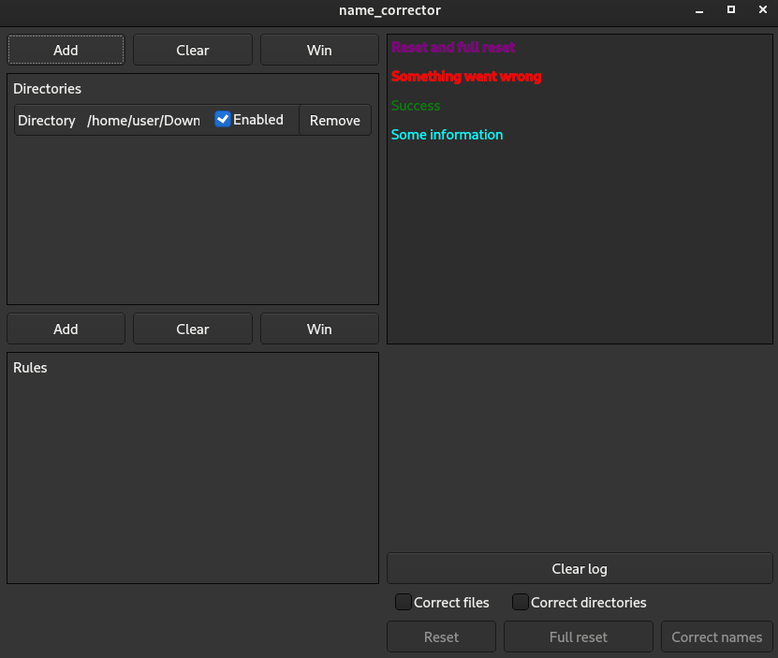
There is a new element in the directory panel:

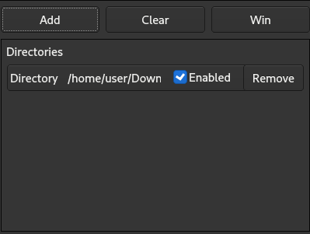

You can click the Remove button to remove this element, do not worry about your directory, the element contain the path to your directory, but does not affect it.
To remove all elements from the directory panel click the Clear button.

Awesome! You have selected the target directory. Now you need rules according to which the program will correct names. To create a new rule click the Add button above the rule panel, program must show you a window like this:

Use the type-combo-box and select the “Replace” type, the program must show you something like this:

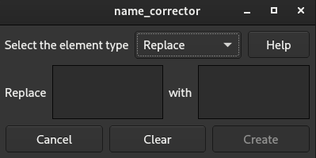

The string in the replaced-text-box will be replaced with the string in the replace-with-text-box.
For example:
Replace qwerty with ytrewq
Old file name: qwerty1234.txt
New file name: ytrewq1234.txt

If your input incorrect (empty replaced-text-box), then program draws your attention to that using the red backlighting, else the Create button becomes active, so click it.

Now you can see something like this:

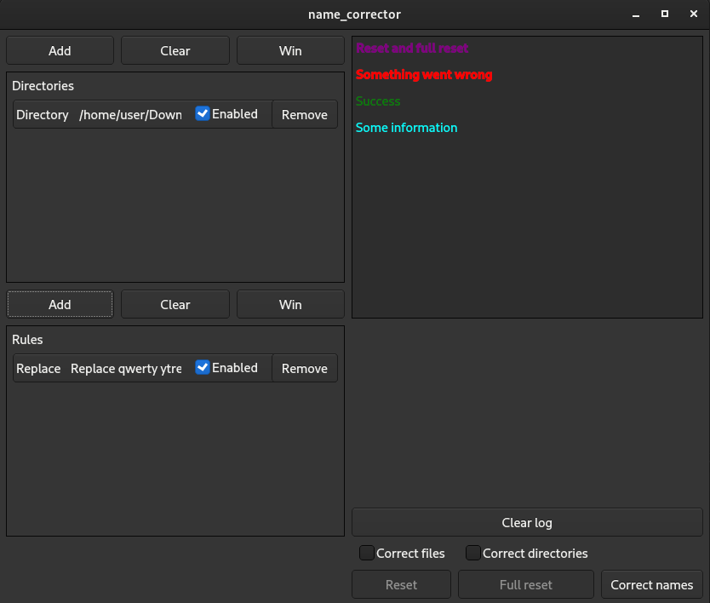

There is new element in the rule panel:
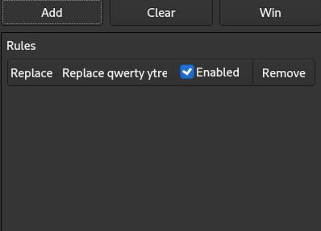

You can click the Remove button to remove this element.
To remove all elements from the rule panel click the Clear button.

Okay, now your main window must be like this:
As you can see the Correct names button is available now, but before click it you need choose what you want to correct, file names or/and directory names. Use check-boxes to choose what you want to correct.

Now, you can click the Correct names button and check the result, also you can see all the results in the log-panel

If you not sure about the correcting just click the Reset(reset the last operation) or the Full reset button(reset all the operations done by the program), you can find these buttons below the check-boxes:

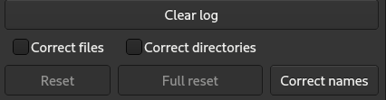

You are great, congratulations!

More about rules:
Replace usage: enter two strings (or symbols), the first will be replaced with the second
Example:
Rule: Replace QW with 12
Old file(directory) name: QWERTY.ber
New file(directory) name: 12ERTY.ber

Remove usage: enter the string and two numbers, the first and the last positions, then program remove all the occurrences (between the first and the last positions) of the string from the object name (you can enter empty string - enter nothing in the first text box - and the program removes all the symbols between the first and the second positions)
Example:
Rule: Remove 12 from 0 to 5
Old file(directory) name: 1212121212.ber
New file(directory) name: 1212.ber

Add usage: enter the string and one number, the position of the addition, the program add your string to the position
Example:
Rule: Add QW to 0
Old file(directory) name: ERTY.ber
New file(directory) name: QWERTY.ber

MakeList usage: select the type of your list (prefix OR postfix AND numeric OR alphabetic) and enter the separator(optional), the program turns your files or/and directories into the selected list

If your input incorrect then the program draws your attention to it using the red backlighting.
Example:
Rule: MakeList prefix numeric with __ as separator
Old files(directories) names: Brown.txt
Fox.txt
Lazy.txt
Dog
New files(directories) names: 0__Brown.txt
1__Fox.txt
2__Lazy.txt
3__Dog

Note:
All rules in the rule panel will be used in order for each directory in the directory panel
Program does not change content of files, it works with names only

About ListWindow
“Win” buttons above the rule panel and the directory panel, opens ListWindow. This window is intended to make work with long lists of rules and directories easier. It must be like follow:

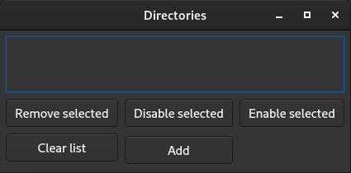

There are Clear list and Add buttons, it usage described above. There are also Remove selected, Disable selected and Enable selected buttons, these buttons are convenient to use when you has to work with really long lists of rules directories to remove, disable or enable several elements at once.

You can select an element by mouse left button click. There is red title of a selected element:

