# Estimates Show Slowest Growth on Record for the Nation’s Population

According to the U.S. Census Bureau’s Vintage 2021 report, the population of the United States grew in the past year by 392,665, or 0.1%, the [lowest rate since the nation’s founding](https://www.census.gov/library/stories/2021/12/us-population-grew-in-2021-slowest-rate-since-founding-of-the-nation.html).

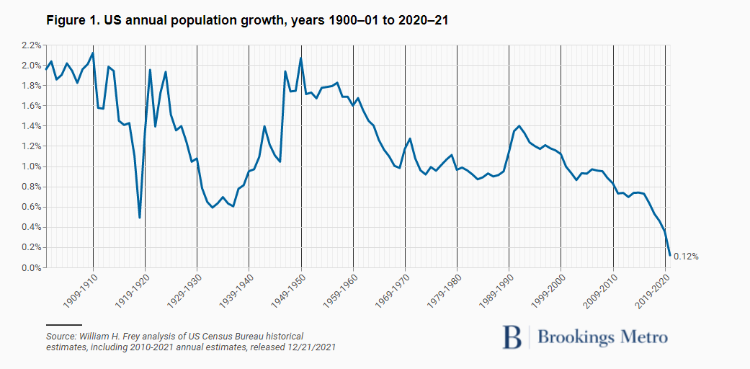

[1] U.S. Census Bureau. New Vintage 2021 Population Estimates Available for the Nation, States and Puerto Rico. <https://www.census.gov/newsroom/press-releases/2021/2021-population-estimates.html> December 2021.

# FACTORS THAT LED TO TODAY’S UNPRECEDENTED FLAT GROWTH RATE

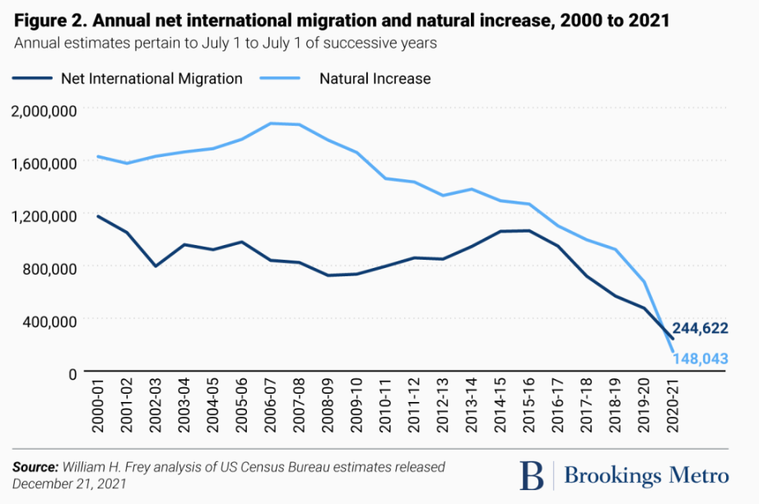

* Figure 2 shows the declines of the nation's 'Natural Increase' (difference of births minus deaths). This is related to
  + More deaths associated with an aging population,
  + After-effects of the Great Recession (2010) in the [postponement of childbearing for young adult women](https://www.cdc.gov/nchs/data/nvsr/nvsr70/nvsr70-02-508.pdf).
  + Immigration trends were more uneven due to changing economic circumstances, including the recession and immediate post-recession downturn, as well as immigration policies that became more restrictive during the Trump administration. [2]

[2] U.S. population growth has nearly flatlined, new census data shows William H. Frey, December 23, 2021. Brookings Metro. Visited May 25, 2022.  
<https://www.brookings.edu/research/u-s-population-growth-has-nearly-flatlined-new-census-data-shows/#:~:text=The%20new%20census%20estimates%20make,in%20the%202020%2D21%20period>.

# EIGHTEEN STATES LOST POPULATION IN THE PAST YEAR

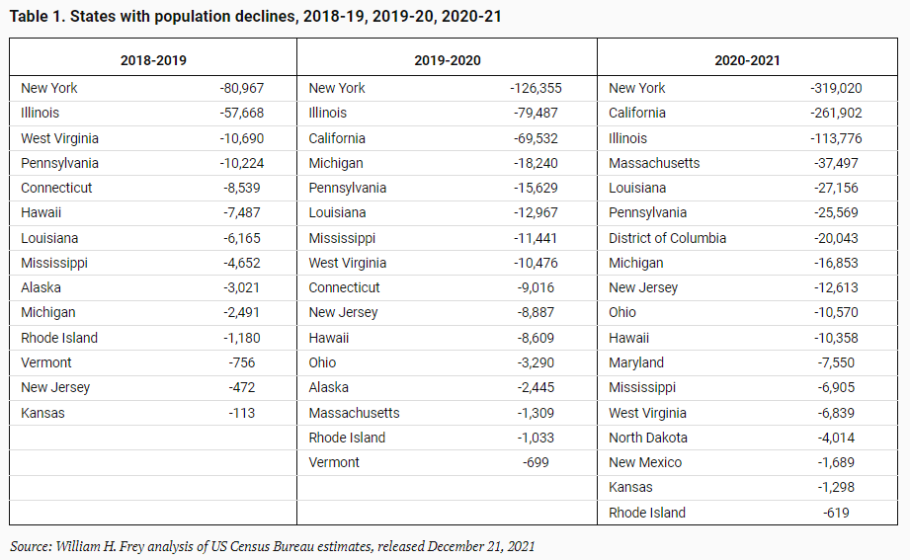

During the 2020-2021 period, 18 states (including Washington, D.C.) lost population. This is up from 16 population-losing states 2019-20; 14 in 2018-19; and just 10 in the two prior years [2].

# USA Population Growth

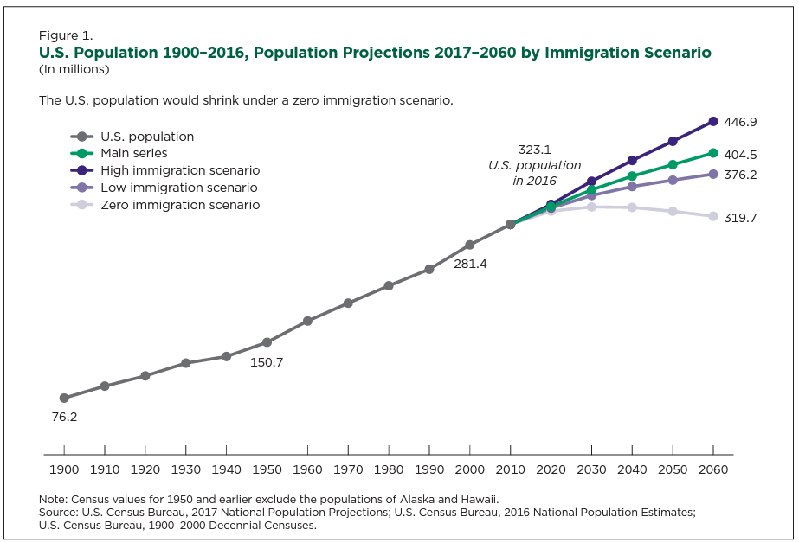

The zero-immigration scenario offers the most dramatic picture of demographic change [3]. This assumption shows what would happen to the existing U.S. population if it did not grow through immigration.

* Births are the only way for the population to grow in the zero-immigration model, but the population can decrease through deaths and emigration.
* Between 2016 and 2038 in this scenario, the number of births and deaths are projected to converge, with births declining and deaths increasing.
* In 2039, the number of deaths is projected to be larger than the number of births; and natural increase (the difference between births and deaths) becomes negative for the first time.

**Conclusion**.

Negative natural increase produces a shrinking population in the zero-immigration scenario, with annual declines starting in 2035 and continuing at an accelerated pace through 2060.

[3] US Census Bureau. A Changing Nation: Population Projections Under Alternative Immigration Scenarios. https://www.census.gov/content/dam/Census/library/publications/2020/demo/p25-1146.pdf