* Run the **vimtutor** command.

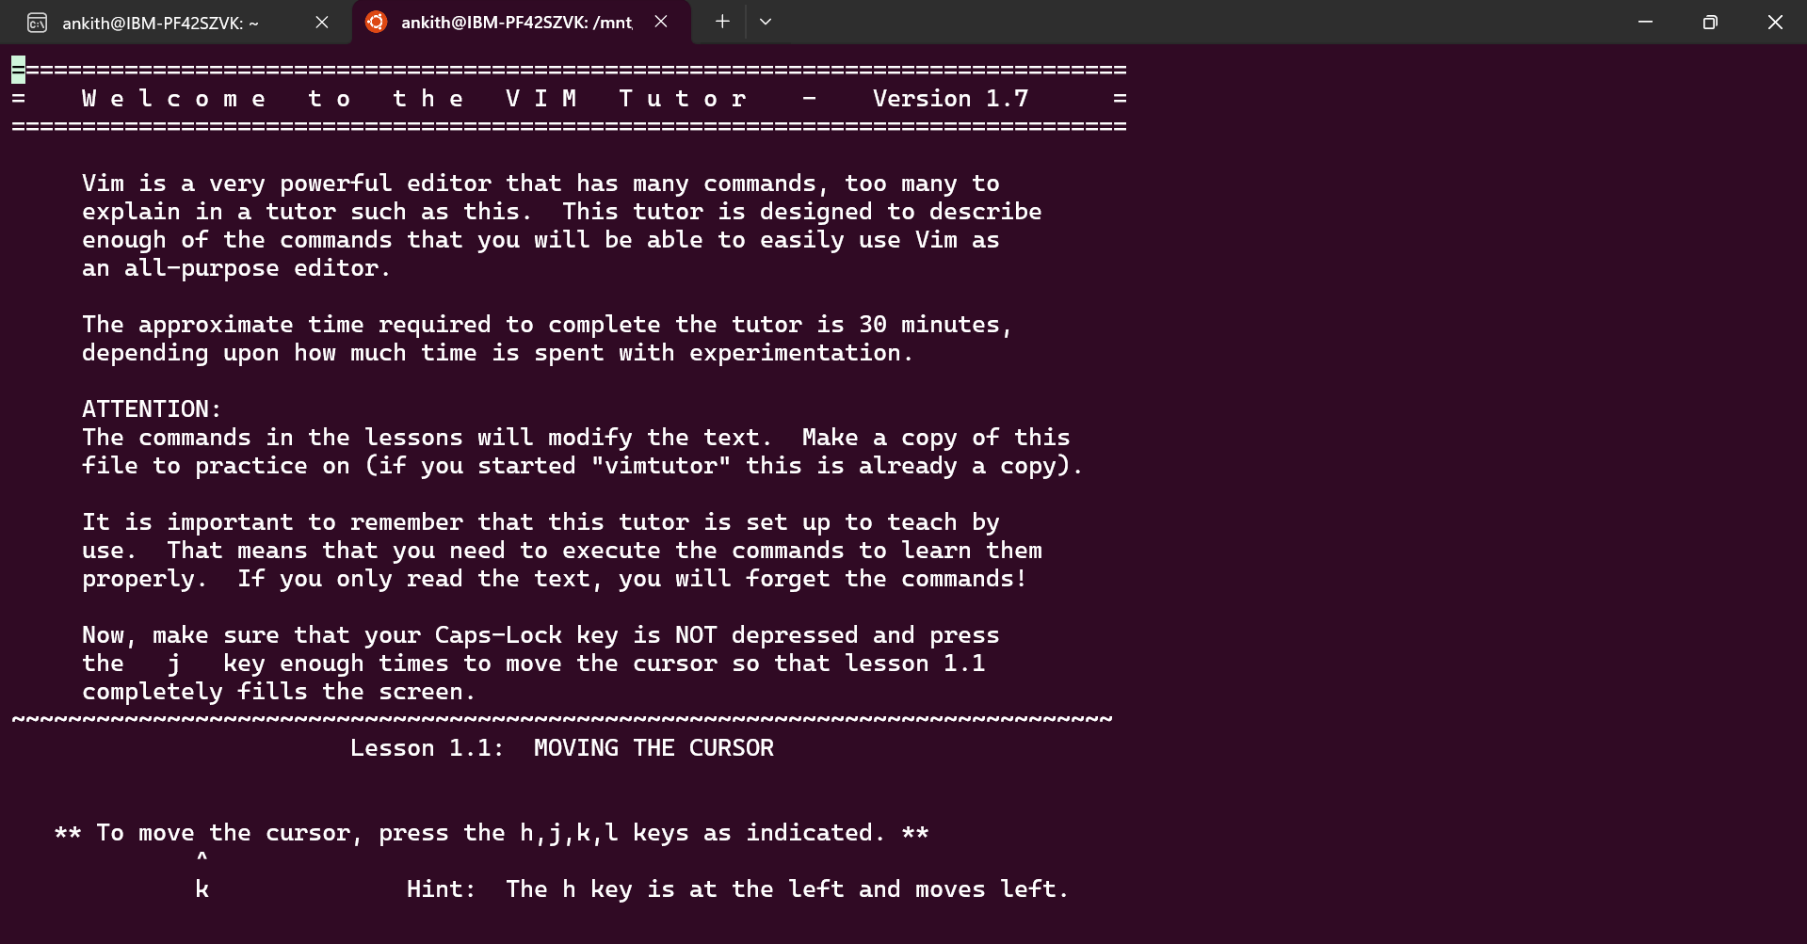

* The vimtutor home page

* The finished lesson 1.3

* The finished lesson 1.4

* The finished lesson 1.5

