**关于2022-2023-2大学英语1期末考试**

考试时间6月24日早上，19周星期六

**I. Listening Comprehension (25%)**

**Section A 来自《新未来大学英语2视听说》各个单元**

**Directions:** In this section, you will hear two news report.（两则新闻） After each news report ,there are some statements about the news report, you should decide whether the statements are true (T) or false (F) .

**主要出自于每个单元的Voice of China**

**Section B**（1篇参考《新未来大学英语2视听说》各个单元）

**Directions:** In this section, you will hear two long conversations.（两则长对话） At the end of each conversation, you will hear four questions. Both the conversation and the questions will be spoken only once. After you hear a question, you must choose the best answer from the four choices marked A), B), C) and D). Then mark the corresponding letter on Answer Sheet with a single line through the centre.

**主要出自每个单元的further listening**

**Conversation One**

**Questions 8 to 11 are based on the conversation you have just heard.**

**Conversation Two**

**Questions 12 to 15 are based on the conversation you have just heard.**

**Section C**（2篇参考《新未来大学英语2视听说》各个单元，1篇参考课外）

**Directions:** In this section, you will hear three passages. （三篇文章）At the end of each passage, you will hear some questions. Both the passage and the questions will be spoken only once. After you hear a question, you must choose the best answer from the four choices marked A), B), C)) and D). Then mark the corresponding letter on Answer Sheet with a single line through the centre.

**主要出自每个单元的further listening**

**Passage One**

**Questions 16 to 18 are based on the passage you have just heard.**

**Passage Two**

**Questions 19 to 21 are based on the passage you have just heard.**

**Passage Three**

**Questions 22 to 25 are based on the passage you have just heard.**

**II. Reading Comprehension (35%)**

**Section A. Banked Cloze (5%) （15选10：此题答案写在答题纸上）（即参考《新未来大学英语综合教程2》各个单元）**

**Directions:** *In this section, there is a passage with ten blanks. You are required to select one word for each blank from a list of choices given in a word bank following the passage. Read the passage through carefully before making your choices. Each choice in the bank is identified by a letter. Please write down the corresponding letter on Answer Sheet. You may not use any of the words in the bank more than once.*

***主要出自每个单元的P23、P53、P85、P117、P147、P177的Banked Cloze，书本上是8个空，考试的时候是10个空，所以会增加2个空，不能背答案，而是要弄懂文章的意思和单词的意思。***

**Section B. Reading in depth (30%：15小题*2分) （来自课外内容）**

**Directions:** *There are 3 passages in this section. Each passage is followed by some questions or unfinished statements. For each of them there are four choices marked A), B), C) and D). You should decide on the best choice and mark the corresponding letter on Answer Sheet with a single line through the centre.*

**Passage 1**

**Passage 2**

**Passage 3**

**III. Vocabulary (15%：30小题* 0.5分) （来自《新未来大学英语综合教程2》各个单元的section 1和section 2的重点词汇）**

**Directions:** *There are 30 incomplete sentences in this part. For each sentence there are four choices marked A., B., C. and D.. Choose the ONE answer that best completes the sentence. Then mark the corresponding letter on the Answer Sheet with a single line through the center.*

***1、2、3、4、5、6单元每个单元section 1、section 2的全部单词，可参考language in focus, vocabulary。(主要出自itest和学习通的3个词汇测试)***

**IV. Translation (English to Chinese，10%：*此题答案写在答题纸上*)（来自《新未来大学英语综合教程2》的课堂授课单元Text A课文）**

**Directions:** *Read the following paragraphs carefully and then translate the underlined segments into Chinese. Your translation should be written neatly on the Answer Sheet.*

***翻译1、2、5、6单元section 2 Text A课文李的段落，英文翻译成中文。***

**V. Writing (15%：*此题答案写在答题纸上*)** *（来自* **《新未来大学英语综合教程2》的intercultural writing**

**Directions:** *For this part, you are required to write* ***an essay.*** *You should write around 100 words according to the outline given bellow.*

***1、2、5、6单元，即P21、P51、P145和P175的intercultural writing，4篇里面出其中一篇，所以大家每一篇都要写。***

***1、2、5、6单元Text A课文翻译:***

***第1单元课文翻译***

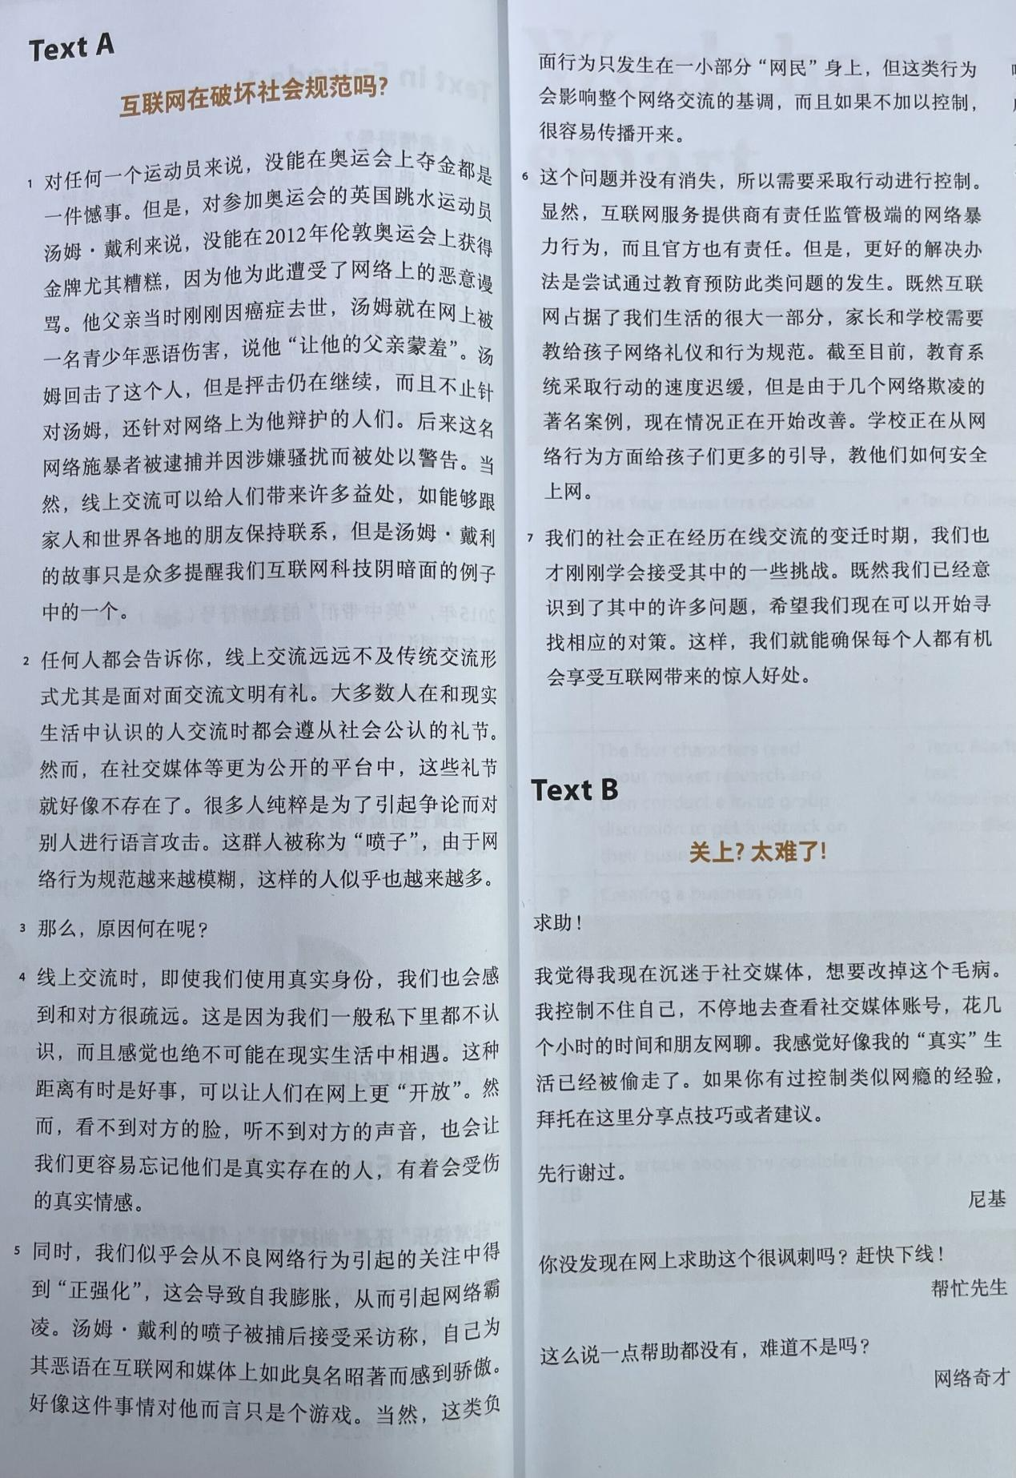

***第2单元课文翻译***

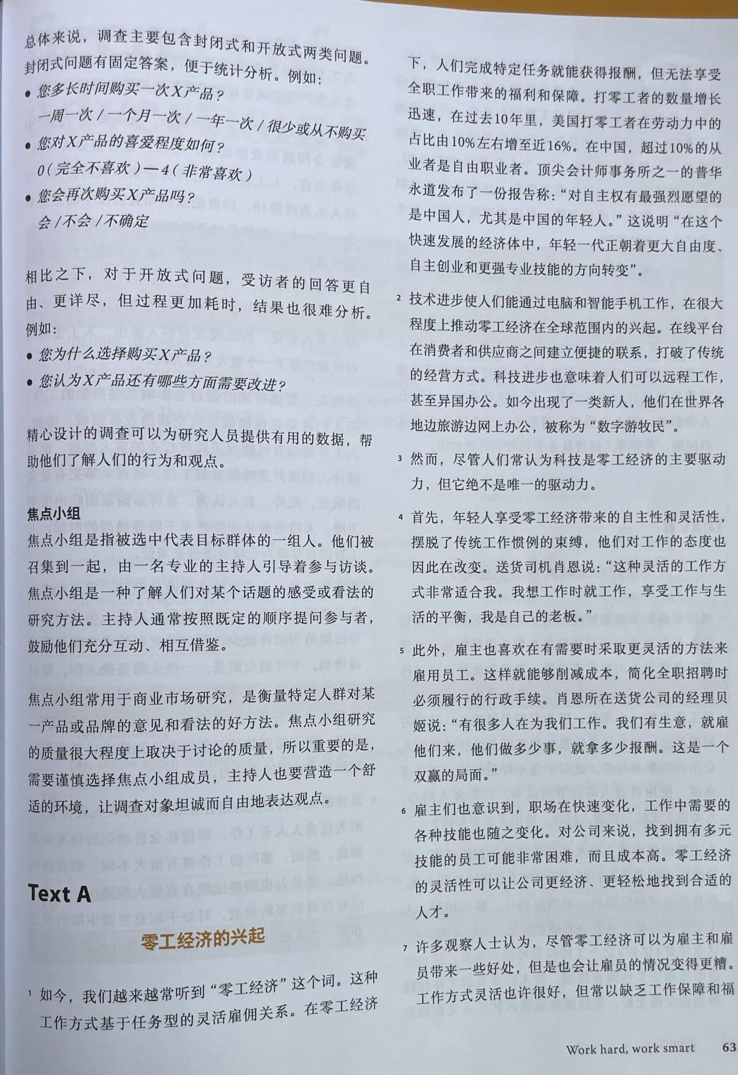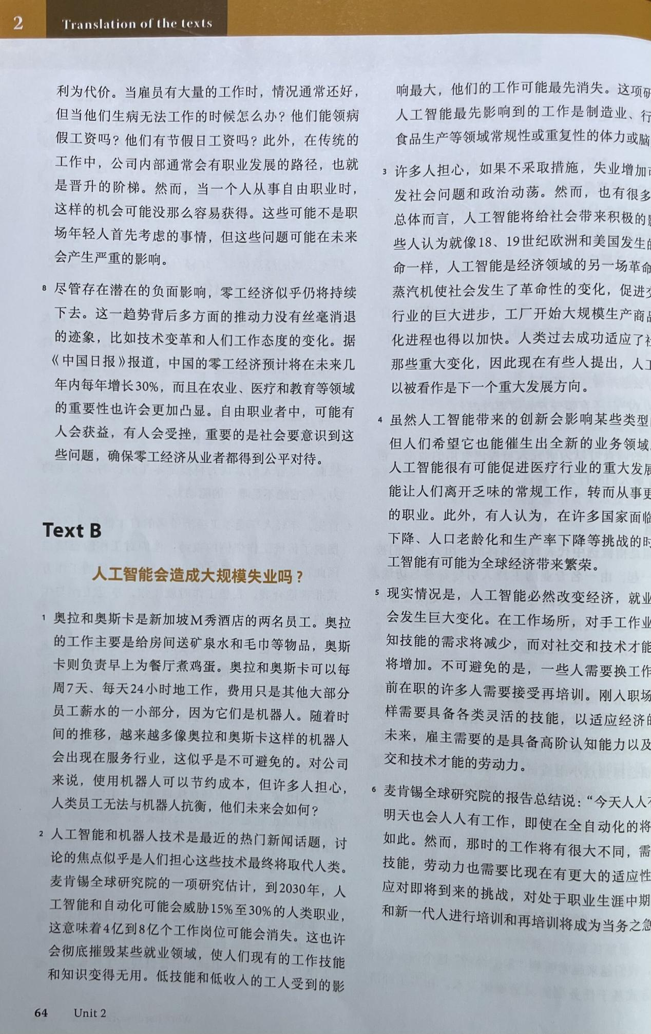

***第5单元课文翻译***

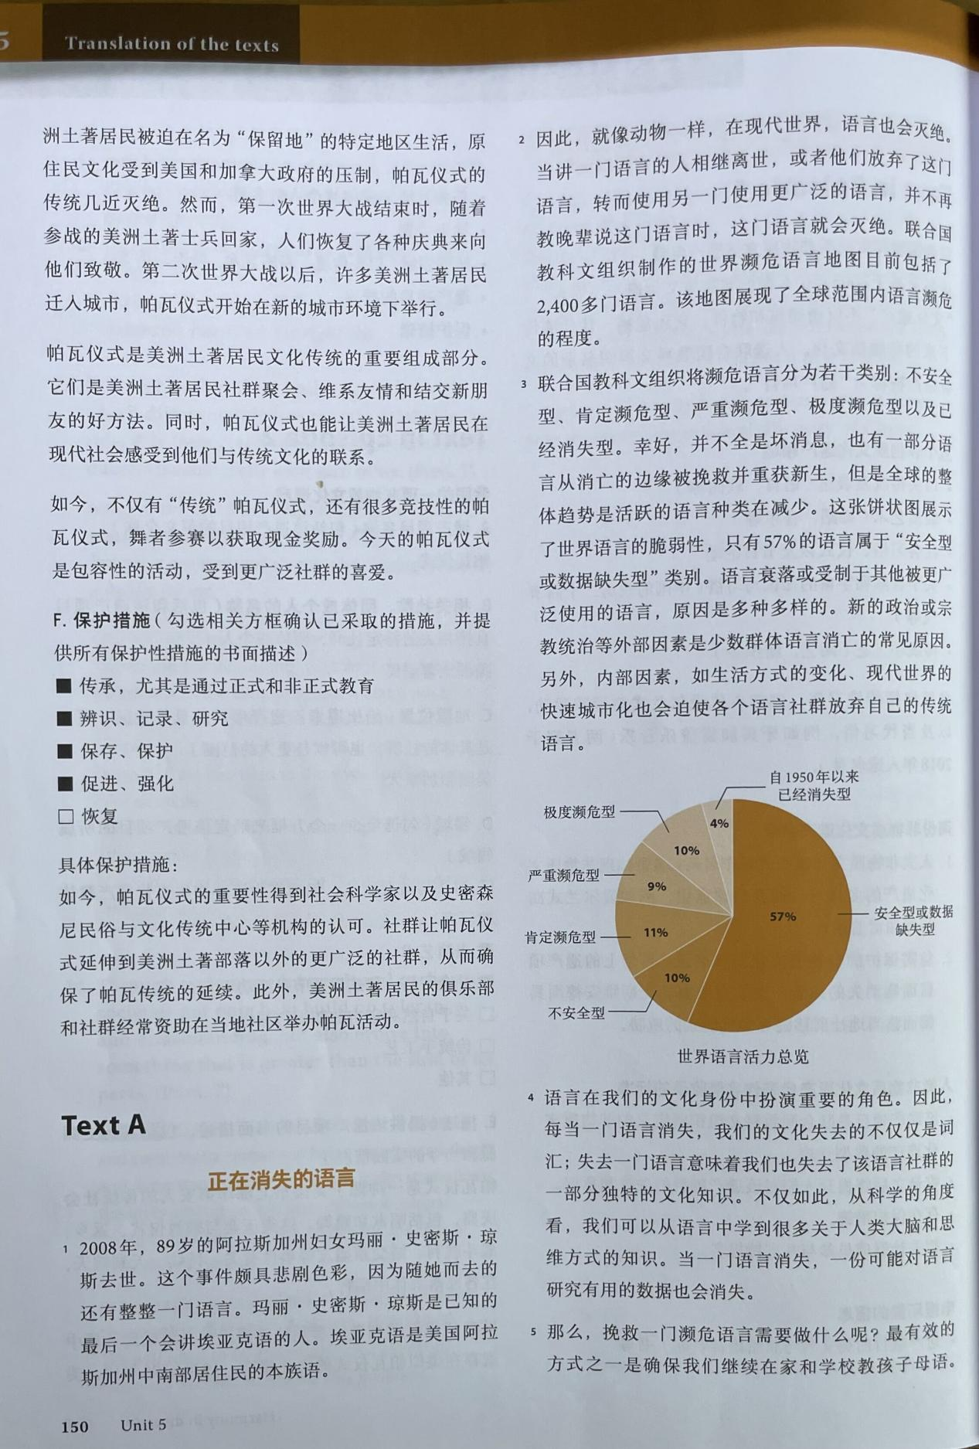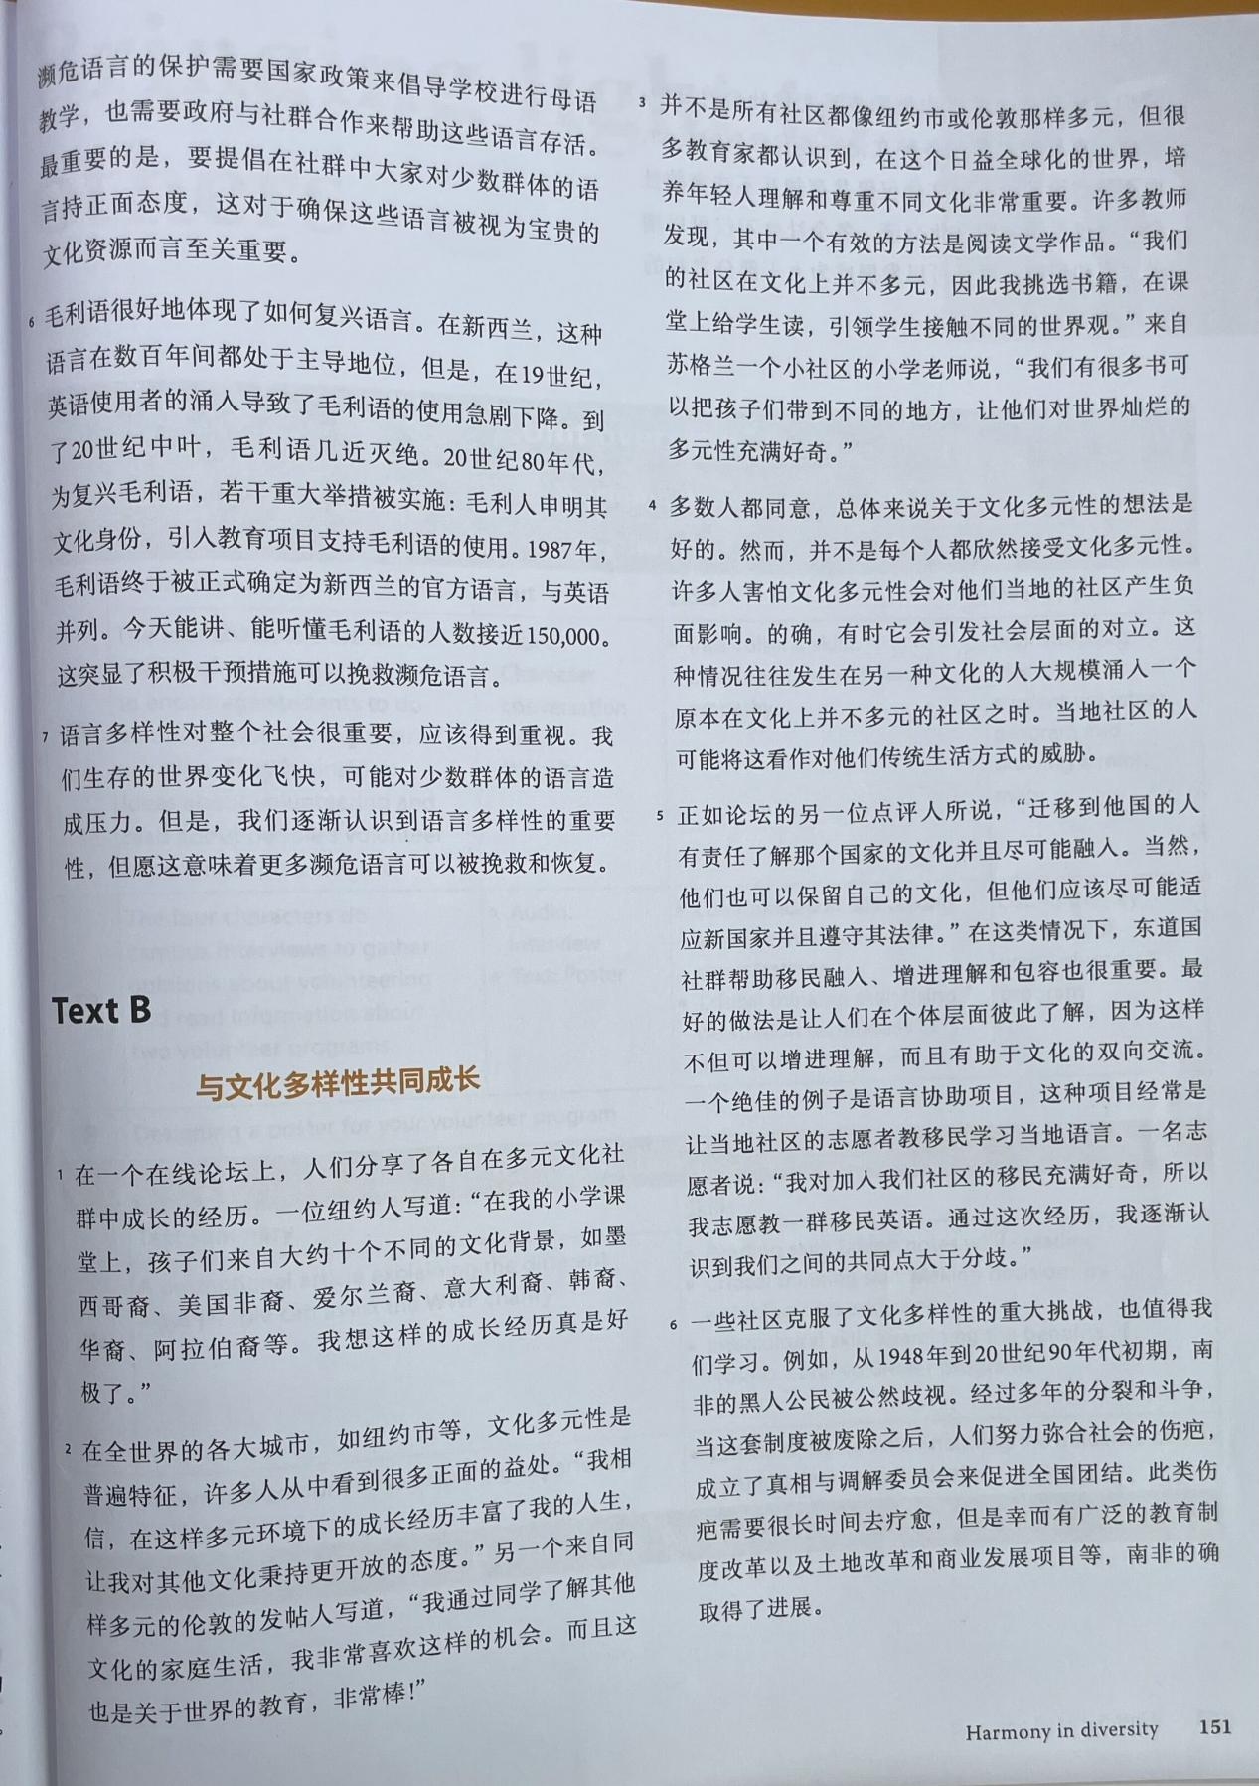

***第6单元课文翻译***

