VIETNAM GENERAL CONFEDERATION OF LABOUR

**TON DUC THANG UNIVERSITY**

**FACULTY OF INFORMATION TECHNOLOGY**



**FINAL PROJECT**

**SOFTWARE ENGINEERING**

*Supervisor*: **TS. PHẠM THÁI KỲ TRUNG**

*Authors*: **NGUYỄN AN KHÁNH – 519H0107**

**VÕ NGUYÊN LONG - 519H0027**

Class **: 19H50204**

Group  **: N7**

**HO CHI MINH CITY, 2021**

VIETNAM GENERAL CONFEDERATION OF LABOUR

**TON DUC THANG UNIVERSITY**

**FACULTY OF INFORMATION TECHNOLOGY**



**FINAL PROJECT**

**SOFTWARE ENGINEERING**

*Supervisor***: TS. PHẠM THÁI KỲ TRUNG**

*Authors*: **NGUYỄN AN KHÁNH – 519H0107**

**VÕ NGUYÊN LONG - 519H0027**

**Class : 19H50204**

**Group : N7**

**HO CHI MINH CITY, 2021**

**PROJECT IS COMPLETED**

**AT TON DUC THANG UNIVERTY**

I commit that this project is our own project and is supervised by Mr. Pham Thai Ky Trung;. The contents, results in this topic are honest and unpublished in any form before. The data in the tables for analyzing, commenting and evaluating are collected from various sources and by the authors and the citations are specified in References section.

In addition, a number of comments and assessments as well as data from other authors and organizations are also used in the project are referenced and annotated clearly.

**If this project has any cheating or plagiarism, we take full responsibility for the content of our project.** Ton Duc Thang University is not related to infringement of copyright caused by us during the process of this project implementation.

***Ho Chi Minh City, December 27th, 2021***

***Authors***



***Võ Nguyên Long***



***Nguyễn An Khánh***

ABSTRACT

Customer database is considered an intangible asset but brings tangible profits to businesses. From the customer data warehouse, businesses can retain customers, increase revenue as well as expand market coverage. Through customer management software, businesses can take care and bring the best services to their customers. Let's learn the process of building a smart customer information management system through the following article.

The more you understand about your potential customers, the better you can understand their psychology and take care of them. Each customer has different shopping behavior and consumption habits, collecting customer information helps, businesses come up with appropriate marketing strategies, thereby improving efficiency and sales revenue. Managers need to take advantage of data about customer information and turn it into valuable, contributing to sales and customer care processes.

Stemming from the above reasons, with the guidance of Mr. Pham Thai Ky Trung, we carried out the topic "Customer information management software" to apply the learned knowledge into practice, build a basic customer information management system.

Because we do not have much experience in research and practice, the implementation of the thesis still has many shortcomings, we hope to receive your comments to improve the topic.

We sincerely thank you!

**Table of Contents**

1. INTRODUCTION 9

**1.1 Overview** 9

**1.2 Scope** 9

**1.3 Purpose** 9

**1.4 Product Overview** 10

2. PROJECT MANAGEMENT PLAN 10

**2.1 Project Organization** 10

**2.2 Lifecycle Model Used** 10

**2.3 Hardware And Software Resource Requirements** 11

2.3.1SQL Server Database Administration System 11

2.3.2 Visual Studio 2019 13

3. REQUIREMENT SPECIFICATIONS 15

**3.1 Use case model** 15

**3.2 ERD diagram** 18

4. DESIGN 19

**4.1 Database design** 19

**4.2 Static model - Class diagram** 21

**4.3 Dynamic model – sequence diagrams** 22

**4.4 Activity diagrams** 31

5. Demo 43

**5.1 Form Chosing** 43

**5.2 Form login KhachHang** 43

**5.3 Form login NhanVien** 44

**5.4 Form UI KhachHang** 45

**5.5 Form information KhachHang** 46

**5.6 Form history order** 47

**5.7 Form UI NhanVien** 48

**5.8 Form search KhachHang** 50

**5.9 Form search NhanVien** 51

**5.10 Form add KhachHang** 51

**5.11 Form add NhanVien** 52

**5.12 Form add Report** 53

**5.13 Form list KhachHang** 54

**5.14 Form list NhanVien** 54

**5.15 Form list Report** 55

6. CONCLUDE 56

**6.1 Result** 56

**6.2 Software review** 56

6.2.1. Advantages 56

6.2.2. Disadvantages 57

**6.3 Direction of development and expansion of the topic** 57

7. REFERENCES 58

**List of Figures**

Figure 1 Project Organization 14

Figure 2 SQL Figure 16

Figure 3 VS 2019 18

Figure 4 Use case edit NhanVien 20

Figure 5 Use case edit KhachHang 20

Figure 6 General Use Case 21

Figure 7 ERD diagram 21

Figure 8 Database Design 22

Figure 9 HoaDon Table 22

Figure 10 KhachHang Table 23

Figure 11 NhanVien Table 23

Figure 12 Class Diagram 24

Figure 13 Sequence Diagram: edit KhachHang 25

Figure 14 Sequence Diagram: Login KhachHang 25

Figure 15 Sequence Diagram: Login NhanVien 26

Figure 16 Sequence Diagram: Create Report 27

Figure 17 Sequence Diagram; Output NhanVien 28

Figure 18 Sequence Diagram: Output KhachHang 28

Figure 19 Sequence Diagram: Edit Report 29

Figure 20 Sequence Diagram: Information NhanVien 29

Figure 21 Sequence Diagram: Information KhachHang 30

Figure 22 Sequence Diagram: Search KhachHang 30

Figure 23 Sequence Diagram: Search NhanVien 31

Figure 24 Sequence Diagram: Show Report 31

Figure 25 Activity: Edit KhachHang 33

Figure 26 Activity: Login KhachHang 34

Figure 27 Activity: Login NhanVien 35

Figure 28 Activity: History Report 36

Figure 29 Activity: Search NhanVien 37

Figure 30 Activity: Search KhachHang 38

Figure 31 Activity: Show KhachHang 39

Figure 32 Activity: Show NhanVien 40

Figure 33 Activity: Edit Report 41

Figure 34 Activity: output KhachHang 42

Figure 35 Activity: output NhanVien 43

Figure 36 Activity: output Report 44

Figure 37 OnCreate Form 45

Figure 38 Login KhachHang Form 46

Figure 39 Login NhanVien Form 47

Figure 40 UI KhachHang 48

Figure 41 Information Form KhachHang 49

Figure 42 History Form 50

Figure 43 UI NhanVien 51

Figure 44 Search Form KhachHang 52

Figure 45 Search Form NhanVien 53

Figure 46 Add Form KhachHang 54

Figure 47 Add Form NhanVien 55

Figure 48 Add Form Report 55

Figure 49 List KhachHang 56

Figure 50 List NhanVien 56

Figure 51 List Report 57

# 1. INTRODUCTION

## **1.1 Overview**

Customer data management or customer data management is how businesses keep track of information collected from their customers. This process includes collecting, storing, analyzing, reporting and sharing information and data about customers within the business. The customer database can include contact information, future purchases, history of past purchases, etc., and any other information that can help with marketing and sales. of the enterprise.

Businesses need to be proactive in managing customer information in order to benefit from increased revenue and increased customer numbers. Through customer database analytics, businesses can:

• Attract and approach more new customers

• Identify seasonal trends

• Build customer trust and loyalty

• Increase customer value,

• Call to action for a new purchase.

## **1.2 Scope**

The document defines the software architecture with requirements in the following areas: functionality, availability, reliability, scalability, maintainability and manageability.

For the logical view, the modules are best described by the introduction of n-tier architecture, which is reflected in the diagrams of the proposed structure.

## **1.3 Purpose**

Through the management of customer data information, businesses can build a warehouse of potential customers, approach and build better customer relationships, thereby increasing the chances of closing sales.

With the right information, you'll be able to generate leads, build better customer relationships, and close deals. Through the data warehouse of customer information, businesses can make appropriate analysis and sales strategy directions. Thereby helping to increase sales efficiency, help businesses become different from competitors in the same industry, increase competitiveness and expand markets.

Managing customer information helps businesses provide better services to customers, increase profits, have better marketing strategies, thereby beating competitors. Through the database, businesses can better manage customer care, increasing customer satisfaction. Avoid waste in marketing activities as well as reduce the cost of reaching customers. Through the customer management process, businesses can retain loyal customers, increase new customers, and reduce pressure on sales staff.

## **1.4 Product Overview**

When logging in to a customer's account, customer information will be saved.

When logging into an employee's account, the employee will control each customer's information.

# 2. PROJECT MANAGEMENT PLAN

## **2.1 Project Organization**

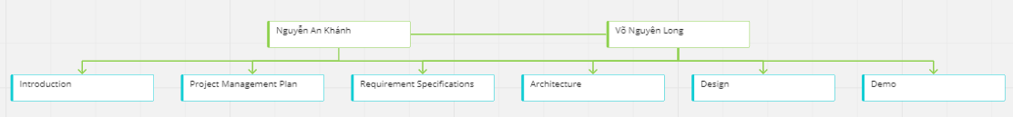

Figure 1 Project Organization

Nguyễn An Khánh: Introductin, Project Management Plan, Requirement Specifications.

Võ Nguyên Long: Architecture, Design, Demo.

## **2.2 Lifecycle Model Used**

We choose using Waterfall Model for the simplicity and common:

**Waterfall Model:**

**Communication:** to find one way to create the software

**Requirement Gathering:** collect all the related informations

**System Analysis:** define any system requirements, Evaluate alternatives to existing prototypes, Perform research and analysis to determine the

needs of end-users.

**Software Design:** first outline the details for the overall application, alongside specific aspects, such as: User interfaces, System interfaces, Use Cases, Activity Diagram, Sequence Diagram, Databases**.**

**Coding:** write code and build the application according to the

earlier design documents and outlined specifications**.**

## **2.3 Hardware And Software Resource Requirements**

2.3.1SQL Server Database Administration System

SQL Server is a relational database management system (Relational Database Management System (RDBMS) that uses SQL statements (Transact-SQL) to exchange data between the Client and the SQL Server machine. An RDBMS includes databases. , the database engine, and the applications used to manage the data and various parts of the RDBMS.



Figure 2 SQL Figure

SQL Server is optimized to run on a very large database environment up to Tera-Byte and can serve thousands of users at the same time. SQL Server can be combined with other servers such as: Microsoft Internet Information Server (IIS), E-Commerce Server, Proxy Server…. Several editions of SQL Server: Enterprise Standard developer Workgroup Express.

Basic components in SQL Server

SQL Server is composed of many components such as Database Engine, Reporting Services, Notification Services, Integration Services, Full Text Search Service…. Together, these components form a complete solution that makes data storage and analysis easy.

SQL Server main components:

− **Database Engine**: This is an engine capable of storing data at scale in the form of supports and tables. In addition, it also has the ability to self-regulate, for example, returning resources to the operating system when a user logs off and using more machine resources when needed.

− **Integration Services**: is a set of programming objects and graphical tools for copying, moving, and transforming data. When you work in a large company, the data is stored in many different places such as: Oracle, SQL Server, DB2, Microsoft Access... and you will certainly have the need to move data between servers. this. In addition, you also want to format the data before saving it to the database. Surely Integration Services will help you solve this job easily.

− **Analysis Services**: This is a very nice data analysis service from Microsoft. Data when stored in the database that you cannot get useful information is considered meaningless. Therefore, this tool was born to help you in analyzing data effectively and easily using data mining techniques - Data mining and the concept of multidimensional cubes.

− **Full Text Search Service**: is a special component for querying and indexing unstructured text data stored in SQL Server databases.

### 2.3.2 Visual Studio 2019

Visual studio is an effective support software to support website programming work. This tool was created and owned by technology giant Microsoft. In 1997, the programming software was now codenamed Project Boston. But then, Microsoft combined the development tools, packaged into a single product.



Figure 3 VS 2019

Visual Studio is the system that brings together everything related to application development, including the code editor, designer, and debugger. That is, you can write code, fix bugs, edit application design easily with just 1 Visual Studio software. Not only that, users can also design interfaces and experiences in Visual Studio like when developing Xamarin, UWP applications using XAML or Blend.

Visual studio software is divided into 2 versions Visual Studio Enterprise and Visual Studio Professional, these premium versions are used by many companies specializing in programming. In addition, Microsoft also launched the Community version (free version) of the software package, providing users with the most basic features, suitable for non-specialist programmers, new to searching. tech-savvy (research subjects, individual developers, fat project support, non-business organizations under 5 users). Up to now, Visual Studio is still considered the leading system programming software, no other software can replace it. Being so appreciated by Visual Studio possesses many extremely attractive features. Specifically:

- Multi-platform

- Software supports Multi-language programming

- Website support

- Rich extension warehouse

- Safe Storage

- Multitasking screen

- Support writing code

- Terminal support

- Git support

- Intellisense

- Comment feature

# 3. REQUIREMENT SPECIFICATIONS

## **3.1 Use case model**

Figure 4 Use case edit NhanVien

Figure 5 Use case edit KhachHang

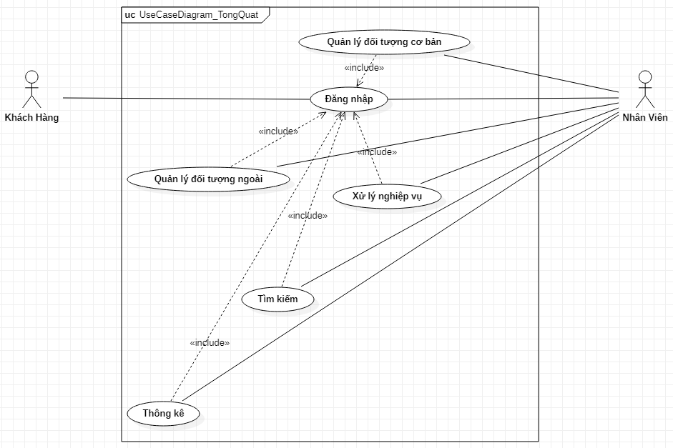

Figure 6 General Use Case

## **3.2 ERD diagram**

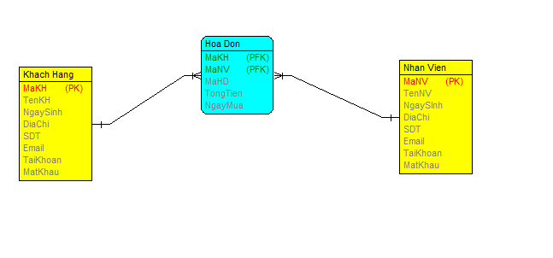

Figure 7 ERD diagram

# 4. DESIGN

## **4.1 Database design**

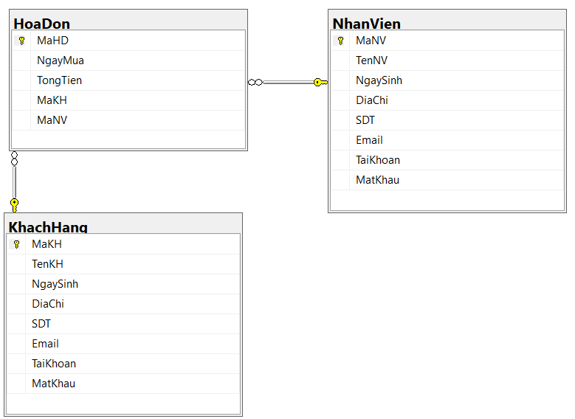

Figure 8 Database Design

1. HoaDon table

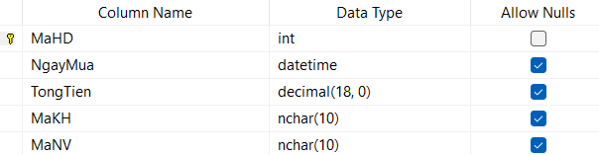

Figure 9 HoaDon Table

1. KhachHang table

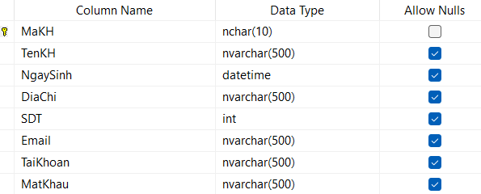

Figure 10 KhachHang Table

1. NhanVien table

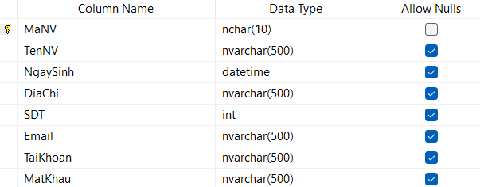

Figure 11 NhanVien Table

## **4.2 Static model - Class diagram**

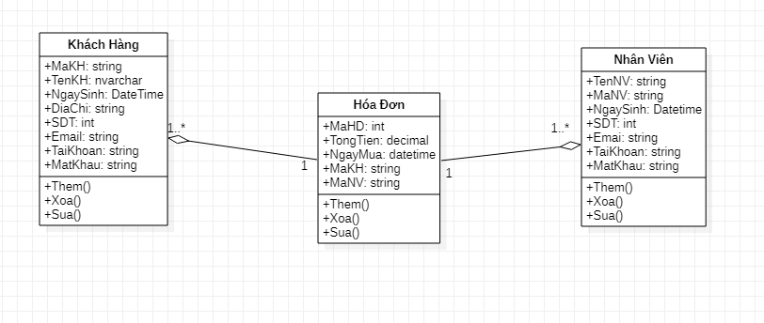

Figure 12 Class Diagram

## **4.3 Dynamic model – sequence diagrams**

Figure 13 Sequence Diagram: edit KhachHang

Figure 14 Sequence Diagram: Login KhachHang

Figure 15 Sequence Diagram: Login NhanVien

Figure 16 Sequence Diagram: Create Report

Figure 17 Sequence Diagram; Output NhanVien

Figure 18 Sequence Diagram: Output KhachHang

Figure 19 Sequence Diagram: Edit Report

Figure 20 Sequence Diagram: Information NhanVien

Figure 21 Sequence Diagram: Information KhachHang

Figure 22 Sequence Diagram: Search KhachHang

Figure 23 Sequence Diagram: Search NhanVien

Figure 24 Sequence Diagram: Show Report

## **4.4 Activity diagrams**

Figure 25 Activity: Edit KhachHang

Figure 26 Activity: Login KhachHang

Figure 27 Activity: Login NhanVien

Figure 28 Activity: History Report

Figure 29 Activity: Search NhanVien

Figure 30 Activity: Search KhachHang

Figure 31 Activity: Show KhachHang

Figure 32 Activity: Show NhanVien

Figure 33 Activity: Edit Report

Figure 34 Activity: output KhachHang

Figure 35 Activity: output NhanVien

Figure 36 Activity: output Report

# 5. Demo

## **5.1 Form Chosing**

This is the begin run of the software .You choose which account to login include: Admin or User:

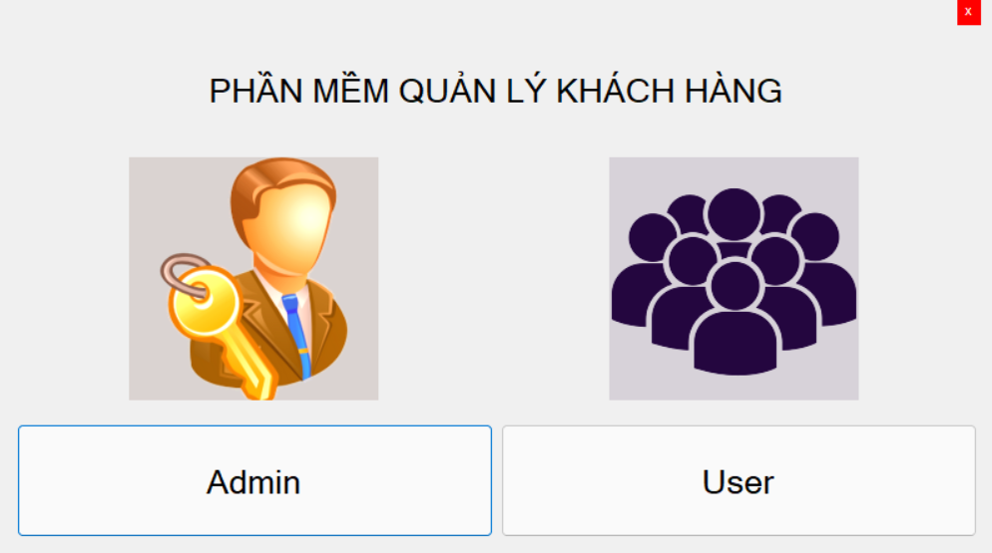

Figure 37 OnCreate Form

## **5.2 Form login KhachHang**

Form login for User account:

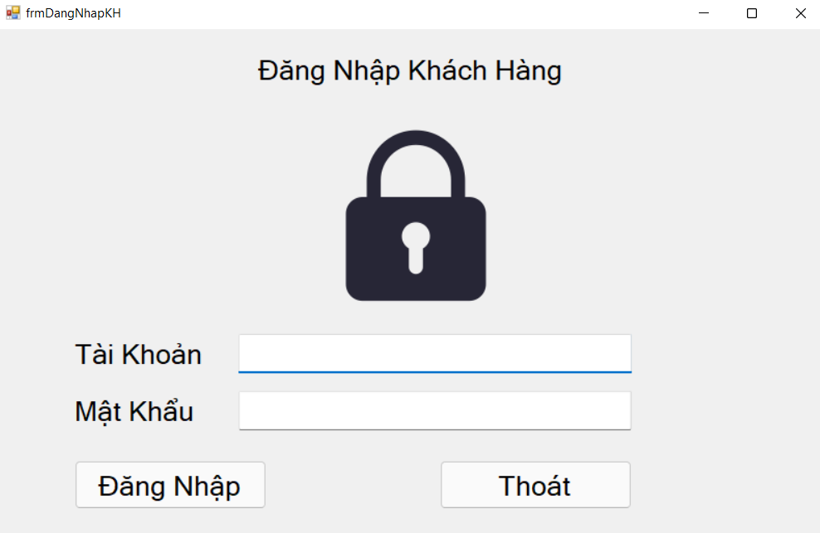

Figure 38 Login KhachHang Form

## **5.3 Form login NhanVien**

Form login for Admin account:

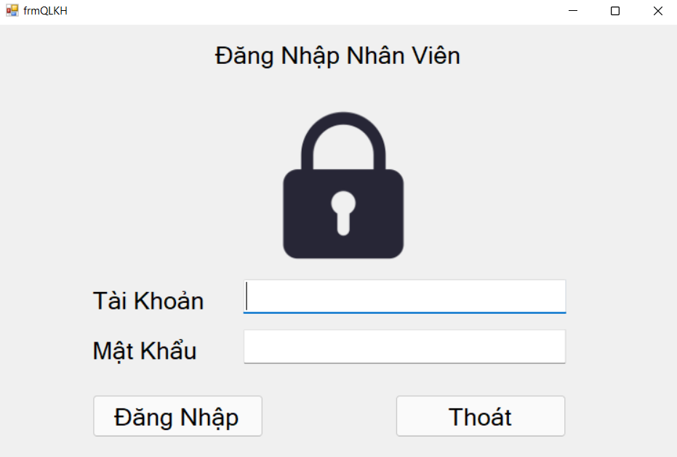

Figure 39 Login NhanVien Form

## **5.4 Form UI KhachHang**

User interface form can view customer information and customer order history:

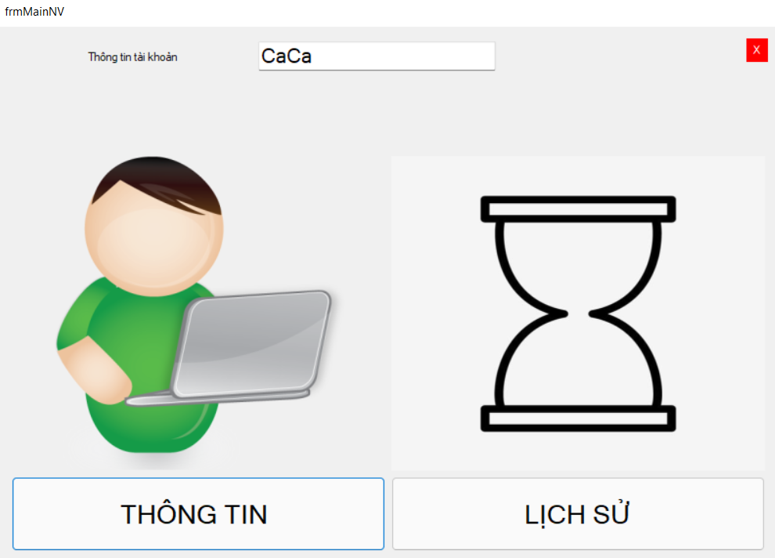

Figure 40 UI KhachHang

## **5.5 Form information KhachHang**

Form of customer information, users can view and edit customer information:

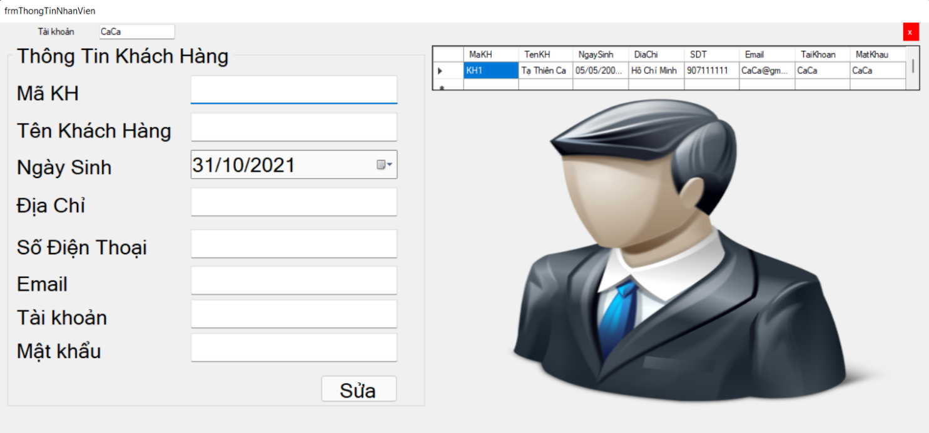

Figure 41 Information Form KhachHang

## **5.6 Form history order**

Order history form, users can view and find orders:

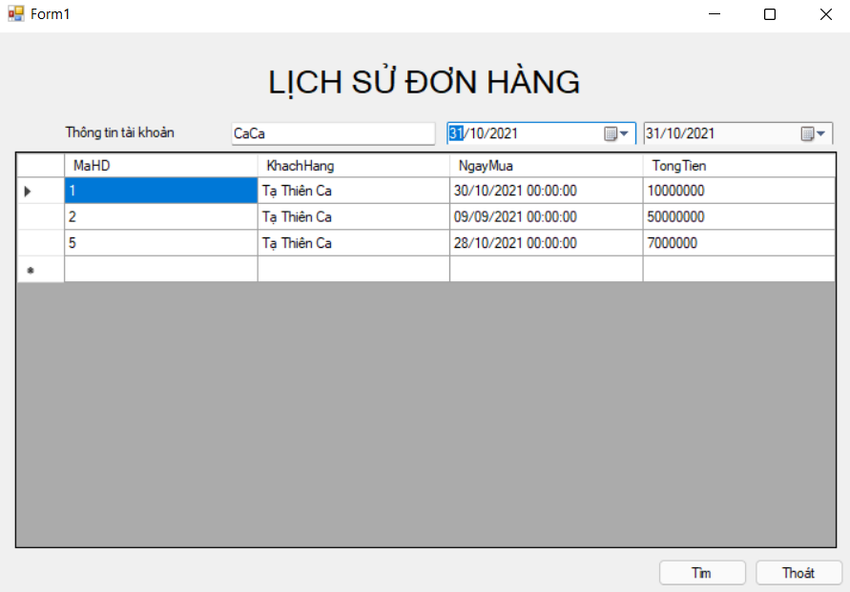

Figure 42 History Form

## **5.7 Form UI NhanVien**

Form of employees interface, the user can manage and search for information about customers, employees, invoices. Print reports on customers, employees, invoices

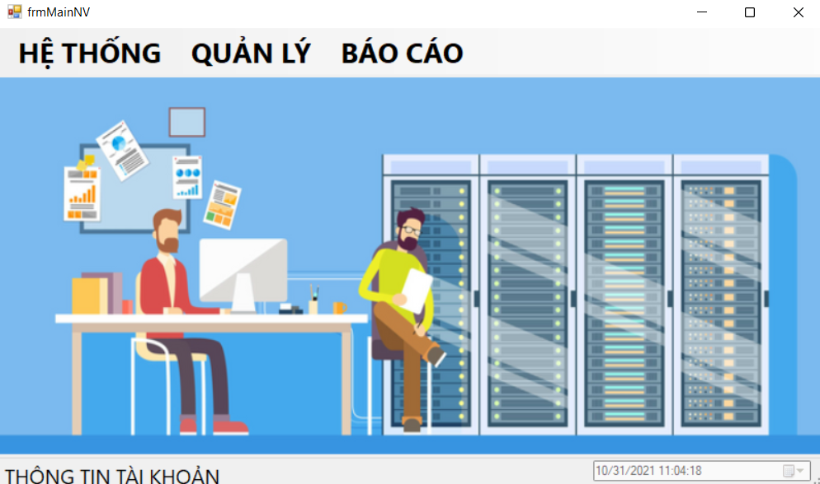

Figure 43 UI NhanVien

## **5.8 Form search KhachHang**

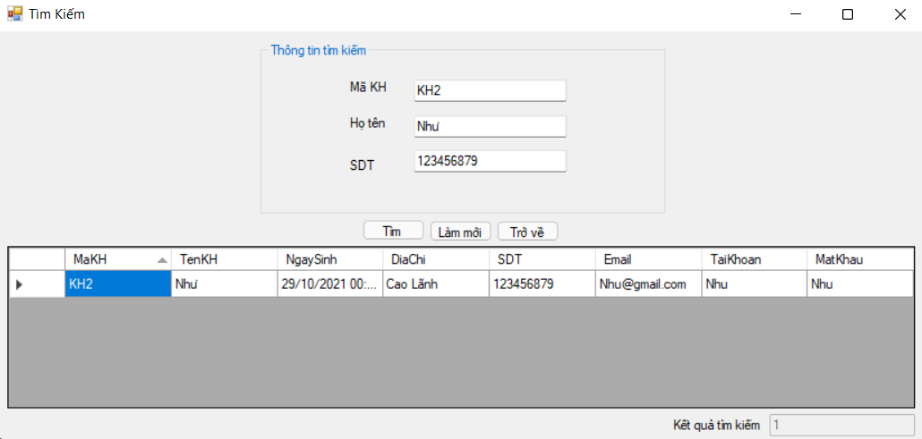

Figure 44 Search Form KhachHang

## **5.9 Form search NhanVien**

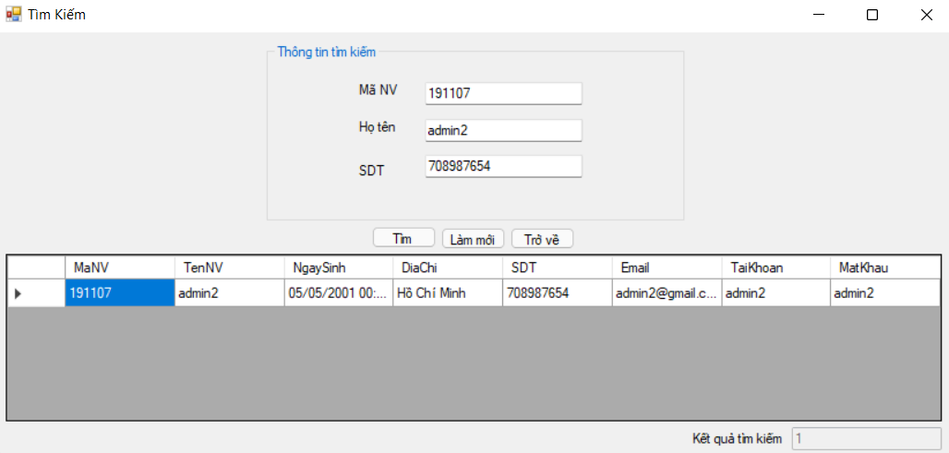

Figure 45 Search Form NhanVien

## **5.10 Form add KhachHang**

Form to enter customer information, users can add, edit, and delete customers:

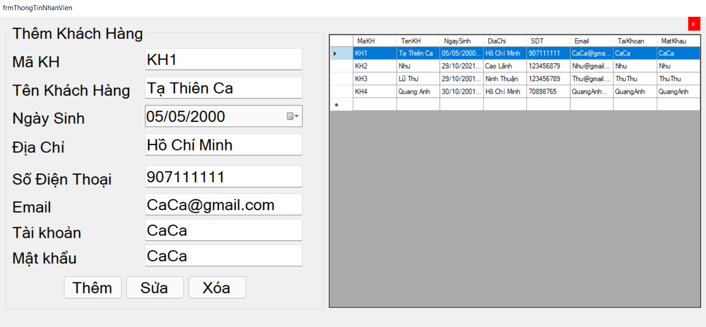

Figure 46 Add Form KhachHang

### 

## **5.11 Form add NhanVien**

Form to enter Employee information, users can add, edit, and delete employees:

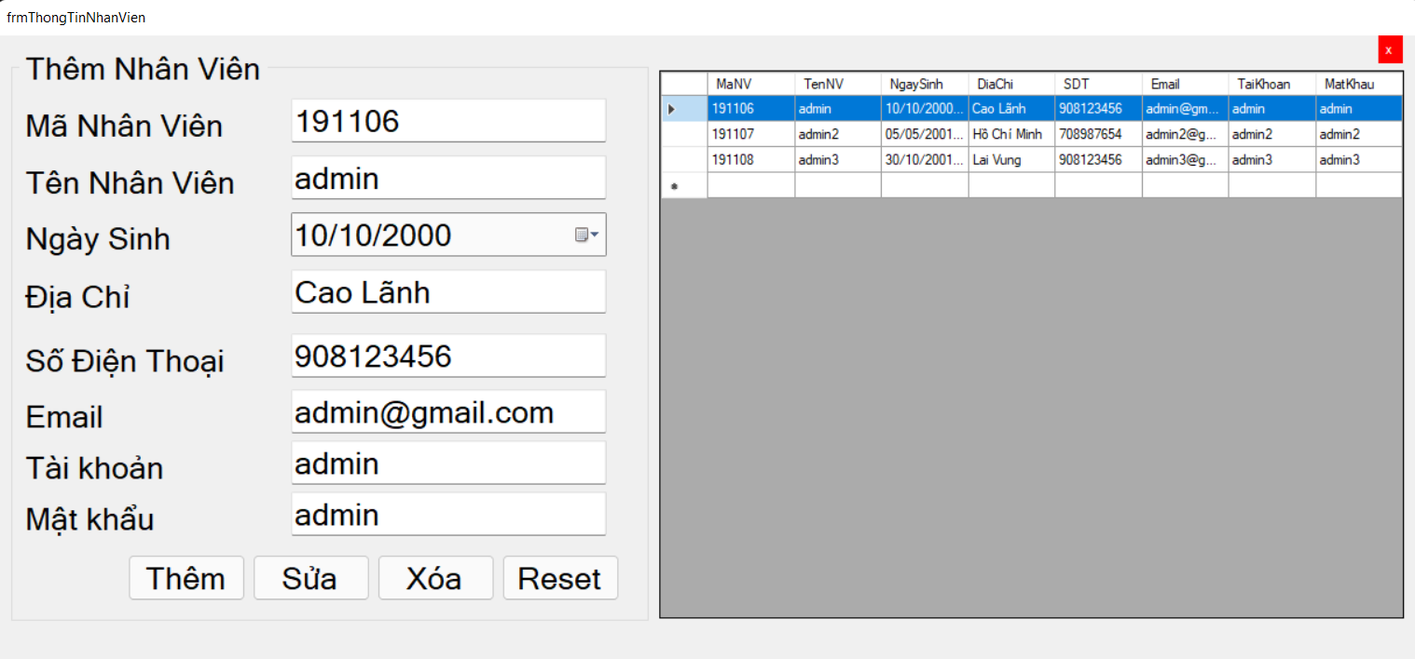

Figure 47 Add Form NhanVien

## **5.12 Form add Report**

Report information form, users can add, edit, and delete report:

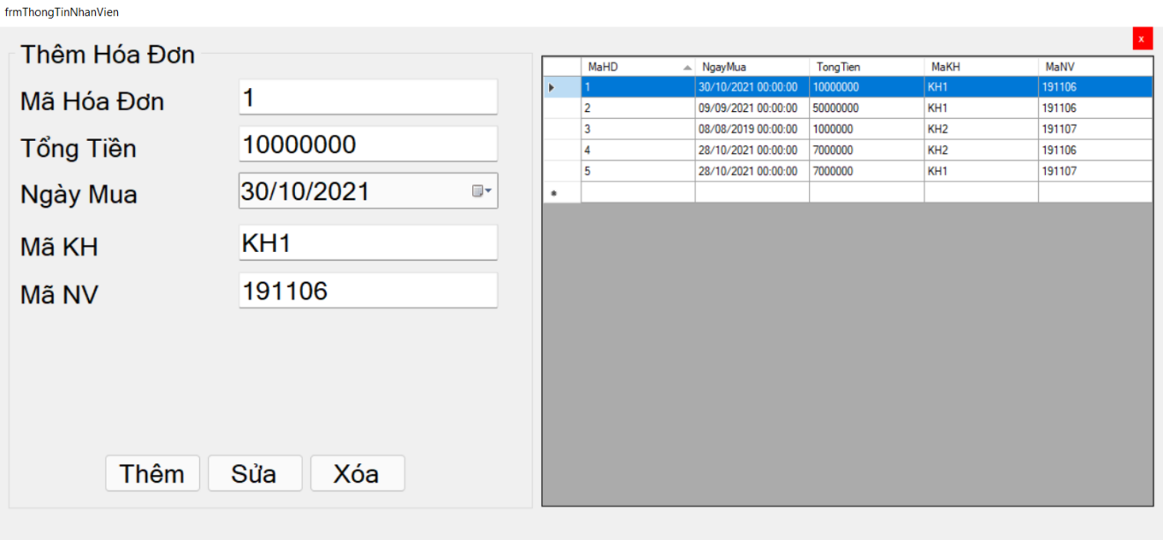

Figure 48 Add Form Report

## **5.13 Form list KhachHang**

Customer statistics form, users can view and print customer reports

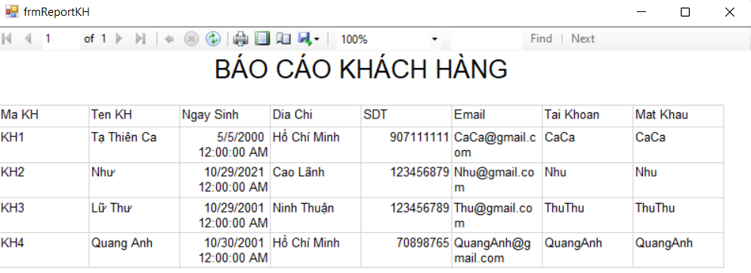

Figure 49 List KhachHang

## **5.14 Form list NhanVien**

Employee statistics form, users can view and print employee reports

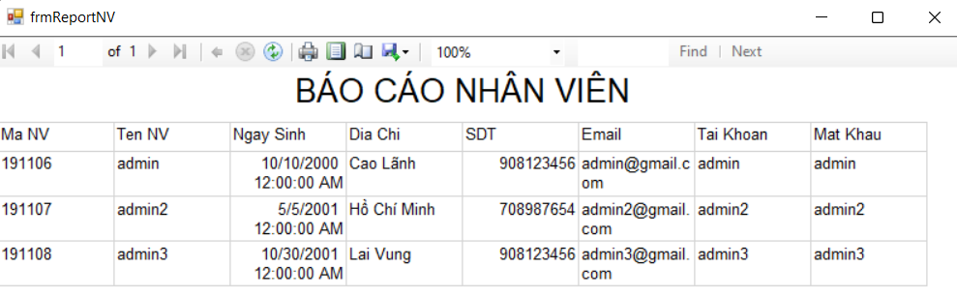

Figure 50 List NhanVien

## **5.15 Form list Report**

Reports statistics form, users can view and print reports.

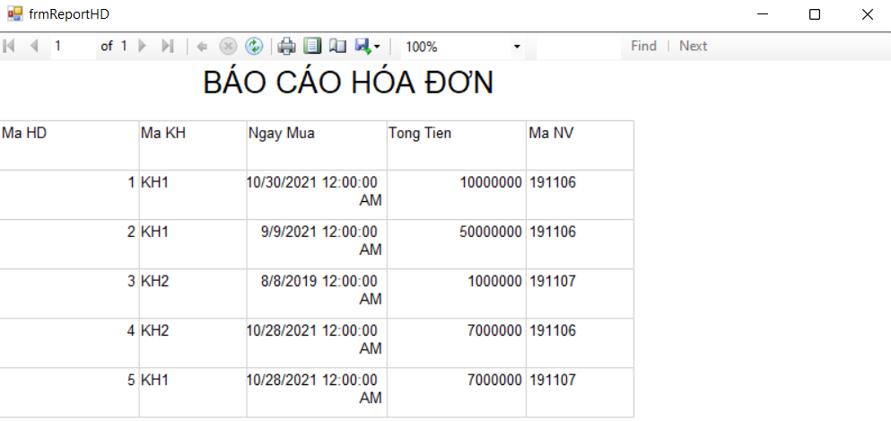

Figure 51 List Report

# 6. CONCLUDE

## **6.1 Result**

Building management software in general and customer information management software in particular is not just simple construction, but requires a systematic process of surveying, analysis and design. .

Faced with the current rapid development of information technology, building grade management software in schools is essential and highly practical. Through researching and building this topic, we have somewhat consolidated our knowledge of programming and understood how to build a software. From there, we can build similar software such as library management, human resource management, hotel management, etc.

## **6.2 Software review**

### 6.2.1. Advantages

* Shorten customer waiting time.
* Using computers to search for detailed information about customer information is easier, faster and more convenient. The storage of customer information is simple, no need to have a large storage place.
* The statistics are convenient and fast
* With the available processing functions, the software makes the management staff's work lighter, one person can also do it.

### 6.2.2. Disadvantages

* To build a good management system, it is necessary to invest costs in machinery and software…
* Some cases in customer information management have not been solved yet.

**6.3 Direction of development and expansion of the topic**

The topic "Customer information management software" needs to be expanded and considered in more aspects so that the software can be perfected, making it easier to manage customer information management systems, reducing the cumbersomeness of books… In this topic, we have only analyzed and built simple software, which needs further development and clarification:.

− Redirect the management of customer information online.

− Expand the web application: allow to enter and edit information remotely.

7. REFERENCES

* 10 Labs of Software Engineering by prof. Pham Thai Ky Trung
* All Lectures from Software Engineering by prof. Pham Thai Ky Trung.