Replenix: Real-World Dataset Validation

1. Experimental Setup
Dataset 1: Retail Store Point-of-Sale (Clean, predictable seasonality).
Dataset 2: UCI Online Retail (Highly sparse, wholesale, volatile spikes).
Training: 500 Episodes per SKU. Compared against Oracle Baseline.

2. Dataset 1 Results
SKU | DQN SL | Oracle SL | DQN Reward | Oracle Reward
P0016 | 100.00% | 99.93% | 18195280 | 17387605
P0020 | 100.00% | 97.81% | 18582220 | 17914485
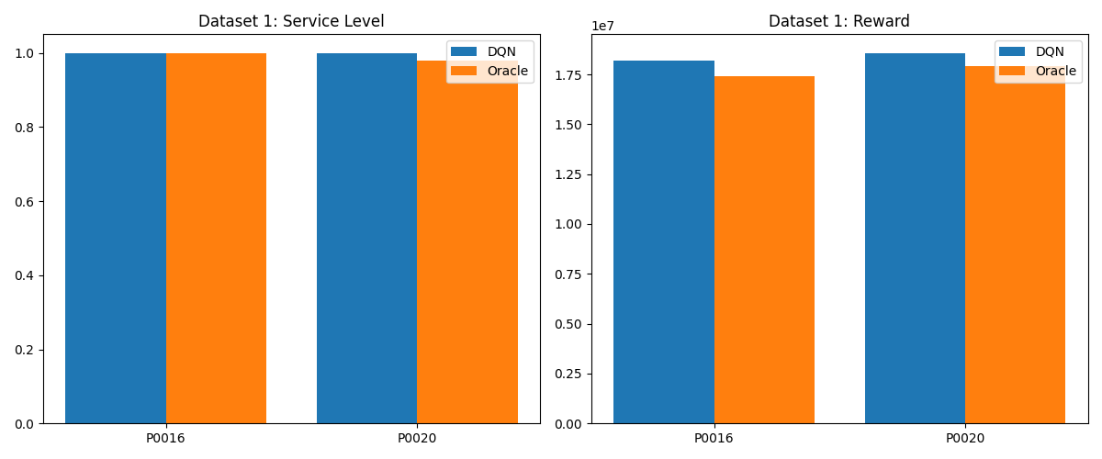

3. Dataset 2 Results (Robust)
SKU | DQN SL | Oracle SL | DQN Reward | Oracle Reward
85123A | 98.43% | 70.75% | 9599434 | 1281182
22423 | 96.86% | 85.06% | 2286548 | 1516422
