INTRODUCTION TO SOCIAL SPARK APP
The Social Spark App is a basic Android app created using Android Studio and Kotlin programming. The app is designed to help users develop pleasant and meaningful social connections through ideas that are relevant to the time of day they access the app. In this busy and often unconnected world, this app is a gentle reminder to connect and interact with others in meaningful ways. (CHATGPT, 2026)
PURPOSE OF THE SOCIAL SPARK APP
The Social Spark App is designed to spark social interactions through simple and innovative ideas based on the time of day. In our busy digital world, it is often difficult to stay in contact with friends, family, and colleagues. The app provides gentle reminders and new ideas to encourage social interaction. (CHATGPT, 2026)
The application is built to encourage continuous and positive social interactions. It does this by taking the information the user has entered, such as the time of day, and using IF statements to create a meaningful social suggestion for the user.
The app helps by creating practical step by step suggestions for Users:
EXAMPLES SHOWN BELOW
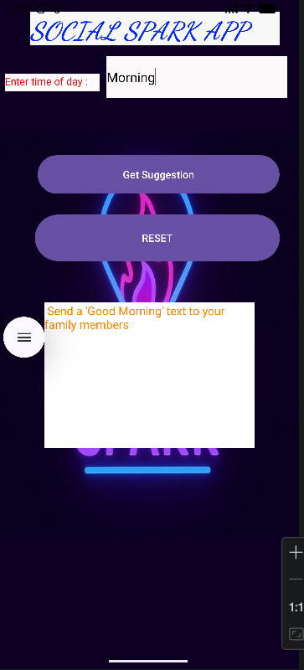
Figure 1: When a user types morning
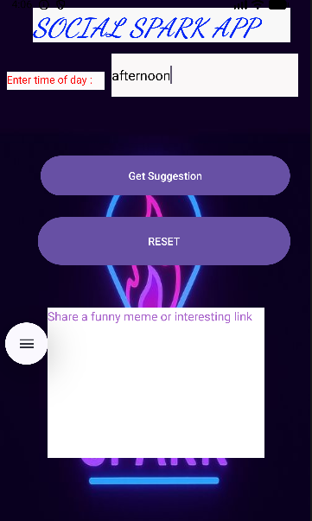
Figure 2: When a User types afternoon

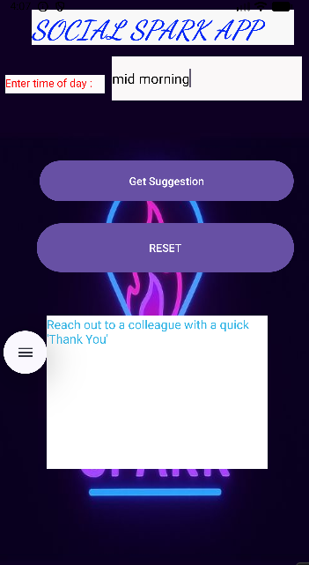
Figure 3: When a User types mid-morning

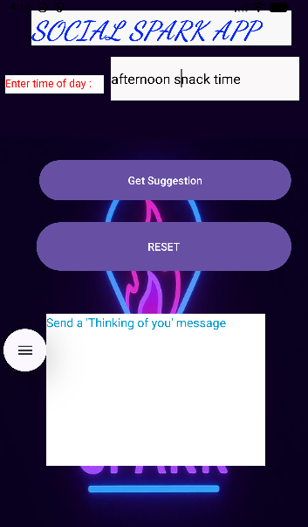
Figure 4:When a User types afternoon snack time
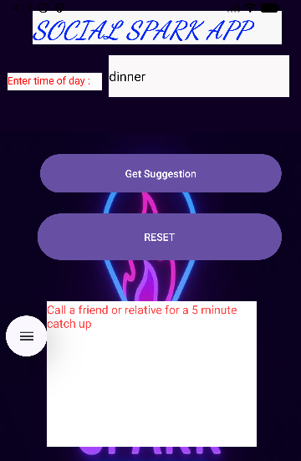
Figure 5: When a User types dinner

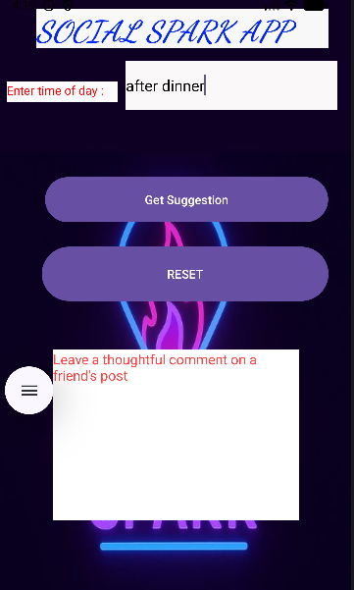
Figure 6: When a User types after dinner
The Social Spark App is useful because it helps people connect socially every day, helps people who don’t know what to say or when to say it, and helps people be positive and connect with others. It’s easy to use, quick, and simple.
In other words, the Social Spark App is a simple yet efficient application that brings technology and social awareness together to encourage users to develop meaningful connections. This not only helps individuals develop their communication skills but also teaches them the fundamental concepts of programming.

GITHUB LINK

