Nolan Van

CIS 1050 DE01

Joshua Lange

February 22, 2025

Website Design and HTML Assignment

Part #1 Initial Sketches

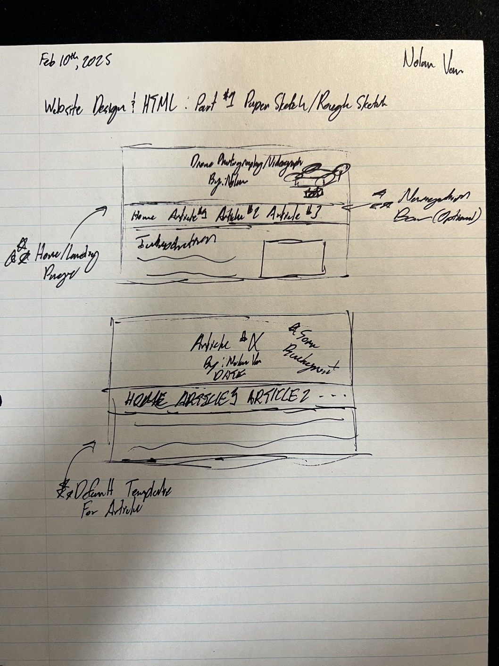

Part #1 PEAR Submission

