**Sheller v0.1**

Library *Sheller* design for organization package data exchange with integrity guarantee.

The package consists of Start-byte, a label for begin parsing package and several bytes of Cyclic redundancy check CRC-16 (CRC-byte) for integrity determination. Struct of package:



The library use CRC-16, therefore, the amount of CRC bytes is 2, and the maximum length of user data is 4095 bytes. Preset value of user data is 8 bytes. Eventually, 8 bytes useful bytes plus 3 service bytes. To speed up processing the CRC is using the table method. The size of the CRC table is 512 bytes. Interaction with this library going through 3 functions: wrap, push, read:

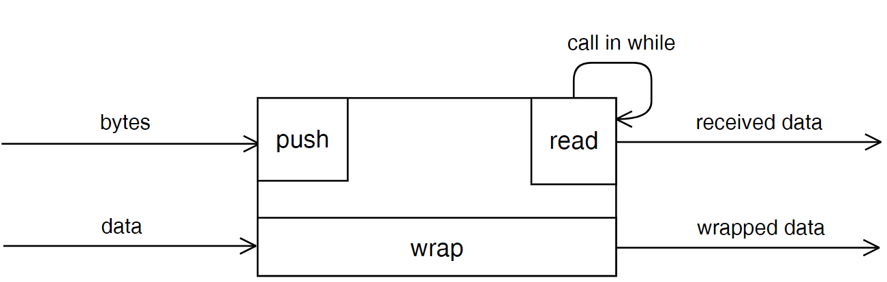

To create the package, the user needs to pass in function wrap a pointer of the sheller`s object, a pointer to data, which needs to send, the length of data, and a pointer to the buffer for storing the package.

uint8_t **sheller_wrap**(sheller_t *desc, uint8_t *data, const uint8_t data_length, uint8_t *dest);

The length of the user`s data must be less than *SHELLER_MESSAGE_LENGTH*, otherwise, the function wrap returns false and creating the package will be failed.

The size of the buffer to storing package declared by *SHELLER_MESSAGE_BUFFER_LENGTH.* Preset this value is 8 + 3 = 11. The created package is already ready to send via channel after call function wrap.

On receive side the package receiving byte by byte. Received bytes push into Sheller by calling function push:

uint8_t **sheller_push**(sheller_t *desc, const uint8_t byte);

In this function pass a pointer of the *Sheller`s* object and received byte via channel. The function returns the result of pushing byte to an internal circular buffer. If overflow occurs therefore the function returns false.

In the main loop of the program need to call non-blocking function read as often as possible to prevent buffer overflow:

uint8_t **sheller_read**(sheller_t *desc, uint8_t *dest);

In this function pass a pointer of the *Sheller`s* object and a pointer to the buffer for the received package. Calling the function read starts the process of parsing the package from an internal circular buffer. The function returns true in case successful reading the package otherwise – false.

The size of circular internal buffer defined by *SHELLER_MESSAGE_BUFFER_LENGTH.*

*Buffer overflow can occur due to frequent call the push function and rare call the function read or too high frequency of receiving bytes and too small size of internal buffer *SHELLER_RX_BUFF_LENGTH*.

Work logic:

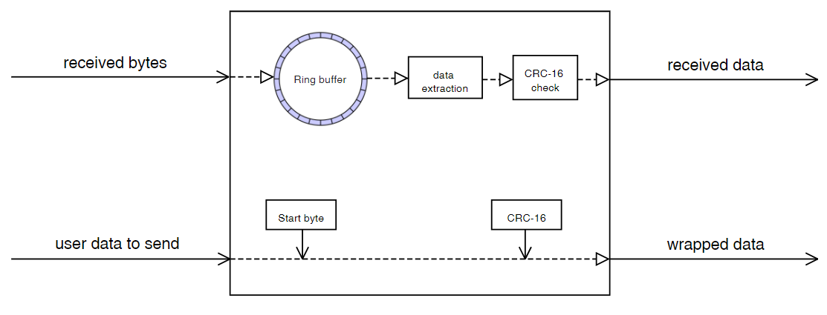

Sheller assumes work in communication channels with a high influence of interference. Functioning under such conditions is achieved by a State-machine, which is used for byte-by-byte data reception and a checksum algorithm.

The illustration below shows examples of the effect of interference on transmitted packets:

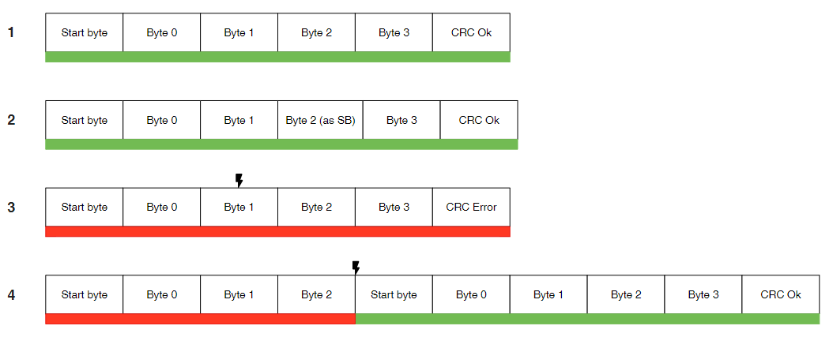

In the first case, the package reached the recipient without damage.

The second case demonstrates that Sheller does not impose restrictions on the transmitted data. The user data may contain service bytes.

In the third case, the interference changed the value of the second byte. As a result, the checksum was not converged on the receiving side and the packet was not transferred to the business logic.

In the fourth case, part of the package was lost due to interference or lack of contact. The checksum did not agree on the receiving side. In this case, a search was performed for the next initial byte, followed by the similarity of the checksum and the transfer of the packet to the business logic of the application.