# Meta-analysis of diagnostic accuracy studies in SAS with madareg

Victoria N Nyaga

# Abstract

Madareg is a statistical procedure to perform fixed- and random-effects meta-analysis of diagnostic accuracy studies. Programmed in SAS , the package has implemented the bivariate random-effects proposed by Reitsma et al. (1). Other capabilities of the package include a forest plot and meta-regression. Madareg was designed to complement and overcome the limitations metadas (2) and RevMan (3).

# Methodology

Data from a diagnostic study are usually summarized as a 2 x 2 cross-tabulation of index versus reference test results (see Table 1). The results are classified as true positive (TP), false positive (FP), true negative (TN) and false negative (FN).

|  |  |  |
| --- | --- | --- |
|  | **True disease status** | |
| **Index test result** | + | - |
| + | TP | FP |
| - | FN | TN |

Table 1: Cross-tabulation of index test results by the reference test results.

The frequencies in the four data cells are then used to compute several diagnostic accuracy measures. The most basic and widely used measure of a test performance is a bivariate outcome consisting of sensitivity (se) and specificity (sp) at a defined test cut-off. These are defined as follows

$$\hat{se}= \frac{TP}{TP+FN}=\frac{TP}{Dis}$$

$$\hat{sp}= \frac{TN}{TN+FP}=\frac{TN}{NDis}$$

Let i=1, …, I index study. The latent variables sensitivity and specificity are modeled as follows

$${TP}_{i} \sim bin\left({se}_{i}, {Dis}_{i}\right)$$

$${TN}_{i} \sim bin\left({sp}_{i}, {NDis}_{i}\right)$$

$$\left({g({se}_{i}) \atop g({sp}_{i})}\right) \sim N\left(\left({Xβ \atop Xα}\right)\right., \left.\left(\begin{matrix}σ_{1}^{2} & {ρσ}_{1}σ_{2} \\ {ρσ}_{1}σ_{2} & σ_{2}^{2}\end{matrix}\right)\right)$$

Here g(.) is a monotonic function mapping sensitivity and specificity onto the real line. The logit function is the most commonly used transformation. $β$ and $α$ are the regression coefficients for sensitivity and specificity in the scale of g. $X$ is the design matrix containing the covariate information. The intercept only model corresponds to $X$ being a single column of 1’s. Consequently, $β$ and $α$ are the mean of sensitivity and specificity in the scale of g.

Transforming $β$ and $α$ using the inverse function of g (.) yields the mean of sensitivity and specificity for hypothetical studies that have the random-effects equal to zero. To obtain the population-averaged mean, the random-effects should be integrated out. This is not a trivial task which is typically overlooked in practice. Nonetheless, it has implications on the interpretation of the results.

There are at least five parameters in the model to be identified. This implies that the model requires at least five observations to enable model identification. When the number of studies is less than five, the analyst can choose to not to estimate the correlation parameter and set it to zero.

The variance –covariance matrix is therefore: $\left(\begin{matrix}σ_{1}^{2} & 0 \\ 0 & σ_{2}^{2}\end{matrix}\right)$

When there are less than three studies, the between-study variability can be assumed to be zero resulting in a fixed effects model with only two parameters to estimate i.e $β$ and $α$.

# Software development

The model is fitted in SAS 9.3 using PROC NLMIXED. The madareg macro requires the following parameters:

dtfile = 'text' The path and name of the Excel or Stata file to import e.g. 'C:\Documents\DTA\Revman Test Data.xls'. The file extension (.xl, .csv or .dta) must be included.

import = y/n If = n, a data set must be provided with the dsname = option. The default is y.

dsname = data set The input data set if no data import is required.

tech = quanew/newrap/trureg/nrridg/dbldog/congra/nmsimp

There are several optimization techniques available with PROC NLMIXED. No algorithm for optimizing general nonlinear functions exists that always finds the global optimum for a general nonlinear minimization problem in a reasonable amount of time. This parameter enables the user to select a technique as they would do if they were running NLMIXED directly. The default is tech=QUANEW. For more information and algorithm descriptions, see the SAS user documentation for NLMIXED.

ident = y/n A potential problem with numerical maximization of the likelihood function is identifiability of model parameters. When this occurs, the likelihood will equal its maximum value at a set of parameter values instead of at a single point. To detect if there is a problem, you could try different initial values of the parameters and check for changes in parameter estimates or by examining the Hessian matrix at convergence. If ident = y the Hessian matrix after optimization is produced and the eigenvalues of the Hessian are calculated (with values saved in _madareg_a_eigenvals_/madareg_cv_eigenvals_). At a true minimum, the eigenvalues will all be positive, i.e., positive definite. The default is y. The starting Hessian matrix is also produced because Proc NLMIXED option START is always used by madareg to output the gradient at the starting values.

tp=variable The number of true positives. The default variable name is tp so that RevMan users or those who have named their variables accordingly do not need to specify this input parameter.

fp = variable The number of false positives. The default variable name is fp.

fn =variable The number of false negatives. The default variable name is fn.

tn = variable The number of true negatives. The default variable name is tn.

subject = variable This determines when new realizations of the random effects are assumed to occur. Proc NLMIXED assumes that a new realization occurs whenever the subject= variable changes from the previous observation, so the input data set is clustered according to this variable. The default variable name is study_id

cialpha = numeric Specifies the alpha level for computing z statistics and confidence limits. The default is 0.05.

byvar = variable This enables multiple analyses, i.e., consecutive calls to PROC NLMIXED for each test or group of studies in the data file. This may also be used to produce separate models using subsets of the data (subgroup analyses as in traditional meta-analysis) but be aware this is not recommended because you cannot formally test for a difference. A better approach is to use all the data and include the variable as a covariate in the model.

covariate(s) = variable(s)

Specifies a covariate(s) for inclusion in the model (meta-regression). The covariates are separated by space.

cvref(s) = 'text'/numeric This specifies the reference level of the covariate. If it is not specified, the reference level is selected based on the sort order. Sorting is done in ascending order by default and for descending specify sortcv = d.

sortcv = d/a The sort order for the covariate. sortcv = d specifies descending order and a specifies ascending. The default is to sort in ascending order.

cvtype = cat/con Type of covariate. Options are cat for categorical or con for continuous. If the parameter is not specified, the covariate is assumed to be categorical.

cveffect = se/sp/sesp For the bivariate model, se specifies that the effect be assessed only on sensitivity while sp on specificity and sesp specifies effect on both sensitivity and specificity. Default is sesp.

cvsummorder(s) = stat/level

Specifies the ordering of items in the table of summary estimates for a model with covariate. If level is specified, items are listed in the table according to covariate level. If stat is specified, items are listed according to summary statistic such that all levels of the covariate are grouped together for each statistic. The default is stat.

formatlr = y/n For formatting the log likelihood difference and p-value obtained for the likelihood ratio test. If y, then -2logL difference is formatted to 3 decimal places if it is greater than or equal to 0.001 otherwise the exact value is reported. The p-value is formatted to 3 d.p. if less than or equal to 0.001 and as <0.001 if less than 0.001. The default is y.

mtitle = text Title of the meta-analysis that is placed in the Word document. Default is 'Meta-analysis of diagnostic test accuracy studies'. NOTE: no quotation marks allowed unlike some of the other text options.

tbpe = data set Use parameters and starting values stored in the named table. The data set can be in either a narrow or wide form. The narrow-form data set contains the variables PARAMETER and ESTIMATE, with parameters and values listed as distinct observations. The wide-form data set has the parameters themselves as variables, and each observation provides a different set of starting values.

Note: In this version of madareg, the data set should only contain the 5 basic parameters the bivariate model (msens, mspec, s2usens, s2uspec, covsesp). If there is a covariate, the starting values for additional parameters can be specified using cspa1 - cspa5, cset1 - cset5 and/or cpb1 - cpb5.

These are the basic parameters and their starting values. There are five such parameters for the model. You can either specify a single number e.g. p1= 2.5 or you can use the TO and BY keywords to specify a number list for a grid search e.g. p1 = -2 to 2 by 0.5. If you specify a grid of points, the objective function value at each grid point is calculated and the best (feasible) grid point is chosen as an initial point for the optimization process. p1 = mean logit sensitivity, p2 = mean logit specificity, p3 = variance of logit sensitivity, p4 = variance of logit specificity, p5 = covariance of logit sensitivity and specificity. The default values are:

p1= -2 to 4 by 1

p2= -2 to 4 by 1

p3= 0 to 1 by 0.2

p4= 0 to 1 by 0.2

p5= -1 to 1 by 0.2

cspa1 - cspa5 These specify starting values for additional specificity parameters e.g. cspa1 = 0 to 2 by 1. cspa1 - cspa5 indicates a maximum of 5 parameters, i.e., a covariate with 6 levels. The default is 0 for any of the 5 parameters, i.e., cspa1 = 0, cspa2 = 0 for a covariate with 3 levels.

cset1 - cset5 Starting values for sensitivity parameters. The maximum is 5, i.e., a covariate with 6 levels,. The default is 0 for any of the 5 parameters, i.e., cset1 = 0, cset2 = 0 for a covariate with 3 levels.

randeffs = y/n Produce table of empirical Bayes estimates of the random effects if = y. The default is n.

relax = y/n Assume correlation is zero. The default is n.

predict = y/n If =y, predictions are obtained using the estimated model, parameter estimates and empirical Bayes estimates of the random effects. Standard errors of prediction are computed using the delta method and the predicted values of logitp (stored in data sets prefixed with _logitp_ and _logitp_cv_) are transformed to obtain predictions of sensitivity and specificity (stored in data sets prefixed with _predsesp_ and _predsesp_cv_). The default is n.

checkmod = y/n If = y, produce histograms and normal probability plots of the empirical Bayes estimates of the random effects to check assumption of normality. The default is n.

debug = y/n Debugging tool. If = y, displays the SAS statements that are generated by macro execution. The default is n.

logfile='text' Path and file name to save the contents of the SAS log. User must add the .log extension. Contents of the log file are scanned and any errors found are stored in _madareg_errors, warnings in _madareg_warnings, and model failure messages generated by madareg in _madareg_modfail. The data set for the log contents is _madareg_log.

outfile='text' Path and filename to save the contents of the SAS output window. The file name must have the .lst extension. This is especially useful if the analysis is expected to run for a while because the output window will fill up and user input is required before SAS can proceed. However, this is not the case if the output is being saved to a file.

keepds=all/some/log/none

Selectively keeps the data sets produced as output from the analyses. Option some is the default. With this option, data sets containing data from the Excel file are kept, including any data sets generated from the log file if a log file was specified. For the option log, only the data sets generated from the log file are kept. If option none is specified, all data sets prefixed with _madareg_ are deleted. Option all keeps all output data sets from NLMIXED as well as two summary ones for covariate summary and relative measures of test accuracy. Data sets for predictions, random effects, the Hessian matrix and eigenvalues are also kept with options all and some if parameters have been specified for them.

madareg output data sets:

All data from Excel file =_madareg_meta

Unique values of the BY variable = _madareg_variablename

Data set for level i of the BY variable = _madareg_dsi

Unique values of the covariate = _madareg_variablename

Predicted logitp for model without covariate=_madareg_logitp_i

Predicted logitp for model with covariate=_madareg_cv*_logitp_i

Predicted sensitivities and specificities for model without covariate = _madareg_predict_i

Predicted sensitivities and specificities for model with

covariate = _madareg_cv*_predict_i

Relative estimates of accuracy measures for

covariate = _madareg_cv*_relsummary_i

Summary estimates of accuracy measures for covariate =

_madareg_cv*_statsummary_i

Eigenvalues for model without covariate =_madareg_a_eigenvals_

Eigenvalues for model with covariate =_madareg_cv*_eigenvals_

SAS NLMIXED output data sets are prefixed by madareg as follows:

Model without covariate

Parameters=_madareg_a_parms_

Parameter estimates=_madareg_a_pe_

Fit statistics=_madareg_a_fit_

Additional estimates=_madareg_a_addest_

Covariance matrix of additional estimates =_madareg_a_covaddest_

Convergence status=_madareg_a_convgstat_

Final Hessian matrix=_madareg_a_hessian_

Model with covariate

Parameters=_madareg_cv*_parms_

Parameter estimates=_madareg_cv*_pe_

Fit statistics=_madareg_cv*_fit_

Additional estimates=_madareg_cv*_addest_

Covariance matrix of additional estimates=_madareg_cv*_covaddest_

Convergence status=_madareg_cv*_convgstat_

Contrasts=_madareg_cv*_contrasts_

Final Hessian matrix=_madareg_cv*_hessian_

For the bivariate model there are 2 additonal tables,

madareg_cv*_covparmest_ and madareg_cv*_covparmest_, for the covariance matrix of parameter estimates.

info = y/n If =y, include details of some of the input parameters specified for the macro. The default is y.

incbasic = y/n If = n then the output for the model with no covariate is suppressed. This may be useful where the model with no covariate is not realistic. The default is y.

rfile = 'text' Path and name of the Word document to save the result of the analyses. The file name must have the .rtf extension (rich text file).

model = RE/FE Random or fixed effects model. If there are two studies, then the fixed-effect model is fitted.

graph = Y/N Include the forest plot or not. Default is Y.

gtitle = 'text' Title of the forest plot. Default is 'Forest plot of sensitivity and specificity and 95% CI'

cltype = AC/W/CP How to compute the confidence intervals for the individual. AC is Agresti-coull, W is for Wilson/Score and CP (default) for Clopper-Pearson, the exact interval.

pmin = A number in the interval [0,1] to indicate the minimum x-axis tick-value.

pmax = A number in the interval [0,1] to indicate the maximum x-axis tick-value.

gwidth = Number to indicate width of the forest plot, default is 800.

gheight = Number to indicate height of the forest plot, default is 800.

gdpi = Number to indicate the resolution of the forest plot, default is 250.

dp = Decimal points to be displayed on the forest plot. Default is 2.

# Application

## Example 1

Fitting random-effects model with test as covariate. Since the number of studies is limited (only three studies), the correlation between logit sensitivity and logit specificity is ignored by setting it equal to zero.

|  |  |  |  |  |  |  |  |  |
| --- | --- | --- | --- | --- | --- | --- | --- | --- |
| **Test** | **Threshold** | **Outcome** | **Study_ID** | **Year_of_study** | **TP** | **FP** | **TN** | **FN** |
| CC | ASCUS+ | CIN2+ | Agorastos T 2005 | 2005 | 2 | 20 | 1272 | 2 |
| PCR | 13 hr types or more | CIN2+ | Agorastos T 2005 | 2005 | 3 | 34 | 1258 | 1 |
| CC | ASCUS+ | CIN2+ | Hovland S 2010 | 2010 | 10 | 11 | 279 | 5 |
| PCR | 13 hr types or more | CIN2+ | Hovland S 2010 | 2010 | 16 | 42 | 255 | 0 |
| CC | ASCUS+ | CIN2+ | Naucler P 2009 | 2009 | 62 | 84 | 6023 | 25 |
| PCR | 13 hr types or more | CIN2+ | Naucler P 2009 | 2009 | 83 | 350 | 5652 | 4 |

Table 1: Data5 containing studies assessing the accuracy of conventional cytology (CC) in ASCUS+ against PCR detecting 13 high risk HPV types to detect CIN2+.

## Analysis procedure:

1. Load the macro

%include "F:\PHD\Projects\madareg\Scripts\Madareg.sas";

1. Read in the data

**data** data5;

infile 'F:\PHD\Projects\E003\Data\analysis5.csv' delimiter = ','

MISSOVER DSD

lrecl=**32767**

firstobs=**2** ;

input

Test $

Threshold $

Outcome $

Study_ID $

Year_of_study

TP

FP

TN

FN

;

run;

**quit**;

1. Fit the model with test as a covariate (assuming that correlation is zero).

%***madareg***(

import = N,

dsname = data5,

tp = TP,

fp = FP,

fn = FN,

tn = TN,

subject = study_id,

covariate = Test,

cvref = CC,

sortcv = D,

cvtype = CAT,

relax = Y,

keepds=all,

incbasic=n,

rfile="F:\PHD\Projects\Madareg\Logs\Example5.rtf");

1. The SAS output is a word document found in F:\PHD\Projects\Madareg\Logs\Example5.rtf.
2. Results based on excerpts from the output in F:\PHD\Projects\Madareg\Logs\Example5.rtf.

This analysis compared the diagnostic accuracy of PCR and conventional cytology (CC) on detection of CIN2+ in the ASCUS+ triage. The reference test was CC. The forest plot in Figure 1 shows large within-study variability in sensitivity. It suggests that the two tests might be equally as specific with PCR being more sensitive. A formal test (see table 2) on the significance of the relative sensitivity confirms that PCR is indeed more sensitive RSE: 1.3655 [1.1964, 1.5585], p value <0.0001. However, PCR is less specific than CC RSP: 0.9520 [0.9198, 0.9852], p value = 0.005.

| **Parameter** | **Estimate** | **Pr > |z|** | **Lower** | **Upper** |
| --- | --- | --- | --- | --- |
| True positive OR Test: 1 vs 0 | 8.8216 | <.0001 | 3.2776 | 23.7432 |
| True negative OR Test: 1 vs 0 | 0.2544 | <.0001 | 0.2064 | 0.3135 |
| RSE Test: 1 vs 0 | 1.3655 | <.0001 | 1.1964 | 1.5585 |
| RSP Test: 1 vs 0 | 0.9520 | 0.0050 | 0.9198 | 0.9852 |
| RDOR Test: 1 vs 0 | 2.2439 | 0.1174 | 0.8157 | 6.1727 |

Table 2: Estimates of relative measures of test accuracy of CC vs PCR.

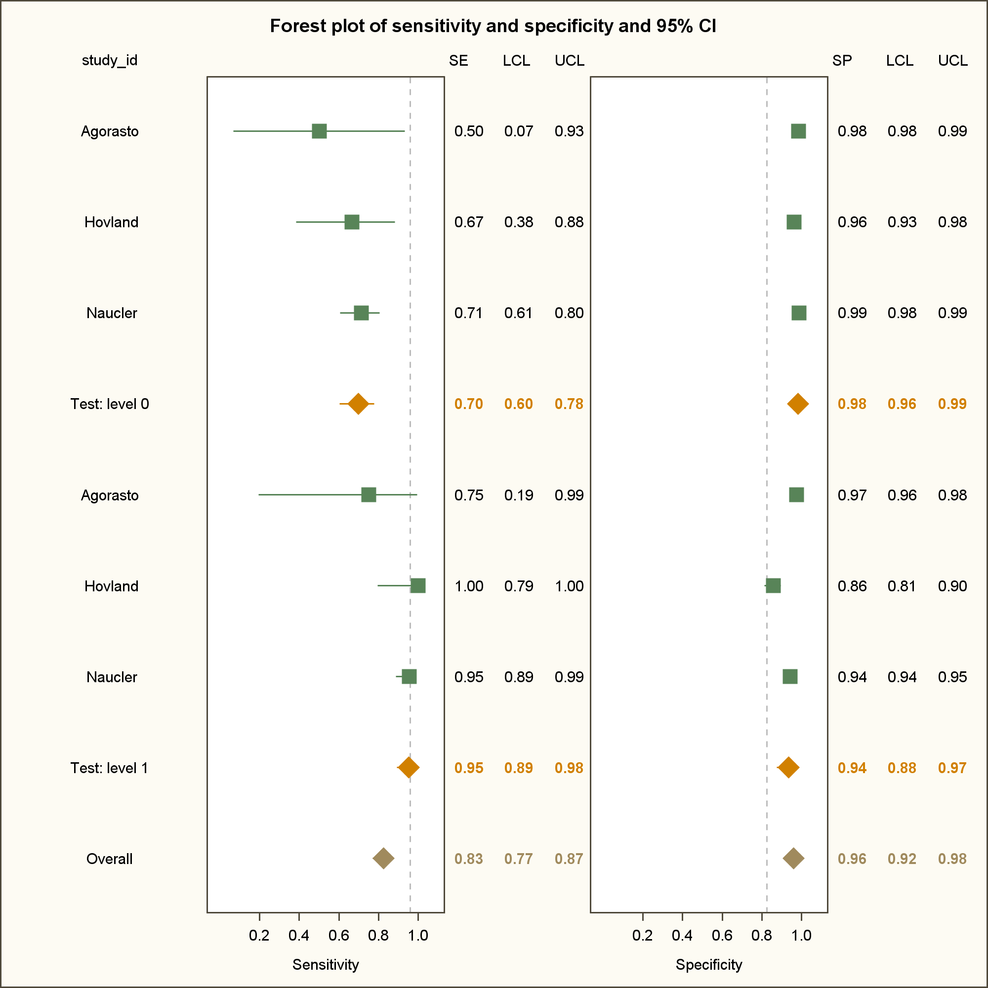

Figure 1: Forest plot of sensitivity and specificity and 95% confidence intervals comparing CC against PCR for detection of CIN2+ in ASCUS+ triage.

## Example 2

Goal: Fitting fixed-effects model with test as covariate.

|  |  |  |  |  |  |  |  |  |
| --- | --- | --- | --- | --- | --- | --- | --- | --- |
| Test | Threshold | Outcome | Study_ID | Year_of_study | TP | FP | TN | FN |
| CC | LSIL+ | CIN2+ | Hovland S 2010 | 2010 | 9 | 7 | 283 | 6 |
| PCR | 13 hr types or more | CIN2+ | Hovland S 2010 | 2010 | 16 | 42 | 255 | 0 |
| CC | LSIL+ | CIN2+ | Schneider A 2000 | 2000 | 21 | 21 | 4626 | 93 |
| PCR | 13 hr types or more | CIN2+ | Schneider A 2000 | 2000 | 108 | 263 | 4384 | 6 |

Table 3: Data10 with studies assessing the accuracy of conventional cytology (CC) in LSIL+ against PCR detecting 13 high risk HPV types to detect CIN2+.

## Analysis procedure

1. Load the macro

%include "F:\PHD\Projects\madareg\Scripts\Madareg.sas";

1. Read in the data

**data** data5;

infile 'F:\PHD\Projects\E003\Data\analysis10.csv' delimiter = ','

MISSOVER DSD

lrecl=**32767**

firstobs=**2** ;

input

Test $

Threshold $

Outcome $

Study_ID $

Year_of_study

TP

FP

TN

FN

;

run;

**quit**;

1. Fit a model with test as a covariate.

%***madareg***(

import = N,

dsname = DATA10,

tp = TP,

fp = FP,

fn = FN,

tn = TN,

subject = study_id,

covariate = Test,

cvtype = CAT,

model = FE,

keepds=all,

incbasic=n,

rfile="F:\PHD\Projects\Madareg\Logs\Example10.rtf");

1. The SAS output is a word document found in F:\PHD\Projects\Madareg\Logs\Example10.rtf.
2. Results based on excerpts from the output in F:\PHD\Projects\Madareg\Logs\Example10.rtf.

In the analysis, CC is taken as the reference test. As seen in Figure 2 and Table 4, PCR is again more sensitive RSE: 4.1015 [2.9899, 5.627], p-value < 0.0001 but less sensitive RSP” 0.9437 [ 0.9366, 0.951], p-value <0.0001 than CC in detection of CIN2+ in the LSIL triage.

| **Parameter** | **Pr > |z|** | **Estimate** | **Lower** | **Upper** |
| --- | --- | --- | --- | --- |
| True positive OR Test: 1 vs 0 | <.0001 | 68.2000 | 27.2723 | 170.548 |
| True negative OR Test: 1 vs 0 | <.0001 | 0.0868 | 0.0588 | 0.128 |
| RSE Test: 1 vs 0 | <.0001 | 4.1015 | 2.9899 | 5.627 |
| RSP Test: 1 vs 0 | <.0001 | 0.9437 | 0.9366 | 0.951 |
| RDOR Test: 1 vs 0 | 0.0005 | 5.9166 | 2.1855 | 16.018 |

Table 4: Estimates of relative measures of test accuracy of PCR vs. CC in detection of CIN2+.

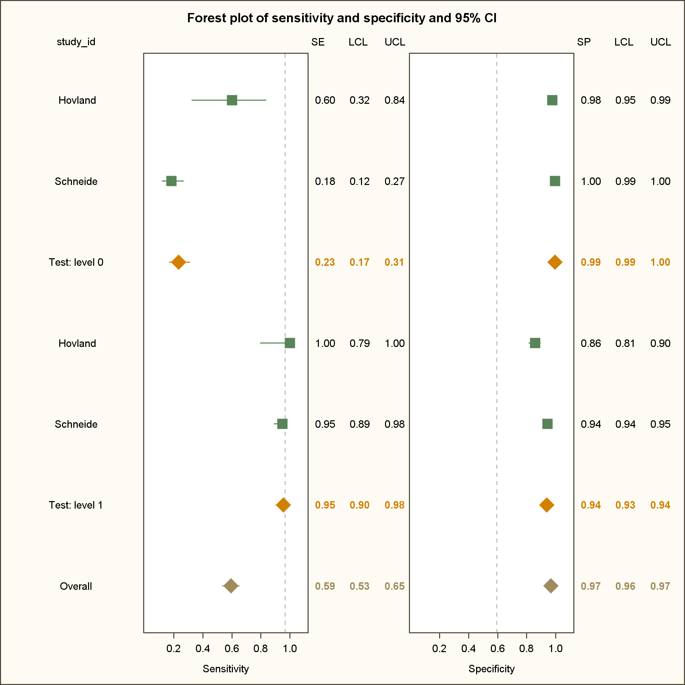

Figure 2: Forest plot of sensitivity and specificity and 95% confidence intervals comparing CC and PCR in detection of CIN2+ in the LSIL triage.

## Example 3

Fit a random-effects model to 1. estimate sensitivity and specificity of HC2 in detecting CIN2+ and 2. assess whether there are differences in diagnostic accuracy of HC2 by location (developing vs developed countries) and age-group (any age group vs. women older than 30 years).

|  |  |  |  |  |  |  |  |  |
| --- | --- | --- | --- | --- | --- | --- | --- | --- |
| **Study_ID** | **TP** | **FP** | **TN** | **FN** | **Age** | **Location** | **Location1** | **Age1** |
| Belinson JL 2003 | 363 | 1652 | 6470 | 12 | Age >30 | Asia | 0 | 1 |
| Bigras G 2005 | 80 | 1063 | 12697 | 2 | Any age | Europe | 1 | 0 |
| Blumenthal PD 2001 | 168 | 721 | 1270 | 40 | Any age | Africa | 0 | 0 |
| Cardenas-Turanzas M 2008 | 11 | 55 | 764 | 5 | Age >30 | North America | 1 | 1 |
| Clavel C 2001 | 129 | 1085 | 6718 | 0 | Any age | Europe | 1 | 0 |
| Cuzick J 2003 | 87 | 697 | 9571 | 3 | Age >30 | Europe | 1 | 1 |
| de Cremoux P 2003 | 150 | 331 | 1273 | 31 | Any age | Europe | 1 | 0 |
| Ferreccio C 2013 | 91 | 742 | 7374 | 5 | Any age | Central and South America | 0 | 0 |
| Gravitt PE 2010 | 34 | 200 | 1975 | 22 | Any age | Asia | 0 | 0 |
| Iftner T 2015 | 86 | 494 | 8867 | 4 | Age >30 | Europe | 1 | 1 |
| Li N 2009 | 67 | 351 | 2137 | 7 | Any age | Asia | 0 | 0 |
| Mahmud SM 2012 | 21 | 148 | 1180 | 3 | Age >30 | Africa | 0 | 1 |
| McAdam M 2010 a | 14 | 34 | 436 | 7 | Age >30 | Oceania and Pacific | 1 | 1 |
| McAdam M 2010b | 22 | 31 | 454 | 5 | Age >30 | Oceania and Pacific | 1 | 1 |
| Monsonego J 2011 | 98 | 595 | 3733 | 3 | Any age | Europe | 1 | 0 |
| Moy LM 2010 | 204 | 1037 | 7268 | 8 | Age >30 | Asia | 0 | 1 |
| Pan Q 2003 | 79 | 248 | 1505 | 4 | Age >30 | Asia | 0 | 1 |
| Petry KU 2003 | 45 | 369 | 7493 | 1 | Age >30 | Europe | 1 | 1 |
| Qiao YL 2008 | 68 | 333 | 1985 | 2 | Age >30 | Asia | 0 | 1 |
| Ronco G 2006 | 73 | 1112 | 15223 | 2 | Age >30 | Europe | 1 | 1 |
| Salmeron J 2003 | 94 | 626 | 7205 | 7 | Any age | Central and South America | 0 | 0 |
| Sankaranarayanan R 2004 | 120 | 750 | 10589 | 59 | Any age | Asia | 0 | 0 |
| Sarian LO 2005 | 52 | 665 | 3467 | 11 | Any age | Central and South America | 0 | 0 |
| Shipitsyna E 2011 | 6 | 101 | 716 | 0 | Age >30 | Europe | 1 | 1 |
| Wu R 2010 | 24 | 306 | 1682 | 3 | Any age | Asia | 0 | 0 |
| Belinson JL 2003 | 363 | 1652 | 6470 | 12 | Age >30 | Asia | 0 | 1 |
| Cardenas-Turanzas M 2008 | 11 | 55 | 764 | 5 | Age >30 | North America | 1 | 1 |
| Cuzick J 2003 | 87 | 697 | 9571 | 3 | Age >30 | Europe | 1 | 1 |
| Iftner T 2015 | 86 | 494 | 8867 | 4 | Age >30 | Europe | 1 | 1 |
| Mahmud SM 2012 | 21 | 148 | 1180 | 3 | Age >30 | Africa | 0 | 1 |
| McAdam M 2010 a | 14 | 34 | 436 | 7 | Age >30 | Oceania and Pacific | 1 | 1 |
| McAdam M 2010b | 22 | 31 | 454 | 5 | Age >30 | Oceania and Pacific | 1 | 1 |
| Moy LM 2010 | 204 | 1037 | 7268 | 8 | Age >30 | Asia | 0 | 1 |
| Pan Q 2003 | 79 | 248 | 1505 | 4 | Age >30 | Asia | 0 | 1 |
| Petry KU 2003 | 45 | 369 | 7493 | 1 | Age >30 | Europe | 1 | 1 |
| Qiao YL 2008 | 68 | 333 | 1985 | 2 | Age >30 | Asia | 0 | 1 |
| Ronco G 2006 | 73 | 1112 | 15223 | 2 | Age >30 | Europe | 1 | 1 |
| Shipitsyna E 2011 | 6 | 57 | 716 | 0 | Age >30 | Europe | 1 | 1 |

Table 5: Data25 containing studies assessing the accuracy of HC2 at threshold of 1 against PCR detecting 13 high risk HPV types to detect CIN2+.

## Analysis procedure

1. Load the macro

%include "F:\PHD\Projects\madareg\Scripts\Madareg.sas";

1. Read in the data

**data** data25;

infile 'F:\PHD\Projects\E003\Data\analysis25.csv' delimiter = ','

MISSOVER DSD

lrecl=**32767**

firstobs=**2** ;

input

Study_ID $

Year_of_study

TP

FP

TN

FN

Age $

Location $

Location1 $

Age1 $

;

run;

**quit**;

1. Fit a model with age1 (dichotomous variable from the variable age) and location1 (dichotomous variable from the variable location) as covariates.

%***madareg***(

import = N,

dsname = data25,

tp = TP,

fp = FP,

fn = FN,

tn = TN,

subject = study_id,

covariate = Age1 Location1,

cvref = **0** **0**,

sortcv = D D,

cvtype = CAT CAT,

relax= N,

model = RE,

rfile="G:\PHD\Projects\Madareg\Logs\Example25.rtf");

1. The SAS output is a word document found in F:\PHD\Projects\Madareg\Logs\Example25.rtf.
2. Results based on excerpts from the output in F:\PHD\Projects\Madareg\Logs\Example25.rtf.

The likelihood ratio test comparing the model with age and location as covariates against the null model is significant (p-value = 0.033). This suggests that there are differences in the diagnostic accuracy of HC2 by location after adjusting for age or vice-versa. Indeed as seen in table 6, HC2 was more specific in the developed countries RSP =1.053 [1.004, 1.105].

| **Parameter** | **Estimate** | **Pr > |z|** | **Lower** | **Upper** |
| --- | --- | --- | --- | --- |
| True positive OR Age1: 1 vs 0 | 1.6265 | 0.3172 | 0.6266 | 4.2217 |
| True negative OR Age1: 1 vs 0 | 1.3272 | 0.1634 | 0.8912 | 1.9764 |
| RSE Age1: 1 vs 0 | 1.0451 | 0.3194 | 0.9581 | 1.1399 |
| RSP Age1: 1 vs 0 | 1.0373 | 0.1590 | 0.9857 | 1.0916 |
| RDOR Age1: 1 vs 0 | 2.1586 | 0.1253 | 0.8068 | 5.7754 |
| True positive OR Location1: 1 vs 0 | 1.8322 | 0.2213 | 0.6940 | 4.8374 |
| True negative OR Location1: 1 vs 0 | 1.5312 | 0.0367 | 1.0267 | 2.2837 |
| RSE Location1: 1 vs 0 | 1.0536 | 0.2120 | 0.9706 | 1.1437 |
| RSP Location1: 1 vs 0 | 1.0533 | 0.0333 | 1.0041 | 1.1049 |
| RDOR Location1: 1 vs 0 | 2.8055 | 0.0434 | 1.0312 | 7.6328 |

Table 6: Estimates of relative measures of test accuracy of HC2 in detecting CIN2+.

# Bibliography

1. Reitsma JB, Glas AS, Rutjes AWS, Scholten RJPM, Bossuyt PM, Zwinderman AH. Bivariate analysis of sensitivity and specificity produces informative summary measures in diagnostic reviews. J Clin Epidemiol. 2005;58(10):982–90.

2. Takwoingi Y, Deeks J. MetaDAS: A SAS macro for meta-analysis of diagnostic accuracy studies User guide [Internet]. 2010 [cited 2017 May 3]. Available from: http://srdta.cochrane.org/.

3. The Cochrane Collaboration. Revien Manager (RevMan). Copenhagen: The Nordic Cochrane Centre; 2014.