1.giaNha <- read.csv("C:\\Users\\Thanh Vo\\Desktop\\BaiTapLon\\gia_nha.csv", header = TRUE)

2a. new_DF <- giaNha[, c(6, 9, 11, 14, 16, 23)]

b. new_DF <- na.omit(new_DF)

3

a.

new_DF$price <- log(new_DF$price)

new_DF$sqft_living15 <- log(new_DF$sqft_living15)

new_DF$sqft_above <- log(new_DF$sqft_above)

new_DF$sqft_living <- log(new_DF$sqft_living)

b.

new_DF$price <- log(new_DF$price)

new_DF$sqft_living15 <- log(new_DF$sqft_living15)

new_DF$sqft_above <- log(new_DF$sqft_above)

new_DF$sqft_living <- log(new_DF$sqft_living)

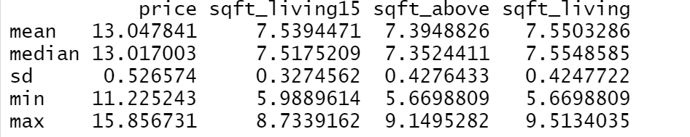

c.

table(new_DF$floors)

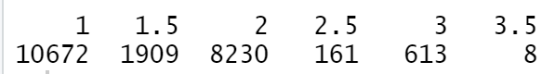

table(new_DF$condition)



d.

hist(new_DF$price)

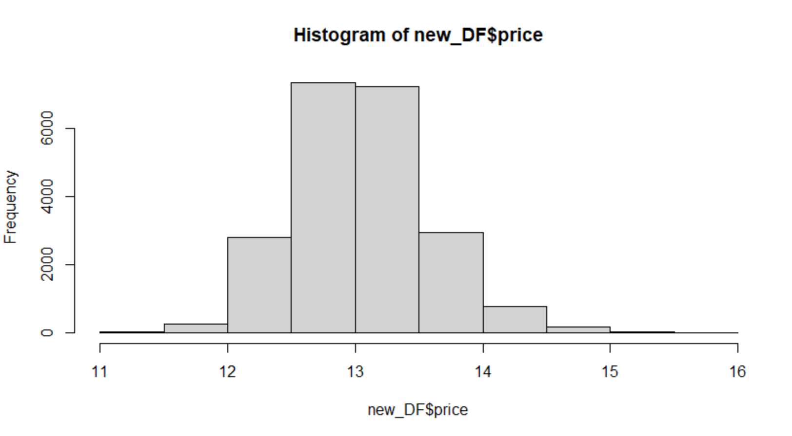

e.

boxplot(price~floors, data = new_DF, main="Boxplot for each floors")

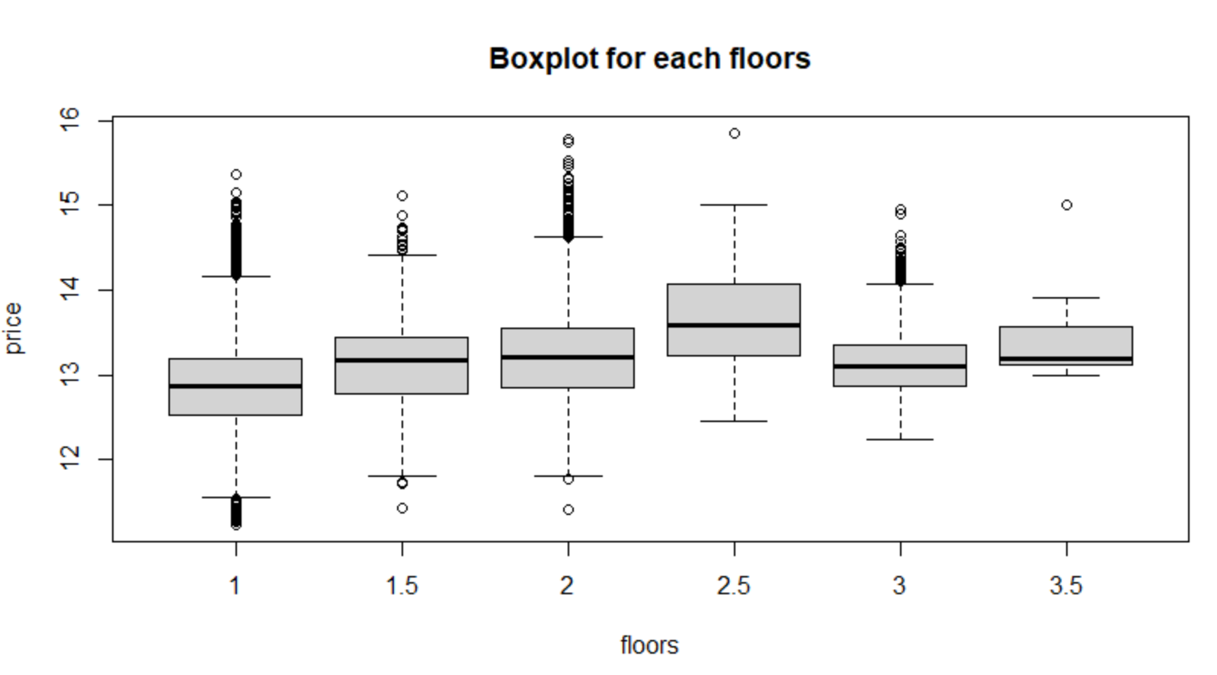

boxplot(price~condition, data = new_DF, main="Boxplot for each condtion")

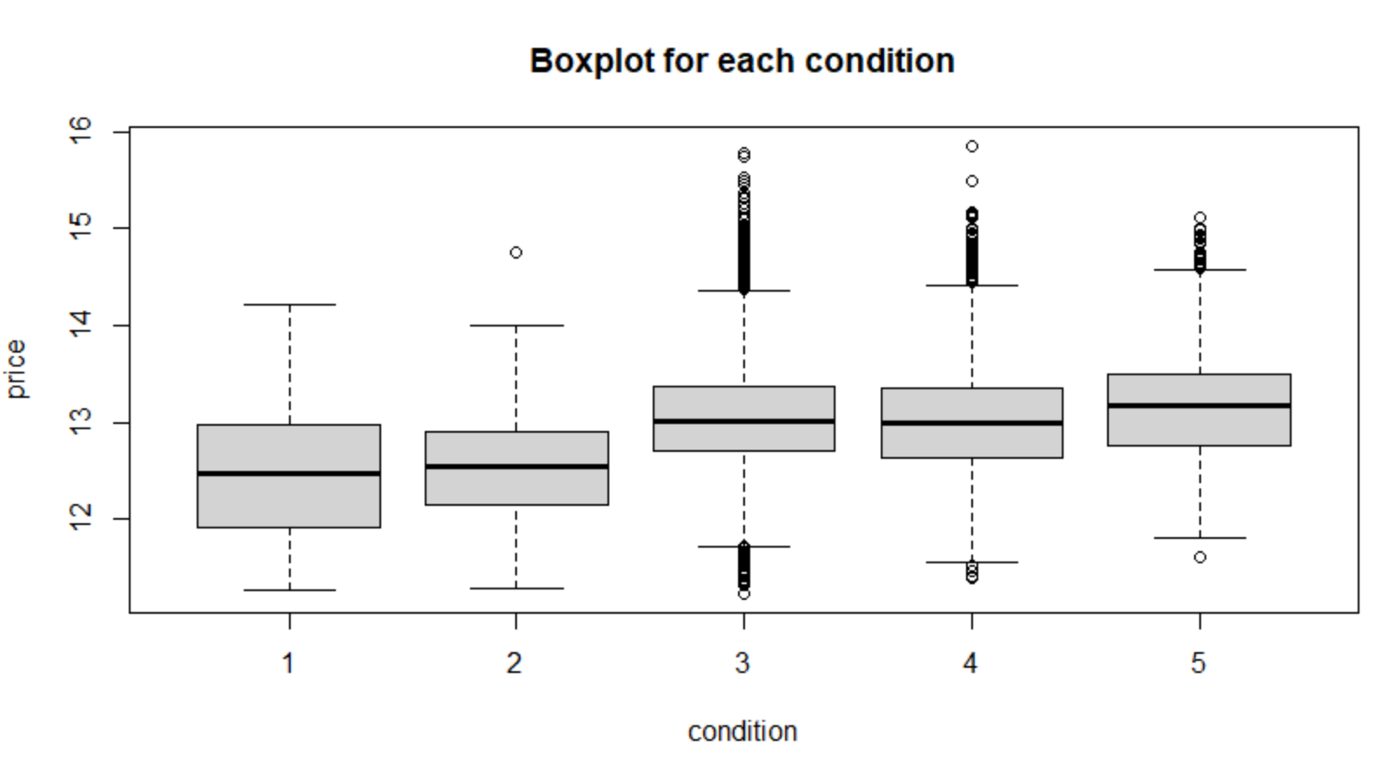

f.

pairs(price~sqft_above+sqft_living+sqft_living15, data = new_DF)

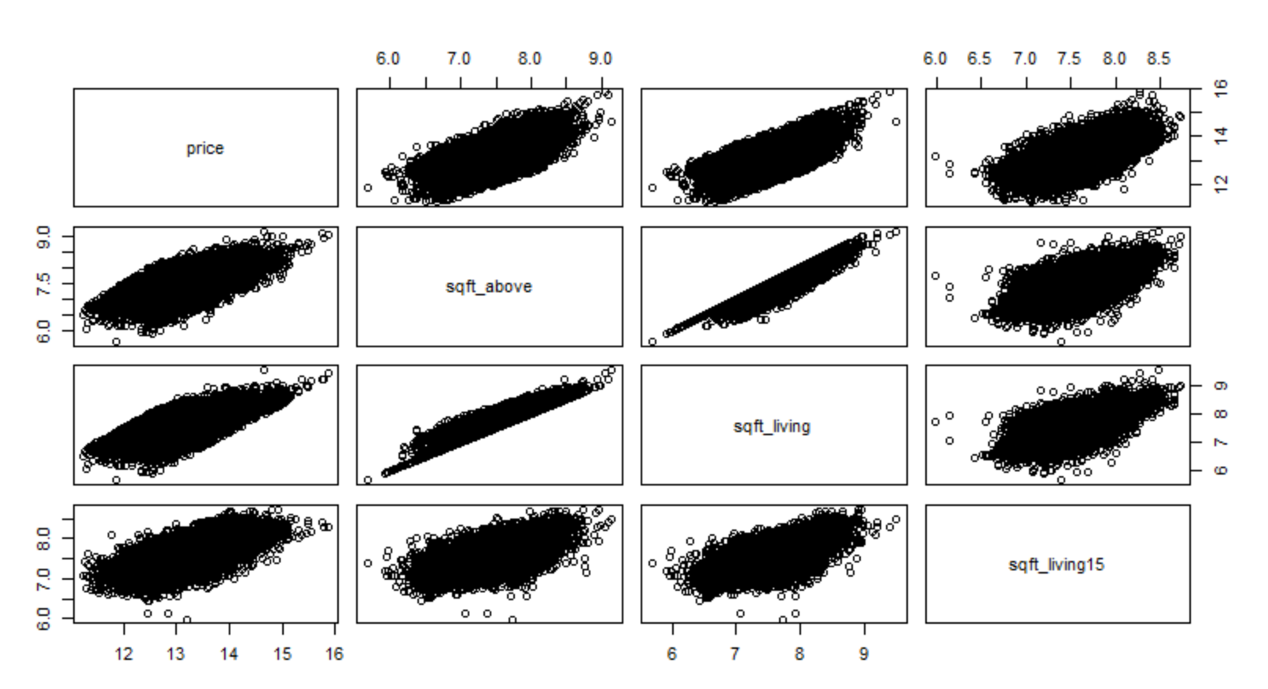

4a.

mulfit <- lm(price~sqft_above+sqft_living+sqft_living15+floors+condition , data = new_DF)

mulfit

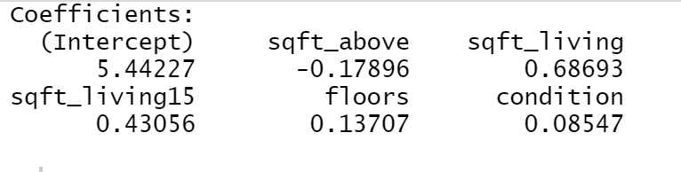

Mô hình:

price = 5.44227 – 0.17896(sqft_above) + 0.68693(sqft_living) + 0.43056(sqft_living15) + 0.13707(floors) + 0.08547(sqft_living)