|  |  |
| --- | --- |
| **Practicum Case** |  |
| COMP6175  Object Oriented Programming |
| **Computer Science** | **E201-COMP6175-LI01-07** |
| ***Valid on*** *Even Semester Year 2019/2020* | **Revision 00** |

## Learning Outcomes

* The additional features of OOP
* A program using additional features of OOP

## Topic

* Inheritance

## Subtopics

* Introduction to Inheritance
* Superclass and Subclass
* Subclass Feature
* Final Class
* Super Keyword
* Class Relationship (Composition and Aggregation)

## Soal

*Case*

**ABC Employee Data**

**ABC Company** is a new company that has just accepted many part-time and full-time employees. To manage their employee list, they ask you to make a program to help them manage the list using **Java programming language** with Object-Oriented Programming concepts such as **Encapsulation** and **Inheritance**.

* The program will consist of **4 menus**:

1. Add employee
2. View employee
3. Resign
4. Exit

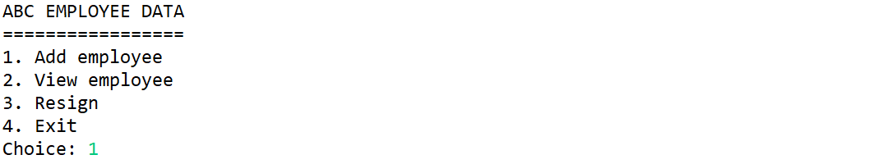

* If the user input 1, then:
* This menu will ask the user to input information regarding the employee, which consists of:
* **Employee’s name**, which **length** must be **more than 3 characters**
* **Employee’s age**, which must be **more than 17**
* **Employee’s role**, which must be **between** “**Assistant**” and “**Programmer**” (**Case Sensitive**)
* **Employee’s type**, which must be **between** “**PartTime**” and “**FullTime**” (**Case Sensitive**)

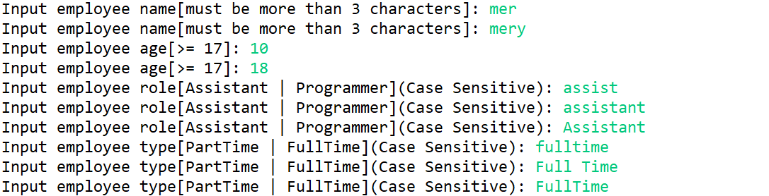

* If the user chose employee typeis “**PartTime**”, then the user needs to input the following information:
* **Employee’s pay per hour**, which must be **more than 10000**
* **Employee’s working hour per week**, which must be **more than 0**

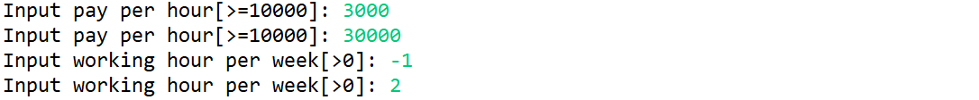

* If the user chose employee typeis “**FullTime**”, then the user needs to input the following information:
* **Employee’s base salary**, which must be **more than 10000**



* After all required input has been filled, the program will automatically set the **employee’s status** to **active**, then **add the input to a vector/array** list and showsuccess messageto the user



* If the user input 2, then:
* If the employee list is **empty**, the program will show the message“**There is no employee data in the list**”to the user



* Otherwise, the program will **show** all employee from the list

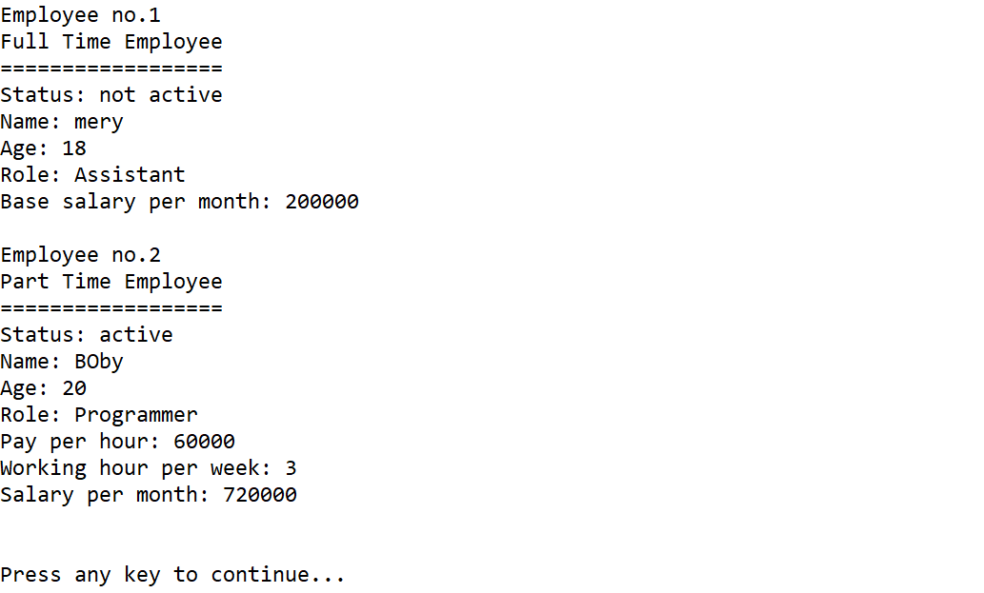

* If the user input 3, then:
* If the employee list is **empty**, the program will show the message“**There is no employee data in the list**”to the user



* Otherwise, the program will:
* **Show** all employee from the list
* Ask the user to input **the employee’s number** that wants to resign, which the **employee’s number must be between 1 – count of employee**

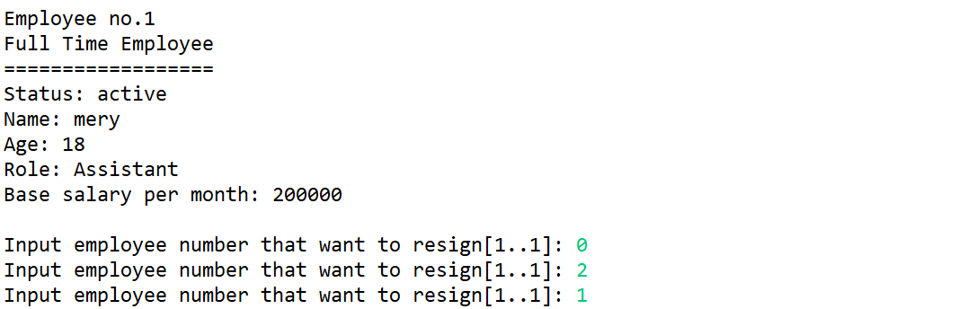

* The program will check whether the **employee’s status** is **active** or **not active** first
* If the **employee’s status** is **not active** already, then show the message “**Employee has already resigned!**”



* If the **employee’s status** is still **active**, then change the **employee’s status** to **not active** and showthe message as below



* If the user input 4, then the program will be closed

**Please ask your teaching assistant if there are any related questions.**