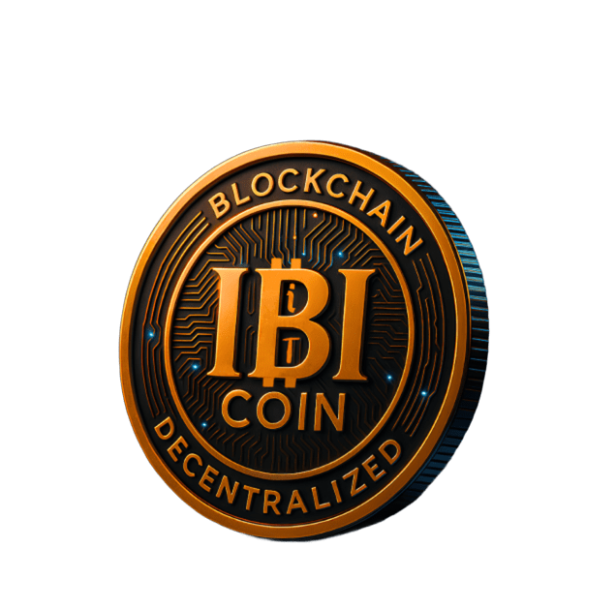
IBITIcoin – Business Plan v2.0 (2025–2026)

1. Executive Summary
IBITIcoin (IBITI) is a DeFi-oriented token on BNB Smart Chain (BEP-20, 8 decimals) with a modular on-chain architecture: staking, NFT-based discounts, dynamic fees, vesting, DAO voting and cross-chain bridge support.
The project is already live on BSC with a verified token contract and a public liquidity pool on PancakeSwap. The goal for 2025–2026 is to turn IBITI from a single token + DEX listing into a full ecosystem: staking, NFT marketplace, referral programs and a transparent on-chain treasury.
This document is a business plan, not an investment prospectus. It describes what exists now, what we plan to build next, and how the project can become sustainable.

2. Problem & Opportunity
Current crypto reality:
- Most retail users face complex DeFi UX and opaque tokenomics.
- Projects often launch tokens first and business logic “someday later”.
- Treasury and fee flows are usually unclear, which scares serious users and partners.
Opportunity for IBITIcoin:
- Provide a simple, visible on-chain structure (fee manager, staking, NFTs, DAO, treasury) that can be verified on BscScan.
- Focus on transparent treasury management and predictable rules instead of hype.
- Use NFTs and staking not just as “bling”, but as mechanisms to manage discounts, loyalty and access.

3. Product & Ecosystem Overview

3.1 Core token
- Network: BNB Smart Chain (BEP-20)
- Symbol: IBITI
- Decimals: 8
- Contract address (BSC mainnet): 0x47F2FFCb164b2EeCCfb7eC436Dfb3637a457B9bb
- Total supply: 100,000,000 IBITI (fixed in the contract)

3.2 Deployed & implemented modules (smart contracts)
Module | Purpose | Status (Q4 2025)
IBITIcoin | Core BEP-20 token, fee hooks, treasury logic | Deployed on BSC
FeeManager | Dynamic buy/sell fees, activity tiers, discounts | Implemented, ready
StakingModule | Fixed-term staking (1–12 months) | Implemented, to deploy
NFTDiscount | NFT-based fee/price discounts | Implemented, to deploy
IBITINFT | NFT collection for discounts / rewards | Implemented, to deploy
PhasedTokenSale | Initial phased sale logic | Completed (historical)
TeamVesting | Linear vesting for team/partners | Implemented, optional
UserStatusManager | On-chain user tiers (volume, behavior, NFTs) | Implemented
BuybackManager | Buyback & burn / treasury operations | Implemented
NFTSaleManager | NFT primary sale via IBITI/USDT | Implemented
DAOModule | Proposals & on-chain voting | Implemented, to enable
BridgeManager | Future cross-chain bridge coordination | Implemented (no bridge)
We do not promise that every module will be launched at once; deployment will be staged, based on audits, gas costs, and real usage.

4. Current State (Reality Check)
As of now:
- IBITI token is live and tradable on BSC.
- An IBITI/USDT pair exists on PancakeSwap (v2) and is the primary liquidity pool.
- The main supply is held by the token contract and treasury wallets. On-chain data (holders, volume, liquidity) is publicly visible on BscScan and PancakeSwap.
- The old sale phases and early experimental contracts are deprecated and not used in the current economics.
We do not claim:
- Any guaranteed APY or fixed “price targets”.
- Any centralized revenue or profit sharing at this stage.
- Any CEX listings or partnerships until they are actually signed.

5. Token & Treasury Model

5.1 Supply
- Max supply: 100,000,000 IBITI
- Minting: One-time mint in the token constructor; no further inflation.
- Burns: Possible via buyback/burn logic and manual transfers to dead address.
We don’t include fictional allocation pie charts here. Actual token distribution can be tracked directly on BscScan:
- Token contract: 0x47F2FFCb164b2EeCCfb7eC436Dfb3637a457B9bb
- Liquidity pool(s): visible via PancakeSwap/BscScan “Holders” and “DEX trading” pages.

5.2 Treasury (Kazna)
The treasury is the on-chain set of wallets/contracts controlled by the project’s multi-sig / owner for:
- Liquidity support (LP tokens, buyback buffers)
- Development & infrastructure costs
- Marketing & partnerships
- Future grants / ecosystem incentives
We intentionally do not put fake dollar amounts here. The plan:
- Treasury addresses are published on the website and in the docs.
- All movement from treasury wallets is visible on-chain.
- Over time, DAO proposals will govern major treasury decisions.

6. Business Model & Revenue Streams
IBITI itself is a utility token within the ecosystem, not a share in a legal entity. The project can generate value and sustainable cash flow via:
Stream | Description
DEX trading fees (indirect) | Part of fees can flow into treasury via FeeManager and BuybackManager.
Staking spread | Share of staking / early-unstake penalties accumulates in the treasury.
NFT primary sales | Users buy discount NFTs; part goes to treasury, part to reward pools.
NFT royalties (if enabled) | Secondary trading fees on NFT marketplaces.
B2B integrations | Custom solutions (discount tokens, loyalty NFTs) for partner businesses.
Bridge / infra fees (later) | Fees for cross-chain operations, if bridge goes live.
Nothing here is guaranteed income. These are potential revenue channels, depending on adoption.

7. Product Components (User-Facing)
Already available or in active development:
- Public website: ibiticoin.com
  - Landing page, blog, news, roadmap
  - Investment calculator, token info, docs
- DeFi frontends:
  - Link to IBITI/USDT pool on PancakeSwap
  - Shop page (IBITI & NFT purchase UX)
  - Staking dashboard (front-end wired to StakingModule)
  - NFT gallery (discount NFTs and lore NFTs)
- Community channels:
  - Twitter / X
  - Telegram group
  - Other social channels (Instagram, Facebook) for announcements

8. Go-to-Market & Growth

8.1 Target users
- DeFi users on BNB Chain who want a smaller, transparent project with visible on-chain mechanics.
- Early adopters interested in NFTs that give real, measurable discounts in the ecosystem (fees, prices, access).
- Partners: small crypto projects or businesses that need tokenized discounts / loyalty / access but don’t want to build it from scratch.

8.2 Growth strategy (2025–2026)
- PancakeSwap & DeFi discovery
  - Maintain healthy initial liquidity and fair volatility.
  - Encourage organic trading rather than pump/dump campaigns.
- Staking & NFT rollout
  - Enable staking first with conservative reward rates and clear penalty rules.
  - Gradually open NFT discount sales, starting with low supply and clear utility.
- Content & transparency
  - Regular tech and treasury updates (blog, GitHub, Twitter).
  - Clear, public roadmap and release notes.
- Partnerships
  - Target a small number of real partners (integrations, co-marketing), not spammy “100 partnerships”.

9. Roadmap (High-Level, Non-Fantasy)
We keep this realistic and aligned with what is already in progress.

Q4 2025
- Token and LP live on BSC (DONE).
- Public website and basic dApps online (DONE / ongoing).
- First round of external code review / light audits (IN PROGRESS).

2026
- Staking launch:
  - Enable StakingModule with 1–12 month terms and transparent APR formulas.
  - Connect staking frontend to mainnet contracts.
- Discount NFT rollout:
  - Launch IBITINFT discount series with clear on-chain discount logic via NFTDiscount.
  - Integrate NFT discounts into FeeManager and shop.
- DAO & governance (alpha):
  - Launch DAOModule for basic proposals (parameters, treasury moves).
  - Start with advisory voting, then gradually increase weight.
- Bridge & multi-chain (research stage):
  - Evaluate safe options to connect IBITI liquidity to one additional chain.
  - Only proceed after audits and risk analysis.
Dates above are targets, not legal commitments. Shipping priority always goes to security and correctness over speed.

10. Organization & Governance

10.1 Project structure
- Core development: responsible for smart contracts, infrastructure, and security.
- Frontend & product: website, dashboards, UX, integrations.
- Operations: community, partnerships, legal and compliance coordination.
At this stage, IBITIcoin operates effectively as a founder-led project with the intention to move towards a DAO-supported model over time.

10.2 Governance evolution
- Phase 1 – Founder-led, transparent
  - All key upgrades and treasury moves are initiated by the core team.
  - Public updates and explanations via site and socials.
- Phase 2 – Hybrid governance
  - DAO proposals for parameter changes and non-critical treasury actions.
  - On-chain voting with IBITI and, over time, NFT-based roles.
- Phase 3 – Strong DAO
  - Multi-sig and time-locked control of key contracts.
  - Most strategic decisions passed through on-chain votes.

11. Risk Factors
Key risks (non-exhaustive):
- Smart contract risk: bugs, vulnerabilities, economic exploits. We mitigate via gradual rollout, audits and limited permissions.
- Market risk: low liquidity, high volatility, low adoption. No one can guarantee token price behavior.
- Regulatory risk: crypto legal frameworks differ by jurisdiction and may change.
- Operational risk: team bandwidth, infrastructure failures, dependency on third-party services (RPCs, DEXes, bridges).
Users and potential partners must not treat IBITI as a guaranteed income product. Always do your own research and consult independent advisors.

12. Legal & Licensing
- Smart contract code: published under the MIT License (see LICENSE in the repository). This allows others to read, audit, reuse or fork the contracts, but does not grant any rights to the IBITI brand or logo.
- Brand assets (name “IBITIcoin”, ticker “IBITI”, logo, website design, NFT art): protected as project IP. Reuse is allowed only with explicit permission. Details are in LICENSE_TECHNOLOGY.md and LICENSE_OVERVIEW.md.
- This business plan is not:
  - an offer of securities,
  - financial advice,
  - a guarantee of profit or token price.
Each jurisdiction has its own rules; users are responsible for complying with their local laws.

13. Contacts
Project name: IBITIcoin
Website: https://ibiticoin.com
Token contract (BSC): 0x47F2FFCb164b2EeCCfb7eC436Dfb3637a457B9bb
Founder / project lead:
Volodymyr Podkorytov
Official email:
info@ibiticoin.com

