1.找到已有的数据表excel表格,格式如下

**第一行为表名信息**

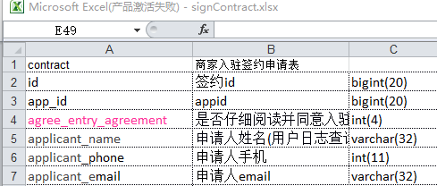

2.打开powerdesign的tools中的execute commands下面的run scripts,输入以下内容

|  |
| --- |
| Option Explicit  Dim mdl ' the current model  Set mdl = ActiveModel  If (mdl Is Nothing) Then  MsgBox "There is no Active Model"  End If    Dim HaveExcel  Dim RQ  RQ = vbYes 'MsgBox("Is Excel Installed on your machine ?", vbYesNo + vbInformation, "Confirmation")  If RQ = vbYes Then  HaveExcel = True  ' Open & Create Excel Document  Dim x1 '  Set x1 = CreateObject("Excel.Application")  x1.Workbooks.Open "C:\Users\Administrator\workspace\moses\documents\design\merchants\db\merchants_contract.xlsx"  x1.Workbooks(1).Worksheets("Sheet1").Activate  Else  HaveExcel = False  End If  a x1, mdl  sub a(x1, mdl)  dim rwIndex  dim tableName  dim colname  dim table  dim col  dim count  'on error Resume Next  For rwIndex = 1 To 62 step 1  With x1.Workbooks(1).Worksheets("Sheet1")  'MsgBox "生成数据表结构共计 1 ="+CStr(.Cells(2,2).Value ), vbOK + vbInformation, "表"  If .Cells(rwIndex, 1).Value = "" Then  Exit For  End If  If .Cells(rwIndex, 3).Value = "" Then  set table = mdl.Tables.CreateNew  table.Name = .Cells(rwIndex , 1).Value  table.Code = .Cells(rwIndex , 2).Value  count = count + 1  Else  colName = .Cells(rwIndex, 1).Value  set col = table.Columns.CreateNew  'MsgBox .Cells(rwIndex, 1).Value, vbOK + vbInformation, "列"  col.Name = .Cells(rwIndex, 1).Value  'MsgBox col.Name, vbOK + vbInformation, "列"  col.Code = .Cells(rwIndex, 1).Value  col.Comment = .Cells(rwIndex,2).Value  col.DataType = .Cells(rwIndex, 3).Value    End If        End With  Next  MsgBox "生成数据表结构共计 " + CStr(count), vbOK + vbInformation, "表"  Exit Sub  End sub |

**记得修改里面的红色部分为自己的excel表格路径,及sheel目录名**

3.执行Run