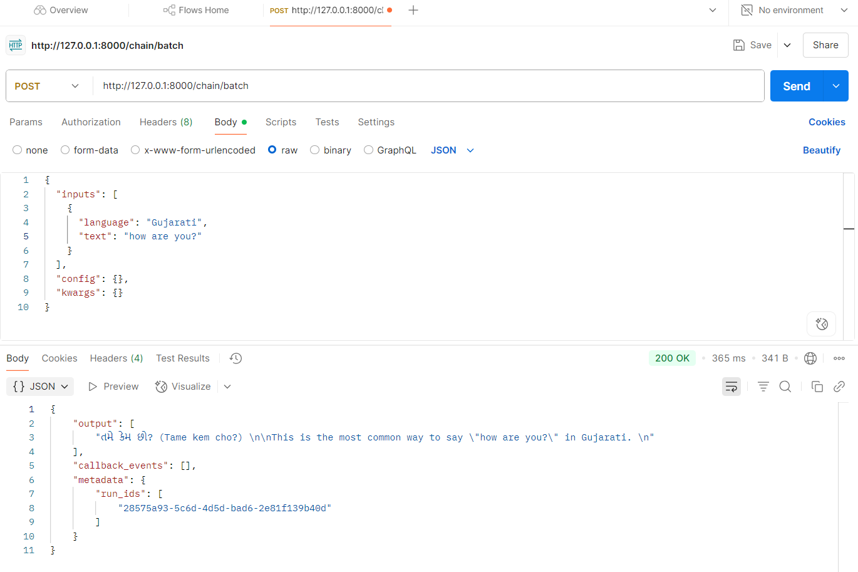

I tested the LangChain Translation API using Postman and successfully invoked the /chain/invoke endpoint. The API accurately translated input text into the specified language, returning clear and natural translations. The FastAPI interactive docs at /docs were helpful for exploring the available endpoints. Overall, the API worked smoothly with the Groq model integration.