DELL POWEREDGE R770 · Semantic Router · Vector Path

INFRASTRUCTURE · AI COST
Cutting cloud AI bills in half with a single rack server
A short walk through how we did it, what we tested, and what the savings look like over five years.
50%  lower inference cost than frontier-only | 97%  of 7,680 graded responses rated Adequate | $1.3M  saved yearly at 1M queries / day | ~4 mo  payback at 100K queries / day

Most production AI traffic does not need a frontier model. Factual lookups, short summaries, routine code questions, and quick translations make up the bulk of what real users ask, and a much cheaper model handles all of it without anyone noticing. The problem is that most AI stacks pick a model once, in application code, and end up paying the frontier rate on every single prompt forever after.
We took a different approach. A Dell PowerEdge R770 sits between the application and the model fleet. It reads each incoming prompt, decides which model is the right fit, and forwards the request. The application keeps making the same OpenAI-compatible API calls it makes today. The expensive frontier model still answers the queries that need it. Everything else lands on something cheaper. None of the application code changes.
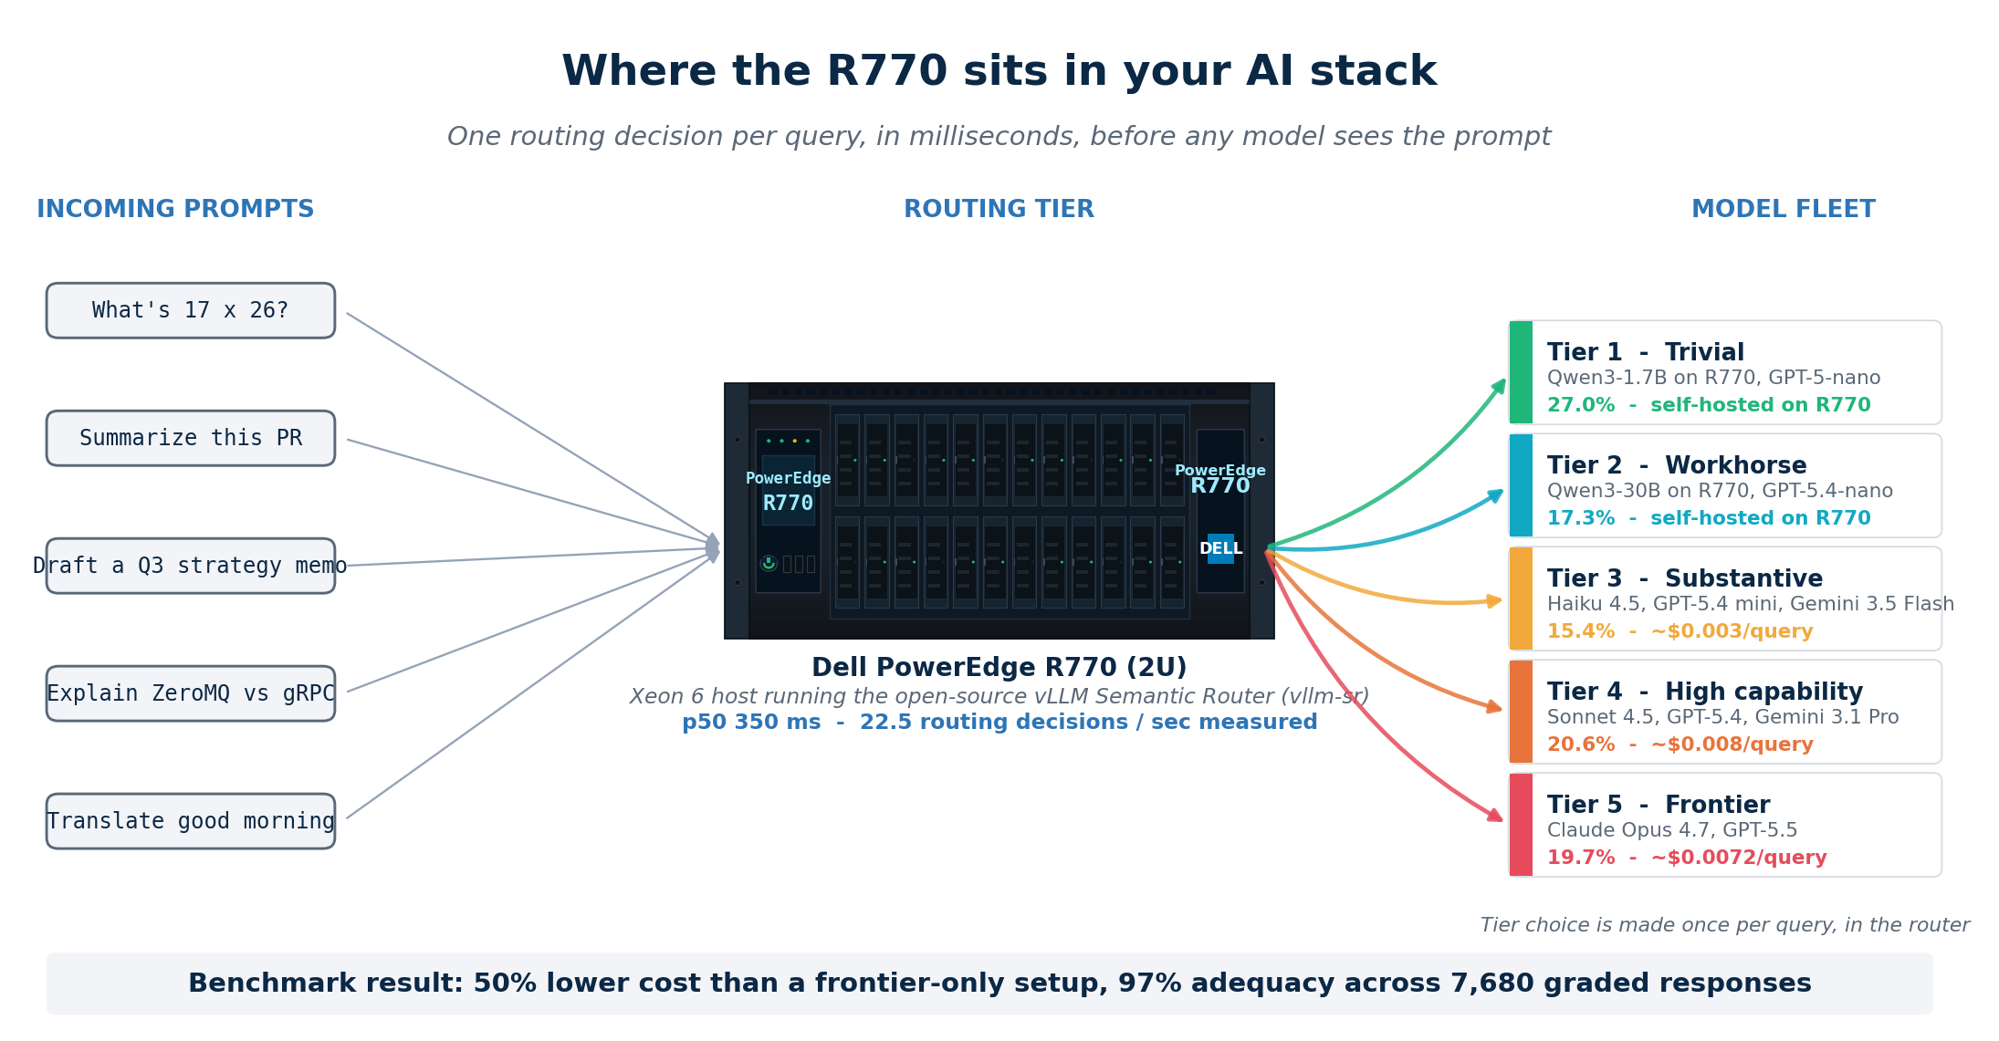
How the routing works
The routing software is vllm-sr, an open-source project from the vLLM community. It runs in Docker behind an Envoy proxy and exposes one OpenAI-compatible endpoint, so the application sees the router the same way it would see any other LLM provider.
There is no training step. We hand the router a small set of example prompts: roughly a dozen hard ones (multi-step reasoning, deep domain expertise, original argument construction) and a dozen easy ones (definitions, single-step math, simple lookups), plus a few archetypes for the tiers in between. When a new prompt comes in, the router scores it by semantic similarity against those examples, combines that score with a couple of simple structural signals like length and presence of code, and maps the result to a tier through threshold cutoffs we set ourselves. The whole configuration lives in one YAML file. Adding a new model takes a single edit and a restart.
What we tested
We ran 797 production-shaped queries through the setup. The query set spanned the full complexity range, from arithmetic and translation at the easy end to multi-domain analysis and long-form synthesis at the hard end. Five tiers of models handled the routed traffic. Tiers 1 and 2 ran a self-hosted Qwen3 stack on the R770 itself. Tiers 3, 4, and 5 ran on cloud APIs, finishing with Claude Opus 4.7 and GPT-5.5 at the frontier.
After each query was answered, two independent LLM judges (Claude Sonnet 4.6 and GPT-5.5) scored the response against the frontier-model reference on four dimensions: correctness, completeness, fitness for purpose, and soundness. Across 7,680 graded responses, 97% came back Adequate. Even on the queries routed to the cheapest tiers, the routed answer matched the frontier reference more than 96% of the time. Under-routing, where the router sent a query to a tier that could not handle it, happened in less than 1% of cases.
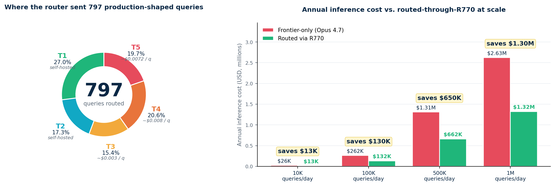
What this is worth over five years
The savings scale linearly with traffic. At 100,000 queries per day, the routed setup costs about $132,000 a year against $262,000 for a frontier-only baseline. The gap widens as volume grows. Over a five-year horizon, the numbers look like this:

Queries per day | Annual savings | 5-year savings | Hardware payback
100,000 | $130,000 | $650,000 | ~4 months
500,000 | $650,000 | $3.25 million | ~3 weeks
1,000,000 | $1.3 million | $6.5 million | ~2 weeks

A configured R770 lands in the $35,000 to $50,000 range depending on memory and storage choices. At 100,000 queries a day, that capital cost pays back in roughly four months. At higher volumes the payback is measured in weeks. After that, the savings drop straight to the bottom line, year after year, with no per-query routing fee or ongoing software license.
If you want to see what this looks like on your own traffic, the dataset, the routing configuration, and the harness are all open. Send us a note and we can scope a two-week pilot on your workload.

