

Blog Post

Most AI Queries Do Not Need a Frontier Model
Stop paying as if they do. Right-size every query on a Dell PowerEdge R470 / R770.

PowerEdge R470 / R770
Efficient on-prem model routing

Powered by Intel® Xeon® 6 |  | 
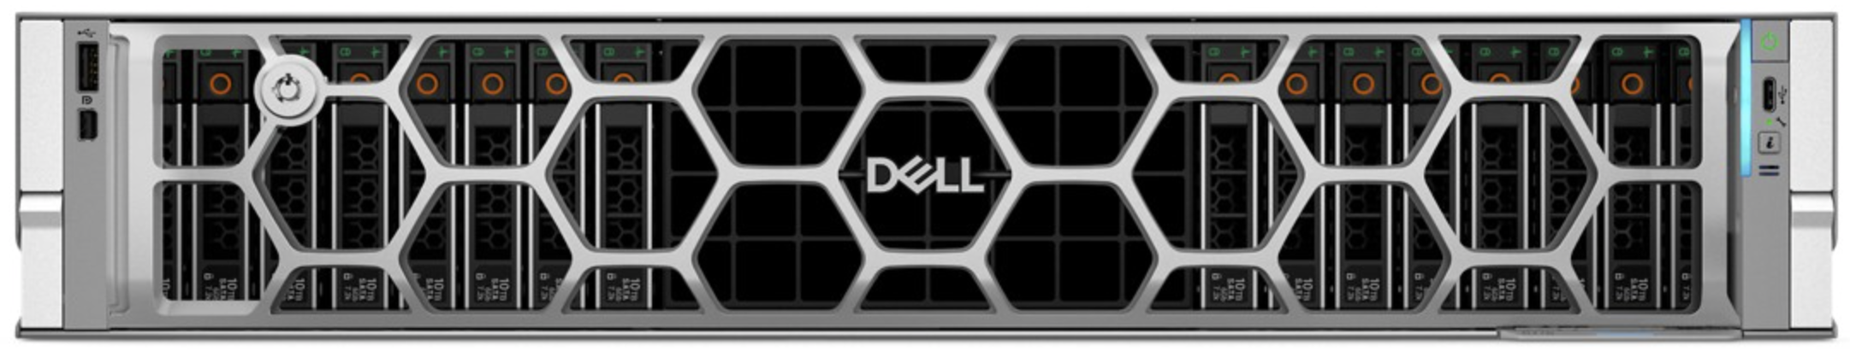

 | Up to  58%  Lower AI Cost
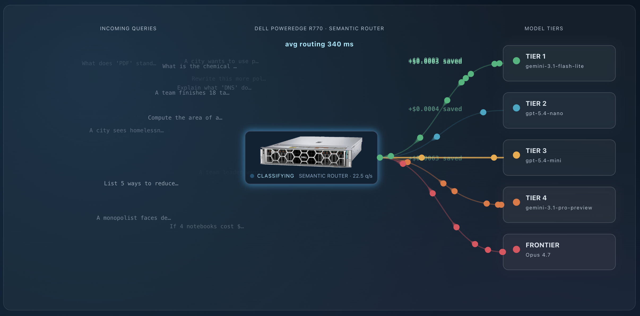
Most AI queries do not need a frontier model. A definition, a unit conversion, a quick rewrite: a small model nails these for a fraction of a cent. Send them all to a frontier model and you pay frontier prices for trivial work. A Dell PowerEdge R470 / R770 sits in front of your AI stack, classifies every query in milliseconds, and forwards it to the cheapest tier that can answer it well.

Right-size every query
Five tiers, from a small fast model up to a frontier model. The router reads each prompt, scores its difficulty, and sends it to the cheapest tier that fits. Trivial questions go cheap. The few that genuinely need frontier reasoning still get it. The user gets the same answer quality, at a fraction of the blended cost.

The proof is measured, not marketing
These numbers come from a real 800-query benchmark: actual routing decisions, actual answers, actual judge verdicts. Two independent LLM judges graded every routed answer against the frontier model. The smaller tier matched the frontier on 98 percent of queries, while cutting cost by up to 58 percent. At 300,000 queries a day, that is roughly $241,000 saved per year.
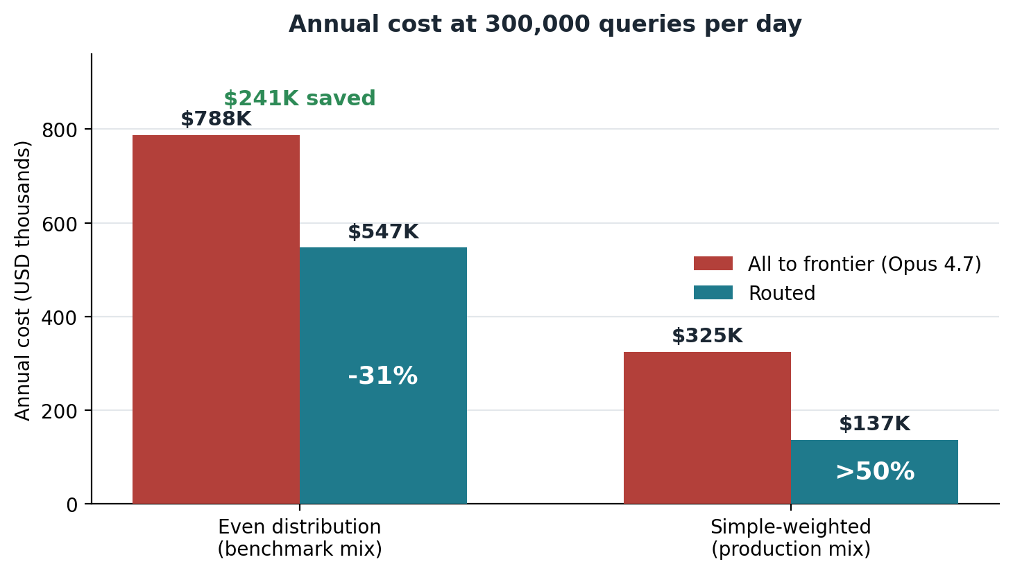

One server orchestrates the whole stack
No GPUs, no models hosted on-prem. The router runs on a single Dell PowerEdge R470 / R770 with Intel Xeon 6 and Intel AMX, in front of your existing cloud model APIs. Every prompt passes through hardware you control, so it is also where you log, inspect, and govern traffic before it leaves your network. Drop it in front of your frontier model, add the cheaper tiers, and let the easy majority of traffic flow to the smaller models while the frontier model keeps handling the rest.

See it in action
Watch queries get routed in real time, replay the benchmark dataset, and price your own daily volume against current supplier rates in the live demo. Right-size every query, and pay for the answer you actually need.
 | 
Learn more about Dell solutions. | Contact a Dell Technologies Expert. | Join the conversation.
© 2026 Dell Inc. or its subsidiaries. All rights reserved. Dell Technologies, Dell, and other trademarks are trademarks of Dell Inc. or its subsidiaries. Other trademarks may be trademarks of their respective owners.



