

White Paper

Right-Sizing the Model to the Question
An on-prem semantic router for cloud model APIs

PowerEdge R470 / R770
Efficient on-prem model routing

Powered by Intel® Xeon® 6 |  | 
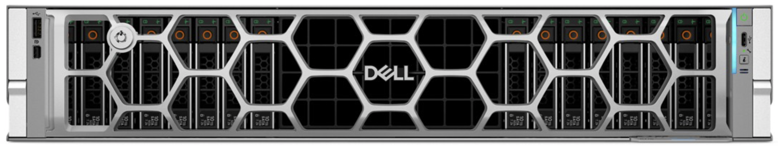

 | Up to  58%  Lower AI Cost

1. Executive summary
Most production traffic to a large language model is easy. A user asks for a definition, a unit conversion, or a quick rewrite. A small fraction is hard: a multi-step proof, or a synthesis that spans several domains. When every request is sent to a single frontier model, the easy questions are answered at the same price as the hard ones. That price gap is the waste a semantic router removes.
A semantic router reads each incoming prompt, estimates how much capability it needs, and forwards it to the smallest model that can answer it well. Trivial questions go to a small, inexpensive model, and the few that genuinely need a frontier model still get one. Answer quality stays the same on a per-question basis while the blended cost falls sharply.
This paper documents a working five-tier router built on the open-source vLLM Semantic Router, run as an on-prem appliance on a single Dell PowerEdge R470 or R770 placed in front of your cloud model APIs. No models run on the box; it only classifies each prompt and forwards it to the chosen cloud model. Because every prompt passes through hardware you control, the appliance is also where you can log, inspect, and apply policy to traffic before it leaves your network. It was measured on a 797-query benchmark spanning trivial lookups to frontier-grade synthesis, with every routed answer scored by two independent LLM judges.
The headline findings:
- The smaller model held up as well as the frontier 98 percent of the time, assessed by two independent LLM judges. The under-routed tail can be re-submitted to the frontier model.
- At least 31 percent lower cost than sending every query to the frontier model, roughly $241,000 a year at 300,000 queries per day.
- 355 millisecond mean routing latency at a sustained 22.5 queries per second.

2. The problem and its economic impact
Frontier models are priced for the most demanding requests. Each tier costs several times the one below it, so a frontier model runs one to two orders of magnitude more than the smallest. Because real traffic is skewed toward the easy end, a deployment that sends everything to the frontier pays the top rate on the large majority of requests that never needed it. A router removes that overpayment by sending each query to the smallest model that can handle it.
The effect is clearest at scale. At 300,000 AI queries per day, routing rather than sending everything to the frontier model produces the annual savings below, shown for two traffic profiles.
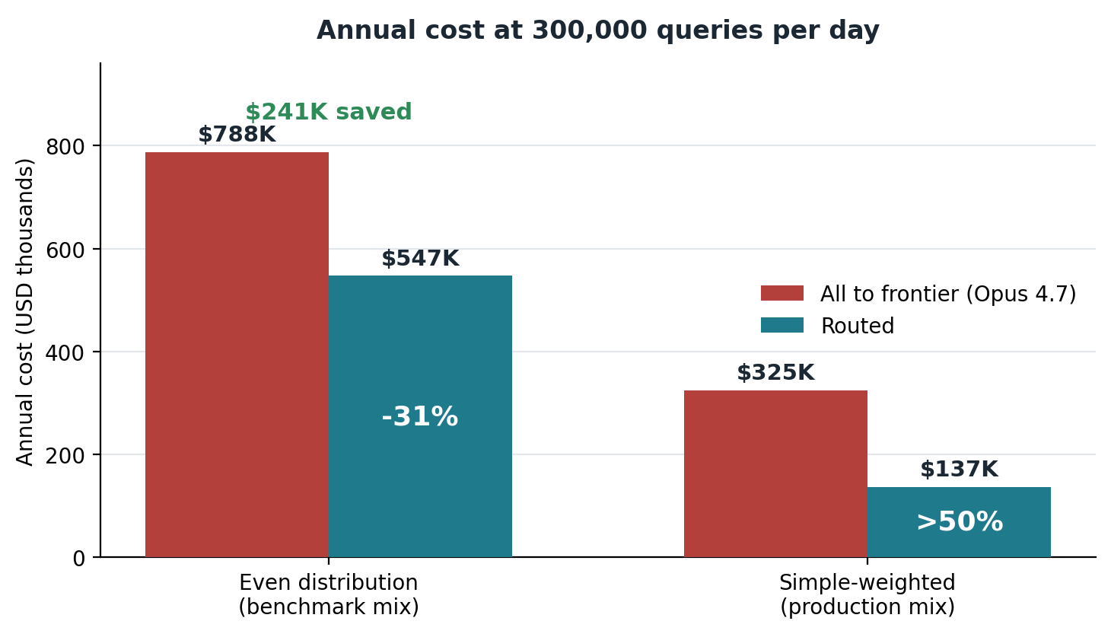
Figure 1. Annual cost at 300,000 queries per day: routing versus sending every query to the frontier model, for two traffic profiles. The routed bar is always compared against the all-frontier cost for that same profile.
We ran a deliberately more demanding benchmark that spreads queries evenly across the difficulty bands, which exercises the router across its whole range. On that profile, routing could cut annual cost from about $788,000 to about $547,000: a saving of about $241,000, or 31 percent. This projects the measured per-query costs to production scale to show the longer-term impact.
As a second comparison, real-world workloads are often easier than this benchmark and consist mostly of simple questions with only a thin tail of hard ones. In this scenario, the savings would rise to more than half. Absolute costs would be less than the even distribution because the simpler queries would result in shorter answers with less overall token cost.
Savings scale with the number of users. At roughly fifty AI queries per active user on a working day, a rate consistent with published enterprise-assistant usage, 300,000 queries a day is about 6,000 active users. The table shows how the same per-query saving scales with organization size.
Organization | Active users | Queries / day | Annual saving
Office Deployment | 200 | 10,000 | $8K
Department | 1,000 | 50,000 | $40K
Mid-size company | 6,000 | 300,000 | $241K
Large enterprise | 20,000 | 1,000,000 | $803K

Each row assumes fifty AI queries per active user per workday; heavier usage reaches the same volumes with fewer users. Savings scale linearly with total query volume, so any organization can read its own figure off the curve below.
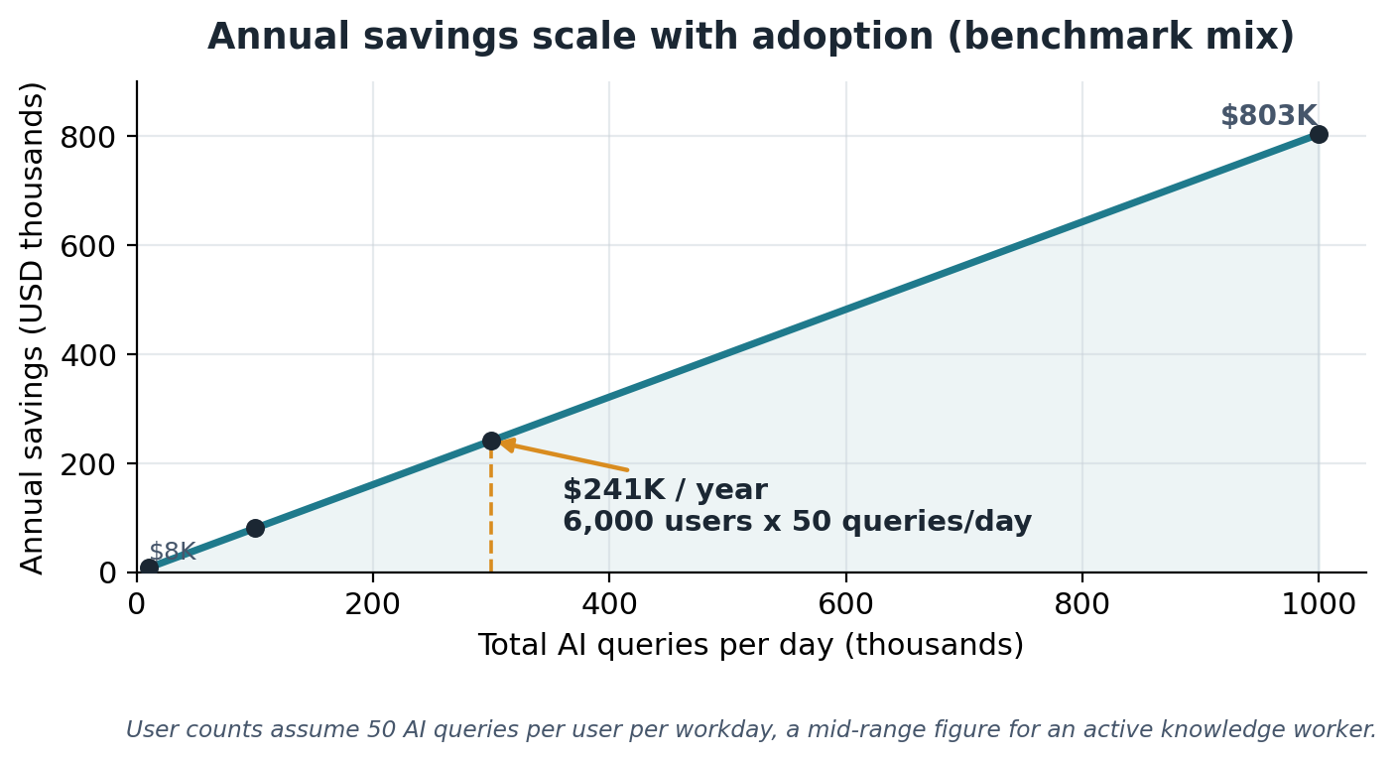
Figure 2. Annual savings against total daily query volume, on the benchmark mix. The marked point is 300,000 queries per day, about $241,000 per year, which at fifty queries per user per day corresponds to roughly 6,000 active users. Savings rise linearly with volume.

3. What semantic routing is, and why it helps
Semantic routing is the practice of choosing which model answers a request based on the meaning and difficulty of the request itself, rather than sending every request to one fixed model. A lightweight classifier reads the prompt, places it on a difficulty scale, and dispatches it to the model tier that matches. The classifier is small and cheap to run, so the routing decision adds little cost or delay while redirecting the expensive work only where it is warranted.
The idea is well supported in the research literature, and the reported savings are large and consistent across independent groups.
RouteLLM, from LMSYS and UC Berkeley, framed routing as a learned choice between a strong, expensive model and a weak, cheap one. Trained on preference data, their routers reached 95 percent of strong-model quality on MT-Bench while sending only 26 percent of queries to the strong model, and with judge-augmented training only 14 percent, a roughly 75 percent reduction in strong-model calls. Across public benchmarks they reported cost reductions of more than two times with no measurable loss in response quality.
The vLLM Semantic Router, introduced by Red Hat and the vLLM community in 2025, brings the same idea to the open inference stack with an intent-and-complexity classifier built on a compact encoder model. Their published MMLU-Pro benchmarks report accuracy on complex tasks improving by 10.2 percent while latency and token usage fell by 47.1 and 48.5 percent respectively. In their reasoning-effort experiments, automating how hard the model thinks cut average token usage to about 20 percent of the original, a five times saving, at equal accuracy.
Other groups report the same direction of effect. Anyscale's published router work and several commercial routing studies describe quality held near frontier levels while the share of frontier calls, and therefore cost, drops by well over half. The common thread is that difficulty is unevenly distributed across real traffic, so a classifier that respects that distribution captures most of the savings without sacrificing the answers that matter.
Two design points explain why the savings do not come at the expense of quality. First, the easy questions that get demoted to a small model are exactly the questions a small model answers correctly, so demoting them costs nothing in quality. Second, the router is tuned to err upward on genuinely ambiguous cases, so the rare hard question that looks easy is still likely to reach a capable tier. The savings come from the large, confidently-easy majority, not from gambling on the hard minority. And on the rare occasion a hard question is under-routed, the user's follow-up escalates it to a higher tier, so the cost of a miss is a second pass rather than a wrong answer.

4. How semantic routing works, and how vLLM-SR works specifically

4.1 The general pipeline
Every semantic router performs four steps on each request. It extracts signals from the prompt, combines those signals into a single difficulty estimate, maps that estimate to a destination tier, and forwards the request to a model in that tier.
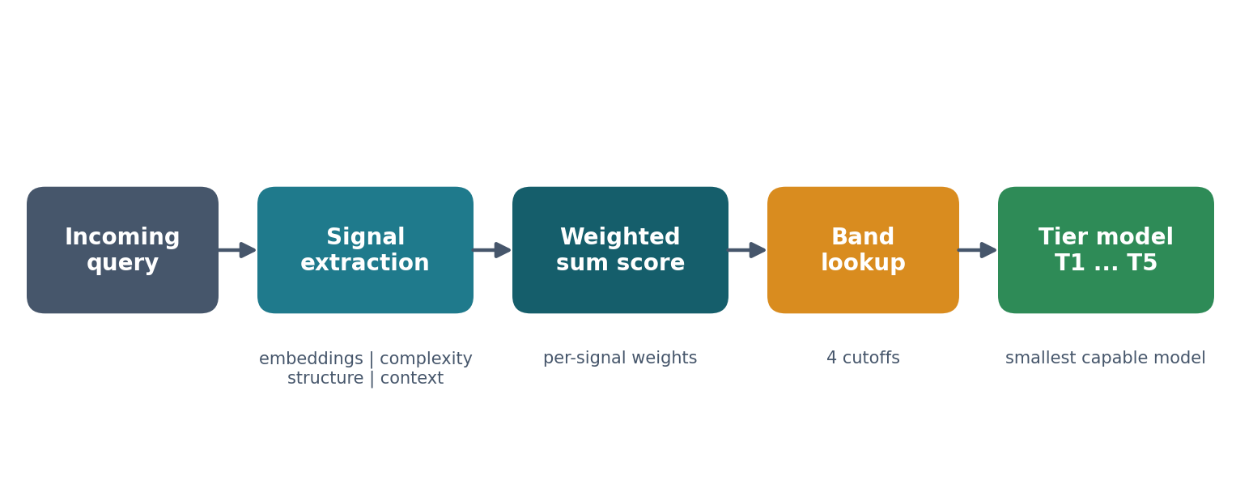
Figure 3. The routing pipeline. Signals extracted from the prompt are combined into one difficulty score, the score is mapped to a tier band, and the request is forwarded to the smallest capable model.
Signals come in several kinds. Embedding signals measure semantic similarity between the prompt and banks of example prompts, so a question that resembles known hard questions scores high. Complexity signals use a contrastive classifier that compares the prompt against a hard bank and an easy bank and reports the margin between them. Structure signals are mechanical and deterministic: prompt length in words, presence of a code block, presence of a numbered list. Context signals capture conversational state. Each signal contributes a weighted amount to the difficulty score, and the weights are where an operator encodes judgment about what makes a query hard.

4.2 How vLLM Semantic Router implements it
The vLLM Semantic Router is delivered as an Envoy proxy with an external processing service. Envoy sits in front of the model backends and, for every request, calls out to the router process, which runs the classifier and decides the destination. The router is lightweight: its classifier is a compact encoder model rather than a generative LLM, so the routing decision is cheap. It runs as a lightweight service in front of the model APIs . A single Dell PowerEdge R470 or R770 routes hundreds of thousands of queries a day, the 300,000-a-day workload in Section 2 among them, enough for thousands of active users on one server.
On first launch the router downloads a small embedding model, mmbert-embed-32k-2d-matryoshka, about 600 megabytes, which produces the vectors the embedding signals compare against. The router stack also brings up its own supporting services, including a Postgres and a Redis backend, and exposes an OpenAI-compatible endpoint so that any client that speaks the standard chat-completions API can sit in front of it without code changes.
The routing decision is returned on the response as three headers: x-vsr-selected-model, x-vsr-selected-category, and x-vsr-selected-reasoning. Downstream code reads these to know which tier handled the request, which makes the system easy to observe and to benchmark.
The version used here emits the v0.3 canonical projections configuration. In that shape, all of the signals feed a single weighted sum named request_difficulty, and a small set of cutoffs partitions that score into tier bands. One decision per band names the model that band routes to. The entire routing logic, the signals, their weights, and the cutoffs, lives in a single human-readable configuration file, so tuning the router never requires touching code.

5. Setting up routing: tiers, models, exemplars, and scoring

5.1 Define the tiers
A tier is a capability band, not a specific model. Defining tiers first, and binding models to them second, lets the model behind a tier change without disturbing the routing logic. The system documented here uses five tiers of hosted models, from the smallest, cheapest model for trivial work up to a frontier model for the hardest combined reasoning and judgment.
Tier | Role | Example models bound to it
T1 | Trivial lookups, format conversion, one-step transforms | gpt-5-nano, gemini-3.1-flash-lite
T2 | Workhorse: standard coding, short explainers, common synthesis | gpt-5.4-nano, gemini-2.5-flash
T3 | Heavy reasoning, deep technical work, complex synthesis | claude-haiku-4-5, gpt-5.4-mini, gemini-3.5-flash
T4 | High-stakes judgment, advice, strategy | claude-sonnet-4-5, gpt-5.4, gemini-3.1-pro
T5 | Frontier: deeply technical and demanding judgment at once | Opus 4.7, GPT-5.5

The two lowest tiers are the heart of the savings. They bind to the smallest, cheapest hosted models, such as gpt-5-nano and gemini-3.1-flash-lite at T1 and gpt-5.4-nano and gemini-2.5-flash at T2. These models cost a small fraction of frontier rates per token, often more than fifty times less, yet they answer the trivial and workhorse questions that make up most real traffic. Routing the easy majority to them is where the bulk of the savings is realized.

5.2 Bind models to tiers
Each tier can front several models from different suppliers. A tier names its callable models in configuration, one indexed slot per model, each carrying an endpoint URL, a model name, and an optional supplier label and timeout. Adding a model is an edit to one configuration entry, never a code change. Every endpoint speaks the OpenAI chat-completions API, so suppliers are interchangeable and a tier can be re-pointed from one vendor to another without touching code. When a tier fronts more than one model, the router can prefer the cheapest model that meets the tier requirement. If that model is unavailable, the next model in the tier takes the request, so a single vendor outage degrades gracefully instead of failing the call.

5.3 The signal categories, and what is fixed versus what you choose
The router never picks a tier directly. For each prompt it computes a single number, request_difficulty, and compares it against a set of cutoffs to choose the band. That number is a weighted sum of signals, where a signal is a measurement of the prompt you have decided is evidence of difficulty.
It helps to fix the scale before looking at any weights. In the configuration here, request_difficulty runs from about -0.15 for an obvious lookup up to about +0.70 for a prompt that trips several difficulty signals at once, and the four cutoffs that split the five tiers sit at 0.03, 0.10, 0.18, and 0.40 (Section 5.6 explains where those come from). On that scale the weights are large: a single signal worth +0.24 is enough to carry a query a full band or two on its own. They are not derived from a formula. Each weight is your estimate of how much a signal should count, set by hand and then corrected against real prompts during tuning.
The scale itself is arbitrary. The router adds up weight times value for every signal and compares the total to the cutoffs, so only two things matter: the weights relative to each other, and the cutoffs sitting on the same scale. Multiply every weight and every cutoff by a hundred and the routing does not change. The small decimals here are just a readable choice; a 0 to 100 scale would work the same way. What is not arbitrary is the sign and the relative size: a +0.22 signal pushes twice as hard as a +0.11 one, and a negative weight pushes the other way.
How a signal turns its weight into a contribution depends on its type. The binary signals, the complexity signal when it fires and every structure and context signal, add their full weight on a match and nothing otherwise. An embedding signal adds its weight scaled by how closely the prompt matches its bank, and that similarity tops out around 0.7 rather than 1.0. So an embedding weight is a ceiling the signal rarely reaches: the +0.22 on moderate_complexity contributes about +0.14 on a good match, which is why the worked example in Section 5.5 shows that smaller number. The practical effect when tuning is that an embedding weight and a binary weight are not the same unit of pull, so an embedding signal is usually set a little higher to land the same influence.
The router framework gives you four categories of signal. The categories and the math that combines them are fixed. The content of each signal is yours to supply:
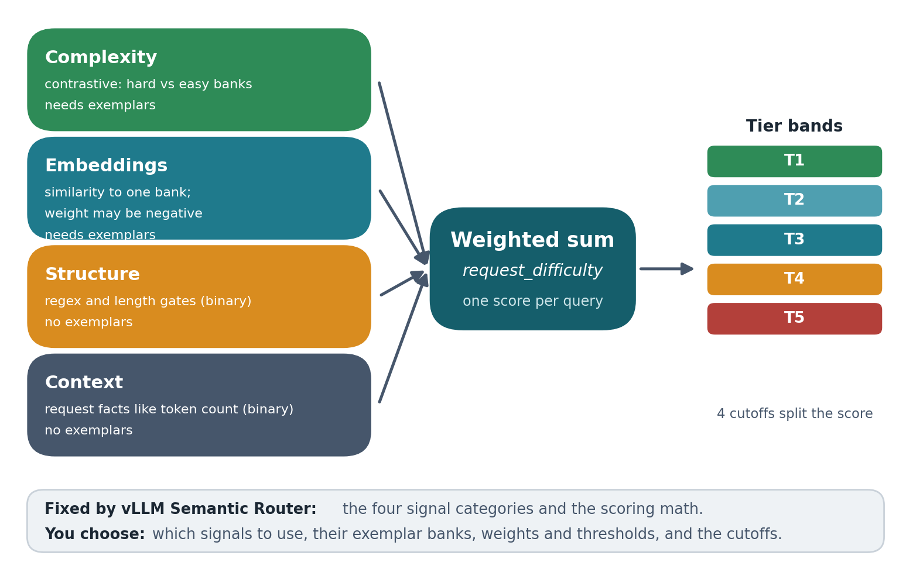
Figure 4. Anatomy of the difficulty score. Each of the four signal categories contributes to one weighted sum, and four cutoffs split that sum into tier bands. The categories and the math are built into the router; the signals, exemplars, weights, thresholds, and cutoffs are yours.
Fixed by vLLM Semantic Router | Chosen by you
The four signal categories: complexity, embeddings, structure, context | Which signals to create within each category
The contrastive classifier and the embedding model | The exemplar prompts that fill each signal bank
The weighted-sum and threshold-band scoring math | Each signal's weight, its sign, and its threshold
The routing decision headers returned per request | The four cutoffs that separate the five tier bands

The four categories differ in what they measure and in whether they need exemplars:
Category | What it measures | Exemplars? | How it fires
Complexity | Contrastive margin: how much more the prompt resembles a hard bank than an easy bank | Yes, two banks | When the margin clears its threshold
Embeddings | Cosine similarity between the prompt and one bank of example prompts | Yes, one bank | In proportion to similarity, above a threshold
Structure | Mechanical properties of the text: word count, code blocks, numbered lists | No | Binary, when a regex or length test passes
Context | Request facts such as token count or modality | No | Binary, when the value falls in range

Complexity, structure, and context contribute in an on-or-off way: when the signal fires, it adds its weight to the score, otherwise it adds nothing. Embedding signals contribute continuously, in proportion to how closely the prompt matches their bank. A weight can be negative. A signal with a negative weight is a detractor: when it fires it pulls the score down, which is how trivial questions are anchored in the cheapest tier rather than drifting upward.
The configuration documented here uses one complexity signal, four embedding signals, several structure signals, and one context signal. The embedding signals are where most of the routing intelligence lives, so they are worth listing with their weights:
Embedding signal | Weight | What it captures
trivial_lookup | -0.20 | Short factual asks and definitions. A detractor that pulls difficulty down and anchors easy queries at T1.
moderate_complexity | +0.22 | Explain-how, compare-and-contrast, and basic-implementation prompts that belong in T2 or T3.
argumentative_construction | +0.18 | Prompts that demand a position, recommendation, or diagnosis, the T4 judgment pattern.
frontier_synthesis | +0.15 | Long-form original argument and multi-domain synthesis, the T5 pattern.

The single complexity signal, query_difficulty, carries a weight of +0.24 and contrasts diverse hard archetypes against diverse trivial ones. The structure signals add small mechanical adjustments: a prompt under twelve words subtracts a little, a prompt over twenty-five words adds a little, a fenced code block or a numbered list adds a little. The context signal adds weight when the request needs a large context window. No single signal decides the tier; the routing comes from their sum.

5.4 Writing exemplars
An exemplar is simply an example prompt you place in a bank. The router converts each one into a vector, and when a new prompt arrives it compares that prompt to the bank by similarity. You are teaching by example: this bank says “questions that look like these are hard,” that bank says “questions that look like these are trivial.” Because the banks are what the router actually compares against, the quality of your exemplars determines the quality of your routing. A small example of the two banks behind a complexity signal:
Hard bank (raises difficulty) | Easy bank (lowers difficulty)
Demonstrate that there are infinitely many primes. | What is the chemical symbol for sodium?
Walk through how Raft handles a split-vote scenario. | Who wrote The Great Gatsby?
Prove that a stated real number is irrational. | Define photosynthesis.

A handful of practices separate banks that route well from banks that do not:
- Use archetypes, not real queries. Fill banks with generic patterns of a difficulty class, not paraphrases of the actual prompts you expect. Ten to fifteen diverse examples per bank is enough. Copying real or test queries into the banks teaches the router to recognize those specific prompts rather than the underlying shape, which looks good in testing and fails in production.
- Cover the category broadly. A hard bank should span the ways a prompt can be hard: multi-step reasoning, deep domain expertise, open-ended judgment, long synthesis. Narrow banks only catch the cases you happened to think of.
- Match the length of your targets. The classifier compares a prompt to its nearest neighbor in the bank, and a short prompt cannot closely resemble a long one in vector space. If some hard prompts are terse, such as a one-line request to prove a number is irrational, the hard bank needs short hard examples alongside the long ones, or those prompts will be missed.
- Keep contaminating vocabulary out of the opposing bank. Shared wording leaks across banks. A math-flavored example placed in an easy bank raises the easy score for genuine proofs and quietly demotes them a tier. Anchor trivial cases with a separate detractor instead of polluting the easy bank.
- Use a detractor to anchor the floor. A negative-weight bank of short factual and lookup prompts is the most reliable way to keep trivial questions in the cheapest tier, more reliable than hoping no positive signal fires on them.
To make this concrete, here are three exemplar choices that look reasonable but route badly, and the fix for each:

Looks reasonable | Why it misroutes | Stronger exemplar
Prove that the square root of 2 is irrational using the p-over-q contradiction in lowest terms. | It is a verbatim test prompt, so the router learns this exact wording; a different proof request sits too far away in vector space to match. | "Prove that a stated number is irrational." A short, generic archetype that any proof request lands near.
A hard bank made only of long, multi-paragraph problems. | A terse "Prove there are infinitely many primes" cannot sit close to a 200-word example, so it scores easy and under-routes. | Mix short and long hard examples so even terse prompts have a near neighbor.
A science question dropped into the easy bank to anchor it. | Its vocabulary leaks across banks and quietly demotes genuine hard-science prompts a tier. | Keep topical vocabulary out of the opposing bank; anchor trivial cases with a separate detractor.

5.5 How the score is computed: a worked example
Putting it together, here is how four prompts flow through the same configuration. The contributions shown are illustrative of the mechanism rather than exact classifier outputs, but the arithmetic is exactly what the router does: add the contributions, compare to the cutoffs, pick the band. Embedding signals contribute their weight scaled by how closely the prompt matches the bank, so the embedding numbers below sit at or under the weights listed earlier, while the binary structure signals add their weight in full.
Prompt | Signals that fire (contribution) | Score | Tier
What is the capital of France? | trivial_lookup (-0.18), short_prompt (-0.05) | -0.23 | T1
Compare TCP, UDP, and SCTP and the trade-offs of each. | moderate_complexity (+0.14) | 0.14 | T3
Should we adopt this framework across the org? Take a position and defend it. | argumentative_construction (+0.18) | 0.18 | T4
Construct an original argument for a non-obvious philosophical position and defend it without retreat. | query_difficulty hard (+0.24), frontier_synthesis (+0.15), long_prompt (+0.08) | 0.47 | T5

Reading the first and last rows shows how the categories behave differently. "What is the capital of France?" fires two detractors: trivial_lookup fires because the prompt's vector lands close to the lookup bank (an embedding signal, so it contributes in proportion to that similarity) and short_prompt fires because the text clears a length test, a binary structure signal that simply adds its weight. Both weights are negative, so the score falls to -0.23, well below the first cutoff, and the query routes to T1. The last prompt fires three positive signals at once: query_difficulty, the contrastive complexity signal, fires because the prompt resembles the hard archetypes far more than the trivial ones and the margin clears its threshold; frontier_synthesis fires on embedding similarity to the long-form synthesis bank; and long_prompt adds a small structural bump for length. Their sum, 0.47, clears the top cutoff and routes to T5. The two middle prompts each fire one signal, landing in the T3 and T4 bands respectively.
The score is the sum of the contributions, and the cutoffs decide the tier. Everything that determines a routing decision is visible in one configuration file, which is what makes the behavior debuggable and tunable rather than opaque.

5.6 Setting the cutoffs and the bands
The cutoffs are the last piece. Four of them split the difficulty score into five bands, one per tier. In this configuration they sit at 0.03, 0.10, 0.18, and 0.40, against a practical score range of roughly minus 0.15 to 0.70. The bottom of that range is a trivial question whose detractors fire and nothing else; the top is a prompt that trips the heaviest positive signals together: the +0.24 complexity signal, a frontier-synthesis match near its maximum, and a structural bump or two. Nothing scores much above 0.70 because there are only so many positive signals to fire, which is why the top band begins well below it, at 0.40.
To place the cutoffs the first time, score a few hundred labeled prompts and look at where they land on the line. Prompts you intend for the same tier cluster together, with gaps between the clusters; put each cutoff in a gap. With no labeled set yet, spread the four cutoffs across the observed range, weighted toward the low end, since most traffic scores low, then correct them once you can see real prompts landing in the wrong band. The cutoffs are a blunt instrument: moving one shifts every query near it, so they are tuned last, after the signals and weights are doing their job.
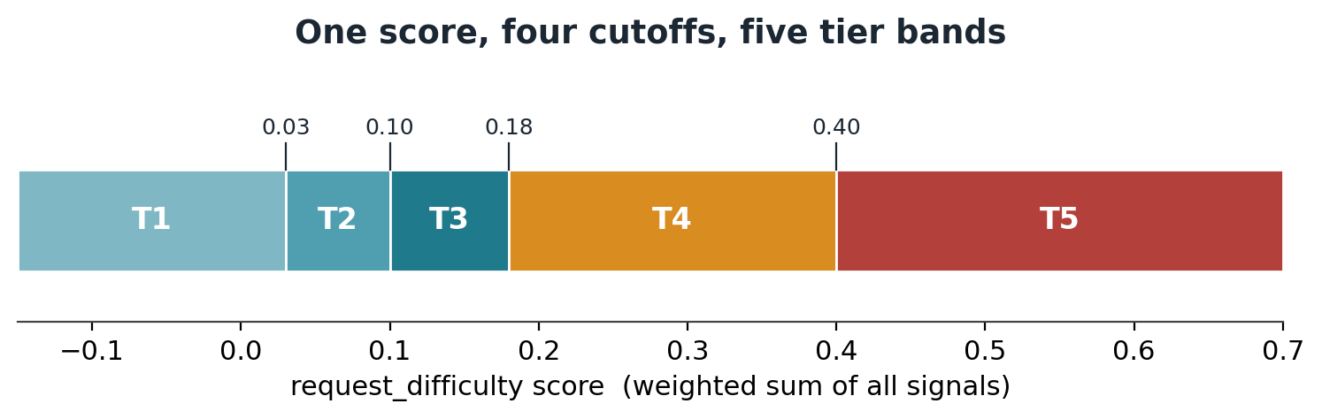
Figure 5. The same scoring model on a number line. Every signal feeds one weighted sum, and the four cutoffs partition that sum into the five tier bands.

6. Tuning: an iterative process
A first configuration is an educated guess. Tuning is the loop that turns it into a reliable router, and it is empirical rather than analytical: you route a set of known queries, see where they land, fix the largest error, and repeat. The three surfaces you adjust all live in the one configuration file, namely the exemplar banks, the per-signal weights, and the band cutoffs. The goal of each pass is to move misrouted queries into the right band without dragging correctly-routed queries out of theirs.
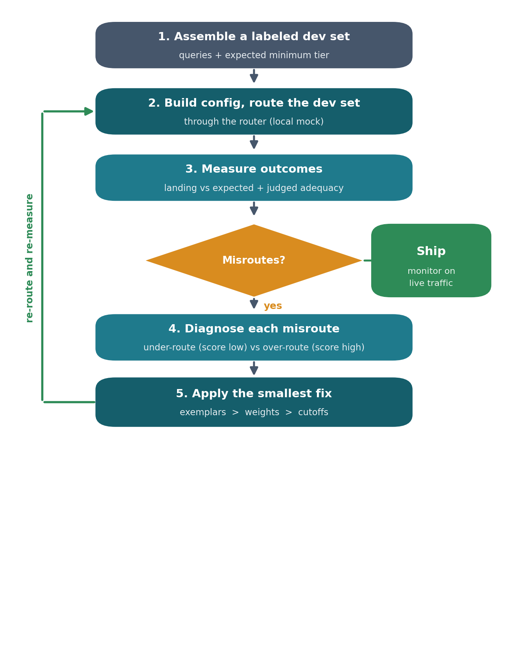
Figure 6. The tuning loop. Route a labeled set, measure where queries land, fix the largest error with the cheapest available lever, and re-measure. Stop when the misroutes that remain are acceptable.
The loop has five steps.
Step 1. Assemble a labeled dev set. Collect a few dozen to a few hundred queries that span the full difficulty range, and tag each with the lowest tier you believe should answer it well. This is your answer key. Keep it separate from the exemplar banks, so you are never grading the router on the very examples you trained it with.
Step 2. Build the config and route the dev set. Compile the configuration and send every dev query through the router, which records the tier each one lands in. Because a routing decision does not require a real model answer, this pass is fast and inexpensive and can run against a local mock rather than paid endpoints.
Step 3. Measure outcomes. Compare where each query landed against its label, and look at the distribution across tiers. Two error types matter: an under-route, where the score came out too low and a hard query went to a small tier, and an over-route, where the score came out too high and an easy query went to an expensive one. Where you can, also judge answer adequacy, because a query that lands one tier below its label but is still answered adequately is not actually a failure.
Step 4. Diagnose each misroute. For each cluster of errors, find the signal at fault. An under-route usually means a signal that should have fired did not: the prompt resembled nothing in the relevant bank, or the threshold was set too high to clear. An over-route usually means a signal fired when it should not have: a bank was too broad, or a detractor that should have anchored the prompt was missing.
Step 5. Apply the smallest fix, then return to Step 2. Reach for the most local lever first. Add or sharpen exemplars before changing weights, and change weights before moving cutoffs. The reason is blast radius: an exemplar edit affects only prompts near it, a weight change affects every query that fires that signal, and a cutoff change moves every query at once. Make one change, recompile, and re-route. Resist changing several things between measurements, or you will not know which one helped.
One pass makes the loop concrete. Suppose the dev set includes a dozen short proof requests ("prove there are infinitely many primes," "show that the harmonic series diverges") all labeled T4. The first route sends them to T2: they score around 0.05, far below the 0.18 cutoff. Step 4 finds the cause which may be that the hard bank holds only long, multi-paragraph problems, so these terse prompts match nothing and query_difficulty never fires. The cheapest fix is an exemplar edit, not a weight change: add three short proof archetypes to the hard bank. On the next route the same prompts score about 0.30 and land in T4, and because the edit only moved prompts near those archetypes, nothing else shifts. Had the fix instead been a blanket increase to the complexity weight, the proofs would have moved but so would every other query that fires that signal, over-routing a batch of moderate questions. That is why the local lever is tried first.
A few additional best practices will also improve the reliability of the routing:
Make signals discriminate, not fire constantly. A signal that fires identically on all inputs carries no information and only adds noise to the sum. The fix is to replace them with a smaller set of signals of different kinds, one contrastive complexity signal, several embedding signals, and a few mechanical structure signals, because different signal types capture different evidence and together give the score real gradient.
Mind the contrastive margin. A contrastive classifier compares a prompt against the nearest example in each bank, so the banks must match the target prompts in both content and length. Short rigorous prompts, such as a one-line request to prove a number is irrational, cannot resemble long hard exemplars in embedding space, so short hard archetypes should be added alongside the long ones. The same care applies in reverse: any math-flavored example placed in an easy bank slightly raised the easy score for genuine proofs and can flip them down a tier.
Tune weights and cutoffs against measured outcomes. Thresholds that look reasonable in the abstract are often unreachable in practice. A complexity threshold set high enough that no query can clear it will under-route. Find working values empirically by routing test cases, reading where queries landed, and adjusting. A single weight bump, for example raising the complexity weight so that one hard match alone clears the T3-to-T4 cutoff, can correct a whole class of misroutes.
Judge quality, not just tier match. It is tempting to grade the router only on whether it hit a hand-labeled minimum tier. That label is a conservative floor, and grading against it alone is misleading. What matters is whether the user would have been satisfied with the answer, which is what the comparison against the frontier captures, and it is the metric to tune toward.
Know when to stop. Tuning has a natural end. When fixes for one query start breaking others, the configuration is near its useful limit and further changes trade one error for another. Two habits protect against over-fitting to the dev set. Keep exemplars generic rather than tailored to specific prompts, and validate the final configuration on a held-out set of queries that you never tuned against. Performance on that held-out set, not on the dev set, is what tells you the router will hold up in production.

7. Benchmark results from this system
The system was exercised against a curated benchmark of 797 queries spanning all five difficulty bands, with the band populations kept roughly equal so that hard queries are over-represented relative to real traffic. Every query was routed and answered at its selected tier, and the same query was also answered by the frontier model. Two independent LLM judges then graded both answers against the same criteria: correctness, completeness, soundness of supporting facts, and fitness for purpose, and reported whether the smaller-tier answer held up as well as the frontier's.

7.1 Where traffic went
The router distributed the 797 queries across all five tiers. Because the benchmark over-weights hard queries, the upper tiers carry more traffic here than they would in production, where the easy tiers would dominate.
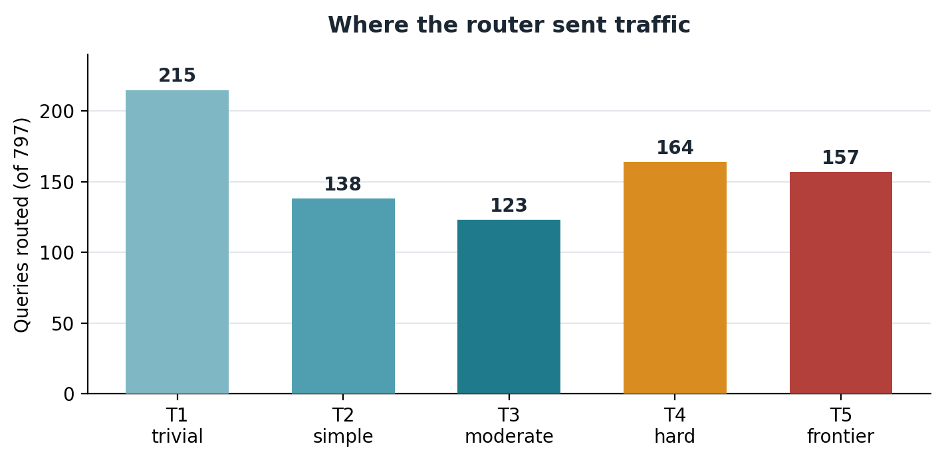
Figure 7. Routing distribution across the 797-query benchmark. The flat-by-difficulty benchmark sends more traffic to the upper tiers than production traffic would.

7.2 Whether the answers were good enough
The smaller-tier answer held up as well as the frontier's on 98 percent of queries, and never below 96 percent on any single tier. The cheapest T1 models matched the frontier on essentially every query routed to them. The small remainder is the under-routed tail: cases where a smaller model fell short and the question would have been better served a tier or two higher. These are recoverable. A user who wants more can ask again or request a deeper answer, which routes the follow-up to a higher tier, so the cost of a miss is a second pass for a small fraction of queries.
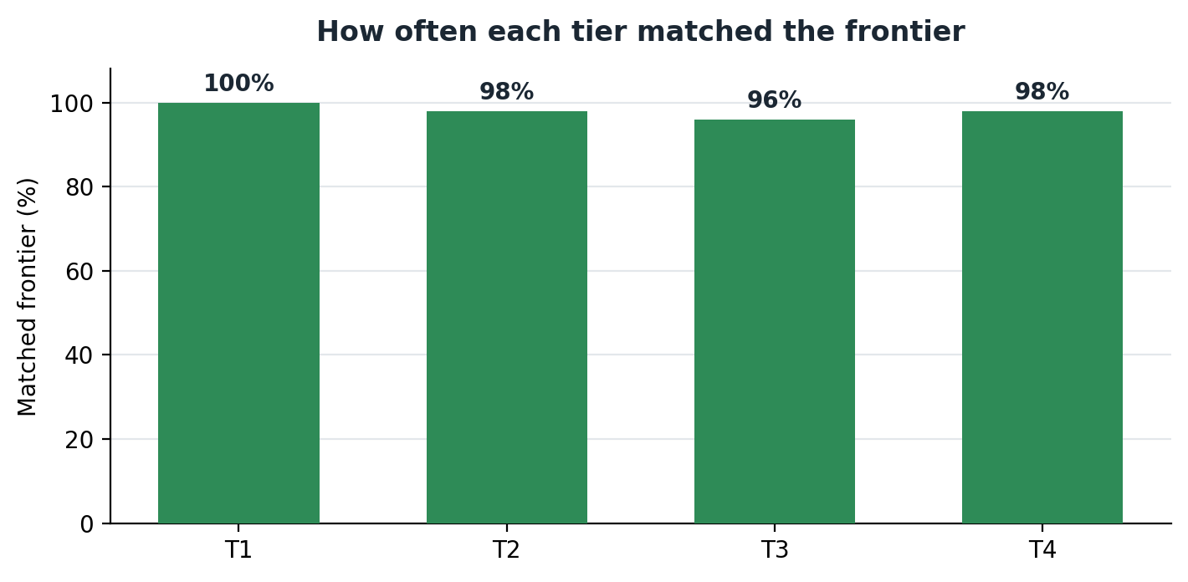
Figure 8. How often each tier's answer matched the frontier, for tiers T1 through T4. The match rate stays between 96 and 100 percent, so right-sizing does not cost quality. (T5 is the frontier reference itself, so it is not compared against.)

7.3 What it cost, and how fast
Cost is computed one query at a time, then averaged, then scaled by volume. For each query, the routed cost is the measured cost of the model the router used for the tier it picked, from real token counts at current supplier rates. The baseline cost for the same query is what it would cost sent to the frontier model instead.
Averaging those per-query costs over the benchmark set gives about $0.0050 per query routed against about $0.0072 per query all-frontier.
The benchmark spreads its queries roughly evenly across the five difficulty bands to exercise the router across its full range. On this mix, routing cut cost against the all-frontier baseline by 31 percent, from about $7,192 to about $4,992 per million queries or about $241,000 saved per year at 300,000 queries per day. This is a conservative figure: an even spread sends far more traffic to the expensive upper tiers than real usage does, so production savings are typically larger.
Real traffic tends to skew heavily toward the lower tiers, so the same per-query method can be re-run against whatever tier distribution an operator measures for their own traffic. The headline figures in this paper stay with the benchmark mix, the harder and more conservative of the two.
The routing decision itself was cheap: mean routing latency was 355 milliseconds with a 99th percentile of 502 milliseconds, sustained at 22.5 queries per second.

8. Summary and system specification
A semantic router earns its place by matching the cost of answering a question to the difficulty of the question. On the benchmark documented here, the router sent 98 percent of traffic to a tier whose answer held up as well as the frontier's, while cutting blended cost by 31 percent. At 300,000 queries per day that is about $241,000 per year. The two cheapest tiers, which carry most production traffic, bind to the smallest models at a small fraction of frontier rates, and the routing decision adds only about a third of a second. The savings come from the large, confidently-easy majority of traffic, and they do not require giving up the frontier model on the questions that need it.
The architecture is portable by design. Tiers are capability bands, models bind to tiers through configuration, and the routing logic lives in an editable configuration file. A new model is an edit, not a deployment. Every backend speaks the same OpenAI-compatible API, so a tier can be re-pointed from one vendor to another without code changes. That makes the design straightforward to adopt incrementally: stand the router in front of the existing frontier API, add the cheaper tiers, and let the easy majority of traffic flow to the smaller models while the frontier model keeps handling the rest.

Reference deployment specification
The router runs as a small service on a single server placed in front of the model APIs. In this deployment, we used a Dell PowerEdge R470 / R770. Queries reach the router first; it classifies each one and forwards it to the chosen model. The models themselves stay where they already are, which in this benchmark were hosted vendor endpoints. Classification and routing run well on Intel® Xeon® CPUs with Intel® AMX, making a Dell PowerEdge R470 or R770 a good choice for this application. The R470 is a compact 1U server for smaller deployments, while the R770 adds cores and memory for larger query volumes. Intel® AMX runs the embedding classifier directly on the CPU, so neither server needs a GPU.
Component | Specification
Router software | vLLM Semantic Router (v0.3), Envoy ingress with an external-processing classifier
Server | Dell PowerEdge R470 / R770 with Intel® Xeon® CPU
Classifier model | mmbert-embed-32k-2d-matryoshka embedding model
Supporting services | Postgres and Redis backends bundled with the router stack
Interface | OpenAI-compatible chat-completions endpoint, in and out
T1 models | gpt-5-nano, gemini-3.1-flash-lite
T2 models | gpt-5.4-nano, gemini-2.5-flash
T3 models | claude-haiku-4-5, gpt-5.4-mini, gemini-3.5-flash
T4 models | claude-sonnet-4-5, gpt-5.4, gemini-3.1-pro
T5 models (frontier and gold) | Opus 4.7, GPT-5.5
Judges | Two independent LLM evaluators

Adding a Dell PowerEdge R470 or R770 with Intel® Xeon® CPU has been shown to provide significant savings without moving any models or changing how they are deployed. Adding this system as a semantic model router in front of your API calls is a straightforward way to manage and control AI costs without degrading user experience.

References
[1] RouteLLM: Learning to Route LLMs with Preference Data (Ong et al., 2024). https://arxiv.org/pdf/2406.18665
[2] RouteLLM: An Open-Source Framework for Cost-Effective LLM Routing, LMSYS Blog (2024). https://lmsys.org/blog/2024-07-01-routellm/
[3] Bringing intelligent, efficient routing to open source AI with vLLM Semantic Router, Red Hat (2025). https://www.redhat.com/en/blog/bringing-intelligent-efficient-routing-open-source-ai-vllm-semantic-router
[4] vLLM Semantic Router: Next Phase in LLM inference, vLLM Blog (2025). https://blog.vllm.ai/2025/09/11/semantic-router.html
[5] When to Reason: Semantic Router for vLLM (2025). https://arxiv.org/pdf/2510.08731
[6] Building an LLM Router for High-Quality and Cost-Effective Responses, Anyscale. https://www.anyscale.com/blog/building-an-llm-router-for-high-quality-and-cost-effective-responses
[7] ChatGPT users send 2.5 billion prompts a day, TechCrunch (2025). https://techcrunch.com/2025/07/21/chatgpt-users-send-2-5-billion-prompts-a-day/
[8] What people do with Copilot: The Copilot Usage Report 2025, Microsoft AI. https://microsoft.ai/wp-content/uploads/2025/12/What_people_do_with_Copilot-8.pdf

Benchmark figures are computed from measured per-query token counts at current supplier pricing. Cost figures use a per-query method: routed cost is the measured cost of the model used for the routed tier, and the baseline reprices each query's frontier reference answer at the frontier rate. Averages are taken over the benchmark set, then scaled by volume. The benchmark-mix figure reflects the measured traffic directly; the simple-weighted figure re-weights the same per-query costs to an illustrative 60/20/12/5/3 distribution across tiers T1 through T5, representing easy-heavy production traffic. The per-user query rate used in Section 2 (about 50 queries per active user per workday) is a midpoint drawn from published 2025 enterprise usage data, references 7 and 8.
 | 
Learn more about Dell solutions. | Contact a Dell Technologies Expert. | Join the conversation.
© 2026 Dell Inc. or its subsidiaries. All rights reserved. Dell Technologies, Dell, and other trademarks are trademarks of Dell Inc. or its subsidiaries. Other trademarks may be trademarks of their respective owners.



