Right-Sizing the Model to the Question
Cutting inference cost with a semantic router on a Dell PowerEdge R470
A technical white paper
Measured results from the vLLM Semantic Router benchmark harness
June 2026

Contents

1. Executive summary
Most production traffic to a large language model is easy. A user asks for the capital of a country, a unit conversion, a short rewrite, or a definition. A small fraction of traffic is hard: a multi-step proof, a high-stakes judgment call, a long synthesis across several domains. When every request is sent to a single frontier model, the easy questions are answered at the same price as the hard ones. That price gap is the waste a semantic router removes.
A semantic router reads each incoming prompt, estimates how much capability the prompt actually requires, and forwards it to the smallest model tier that can answer it well. Trivial questions go to a small local model running on commodity hardware. The few questions that genuinely need a frontier model still get one. The result is the same answer quality on a per-question basis at a fraction of the blended cost.
This paper documents a working five-tier router built on the open-source vLLM Semantic Router, hosted on a single Dell PowerEdge R470, a 1U Intel Xeon 6 server. The router and the two smallest model tiers run on the R470 CPUs at no per-token cost; only the upper tiers reach out to paid vendor APIs. We measured the system against a curated 797-query benchmark spanning trivial lookups to frontier-grade synthesis, and scored every routed answer with two independent LLM judges.
The headline findings, all measured on this code base:
- 97 percent of routed answers were judged adequate across 7,680 answer-by-judge comparisons, with per-tier adequacy between 96 and 98 percent.
- 41 percent cost reduction against an all-frontier baseline on the benchmark mix, which deliberately over-weights hard queries.
- Roughly 88 percent cost reduction when the same per-tier economics are projected onto a realistic production traffic mix, where most queries are easy.
- 355 millisecond mean routing latency at a sustained 22.5 queries per second, so the routing decision is a small fraction of total response time.
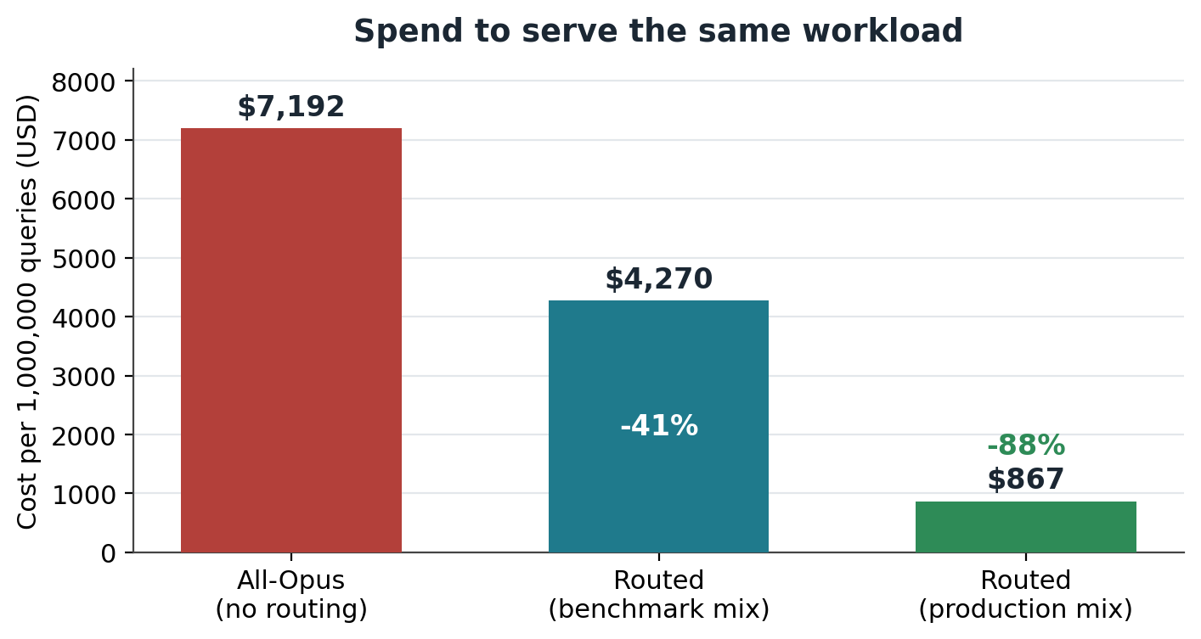
Figure 1. Cost to serve the same 797-query workload three ways. Numbers are dollars per one million queries at the measured token counts and current supplier rates.

2. The problem and its economic impact
Frontier models are priced for their hardest use. A top-tier model charges several dollars per million input tokens and five to six times that per million output tokens, because serving it requires large amounts of accelerator memory and compute. That price is justified when the question demands frontier reasoning. It is pure overpayment when the question is a definition lookup that a one-billion-parameter model answers correctly in a few tokens.
The economic problem is that real traffic is heavily skewed toward the easy end, while naive deployments price all of it at the hard end. In the benchmark used here, the per-query cost of answering with a top-tier model ranges from about five cents per hundred queries for the easiest band to fifteen times that for the hardest. A deployment that sends everything to the top tier pays the high rate on every request, including the large majority that a far cheaper model would have handled correctly.
To make the scale concrete, consider one million queries drawn from the benchmark mix. Answered entirely by a frontier model, they cost about $7,192 at the token counts we measured. The same workload, routed, costs about $4,270. On a production traffic mix weighted toward easy questions, the routed cost falls to roughly $867. At enterprise volume, where a busy assistant can field tens of millions of queries per month, the difference compounds into six and seven figure annual sums.
There is a second cost that pure dollar figures understate. Sending trivial work to a frontier model also spends scarce accelerator capacity and adds latency and token consumption that a smaller model would avoid. Independent work on the vLLM Semantic Router measured token usage falling to about one fifth of the original when reasoning effort was matched to the question, alongside lower latency. Cost, capacity, and speed all improve together when the model is sized to the question.
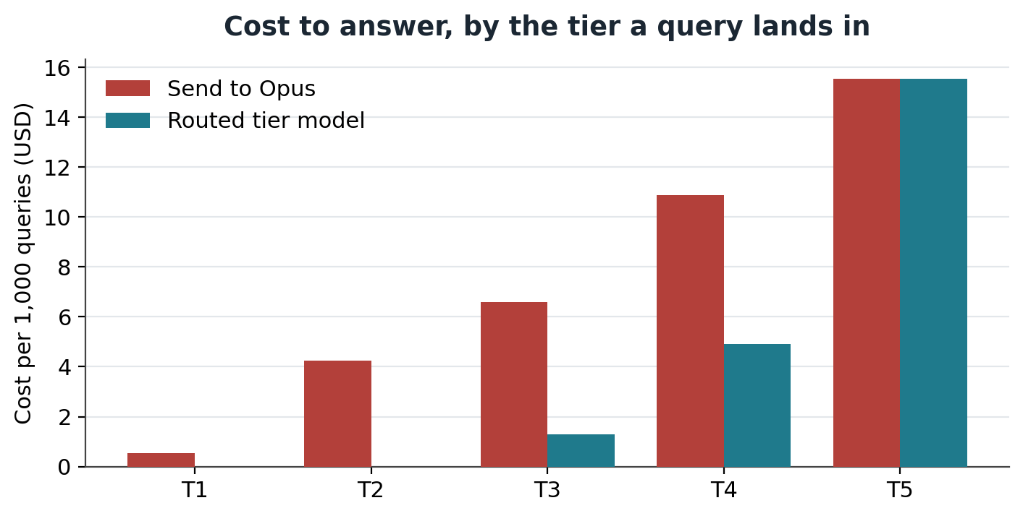
Figure 2. Per-tier economics. For each band a query can land in, the cost of answering with the frontier model versus the routed tier model, in dollars per thousand queries. The first two bands are served by self-hosted models on the R470 at no per-token cost.

3. What semantic routing is, and why it helps
Semantic routing is the practice of choosing which model answers a request based on the meaning and difficulty of the request itself, rather than sending every request to one fixed model. A lightweight classifier reads the prompt, places it on a difficulty scale, and dispatches it to the model tier that matches. The classifier is small and cheap to run, so the routing decision adds little cost or delay while redirecting the expensive work only where it is warranted.
The idea is well supported in the research literature, and the reported savings are large and consistent across independent groups.
RouteLLM, from LMSYS and UC Berkeley, framed routing as a learned choice between a strong, expensive model and a weak, cheap one. Trained on preference data, their routers reached 95 percent of strong-model quality on MT-Bench while sending only 26 percent of queries to the strong model, and with judge-augmented training only 14 percent, a roughly 75 percent reduction in strong-model calls. Across public benchmarks they reported cost reductions of more than two times with no measurable loss in response quality.
The vLLM Semantic Router, introduced by Red Hat and the vLLM community in 2025, brings the same idea to the open inference stack with an intent-and-complexity classifier built on a compact encoder model. Their published benchmarks on MMLU-Pro with a Qwen3 30B model report accuracy on complex tasks improving by 10.2 percent while latency and token usage fell by 47.1 and 48.5 percent respectively. In their reasoning-effort experiments, automating how hard the model thinks cut average token usage to about 20 percent of the original, a five times saving, at equal accuracy.
Other groups report the same direction of effect. Anyscale's published router work and several commercial routing studies describe quality held near frontier levels while the share of frontier calls, and therefore cost, drops by well over half. The common thread is that difficulty is unevenly distributed across real traffic, so a classifier that respects that distribution captures most of the savings without sacrificing the answers that matter.
Two design points explain why the savings do not come at the expense of quality. First, the easy questions that get demoted to a small model are exactly the questions a small model answers correctly, so demoting them costs nothing in quality. Second, the router is tuned to err upward on genuinely ambiguous cases, so the rare hard question that looks easy is still likely to reach a capable tier. The savings come from the large, confidently-easy majority, not from gambling on the hard minority.

4. How semantic routing works, and how vLLM-SR works specifically

4.1 The general pipeline
Every semantic router performs four steps on each request. It extracts signals from the prompt, combines those signals into a single difficulty estimate, maps that estimate to a destination tier, and forwards the request to a model in that tier. The art is in the signals and the mapping; the rest is plumbing.
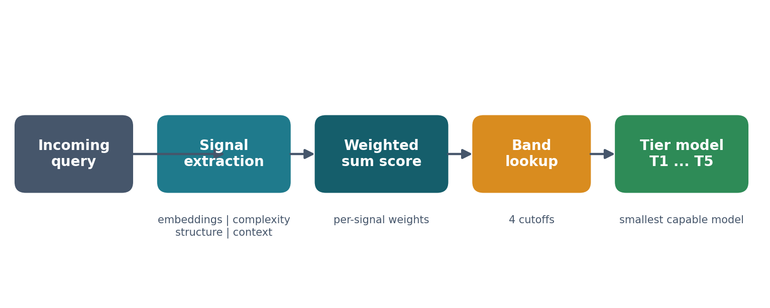
Figure 3. The routing pipeline. Signals extracted from the prompt are combined into one difficulty score, the score is mapped to a tier band, and the request is forwarded to the smallest capable model.
Signals come in several kinds. Embedding signals measure semantic similarity between the prompt and banks of example prompts, so a question that resembles known hard questions scores high. Complexity signals use a contrastive classifier that compares the prompt against a hard bank and an easy bank and reports the margin between them. Structure signals are mechanical and deterministic: prompt length in words, presence of a code block, presence of a numbered list. Context signals capture conversational state. Each signal contributes a weighted amount to the difficulty score, and the weights are where an operator encodes judgment about what makes a query hard.

4.2 How vLLM Semantic Router implements it
The vLLM Semantic Router is delivered as an Envoy proxy with an external processing service. Envoy sits in front of the model backends and, for every request, calls out to the router process, which runs the classifier and decides the destination. The router is built for CPU execution: its classifier is a compact encoder model rather than a generative LLM, so the routing decision is cheap and does not need an accelerator. This is precisely why a CPU server such as the R470 is the natural host for both the router and the small model tiers.
On first launch the router downloads a small embedding model, mmbert-embed-32k-2d-matryoshka, about 600 megabytes, which produces the vectors the embedding signals compare against. The router stack also brings up its own supporting services, including a Postgres and a Redis backend, and exposes an OpenAI-compatible endpoint so that any client that speaks the standard chat-completions API can sit in front of it without code changes.
The routing decision is returned on the response as three headers: x-vsr-selected-model, x-vsr-selected-category, and x-vsr-selected-reasoning. Downstream code reads these to know which tier handled the request, which makes the system easy to observe and to benchmark.
The version used here emits the v0.3 canonical projections configuration. In that shape, all of the signals feed a single weighted sum named request_difficulty, and a small set of cutoffs partitions that score into tier bands. One decision per band names the model that band routes to. The entire routing logic, the signals, their weights, and the cutoffs, lives in a single human-readable configuration file, so tuning the router never requires touching code.

5. Setting up routing: tiers, models, exemplars, and scoring

5.1 Define the tiers
A tier is a capability band, not a specific model. Defining tiers first, and binding models to them second, lets the model behind a tier change without disturbing the routing logic. The system documented here uses five tiers, from a small local model for trivial work up to a frontier model for the hardest combined reasoning and judgment.
Tier | Role | Example models bound to it
T1 | Trivial lookups, format conversion, one-step transforms | Qwen3-1.7B (local), gpt-5-nano, gemini-flash-lite
T2 | Workhorse: standard coding, short explainers, common synthesis | Qwen3-30B-A3B MoE (local), gpt-5.4-nano, gemini-2.5-flash
T3 | Heavy reasoning, deep technical work, complex synthesis | GPT-OSS 120B, claude-haiku-4-5, gemini-3.5-flash
T4 | High-stakes judgment, advice, strategy | claude-sonnet-4-5, gpt-5.4, gemini-3.1-pro
T5 | Frontier: deeply technical and demanding judgment at once | Opus 4.7, GPT-5.5

The two lowest tiers are the heart of the savings, and they run locally on the R470. Qwen3-1.7B handles T1. Qwen3-30B-A3B handles T2: it is a mixture-of-experts model with about three billion active parameters per token, so it delivers thirty-billion-class quality at roughly three-billion compute cost, which suits CPU inference on a Xeon 6. Because both run on hardware the operator already owns, every query they answer carries no per-token cost.

5.2 Bind models to tiers
Each tier can front several models from different suppliers. A tier names its callable models in environment configuration, one indexed slot per model, each carrying an endpoint URL, a model name, and an optional supplier label and timeout. A tier-agnostic launcher walks those slots, and for any model whose endpoint is local it consults a launch-recipe library that holds the exact container arguments for that model on the available CPU type. Adding a model is an edit to one configuration entry, never a code change. Every endpoint speaks the OpenAI chat-completions API, so backends are interchangeable.

5.3 Write the exemplars
Exemplars are the worked examples the router learns difficulty from. They are grouped into signal banks. A complexity signal holds a hard bank and an easy bank; the classifier reports the margin by which a prompt resembles hard examples more than easy ones. Embedding signals hold a single bank each and contribute in proportion to how closely a prompt matches it.
The configuration used here carries one complexity signal and four embedding signals. The complexity signal contrasts diverse hard archetypes, such as multi-step proofs, deep domain questions, and open-ended judgment, against diverse trivial archetypes, such as factual lookups and simple definitions. The four embedding signals each capture a specific pattern:
Signal | Weight | What it captures
trivial_lookup | -0.20 | Short factual asks and definitions. Pulls difficulty down, anchoring easy queries at T1.
moderate_complexity | +0.22 | Explain-how, compare-and-contrast, and basic-implementation prompts that belong in T2 or T3.
argumentative_construction | +0.18 | Prompts that demand a position, recommendation, or diagnosis, the T4 judgment pattern.
frontier_synthesis | +0.15 | Long-form original argument and multi-domain synthesis, the T5 pattern.

A signal with a negative weight is a detractor: when it fires, it lowers the difficulty score. The trivial_lookup detractor is the upstream-recommended way to firmly anchor short factual questions in the cheapest tier. Structure signals add small mechanical adjustments: a prompt under twelve words subtracts a little, a prompt over twenty-five words adds a little, and a very long prompt adds more.

5.4 Set the scoring and the bands
Each signal contributes its weight times its confidence to a single difficulty score. Four cutoffs split that score into five bands, one per tier. In this configuration the cutoffs are 0.03, 0.10, 0.18, and 0.40, against a practical score range of roughly minus 0.15 to 0.70. A trivial question that strongly matches the detractor lands below the first cutoff and routes to T1. A question that fires the frontier signal and the long-prompt signal clears the top cutoff and routes to T5.
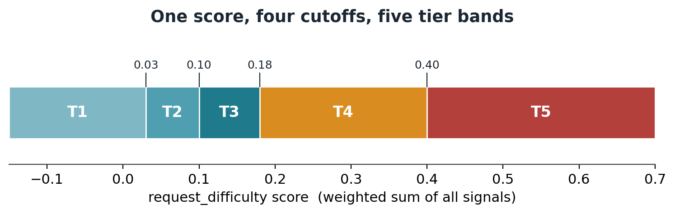
Figure 4. The scoring model in one line. Every signal feeds a single weighted sum, and four cutoffs partition that score into the five tier bands.

6. Tuning for best results
Routing quality is governed by three tuning surfaces, all in the one configuration file: the exemplar banks, the per-signal weights, and the band cutoffs. Tuning is the work of moving misrouted queries into the right band without dragging correctly-routed queries out of theirs. A few lessons from building this system generalize.
Make signals discriminate, not fire constantly. An early version used four complexity signals that, on inspection, all reported the same middle value on every query. A signal that fires identically on all inputs carries no information and only adds noise to the sum. The fix was to replace them with a smaller set of signals of different kinds, one contrastive complexity signal, several embedding signals, and a few mechanical structure signals, because different signal types capture different evidence and together give the score real gradient.
Mind the contrastive margin. A contrastive classifier compares a prompt against the nearest example in each bank, so the banks must match the target prompts in both content and length. Short rigorous prompts, such as a one-line request to prove a number is irrational, cannot resemble long hard exemplars in embedding space, so short hard archetypes had to be added alongside the long ones. The same care applies in reverse: any math-flavored example placed in an easy bank slightly raised the easy score for genuine proofs and flipped them down a tier, so math examples were kept out of the easy and detractor banks and trivial arithmetic was anchored with a separate detractor instead.
Tune weights and cutoffs against measured outcomes. Thresholds that look reasonable in the abstract are often unreachable in practice. One complexity threshold was originally set so high that no query ever cleared it. The working values were found empirically by routing the benchmark, reading where queries landed, and adjusting. A single weight bump, for example raising the complexity weight so that one hard match alone clears the T3-to-T4 cutoff, can correct a whole class of misroutes.
Judge quality, not just tier match. It is tempting to grade the router only on whether it hit a hand-labeled minimum tier. That label is a conservative floor, and grading against it alone is misleading. In this benchmark the router selected a tier at or above the hand-labeled minimum on 70 percent of queries, yet 97 percent of the answers it produced were judged adequate by independent LLM judges. The gap means the smaller tiers answered many queries adequately that a cautious human had marked as needing a larger model. The honest measure of a router is whether the user would have been satisfied with the answer, which is what the adequacy judgment captures, and it is the metric to tune toward.

7. Benchmark results from this system
The system was exercised against a curated benchmark of 797 queries spanning all five difficulty bands, with the band populations kept roughly equal so that hard queries are deliberately over-represented relative to real traffic. Every query was routed, every routed tier produced answers from each model it fronts, and every routed answer was scored by two independent LLM judges against gold reference answers from the frontier tier. The rubric scored four dimensions on a one-to-four scale and assigned an overall verdict of Adequate, Marginal, or Failure.

7.1 Where traffic went
The router distributed the 797 queries across all five tiers. Because the benchmark over-weights hard queries, the upper tiers carry more traffic here than they would in production, where the easy tiers would dominate.
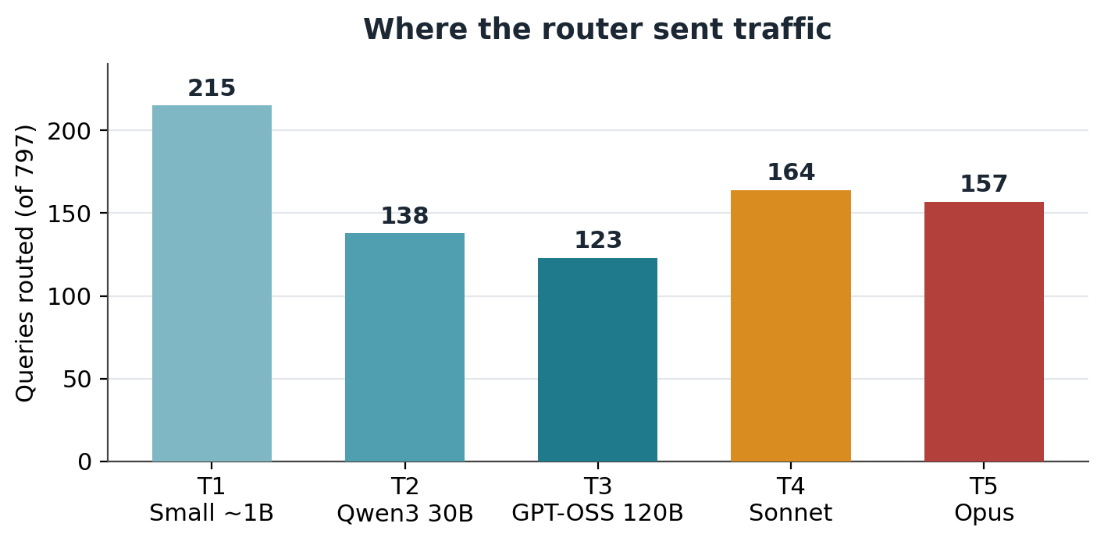
Figure 5. Routing distribution across the 797-query benchmark. The flat-by-difficulty benchmark sends more traffic to the upper tiers than production traffic would.

7.2 Whether the answers were good enough
Across 7,680 answer-by-judge comparisons of routed answers, 97 percent were judged Adequate, 2 percent Marginal, and under 1 percent Failure. Per-tier adequacy held between 96 and 98 percent, so the small tiers were not trading quality for cost. The self-hosted models carried their share: the local Qwen3 models alone were judged adequate 92.5 percent of the time on the queries routed to them, and they answer at no per-token cost. Averaged across all routed answers, the judges scored correctness at 3.96 out of 4, completeness at 3.95, supporting-fact soundness at 3.96, and fitness for purpose at 3.58.
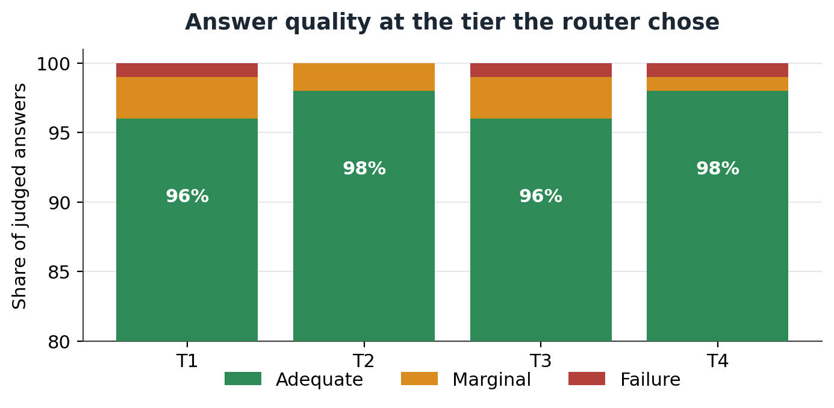
Figure 6. Answer quality at the tier the router selected. Adequacy stays between 96 and 98 percent across tiers, so right-sizing does not cost quality.

7.3 What it cost, and how fast
On the benchmark mix, routing cut cost against an all-frontier baseline by 41 percent, from about $7,192 to about $4,270 per million queries. That figure is conservative because the benchmark over-weights hard queries. Re-weighting the same measured per-tier costs onto a realistic production mix, where roughly six in ten queries are trivial, brings routed cost to about $867 per million, an 88 percent reduction. The routing decision itself was cheap: mean routing latency was 355 milliseconds with a 99th percentile of 502 milliseconds, sustained at 22.5 queries per second.
Metric | Value | Basis
Queries benchmarked | 797 | All five difficulty bands
Routed-answer judgments | 7,680 | Two independent judges
Adequate verdicts | 97% | Across all routed answers
Per-tier adequacy | 96 to 98% | Tiers T1 through T4
Local-model adequacy | 92.5% | Self-hosted Qwen3, $0 per token
Cost reduction, benchmark mix | 41% | vs all-frontier baseline
Cost reduction, production mix | ~88% | Re-weighted per-tier costs
Mean routing latency | 355 ms | p99 = 502 ms
Sustained throughput | 22.5 qps | Concurrency 8

8. Summary and system specification
A semantic router earns its place by matching the cost of answering a question to the difficulty of the question. On the benchmark documented here, the router sent 97 percent of traffic to a tier whose answer independent judges accepted, while cutting blended cost by 41 percent on a hard-weighted benchmark and by roughly 88 percent on a realistic production mix. The two cheapest tiers, which carry most production traffic, run on a single Dell PowerEdge R470 at no per-token cost, and the routing decision adds only about a third of a second. The savings come from the large, confidently-easy majority of real traffic, and they do not require giving up the frontier model on the questions that need it.
The architecture is deliberately portable. Tiers are capability bands, models bind to tiers through configuration, and the routing logic lives in one human-readable file. A new model is an edit, not a deployment. Every backend speaks the same OpenAI-compatible API, so a tier can be re-pointed from a local model to a vendor API, or the reverse, without code changes. That makes the design straightforward to adopt incrementally: stand up the router and the two local tiers on one server, route the easy majority of traffic to them, and keep the existing frontier model for the rest.

System hero specification
The reference host is a single 1U server that runs the router and both self-hosted tiers.
Component | Specification
Server | Dell PowerEdge R470, 1U single-socket rack server
Processor | Intel Xeon 6, up to 144 E-cores or up to 86 P-cores in one socket
Memory | 8-channel DDR5 up to 6,400 MT/s; up to 1 TB (E-core) or 4 TB (P-core)
Storage | Up to 8x 2.5-inch SAS, SATA, or NVMe, or up to 16x E3.S Gen5 NVMe
Networking | Up to 400 GbE per x16 slot
Power | 800 W Platinum to 1,500 W Titanium redundant supplies
Management | iDRAC10 with dedicated security processor
Router software | vLLM Semantic Router (v0.3), Envoy ingress with external-processing classifier
Classifier model | mmbert-embed-32k-2d-matryoshka embedding model, CPU-resident
Local tier models | T1: Qwen3-1.7B. T2: Qwen3-30B-A3B mixture-of-experts
Interface | OpenAI-compatible chat-completions endpoint

Why this server suits the job: the router classifier and the small tier models are CPU workloads, and the R470 pairs a high core count with up to a terabyte of fast DDR5 in a single low-power 1U chassis. The mixture-of-experts design of the T2 model keeps active compute near three billion parameters, which a Xeon 6 handles without an accelerator. The whole self-hosted side of the routing system, the decision layer and the two tiers that carry most of the traffic, fits on one server that an operator already controls.

References
[1] RouteLLM: Learning to Route LLMs with Preference Data (Ong et al., 2024). https://arxiv.org/pdf/2406.18665
[2] RouteLLM: An Open-Source Framework for Cost-Effective LLM Routing, LMSYS Blog (2024). https://lmsys.org/blog/2024-07-01-routellm/
[3] Bringing intelligent, efficient routing to open source AI with vLLM Semantic Router, Red Hat (2025). https://www.redhat.com/en/blog/bringing-intelligent-efficient-routing-open-source-ai-vllm-semantic-router
[4] vLLM Semantic Router: Next Phase in LLM inference, vLLM Blog (2025). https://blog.vllm.ai/2025/09/11/semantic-router.html
[5] When to Reason: Semantic Router for vLLM (2025). https://arxiv.org/pdf/2510.08731
[6] Building an LLM Router for High-Quality and Cost-Effective Responses, Anyscale. https://www.anyscale.com/blog/building-an-llm-router-for-high-quality-and-cost-effective-responses
[7] Dell PowerEdge R470 Technical Guide, Dell Technologies. https://www.delltechnologies.com/asset/en-us/products/servers/technical-support/poweredge-r470-technical-guide.pdf

Benchmark figures are computed from the project exports (demo_data.json, routed_queries_with_answers.json, evaluations.json) and supplier pricing in pricing.json. Cost projections use measured token counts at current published per-million-token rates; the production-mix projection re-weights measured per-tier costs to an illustrative 60/20/12/5/3 distribution across tiers T1 through T5.

