

HOTEL

1. *Participants:*

Valentin Petrov - [VPPetrov18@codingburgas.bg](mailto:VPPetrov18@codingburgas.bg)

Boyan Binev – [BGBinev18@codingburgas.bg](mailto:BGBinev18@codingburgas.bg)

Raya Lilova – [RSLilova18@codingburgas.bg](mailto:RSLilova18@codingburgas.bg)

1. *Content:*

Level1- Participants

Level2-Content

Level3-Purpose for our project

Level4-Diagram of the menu

Level5- Main functions from the program and their purpose

Level6- Diagram of the functions and their purpose

Level7- Description of arguments: type and purpose of the corresponding parameter

Level8- The type of return value and for what purpose it will be used in the program

1. *Purpose for our project*

The purpose of our project is to facilitate the Hotel Owner or the manager to enter the new employee’s names and to analyses the main information about them (for ex. Name, phone number, salary etc...)

1. *Diagram of the menu:*

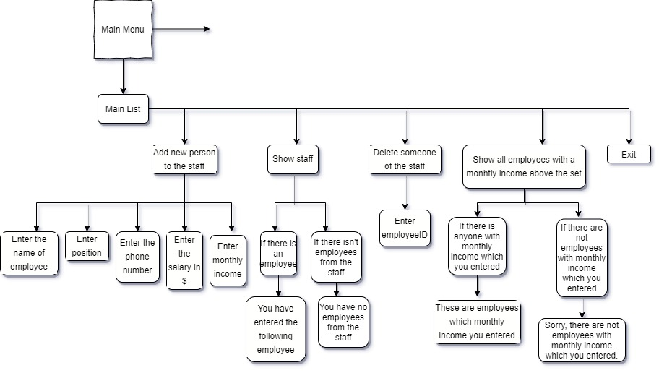

1. *Main functions from the program and their purpose*

|  |  |
| --- | --- |
| **Name of the function:** | **The main idea of the function:** |
| insertStaff | To insert people in the Staff |
| showStaff | To do the operation “show the Staff” |
| ShowEmployeeIncomeOverMenu | To show which employees are with monthly income |
| ShowEmployeeIncomeOver | To do the operation |
| getEmployeeById | To get the Id for the employees |
| deleteEmployee | To delete someone from the Staff |
| deleteEmployeeMenu | For the menu to delete someone from the data |
| showMainList | To show the Menu |

1. *Diagram of the functions and their purpose*

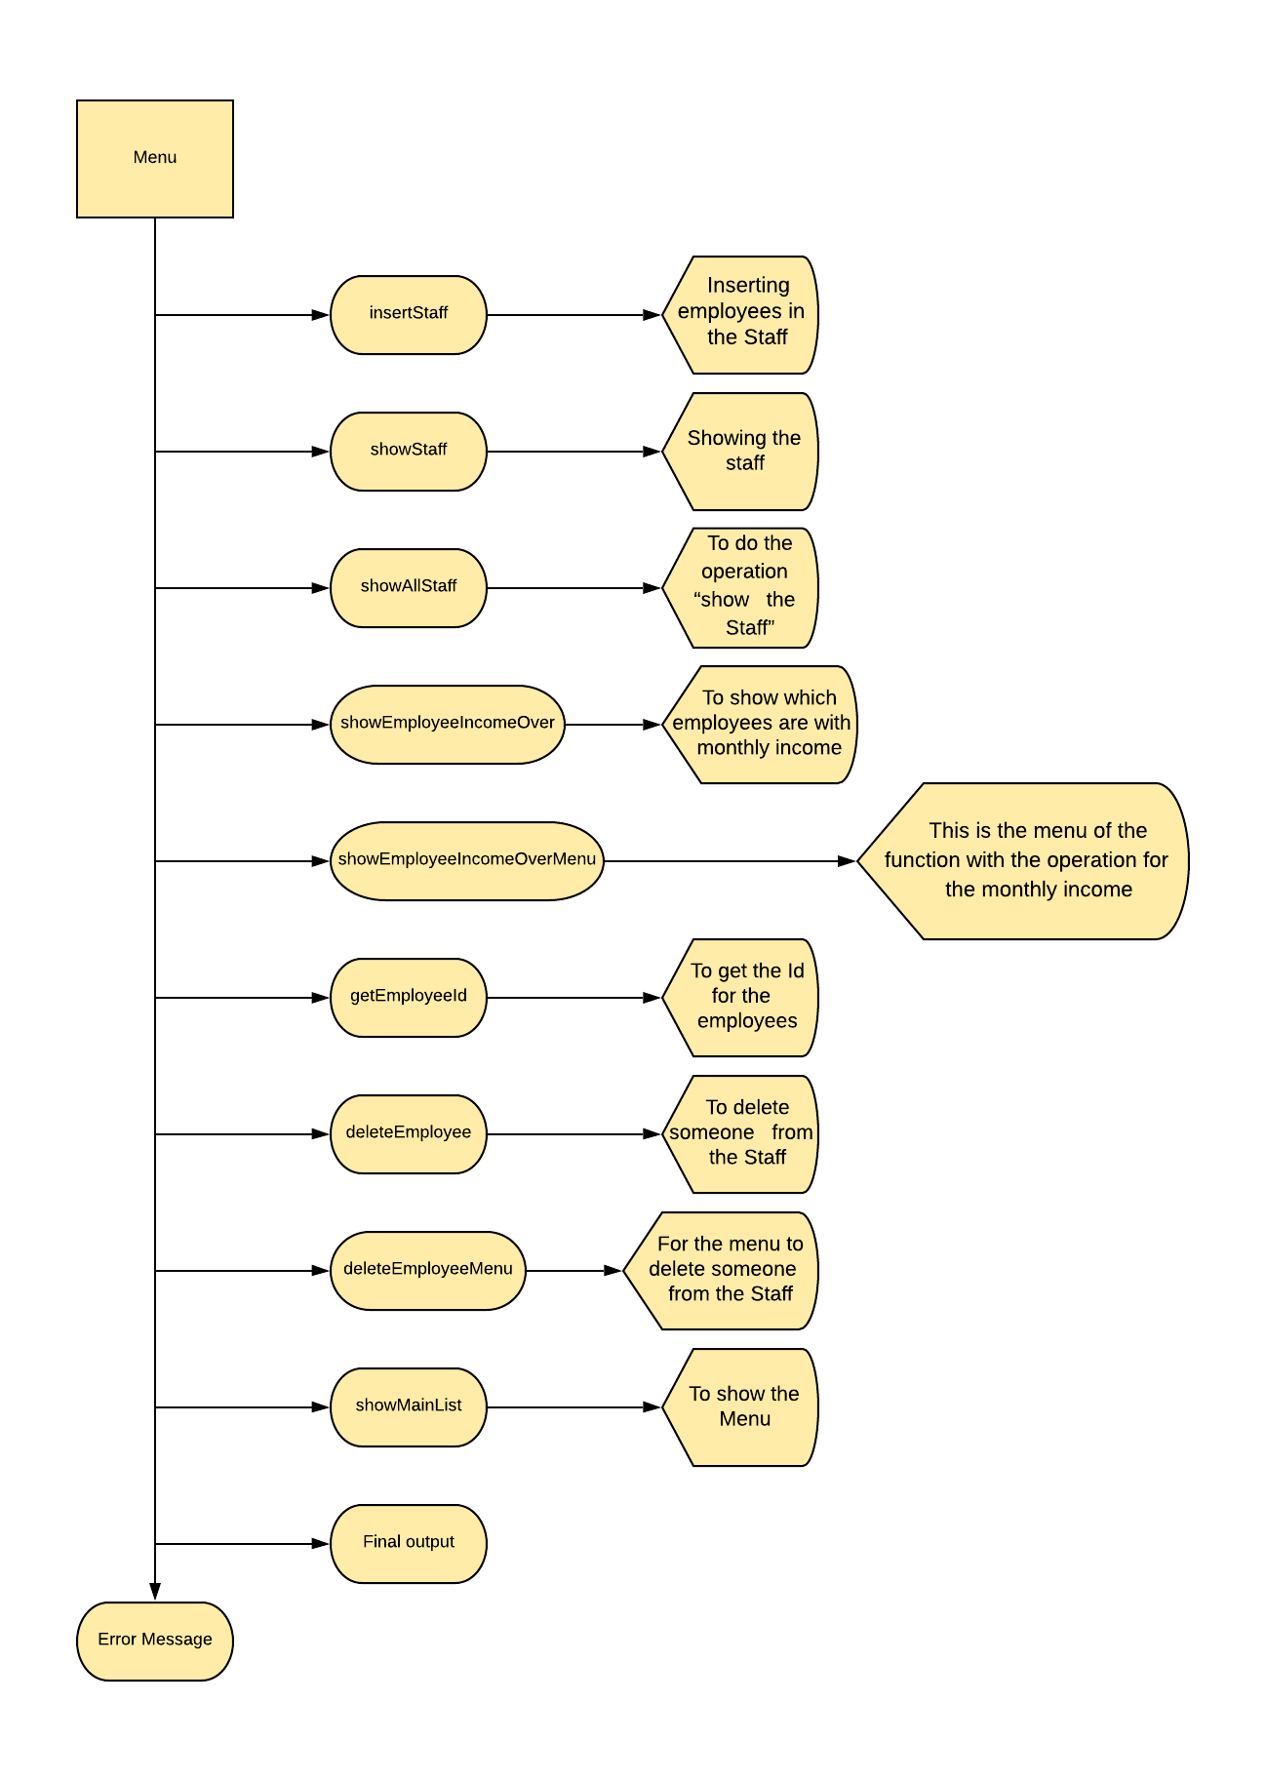

Functions

1. *Description of arguments: type and purpose of the corresponding parameter.*

|  |  |
| --- | --- |
| **Type of the corresponding parameter** | **Purpose** |
| Parameter “Employee” from struct STAFF Initialized as an array | To conserve the data in the Staff |
| Parameter “EmployeeCount”- type integer and pseudonym | To count how many employees are in the Staff |
| Parameter “MaxId” - pseudonym and type integer | To conserve employee’s ID in the Staff |
| Parameter “income” – type integer | Condition for showing the revenue sought |
| Parameter “Id” - type integer | For the “delete” function |

1. *The type of return value and for what purpose it will be used in the program.*

|  |  |
| --- | --- |
| **Return values** | **Purpose** |
| “ Return maxId ” - type integer | To generate the ID |
| “ Return ‘I’ ” – from cycle for getting employee’s ID | To get employee’s ID |
| Return ‘false’ and return ‘true’ are also return values from the function “showMainList” | |