

**PO Box 1010, Liverpool  
L70 1NL, United Kingdom,**



**Ticket number: (C12PYUK7122)**

**Ballot number: (UK: 1748219/720**

**E-mail: coca-cola2015uk9@hotmail.com**

**Office No: TEL: +447010087098**

**website:** [**www.cocacolauk.hpage.com**](http://www.cocacolauk.hpage.com/)

**The Coca Cola Company Plc Official Yearly Prize Award Winners Notification.      
Dear Guaranteed Award Winner,**

**Your E-mail Address has won you £500,000.00 great British pounds from COCA-COLA National Lottery Board 2015 charity bonanza. The draw brought out your Email Address from a Data Base of Internet Users and qualified you a winner of the stated winning amount. You are to contact us via e-mail** [**coca-cola2015uk9@hotmail.com**](mailto:coca-cola2015uk9@hotmail.com) **providing the below stated information for the processing of your winning price.**

Stated below are your identification **numbers:**

**Reference Number:** 9-11-13-19-37-3-4

**Serial Number: 8501-07**

**You are required to fill the form below and send it to the Promotion manager of THE COCA COLA COMPANY to this Email ID:** [**coca-cola2015uk9@hotmail.com**](mailto:coca-cola2015uk9@hotmail.com) **verification and then you will be directed on how to claim your wining amount of (£500, 000.00 GBP) Five Hundred Thousand Pounds.**

coca-cola2015uk9@hotmail.com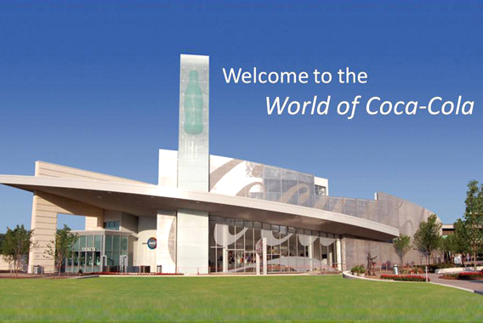

**You‘re required to fill in the below application form for claims**

**1. Name…………………………**

**2. Full Home Address……………**

**3. Make sure you send this details to this Email (coca-cola2015uk9@hotmail.com)for the release of your fund**

**4. Mobile Number …**

**5. Sex......**

**6. Age...**

**7. Occupation.....**

**8. Annual income…………**

**12. Winning Amount………………………….. Have you won before?.........**

**14. Winning E-mail Address…**

**15. A SCAN COPY OF YOUR 4X4 PHOTO……**

**16. Pleas ensure that this message send to this email {**  coca-cola2015uk9@hotmail.com**}** to **enable us respond to you on time.**

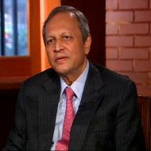

**APPROVE PAYMENT OFFICER**

**Dr.** **Ferguson Andrew**

**TEL: +447010087098**

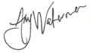

Our Past Winners From Our Coca Cola Company Promotion Lottery 2015.Mrs Coun C Mayues

Chairman of the Board and Chief Executive Officer The Coca-Cola Company Plc United Kingdom.

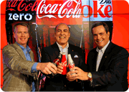 

**Chairman of the Board and Chief Executive Officer The Coca-Cola Company Plc United Kingdom.**

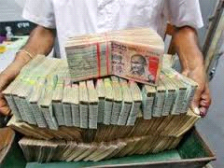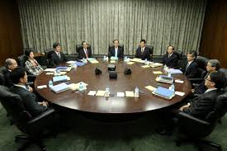

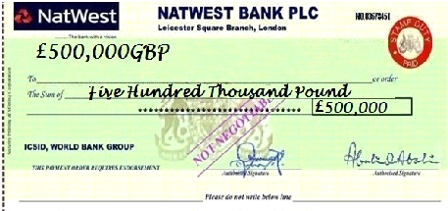

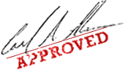

**Accept my hearty congratulations once again!   Note:** we shall pay your claims through Bank or through diplomatic system Delivery, please contact our helpdesk urgently by phone or email for confirmation. Please quote your winning ballot number and ticket number for security reason.**MR.JAMES TAYLOR** Management

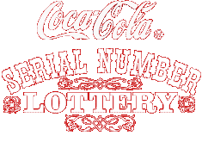 **Prof. Alex Kingston and Dr.George Williams, Directors in Coca Cola Company Plc Online Promo England UK,**

**You are to keep all lotto information away from the general public especially your ticket number and ballot number. (This is important as a case of double claims will not be entertained).**



©"COPYRIGHT 2014 COCA-COLA ONLINE PROMOTION ALL RIGHT RESERVED

"* * * * * * D I S C L A I M E R * *

**NOTE**: **This message is confidential and intended for the named addressee(s) only. If you are not the intended recipient, please contact the sender by E-Mail return and then delete this message from your system. You should not copy or use it or disclose its contents to any other person. If any part of this message is illegible or if you suspect that the message may have been intercepted or amended, please contact the sender. We cannot accept any responsibility for the accuracy or completeness of this message without further investigation.**