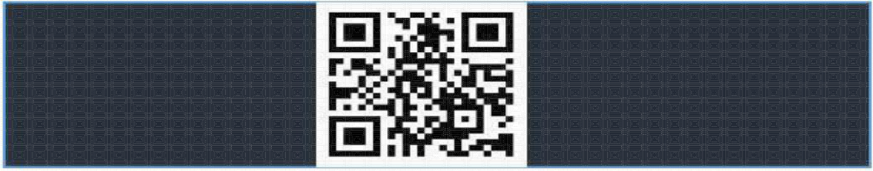

**Vishal**

**Panjeta**

# P 4/6, SSC BASERA

AFS JALAHLLI EAST

BANGALORE

# +91 85 530 65800

[vishalpanjeta@gmail.com](mailto:vishalpanjeta@gmail.com) https://github.com/VPanjeta

CAREER OBJECTIVE

*To enrich my knowledge and utilise my technical and behavioural skills for the development of the organisation and myself. Looking to work in a challenging environment that makes the most out of my abilities and people skills.*

## SYNOPSIS

A Fresher in IT sector with two successful years in an undergraduate degree for Computer Science & Engineering at

1. S. Ramaiah Inst. of Technology, Bangalore. Possess practical and theoretical knowledge of object oriented programming using C++ and python.
   * A National level Basketball player.
   * Quizzing enthusiast
   * Sports and NEWS follower.

**Github profile :** [**https://github.com/VPanjeta**](https://github.com/VPanjeta)

**TECHNICAL PROFILE**

* + Well versed in basic Machine Learning and Deep Learning concepts
  + Well versed in Data Structures, Discrete Mathematics and Algorithmic Programming
  + Well versed in OOPs using C++ and python.
  + Knowledge of Database Management in MongoDB and SQL
  + Knowledge of basic microprocessors programming(8086, ARM and MIPS)
  + Knowledge of basic android app development using Android Studio and Kivy
  + Knowledge of Web development with Flask, NodeJS, Express and Javascripting.

## INTERNSHIP EXPERIENCE

## BHARAT ELECTRONICS LIMITED (BEL SOFTWARE TECH CENTRE) [JUN 17 - JUL 17]

## Worked on developing a Multipurpose Naval Radar and simulator

## Technologies used for development : C++, Qt and OpenGL

## STRIDE.AI [AUG 2017 - PRESENT]

## Worked on automation of Natural Language tasks and Natural Language Query

## Processing using basic ML, NLP and Deep Learning Approaches

## Technologies used for development : Wordnets and words2vec in python using nltk

## PROJECTS UNDERTAKEN (*The given projects can be found at* [*https://github.com/VPanjeta*](https://github.com/VPanjeta))

## MEME CLASSIFIER

## A deep Convolution Neural Net to classify the template and type of the given meme

## MODISCRIPT

## A simple, fun and easy turing complete scripting/programming language

## Write codes in form of Prime Minister Narendra Modi’s Speeches

## DEEP LEARNING MODELS

## An implementation of Basic DL models from scratch using numpy arrays

## HOTDOG OR NOT HOTDOG

## An implementation of Not Hotdog app from Silicon Valley Season 4 episode 4

## A Deep CNN to classify images of given food as *Hotdog* or *Not Hotdog*

## SELF DRIVING CAR

## A simulation of self driving car in Udacity’s Unity Car Game model

## A deep Neural network that sees pixels on screen and uses reinforcement learning

## STYLE TRANSFER

## An AI model that repaints a given picture/painting in the style of Claude Monet

## EDUCATION

2014-Present **M. S. RAMAIAH INSTITUTE OF TECHNOLOGY**

*Bachelors in Engineering*

* + - CGPA 9.17 (After 6 Semesters)

June 2011 – **KENDRIYA VIDYALAYA UTTARLAI, BARMER, RAJASTHAN**

March 2013 *10+2 (C.B.S.E.)*

* + - Scored 85.4% marks in AISSCE board exams.
    - School captain during the session 2012-2013.

June 2006 – **ARMY PUBLIC SCHOOL KOLKATA**

March 2011 *10th (C.B.S.E.)*

* CGPA 8.6/10 .
* School basketball and Volleyball team player.

## CURRICULAR AND NON CURRICULAR ACTIVITIES AND ACHIEVEMENTS

### 1st in hackathon conducted by DreamWorks and IIIT Bangalore at ABAI Fest 2016.

* **1st SAP India Hackathon on SAPUI5 and SAP cloud HANA platform.**
* **2nd JP Morgan Chase & Co’s Code for Good 2017.**
* **All India Rank 8th (tied) in course of Design and Analysis of algorithms (2016) by NPTEL.**
* **All India Rank 1st (tied) in course of Introduction to C programming (2015) by NPTEL.**
* National finalists in TCS IT Wiz Kolkata (2010) conducted by TCS.
* 1st in General Quiz 2015 at M.S. Ramaiah Medical College and General Qiuz 2017 at NMIT
* Winners of cluster level basketball and volleyball events.

**SOFTWARE SKILLS**

LANGUAGES C/C++/Python/Java

OPERATING SYSTEM Windows, Linux

## ADDITIONAL SKILLS

* Great team member and good at teamwork.
* Great sense of humour

## FIELDS OF INTERESTS

* Utilisation and application of Deep Learning and Machine Learning concepts
* Artificial intelligence and its applications
* Working on new software and exploring new platforms..

## STRENGTHS

* Determined to learn with practical and theoretical approach.
* Readily take up responsibilities and challenge myself to make the most of myself.
* Good communication skills and a people person.
* Enthusiastic and can produce results under provided constraints.

**Name: Vishal Panjeta**

## PERSONAL DETAILS

Father's Name Rajesh Kumar

Date of Birth 30-11-1995

Sex Male

Marital Status Single

Languages known English, Hindi, Punjabi and Haryanvi

Contact on other platforms <https://vpanjeta.github.io/>