ITC 4214: Internet Programming
Dr. Leonardos Mageiros
Summer Term 2026
Evangelos Passas (315237)
Pile Of Shame Report
GitHub Repository:
https://github.com/VPassas/ITC4214-PileOfShame.git
June 16th, 2026

Introduction
Pile Of Shame is a website with the purpose to help people who purchased multiple video games titles, but never got around to playing them, manage their time and budget. This is done by letting users create an organized list of titles they mean to play in their spare time. They can add games, set priorities, mark them as beaten, filter/sort the list and see their progress. The purpose is to minimize the number of games purchased and not played, which in turn will benefit both the time and the money of the client.
The website is built with JavaScript and Bootstrap, is fully responsive, supports light/dark mode and pulls live data from a public API.

Pages
Home (index.html): This page includes a welcome section, a latest activity feature, a progress chart and live game deals through API.
Backlog (backlog.html): This page comes with add/delete/edit/complete game buttons, filter, sort and summary counts.
Gaming Tips (tips.html): This is my personal page, it has a daily tip feature, a tips accordion and a random game picker.
About (about.html): This includes app info, team cards and a testimonials carousel
Contact (contact.html): This page has a contact form, a confirmation popup, a Google Map integration and social media links.

Technologies
HTML5: Markup with appropriate metadata.
CSS3 + Bootstrap 5 (via CDN): Responsive layout and components and a small
custom style.css adds the "Ember" fiery theme and the sticky footer.
Vanilla JavaScript: All DOM manipulation uses querySelector /querySelectorAll. Events use addEventListener.
Chart.js (via CDN): The progress bar chart on the Home page.
Bootstrap Icons: Social and UI icons.
localStorage: Persists the games list and the theme choice.
CheapShark API: Live game deals on the Home page.
Google Fonts (Orbitron): The heading font.

The Game Management System
The main feature of the site is the Backlog page. A game is a JavaScript object:

{
id: 1718041234567,
title: "Elden Ring",
platform: "PC",
genre: "RPG",
priority: "High",
status: "Backlog",
dateAdded: "13/6/2026"
}

All games are placed in a games array. The array is saved to localStorage so the data is maintained after the page refreshes and is shared between pages (the Home chart and activity feed use the same array).
The whole page follows the pattern of first changing the array, then saving it and then rendering the table.

Documentation of Important Decisions

JavaScript Injections
In order to avoid repeated code, each time I encountered a feature where it would require the save html segment repeated more than once, I created a .js file and after placing the html segment there, I applied it to as many pages, as many times it was needed. This technique was used for the header and footer in main.js, which is applied to every HTML form. A similar technique was also used for the team cards in about.js and on the tips dropdown in tips.js.

Backlog Page
Add: The submit event builds a new object from the inputs and sends it to the array. Event.preventDefault() stops the page from reloading.
Edit: The edit button loads the values of a gam back to the form and stores the game ID in a variable. The next submission “Updates” the game instead of “Adding” a new one.
Delete/Beat: One click on the table body will read the clicked button’s data-id and class. Delete asks for confirmation before actually deleting.
Summary: Total/Backlog/Beaten counts update on every render.
Filter/Sort: The table renders from a filtered and sorted copy of the array, without changing the original order. Priorities are also colored with Bootstrap badges and the active filter or sort button is highlighted.

Latest Activity (Home)
The Home page reads localStorage in order to get the games, sorts it by newest first using the timestamp id (b.id – a.id), keeps the latest 5 and lists them. In case there are no games, a message is shown.

Gaming Tips
Tip of the Day: A tip is chosen from an array of tips using the date, so it changes daily.
Tips dropdown: A Bootstrap accordion is generated from a data array.
Random game picked: It reads the user’s backlog from the localStorage, filters out beaten games and suggest a random one. This solves the user’s main problem of deciding what to play.

Security
In order to make user input safer, escapeHTML() was created and applied to every user input in order to disable attempts to inject scripts. This works by rendering typed inputs as plain text instead of HTML. Inputs are also trimmed and capped with maxlength.

Dark Mode
This button triggers Bootstrap’s built in data-bs-theme attribute. The choice is saved in localStorage and the button updates with regards to what it will switch to, each time.

API
The homepage uses the CheapShark API with fetch(), parsen the JSOn and creates cards with game deals. If the request fails, a message is printed instead.

Accessibility and Responsiveness
For accessibility, several steps were taken. Specifically: the alt text on images, aria-label on icon links, the hamburger menu, labels on every form input, correct heading order and a sticky footer so short pages will not look broken.
Similarly for responsiveness: Bootstrap’s grid stacks columns on small screens, the navbar collapses into a hamburger menu, the backlog table only shows the more important features on phones to avoid horizontal scrolling

Performance Audit with Chrome Lighthouse
I audited the Home page which is the most feature heavy on both desktop and mobile. The other pages follow a similar structure and contain less features so their scores are similar.
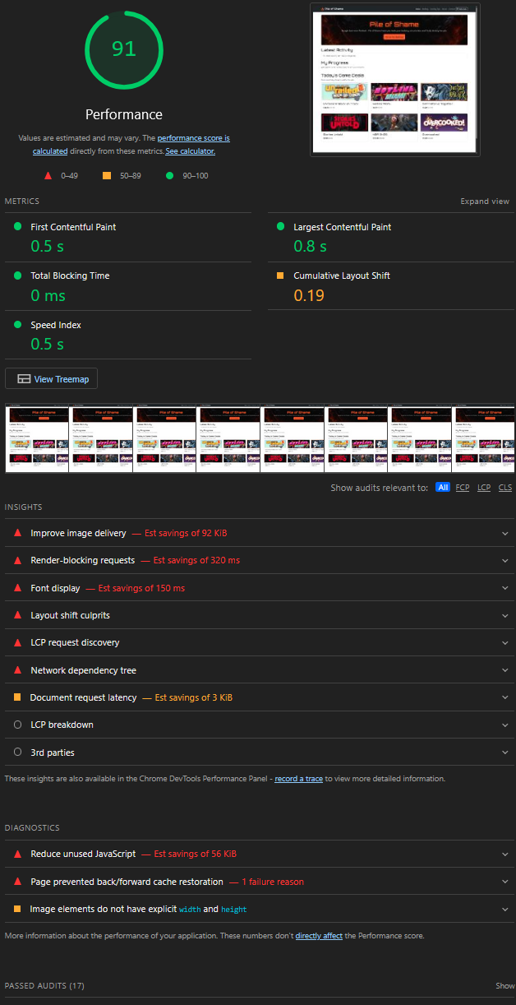
Figure 1 - Lighthouse Performance on Desktop
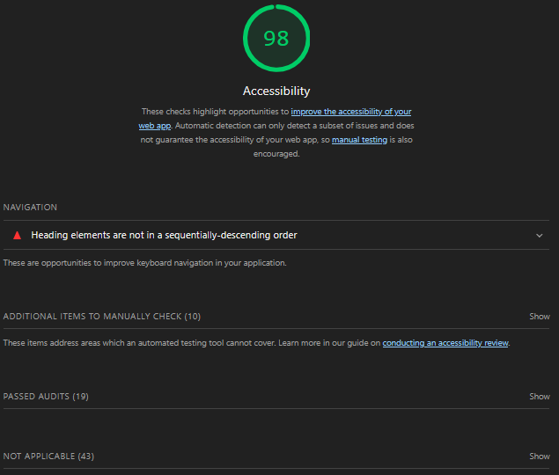
Figure 2 - Lighthouse Accessibility on Desktop

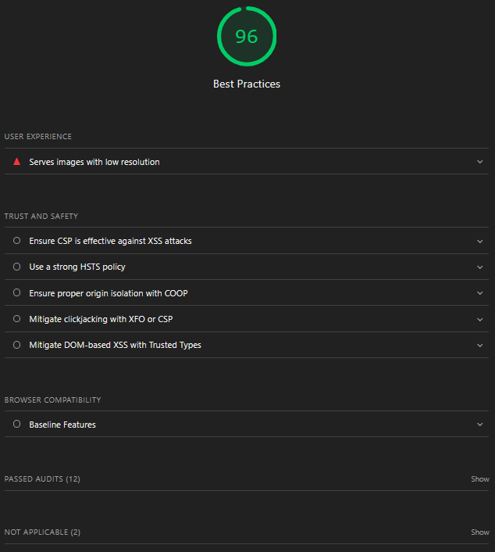
Figure 3 - Lighthouse Best Practices on Desktop

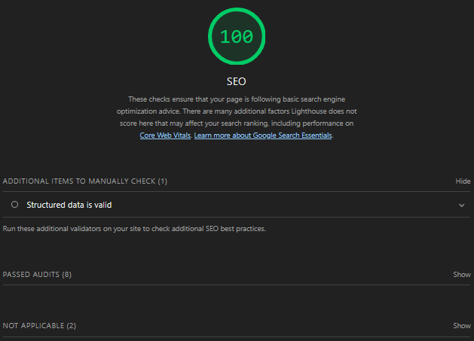
Figure 4 - Lighthouse SEO on Desktop

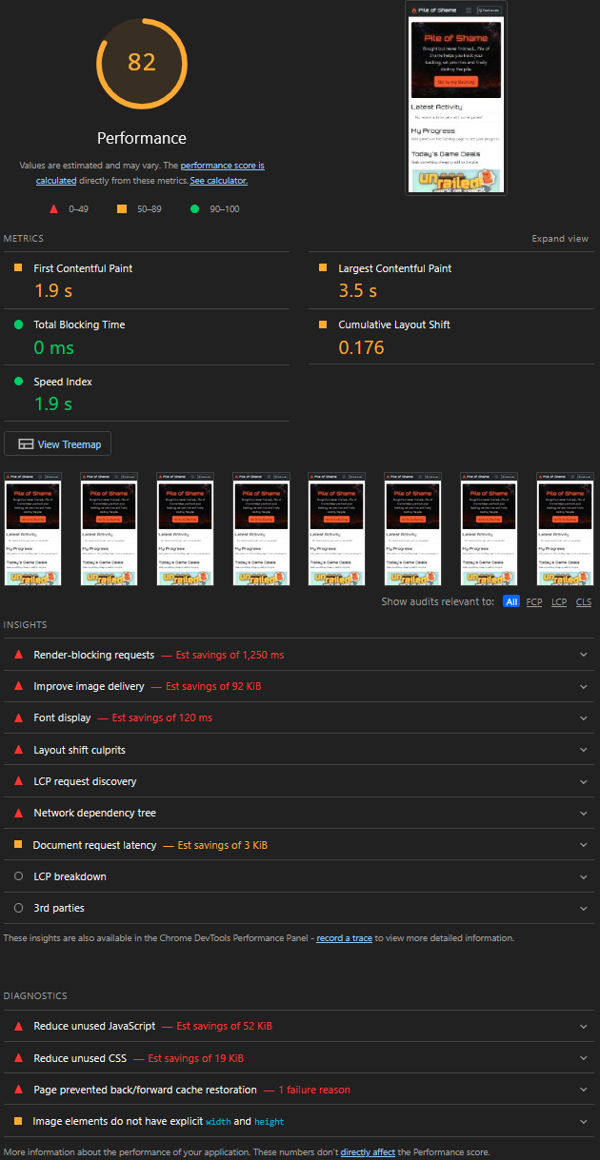
Figure 5 - Lighthouse Performance on Phone

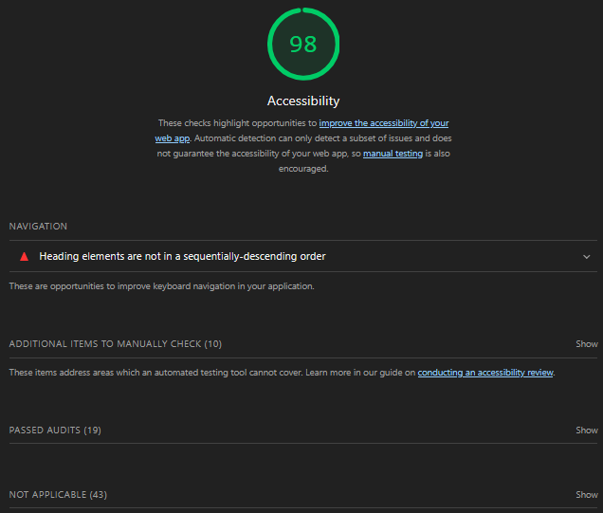
Figure 6 - Lighthouse Accessibility on Phone

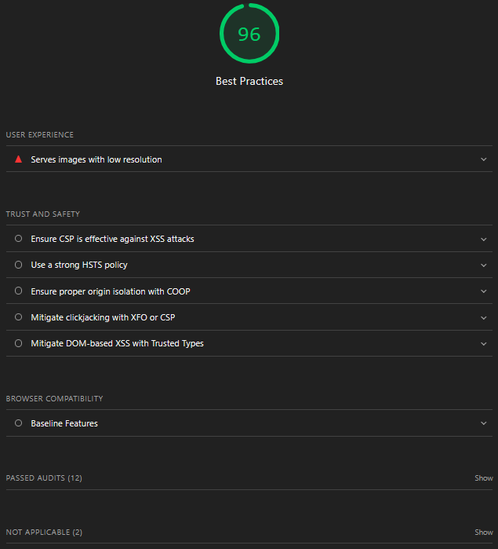
Figure 7 - Lighthouse Best Practices on Phone

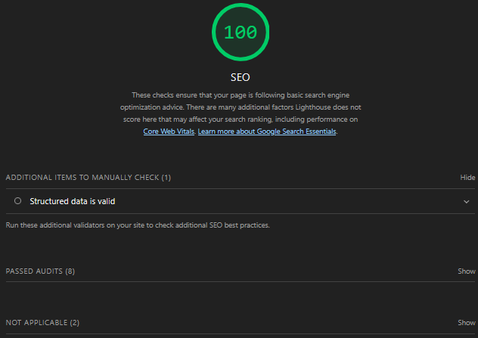
Figure 8 - Lighthouse SEO on Phones

Reflection on Lighthouse Audits
Accessibility (98): The first test I conducted flagged a low contrast button and a skipped heading level. I fixed the contrast issue by using dark text on the orange button and corrected the heading order as well, which raised the score.
Performance (82 Phones vs 91 Desktop): Lighthouse throttles the CU and network on mobile in order to simulate a slow phone, so load times are higher.
Best Practices (96): The only flag here is the image resolution, which refers to the thumbnails that CheapShark returns, which is outside of my control.

Reflections and Challenges
The first challenge that I had to overcome was the issue of minimizing duplicate code. For this I had to look up for techniques and was presented with JS injections, which solved the issue completely.
Another big issue was handling events on dynamic elements. This means that table rows, which are created at runtime, cannot support a listener for each button. To solve this I learned event delegation, which essentially means using a single listener that reads the clicked element.
Editing vs adding was another issue, to solve this I had to use an editingId to save which game was being edited.

