Mandatory Hands-On

1). Objectives

- Define SPA and its benefits
- Define React and identify its working
- Identify the differences between SPA and MPA
- Explain Pros & Cons of Single-Page Application
- Explain about React
- Define virtual DOM
- Explain Features of React

Code Implementation:

App.js

import React from 'react';

function App() {
return (
<div>
<h1>Welcome the first session of React</h1>
</div>
);
}

export default App;

Output:
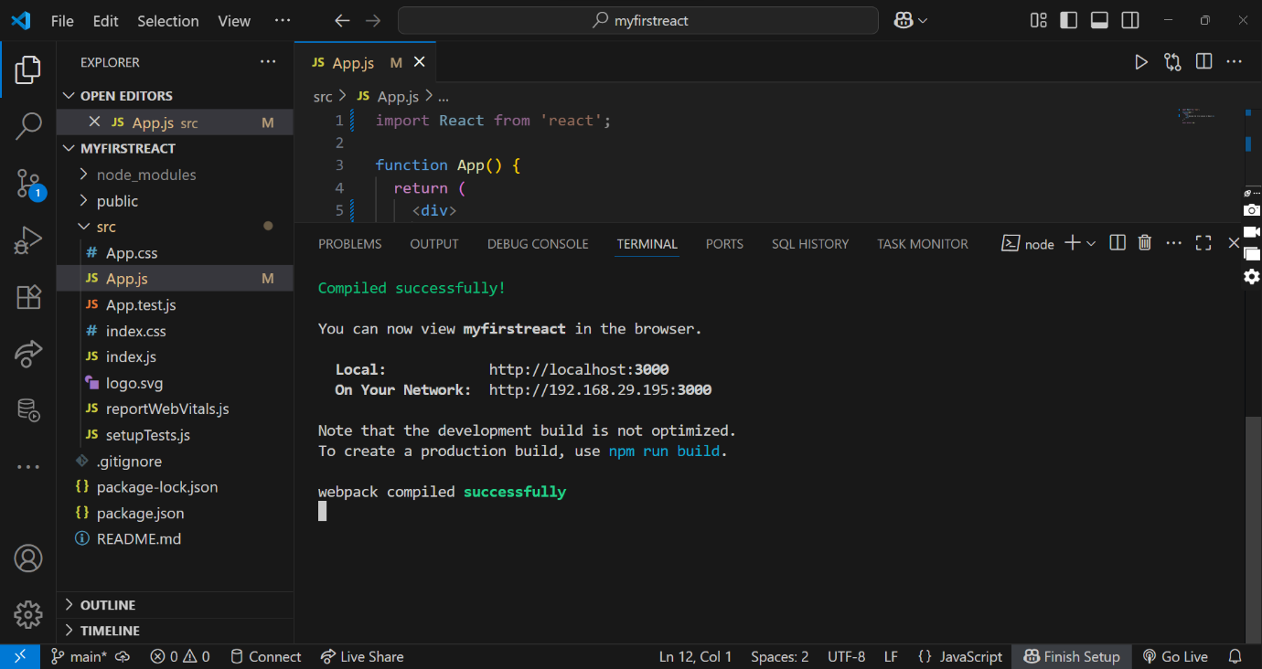

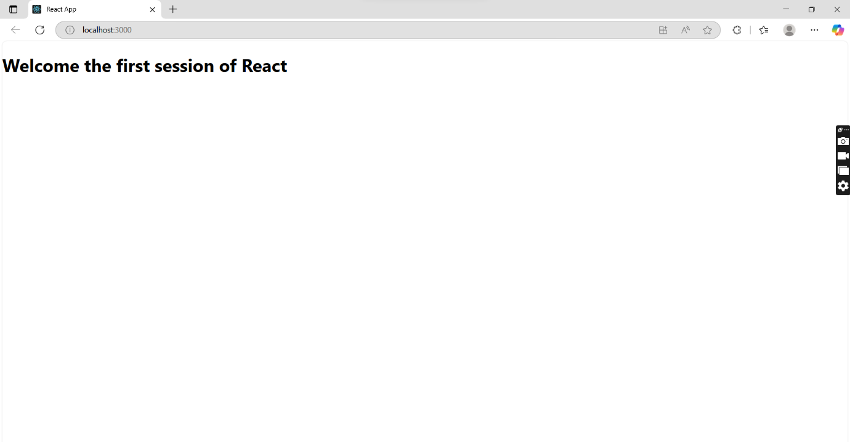

2). Objectives

- Explain React components
- Identify the differences between components and JavaScript functions
- Identify the types of components
- Explain class component
- Explain function component
- Define component constructor
- Define render() function

Code Implementation:

Home.js
import React from 'react';

class Home extends React.Component {
render() {
return (
<h1>Welcome to the Home page of Student Management Portal</h1>
);
}
}

export default Home;

About.js
import React from 'react';

class About extends React.Component {
render() {
return (
<h1>Welcome to the About page of Student Management Portal </h1>
);
}
}

export default About;

Contact.js

import React from 'react';

class Contact extends React.Component {
render() {
return (
<h1>Welcome to the Contact page of Student Management Portal </h1>
);
}
}

export default Contact;

App.js

import React from 'react';
import Home from './Components/Home';
import About from './Components/About';
import Contact from './Components/Contact';

function App() {
return (
<div>
<Home />
<About />
<Contact />
</div>
);
}

export default App;

Output:
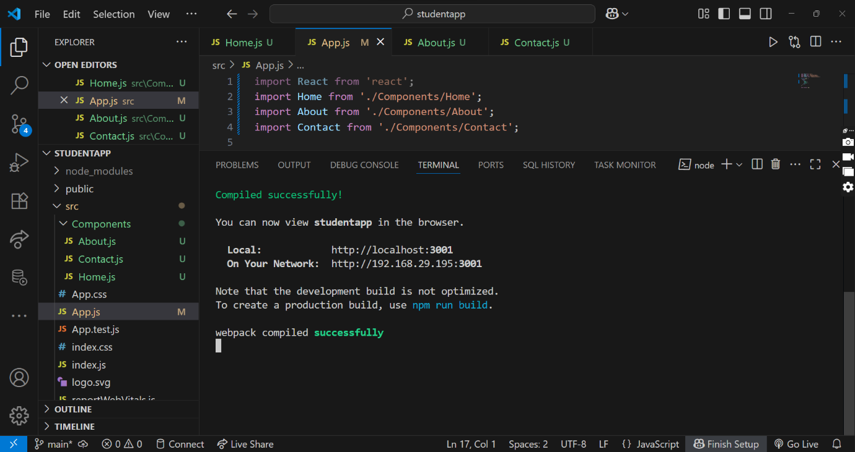

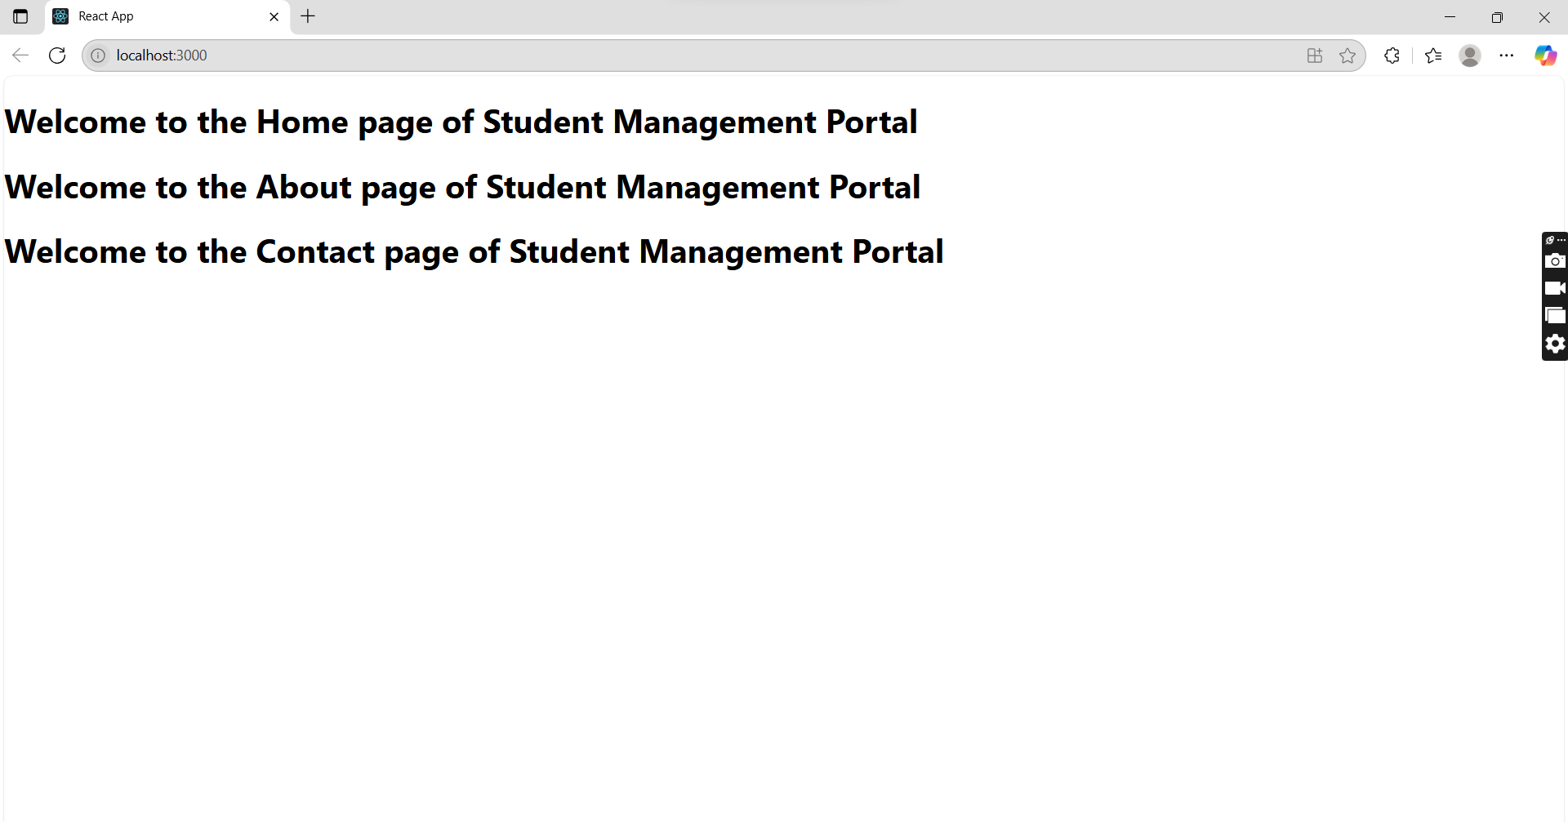

3). Objectives

- Explain React components
- Identify the differences between components and JavaScript functions
- Identify the types of components
- Explain class component
- Explain function component
- Define component constructor
- Define render() function

Create a react app for Student Management Portal named scorecalculatorapp and create a function component named “CalculateScore” which will accept Name, School, Total and goal in order to calculate the average score of a student and display the same.

Code Implementation:

CalculateScore.js

import React from 'react';

function CalculateScore() {
const name = "Carol Denvers";
const school = "DAV public School";
const total = 590;
const goal = 600;

const average = (total / goal) * 100;

return (
<div>
<h2>Student Score Details</h2>
<p><strong>Name:</strong> {name}</p>
<p><strong>School:</strong> {school}</p>
<p><strong>Total Marks:</strong> {total}</p>
<p><strong>Goal Marks:</strong> {goal}</p>
<p><strong>Average Score:</strong> {average.toFixed(2)}%</p>
</div>
);
}

export default CalculateScore;

App.js

import React from 'react';
import './App.css';
import CalculateScore from './Components/CalculateScore';

function App() {
return (
<div className="App">
<h1 style={{ color: '#2c3e50', marginTop: '20px' }}>
Student Score Calculator
</h1>

<div>
<CalculateScore />
</div>
</div>
);
}

export default App;

Output:
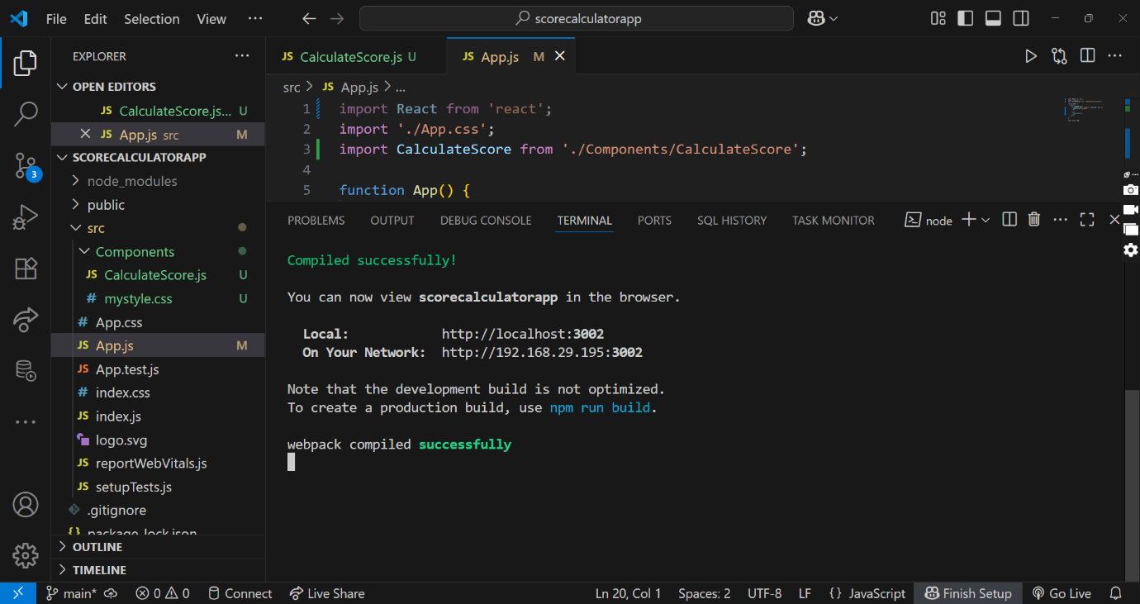

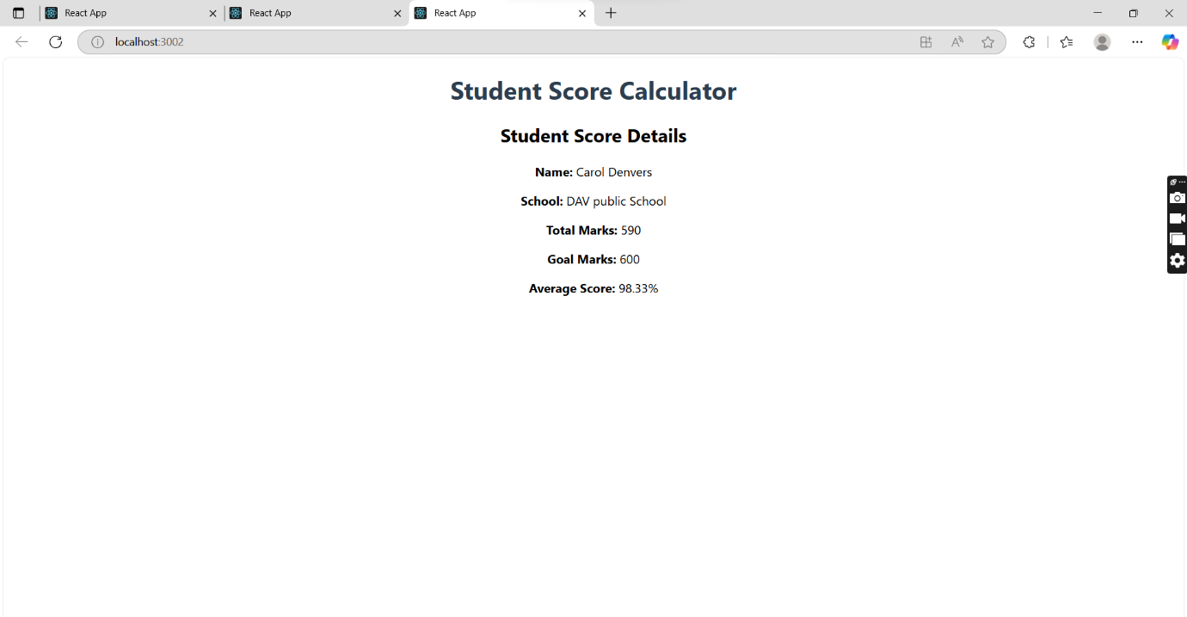

4). Objectives
- Explain the need and Benefits of component life cycle
- Identify various life cycle hook methods
- List the sequence of steps in rendering a component

Create a new react application using create-react-app tool with the name as “blogapp”

Code Implementation:

Post.js

import React from 'react';
import Post from './Post';

class Posts extends React.Component {
constructor(props) {
super(props);
this.state = {
posts: []
};
}

loadPosts() {
fetch('https://jsonplaceholder.typicode.com/posts')
.then(response => response.json())
.then(data => {
const postsList = data.map(post => new Post(post.id, post.title, post.body));
this.setState({ posts: postsList });
})
.catch(error => {
console.error("Error fetching posts:", error);
alert("Failed to fetch posts.");
});
}

componentDidMount() {
this.loadPosts();
}

componentDidCatch(error, info) {
alert("An error occurred: " + error.toString());
}

render() {
return (
<div>
<h1>Posts</h1>
{this.state.posts.map(post => (
<div key={post.id} style={{ marginBottom: '20px' }}>
<h3>{post.title}</h3>
<p>{post.body}</p>
</div>
))}
</div>
);
}
}

export default Posts;

Posts.js

import React from 'react';
import Post from './Post';

class Posts extends React.Component {
constructor(props) {
super(props);
this.state = {
posts: []
};
}

loadPosts() {
fetch('https://jsonplaceholder.typicode.com/posts')
.then(response => response.json())
.then(data => {
const postsList = data.map(post => new Post(post.id, post.title, post.body));
this.setState({ posts: postsList });
})
.catch(error => {
console.error("Error fetching posts:", error);
alert("Failed to fetch posts.");
});
}

componentDidMount() {
this.loadPosts();
}

componentDidCatch(error, info) {
alert("An error occurred: " + error.toString());
}

render() {
return (
<div style={{ padding: '20px' }}>
<h1>Blog Posts</h1>
{this.state.posts.map(post => (
<div key={post.id} style={{ marginBottom: '20px', borderBottom: '1px solid #ccc' }}>
<h3>{post.title}</h3>
<p>{post.body}</p>
</div>
))}
</div>
);
}
}

export default Posts;

App.js

import React from 'react';
import Posts from './Posts';

function App() {
return (
<div className="App">
<Posts />
</div>
);
}

export default App;

Output:
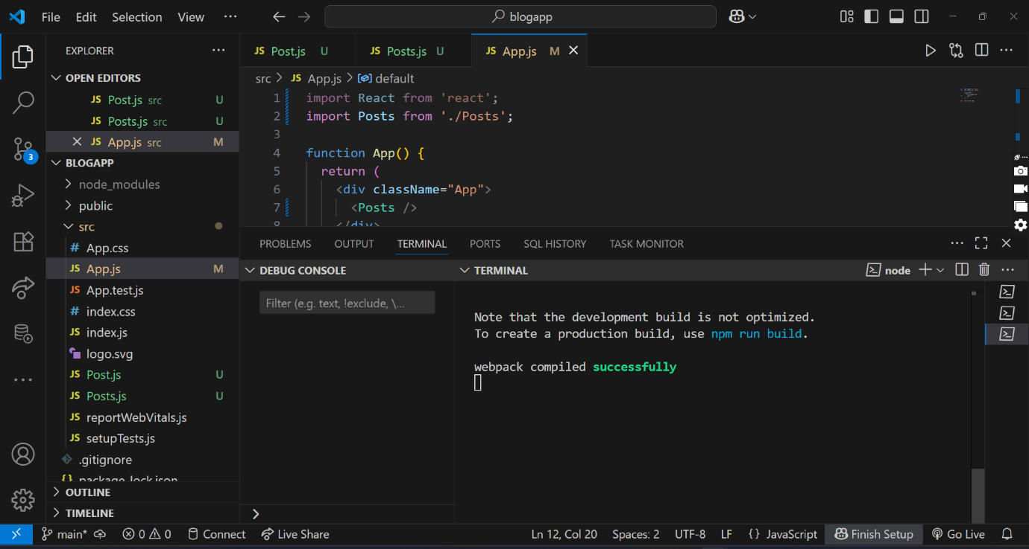

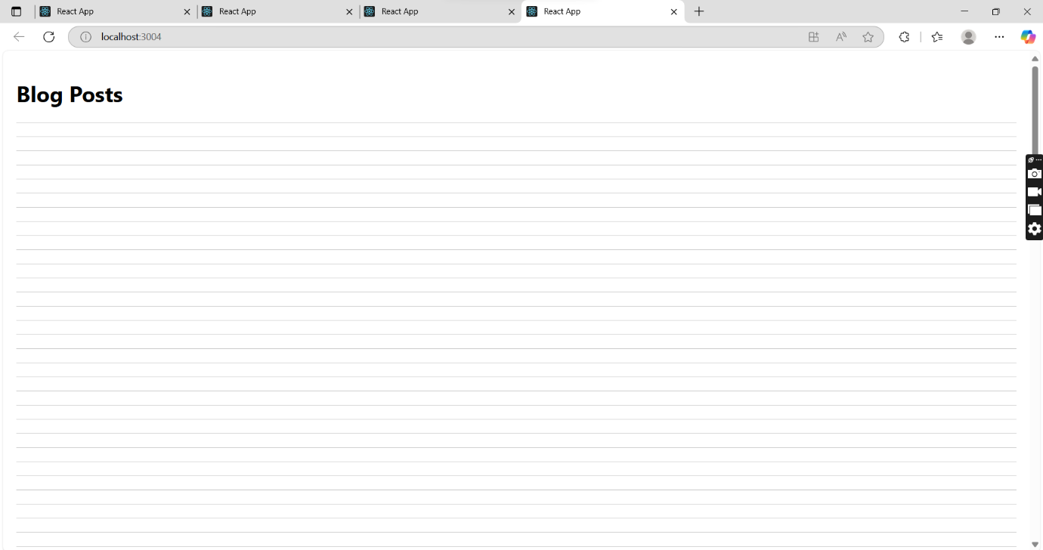

5). Objectives
- Understanding the need for styling react component
- Working with CSS Module and inline styles

- Style a react component
- Define styles using the CSS Module
- Apply styles to components using className and style properties

My Academy team at Cognizant want to create a dashboard containing the details of ongoing and completed cohorts. A react application is created which displays the detail of the cohorts using react component. You are assigned the task of styling these react components.

Code Implementation

data.js

const cohorts = [
{
id: 1,
name: "INTADMDF10 - .NET FSD",
startDate: "22-Feb-2022",
status: "Scheduled",
coach: "Aathma",
trainer: "Jojo Jose",
},
{
id: 2,
name: "ADM21JF014 - Java FSD",
startDate: "10-Sep-2021",
status: "Ongoing",
coach: "Apoorv",
trainer: "Elisa Smith",
},
{
id: 3,
name: "CDBJF21025 - Java FSD",
startDate: "24-Dec-2021",
status: "Ongoing",
coach: "Aathma",
trainer: "John Doe",
}
];

export default cohorts;

CohortDetails.module.css

.box {
width: 300px;
display: inline-block;
margin: 10px;
padding: 10px 20px;
border: 1px solid black;
border-radius: 10px;
}

dt {
font-weight: 500;
}

CohortDetails.js

import React from "react";
import styles from "./CohortDetails.module.css";

const CohortDetails = ({ data }) => {
return (
<div>
<h2>Cohorts Details</h2>
{data.map((cohort) => (
<div key={cohort.id} className={styles.box}>
<h3
style={{
color: cohort.status === "Ongoing" ? "green" : "blue"
}}
>
{cohort.name}
</h3>
<dl>
<dt>Started On</dt>
<dd>{cohort.startDate}</dd>

<dt>Current Status</dt>
<dd>{cohort.status}</dd>

<dt>Coach</dt>
<dd>{cohort.coach}</dd>

<dt>Trainer</dt>
<dd>{cohort.trainer}</dd>
</dl>
</div>
))}
</div>
);
};

export default CohortDetails;

index.html

<!DOCTYPE html>
<html lang="en">
<head>
<meta charset="UTF-8" />
<title>Cohort Tracker</title>
</head>
<body>
<div id="root"></div>
</body>
</html>

index.js

import React from "react";
import ReactDOM from "react-dom/client";
import App from "./App";

const root = ReactDOM.createRoot(document.getElementById("root"));
root.render(<App />);

App.js

import React from "react";
import CohortDetails from "./components/CohortDetails";
import cohortData from "./data";

function App() {
return (
<div className="App">
<CohortDetails data={cohortData} />
</div>
);
}

export default App;

Output:

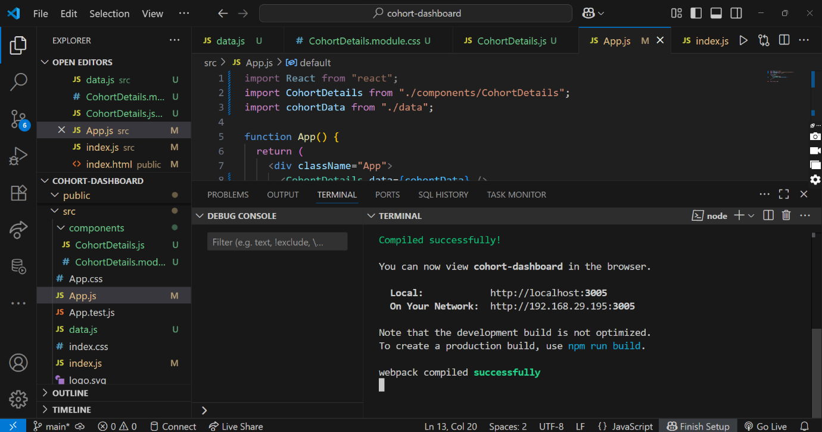

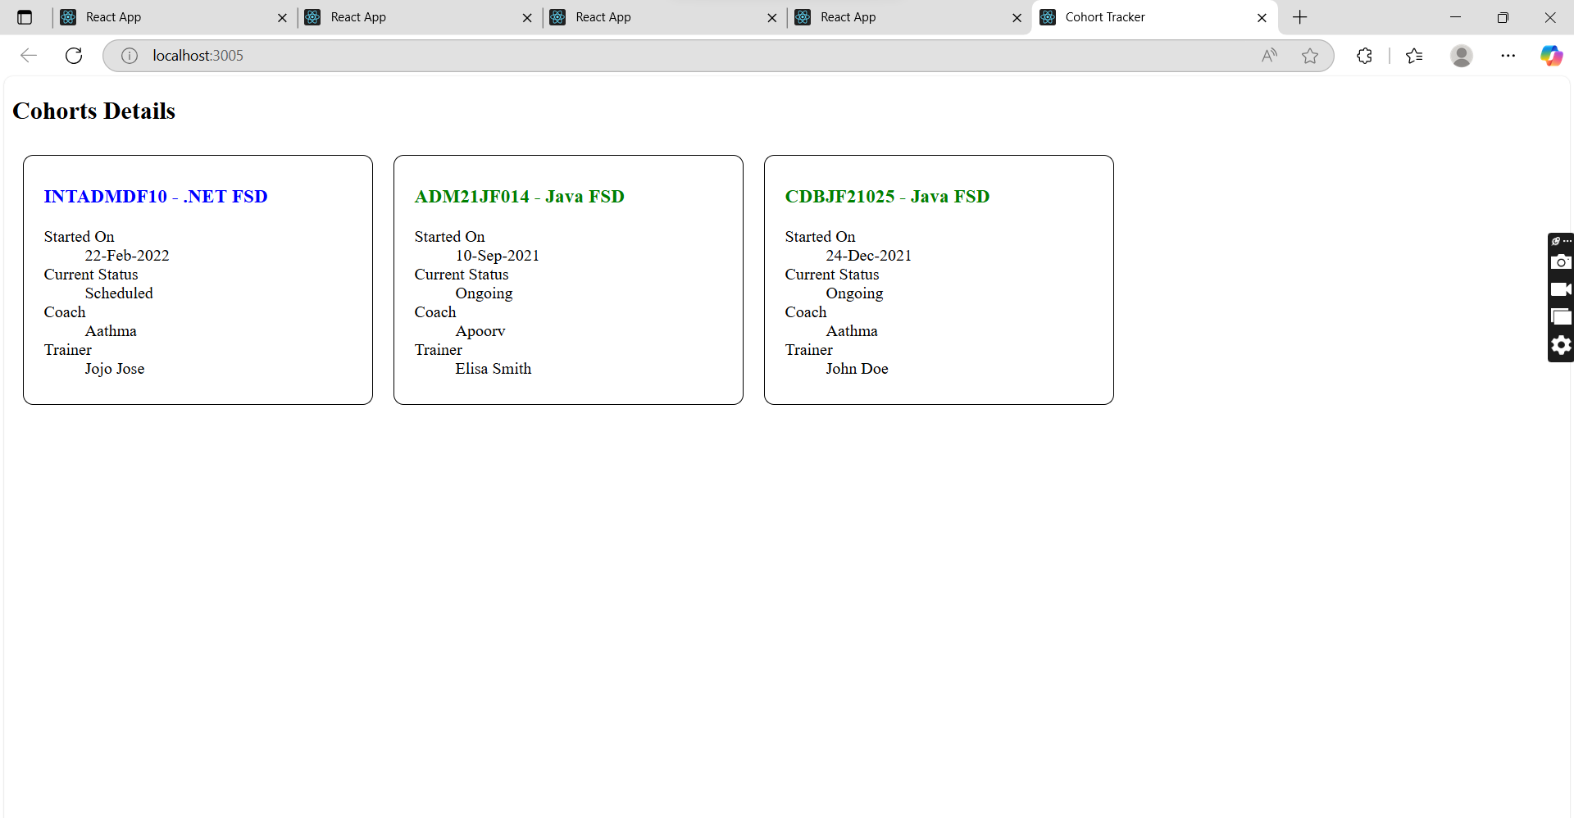

Additional Important Hands-on

6). Objectives
- Explain the need and benefits of React Router
- Identify the Components in React Router
- List the types of Router Components
- Parameter passing via url

Cognizant Academy teams want to maintain a list of trainers along with their expertise in a SPA using React as the technology. You are assigned the task of creating this React app.
The following trainers’ data application will deal.
- T-ID
- Name
- Phone
- Email
- Stream
- Skills

Code Implementation:

Trainers.js

export default class Trainer {
constructor(id, name, email, phone, tech, skills) {
this.trainerId = id;
this.name = name;
this.email = email;
this.phone = phone;
this.technology = tech;
this.skills = skills;
}
}

TrainersMock.js

import Trainer from "./Trainer";

const trainersMock = [
new Trainer(
"t-syed8",
"Syed Khaleelullah",
"khaleelullah@cognizant.com",
"97676516962",
".NET",
["C#", "SQL Server", "React", ".NET Core"]
),
new Trainer(
"t-jojo",
"Jojo Jose",
"jojo@cognizant.com",
"9897199231",
"Java",
["Java", "JSP", "Angular", "Spring"]
),
new Trainer(
"t-elisa",
"Elisa Jones",
"elisa@cognizant.com",
"9871212235",
"Python",
["Python", "Django", "Angular"]
),
];

export default trainersMock;

Home.js
import React from "react";

function Home() {
return (
<div>
<h2>Welcome to My Academy trainers page</h2>
</div>
);
}

export default Home;

TrainerList.js
import React from 'react';
import { Link } from 'react-router-dom';

function TrainerList({ trainers }) {
return (
<div>
<h2>Trainer List</h2>
<ul>
{trainers.map((trainer) => (
<li key={trainer.trainerId}>
<Link to={`/trainer/${trainer.trainerId}`}>{trainer.name}</Link>
</li>
))}
</ul>
</div>
);
}

export default TrainerList;

TrainerList.js

import React from "react";
import { useParams } from "react-router-dom";
import trainersMock from "../TrainersMock";

function TrainerDetails() {
const { id } = useParams();
const trainer = trainersMock.find((t) => t.trainerId === id);

if (!trainer) return <p>Trainer not found</p>;

return (
<div>
<h3>Trainers Details</h3>
<strong>{trainer.name} ({trainer.technology})</strong><br />
<span>{trainer.email}</span><br />
<span>{trainer.phone}</span>
<ul>
{trainer.skills.map((skill, idx) => (
<li key={idx}>{skill}</li>
))}
</ul>
</div>
);
}

export default TrainerDetails;

App.js
import React from "react";
import { BrowserRouter, Routes, Route, Link, Navigate } from "react-router-dom";
import Home from "./components/Home";
import TrainerList from "./components/TrainerList";
import TrainerDetails from "./components/TrainerDetails";
import trainersMock from "./TrainersMock";

function App() {
return (
<BrowserRouter>
<div>
<h1>My Academy Trainers App</h1>
<nav>
<Link to="/">Home</Link> | <Link to="/trainers">Show Trainers</Link>
</nav>

<Routes>
<Route path="/" element={<Navigate to="/home" />} />
<Route path="/home" element={<Home />} />
<Route path="/trainers" element={<TrainerList trainers={trainersMock} />} />
<Route path="/trainer/:id" element={<TrainerDetails />} />
</Routes>
</div>
</BrowserRouter>
);
}

export default App;

index.js

import React from "react";
import ReactDOM from "react-dom/client";
import App from "./App";

const root = ReactDOM.createRoot(document.getElementById("root"));
root.render(<App />);

Output:
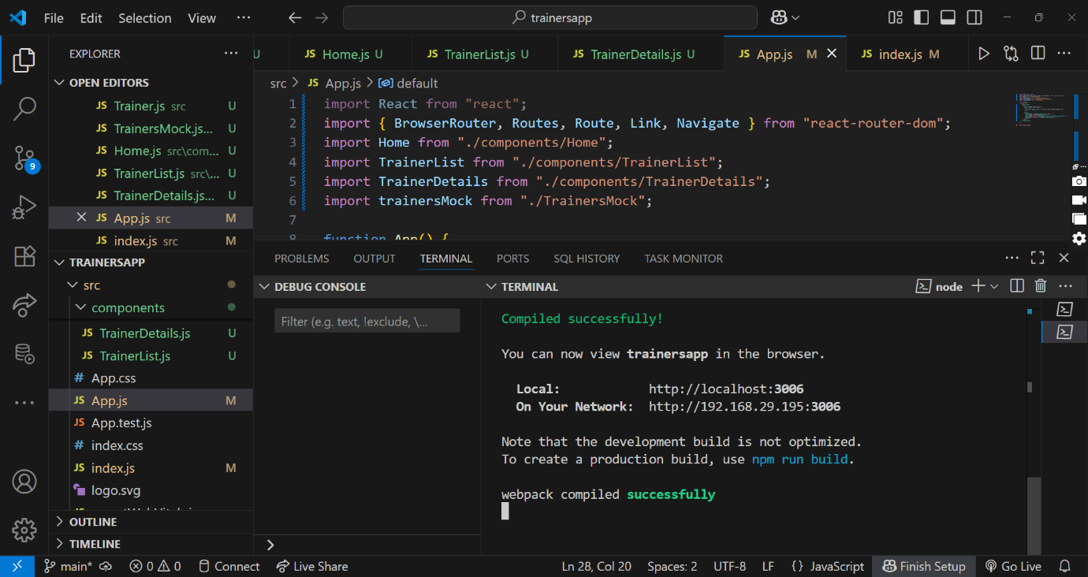

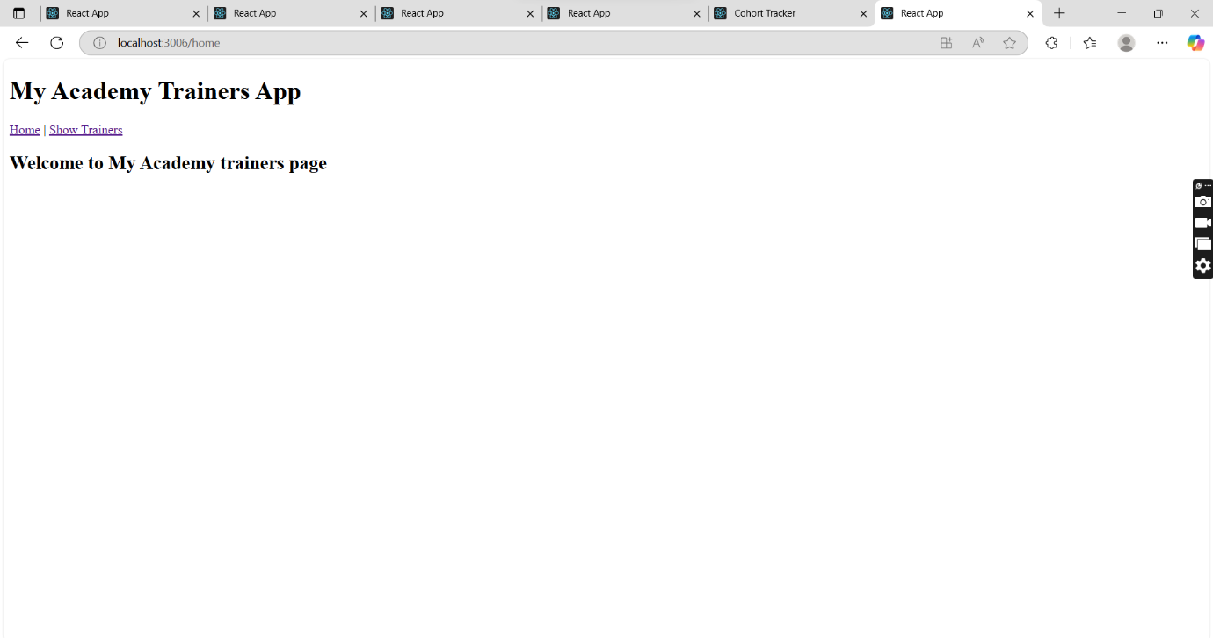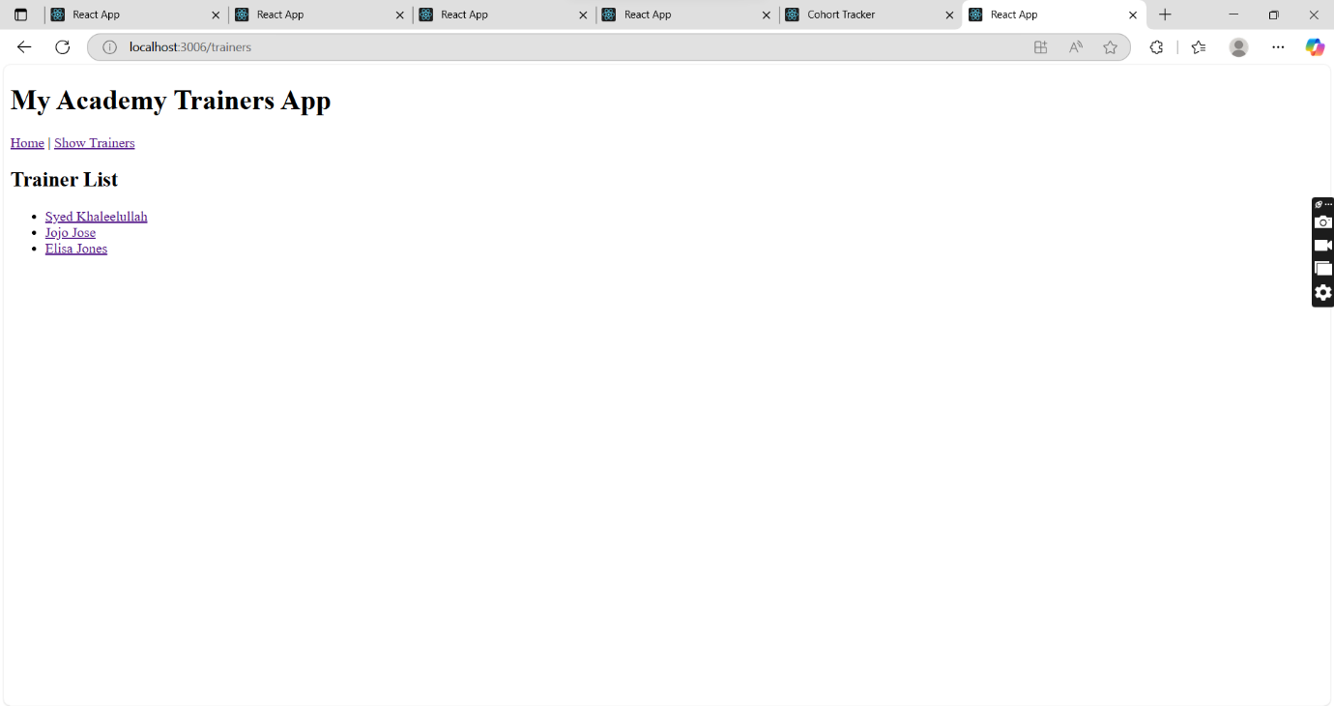

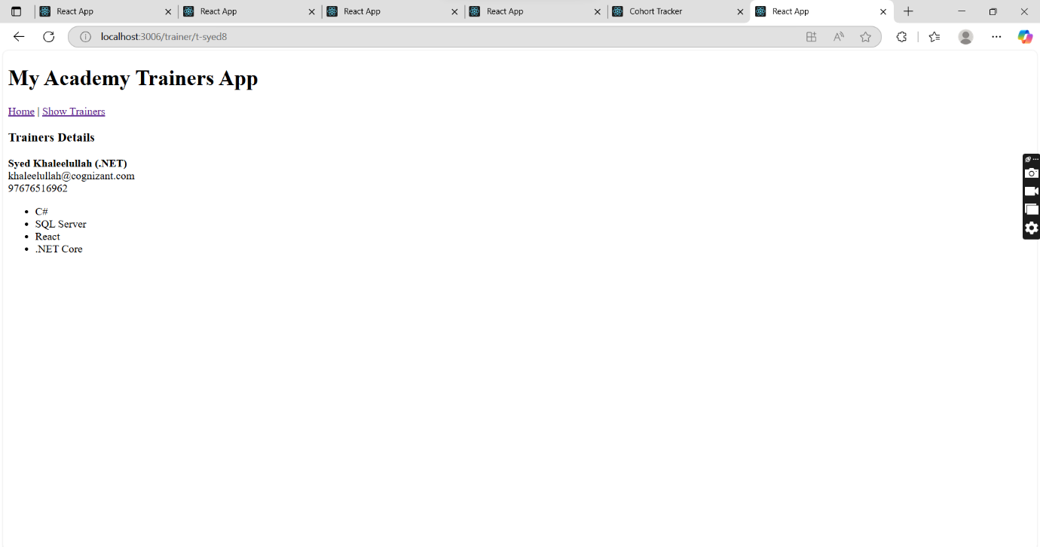

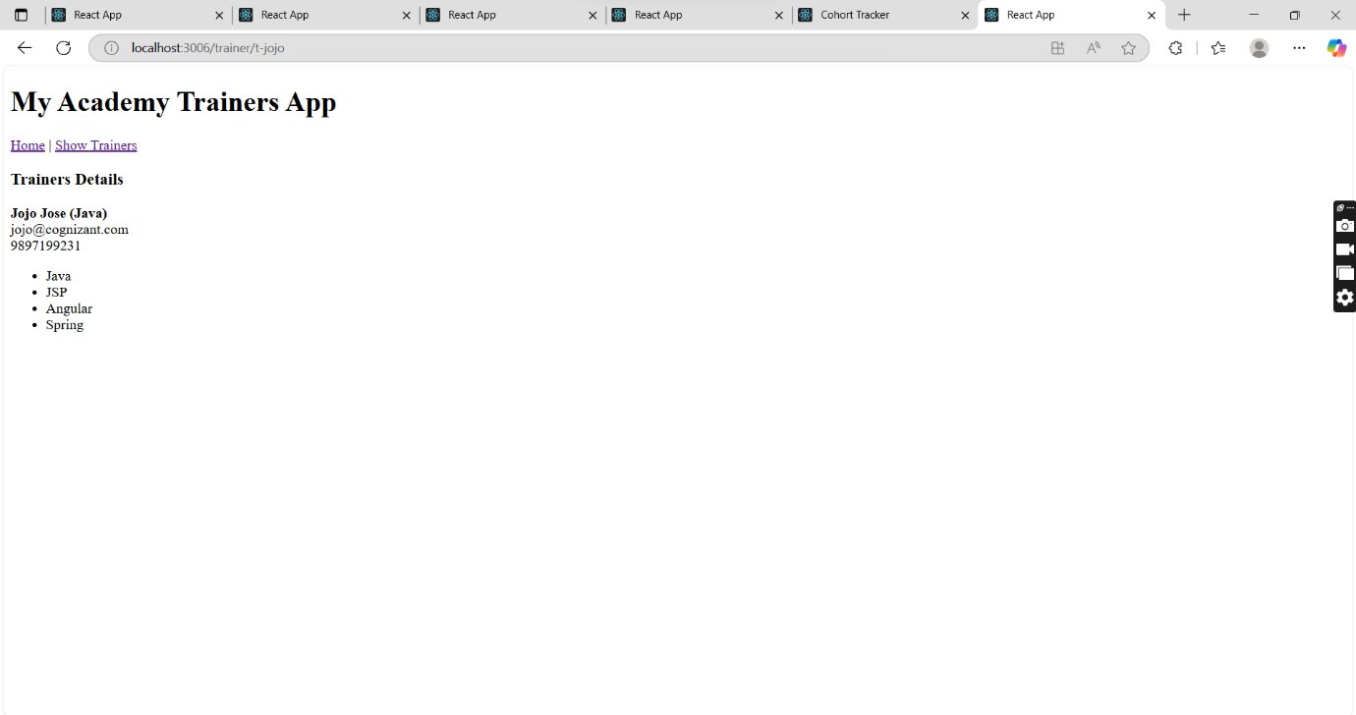
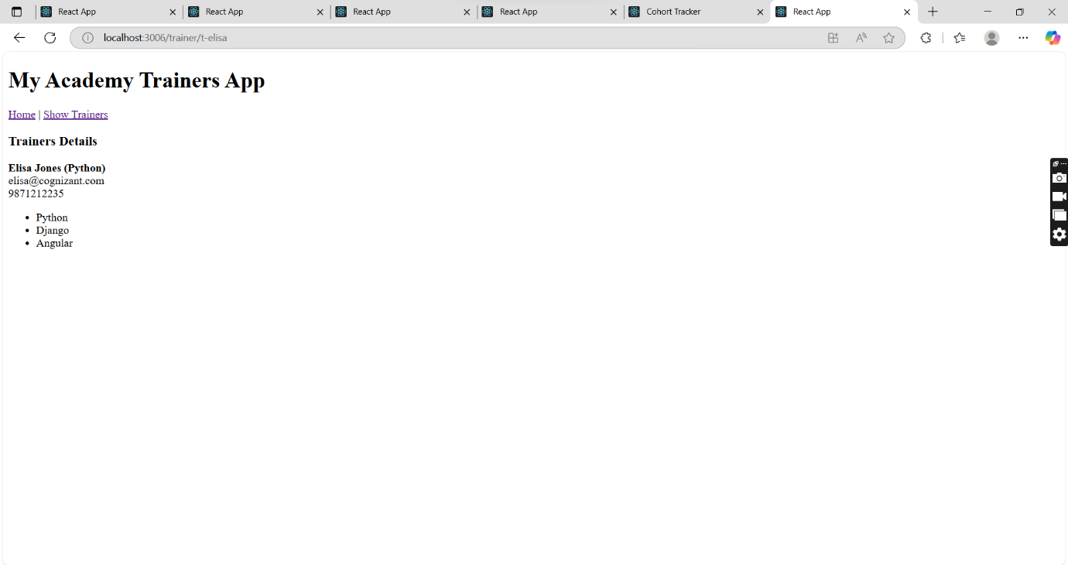

7). Objectives

- Define Props
- Explain Default Props
- Identify the differences between State and Props
- Explain reactDOM.render()

Create a React Application named “shoppingapp” with a class component named “OnlineShopping” and “Cart”.

Code Implementation:

Cart.js

import React, { Component } from 'react';

class Cart extends Component {
render() {
return (
<table border="1" align="center">
<thead>
<tr>
<th>Name</th>
<th>Price</th>
</tr>
</thead>
<tbody>
{this.props.item.map((item, index) => (
<tr key={index}>
<td>{item.itemname}</td>
<td>{item.price}</td>
</tr>
))}
</tbody>
</table>
);
}
}

export default Cart;

App.js

import React, { Component } from 'react';
import Cart from './Cart';

class OnlineShopping extends Component {
render() {
const CartInfo = [
{ itemname: "Laptop", price: 80000 },
{ itemname: "TV", price: 120000 },
{ itemname: "Washing Machine", price: 50000 },
{ itemname: "Mobile", price: 30000 },
{ itemname: "Fridge", price: 70000 }
];

return (
<div className="mydiv" style={{ textAlign: "center", color: "green" }}>
<h1>Items Ordered :</h1>
<Cart item={CartInfo} />
</div>
);
}
}

export default OnlineShopping;

Output:
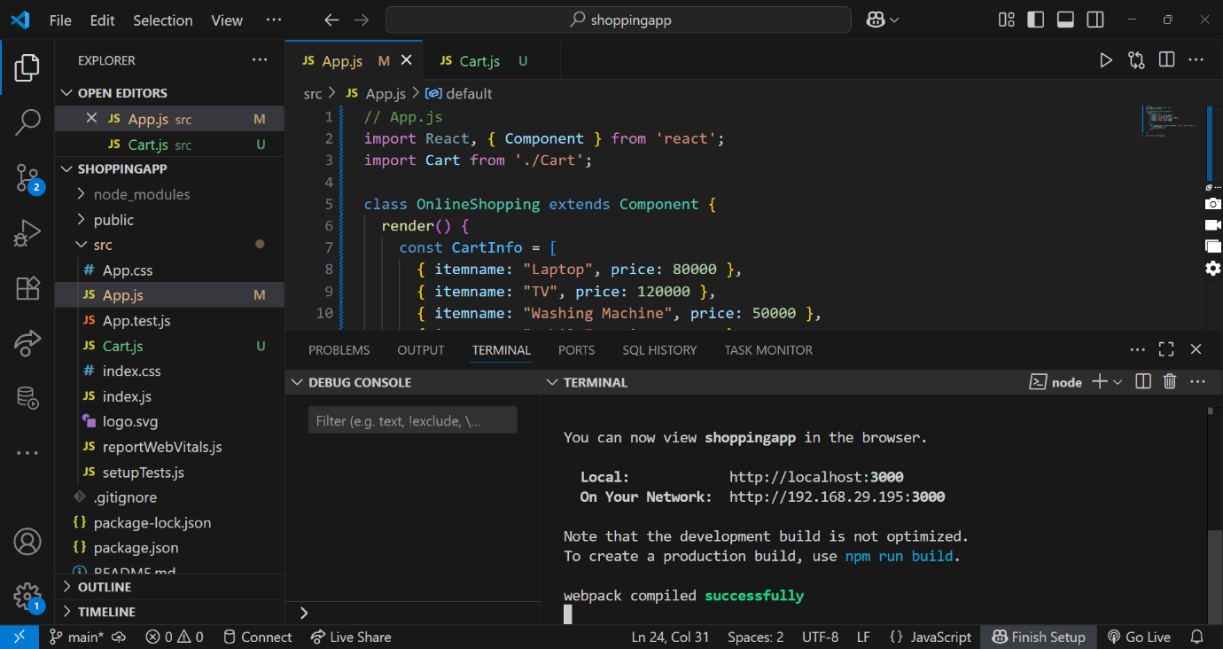

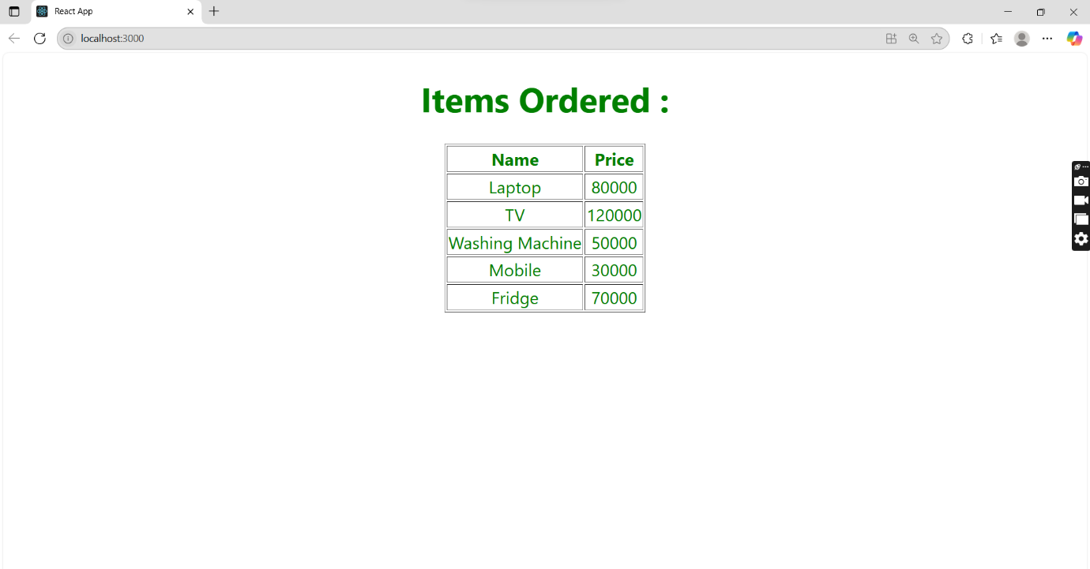

8). Objectives

- Explain React State

In this hands-on lab, you will learn how to:
- Use React State object

Create a React App “counterapp” which will have a component named “CountPeople” which will have 2 methods.

UpdateEntry() which will display the number of people who entered the mall.
UpdateExit() which will display the number of people who exited the mall.

Use Constructor and state to Store the entrycount and exitcount.

The component has 2 buttons
- Login when clicked, the entrycount should get incremented by 1
- Exit when clicked, the exitcount should get incremented by 1

Code Implementation:

CountPeople.js

import React, { Component } from 'react';

class CountPeople extends Component {
constructor() {
super();
this.state = {
entrycount: 0,
exitcount: 0
};
}

updateEntry = () => {
this.setState((prevState) => ({
entrycount: prevState.entrycount + 1
}));
}

updateExit = () => {
this.setState((prevState) => ({
exitcount: prevState.exitcount + 1
}));
}

render() {
return (
<div style={{ textAlign: "center", marginTop: "50px" }}>
<div style={{ display: "flex", justifyContent: "center", alignItems: "center", gap: "40px" }}>
{/* Entry Section */}
<div style={{ display: "flex", alignItems: "center", gap: "10px" }}>
<button
onClick={this.updateEntry}
style={{ backgroundColor: "green", color: "white", padding: "10px 20px", borderRadius: "5px" }}
>
Login
</button>
<span>{this.state.entrycount} People Entered!!!</span>
</div>

{/* Exit Section */}
<div style={{ display: "flex", alignItems: "center", gap: "10px" }}>
<button
onClick={this.updateExit}
style={{ backgroundColor: "green", color: "white", padding: "10px 20px", borderRadius: "5px" }}
>
Exit
</button>
<span>{this.state.exitcount} People Left!!!</span>
</div>
</div>
</div>
);
}
}

export default CountPeople;

App.js

import React from 'react';
import CountPeople from './CountPeople';

function App() {
return (
<div className="App">
<CountPeople />
</div>
);
}

export default App;

Output:

