Mandatory Hands On

Q1). Objectives

- List the features of ES6
- Explain JavaScript let
- Identify the differences between var and let
- Explain JavaScript const
- Explain ES6 class fundamentals
- Explain ES6 class inheritance
- Define ES6 arrow functions
- Identify set(), map()

In this hands-on lab, you will learn how to:
- Use map() method of ES6
- Apply arrow functions of ES6
- Implement Destructuring features of ES6

Create a React Application named “cricketapp”:

Ans.

ListOfPlayers.js

import React from 'react';

const ListOfPlayers = () => {

const players = [
{ name: 'Rohit Sharma', score: 90 },
{ name: 'Virat Kohli', score: 88 },
{ name: 'KL Rahul', score: 65 },
{ name: 'Shubman Gill', score: 70 },
{ name: 'Hardik Pandya', score: 45 },
{ name: 'Ravindra Jadeja', score: 72 },
{ name: 'Shreyas Iyer', score: 55 },
{ name: 'Rishabh Pant', score: 78 },
{ name: 'Bumrah', score: 60 },
{ name: 'Siraj', score: 35 },
{ name: 'Kuldeep Yadav', score: 82 },
];

const below70 = players.filter(player => player.score < 70);

return (
<div>
<h2>All Players</h2>
<ul>
{players.map((player, index) => (
<li key={index}>{player.name} - {player.score}</li>
))}
</ul>

<h2>Players Scoring Below 70</h2>
<ul>
{below70.map((player, index) => (
<li key={index}>{player.name} - {player.score}</li>
))}
</ul>
</div>
);
};

export default ListOfPlayers;

IndianPlayer.js

import React from 'react';

const IndianPlayers = () => {
const oddTeam = ['Rohit', 'Virat', 'Gill', 'Pant', 'Jadeja'];
const evenTeam = ['Rahul', 'Iyer', 'Hardik', 'Bumrah', 'Siraj'];

const [odd1, odd2, ...restOdd] = oddTeam;
const [even1, even2, ...restEven] = evenTeam;

const T20Players = ['Surya', 'Ishan'];
const RanjiTrophyPlayers = ['Ruturaj', 'Tripathi'];

const mergedPlayers = [...T20Players, ...RanjiTrophyPlayers];

return (
<div>
<h2>Odd Team Players</h2>
<ul>
<li>{odd1}</li>
<li>{odd2}</li>
{restOdd.map((p, i) => <li key={i}>{p}</li>)}
</ul>

<h2>Even Team Players</h2>
<ul>
<li>{even1}</li>
<li>{even2}</li>
{restEven.map((p, i) => <li key={i}>{p}</li>)}
</ul>

<h2>Merged Players (T20 + Ranji)</h2>
<ul>
{mergedPlayers.map((player, index) => (
<li key={index}>{player}</li>
))}
</ul>
</div>
);
};

export default IndianPlayers;

Index.js
import React from 'react';
import ReactDOM from 'react-dom/client';
import './index.css';
import App from './App';
import reportWebVitals from './reportWebVitals';

const root = ReactDOM.createRoot(document.getElementById('root'));
root.render(
<React.StrictMode>
<App />
</React.StrictMode>
);

reportWebVitals();

App.js

import React from 'react';
import ListOfPlayers from './ListOfPlayers';
import IndianPlayers from './IndianPlayers';

function App() {
const flag = false;

return (
<div>
<h1>Welcome to Cricket App</h1>
{flag ? <ListOfPlayers /> : <IndianPlayers />}
</div>
);
}

export default App;

Output:

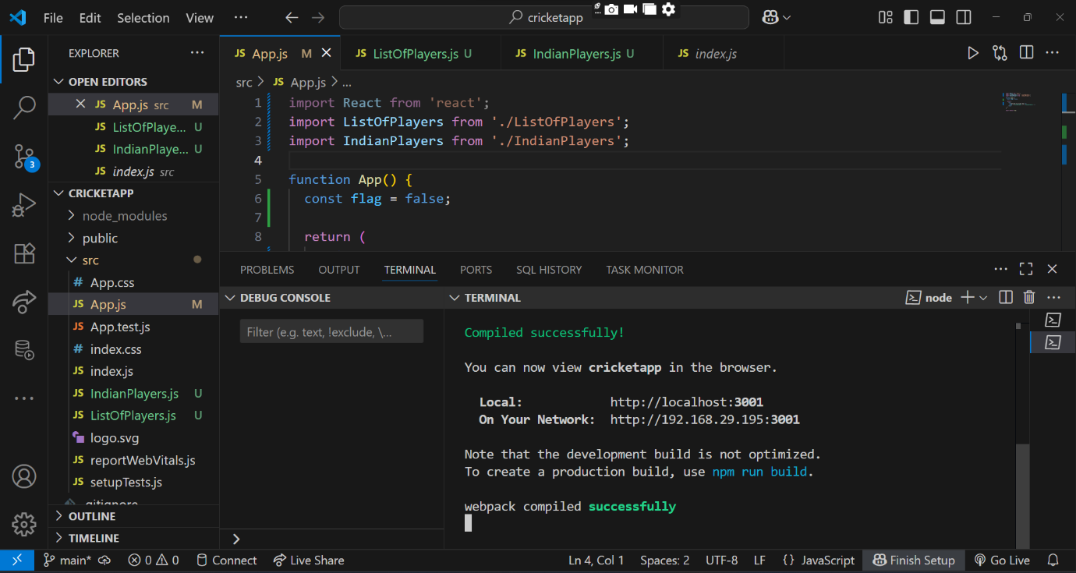

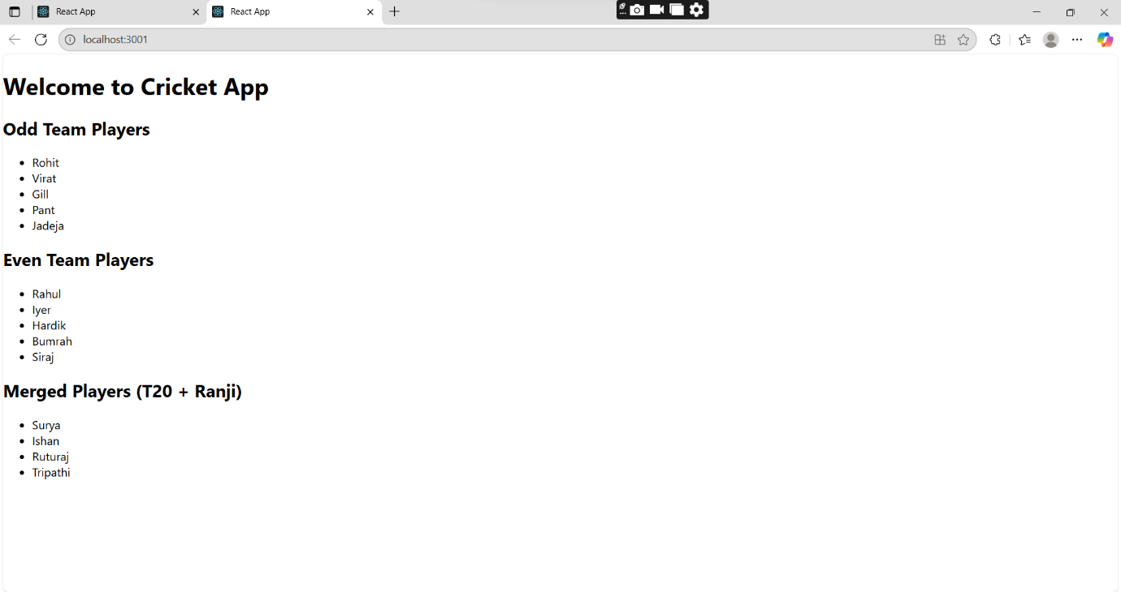
const flag = false;

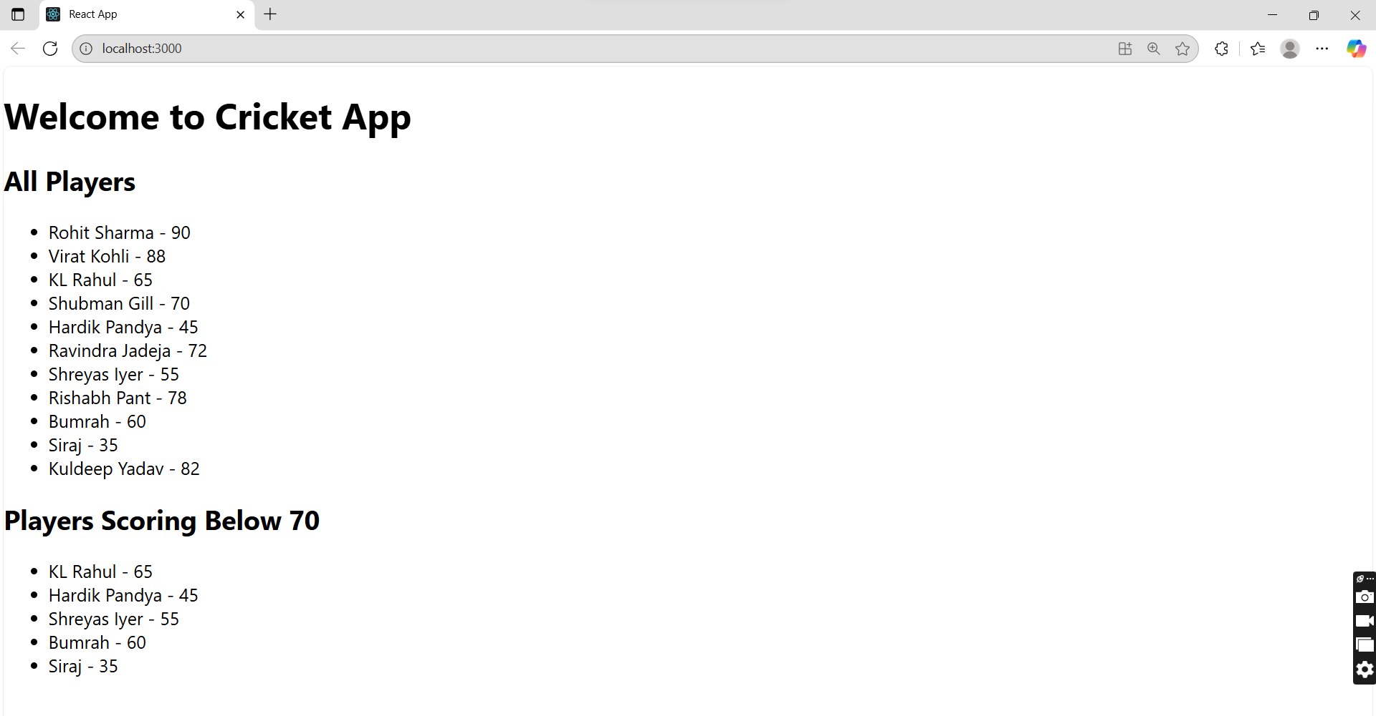

const flag = true;

Q2). Objectives

- Define JSX
- Explain about ECMA Script
- Explain React.createElement()
- Explain how to create React nodes with JSX
- Define how to render JSX to DOM
- Explain how to use JavaScript expressions in JSX
- Explain how to use inline CSS in JSX

In this hands-on lab, you will learn how to:
- Use JSX syntax in React applications
- Use inline CSS in JSX

Create a React Application named “officespacerentalapp” which uses React JSX to create elements, attributes and renders DOM to display the page.

Code Implementation:

App.js

import React from 'react';

function App() {

const heading = <h1>Office Space Rental App</h1>;

const imageUrl = "/office.jpg";

const office = {
name: "SwiftHQ",
rent: 68000,
address: "2nd Floor, Phase-1, Electronic City, Bangalore"
};

const officeList = [
{
name: "Stark Innovations",
rent: 82000,
address: "Residency Road, Bangalore"
},
{
name: "Wakanda Worklabs",
rent: 58000,
address: "Koramangala, Bangalore"
},
{
name: "Debug Den",
rent: 80000,
address: "Outer Ring Road, Bangalore"
}
];

const rentStyle = (rent) => ({
color: rent < 60000 ? 'red' : 'green',
fontWeight: 'bold'
});

return (
<div style={{ padding: '20px', fontFamily: 'Arial' }}>
{heading}

<img src={imageUrl} alt="Office Space" width="300" />

<h2>Featured Office</h2>
<p><strong>Name:</strong> {office.name}</p>
<p><strong>Rent:</strong> <span style={rentStyle(office.rent)}>{office.rent}</span></p>
<p><strong>Address:</strong> {office.address}</p>

<h2>Other Available Offices</h2>
<ul>
{officeList.map((item, index) => (
<li key={index} style={{ marginBottom: '10px' }}>
<p><strong>Name:</strong> {item.name}</p>
<p><strong>Rent:</strong> <span style={rentStyle(item.rent)}>{item.rent}</span></p>
<p><strong>Address:</strong> {item.address}</p>
</li>
))}
</ul>
</div>
);
}

export default App;

OUTPUT:

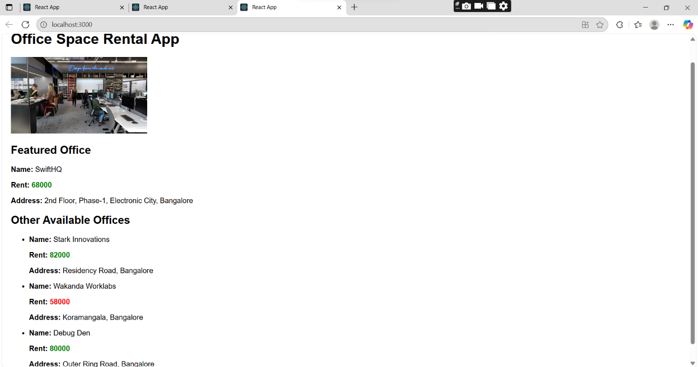

Q3). Objectives

- Explain React events
- Explain about event handlers
- Define Synthetic event
- Identify React event naming convention

In this hands-on lab, you will learn how to:
- Implement Event handling concept in React applications
- Use this keyword
- Use synthetic event

Create a React Application “eventexamplesapp” to handle various events of the form elements in HTML.

Ans:

App.js

import React, { Component } from 'react';
import CurrencyConvertor from './CurrencyConvertor';

class App extends Component {
constructor() {
super();
this.state = {
count: 0
};
}

increase = () => {
this.setState({ count: this.state.count + 1 });
this.sayHello();
};

sayHello = () => {
alert("Hello! Welcome everyone");
};

decrease = () => {
this.setState({ count: this.state.count - 1 });
};

sayWelcome = (message) => {
alert(message);
};

handlePress = (event) => {
alert("I was clicked!");
console.log("Synthetic Event:", event);
};

render() {
return (
<div style={{ padding: '20px' }}>
<h1>React Event Handling Demo</h1>
<h2>Counter: {this.state.count}</h2>

<button onClick={this.increase}>Increase</button>
<button onClick={this.decrease}>Decrease</button>

<br /><br />

<button onClick={() => this.sayWelcome("Welcome to the React World!")}>
Say Welcome
</button>

<br /><br />

<button onClick={this.handlePress}>
Click Me (Synthetic Event)
</button>

<br /><br />

<CurrencyConvertor />
</div>
);
}
}

export default App;

CurrencyConvertor.js

import React, { Component } from 'react';

class CurrencyConvertor extends Component {
constructor() {
super();
this.state = {
rupees: '',
euros: ''
};
}

handleChange = (e) => {
this.setState({ rupees: e.target.value });
};

handleSubmit = () => {
const conversionRate = 0.011;
const euros = (parseFloat(this.state.rupees) * conversionRate).toFixed(2);
this.setState({ euros });
};

render() {
return (
<div style={{ marginTop: '40px' }}>
<h2>Currency Converter (INR : EUR)</h2>
<input
type="number"
placeholder="Enter INR"
value={this.state.rupees}
onChange={this.handleChange}
/>
<button onClick={this.handleSubmit}>Convert</button>

{this.state.euros && (
<p>{this.state.rupees} INR = {this.state.euros} EUR</p>
)}
</div>
);
}
}

export default CurrencyConvertor;

OUTPUT:

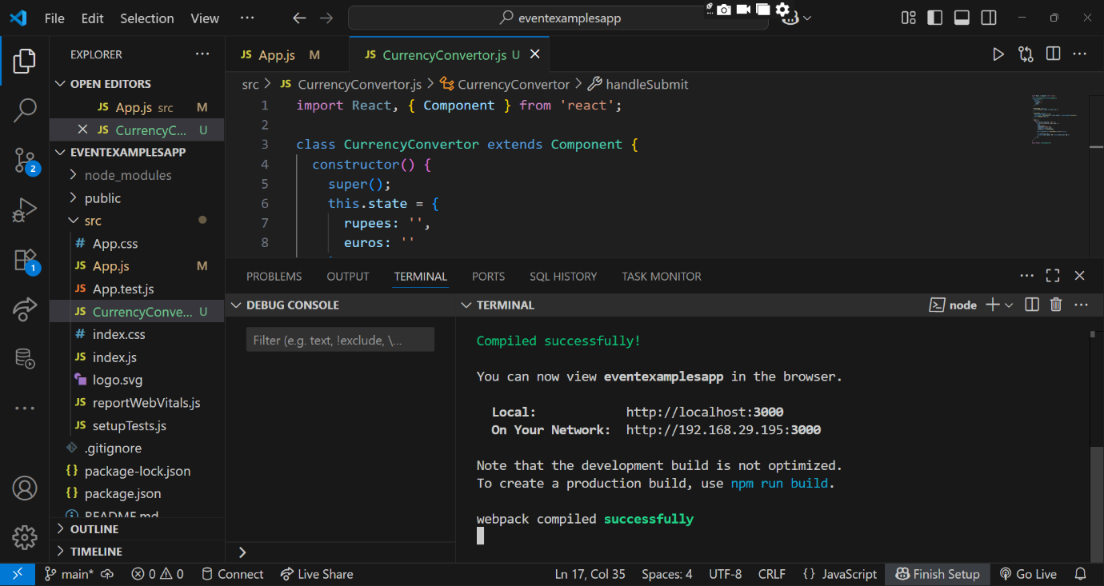

Increment:
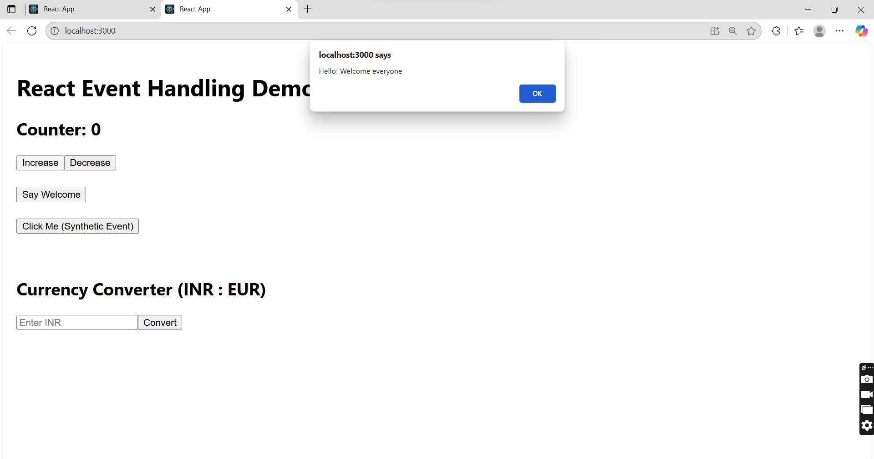
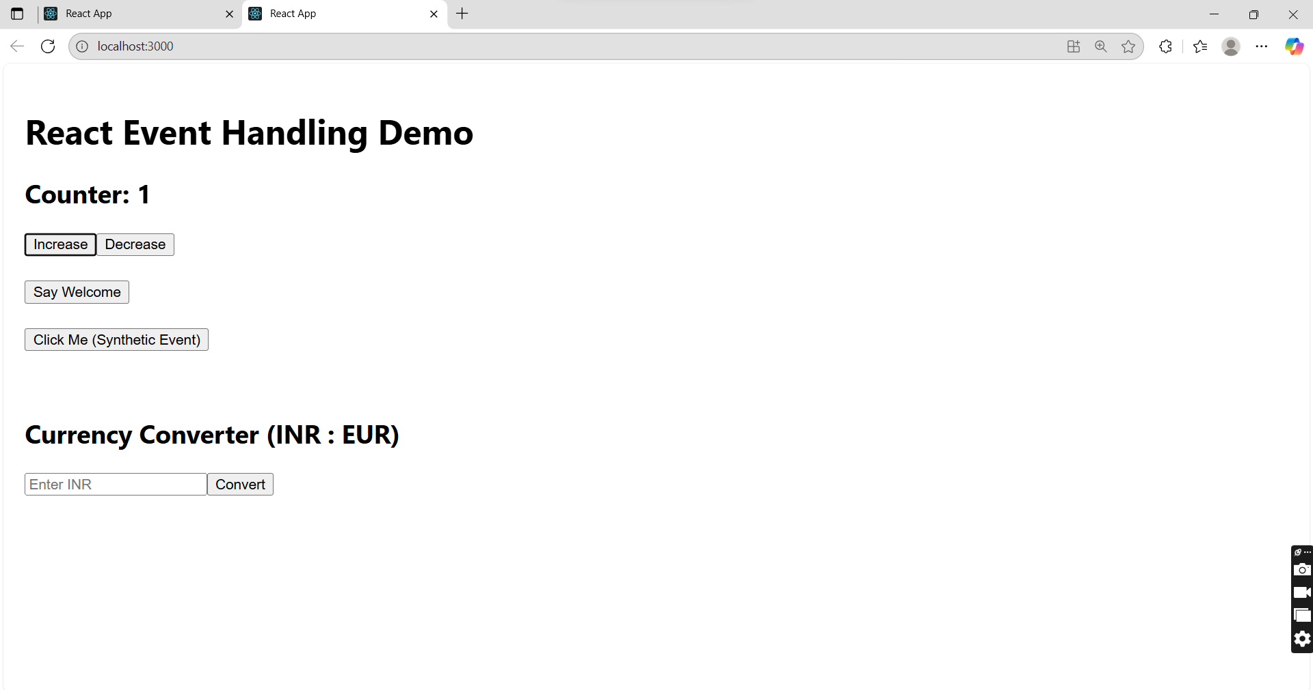

Decrement:
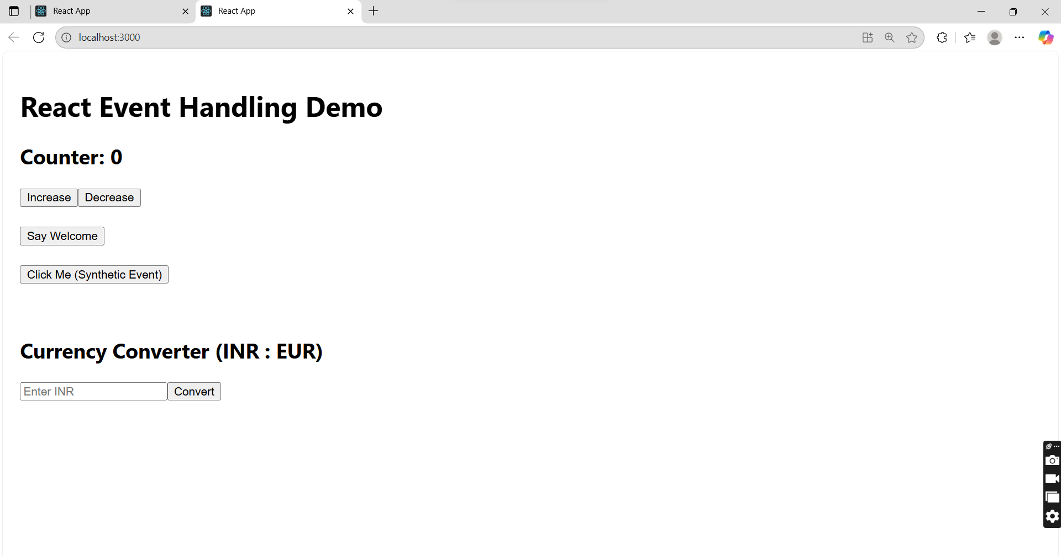

Say Welcome:

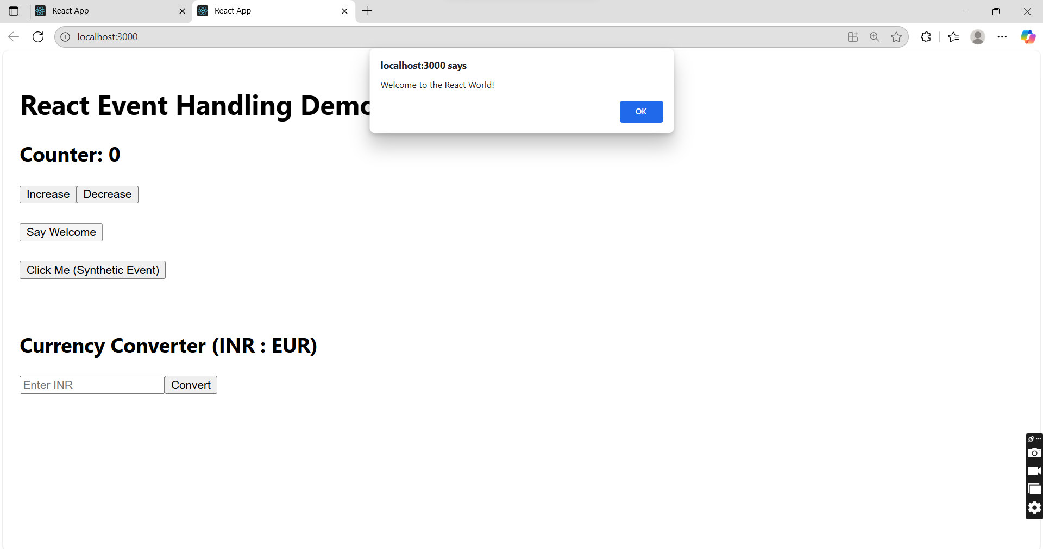

Clicked:

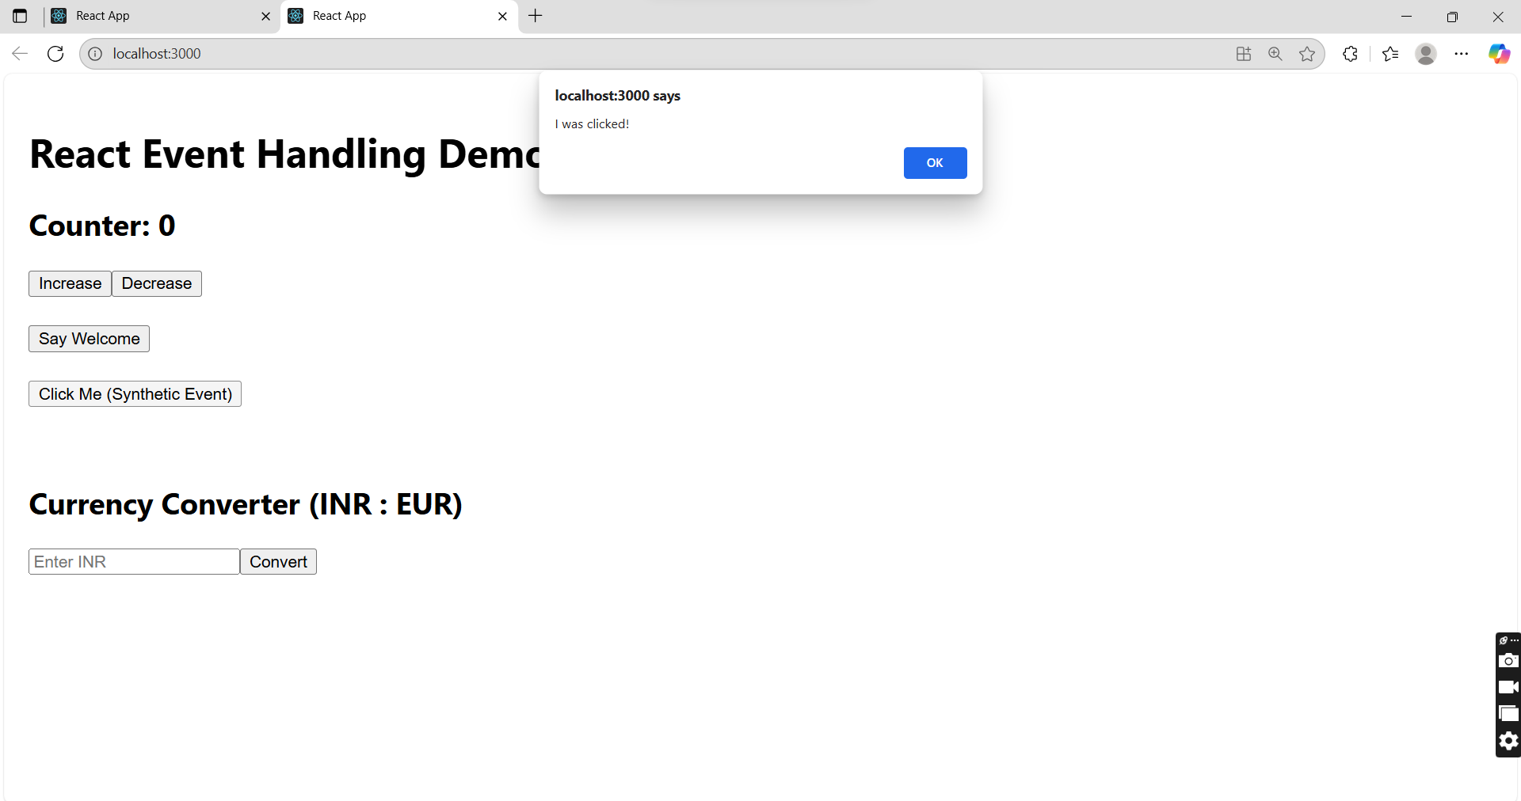

Currency Converter

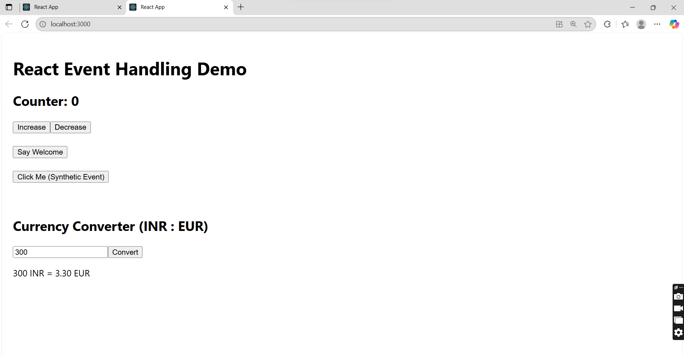

Q4). Objectives

- Explain about conditional rendering in React
- Define element variables
- Explain how to prevent components from rendering

In this hands-on lab, you will learn how to:
- Implement conditional rendering in React applications

Create a React Application named “ticketbookingapp” where the guest user can browse the page where the flight details are displayed whereas the logged in user only can book tickets.

The Login and Logout buttons should accordingly display different pages. Once the user is logged in the User page should be displayed. When the user clicks on Logout, the Guest page should be displayed.

Code Implementation:

GuestPage.js

import React from 'react';

function GuestPage() {
return (
<div>
<h2>Welcome Guest!</h2>
<p>You can browse flight details but need to log in to book tickets.</p>
</div>
);
}

export default GuestPage;

UserPage.js

import React from 'react';

function UserPage() {
return (
<div>
<h2>Welcome User!</h2>
<p>You are logged in. You can now book tickets.</p>
</div>
);
}

export default UserPage;

Navigation.js

import React from 'react';

function Navigation({ isLoggedIn, handleLogin, handleLogout }) {
return (
<div style={{ marginBottom: '20px' }}>
{isLoggedIn ? (
<button onClick={handleLogout}>Logout</button>
) : (
<button onClick={handleLogin}>Login</button>
)}
</div>
);
}

export default Navigation;

App.js

import React, { useState } from 'react';
import './App.css';
import GuestPage from './components/GuestPage';
import UserPage from './components/UserPage';
import Navigation from './components/Navigation';

function App() {
const [isLoggedIn, setIsLoggedIn] = useState(false);

const handleLogin = () => {
setIsLoggedIn(true);
};

const handleLogout = () => {
setIsLoggedIn(false);
};

return (
<div className="App">
<h1>Flight Ticket Booking App</h1>
<Navigation
isLoggedIn={isLoggedIn}
handleLogin={handleLogin}
handleLogout={handleLogout}
/>
{isLoggedIn ? <UserPage /> : <GuestPage />}
</div>
);
}

export default App;

App.css

.App {
text-align: center;
margin-top: 50px;
}

button {
padding: 10px 20px;
margin: 10px;
cursor: pointer;
}

OUTPUT:

Login

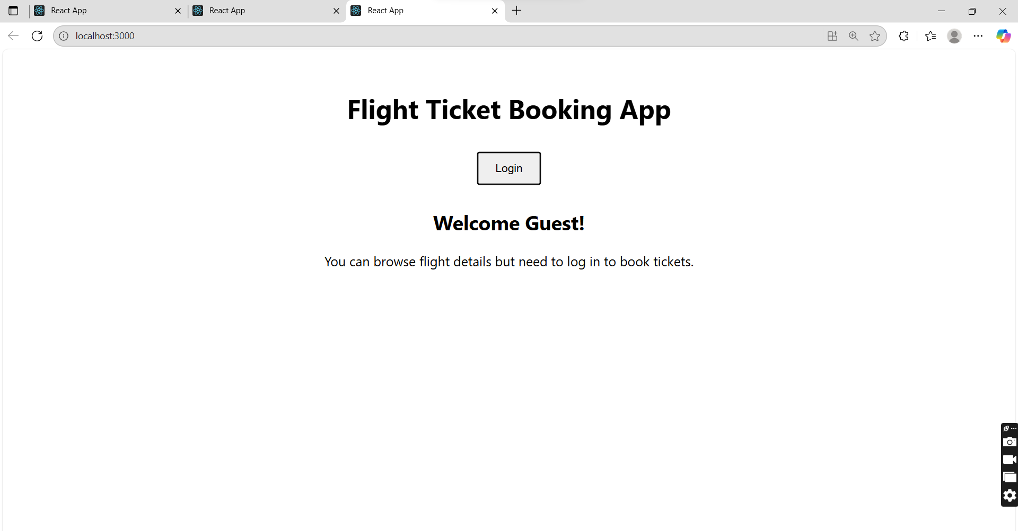

Logout

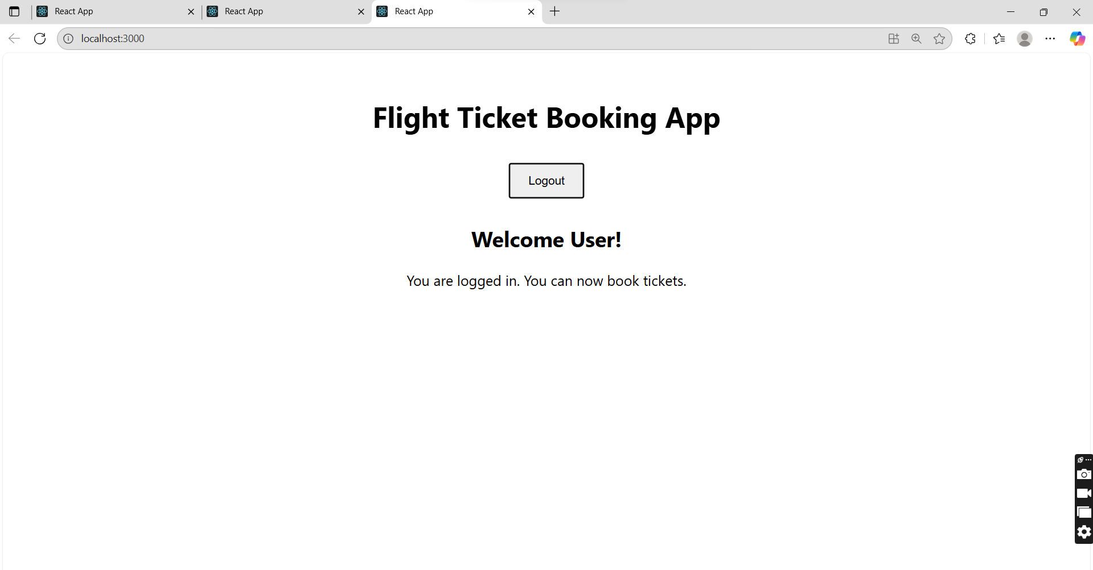

Q5). Objectives

- Explain various ways of conditional rendering
- Explain how to render multiple components
- Define list component
- Explain about keys in React applications
- Explain how to extract components with keys
- Explain React Map, map() function

In this hands-on lab, you will learn how to:
- Implement conditional rendering in React applications

Create a React App named “bloggerapp” in with 3 components.

- Book Details
- Blog Details
- Course Details

Implement this with as many ways possible of Conditional Rendering.

Code Implementation:

BookDetails.js

import React from "react";
import "./App.css";
import CourseDetails from "./components/CourseDetails";
import BookDetails from "./components/BookDetails";
import BlogDetails from "./components/BlogDetails";
import { courses, books, blogs } from "./data";

function App() {
return (
<div className="container">
<CourseDetails courses={courses} />
<BookDetails books={books} />
<BlogDetails blogs={blogs} />
</div>
);
}

export default App;

BlogDetails.js

import React from "react";

const BlogDetails = ({ blogs }) => (
<div>
<h2>Blog Details</h2>
{blogs.map((blog, index) => (
<div key={index}>
<h3>{blog.title}</h3>
<strong>{blog.author}</strong>
<p>{blog.content}</p>
</div>
))}
</div>
);

export default BlogDetails;

CourseDetails.js

import React from "react";

const CourseDetails = ({ courses }) => (
<div>
<h2>Course Details</h2>
{courses.map((course, index) => (
<div key={index}>
<h3>{course.name}</h3>
<p>{course.date}</p>
</div>
))}
</div>
);

export default CourseDetails;

App.js

import React from "react";
import "./App.css";
import CourseDetails from "./components/CourseDetails";
import BookDetails from "./components/BookDetails";
import BlogDetails from "./components/BlogDetails";
import { courses, books, blogs } from "./data";

function App() {
return (
<div className="container">
<CourseDetails courses={courses} />
<BookDetails books={books} />
<BlogDetails blogs={blogs} />
</div>
);
}

export default App;

data.js

export const courses = [
{ name: "Angular", date: "4/5/2021" },
{ name: "React", date: "6/3/2021" },
];

export const books = [
{ title: "Master React", price: 670 },
{ title: "Deep Dive into Angular 11", price: 800 },
{ title: "Mongo Essentials", price: 450 },
];

export const blogs = [
{
title: "React Learning",
author: "Stephen Biz",
content: "Welcome to learning React!",
},
{
title: "Installation",
author: "Schewzdenier",
content: "You can install React from npm.",
},
];

App.css

.container {
display: flex;
justify-content: space-around;
margin: 40px;
font-family: Arial, sans-serif;
}

.container > div {
border-left: 4px solid green;
padding-left: 20px;
width: 25%;
}

Output:

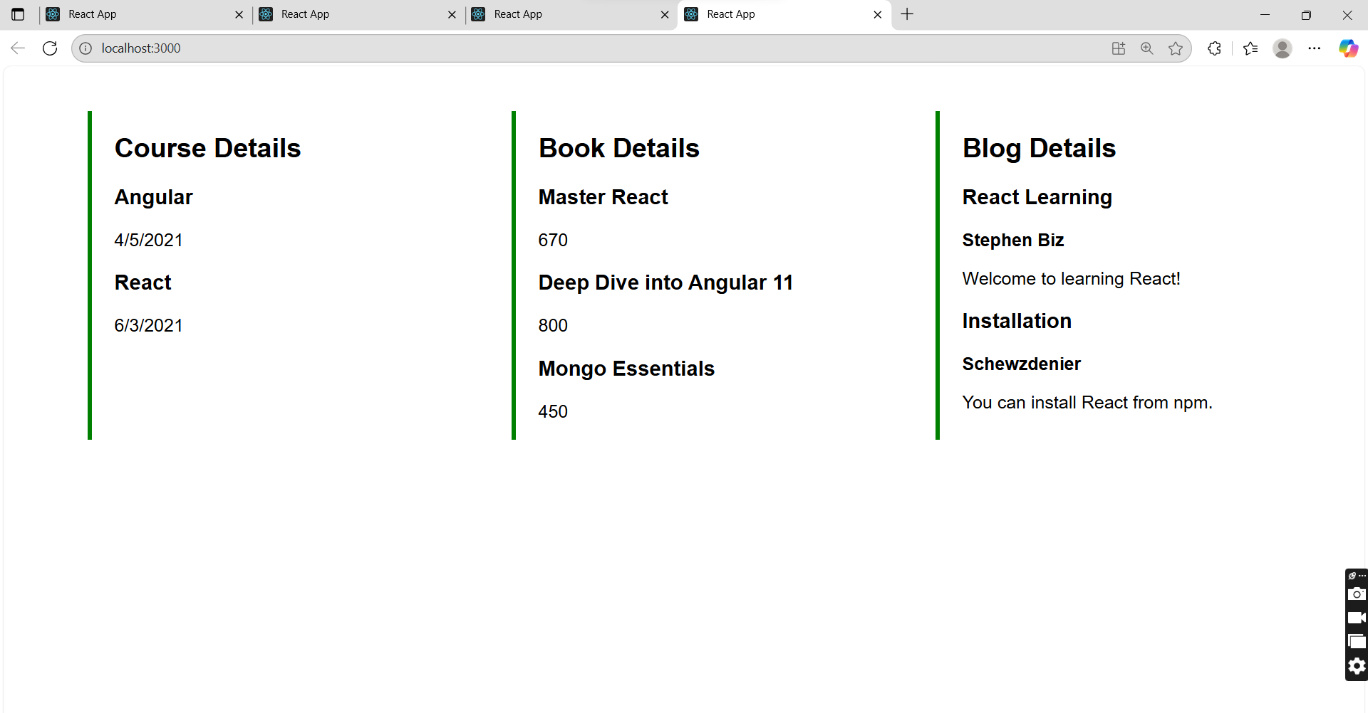

Additional Important HandsOn

Q1). Objectives
- Explain the need and Benefits of React Context API
- Working with createContext()
- List the types of Router Components

In this hands-on lab, you will learn how to:
- Create a context to be used by child components
- Create a provider and consumer of the context

Employee-management-App

Code Implementation:

ThemeContext.js

import { createContext } from 'react';

const ThemeContext = createContext('light');

export default ThemeContext;

App.js

import React, { useState } from 'react';
import EmployeesList from './components/EmployeesList';
import ThemeContext from './ThemeContext';

function App() {
const [theme, setTheme] = useState('light');

const toggleTheme = () => {
setTheme(prev => (prev === 'light' ? 'dark' : 'light'));
};

return (
<ThemeContext.Provider value={theme}>
<div className="App">
<h1>Employee Management</h1>
<button onClick={toggleTheme}>
Switch to {theme === 'light' ? 'Dark' : 'Light'} Theme
</button>
<EmployeesList />
</div>
</ThemeContext.Provider>
);
}

export default App;

EmployeeList.js

import React from 'react';
import EmployeeCard from './EmployeeCard';

const EmployeesList = () => {
const employees = [
{ id: 1, name: 'Vanya', designation: 'Manager' },
{ id: 2, name: 'Carol', designation: 'Developer' },
];

return (
<div>
{employees.map(emp => (
<EmployeeCard key={emp.id} employee={emp} />
))}
</div>
);
};

export default EmployeesList;

EmployeeCard.js

import React, { useContext } from 'react';
import ThemeContext from '../ThemeContext';

const EmployeeCard = ({ employee }) => {
const theme = useContext(ThemeContext); // get value from context

return (
<div className="employee-card">
<h3>{employee.name}</h3>
<p>{employee.designation}</p>
<button className={theme === 'dark' ? 'btn-dark' : 'btn-light'}>
View Profile
</button>
</div>
);
};

export default EmployeeCard;

index.css

.employee-card {
border: 1px solid gray;
padding: 10px;
margin: 10px;
border-radius: 8px;
}

.btn-light {
background-color: white;
color: black;
border: 1px solid black;
padding: 6px 12px;
cursor: pointer;
}

.btn-dark {
background-color: black;
color: white;
border: 1px solid white;
padding: 6px 12px;
cursor: pointer;
}

App.css

.btn-light {
background-color: white;
color: black;
border: 1px solid #ccc;
}

.btn-dark {
background-color: black;
color: white;
border: 1px solid #555;
}

.employee-card {
border: 1px solid #ddd;
margin: 10px;
padding: 15px;
border-radius: 5px;
}

Output:

Light Theme:

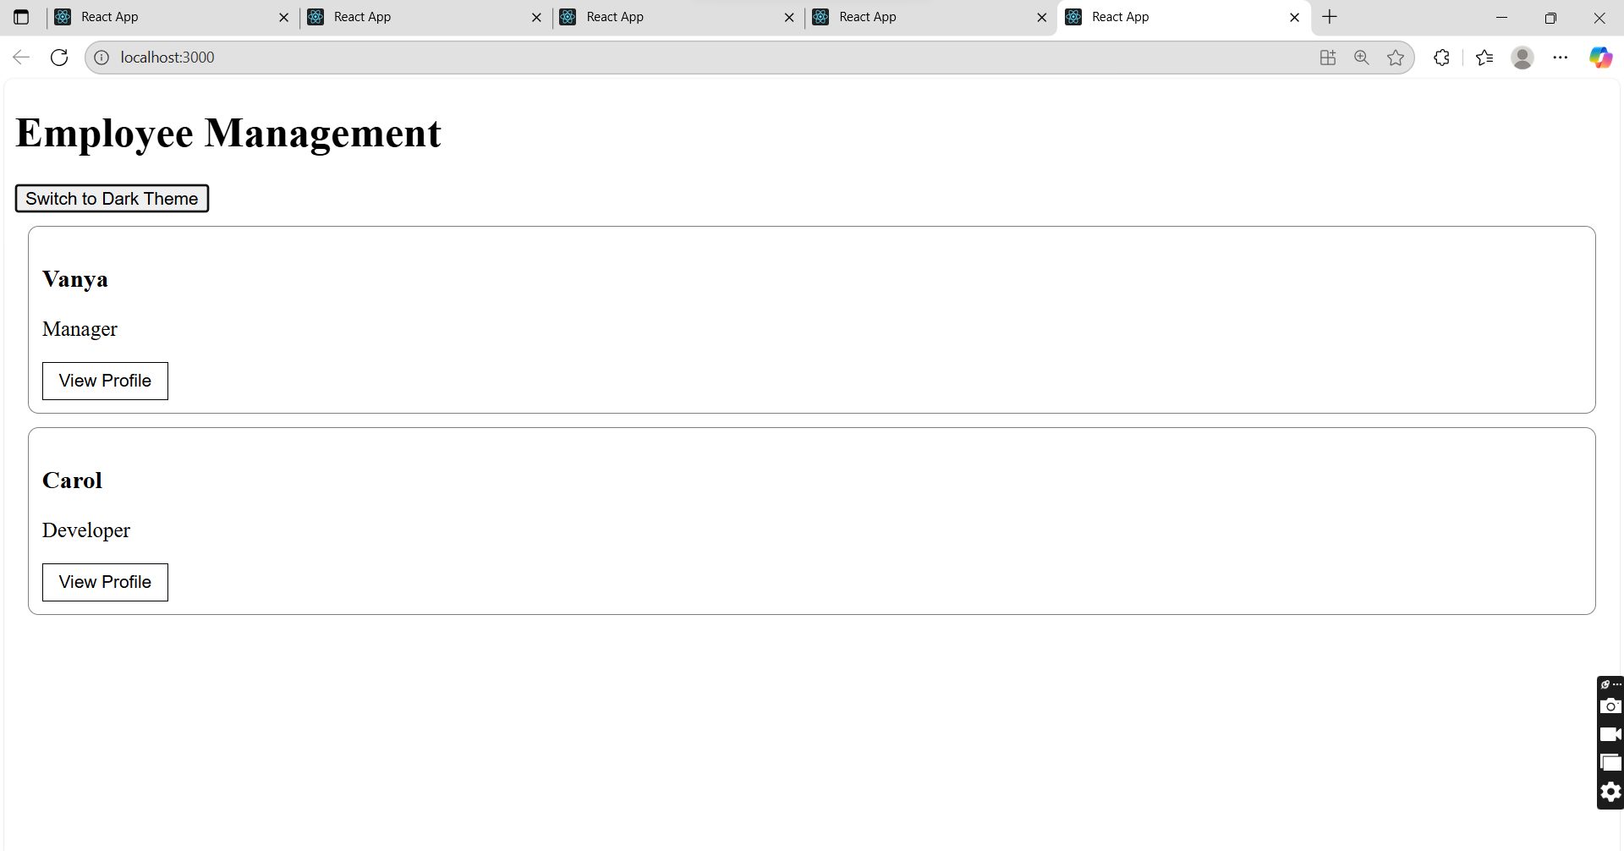

Dark Theme:

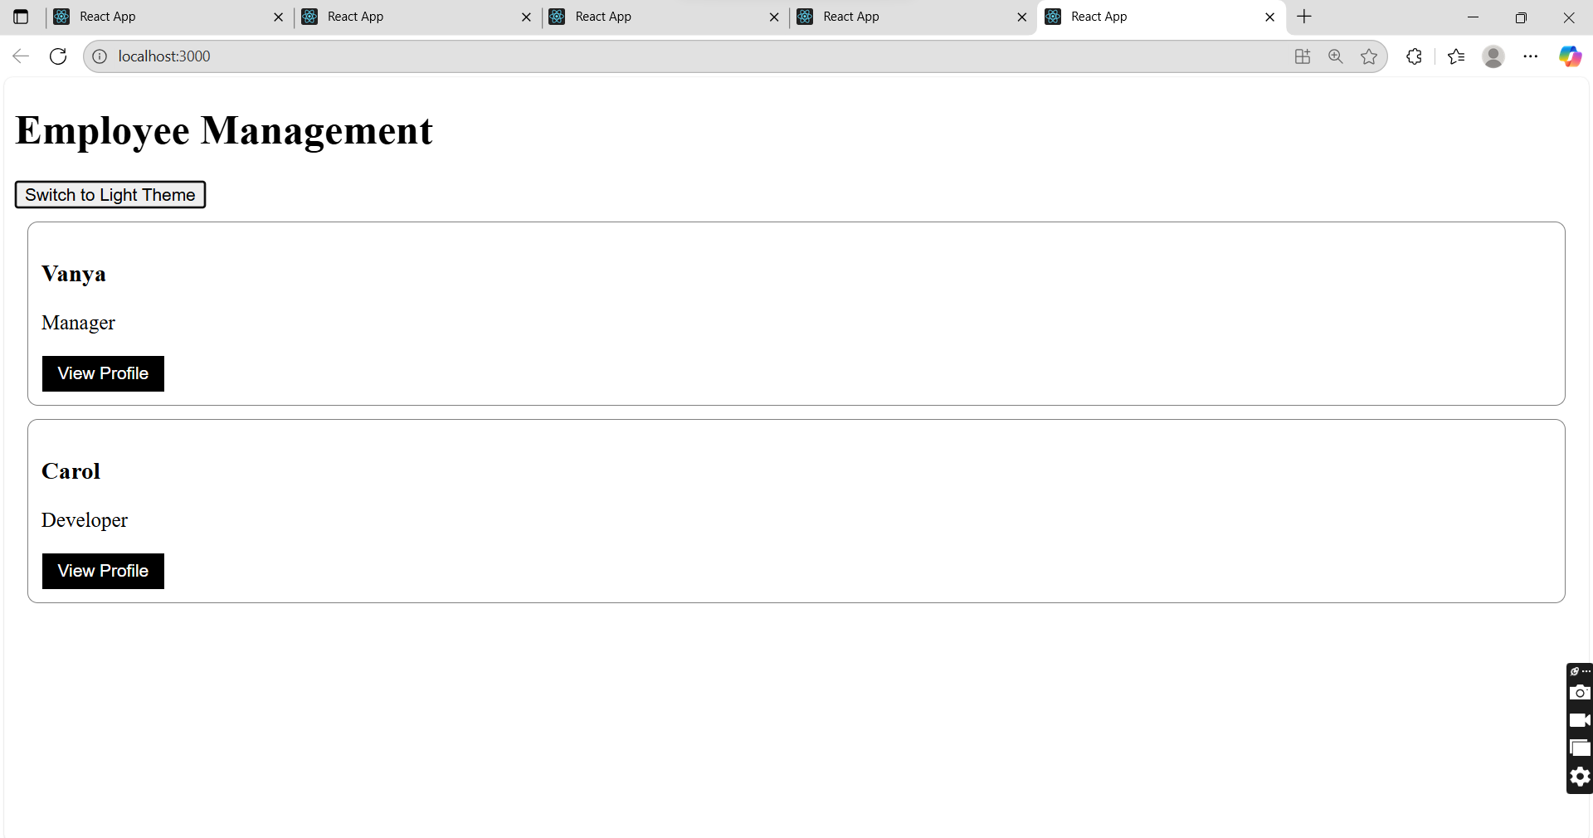

Q2). Objectives

- Explain about React forms
- Define controlled components
- Explain about various input controls
- Explain about handling forms
- Explain about submitting forms
In this hands-on lab, you will learn how to:
- Implement React forms
- Use various input controls like textbox, button and textarea

Create a React App named “ticketraisingapp” which will help to raise a complaint and get it resolved.

Create a component named “ComplaintRegister” with a form containing a textbox to enter the employee name and a textarea to enter the complaint. Use “handleSubmit” event of the button to submit the complaint and generate a Reference number for further follow ups in the alert box.

Code Implementation:

ComplaintRegister.js

import React, { useState } from "react";
import "./ComplaintRegister.css";

function ComplaintRegister() {
const [employeeName, setEmployeeName] = useState("");
const [complaint, setComplaint] = useState("");

const handleSubmit = (e) => {
e.preventDefault();

const referenceNumber = Math.floor(100000 + Math.random() * 900000);
alert(
`Complaint Registered!\nName: ${employeeName}\nComplaint: ${complaint}\nReference Number: REF${referenceNumber}`
);

setEmployeeName("");
setComplaint("");
};

return (
<div className="complaint-form-container">
<h2>Raise a Complaint</h2>
<form onSubmit={handleSubmit}>
<div>
<label>Employee Name:</label>
<input
type="text"
value={employeeName}
onChange={(e) => setEmployeeName(e.target.value)}
required
/>
</div>
<div>
<label>Complaint:</label>
<textarea
value={complaint}
onChange={(e) => setComplaint(e.target.value)}
required
></textarea>
</div>
<button type="submit">Submit Complaint</button>
</form>
</div>
);
}

export default ComplaintRegister;

App.js

import React from "react";
import ComplaintRegister from "./components/ComplaintRegister";
import "./App.css";

function App() {
return (
<div className="App">
<ComplaintRegister />
</div>
);
}

export default App;

ComplaintRegister.css

.complaint-form-container {
width: 400px;
margin: 50px auto;
padding: 25px;
border: 1px solid #ccc;
border-radius: 8px;
background-color: #f9f9f9;
}

.complaint-form-container h2 {
text-align: center;
margin-bottom: 20px;
}

.complaint-form-container label {
display: block;
margin-bottom: 6px;
font-weight: bold;
}

.complaint-form-container input,
.complaint-form-container textarea {
width: 100%;
padding: 8px;
margin-bottom: 12px;
border: 1px solid #aaa;
border-radius: 4px;
}

.complaint-form-container button {
width: 100%;
padding: 10px;
background-color: #007bff;
color: white;
border: none;
border-radius: 4px;
cursor: pointer;
}

Output:

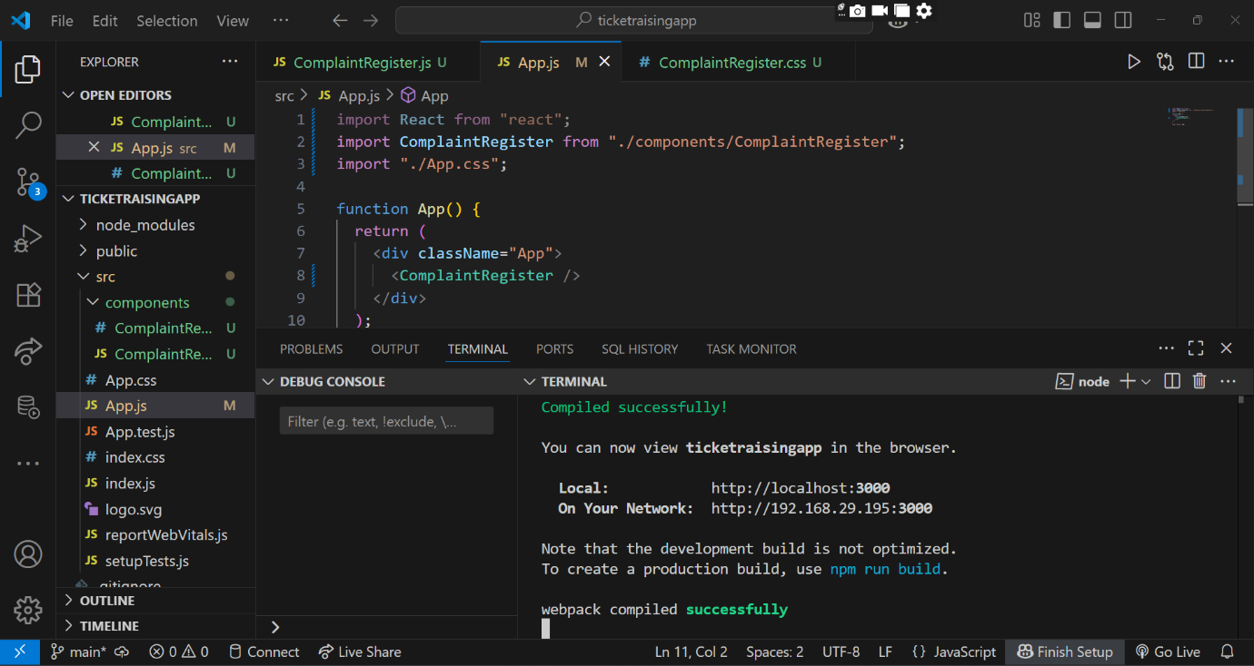

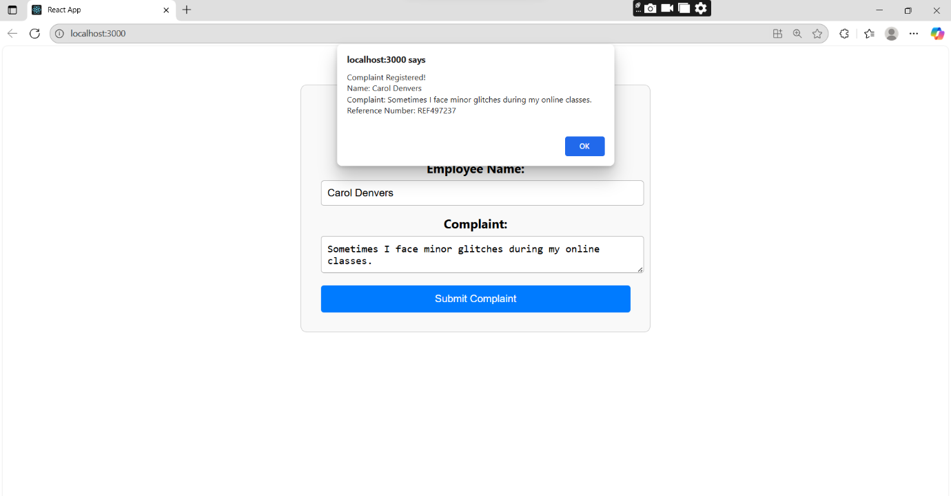

Q3). Objectives

- Explain React Forms validation
- Identify the differences between React Form and HTML Form
- Explain about controlled components
- Identify various React Form input controls
- Explain how to handle React Forms
- Explain about submitting forms in React

In this hands-on lab, you will learn how to:
- Implement React forms validation
- Use various input controls like textbox, button and textarea
Create a React App named “mailregisterapp” which will have a component named “register.js”. Create a form which accepts the name, email and password and validate the fields as per the following:

- Name should have atleast 5 characters
- Email should have @ and .
- Password should have atleast 8 characters.

Ensure that validations are implemented through eventhandle and eventsubmit of a form.

Code Implementation:

Register.js

import React, { useState } from "react";

function Register() {
const [name, setName] = useState("");
const [email, setEmail] = useState("");
const [password, setPassword] = useState("");
const [error, setError] = useState("");

const handleSubmit = (e) => {
e.preventDefault();

if (name.length < 5) {
setError("Name must be at least 5 characters.");
} else if (!email.includes("@") || !email.includes(".")) {
setError("Email must include '@' and '.'.");
} else if (password.length < 8) {
setError("Password must be at least 8 characters.");
} else {
alert(`Form submitted successfully!\nName: ${name}\nEmail: ${email}`);
setName("");
setEmail("");
setPassword("");
setError("");
}
};

return (
<div style={{ width: "300px", margin: "50px auto" }}>
<h2>Register</h2>
{error && <p style={{ color: "red" }}>{error}</p>}
<form onSubmit={handleSubmit}>
<div>
<label>Name:</label><br />
<input
type="text"
value={name}
onChange={(e) => setName(e.target.value)}
required
/>
</div>
<div>
<label>Email:</label><br />
<input
type="email"
value={email}
onChange={(e) => setEmail(e.target.value)}
required
/>
</div>
<div>
<label>Password:</label><br />
<input
type="password"
value={password}
onChange={(e) => setPassword(e.target.value)}
required
/>
</div>
<br />
<button type="submit">Submit</button>
</form>
</div>
);
}

export default Register;

App.js

import React from "react";
import Register from "./Register";
import "./App.css";

function App() {
return (
<div className="App">
<Register />
</div>
);
}

export default App;

App.css

.form-container {
width: 300px;
margin: 40px auto;
padding: 20px;
border: 1px solid #ccc;
background: #f2f2f2;
border-radius: 5px;
font-family: sans-serif;
}

.form-container h2 {
text-align: center;
margin-bottom: 15px;
}

.form-container label {
display: block;
margin-bottom: 4px;
}

.form-container input {
width: 100%;
padding: 6px;
margin-bottom: 10px;
border: 1px solid #aaa;
border-radius: 3px;
}

.form-container .error {
color: red;
font-size: 13px;
margin-bottom: 8px;
}

.form-container button {
width: 100%;
padding: 8px;
background-color: #4285f4;
color: white;
border: none;
border-radius: 3px;
cursor: pointer;
}

Output:
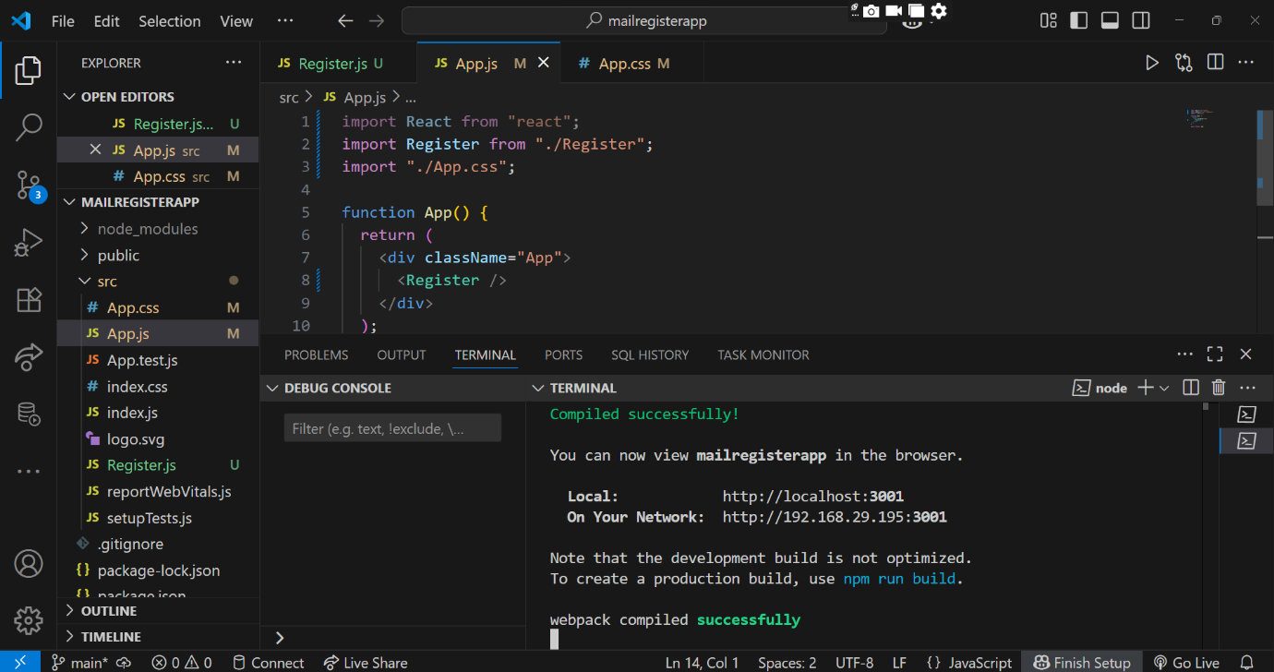

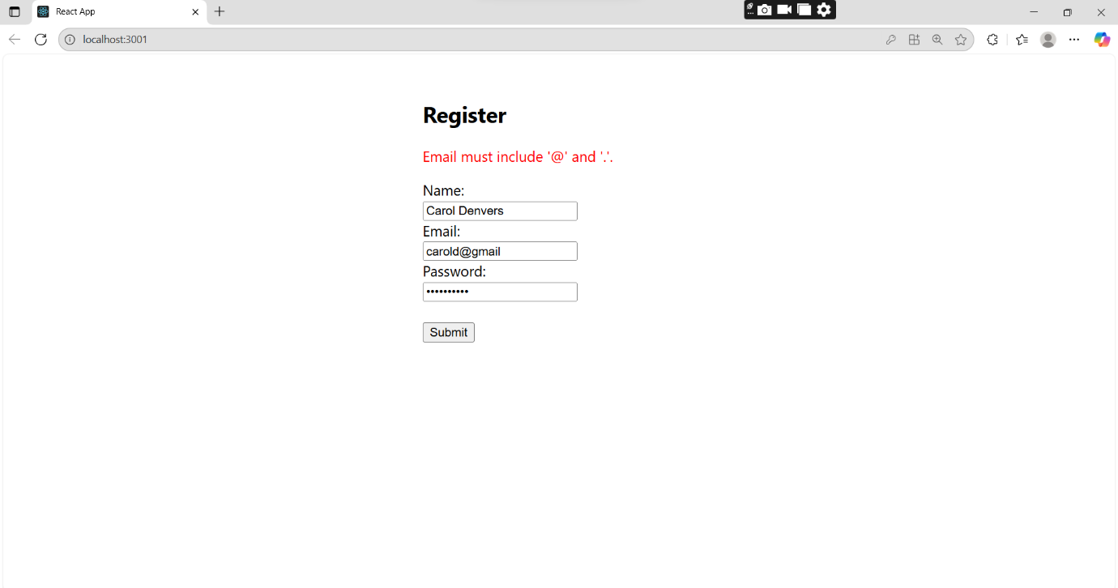

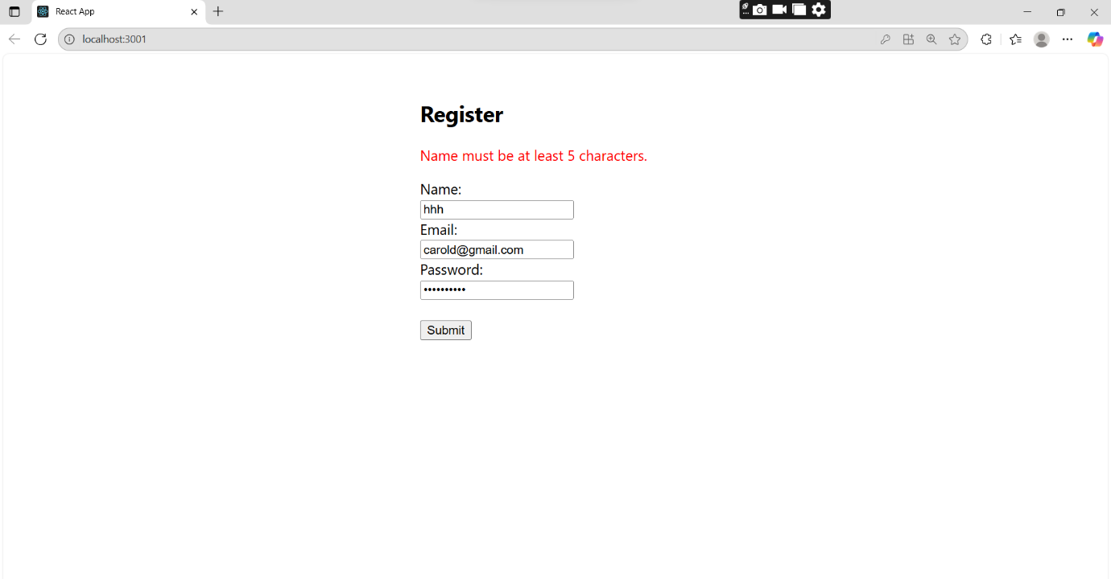

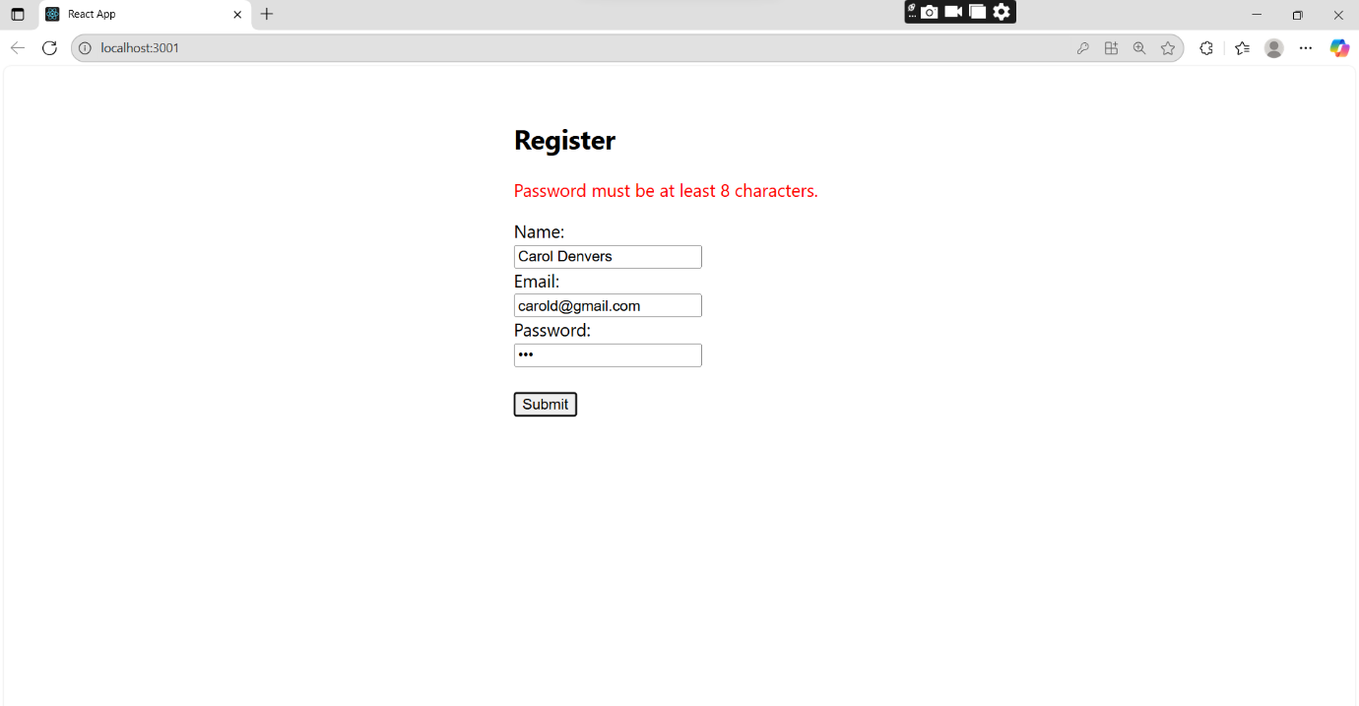

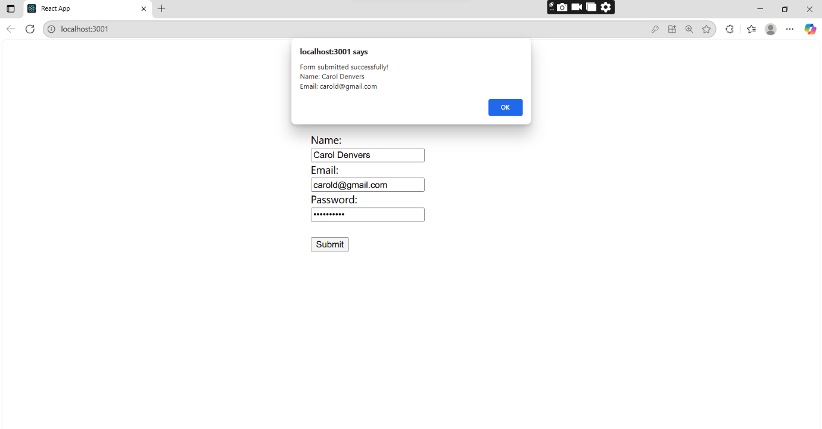

Q4). Objectives

- Explain how to consume REST APIs from React applications

In this hands-on lab, you will learn how to:
- Construct a React application that invokes the REST API and fetch data from the API

Create a React Application “fetchuserapp” which will retrieve the user details from https://api.randomuser.me/ and display the title, firstname and image of a user.
Create a component named “Getuser” and in the asynchronous method “ComponentDidMount ()” invoke the URL using fetch method and the response can be displayed in the render method of the component.

Code Implementation:

Getuser.js

import React from "react";

class Getuser extends React.Component {
constructor() {
super();
this.state = {
title: "",
firstname: "",
image: "",
};
}

componentDidMount() {

setTimeout(() => {
this.setState({
title: "The",
firstname: "Captain Marvel (Carol Danvers)",
image: "/Carol.jpg",
});
}, 1000);
}

render() {
return (
<div style={{ textAlign: "center", marginTop: "50px" }}>
<h1>{this.state.title} {this.state.firstname}</h1>
<img
src={this.state.image}
alt="Carol Danvers"
width="150"
height="150"
style={{ borderRadius: "8px" }}
/>
</div>
);
}
}

export default Getuser;

App.js

import React from "react";
import Getuser from "./Getuser";

function App() {
return (
<div className="App">
<Getuser />
</div>
);
}

export default App;

Output:

