B. K. BIRLA COLLEGE, KALYAN
DATA ENGINEERING
PRACTICAL JOURNAL
Name | Vedant Vinod Rakshe
Roll No. | 37
Student ID | 5176220
Subject | Data Engineering
Practicals | 1 to 10
Practical 10 (Mini Project) was completed as a group with Aayushman Rajeev Verma (Roll No. 57, Student ID 5176202).

INDEX
Data Engineering Practical Journal | Vedant Vinod Rakshe | Roll No. 37
Sr. No. | Title of Practical | Page No.
1 | Parsing Text, CSV, HTML, XML & JSON, Binary Files, Regular Expressions and SQL CRUD | 2
2 | ETL Process in Power BI (Extract, Transform and Load) | 10
3 | MongoDB Operations | 14
4 | Data Preprocessing, Noise Elimination, Feature Selection and Exploratory Data Analysis | 17
5 | Extracting Data from APIs and Flat Files using Python | 23
6 | Installing Apache Airflow and Creating a Scheduled DAG | 26
7 | ETL Pipelines: CSV and JSON Sources, Invalid Records, Validation and Incremental Loading | 31
8 | Distributed Data Processing with PySpark DataFrames | 37
9 | End-to-End Data Pipelines: E-Commerce ETL with Historical and Newly Arriving Data | 42
10 | Mini Project: Retail Sales Data Warehouse - End-to-End Data Engineering Solution | 48

Practical No. 1: Parsing Text, CSV, HTML, XML & JSON, Binary Files, Regular Expressions and SQL CRUD
Aim: To write Python programs that read text, CSV, HTML, XML and JSON documents, extract data from them and check the data for missing values, duplicates and out-of-range (anomalous) values; to read and write binary files; to search, split and replace text using regular expressions; and to design a relational database and perform CRUD operations with SQL.

Step 1: Create the Employee Data Files (Text, CSV, HTML, XML, JSON)
Code:
# Name: Vedant Vinod Rakshe
# Practical 1 - Setup: one employee data set stored in five different file formats
print("Name: Vedant Vinod Rakshe")
import json

EMP = [ # (emp_id, name, dept, salary, age) -> contains deliberate data problems
("E101", "Aarav Mehta", "IT", 65000, 28),
("E102", "Isha Nair", "HR", 48000, 31),
("E103", "Kabir Singh", "IT", -52000, 45), # negative salary
("E104", "Meera Joshi", "", 39000, 26), # missing department
("E105", "Nikhil Rao", "Finance", 72000, 150), # impossible age
("E102", "Isha Nair", "HR", 48000, 31), # duplicate record
("E106", "Pooja Desai", "Sales", None, 35), # missing salary
("E107", "Sameer Khan", "Sales", 41000, 17), # below working age
]
show = lambda v: "" if v is None else str(v)

with open("employees.txt", "w") as f: # pipe-delimited text
f.write("# Employee export | delimiter = |\n")
for rec in EMP:
f.write("|".join(show(v) for v in rec) + "\n")

with open("employees.csv", "w") as f: # comma separated
f.write("emp_id,name,dept,salary,age\n")
for rec in EMP:
f.write(",".join(show(v) for v in rec) + "\n")

rows = "".join("<tr>" + "".join(f"<td>{show(v)}</td>" for v in rec) + "</tr>\n" for rec in EMP)
with open("employees.html", "w") as f: # HTML page with a table
f.write("<html><body><h1>Employee Directory</h1>\n<table border='1'>\n"
"<tr><th>emp_id</th><th>name</th><th>dept</th><th>salary</th><th>age</th></tr>\n" + rows + "</table></body></html>")

with open("employees.xml", "w") as f: # XML where the data sits in attributes
f.write("<company>\n")
for e, n, d, s, a in EMP:
f.write(f' <employee emp_id="{e}" name="{n}" dept="{d}" salary="{show(s)}" age="{a}"/>\n')
f.write("</company>")

records = [dict(zip(["emp_id", "name", "dept", "salary", "age"], rec)) for rec in EMP]
for r in records:
r["skills"] = ["python", "sql"] if r["dept"] == "IT" else ["excel"]
with open("employees.json", "w") as f:
json.dump({"company": "Nova Tech", "employees": records}, f, indent=2)

print("Created: employees.txt, employees.csv, employees.html, employees.xml, employees.json")
Output:

Step 2: A Reusable Data Quality Checker Class
One class is used for every file format. It converts empty values to missing values, fixes data types and reports missing values, duplicate rows and values outside the allowed range (salary above 0 and age between 18 and 65).
Code:
# Name: Vedant Vinod Rakshe
import pandas as pd
import numpy as np

class DataQualityChecker:
"""Reusable quality checker: missing values, duplicates and out-of-range values."""
RULES = {"salary": (1, 1_000_000), "age": (18, 65)} # allowed (min, max)

def __init__(self, df, source):
self.source = source
self.df = df.replace("", np.nan) # treat empty strings as missing
for col in ("salary", "age"):
self.df[col] = pd.to_numeric(self.df[col], errors="coerce")

def missing(self):
return self.df.isna().sum()

def duplicates(self):
return self.df[self.df.duplicated(keep="first")]

def anomalies(self):
found = []
for col, (lo, hi) in self.RULES.items():
bad = self.df[(self.df[col] < lo) | (self.df[col] > hi)]
found += [(r.emp_id, col, r[col]) for _, r in bad.iterrows()]
return found

def report(self):
print(f"##### QUALITY REPORT : {self.source} #####")
print(self.df.to_string(index=False), "\n")
miss = self.missing()
print("Missing values :", {c: int(v) for c, v in miss.items() if v})
dup = self.duplicates()
print("Duplicate rows :", len(dup), list(dup["emp_id"]))
print("Out-of-range :")
for emp, col, val in self.anomalies():
print(f" {emp} -> {col} = {val:g} (allowed {self.RULES[col][0]} to {self.RULES[col][1]})")
return self.df

Step 3: Parse a Text File (pipe delimited)
Code:
print("Name: Vedant Vinod Rakshe")
def load_txt(path):
rows = []
with open(path) as fh:
for line in fh:
if line.startswith("#") or not line.strip():
continue
rows.append(line.rstrip("\n").split("|"))
return pd.DataFrame(rows, columns=["emp_id", "name", "dept", "salary", "age"])

DataQualityChecker(load_txt("employees.txt"), "TEXT (pipe delimited)").report()
Output:
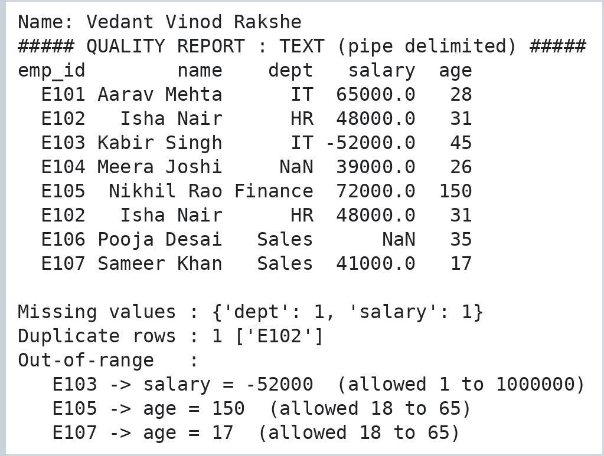

Step 4: Parse a CSV File
Code:
print("Name: Vedant Vinod Rakshe")
df_csv = pd.read_csv("employees.csv", dtype=str, keep_default_na=False)
DataQualityChecker(df_csv, "CSV file").report()
Output:
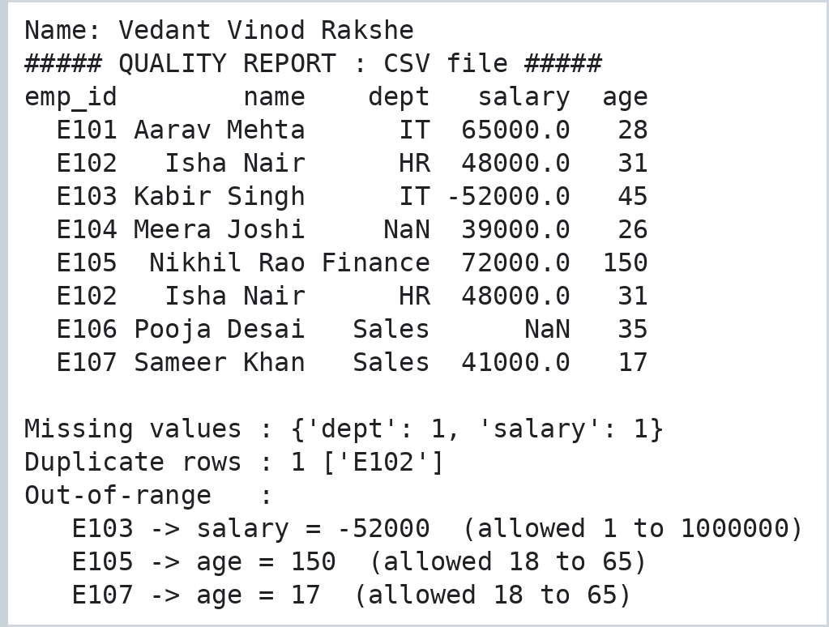

Step 5: Parse an HTML Document
Code:
print("Name: Vedant Vinod Rakshe")
import io
from lxml import html as lh

page = open("employees.html").read()
tree = lh.fromstring(page)
print("Page heading :", tree.xpath("//h1/text()")[0])
print("Table rows :", len(tree.xpath("//table//tr")) - 1, "\n")

df_html = pd.read_html(io.StringIO(page), keep_default_na=False)[0].astype(str)
DataQualityChecker(df_html, "HTML table").report()
Output:
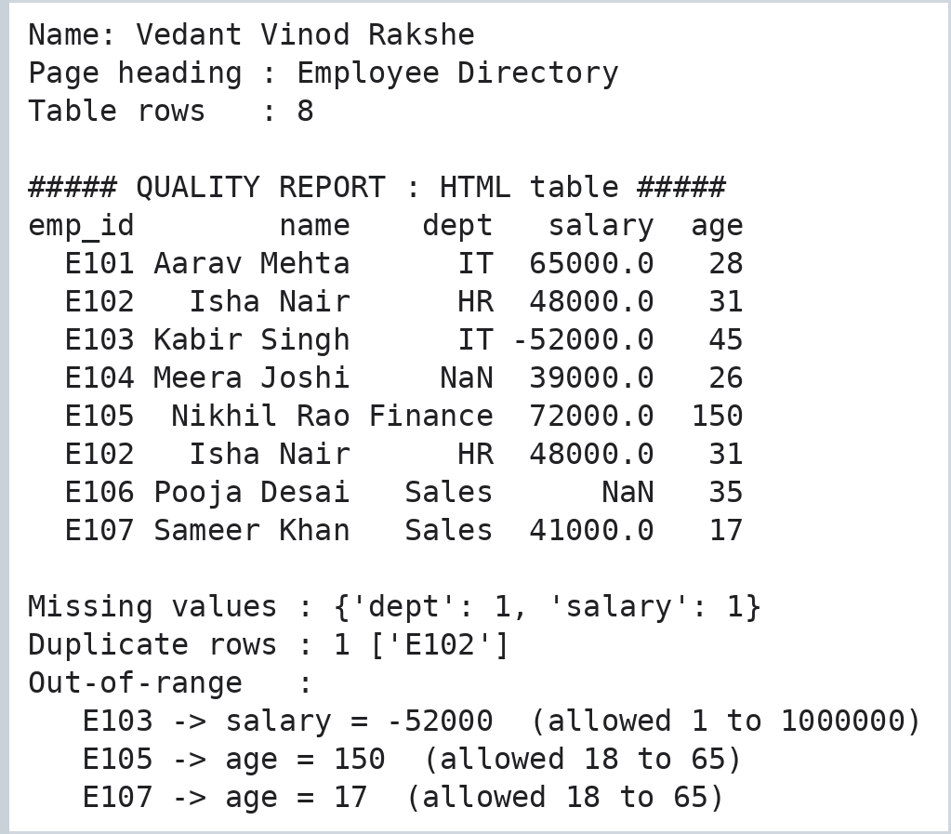

Step 6: Parse an XML Document
Code:
print("Name: Vedant Vinod Rakshe")
import xml.etree.ElementTree as ET

root = ET.parse("employees.xml").getroot()
df_xml = pd.DataFrame([emp.attrib for emp in root.iter("employee")])
print("Root tag:", root.tag, "| employee elements:", len(df_xml), "\n")
DataQualityChecker(df_xml, "XML (attributes)").report()
Output:
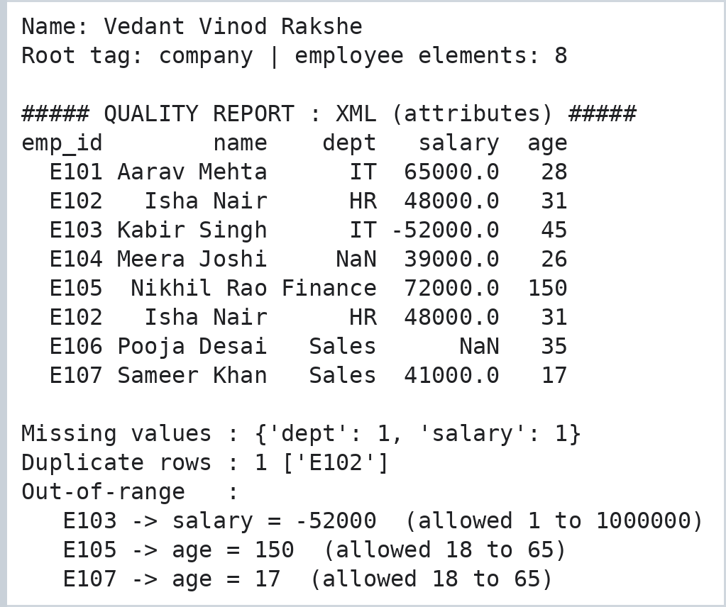

Step 7: Parse a JSON Document
Code:
print("Name: Vedant Vinod Rakshe")
import json

doc = json.load(open("employees.json"))
print("Company:", doc["company"], "| records:", len(doc["employees"]))
df_json = pd.DataFrame(doc["employees"])
df_json["skill_count"] = df_json["skills"].apply(len) # derived column from a nested list
print("Skill counts:", dict(zip(df_json["emp_id"], df_json["skill_count"])), "\n")
DataQualityChecker(df_json.drop(columns=["skills", "skill_count"]), "JSON document").report()
Output:
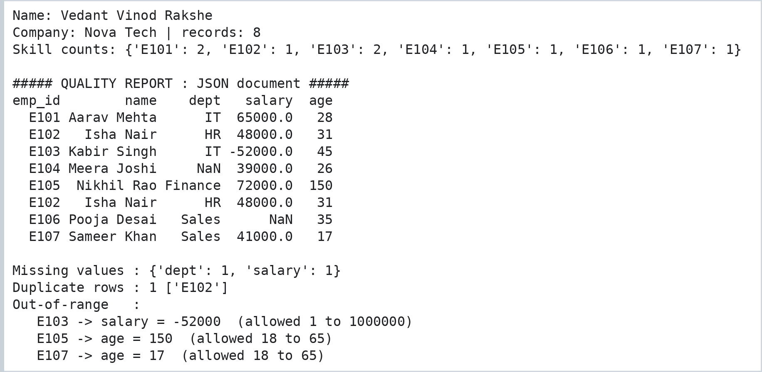

Step 8: Binary Files - Custom File Format with Header and Records
Code:
print("Name: Vedant Vinod Rakshe")
import struct, zlib, os

MAGIC, VERSION = b"EMPD", 1
HEADER = struct.Struct("<4sBI") # magic, version, record count
RECORD = struct.Struct("<4sfB") # emp code, salary, age

staff = [(b"E101", 65000.0, 28), (b"E102", 48000.0, 31), (b"E106", 39500.5, 35)]
with open("staff.bin", "wb") as f: # ---- WRITE
f.write(HEADER.pack(MAGIC, VERSION, len(staff)))
for rec in staff:
f.write(RECORD.pack(*rec))
print("File size:", os.path.getsize("staff.bin"), "bytes =", HEADER.size, "header +", len(staff), "x", RECORD.size)

data = open("staff.bin", "rb").read() # ---- READ (whole file as bytes)
print("First 16 bytes:", data[:16].hex(" "))
magic, ver, count = HEADER.unpack_from(data, 0)
print("Header ->", magic.decode(), "| version", ver, "| records", count)
for i in range(count):
code, sal, age = RECORD.unpack_from(data, HEADER.size + i * RECORD.size)
print(f" record {i+1}: {code.decode()} salary={sal:.1f} age={age}")

buf = bytearray(data) # ---- MODIFY in memory, then save
RECORD.pack_into(buf, HEADER.size + RECORD.size, b"E102", 52000.0, 32)
open("staff_updated.bin", "wb").write(buf)
print("Updated record 2 ->", RECORD.unpack_from(open("staff_updated.bin", "rb").read(), HEADER.size + RECORD.size))

print("CRC32 original :", hex(zlib.crc32(data))) # integrity check
print("CRC32 modified :", hex(zlib.crc32(bytes(buf))))
Output:
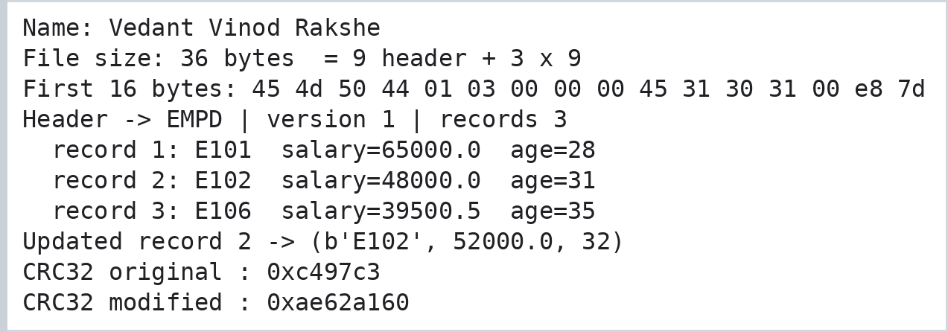

Step 9: Regular Expressions on a Web-Server Log
Code:
print("Name: Vedant Vinod Rakshe")
import re

log = """2026-03-04 10:15:32 INFO 192.168.1.10 GET /home 200
2026-03-04 10:16:05 ERROR 10.0.0.77 POST /login 500
2026-03-04 10:17:44 WARN 172.16.4.9 GET /reports/q1.pdf 404
2026-03-04 10:19:10 ERROR 192.168.1.10 GET /api/data 503"""

# 1. SEARCH with a compiled pattern and named groups
pattern = re.compile(r"(?P<date>\d{4}-\d{2}-\d{2}) (?P<time>[\d:]{8}) (?P<level>[A-Z]+)\s+(?P<ip>[\d.]+) (?P<method>GET|POST) (?P<url>\S+) (?P<code>\d{3})")
for m in pattern.finditer(log):
print(m.group("level").ljust(5), m.group("ip").ljust(13), m.group("url").ljust(16), m.group("code"))

print("Error lines :", len(re.findall(r"^.*ERROR.*$", log, flags=re.M)))
print("Unique IPs :", sorted(set(re.findall(r"\b(?:\d{1,3}\.){3}\d{1,3}\b", log))))

# 2. SPLIT
first = log.split("\n")[0]
print("Split line :", re.split(r"\s+", first))
print("Split on / and space:", re.split(r"[/\s]+", "GET /reports/q1.pdf 404"))

# 3. REPLACE (plain text and with a function)
mask = lambda m: ".".join(m.group().split(".")[:2] + ["x", "x"])
print("Masked IPs :", re.findall(r"\b\d+\.\d+\.x\.x\b", re.sub(r"\b(?:\d{1,3}\.){3}\d{1,3}\b", mask, log)))
print("Levels lower:", re.sub(r"\b(INFO|WARN|ERROR)\b", lambda m: m.group().lower(), first))
print("Dates DD/MM/YYYY:", re.sub(r"(\d{4})-(\d{2})-(\d{2})", r"\3/\2/\1", first)[:10])
Output:
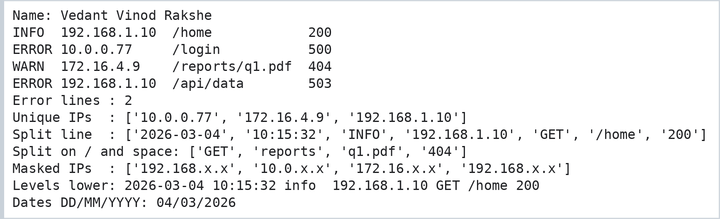

Step 10: Relational Database Design (Library System) and CRUD Operations
Three related tables - Book, Member and Issue - are created. Issue links books and members through foreign keys; deleting a book also removes its issue records (ON DELETE CASCADE).
Code:
print("Name: Vedant Vinod Rakshe")
import sqlite3

con = sqlite3.connect("library.db")
cur = con.cursor()
cur.executescript("""
PRAGMA foreign_keys = ON;
DROP TABLE IF EXISTS Issue; DROP TABLE IF EXISTS Member; DROP TABLE IF EXISTS Book;
CREATE TABLE Book (book_id INTEGER PRIMARY KEY, title TEXT NOT NULL, author TEXT, price REAL CHECK (price > 0), copies INTEGER DEFAULT 1);
CREATE TABLE Member (member_id INTEGER PRIMARY KEY, name TEXT NOT NULL, joined TEXT);
CREATE TABLE Issue (issue_id INTEGER PRIMARY KEY AUTOINCREMENT,
book_id INTEGER NOT NULL REFERENCES Book(book_id) ON DELETE CASCADE,
member_id INTEGER NOT NULL REFERENCES Member(member_id),
issue_date TEXT, returned INTEGER DEFAULT 0);
""")

def table(sql, params=()):
print(pd.read_sql(sql, con, params=params).to_string(index=False), "\n")

# ---- CREATE
cur.executemany("INSERT INTO Book (title, author, price, copies) VALUES (?,?,?,?)", [
("Database Systems", "Elmasri", 650.0, 4), ("Python Basics", "Matthes", 480.0, 6), ("Data Pipelines", "Reis", 720.0, 2)])
cur.executemany("INSERT INTO Member (name, joined) VALUES (?,?)", [("Anaya", "2026-01-10"), ("Veer", "2026-02-01")])
cur.executemany("INSERT INTO Issue (book_id, member_id, issue_date) VALUES (?,?,?)", [(1, 1, "2026-03-01"), (2, 1, "2026-03-02"), (3, 2, "2026-03-03")])
con.commit()
print("CREATE -> books:"); table("SELECT * FROM Book")

# ---- READ
print("READ -> books issued per member:")
table("""SELECT m.name AS member, COUNT(*) AS books_issued, GROUP_CONCAT(b.title, ' | ') AS titles
FROM Issue i JOIN Member m USING (member_id) JOIN Book b USING (book_id) GROUP BY m.name""")
print("READ -> books costing more than 500:")
table("SELECT title, price FROM Book WHERE price > ? ORDER BY price DESC", (500,))

# ---- UPDATE
cur.execute("UPDATE Book SET copies = copies - 1 WHERE book_id = 1")
cur.execute("UPDATE Issue SET returned = 1 WHERE issue_id = 2")
con.commit()
print("UPDATE -> stock and returns:")
table("SELECT book_id, title, copies FROM Book")
table("SELECT issue_id, book_id, returned FROM Issue")

# ---- DELETE (cascades to the Issue table)
cur.execute("DELETE FROM Book WHERE book_id = 3")
con.commit()
print("DELETE -> remaining books and issues:")
table("SELECT book_id, title FROM Book")
table("SELECT issue_id, book_id, member_id FROM Issue")
con.close()
Output:
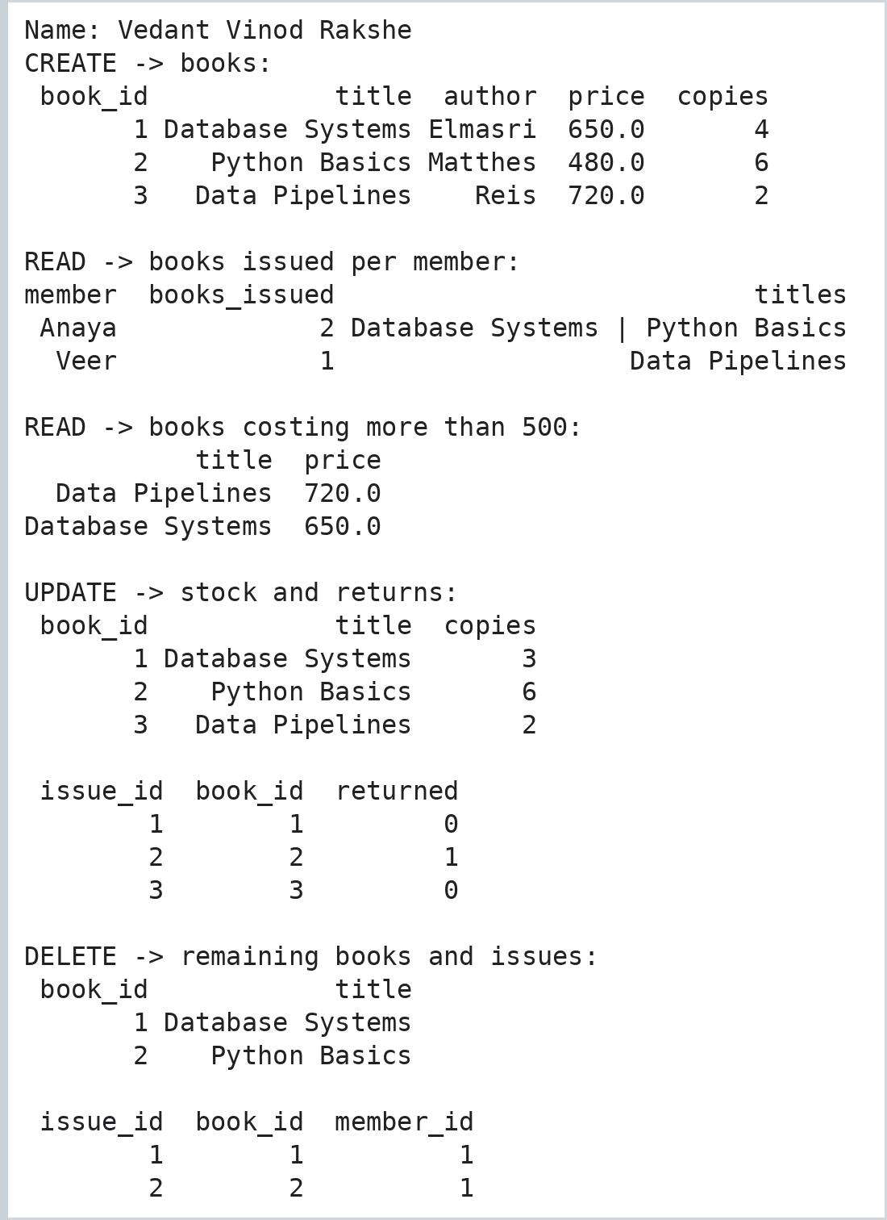

Practical No. 2: ETL Process in Power BI (Extract, Transform and Load)
Aim: To perform the ETL process in Power BI by extracting, transforming, and loading data to prepare it for analysis.

Step 1: Import Excel Data into Power BI
The Excel workbook containing the Products, Orders, and Order_Details tables was imported into Power BI for further data transformation and analysis.
Output:
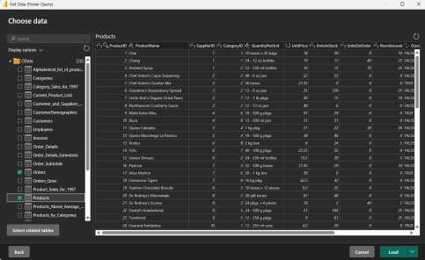

Step 2: Open Power Query Editor
Power Query Editor was opened to perform the required data transformation operations on the imported tables.
Output:
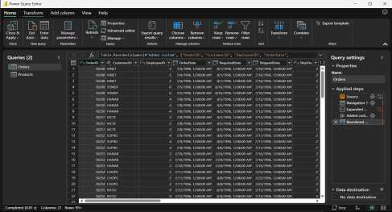

Step 3: Remove Unnecessary Columns
Unnecessary columns were removed from the Products table to retain only the fields required for further analysis.
Output:
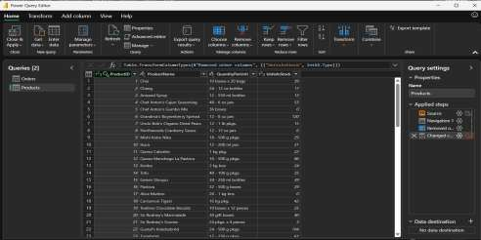

Step 4: Verify the Data Type of UnitsInStock
The data type of the UnitsInStock column was verified as Whole Number, which is appropriate for representing stock quantities.
Output:
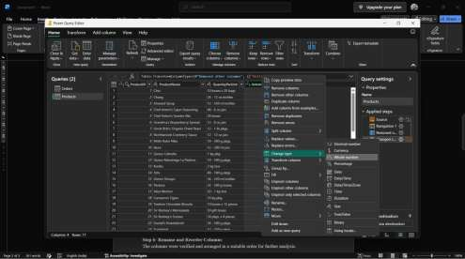

Step 5: Calculate Line Total
A new LineTotal column was created by multiplying UnitPrice by Quantity for each order detail (Add Column > Custom Column).
Code:
LineTotal = [UnitPrice] * [Quantity]
Output:
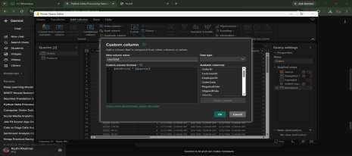

Step 6: Rename and Reorder Columns
The columns were verified and arranged in a suitable order for further analysis.
Output:
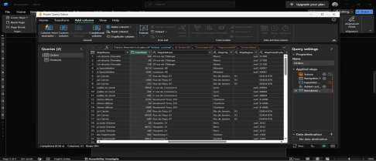

Step 7: Load the Transformed Data
The transformed data was loaded into Power BI Desktop using the Close & Apply option.
Output:
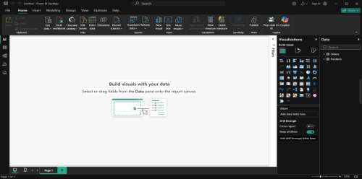

Step 8: Create Relationships Between Tables
Relationships were created between the related tables using their common key fields to establish the data model.
Output:
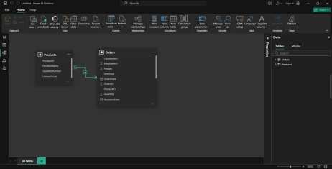

Step 9: Result
The ETL process was successfully performed in Power BI by extracting data from an Excel workbook, transforming the data using Power Query, creating the LineTotal column, loading the transformed data, and establishing relationships between the tables. A report page with card visuals and a clustered bar chart of Sum of LineTotal by ShipCountry was built on the loaded model.
Output:
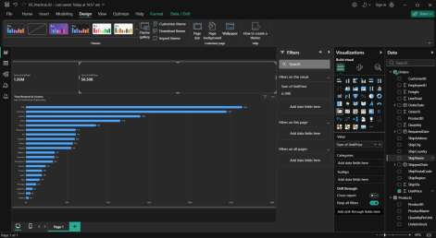

Practical No. 3: MongoDB Operations
Aim: To perform single and multiple document insertion and retrieval using MongoDB shell (mongosh).

Step 1: Insert Single Document
Code:
db.items.insertOne({ name: "laptop", price: 999 });
Output:
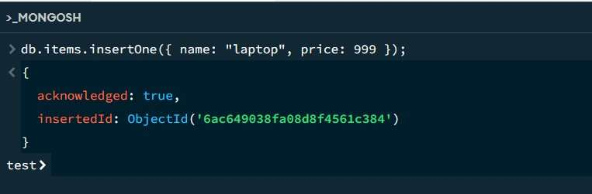

Step 2: View Inserted Document
Code:
db.items.find();
Output:
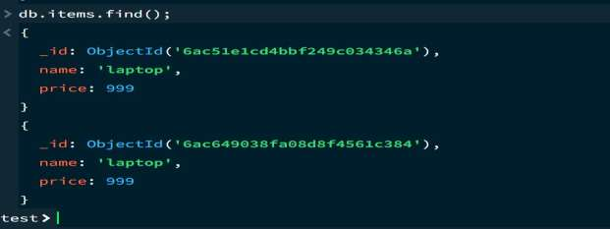

Step 3: Insert Multiple Documents
Code:
db.products.insertMany([
{ name: "phone", price: 500, stock: 10 },
{ name: "tablet", price: 300, stock: 5 },
{ name: "watch", price: 150, stock: 0 }
]);
Output:
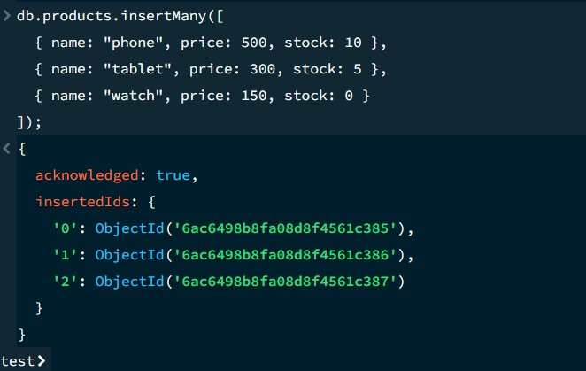

Step 4: View Products in Formatted JSON
Code:
db.products.find().pretty();
Output:
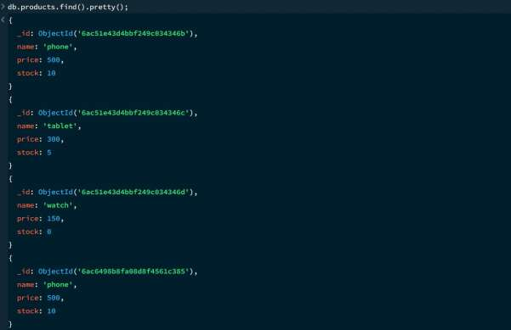
Output:
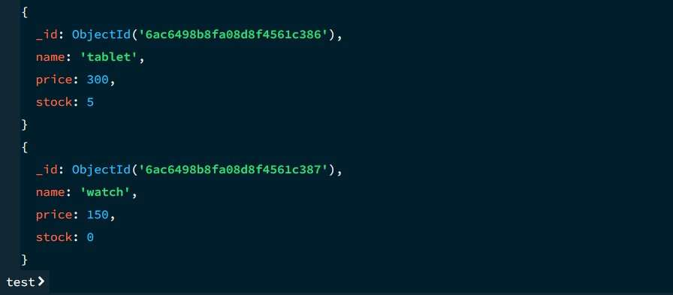

Practical No. 4: Data Preprocessing, Noise Elimination, Feature Selection and Exploratory Data Analysis
Aim: To use Pandas, NumPy, Scikit-learn, Matplotlib and Seaborn to clean a data set (missing values and duplicates), scale it (normalisation and standardisation), remove noise, select the useful features and explore the data with statistics and plots (EDA).

Step 1: Cleaning, Normalization and Standardization (Part A)
A synthetic housing data set (32 rows) is generated with deliberate problems: missing numbers and text, two duplicate rows, a constant column, a redundant column (price in lakh) and two noisy prices.
Code:
# Name: Vedant Vinod Rakshe
# PART A : data cleaning and scaling on a housing data set
print("Name: Vedant Vinod Rakshe")
import numpy as np
import pandas as pd
from sklearn.preprocessing import MinMaxScaler, StandardScaler

rng = np.random.default_rng(7)
n = 30
houses = pd.DataFrame({
"sqft": rng.integers(600, 2400, n).astype(float),
"bedrooms": rng.integers(1, 5, n).astype(float),
"age_years": rng.integers(1, 40, n).astype(float),
"distance_km": np.round(rng.uniform(1, 25, n), 1),
"city": rng.choice(["Pune", "Mumbai", "Nashik"], n),
})
houses["price"] = (houses["sqft"] * 4200 - houses["age_years"] * 9000 - houses["distance_km"] * 12000
+ rng.normal(0, 60000, n)).round(-3)
houses["price_lakh"] = houses["price"] / 100000 # same information as price (redundant)
houses["country_code"] = 91 # constant column
houses = pd.concat([houses, houses.iloc[[3, 11]]], ignore_index=True) # 2 duplicate rows
houses.loc[[2, 9, 17], "sqft"] = np.nan # missing numbers
houses.loc[[5, 20], "city"] = None # missing text
houses.loc[[4], "price"] = 45_000_000 # extreme price (noise)
houses.loc[[13], "price"] = -250_000 # impossible price (noise)

print("Shape:", houses.shape)
print("\nMissing values:\n", houses.isna().sum()[lambda s: s > 0].to_string())
print("\nDuplicate rows:", houses.duplicated().sum())

clean = houses.drop_duplicates().copy() # 1. duplicates
clean["sqft"] = clean["sqft"].fillna(clean["sqft"].median()) # 2. numeric -> median
clean["city"] = clean["city"].fillna(clean["city"].mode()[0]) # text -> most common
print("\nAfter cleaning -> rows:", len(clean), "| missing values left:", int(clean.isna().sum().sum()))

cols = ["sqft", "bedrooms", "age_years", "distance_km"]
scaled_mm = pd.DataFrame(MinMaxScaler().fit_transform(clean[cols]), columns=cols) # 3. normalisation
scaled_z = pd.DataFrame(StandardScaler().fit_transform(clean[cols]), columns=cols) # standardisation
print("\nMin-Max scaled (first 4 rows):\n", scaled_mm.head(4).round(3).to_string())
print("\nZ-score scaled (mean, std):\n", pd.DataFrame({"mean": scaled_z.mean().round(3) + 0.0, "std": scaled_z.std(ddof=0).round(3)}).to_string())
Output:
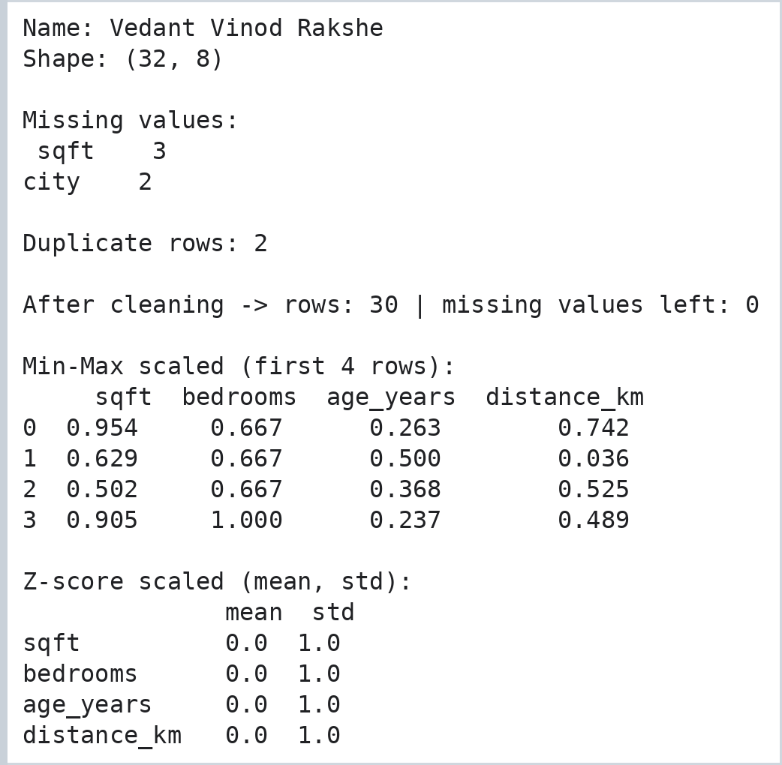

Step 2: Noise Elimination (Z-score filter and Smoothing) (Part B1)
Code:
# PART B1 : noise elimination
print("Name: Vedant Vinod Rakshe")
import matplotlib.pyplot as plt

# (a) outliers in price: keep rows whose |z-score| is at most 2.5
price_z = (clean["price"] - clean["price"].mean()) / clean["price"].std()
noisy_rows = clean[price_z.abs() > 2.5]
print("Rows removed as noise (|z| > 2.5):\n", noisy_rows[["sqft", "price"]].to_string())
print("Rows with impossible (non-positive) price:\n", clean[clean["price"] <= 0][["sqft", "price"]].to_string())
no_outliers = clean[price_z.abs() <= 2.5]
data = no_outliers[no_outliers["price"] > 0].reset_index(drop=True) # impossible values removed too
print("Rows before:", len(clean), "| after noise removal:", len(data))

# (b) smoothing a noisy sensor signal with a moving average
t = np.arange(40)
signal = np.sin(t / 5) * 10 + 50 + rng.normal(0, 2.5, 40)
signal[[8, 25]] += 25 # two spikes
smooth = pd.Series(signal).rolling(window=5, center=True, min_periods=1).median()
print("\nSignal std before smoothing:", round(signal.std(), 2), "| after:", round(smooth.std(), 2))

plt.figure(figsize=(7, 3.2))
plt.plot(t, signal, color="#c0392b", alpha=0.7, label="raw signal (with spikes)")
plt.plot(t, smooth, color="#1e8449", lw=2, label="rolling median (window = 5)")
plt.legend(); plt.title("Noise elimination by smoothing"); plt.xlabel("time step")
plt.gcf().text(0.99, 0.005, "Name: Vedant Vinod Rakshe", ha="right", va="bottom", fontsize=8, color="gray")
plt.savefig("p4_noise.png", dpi=110, bbox_inches="tight")
plt.show()
Output:
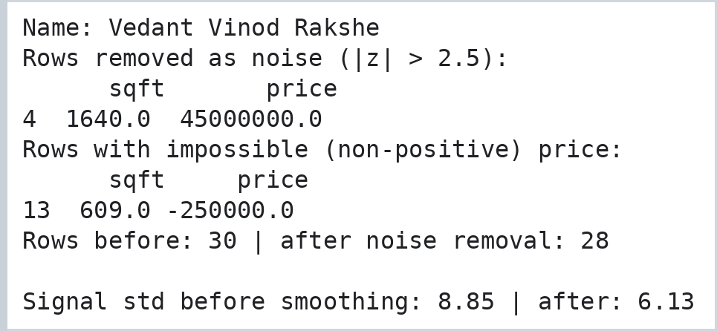
Output:
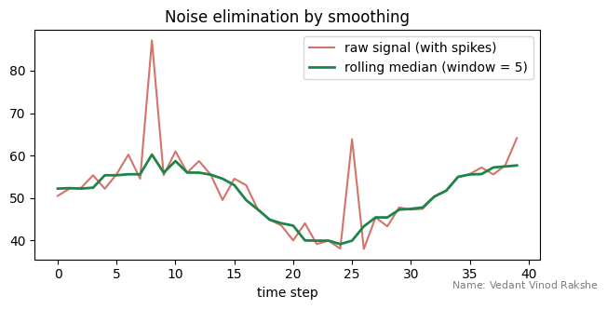

Step 3: Feature Selection (Variance, Correlation and F-test) (Part B2)
Code:
# PART B2 : feature selection
print("Name: Vedant Vinod Rakshe")
from sklearn.feature_selection import VarianceThreshold, SelectKBest, f_regression

features = ["sqft", "bedrooms", "age_years", "distance_km", "price_lakh", "country_code"]
X, y = data[features], data["price"]

# step 1 - remove constant columns
vt = VarianceThreshold(threshold=0.0).fit(X)
print("Constant features removed:", [c for c, keep in zip(features, vt.get_support()) if not keep])
X = X.loc[:, vt.get_support()]

# step 2 - remove one of every pair of highly correlated features (|r| > 0.95)
corr = X.corr().abs()
upper = corr.where(np.triu(np.ones(corr.shape), k=1).astype(bool))
redundant = [c for c in upper.columns if (upper[c] > 0.95).any()]
print("Redundant (correlated) features removed:", redundant)
X = X.drop(columns=redundant)

# step 3 - keep the 3 features most related to price (ANOVA F-test)
sk = SelectKBest(f_regression, k=3).fit(X, y)
scores = pd.Series(sk.scores_, index=X.columns).sort_values(ascending=False)
print("\nF-scores:\n", scores.round(1).to_string())
selected = list(X.columns[sk.get_support()])
print("\nSelected features:", selected)
Output:
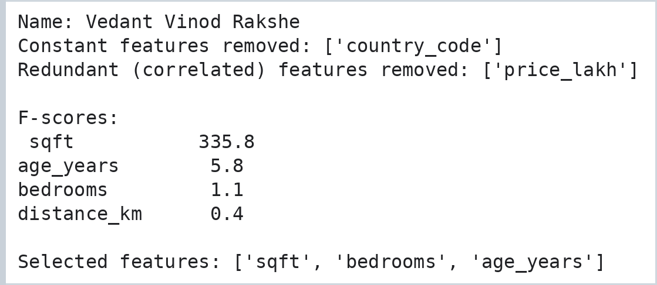

Step 4: Exploratory Data Analysis (Part C)
Code:
# PART C : exploratory data analysis (EDA)
print("Name: Vedant Vinod Rakshe")
import seaborn as sns
eda = data[selected + ["price", "city"]]

print("Dataset information:")
eda.info()
print("\nStatistical summary:\n", eda.describe().round(1).to_string())
print("\nCity-wise average price:\n", eda.groupby("city")["price"].agg(["count", "mean"]).round(0).to_string())
print("\nCorrelation with price:\n", eda.drop(columns="city").corr()["price"].round(3).to_string())

fig, ax = plt.subplots(2, 2, figsize=(10, 7))
sns.histplot(eda["price"], bins=10, color="#2e86c1", ax=ax[0, 0]).set_title("Histogram of price")
sns.boxplot(data=eda, x="city", y="price", palette="Set2", ax=ax[0, 1]).set_title("Price by city")
sns.heatmap(eda.drop(columns="city").corr(), annot=True, fmt=".2f", cmap="YlGnBu", ax=ax[1, 0]); ax[1, 0].set_title("Correlation heatmap")
sns.scatterplot(data=eda, x="sqft", y="price", hue="city", ax=ax[1, 1]); ax[1, 1].set_title("Area vs price")
plt.tight_layout()
plt.gcf().text(0.99, 0.005, "Name: Vedant Vinod Rakshe", ha="right", va="bottom", fontsize=8, color="gray")
plt.savefig("p4_eda_overview.png", dpi=110, bbox_inches="tight")
plt.show()
Output:
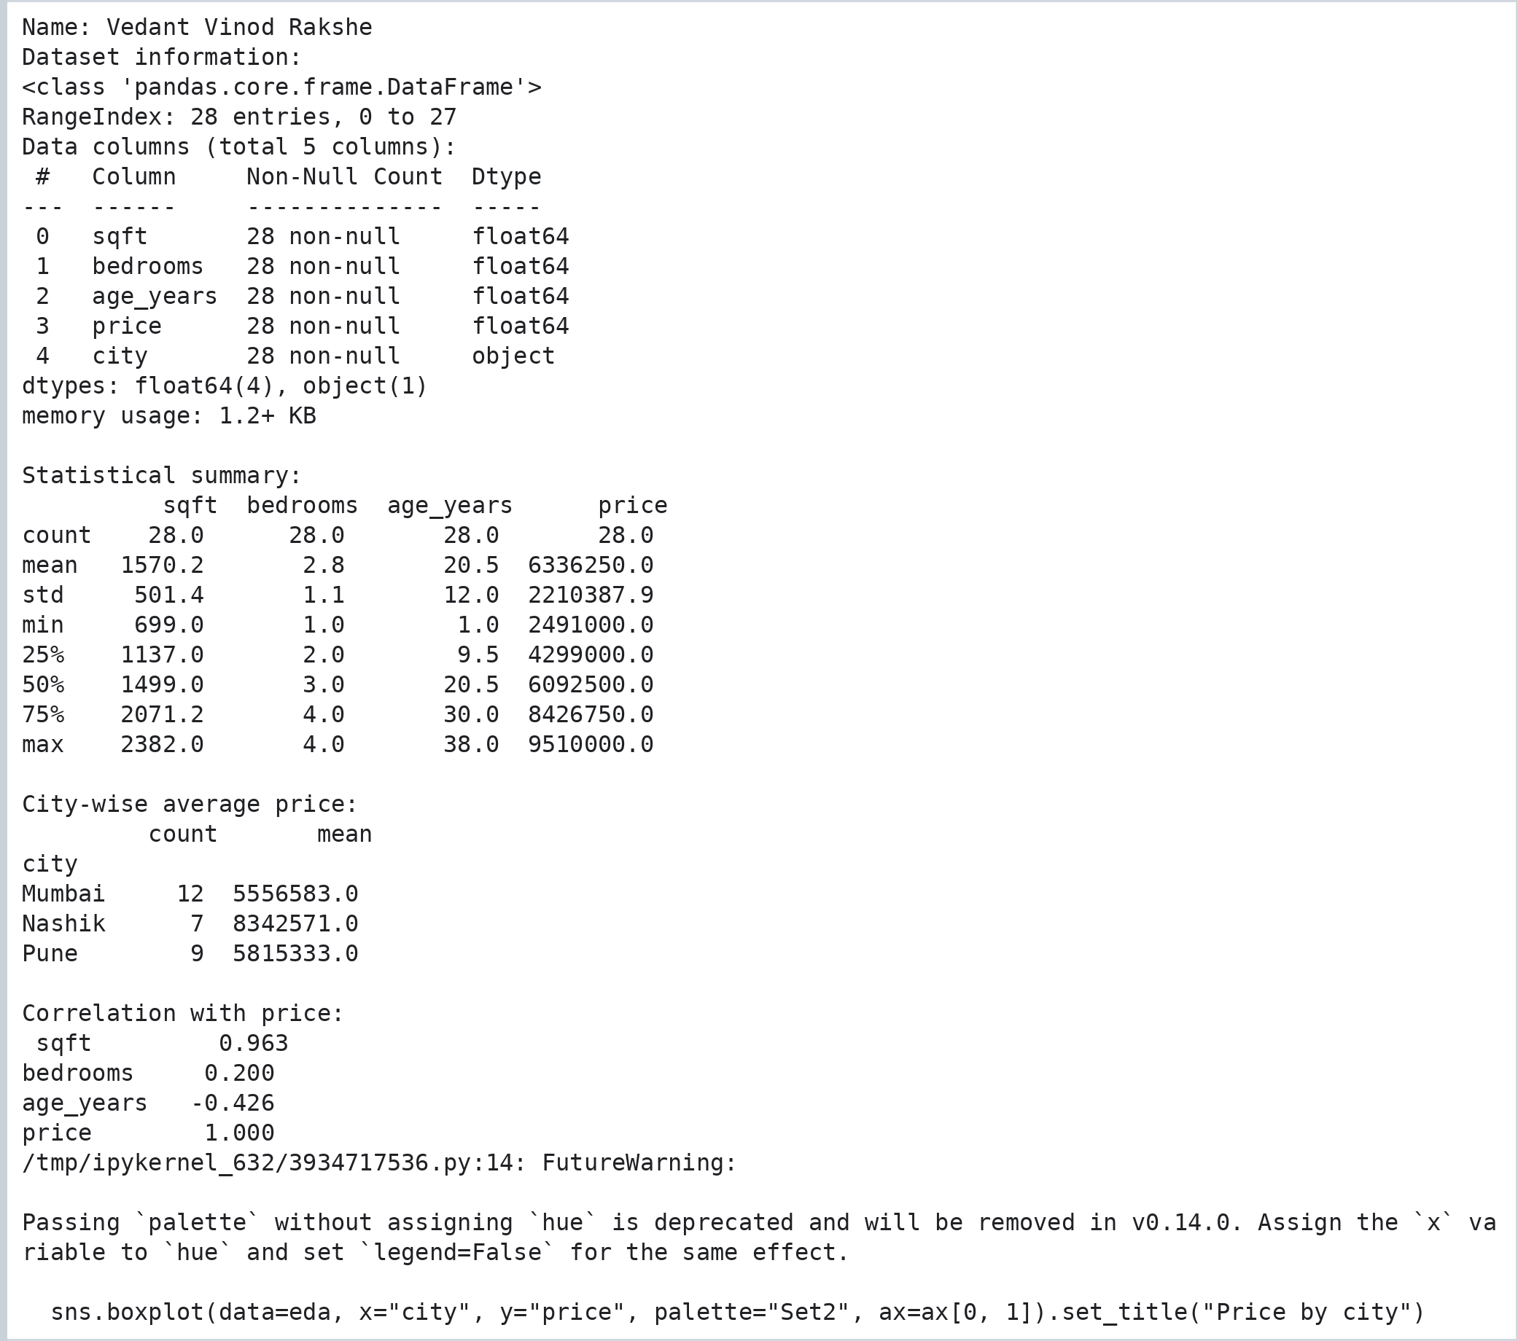
Output:
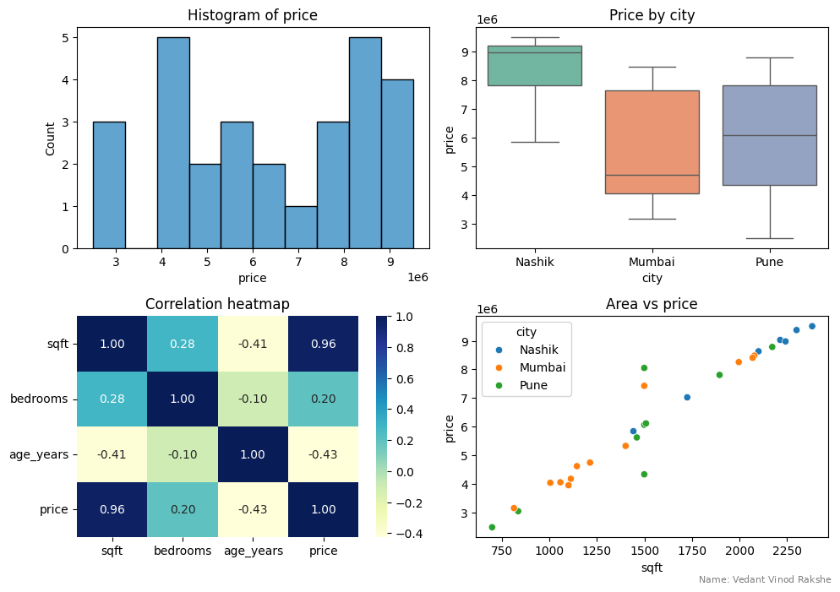

Practical No. 5: Extracting Data from APIs and Flat Files using Python
Aim: To write a Python program (extract_pipeline.py) that collects task data from a public REST API with retry handling, reads a flat CSV file, merges and transforms both sources and saves a clean report as CSV and JSON.

Step 1: API + CSV Extraction and Transformation (extract_pipeline.py)
The complete program is provided as practical_05_extract_pipeline.py (it is copied as extract_pipeline.py for the Airflow DAG of Practical 6). API used: https://jsonplaceholder.typicode.com/todos?_limit=10
Code:
# Name: Vedant Vinod Rakshe
# extract_pipeline.py : REST API (JSON) + flat file (CSV) -> one clean report file
print("Name: Vedant Vinod Rakshe")
import json, time
import pandas as pd
import requests

API_URL = "https://jsonplaceholder.typicode.com/todos?_limit=10"
CACHED_SAMPLE = [ # cached sample of the same API response, used only when the API is unreachable
{"userId": 1, "id": 1, "title": "delectus aut autem", "completed": False},
{"userId": 1, "id": 2, "title": "quis ut nam facilis et officia qui", "completed": False},
{"userId": 1, "id": 3, "title": "fugiat veniam minus", "completed": False},
{"userId": 1, "id": 4, "title": "et porro tempora", "completed": True},
{"userId": 1, "id": 5, "title": "laboriosam mollitia et enim quasi adipisci quia provident illum", "completed": False},
{"userId": 1, "id": 6, "title": "qui ullam ratione quibusdam voluptatem quia omnis", "completed": False},
{"userId": 1, "id": 7, "title": "illo expedita consequatur quia in", "completed": False},
{"userId": 1, "id": 8, "title": "quo adipisci enim quam ut ab", "completed": True},
{"userId": 1, "id": 9, "title": "molestiae perspiciatis ipsa", "completed": False},
{"userId": 1, "id": 10, "title": "illo est ratione doloremque quia maiores aut", "completed": True},
]

def fetch_json(url, retries=3, wait=1):
"""GET with retries; returns (data, source_label)."""
for attempt in range(1, retries + 1):
try:
r = requests.get(url, timeout=8)
r.raise_for_status()
return r.json(), "live API"
except requests.RequestException as err:
print(f" attempt {attempt}/{retries} failed: {type(err).__name__}")
time.sleep(wait)
return CACHED_SAMPLE, "cached sample (API not reachable)"

def read_categories(path):
pd.DataFrame({
"id": range(1, 11),
"category": ["work", "home", "work", "study", "home", "study", "work", "health", "home", "health"],
"due_in_days": [2, 5, 1, 7, 3, 10, 2, 4, 6, 8],
}).to_csv(path, index=False) # create the flat file used in this lab
return pd.read_csv(path)

def build_report(api_rows, cat_df):
todos = pd.json_normalize(api_rows)
todos["status"] = todos["completed"].map({True: "Done", False: "Pending"})
todos["title_words"] = todos["title"].str.split().str.len()
todos["title"] = todos["title"].str.capitalize()
report = todos.merge(cat_df, on="id", how="left", validate="one_to_one")
return report[["id", "userId", "title", "category", "due_in_days", "title_words", "status"]]

if __name__ == "__main__":
print("Step 1: calling the API ...")
rows, source = fetch_json(API_URL, retries=2, wait=0)
print("Data source:", source, "| records:", len(rows))

print("\nStep 2: reading the CSV file")
categories = read_categories("task_categories.csv")
print(categories.head(3).to_string(index=False))

print("\nStep 3: merging and transforming")
report = build_report(rows, categories)
pd.set_option("display.width", 130, "display.max_colwidth", 38)
print(report.to_string(index=False))

print("\nStep 4: summary by category")
print(report.groupby("category").agg(tasks=("id", "count"), avg_due_days=("due_in_days", "mean"),
done=("status", lambda s: (s == "Done").sum())).round(1).to_string())
report.to_csv("todo_report.csv", index=False)
report.to_json("todo_report.json", orient="records", indent=1)
print("\nSaved: todo_report.csv and todo_report.json")
Output:
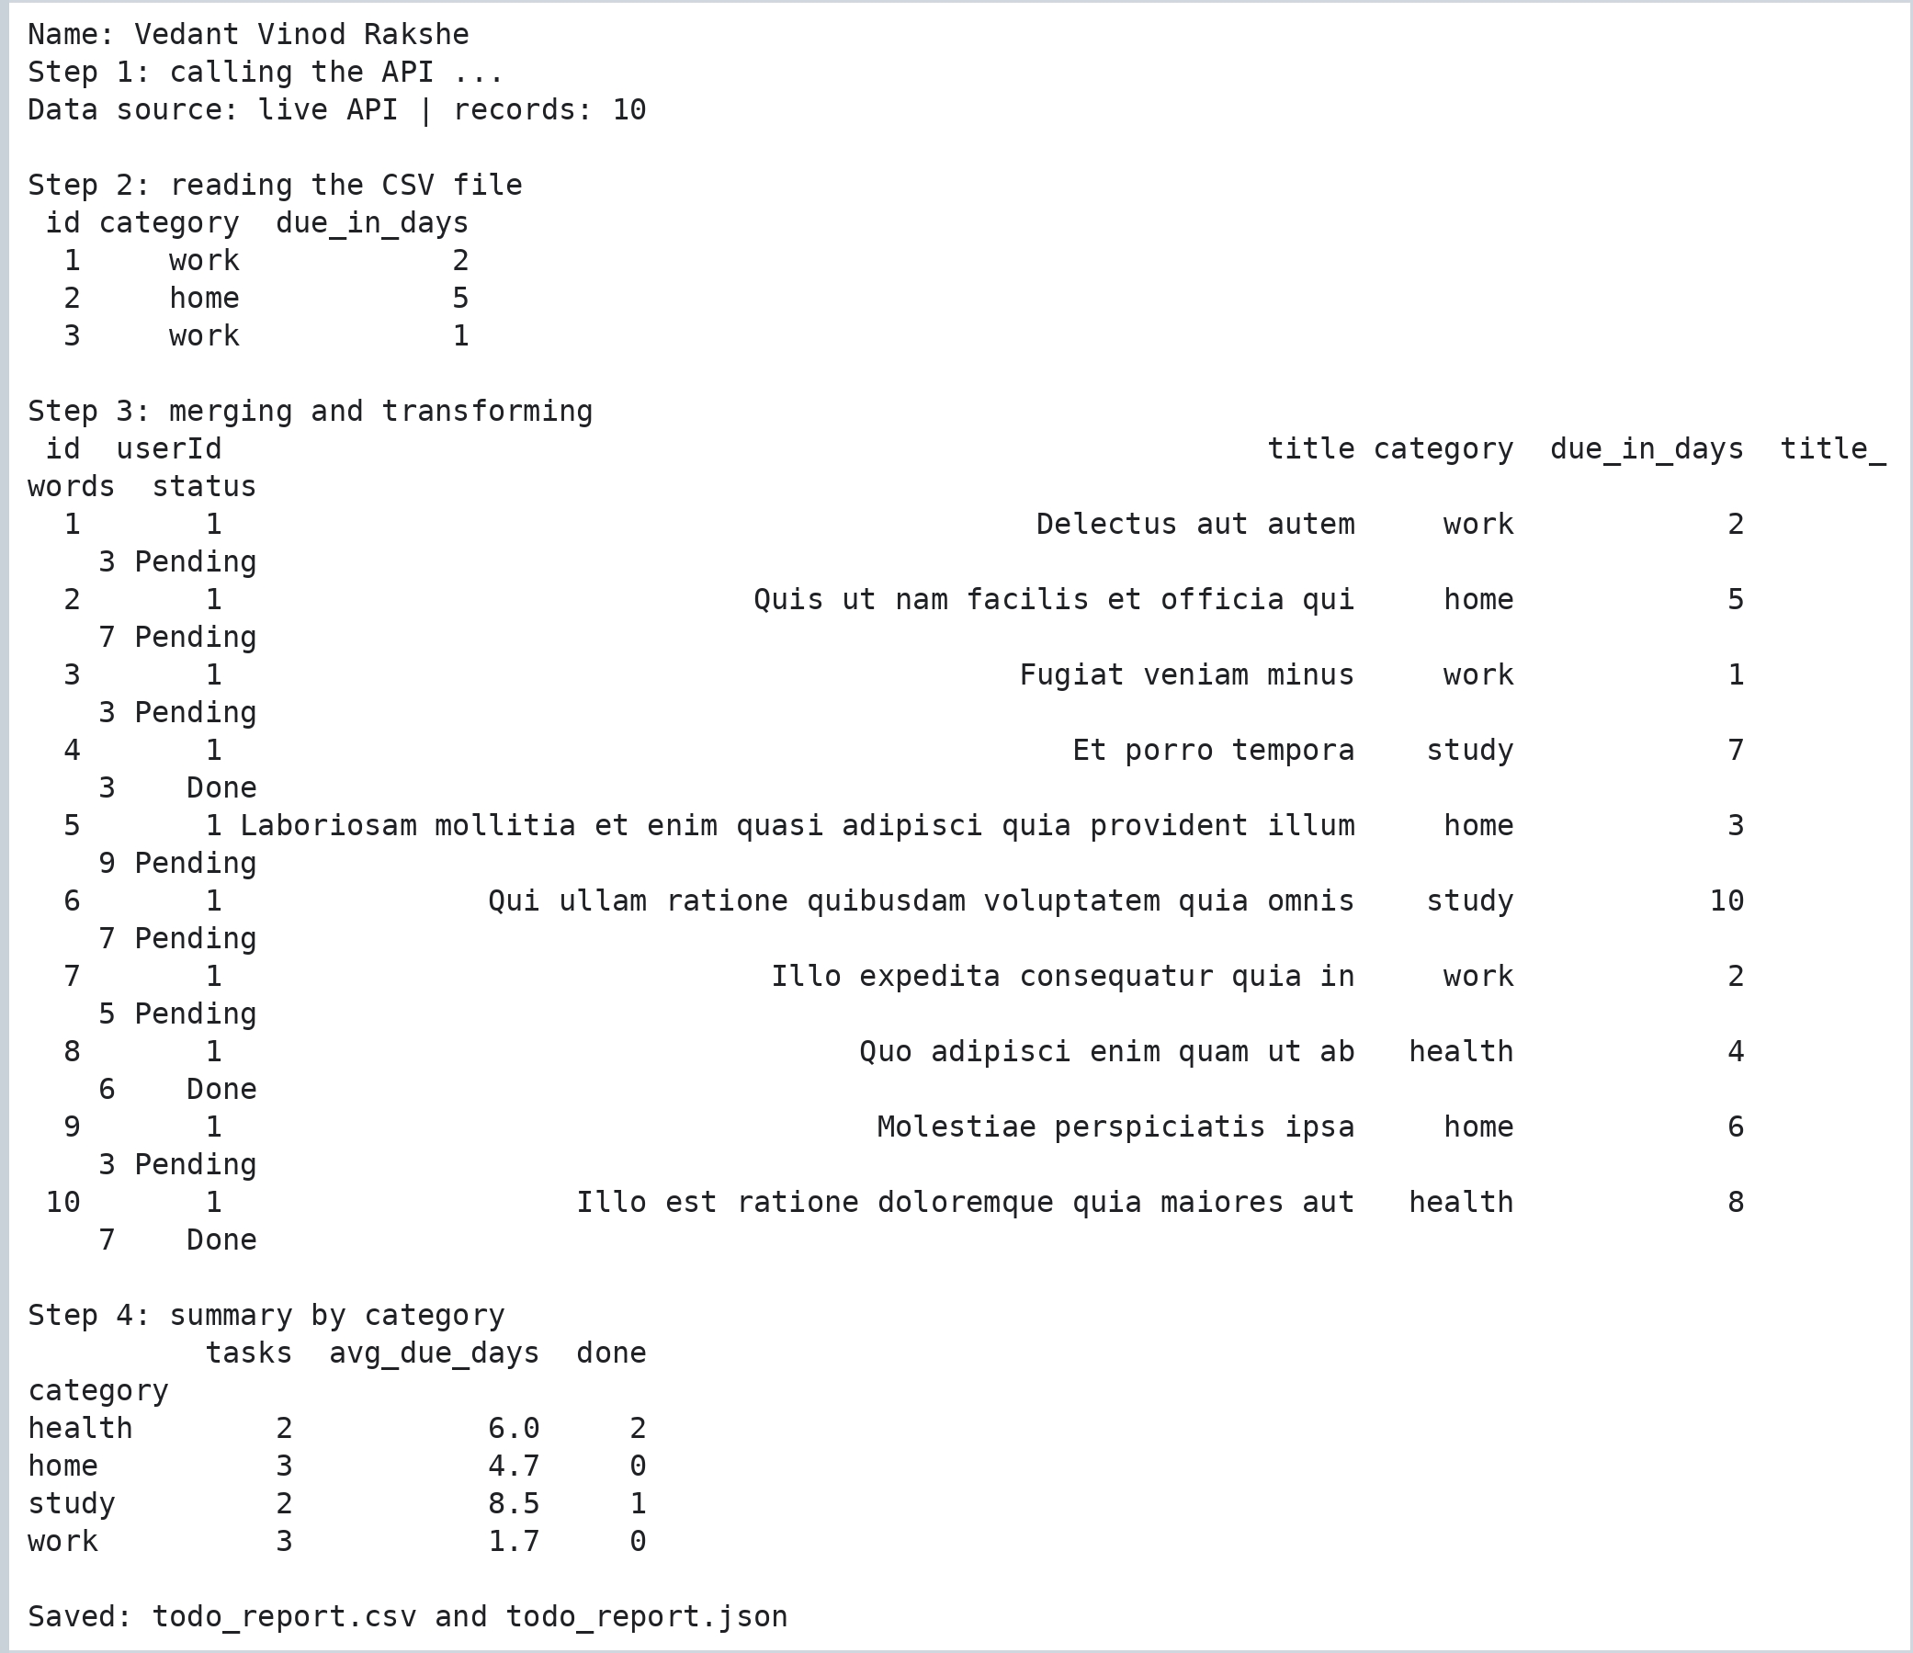

Step 2: Verify the Saved Report
Code:
print("Name: Vedant Vinod Rakshe")
import pandas as pd
check = pd.read_csv("todo_report.csv")
print("Rows:", len(check), "| Columns:", list(check.columns))
print("Duplicate ids :", check["id"].duplicated().sum())
print("Missing values:", int(check.isna().sum().sum()))
print("Pending tasks :", (check["status"] == "Pending").sum(), "| Done:", (check["status"] == "Done").sum())
Output:
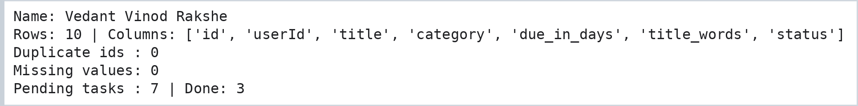

Practical No. 6: Installing Apache Airflow and Creating a Scheduled DAG
Aim: To set up Apache Airflow and write a DAG that runs every day at 06:00 and executes five dependent tasks: a start marker, the extraction program of Practical 5, a Python quality check, a success notification and an end marker.
Airflow runs on Linux / macOS / WSL2 / Google Colab. This notebook installs Airflow, writes the extraction program (Practical 5) and the DAG file into `~/airflow`, validates the DAG, runs its quality check and draws the task graph.

Step 1: Install Apache Airflow
Code:
%pip install -q apache-airflow
Output:
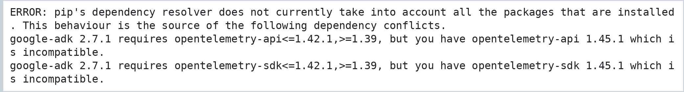
Code:
!airflow db migrate
Output:
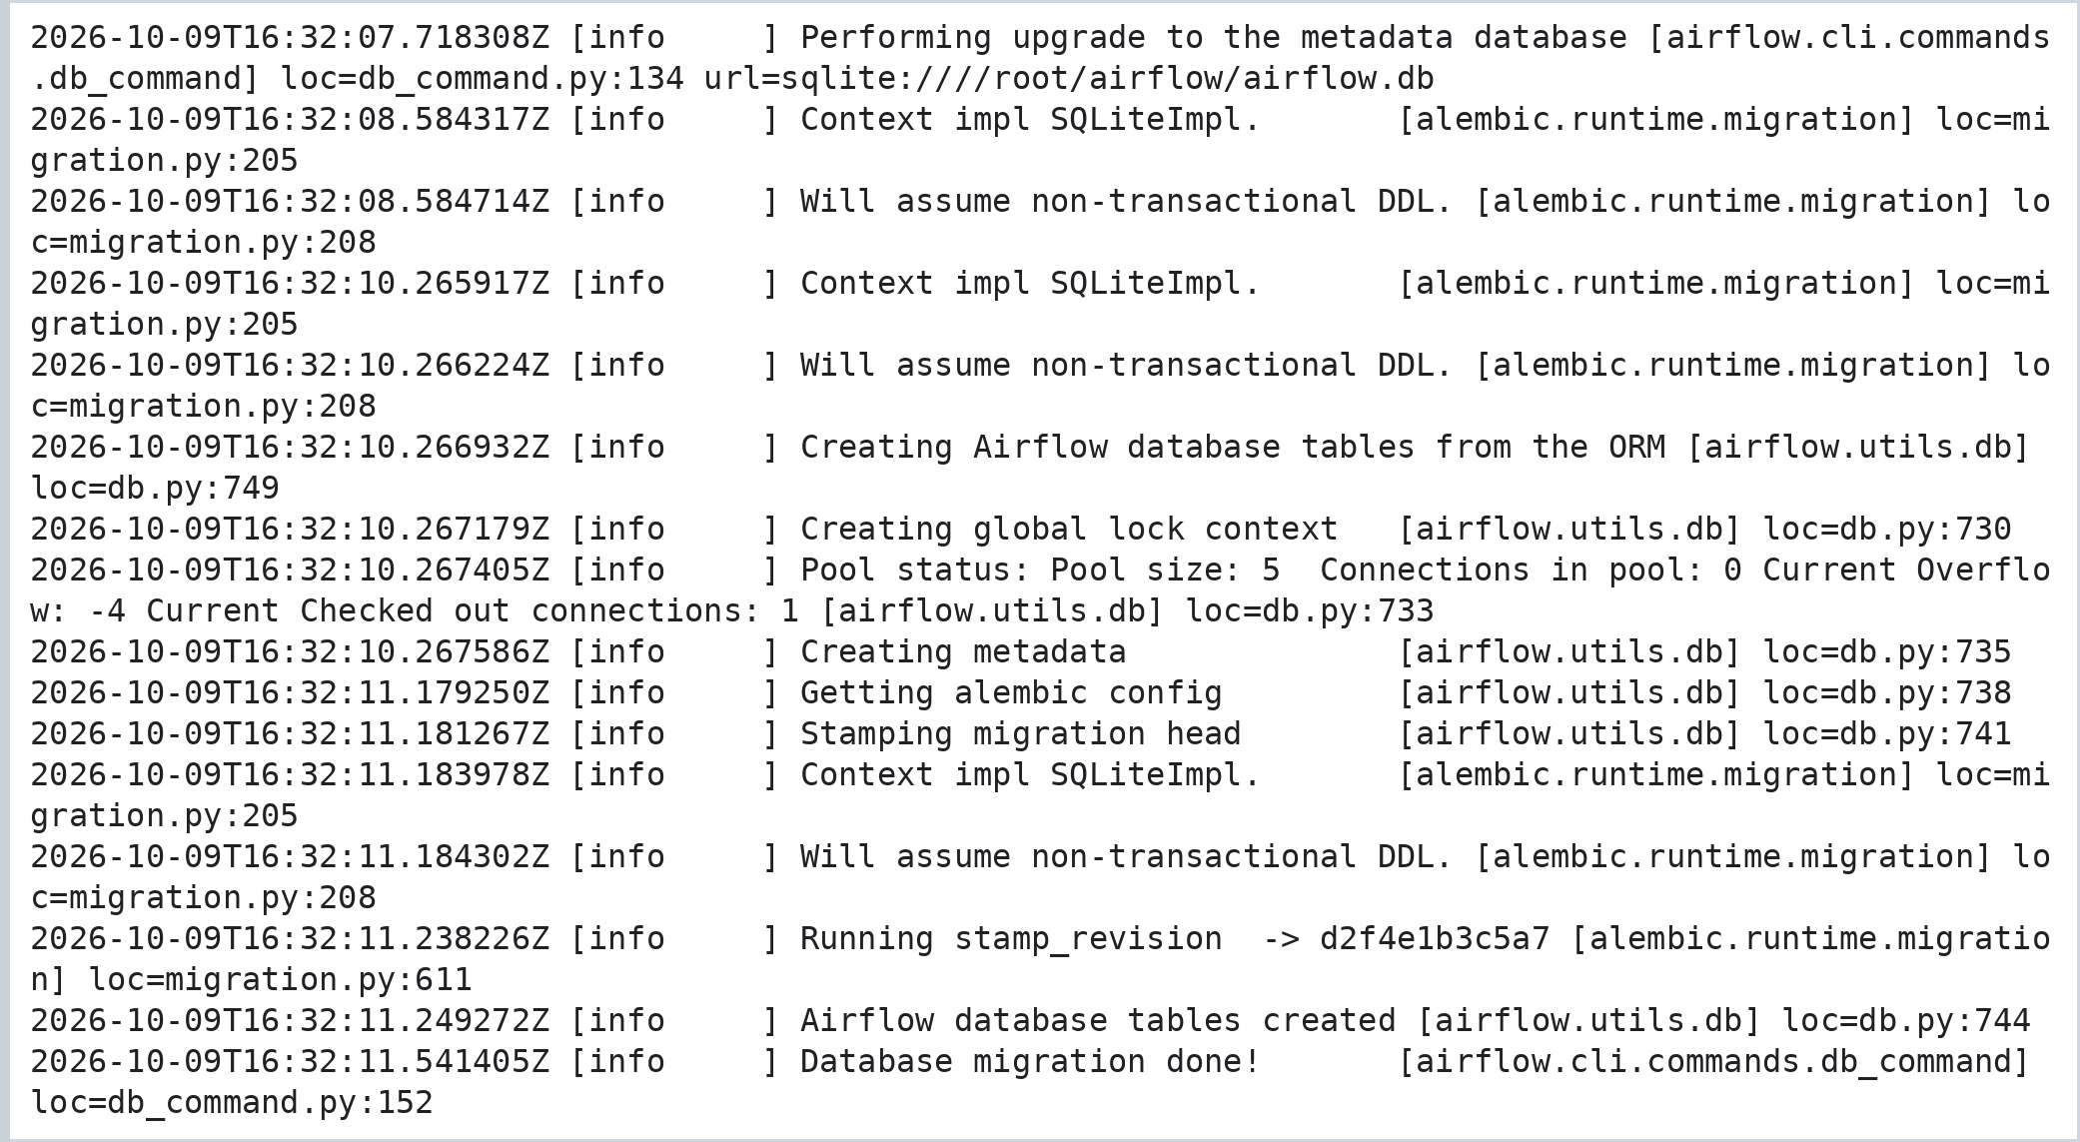

Step 2: Write the Extraction Program and the DAG File
Code:
import os
print("Name: Vedant Vinod Rakshe")

extract_code = r'''
# Name: Vedant Vinod Rakshe
# extract_pipeline.py : REST API (JSON) + flat file (CSV) -> one clean report file
print("Name: Vedant Vinod Rakshe")
import json, time
import pandas as pd
import requests

API_URL = "https://jsonplaceholder.typicode.com/todos?_limit=10"
CACHED_SAMPLE = [ # cached sample of the same API response, used only when the API is unreachable
{"userId": 1, "id": 1, "title": "delectus aut autem", "completed": False},
{"userId": 1, "id": 2, "title": "quis ut nam facilis et officia qui", "completed": False},
{"userId": 1, "id": 3, "title": "fugiat veniam minus", "completed": False},
{"userId": 1, "id": 4, "title": "et porro tempora", "completed": True},
{"userId": 1, "id": 5, "title": "laboriosam mollitia et enim quasi adipisci quia provident illum", "completed": False},
{"userId": 1, "id": 6, "title": "qui ullam ratione quibusdam voluptatem quia omnis", "completed": False},
{"userId": 1, "id": 7, "title": "illo expedita consequatur quia in", "completed": False},
{"userId": 1, "id": 8, "title": "quo adipisci enim quam ut ab", "completed": True},
{"userId": 1, "id": 9, "title": "molestiae perspiciatis ipsa", "completed": False},
{"userId": 1, "id": 10, "title": "illo est ratione doloremque quia maiores aut", "completed": True},
]

def fetch_json(url, retries=3, wait=1):
"""GET with retries; returns (data, source_label)."""
for attempt in range(1, retries + 1):
try:
r = requests.get(url, timeout=8)
r.raise_for_status()
return r.json(), "live API"
except requests.RequestException as err:
print(f" attempt {attempt}/{retries} failed: {type(err).__name__}")
time.sleep(wait)
return CACHED_SAMPLE, "cached sample (API not reachable)"

def read_categories(path):
pd.DataFrame({
"id": range(1, 11),
"category": ["work", "home", "work", "study", "home", "study", "work", "health", "home", "health"],
"due_in_days": [2, 5, 1, 7, 3, 10, 2, 4, 6, 8],
}).to_csv(path, index=False) # create the flat file used in this lab
return pd.read_csv(path)

def build_report(api_rows, cat_df):
todos = pd.json_normalize(api_rows)
todos["status"] = todos["completed"].map({True: "Done", False: "Pending"})
todos["title_words"] = todos["title"].str.split().str.len()
todos["title"] = todos["title"].str.capitalize()
report = todos.merge(cat_df, on="id", how="left", validate="one_to_one")
return report[["id", "userId", "title", "category", "due_in_days", "title_words", "status"]]

if __name__ == "__main__":
print("Step 1: calling the API ...")
rows, source = fetch_json(API_URL, retries=2, wait=0)
print("Data source:", source, "| records:", len(rows))

print("\nStep 2: reading the CSV file")
categories = read_categories("task_categories.csv")
print(categories.head(3).to_string(index=False))

print("\nStep 3: merging and transforming")
report = build_report(rows, categories)
pd.set_option("display.width", 130, "display.max_colwidth", 38)
print(report.to_string(index=False))

print("\nStep 4: summary by category")
print(report.groupby("category").agg(tasks=("id", "count"), avg_due_days=("due_in_days", "mean"),
done=("status", lambda s: (s == "Done").sum())).round(1).to_string())
report.to_csv("todo_report.csv", index=False)
report.to_json("todo_report.json", orient="records", indent=1)
print("\nSaved: todo_report.csv and todo_report.json")
'''

dag_code = r'''
# Name: Vedant Vinod Rakshe
# File: ~/airflow/dags/api_csv_daily_pipeline.py
import os
from datetime import datetime, timedelta
from airflow import DAG

try: # Airflow 3.x import paths
from airflow.providers.standard.operators.bash import BashOperator
from airflow.providers.standard.operators.empty import EmptyOperator
from airflow.providers.standard.operators.python import PythonOperator
except ImportError: # Airflow 2.x import paths
from airflow.operators.bash import BashOperator
from airflow.operators.empty import EmptyOperator
from airflow.operators.python import PythonOperator

SCRIPT_DIR = os.path.expanduser("~/airflow/scripts")

def quality_check():
"""Fail the task when the report is missing or has too few rows."""
import csv
with open(os.path.join(SCRIPT_DIR, "todo_report.csv")) as f:
rows = list(csv.DictReader(f))
if len(rows) < 10:
raise ValueError(f"Only {len(rows)} rows found - expected at least 10")
print(f"Quality check passed: {len(rows)} rows in todo_report.csv")

with DAG(
dag_id="api_csv_daily_pipeline",
description="Daily API + CSV extraction followed by a quality check",
start_date=datetime(2026, 1, 1),
schedule="0 6 * * *", # every day at 06:00
catchup=False,
tags=["practical6", "etl"],
default_args={"owner": "vedant", "retries": 2, "retry_delay": timedelta(minutes=2)},
) as dag:

begin = EmptyOperator(task_id="begin")

fetch_and_clean = BashOperator( # runs the program from Practical 5
task_id="fetch_and_clean",
bash_command=f"cd {SCRIPT_DIR} && python3 extract_pipeline.py",
)

check_quality = PythonOperator(task_id="check_quality", python_callable=quality_check)

notify = BashOperator(
task_id="notify_success",
bash_command='echo "Pipeline finished OK on $(date +%F)"',
)

end = EmptyOperator(task_id="end")

begin >> fetch_and_clean >> check_quality >> notify >> end
'''

for folder in ("dags", "scripts"):
os.makedirs(os.path.expanduser(f"~/airflow/{folder}"), exist_ok=True)
open(os.path.expanduser("~/airflow/scripts/extract_pipeline.py"), "w").write(extract_code)
open(os.path.expanduser("~/airflow/dags/api_csv_daily_pipeline.py"), "w").write(dag_code)
print("Written: ~/airflow/scripts/extract_pipeline.py")
print("Written: ~/airflow/dags/api_csv_daily_pipeline.py")
Output:
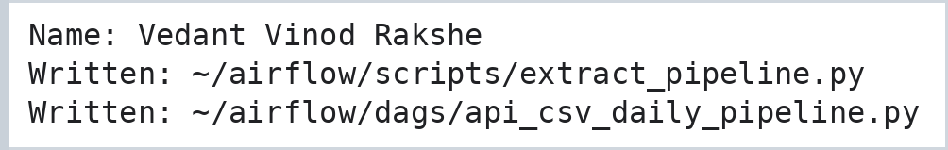

Step 3: Run the Extraction Program, then Validate the DAG
Code:
import subprocess
subprocess.run('cd ~/airflow/scripts && python3 extract_pipeline.py', shell=True)
Output:
Code:
import os
from airflow.models import DagBag

print("Name: Vedant Vinod Rakshe")
bag = DagBag(os.path.expanduser("~/airflow/dags"))
print("Import errors :", bag.import_errors or "None")

dag = bag.get_dag("api_csv_daily_pipeline")
print("DAG id :", dag.dag_id)
print("Schedule (cron) :", dag.schedule)
print("Tags :", sorted(dag.tags))
print("Default retries :", dag.default_args["retries"])
print("Tasks :", len(dag.tasks))
print("\nDependency chain:")
for t in dag.tasks:
nxt = ", ".join(sorted(t.downstream_task_ids)) or "(last task)"
print(f" {t.task_id:<16} [{type(t).__name__:<14}] --> {nxt}")
Output:
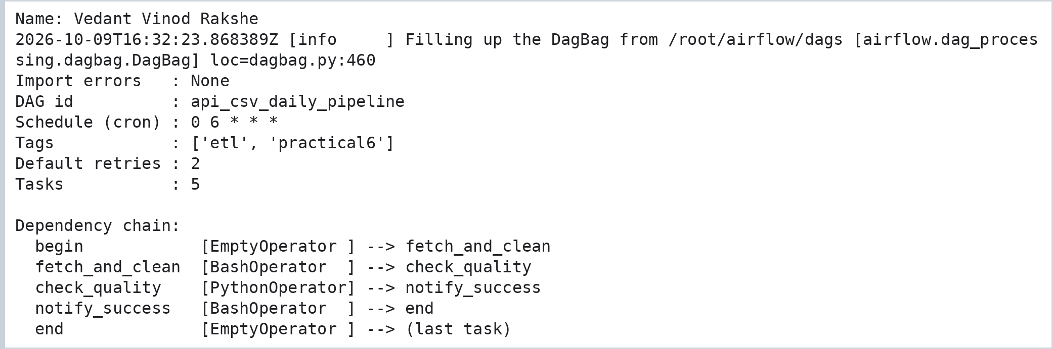
Code:
# Run the quality-check function of the DAG on its own
print("Name: Vedant Vinod Rakshe")
import importlib.util, os
spec = importlib.util.spec_from_file_location("dag_file", os.path.expanduser("~/airflow/dags/api_csv_daily_pipeline.py"))
mod = importlib.util.module_from_spec(spec); spec.loader.exec_module(mod)
mod.quality_check()
Output:

Code:
import matplotlib.pyplot as plt
from matplotlib.patches import FancyBboxPatch

steps = [("begin", "EmptyOperator", "#e5e7eb"), ("fetch_and_clean", "BashOperator", "#bfdbfe"),
("check_quality", "PythonOperator", "#fde68a"), ("notify_success", "BashOperator", "#bfdbfe"),
("end", "EmptyOperator", "#e5e7eb")]
fig, ax = plt.subplots(figsize=(11, 2.2))
for i, (name, kind, col) in enumerate(steps):
x = i * 2.25
ax.add_patch(FancyBboxPatch((x, 0.25), 1.85, 1.0, boxstyle="round,pad=0.04", fc=col, ec="#374151"))
ax.text(x + 0.925, 0.9, name, ha="center", va="center", fontsize=8.5, fontweight="bold")
ax.text(x + 0.925, 0.52, kind, ha="center", va="center", fontsize=7.5, color="#4b5563")
if i < len(steps) - 1:
ax.annotate("", xy=(x + 2.25, 0.75), xytext=(x + 1.9, 0.75), arrowprops=dict(arrowstyle="-|>", lw=1.6, color="#374151"))
ax.set_xlim(-0.2, 11.2); ax.set_ylim(0, 1.5); ax.axis("off")
ax.set_title("DAG api_csv_daily_pipeline (schedule: every day at 06:00)", fontsize=10)
plt.gcf().text(0.99, 0.005, "Name: Vedant Vinod Rakshe", ha="right", va="bottom", fontsize=8, color="gray")
plt.savefig("p6_dag.png", dpi=120, bbox_inches="tight")
Output:
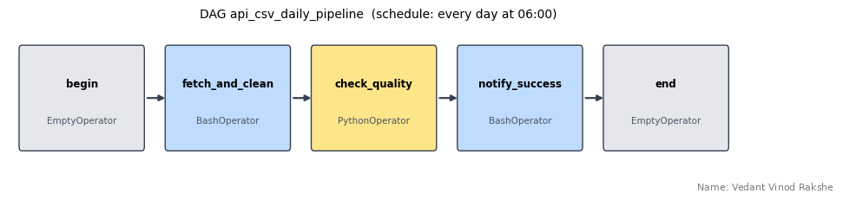

Step 4: Run the DAG
Run the following command in a terminal, open http://localhost:8080, unpause the DAG api_csv_daily_pipeline and trigger it. All five tasks turn green when the run succeeds.
Code:
airflow standalone

Practical No. 7: ETL Pipelines: CSV and JSON Sources, Invalid Records, Validation and Incremental Loading
Aim: To build ETL pipelines for an HR payroll data set that extract data from one CSV file, from several CSV files and from a JSON document, clean and transform the data, find and remove invalid records, validate batches before loading, load them into a relational database and perform incremental loads using a watermark.

Step 1: Create the Source Files and the Target Database
Code:
# Name: Vedant Vinod Rakshe
print("Name: Vedant Vinod Rakshe")
import os, glob, json, sqlite3
import numpy as np
import pandas as pd

HEAD = "emp_id,name,dept,monthly_salary,join_date,updated_at\n"
files = {
"payroll_it.csv": [
"E101, aarav mehta ,IT,65000,2021-06-15,2026-01-05 10:00:00",
"E102,ISHA NAIR,IT,72000,2019-03-01,2026-01-05 10:00:00",
"E103,kabir singh,IT,-52000,2022-09-12,2026-01-06 09:30:00", # negative salary
"E101, aarav mehta ,IT,65000,2021-06-15,2026-01-05 10:00:00"], # duplicate row
"payroll_hr.csv": [
"E201,Meera Joshi,HR,48000,2020-11-23,2026-01-05 11:00:00",
"E202,nikhil rao,HR,,2023-01-09,2026-01-05 11:00:00", # missing salary
"E203,Pooja Desai,HR,51000,31-02-2022,2026-01-07 08:15:00"], # invalid date
"payroll_sales.csv": [
"E301,Sameer Khan,Sales,41000,2022-07-18,2026-01-05 12:00:00",
"E302,Tara Iyer,Sales,39000,2024-02-05,2026-01-08 14:20:00",
"E303,Uday Patil,Sales,44500,2021-10-30,2026-01-08 14:45:00"],
}
for fname, lines in files.items():
with open(fname, "w") as f:
f.write(HEAD + "\n".join(lines) + "\n")

attendance = {"month": "2026-01", "working_days": 22, "records": [
{"emp_id": "E101", "days_present": 21, "leaves": {"casual": 1, "sick": 0}},
{"emp_id": "E102", "days_present": 22, "leaves": {"casual": 0, "sick": 0}},
{"emp_id": "E201", "days_present": 18, "leaves": {"casual": 2, "sick": 2}},
{"emp_id": "E301", "days_present": 20, "leaves": {"casual": 1, "sick": 1}},
{"emp_id": "E999", "days_present": 22, "leaves": {"casual": 0, "sick": 0}}, # unknown employee
]}
json.dump(attendance, open("attendance.json", "w"), indent=2)

if os.path.exists("payroll_dw.db"):
os.remove("payroll_dw.db")
db = sqlite3.connect("payroll_dw.db")
print("Created 3 department CSV files, attendance.json and the target database payroll_dw.db")
Output:

Step 2: ETL for a Single CSV File
Three functions are reused in all later tasks: standardise() fixes text, dates and duplicates; enrich() adds annual salary, tax slab and tenure; to_db_types() prepares dates for SQLite.
Code:
# ---- reusable transformation functions
print("Name: Vedant Vinod Rakshe")
def standardise(df):
out = df.copy()
out["name"] = out["name"].str.strip().str.title()
out["dept"] = out["dept"].str.strip().str.upper()
out["join_date"] = pd.to_datetime(out["join_date"], format="%Y-%m-%d", errors="coerce")
out["updated_at"] = pd.to_datetime(out["updated_at"])
return out.drop_duplicates()

def enrich(df):
out = df.copy()
out["annual_salary"] = out["monthly_salary"] * 12
out["tax_pct"] = np.select([out["monthly_salary"] <= 40000, out["monthly_salary"] <= 70000], [5, 10], default=20)
out["tenure_years"] = ((pd.Timestamp("2026-04-01") - out["join_date"]).dt.days / 365.25).round(1)
return out

def to_db_types(df): # SQLite stores dates as text
out = df.copy()
out["join_date"] = out["join_date"].dt.strftime("%Y-%m-%d")
out["updated_at"] = out["updated_at"].dt.strftime("%Y-%m-%d %H:%M:%S")
return out

# ---- E X T R A C T
raw_it = pd.read_csv("payroll_it.csv")
print("Extracted:", len(raw_it), "rows\n", raw_it.to_string(index=False), "\n")

# ---- T R A N S F O R M
it = enrich(standardise(raw_it))
print("Transformed:", len(it), "rows (duplicate removed)\n", it[["emp_id", "name", "dept", "monthly_salary", "tax_pct", "tenure_years"]].to_string(index=False), "\n")

# ---- L O A D
to_db_types(it).to_sql("payroll_it", db, if_exists="replace", index=False)
print("Loaded into table payroll_it ->", db.execute("SELECT COUNT(*) FROM payroll_it").fetchone()[0], "rows")
Output:
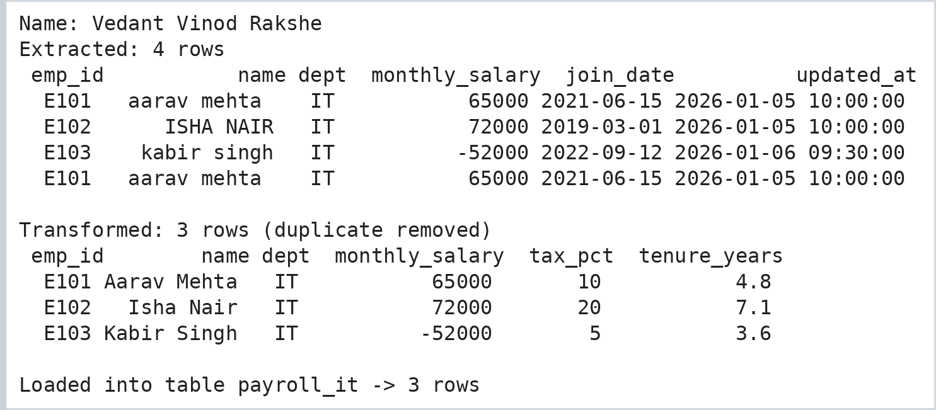

Step 3: Extract Multiple CSV Files and Combine Them
Code:
print("Name: Vedant Vinod Rakshe")
parts = {}
for path in sorted(glob.glob("payroll_*.csv")):
parts[os.path.basename(path)] = pd.read_csv(path)
print(f"{path:<18} rows: {len(parts[path]):>2}")

combined = pd.concat(parts, names=["source_file", "row"]).reset_index(level="source_file") # keeps the file name
print("\nRows combined:", len(combined))
combined = enrich(standardise(combined))
print("Rows after standardise + de-duplicate:", len(combined))

to_db_types(combined).to_sql("payroll_all", db, if_exists="replace", index=False)
print("\nRows per department in table payroll_all:")
print(pd.read_sql("SELECT dept, COUNT(*) AS employees, ROUND(AVG(monthly_salary)) AS avg_salary FROM payroll_all GROUP BY dept", db).to_string(index=False))
Output:
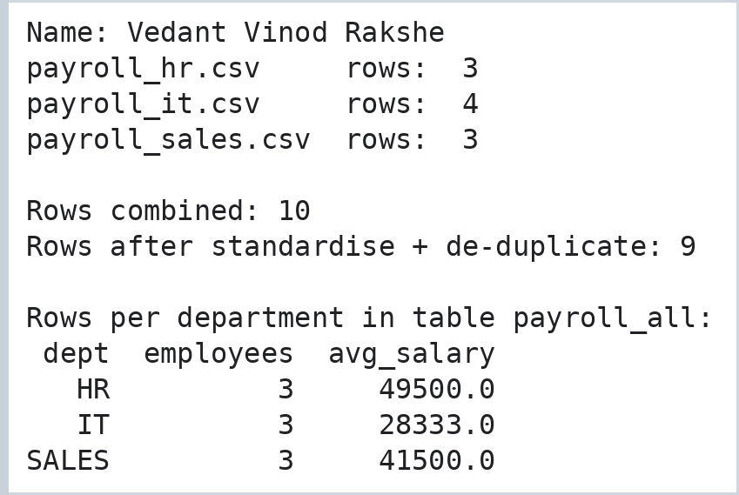

Step 4: Extract and Flatten a JSON Document
Code:
print("Name: Vedant Vinod Rakshe")
doc = json.load(open("attendance.json"))
att = pd.json_normalize(doc, record_path="records", meta=["month", "working_days"], sep="_") # flatten nested leaves
att["attendance_pct"] = (att["days_present"] / att["working_days"] * 100).round(1)
att["total_leaves"] = att["leaves_casual"] + att["leaves_sick"]
att = att[["emp_id", "month", "days_present", "total_leaves", "attendance_pct"]]
print(att.to_string(index=False))

att.to_sql("attendance", db, if_exists="replace", index=False)
print("\nJoin check - attendance of known employees only:")
print(pd.read_sql("""SELECT a.emp_id, p.name, p.dept, a.attendance_pct FROM attendance a
JOIN payroll_all p ON p.emp_id = a.emp_id ORDER BY a.emp_id""", db).to_string(index=False))
Output:
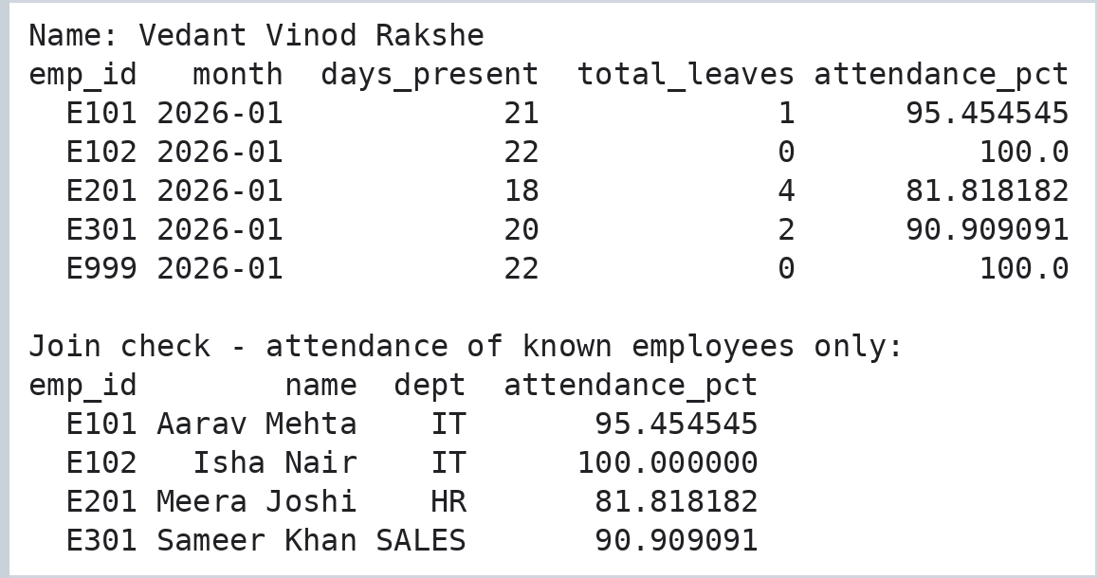

Step 5: Identify and Remove Invalid Records (Rule Based)
Every rule is a message plus a function. A row that breaks a rule goes to the payroll_rejects table together with the reasons.
Code:
# Each rule is (message, function that is True for a valid row)
print("Name: Vedant Vinod Rakshe")
RULES = {
"monthly_salary must be a positive number": lambda r: pd.notna(r["monthly_salary"]) and r["monthly_salary"] > 0,
"join_date must be a valid date": lambda r: pd.notna(r["join_date"]),
"name must not be empty": lambda r: bool(str(r["name"]).strip()),
}

def split_valid_invalid(df):
reasons = df.apply(lambda r: "; ".join(msg for msg, ok in RULES.items() if not ok(r)), axis=1)
return df[reasons == ""], df[reasons != ""].assign(reason=reasons[reasons != ""])

valid, invalid = split_valid_invalid(combined)
print(f"Total: {len(combined)} | valid: {len(valid)} | invalid: {len(invalid)}\n")
print("Rejected records:")
print(invalid[["emp_id", "name", "reason"]].to_string(index=False))
to_db_types(invalid).to_sql("payroll_rejects", db, if_exists="replace", index=False)
Output:
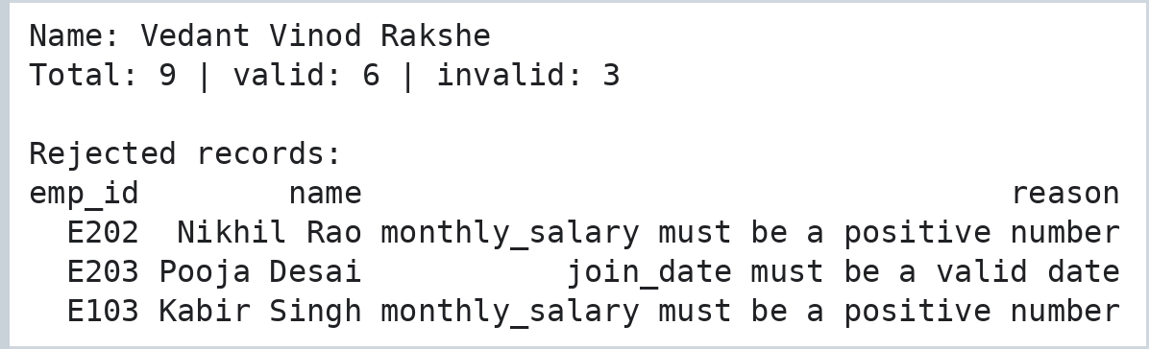

Step 6: Validate Data Before Loading to the Target Database
validate_batch() raises a ValidationError when a batch is unsafe to load; the load function catches it, reports the reason and loads nothing. The target table also has a primary key and a CHECK constraint.
Code:
print("Name: Vedant Vinod Rakshe")
class ValidationError(Exception):
pass

REQUIRED = ["emp_id", "name", "dept", "monthly_salary", "join_date", "updated_at"]

def validate_batch(df):
"""Raises ValidationError when the batch must NOT be loaded."""
missing = [c for c in REQUIRED if c not in df.columns]
if missing:
raise ValidationError(f"missing columns {missing}")
problems = []
if df["emp_id"].duplicated().any(): problems.append("duplicate emp_id")
if df["monthly_salary"].isna().any() or (df["monthly_salary"] <= 0).any():
problems.append("invalid salary")
if problems:
raise ValidationError("; ".join(problems))

db.executescript("""
DROP TABLE IF EXISTS payroll_clean;
CREATE TABLE payroll_clean (emp_id TEXT PRIMARY KEY, name TEXT NOT NULL, dept TEXT, monthly_salary REAL CHECK (monthly_salary > 0),
join_date TEXT, updated_at TEXT, annual_salary REAL, tax_pct INTEGER, tenure_years REAL);
""")
COLS = ["emp_id", "name", "dept", "monthly_salary", "join_date", "updated_at", "annual_salary", "tax_pct", "tenure_years"]

def guarded_load(batch, label):
try:
validate_batch(batch)
except ValidationError as err:
print(f"[{label}] REJECTED -> {err}")
return
to_db_types(batch)[COLS].to_sql("payroll_clean", db, if_exists="append", index=False)
print(f"[{label}] ACCEPTED -> {len(batch)} rows loaded")

guarded_load(valid.drop(columns=["monthly_salary"]), "batch 1: salary column missing")
guarded_load(pd.concat([valid, valid.head(1)]), "batch 2: repeated employee")
guarded_load(invalid.drop(columns="reason"), "batch 3: bad salaries")
guarded_load(valid, "batch 4: clean data")
print("\nTarget table payroll_clean:")
print(pd.read_sql("SELECT emp_id, name, dept, monthly_salary, tax_pct, updated_at FROM payroll_clean", db).to_string(index=False))
Output:
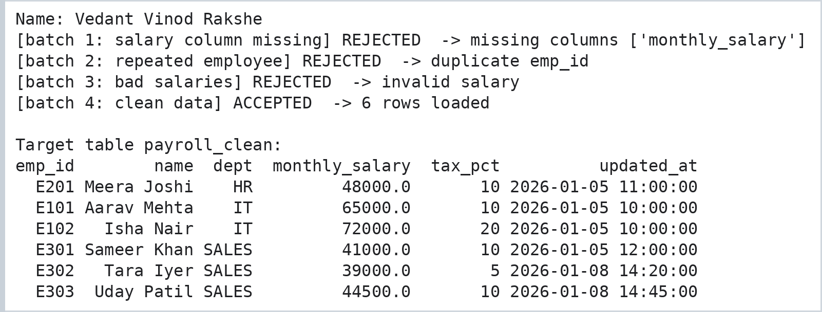

Step 7: Incremental Loading with a Watermark
The watermark table stores the newest updated_at that was loaded. A new run only processes rows that are newer, updates changed employees and inserts new ones.
Code:
# Incremental load using a WATERMARK (the newest updated_at that was already loaded)
print("Name: Vedant Vinod Rakshe")
db.execute("CREATE TABLE IF NOT EXISTS etl_watermark (table_name TEXT PRIMARY KEY, last_loaded TEXT)")
db.execute("INSERT OR REPLACE INTO etl_watermark SELECT 'payroll_clean', MAX(updated_at) FROM payroll_clean")
db.commit()

with open("payroll_update.csv", "w") as f:
f.write(HEAD + "\n".join([
"E101,Aarav Mehta,IT,68000,2021-06-15,2026-01-10 09:00:00", # salary revised -> changed
"E302,Tara Iyer,Sales,39000,2024-02-05,2026-01-08 14:20:00", # unchanged (older than watermark)
"E304,Vikram Sethi,Sales,46000,2025-12-01,2026-01-11 10:00:00", # new employee
"E201,Meera Joshi,HR,50000,2020-11-23,2026-01-12 16:30:00"]) + "\n") # salary revised

def incremental_load(path):
mark = db.execute("SELECT last_loaded FROM etl_watermark WHERE table_name = 'payroll_clean'").fetchone()[0]
incoming = enrich(standardise(pd.read_csv(path)))
fresh = incoming[incoming["updated_at"] > pd.Timestamp(mark)] # only rows newer than the watermark
print(f" watermark = {mark} | incoming = {len(incoming)} | newer = {len(fresh)} | skipped = {len(incoming) - len(fresh)}")
if fresh.empty:
return
validate_batch(fresh)
db.executemany("""INSERT INTO payroll_clean VALUES (?,?,?,?,?,?,?,?,?) ON CONFLICT(emp_id) DO UPDATE SET
monthly_salary = excluded.monthly_salary, updated_at = excluded.updated_at,
annual_salary = excluded.annual_salary, tax_pct = excluded.tax_pct""",
to_db_types(fresh)[COLS].astype(object).values.tolist())
db.execute("UPDATE etl_watermark SET last_loaded = (SELECT MAX(updated_at) FROM payroll_clean) WHERE table_name = 'payroll_clean'")
db.commit()

print("Rows before:", db.execute("SELECT COUNT(*) FROM payroll_clean").fetchone()[0])
print("Run 1 - new file arrives:")
incremental_load("payroll_update.csv")
print("Run 2 - same file again:")
incremental_load("payroll_update.csv")
print("\nRows after:", db.execute("SELECT COUNT(*) FROM payroll_clean").fetchone()[0])
print(pd.read_sql("SELECT emp_id, name, monthly_salary, tax_pct, updated_at FROM payroll_clean ORDER BY emp_id", db).to_string(index=False))
Output:
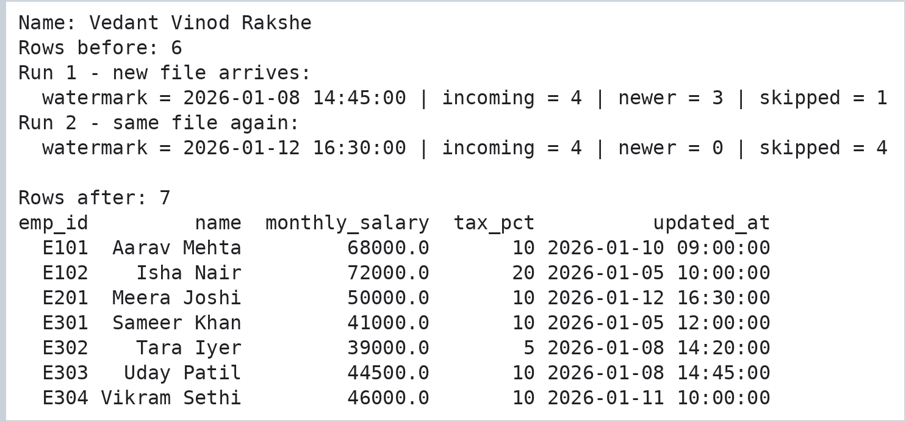

Practical No. 8: Distributed Data Processing with PySpark DataFrames
Aim: To use PySpark to read a CSV data set with an explicit schema, perform filtering, grouping and aggregation, remove duplicate records, join two data sets and calculate the average salary of every department (with the DataFrame API and with Spark SQL).
Run this cell once if PySpark is not installed (Google Colab already has Java).
Code:
%pip install -q pyspark

Step 1: Start a Spark Session and Create the Input Files
Code:
# Name: Vedant Vinod Rakshe
print("Name: Vedant Vinod Rakshe")
from pyspark.sql import SparkSession, functions as F, Window
from pyspark.sql.types import StructType, StructField, StringType, IntegerType, DoubleType

spark = (SparkSession.builder.appName("Practical8_Employees").master("local[2]")
.config("spark.ui.enabled", "false").config("spark.sql.shuffle.partitions", "4").getOrCreate())
spark.sparkContext.setLogLevel("ERROR")
print("Spark version:", spark.version)

emp_rows = """101,Aarav Mehta,IT,65000,Pune,2021
102,Isha Nair,HR,48000,Mumbai,2019
103,Kabir Singh,IT,52000,Pune,2022
104,Meera Joshi,Finance,58000,Nashik,2020
105,Nikhil Rao,Finance,72000,Mumbai,2018
106,Pooja Desai,Sales,41000,Pune,2023
107,Sameer Khan,Sales,39000,Nashik,2024
102,Isha Nair,HR,48000,Mumbai,2019
108,Tara Iyer,IT,91000,Mumbai,2017
109,Uday Patil,Legal,60000,Pune,2022
106,Pooja Desai,Sales,41000,Pune,2023
110,Vikram Sethi,Sales,47000,Mumbai,2021"""
with open("employees.csv", "w") as f:
f.write("emp_id,name,dept,salary,city,join_year\n" + emp_rows + "\n")
with open("departments.csv", "w") as f:
f.write("dept,head,budget\nIT,Rohan Kulkarni,5000000\nHR,Anita Rao,2000000\nFinance,Sanjay Gupta,3500000\nSales,Neha Kapoor,4000000\n")
Output:


Step 2: Read a CSV Data Set with an Explicit Schema
Code:
# Read the CSV file with an explicit schema (no guessing) and display it
print("Name: Vedant Vinod Rakshe")
schema = StructType([
StructField("emp_id", IntegerType(), False), StructField("name", StringType(), True),
StructField("dept", StringType(), True), StructField("salary", DoubleType(), True),
StructField("city", StringType(), True), StructField("join_year", IntegerType(), True)])

emp = spark.read.csv("employees.csv", header=True, schema=schema)
dept = spark.read.csv("departments.csv", header=True, inferSchema=True)

emp.printSchema()
print("Employees:", emp.count(), "rows | Departments:", dept.count(), "rows")
emp.show()
Output:
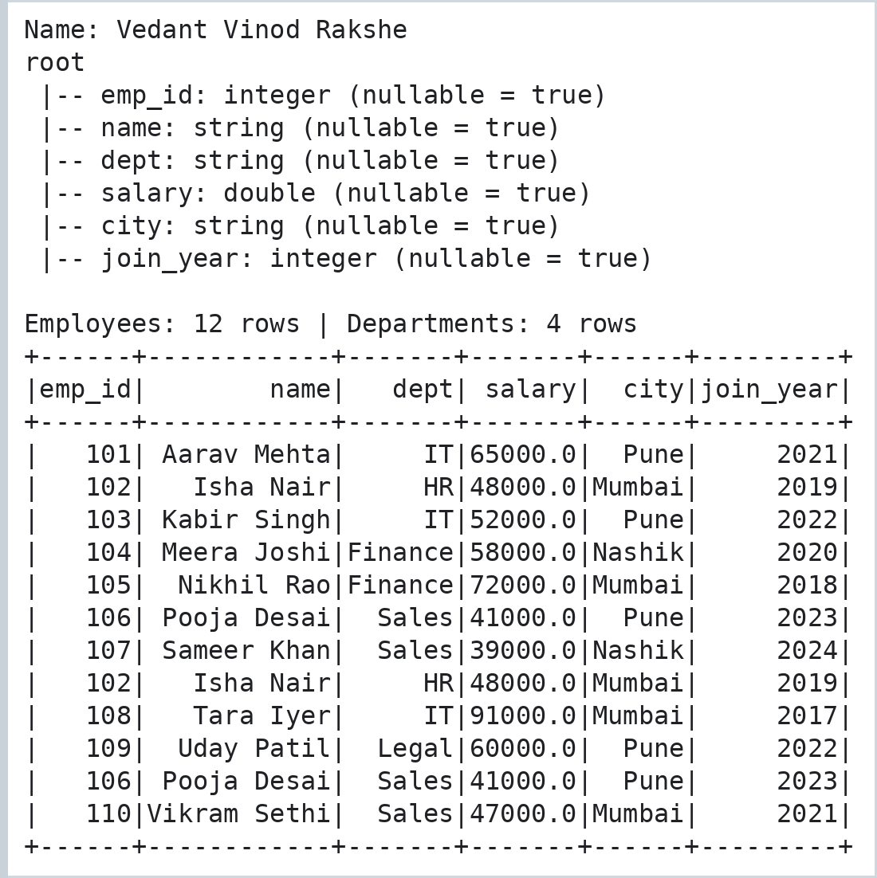

Step 3: Filtering, Grouping and Aggregation
Code:
# FILTERING - column expressions and SQL-style conditions
print("Name: Vedant Vinod Rakshe")
print("Employees in Pune earning more than 50000:")
emp.filter((F.col("city") == "Pune") & (F.col("salary") > 50000)).select("name", "dept", "salary", "city").show()

print("Salary between 40000 and 60000, joined after 2020:")
emp.where("salary BETWEEN 40000 AND 60000 AND join_year > 2020").select("name", "salary", "join_year").show()

# GROUPING and AGGREGATION
print("Department summary:")
(emp.groupBy("dept")
.agg(F.count("*").alias("headcount"), F.round(F.avg("salary"), 1).alias("avg_salary"),
F.max("salary").alias("highest"), F.sum("salary").alias("payroll"))
.orderBy(F.desc("payroll")).show())
Output:
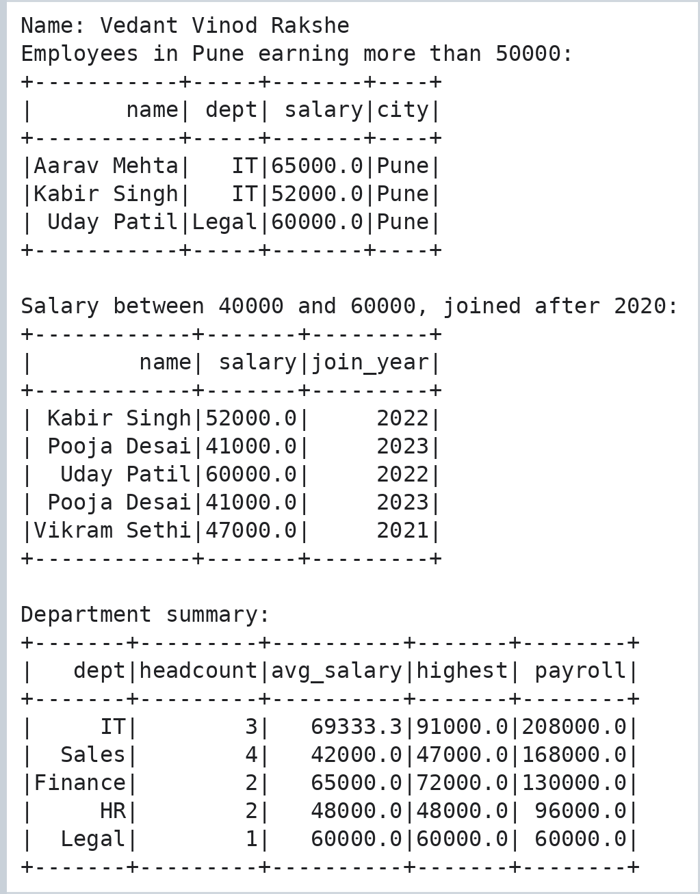

Step 4: Find and Remove Duplicate Records
Code:
# DUPLICATE RECORDS - first find them, then remove them
print("Name: Vedant Vinod Rakshe")
dups = emp.groupBy(emp.columns).count().filter("count > 1")
print("Duplicate records found:")
dups.show()

emp_clean = emp.dropDuplicates()
print("Rows before:", emp.count(), "| after dropDuplicates():", emp_clean.count())
print("Distinct emp_id values:", emp_clean.select("emp_id").distinct().count())
Output:
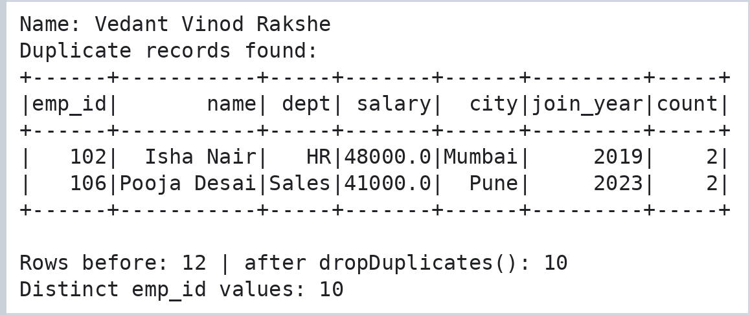

Step 5: Join Two Data Sets
Code:
# JOINS
print("Name: Vedant Vinod Rakshe")
inner = emp_clean.join(dept, on="dept", how="inner")
print("Inner join - employees with their department head:")
inner.select("emp_id", "name", "dept", "head", "salary").orderBy("emp_id").show()

print("Left anti join - employees whose department is missing in departments.csv:")
emp_clean.join(dept, on="dept", how="left_anti").select("emp_id", "name", "dept").show()

print("Department budget per employee:")
(inner.groupBy("dept", "budget").agg(F.count("*").alias("staff"))
.withColumn("budget_per_employee", F.round(F.col("budget") / F.col("staff"))).orderBy("dept").show())
Output:
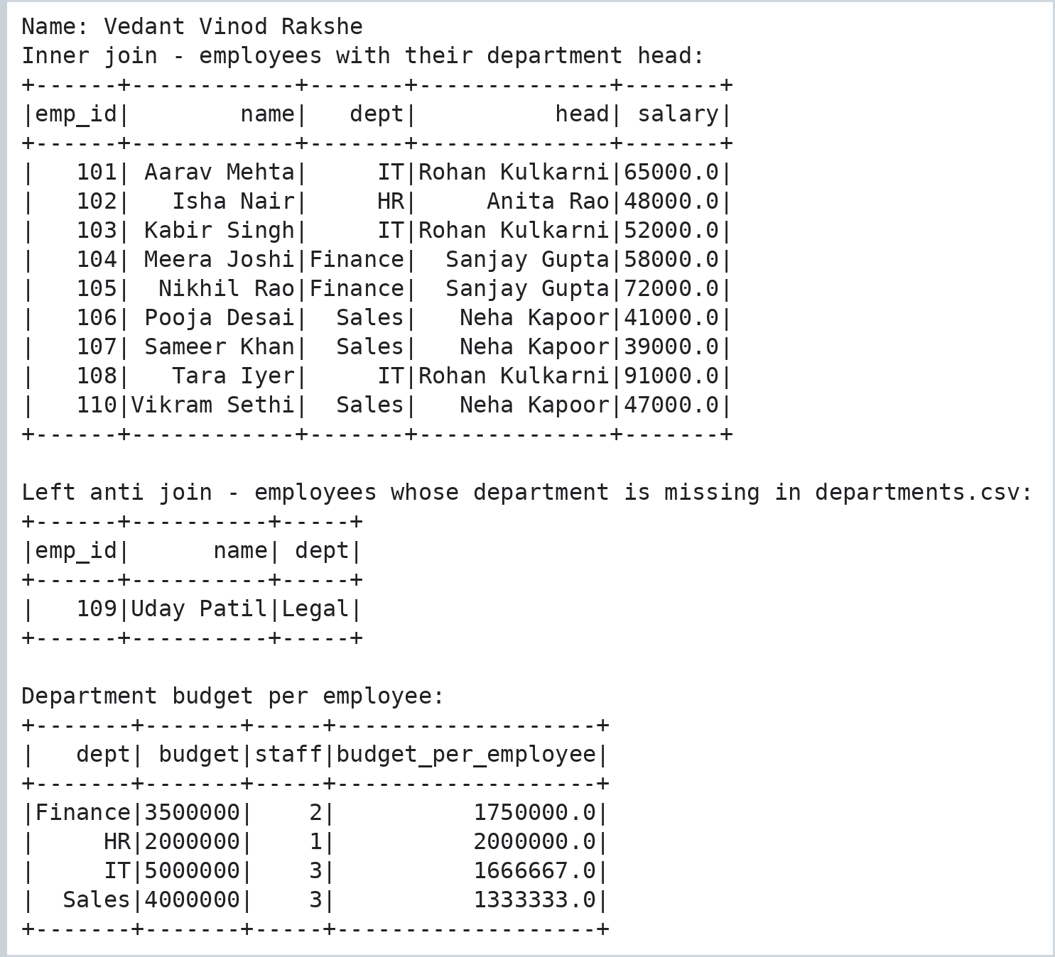

Step 6: Average Salary by Department (DataFrame API and Spark SQL)
Code:
# AVERAGE SALARY BY DEPARTMENT - DataFrame API
print("Name: Vedant Vinod Rakshe")
avg_df = emp_clean.groupBy("dept").agg(F.round(F.avg("salary"), 2).alias("average_salary")).orderBy(F.desc("average_salary"))
avg_df.show()

# the same result with Spark SQL
emp_clean.createOrReplaceTempView("employees")
spark.sql("SELECT dept, ROUND(AVG(salary), 2) AS average_salary FROM employees GROUP BY dept ORDER BY average_salary DESC").show()

# extra: highest paid employee in every department (window function)
w = Window.partitionBy("dept").orderBy(F.desc("salary"))
emp_clean.withColumn("rank_in_dept", F.rank().over(w)).filter("rank_in_dept = 1").select("dept", "name", "salary").orderBy("dept").show()
spark.stop()
Output:
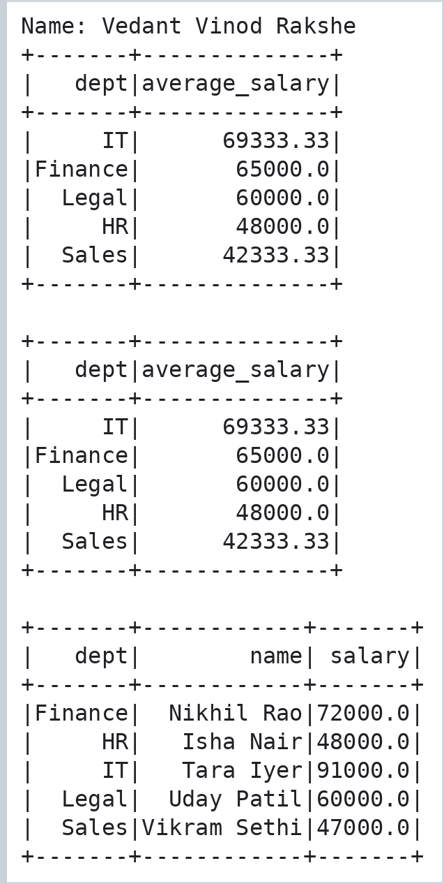

Practical No. 9: End-to-End Data Pipelines: E-Commerce ETL with Historical and Newly Arriving Data
Aim: To build an end-to-end pipeline from a CSV file through Pandas cleaning and a SQL database to a report; to build an ETL pipeline for an e-commerce data set with customers, products, orders and payments; and to design a pipeline that processes historical data and newly arriving files without loading anything twice.

Step 1: Pipeline 1 - CSV to Pandas to Cleaning to SQL Database to Report
Code:
# Name: Vedant Vinod Rakshe
# PIPELINE 1 : movie-theatre bookings CSV -> Pandas (method chaining) -> SQL database -> report
print("Name: Vedant Vinod Rakshe")
import sqlite3
import pandas as pd
import matplotlib.pyplot as plt

with open("bookings_raw.csv", "w") as f:
f.write("booking_id,show_date,movie,seats,price_per_seat,screen\n")
f.write("\n".join([
"B1,2026-03-02, inception ,3,250,Screen 1", "B2,2026-03-02,INTERSTELLAR,2,300,Screen 2",
"B3,2026-03-03,Inception,4,250,Screen 1", "B3,2026-03-03,Inception,4,250,Screen 1",
"B4,2026-03-04,Dune,-2,280,Screen 3", "B5,2026-03-05,Interstellar,5,,Screen 2",
"B6,2026-03-06,dune,6,280,Screen 3", "B7,2026-03-07,Inception,2,250,Screen 1",
"B8,31-13-2026,Dune,2,280,Screen 3", "B9,2026-03-08,Interstellar,3,300,Screen 2"]) + "\n")

# small, named cleaning steps that are chained with .pipe()
def tidy_text(d): return d.assign(movie=d["movie"].str.strip().str.title(), screen=d["screen"].str.strip())
def parse_dates(d): return d.assign(show_date=pd.to_datetime(d["show_date"], format="%Y-%m-%d", errors="coerce"))
def drop_invalid(d): return d.dropna(subset=["show_date", "price_per_seat"]).query("seats > 0")
def add_revenue(d): return d.assign(revenue=d["seats"] * d["price_per_seat"], weekday=d["show_date"].dt.day_name())

raw = pd.read_csv("bookings_raw.csv")
clean = (raw.drop_duplicates().pipe(tidy_text).pipe(parse_dates).pipe(drop_invalid).pipe(add_revenue))
print(f"Rows: raw = {len(raw)}, clean = {len(clean)} -> {len(raw) - len(clean)} rows removed")
print(clean[["booking_id", "show_date", "movie", "seats", "revenue", "weekday"]].to_string(index=False))

con1 = sqlite3.connect("theatre.db")
clean.assign(show_date=clean["show_date"].dt.strftime("%Y-%m-%d")).to_sql("bookings", con1, if_exists="replace", index=False)

report = pd.read_sql("""SELECT movie, COUNT(*) AS bookings, SUM(seats) AS seats_sold, SUM(revenue) AS revenue,
ROUND(AVG(price_per_seat), 1) AS avg_price
FROM bookings GROUP BY movie ORDER BY revenue DESC""", con1)
print("\nREPORT - revenue by movie")
print(report.to_string(index=False))
by_day = pd.read_sql("SELECT weekday, SUM(revenue) AS revenue FROM bookings GROUP BY weekday ORDER BY revenue DESC", con1)
print("\nREPORT - best selling weekday:", by_day.iloc[0, 0], "with Rs.", int(by_day.iloc[0, 1]))
report.to_csv("theatre_report.csv", index=False)

ax = report.plot(kind="barh", x="movie", y="revenue", color="#8e44ad", legend=False, figsize=(6, 2.8))
ax.set_title("Revenue by movie (Rs.)"); ax.invert_yaxis()
plt.gcf().text(0.99, 0.005, "Name: Vedant Vinod Rakshe", ha="right", va="bottom", fontsize=8, color="gray")
plt.savefig("p9_theatre.png", dpi=110, bbox_inches="tight")
plt.show()
Output:
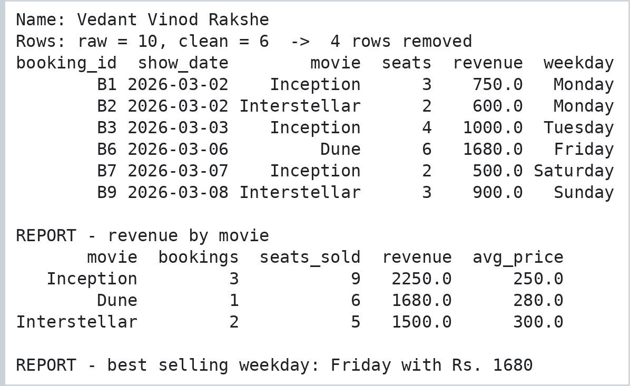
Output:
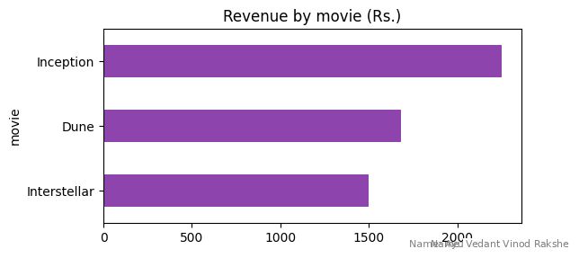

Step 2: Pipeline 2 - Create the E-Commerce Source Data (Master Data and Inbox Files)
Customers and products are master data. Orders (with their payment details) arrive as files in an inbox folder: one historical monthly file and daily files that come later.
Code:
# PIPELINE 2 : GadgetHub e-commerce ETL (customers, products, orders, payments)
print("Name: Vedant Vinod Rakshe")
import os, glob

os.makedirs("inbox", exist_ok=True)
customers_df = pd.DataFrame({
"customer_id": ["C01", "C02", "C03", "C04", "C05"],
"name": ["aman gupta", "Bhavna Rao", "chirag shah", "Divya Menon", "Esha Kapoor"],
"email": ["aman@mail.com", "bhavna@mail.com", "CHIRAG@MAIL.COM", "divya@mail", "esha@mail.com"],
"city": ["Mumbai", "Pune", "Nashik", "Delhi", "Pune"]})
products_df = pd.DataFrame({
"sku": ["G1", "G2", "G3", "G4", "G5"],
"product_name": ["Wireless Earbuds", "Smart Watch", "Power Bank 20000mAh", "Bluetooth Speaker", "USB-C Hub"],
"category": ["Audio", "Wearables", "Accessories", "Audio", "Accessories"],
"price": [2499, 6999, 1799, 3299, 1299]})

BATCH_HEADER = "order_id,customer_id,sku,qty,order_date,status,pay_amount,pay_mode,pay_status\n"
def write_batch(name, rows):
with open(f"inbox/{name}", "w") as f:
f.write(BATCH_HEADER + "\n".join(rows) + "\n")

write_batch("orders_2026-01.csv", [ # HISTORICAL data (a whole month)
"5001,C01,G1,1,2026-01-12,delivered,2499,UPI,PAID", "5002,C02,G2,1,2026-01-15,delivered,6999,CARD,PAID",
"5003,C03,G3,2,2026-01-18,shipped,3598,UPI,PAID", "5004,C05,G4,1,2026-01-22,placed,0,COD,PENDING",
"5005,C09,G1,1,2026-01-25,delivered,2499,UPI,PAID", "5006,C04,G5,0,2026-01-26,placed,0,UPI,PENDING",
"5007,C02,G9,1,2026-01-28,delivered,999,CARD,PAID", "5008,C01,G5,3,2026-01-30,delivered,3897,CARD,PAID"])
write_batch("orders_2026-02-01.csv", [ # daily files that arrive later
"5004,C05,G4,1,2026-01-22,shipped,3299,UPI,PAID", # status update of a historical order
"5009,C03,G2,1,2026-02-01,placed,6999,CARD,PAID", "5010,C04,G1,2,2026-02-01,delivered,4998,UPI,PAID"])
write_batch("orders_2026-02-02.csv", [
"5011,C01,G3,1,2026-02-02,placed,1799,UPI,PAID", "5012,C05,G2,1,2026-02-02,delivered,6000,CARD,PAID"])
print("Inbox files:", sorted(os.listdir("inbox")))
Output:

Step 3: ETL Class - Clean, Validate and Load Each File (Historical Load)
The class cleans each file, rejects invalid orders with a reason, upserts orders and payments, and records every processed file in the pipeline_runs table.
Code:
print("Name: Vedant Vinod Rakshe")
class GadgetHubETL:
"""Extract -> clean -> load, one inbox file at a time. Every processed file is logged, so a file is never loaded twice."""
def __init__(self, db_path):
self.con = sqlite3.connect(db_path)
self.con.executescript("""
PRAGMA foreign_keys = ON;
DROP TABLE IF EXISTS payments; DROP TABLE IF EXISTS orders; DROP TABLE IF EXISTS rejected_orders;
DROP TABLE IF EXISTS pipeline_runs; DROP TABLE IF EXISTS products; DROP TABLE IF EXISTS customers;
CREATE TABLE customers (customer_id TEXT PRIMARY KEY, name TEXT, email TEXT, city TEXT);
CREATE TABLE products (sku TEXT PRIMARY KEY, product_name TEXT, category TEXT, price REAL);
CREATE TABLE orders (order_id INTEGER PRIMARY KEY, customer_id TEXT NOT NULL REFERENCES customers, sku TEXT NOT NULL REFERENCES products,
qty INTEGER CHECK (qty > 0), order_date TEXT, status TEXT);
CREATE TABLE payments (order_id INTEGER PRIMARY KEY REFERENCES orders, amount REAL CHECK (amount > 0), mode TEXT, status TEXT);
CREATE TABLE rejected_orders (file_name TEXT, order_id INTEGER, reason TEXT);
CREATE TABLE pipeline_runs (file_name TEXT PRIMARY KEY, rows_in INTEGER, orders_new INTEGER, orders_updated INTEGER, payments_saved INTEGER, rejected INTEGER);
""")

def load_masters(self, customers, products):
c = customers.assign(name=customers["name"].str.strip().str.title(), email=customers["email"].str.lower())
c.loc[~c["email"].str.match(r"^[\w.]+@\w+\.[a-z]{2,}$"), "email"] = None # invalid e-mail -> NULL
c.to_sql("customers", self.con, if_exists="append", index=False)
products.to_sql("products", self.con, if_exists="append", index=False)

def process_file(self, path):
name = os.path.basename(path)
df = pd.read_csv(path)
df["status"] = df["status"].str.upper()
customers = set(pd.read_sql("SELECT customer_id FROM customers", self.con)["customer_id"])
skus = set(pd.read_sql("SELECT sku FROM products", self.con)["sku"])
reason = pd.Series("", index=df.index)
reason[df["qty"] <= 0] = "quantity must be positive"
reason[~df["sku"].isin(skus)] = "unknown product"
reason[~df["customer_id"].isin(customers)] = "unknown customer"
bad, good = df[reason != ""], df[reason == ""]
for oid, why in zip(bad["order_id"], reason[reason != ""]):
self.con.execute("INSERT INTO rejected_orders VALUES (?,?,?)", (name, int(oid), why))

existing = set(pd.read_sql("SELECT order_id FROM orders", self.con)["order_id"])
new = int((~good["order_id"].isin(existing)).sum())
self.con.executemany("""INSERT INTO orders VALUES (?,?,?,?,?,?)
ON CONFLICT(order_id) DO UPDATE SET status = excluded.status""",
good[["order_id", "customer_id", "sku", "qty", "order_date", "status"]].astype(object).values.tolist())
paid = good[good["pay_amount"] > 0]
self.con.executemany("""INSERT INTO payments VALUES (?,?,?,?)
ON CONFLICT(order_id) DO UPDATE SET amount = excluded.amount, mode = excluded.mode, status = excluded.status""",
paid[["order_id", "pay_amount", "pay_mode", "pay_status"]].astype(object).values.tolist())
self.con.execute("INSERT INTO pipeline_runs VALUES (?,?,?,?,?,?)", (name, len(df), new, len(good) - new, len(paid), len(bad)))
self.con.commit()
print(f" {name:<22} rows={len(df)} new={new} updated={len(good) - new} payments={len(paid)} rejected={len(bad)}")

def run(self, inbox):
done = {r[0] for r in self.con.execute("SELECT file_name FROM pipeline_runs")}
todo = [p for p in sorted(glob.glob(f"{inbox}/orders_*.csv")) if os.path.basename(p) not in done]
print(f"Run: {len(todo)} new file(s) to process, {len(done)} already processed")
for p in todo:
self.process_file(p)

etl = GadgetHubETL("gadgethub.db")
etl.load_masters(customers_df, products_df)
print("RUN 1 - historical file + the first daily files")
etl.run("inbox")
print("\nRejected orders:")
print(pd.read_sql("SELECT * FROM rejected_orders", etl.con).to_string(index=False))
Output:
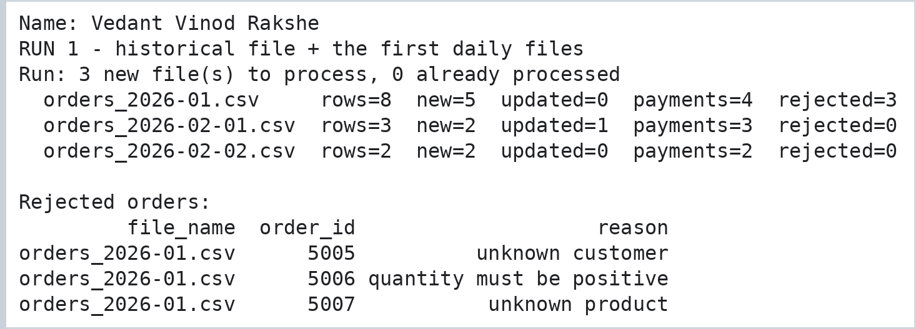

Step 4: Newly Arriving Data - Process Only New Files
Code:
# NEW DATA ARRIVES: one more daily file, containing a new order and a status update of an old order
print("Name: Vedant Vinod Rakshe")
write_batch("orders_2026-02-03.csv", [
"5013,C02,G4,2,2026-02-03,placed,6598,CARD,PAID",
"5003,C03,G3,2,2026-01-18,delivered,3598,UPI,PAID"])

print("Status of order 5003 BEFORE:", etl.con.execute("SELECT status FROM orders WHERE order_id = 5003").fetchone()[0])
print("RUN 2 - only the new file is processed")
etl.run("inbox")
print("Status of order 5003 AFTER :", etl.con.execute("SELECT status FROM orders WHERE order_id = 5003").fetchone()[0])
print("\nRUN 3 - nothing new in the inbox")
etl.run("inbox")

print("\nPipeline log:")
print(pd.read_sql("SELECT * FROM pipeline_runs", etl.con).to_string(index=False))
Output:
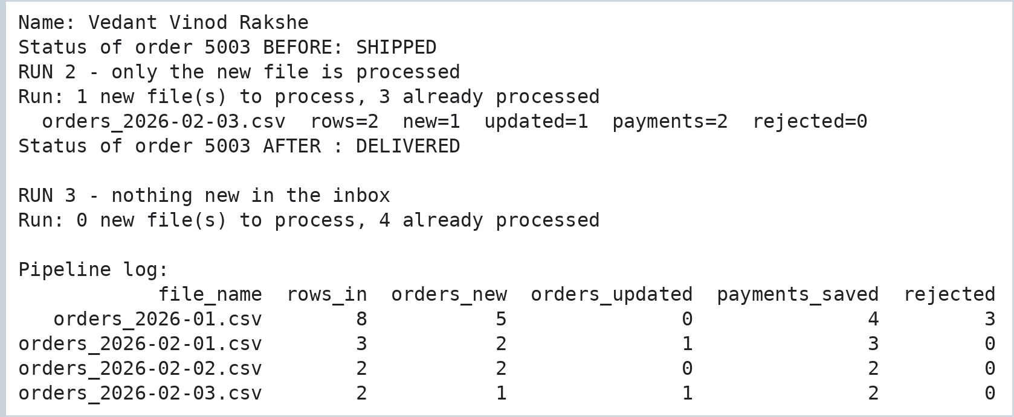

Step 5: Business Report
Code:
print("Name: Vedant Vinod Rakshe")
con = etl.con
print("1. REVENUE BY CATEGORY (cancelled orders excluded)")
print(pd.read_sql("""SELECT p.category, COUNT(*) AS orders, SUM(o.qty) AS units, SUM(o.qty * p.price) AS revenue
FROM orders o JOIN products p USING (sku) WHERE o.status <> 'CANCELLED'
GROUP BY p.category ORDER BY revenue DESC""", con).to_string(index=False))

print("\n2. DAILY REVENUE WITH RUNNING TOTAL (window function)")
daily = pd.read_sql("""SELECT order_date, SUM(o.qty * p.price) AS revenue,
SUM(SUM(o.qty * p.price)) OVER (ORDER BY order_date) AS running_total
FROM orders o JOIN products p USING (sku) GROUP BY order_date ORDER BY order_date""", con)
print(daily.to_string(index=False))

print("\n3. PAYMENT CHECK (order value vs amount paid)")
print(pd.read_sql("""SELECT o.order_id, c.name AS customer, o.qty * p.price AS order_value, COALESCE(y.amount, 0) AS paid,
CASE WHEN y.amount IS NULL THEN 'NO PAYMENT'
WHEN y.amount = o.qty * p.price THEN 'MATCHED' ELSE 'MISMATCH' END AS check_result
FROM orders o JOIN customers c USING (customer_id) JOIN products p USING (sku)
LEFT JOIN payments y USING (order_id) ORDER BY o.order_id""", con).to_string(index=False))

fig, ax = plt.subplots(figsize=(7, 3.2))
ax.bar(daily["order_date"], daily["revenue"], color="#2980b9", label="daily revenue")
ax.plot(daily["order_date"], daily["running_total"], color="#e67e22", marker="o", label="running total")
ax.set_title("GadgetHub revenue"); ax.legend(); plt.xticks(rotation=45, ha="right")
plt.tight_layout()
plt.gcf().text(0.99, 0.005, "Name: Vedant Vinod Rakshe", ha="right", va="bottom", fontsize=8, color="gray")
plt.savefig("p9_gadgethub.png", dpi=110, bbox_inches="tight")
plt.show()
Output:
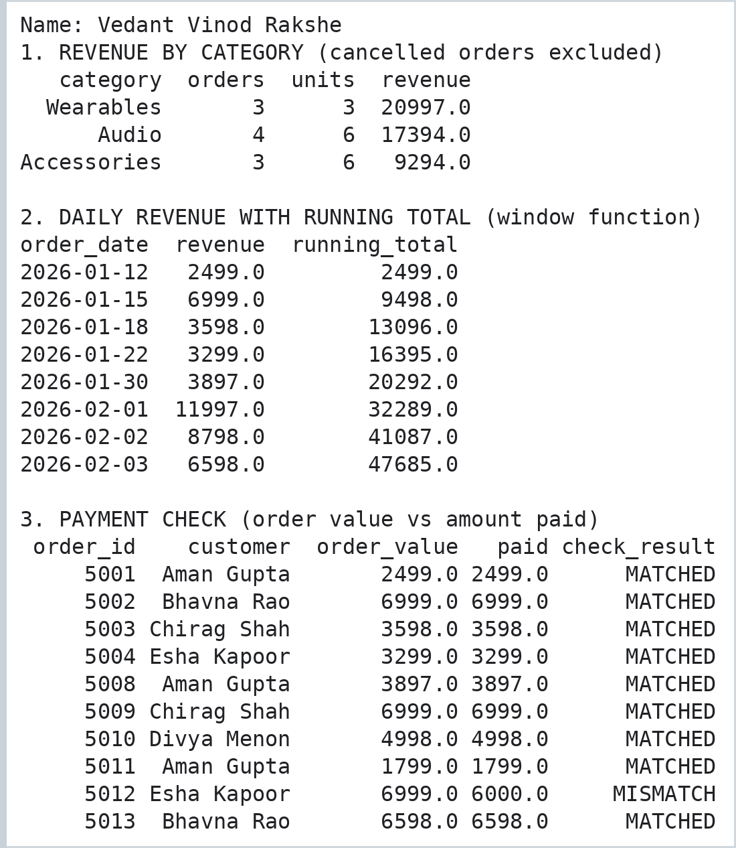
Output:
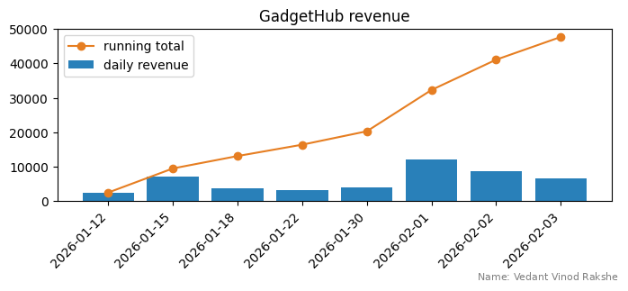

Practical No. 10: Mini Project: Retail Sales Data Warehouse - End-to-End Data Engineering Solution
Vedant Vinod Rakshe | Roll No. 37 | Student ID 5176220
Aayushman Rajeev Verma | Roll No. 57 | Student ID 5176202
Aim: To design and implement an end-to-end data engineering solution covering data ingestion, cleaning, transformation, storage, data warehouse design and reporting for a retail sales dataset.

Step 1: Problem Statement and Solution Architecture
A retail company receives its sales data as raw CSV files (customers, products and transactions). The files contain duplicates, missing values, invalid dates and quantities, unknown products and inconsistent text. The management wants clean, reliable data in a data warehouse so that revenue, product, city and customer reports can be produced with simple SQL queries.
The solution is built as a six-stage pipeline in Python (Pandas, NumPy, Matplotlib) with SQLite as the storage engine. Since the company's real files are not available, the first stage creates a synthetic dataset of 150 customers, 20 products and 1,236 transaction rows (including 36 duplicates) with deliberately injected data-quality problems.
Code:
import matplotlib.pyplot as plt
from matplotlib.patches import FancyBboxPatch
fig, ax = plt.subplots(figsize=(11, 2.6))
stages = [("1. SOURCES", "customers.csv\nproducts.csv\ntransactions.csv", "#e9ecef"),
("2. INGESTION", "Read files\nStore in RAW\nlayer (DB)", "#cde7f0"),
("3. CLEANING", "Remove duplicates\nFix formats\nReject bad rows", "#d8f3dc"),
("4. TRANSFORMATION", "Derive amounts\nBuild dimensions\nSurrogate keys", "#fff3b0"),
("5. DATA WAREHOUSE", "Star schema\nFact + 4 dims\nSQLite DB", "#ffd6a5"),
("6. REPORTING", "SQL KPIs\nCharts\nCSV exports", "#e0c3fc")]
for i, (title, body, color) in enumerate(stages):
x = i * 1.85
ax.add_patch(FancyBboxPatch((x, 0.2), 1.55, 1.7, boxstyle="round,pad=0.05", fc=color, ec="black"))
ax.text(x + 0.775, 1.6, title, ha="center", va="center", fontsize=7.5, fontweight="bold")
ax.text(x + 0.775, 0.9, body, ha="center", va="center", fontsize=7)
if i < len(stages) - 1:
ax.annotate("", xy=(x + 1.85, 1.05), xytext=(x + 1.6, 1.05), arrowprops=dict(arrowstyle="->", lw=1.6))
ax.set_xlim(-0.1, 11.2); ax.set_ylim(0, 2.1); ax.axis("off")
plt.gcf().text(0.99, 0.005, "Name: Vedant Vinod Rakshe | Aayushman Rajeev Verma", ha="right", va="bottom", fontsize=8, color="gray")
plt.savefig("p10_architecture.png", dpi=130, bbox_inches="tight")
Output:
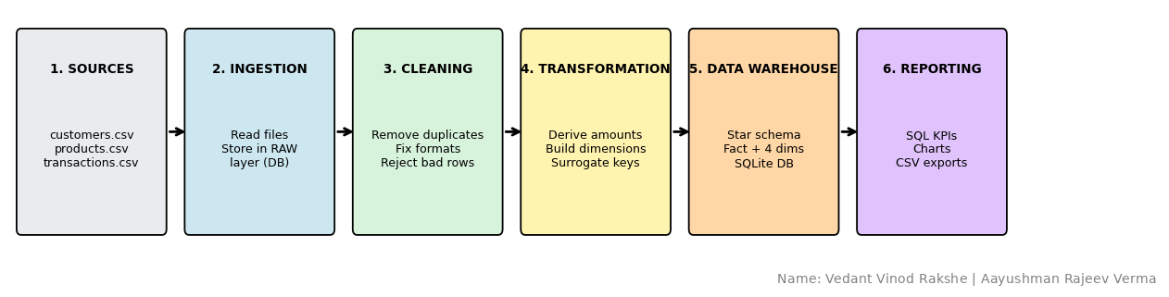

Step 2: Source Data Creation and Data Ingestion
Code:
# Name: Vedant Vinod Rakshe
# Name: Aayushman Rajeev Verma
# MINI PROJECT: Retail Sales Data Warehouse (end-to-end data engineering solution)
print("Name: Vedant Vinod Rakshe | Group partner: Aayushman Rajeev Verma")
import os, sqlite3
import numpy as np
import pandas as pd
import matplotlib.pyplot as plt

run_log = [] # records every stage of the pipeline
def log(stage, rows_in, rows_out, note=""):
run_log.append({"stage": stage, "rows_in": rows_in, "rows_out": rows_out, "note": note})

# ---------------------------------------------------------------
# STAGE 1 : SOURCE SYSTEM SIMULATION (creates the raw CSV files)
# ---------------------------------------------------------------
rng = np.random.default_rng(42)
catalog = {"Electronics": [("Laptop", 55000), ("Smartphone", 22000), ("Headphones", 2500),
("Smart Watch", 6500), ("Mouse", 500), ("Keyboard", 1500)],
"Furniture": [("Office Chair", 3500), ("Study Desk", 9000), ("Bookshelf", 6000),
("Table Lamp", 900), ("Sofa", 25000)],
"Stationery": [("Notebook", 60), ("Pen Pack", 120), ("Backpack", 1200),
("Calculator", 850), ("Marker Set", 300)],
"Fashion": [("T-Shirt", 700), ("Jeans", 1800), ("Sneakers", 3200), ("Jacket", 4500)]}
rows = [(cat, n, p) for cat, items in catalog.items() for n, p in items]
products = pd.DataFrame({"product_id": [f"P{i+1:02d}" for i in range(len(rows))],
"product_name": [r[1] for r in rows], "category": [r[0] for r in rows],
"unit_price": [r[2] for r in rows]})

first = ["Amit", "Riya", "Neha", "Karan", "Sana", "Dev", "Tina", "Rahul", "Pooja",
"Vikram", "Anjali", "Rohan"]
last = ["Shah", "Patil", "Rao", "Jain", "Khan", "Mehta", "Dsouza", "Verma", "Kulkarni", "Singh"]
cities = ["Mumbai", "Pune", "Delhi", "Nashik", "Surat", "Goa"]
n_cust = 150
fn, ln = rng.choice(first, n_cust), rng.choice(last, n_cust)
city = rng.choice(cities, n_cust).astype(object)
for i in range(n_cust): # messy text formats
r = rng.random()
city[i] = city[i].lower() if r < 0.15 else (city[i].upper() + " " if r < 0.25 else city[i])
signup = pd.Timestamp("2025-06-01") + pd.to_timedelta(rng.integers(0, 120, n_cust), unit="D")
customers = pd.DataFrame({
"customer_id": [f"C{i+1:03d}" for i in range(n_cust)], "name": [f"{a} {b}" for a, b in zip(fn, ln)],
"email": [f"{a}.{b}{i+1}@Mail.com" for i, (a, b) in enumerate(zip(fn, ln))], "city": city,
"signup_date": signup.strftime("%Y-%m-%d")})

n_tx = 1200
price_of = dict(zip(products["product_id"], products["unit_price"]))
pid = rng.choice(products["product_id"], n_tx)
qty = rng.integers(1, 6, n_tx)
qty = np.where(np.array([price_of[p] for p in pid]) > 20000, rng.integers(1, 3, n_tx), qty)
days = pd.Timestamp("2025-10-01") + pd.to_timedelta(rng.integers(0, 182, n_tx), unit="D")
tx = pd.DataFrame({
"order_id": 100001 + np.arange(n_tx),
"order_date": days.strftime("%Y-%m-%d"),
"customer_id": rng.choice(customers["customer_id"], n_tx), "product_id": pid, "quantity": qty,
"discount_pct": rng.choice([0, 0, 0, 5, 10, 15], n_tx),
"payment_mode": rng.choice(["UPI", "CARD", "COD", "NETBANKING"], n_tx, p=[0.4, 0.3, 0.15, 0.15])})

# inject data-quality problems into the transactions
bad = rng.choice(n_tx, 72, replace=False)
tx.loc[bad[:24], "customer_id"] = None # missing customer
tx.loc[bad[24:42], "quantity"] = rng.choice([0, -1], 18) # invalid quantity
tx.loc[bad[42:60], "order_date"] = rng.choice(["N/A", "31-02-2026"], 18) # invalid date
tx.loc[bad[60:72], "product_id"] = "P99" # unknown product
tx["payment_mode"] = [m.lower() if r < 0.1 else (m.title() if r < 0.2 else m)
for m, r in zip(tx["payment_mode"], rng.random(n_tx))]
tx = pd.concat([tx, tx.sample(36, random_state=1)], ignore_index=True) # 36 duplicate rows

os.makedirs("source", exist_ok=True)
products.to_csv("source/products.csv", index=False)
customers.to_csv("source/customers.csv", index=False)
tx.to_csv("source/transactions.csv", index=False)

# ---------------------------------------------------------------
# STAGE 2 : DATA INGESTION (read source files, store in RAW layer)
# ---------------------------------------------------------------
if os.path.exists("warehouse.db"):
os.remove("warehouse.db")
conn = sqlite3.connect("warehouse.db")
raw = {name: pd.read_csv(f"source/{name}.csv") for name in ["customers", "products", "transactions"]}
for name, df in raw.items():
df.assign(batch_id="BATCH_001").to_sql(f"raw_{name}", conn, if_exists="replace", index=False)
log("ingest_" + name, len(df), len(df))
print(f"Ingested {name:<13}: {len(df):>5} rows, {df.shape[1]} columns -> table raw_{name}")
print("\nSample of raw transactions:")
print(raw["transactions"].head(5).to_string(index=False))
Output:
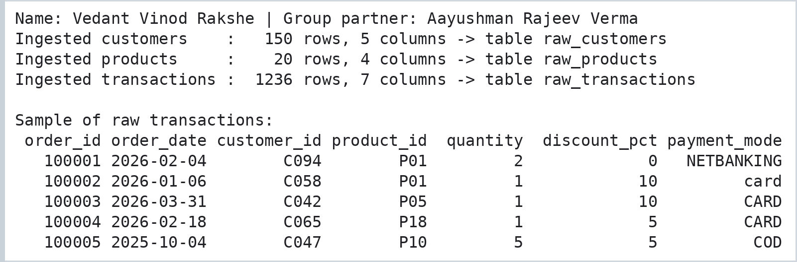

Step 3: Data Cleaning and Data Quality Report
Five validation rules are applied to the transactions: remove duplicates, invalid dates, invalid quantities, missing customer ids and unknown products. Payment modes and customer text fields are standardised.
Code:
# ---------------------------------------------------------------
# STAGE 3 : DATA CLEANING (with a data-quality report)
# ---------------------------------------------------------------
print("Name: Vedant Vinod Rakshe | Group partner: Aayushman Rajeev Verma")
t = raw["transactions"].copy()
dq = [("Raw rows received", len(t))]

n = len(t); t = t.drop_duplicates()
dq.append(("Duplicate rows removed", n - len(t)))

t["order_date"] = pd.to_datetime(t["order_date"], format="%Y-%m-%d", errors="coerce")
n = len(t); t = t[t["order_date"].notna()]
dq.append(("Invalid dates removed", n - len(t)))

n = len(t); t = t[t["quantity"] > 0]
dq.append(("Invalid quantity removed", n - len(t)))

n = len(t); t = t[t["customer_id"].notna()]
dq.append(("Missing customer_id removed", n - len(t)))

n = len(t); t = t[t["product_id"].isin(raw["products"]["product_id"])]
dq.append(("Unknown product removed", n - len(t)))

t["payment_mode"] = t["payment_mode"].str.strip().str.upper() # UPI / Upi / upi -> UPI
dq.append(("Clean rows kept", len(t)))
clean_tx = t.reset_index(drop=True)

c = raw["customers"].copy()
c["name"] = c["name"].str.strip().str.title()
c["city"] = c["city"].str.strip().str.title() # 'PUNE ' -> 'Pune'
c["email"] = c["email"].str.strip().str.lower()
clean_cust = c.drop_duplicates("customer_id")
clean_prod = raw["products"].drop_duplicates("product_id")

print(pd.DataFrame(dq, columns=["Data quality check", "Rows"]).to_string(index=False))
print("\nCity values before:", sorted(raw["customers"]["city"].unique())[:6], "...")
print("City values after :", sorted(clean_cust["city"].unique()))
log("clean_transactions", len(raw["transactions"]), len(clean_tx), "5 quality rules applied")
log("clean_customers", len(raw["customers"]), len(clean_cust), "text standardised")
Output:
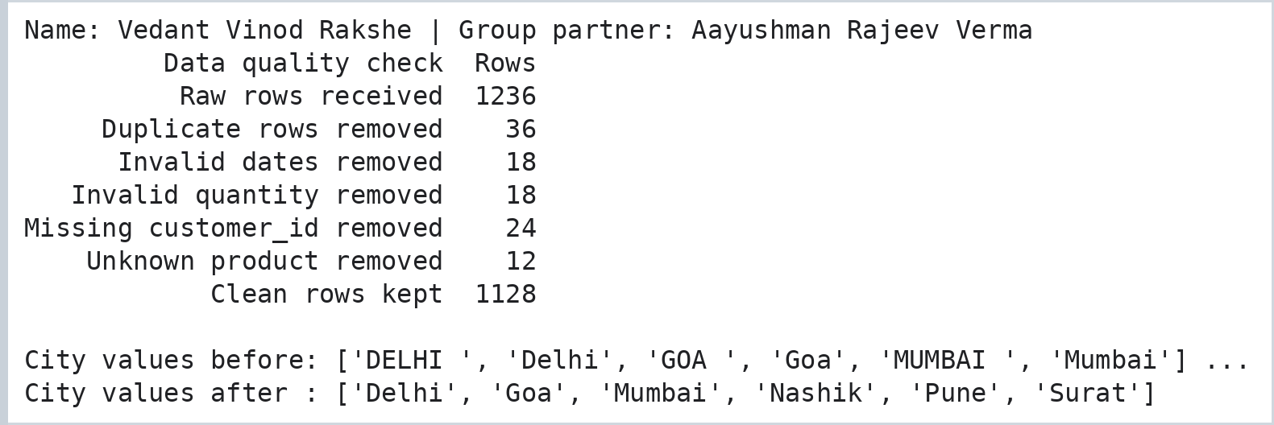

Step 4: Data Transformation
Gross, discount and net amounts are derived, and the clean data is reshaped into dimension tables (date, customer, product, payment) and a fact table that uses surrogate keys.
Code:
# ---------------------------------------------------------------
# STAGE 4 : TRANSFORMATION (business columns + dimension tables)
# ---------------------------------------------------------------
# Derived measures
print("Name: Vedant Vinod Rakshe | Group partner: Aayushman Rajeev Verma")
f = clean_tx.merge(clean_prod[["product_id", "unit_price"]], on="product_id")
f["gross_amount"] = f["quantity"] * f["unit_price"]
f["discount_amount"] = (f["gross_amount"] * f["discount_pct"] / 100).round(2)
f["net_amount"] = f["gross_amount"] - f["discount_amount"]

# Dimension tables with surrogate keys
dim_date = pd.DataFrame({"full_date": pd.date_range(f["order_date"].min(), f["order_date"].max())})
dim_date["date_key"] = dim_date["full_date"].dt.strftime("%Y%m%d").astype(int)
dim_date["day_name"] = dim_date["full_date"].dt.day_name()
dim_date["month_name"] = dim_date["full_date"].dt.strftime("%b %Y")
dim_date["month_num"] = dim_date["full_date"].dt.strftime("%Y-%m")
dim_date["quarter"] = "Q" + dim_date["full_date"].dt.quarter.astype(str)
dim_date["year"] = dim_date["full_date"].dt.year
dim_date["is_weekend"] = dim_date["full_date"].dt.dayofweek.isin([5, 6]).astype(int)
dim_date["full_date"] = dim_date["full_date"].dt.strftime("%Y-%m-%d")
dim_date = dim_date[["date_key", "full_date", "day_name", "month_name", "month_num",
"quarter", "year", "is_weekend"]]

dim_customer = clean_cust.reset_index(drop=True)
dim_customer.insert(0, "customer_key", dim_customer.index + 1)
dim_product = clean_prod.reset_index(drop=True)
dim_product.insert(0, "product_key", dim_product.index + 1)
dim_payment = pd.DataFrame({"payment_mode": sorted(f["payment_mode"].unique())})
dim_payment.insert(0, "payment_key", dim_payment.index + 1)

# Fact table: replace business keys with surrogate keys
fact_sales = (f.assign(date_key=f["order_date"].dt.strftime("%Y%m%d").astype(int))
.merge(dim_customer[["customer_key", "customer_id"]], on="customer_id")
.merge(dim_product[["product_key", "product_id"]], on="product_id")
.merge(dim_payment, on="payment_mode"))
fact_sales = fact_sales[["order_id", "date_key", "customer_key", "product_key", "payment_key", "quantity",
"unit_price", "discount_pct", "gross_amount", "discount_amount", "net_amount"]]
fact_sales.insert(0, "sales_key", range(1, len(fact_sales) + 1))

print("fact_sales rows :", len(fact_sales), "| dim_date:", len(dim_date), "| dim_customer:",
len(dim_customer), "| dim_product:", len(dim_product), "| dim_payment:", len(dim_payment))
print("\nFact table sample:")
show = ["sales_key", "order_id", "date_key", "customer_key", "product_key", "quantity", "net_amount"]
print(fact_sales[show].head(5).to_string(index=False))
log("transform", len(clean_tx), len(fact_sales), "fact + 4 dimensions built")
Output:
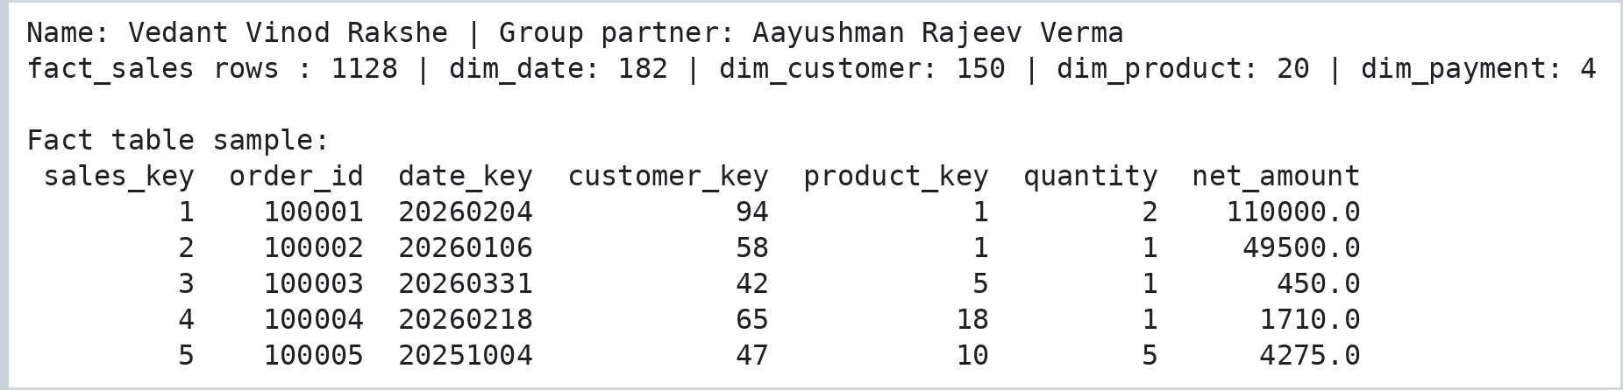

Step 5: Data Warehouse Design (Star Schema), Storage and Load
A star schema was chosen because it makes analytical queries simple and fast: one central fact table holds the measurable events (sales) and four dimension tables describe them.
Code:
import matplotlib.pyplot as plt
fig, ax = plt.subplots(figsize=(10, 6.2))
def box(x, y, text, color):
ax.text(x, y, text, ha="center", va="center", family="monospace", fontsize=8.5,
bbox=dict(boxstyle="round,pad=0.5", fc=color, ec="black"), zorder=3)
centers = {"date": (1.7, 5.0), "cust": (8.3, 5.0), "prod": (1.7, 1.2), "pay": (8.3, 1.2)}
for (x, y) in centers.values():
ax.plot([5, x], [3.1, y], color="gray", lw=1.5, zorder=1)
box(5, 3.1, "FACT_SALES\n-----------------\nPK sales_key\nFK date_key\nFK customer_key\nFK product_key\nFK payment_key\norder_id\nquantity\nunit_price\ndiscount_pct\ngross_amount\ndiscount_amount\nnet_amount", "#ffd6a5")
box(*centers["date"], "DIM_DATE\n-----------\nPK date_key\nfull_date\nday_name\nmonth_name\nmonth_num\nquarter\nyear\nis_weekend", "#cde7f0")
box(*centers["cust"], "DIM_CUSTOMER\n--------------\nPK customer_key\ncustomer_id\nname\nemail\ncity\nsignup_date", "#d8f3dc")
box(*centers["prod"], "DIM_PRODUCT\n--------------\nPK product_key\nproduct_id\nproduct_name\ncategory\nunit_price", "#fff3b0")
box(*centers["pay"], "DIM_PAYMENT\n--------------\nPK payment_key\npayment_mode", "#e0c3fc")
ax.set_xlim(0, 10); ax.set_ylim(0, 6.4); ax.axis("off")
ax.set_title("Star Schema of the Retail Sales Data Warehouse", fontsize=11)
plt.gcf().text(0.99, 0.005, "Name: Vedant Vinod Rakshe | Aayushman Rajeev Verma", ha="right", va="bottom", fontsize=8, color="gray")
plt.savefig("p10_star_schema.png", dpi=120, bbox_inches="tight")
Output:
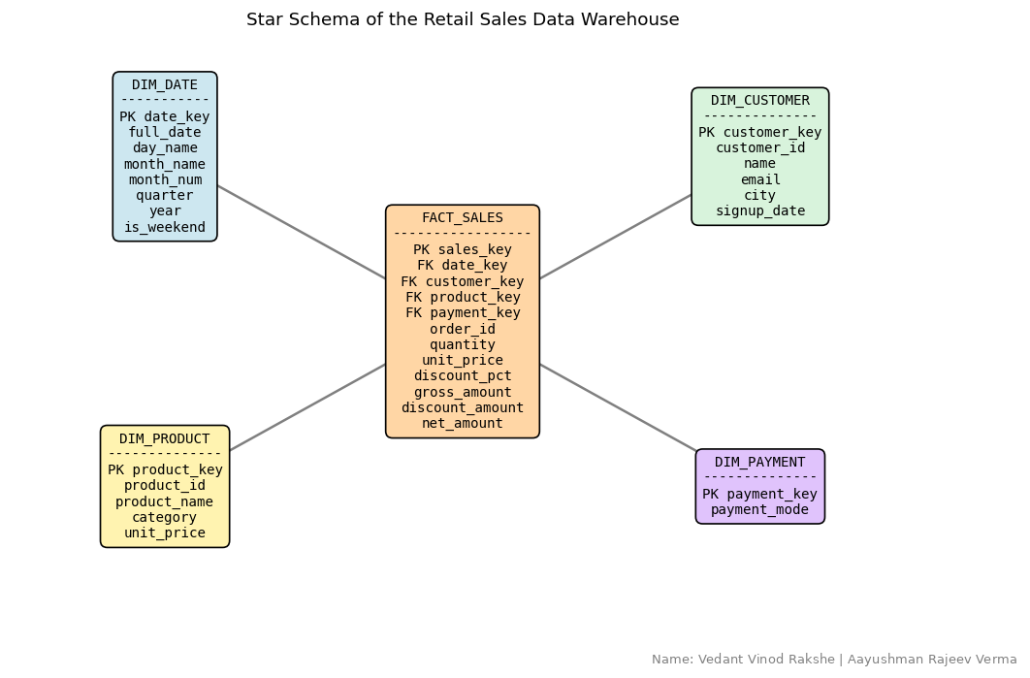
Code:
# ---------------------------------------------------------------
# STAGE 5 : STORAGE - DATA WAREHOUSE DESIGN (star schema) AND LOAD
# ---------------------------------------------------------------
print("Name: Vedant Vinod Rakshe | Group partner: Aayushman Rajeev Verma")
conn.execute("PRAGMA foreign_keys = ON")
conn.executescript("""
CREATE TABLE dim_date (date_key INTEGER PRIMARY KEY, full_date TEXT, day_name TEXT, month_name TEXT,
month_num TEXT, quarter TEXT, year INTEGER, is_weekend INTEGER);
CREATE TABLE dim_customer (customer_key INTEGER PRIMARY KEY, customer_id TEXT UNIQUE, name TEXT,
email TEXT, city TEXT, signup_date TEXT);
CREATE TABLE dim_product (product_key INTEGER PRIMARY KEY, product_id TEXT UNIQUE, product_name TEXT,
category TEXT, unit_price REAL);
CREATE TABLE dim_payment (payment_key INTEGER PRIMARY KEY, payment_mode TEXT UNIQUE);
CREATE TABLE fact_sales (
sales_key INTEGER PRIMARY KEY, order_id INTEGER UNIQUE,
date_key INTEGER REFERENCES dim_date(date_key),
customer_key INTEGER REFERENCES dim_customer(customer_key),
product_key INTEGER REFERENCES dim_product(product_key),
payment_key INTEGER REFERENCES dim_payment(payment_key),
quantity INTEGER CHECK (quantity > 0), unit_price REAL, discount_pct REAL,
gross_amount REAL, discount_amount REAL, net_amount REAL);
CREATE INDEX idx_fact_date ON fact_sales(date_key);
CREATE INDEX idx_fact_customer ON fact_sales(customer_key);
CREATE INDEX idx_fact_product ON fact_sales(product_key);
""")
for name, df in [("dim_date", dim_date), ("dim_customer", dim_customer), ("dim_product", dim_product),
("dim_payment", dim_payment), ("fact_sales", fact_sales)]:
df.to_sql(name, conn, if_exists="append", index=False)
print(f"{name:<13} loaded: {conn.execute(f'SELECT COUNT(*) FROM {name}').fetchone()[0]:>5} rows")
conn.commit()

violations = conn.execute("PRAGMA foreign_key_check").fetchall()
print("\nForeign key violations:", len(violations))
print("Revenue check -> Pandas:", round(fact_sales["net_amount"].sum(), 2),
"| SQL:", round(conn.execute("SELECT SUM(net_amount) FROM fact_sales").fetchone()[0], 2))
n_fact = conn.execute("SELECT COUNT(*) FROM fact_sales").fetchone()[0]
log("load_warehouse", len(fact_sales), n_fact, "FK check passed")
Output:
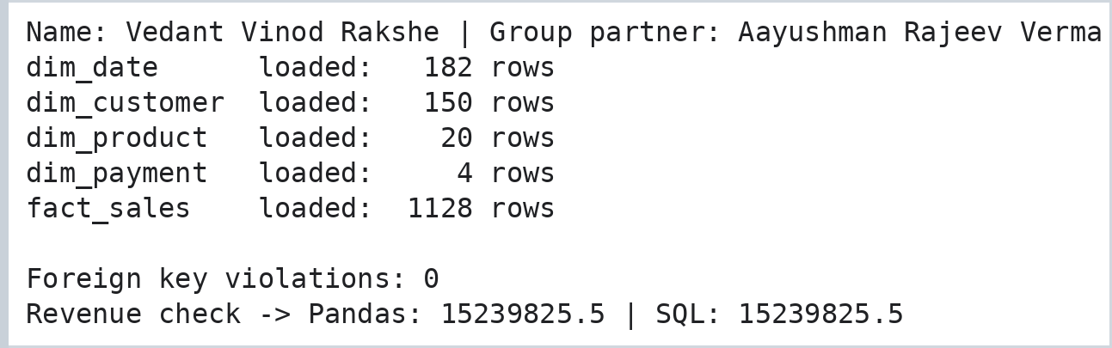

Step 6: Reporting and Analytics
Code:
# ---------------------------------------------------------------
# STAGE 6 : REPORTING (SQL on the star schema)
# ---------------------------------------------------------------
print("Name: Vedant Vinod Rakshe | Group partner: Aayushman Rajeev Verma")
q = lambda sql: pd.read_sql(sql, conn)

kpi = q("""SELECT COUNT(*) AS orders, SUM(quantity) AS units,
ROUND(SUM(net_amount), 2) AS net_revenue,
ROUND(SUM(discount_amount), 2) AS discount_given,
ROUND(AVG(net_amount), 2) AS avg_order_value
FROM fact_sales""")
print("KEY PERFORMANCE INDICATORS"); print(kpi.to_string(index=False))

monthly = q("""SELECT d.month_num AS month, COUNT(*) AS orders, ROUND(SUM(f.net_amount), 2) AS net_revenue
FROM fact_sales f JOIN dim_date d ON d.date_key = f.date_key
GROUP BY d.month_num ORDER BY d.month_num""")
print("\nMONTHLY REVENUE"); print(monthly.to_string(index=False))

by_cat = q("""SELECT p.category, SUM(f.quantity) AS units, ROUND(SUM(f.net_amount), 2) AS net_revenue
FROM fact_sales f JOIN dim_product p ON p.product_key = f.product_key
GROUP BY p.category ORDER BY net_revenue DESC""")
print("\nREVENUE BY CATEGORY"); print(by_cat.to_string(index=False))

by_city = q("""SELECT c.city, COUNT(*) AS orders, ROUND(SUM(f.net_amount), 2) AS net_revenue
FROM fact_sales f JOIN dim_customer c ON c.customer_key = f.customer_key
GROUP BY c.city ORDER BY net_revenue DESC""")
print("\nREVENUE BY CITY"); print(by_city.to_string(index=False))

top_products = q("""SELECT p.product_name, p.category, SUM(f.quantity) AS units,
ROUND(SUM(f.net_amount), 2) AS net_revenue
FROM fact_sales f JOIN dim_product p ON p.product_key = f.product_key
GROUP BY p.product_name ORDER BY net_revenue DESC LIMIT 5""")
print("\nTOP 5 PRODUCTS"); print(top_products.to_string(index=False))

top_customers = q("""SELECT c.name, c.city, COUNT(*) AS orders,
ROUND(SUM(f.net_amount), 2) AS net_revenue
FROM fact_sales f JOIN dim_customer c ON c.customer_key = f.customer_key
GROUP BY c.customer_key ORDER BY net_revenue DESC LIMIT 5""")
print("\nTOP 5 CUSTOMERS"); print(top_customers.to_string(index=False))

pay = q("""SELECT y.payment_mode, COUNT(*) AS orders, ROUND(SUM(f.net_amount), 2) AS net_revenue
FROM fact_sales f JOIN dim_payment y ON y.payment_key = f.payment_key
GROUP BY y.payment_mode ORDER BY orders DESC""")
print("\nPAYMENT MODES"); print(pay.to_string(index=False))

weekend = q("""SELECT CASE d.is_weekend WHEN 1 THEN 'Weekend' ELSE 'Weekday' END AS day_type,
COUNT(*) AS orders, ROUND(AVG(f.net_amount), 2) AS avg_order_value
FROM fact_sales f JOIN dim_date d ON d.date_key = f.date_key GROUP BY d.is_weekend""")
print("\nWEEKDAY vs WEEKEND"); print(weekend.to_string(index=False))
log("reporting", len(fact_sales), 8, "8 report queries")
Output:
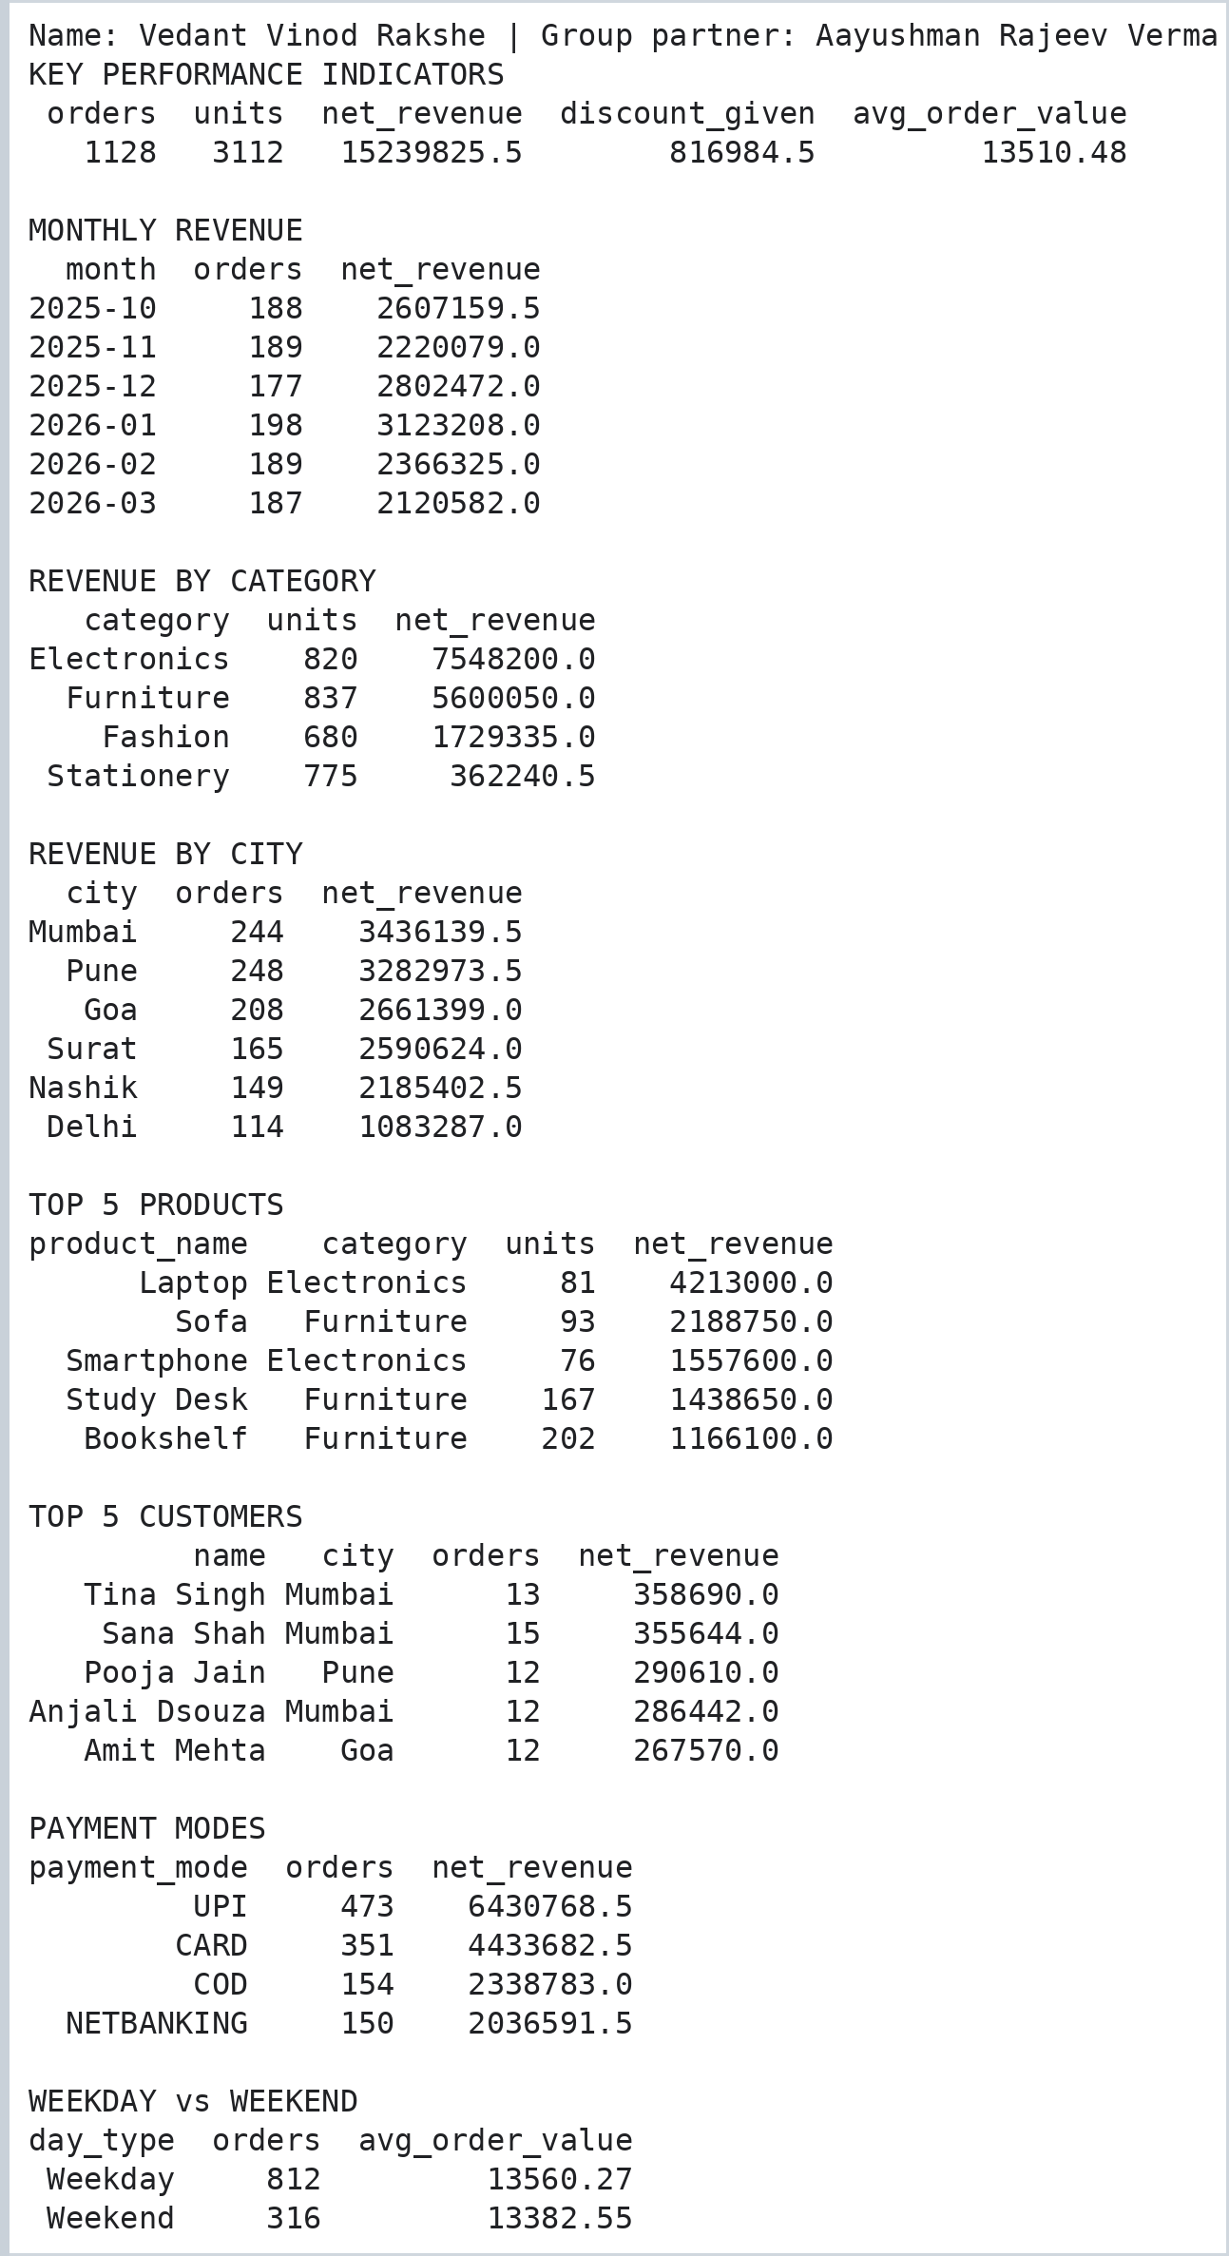

Step 7: Dashboard, Report Export and Pipeline Run Summary
Code:
# ---- Dashboard charts and report exports
print("Name: Vedant Vinod Rakshe | Group partner: Aayushman Rajeev Verma")
fig, ax = plt.subplots(2, 2, figsize=(11, 7))
ax[0, 0].plot(monthly["month"], monthly["net_revenue"], marker="o", color="#2a6f97")
ax[0, 0].set_title("Monthly Net Revenue"); ax[0, 0].tick_params(axis="x", rotation=30)
ax[0, 1].bar(by_cat["category"], by_cat["net_revenue"], color="#52b788")
ax[0, 1].set_title("Net Revenue by Category")
ax[1, 0].barh(by_city["city"], by_city["net_revenue"], color="#f4a261")
ax[1, 0].set_title("Net Revenue by City"); ax[1, 0].invert_yaxis()
ax[1, 1].pie(pay["orders"], labels=pay["payment_mode"], autopct="%1.0f%%", startangle=90)
ax[1, 1].set_title("Orders by Payment Mode")
plt.suptitle("Retail Sales Data Warehouse - Dashboard", fontsize=13)
plt.tight_layout()
plt.gcf().text(0.99, 0.005, "Name: Vedant Vinod Rakshe | Aayushman Rajeev Verma", ha="right", va="bottom", fontsize=8, color="gray")
plt.savefig("p10_dashboard.png", dpi=110, bbox_inches="tight")
plt.show()

os.makedirs("reports", exist_ok=True)
for name, df in [("kpi", kpi), ("monthly_revenue", monthly), ("by_category", by_cat),
("by_city", by_city), ("top_products", top_products), ("top_customers", top_customers)]:
df.to_csv(f"reports/{name}.csv", index=False)
print("Reports exported to the reports/ folder:")
for file in sorted(os.listdir("reports")):
print(" ", file)
Output:
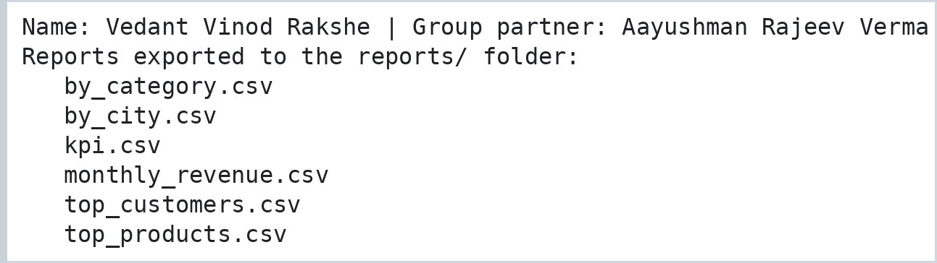
Output:
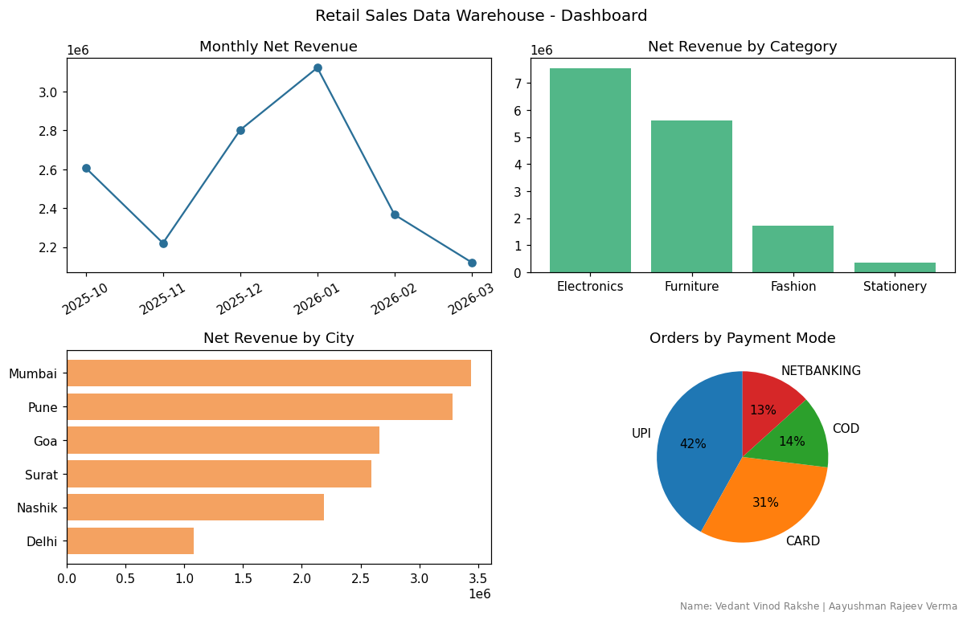
Code:
# ---- Pipeline run summary (audit trail of all stages)
print("Name: Vedant Vinod Rakshe | Group partner: Aayushman Rajeev Verma")
print(pd.DataFrame(run_log).to_string(index=False))
conn.close()
Output:
