|  |  |  |
| --- | --- | --- |
| **E** | **EVACUATIESYMBOLEN** | |
| E029 Vluchtmasker | |
| Categorie | Evacuatie |
| Bestandsnaam | E029_Vluchtmasker.svg |
| Bestandstype | SVG Scalable Vector Graphics |

|  |  |
| --- | --- |
| **X** | NEN‐EN‐ISO 7010 (ISO International Standardization) |
| **X** | NEN 1414-1:2019 (Nederlandse norm) |

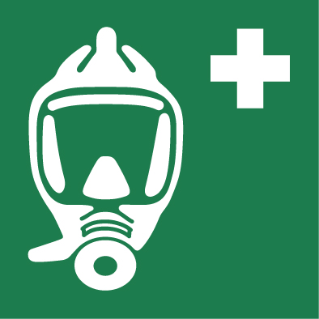

**Omschrijving**:

**Aanvullende informatie:**

**NEN1414-1:2019 Tabel F.1 — Symboolkleuren**

|  |  |  |  |  |  |  |  |  |  |
| --- | --- | --- | --- | --- | --- | --- | --- | --- | --- |
| **Kleur** | **RAL** | **PANTONE** | **RGB** | | | **CMYK** | | | |
| Wit | 9003 | - | 255 | 255 | 255 | 0 | 0 | 0 | 0 |
| Groen | 6032 | 348c | 35 | 127 | 82 | 90 | 10 | 80 | 10 |

**Invulvelden achter symbool voor weergave in MOI**

|  |  |
| --- | --- |
| **Bouwlaag** |  |
| **Categorie** | Ontruiming |
| **Soort** | Noodvoorziening |
| **Omschrijving** | Vluchtmasker |
| **Sturing** |  |
| **Locatie** |  |
| **Opmerking** |  |