|  |  |  |
| --- | --- | --- |
| **W** | **WAARSCHUWINGSSYMBOLEN** | |
| W013 Hondenbewaking | |
| Categorie | Waarschuwing |
| Bestandsnaam | W013_honden_bewaking.svg |
| Bestandstype | SVG Scalable Vector Graphics |

|  |  |
| --- | --- |
| **X** | NEN‐EN‐ISO 7010 (ISO International Standardization) |
| **X** | NEN 1414-1:2019 (Nederlandse norm) |

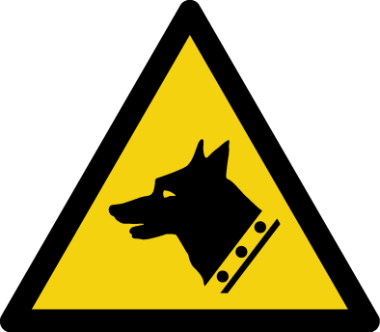

**Omschrijving**: Hondenbewaking

**Aanvullende informatie: -**

**NEN1414-1:2019 Tabel F.1 — Symboolkleuren**

|  |  |  |  |  |  |  |  |  |  |
| --- | --- | --- | --- | --- | --- | --- | --- | --- | --- |
| **Kleur** | **RAL** | **PANTONE** | **RGB** | | | **CMYK** | | | |
| Geel | 1003 | 116c | 249 | 168 | 0 | 0 | 35 | 100 | 0 |
| Zwart | 9004 | - | 0 | 0 | 0 | 0 | 0 | 0 | 100 |

**Invulvelden achter symbool voor weergave in MOI**

|  |  |
| --- | --- |
| **Bouwlaag** |  |
| **Categorie** | Waarschuwing |
| **Soort gevaar** | Hondenbewaking |
| **Omschrijving gevaar** |  |
| **Locatie** |  |
| **Ruimte** |  |
| **Opmerking** |  |