Practical: 11
Practical 11: Student Management CRUD with Search and Filter
Problem Definition: Create a student management module to add, view, edit, delete, search and filter student records. All database operations must use MYSQLi statements and clear success/failure messages.
A. Theory
1. Are SELECT, INSERT, UPDATE, and DELETE operations working?
Yes. All four CRUD operations are implemented using MySQLi prepared statements. SELECT retrieves student lists, INSERT adds new student records, UPDATE modifies existing records by student_id, and DELETE removes records with clear user feedback messages.
2. Is search by name/email/course implemented?
Yes. A dynamic SQL query with prepared parameter binding allows searching by student name and email using 'LIKE %...%', and filtering by specific course using exact equality matching ('course = ?').
3. Are delete operations confirmed before execution?
Yes. Delete actions trigger a JavaScript confirmation dialog (confirm('Delete this student?')) to prevent accidental deletion before the POST request is submitted.
B. Implementation / Output
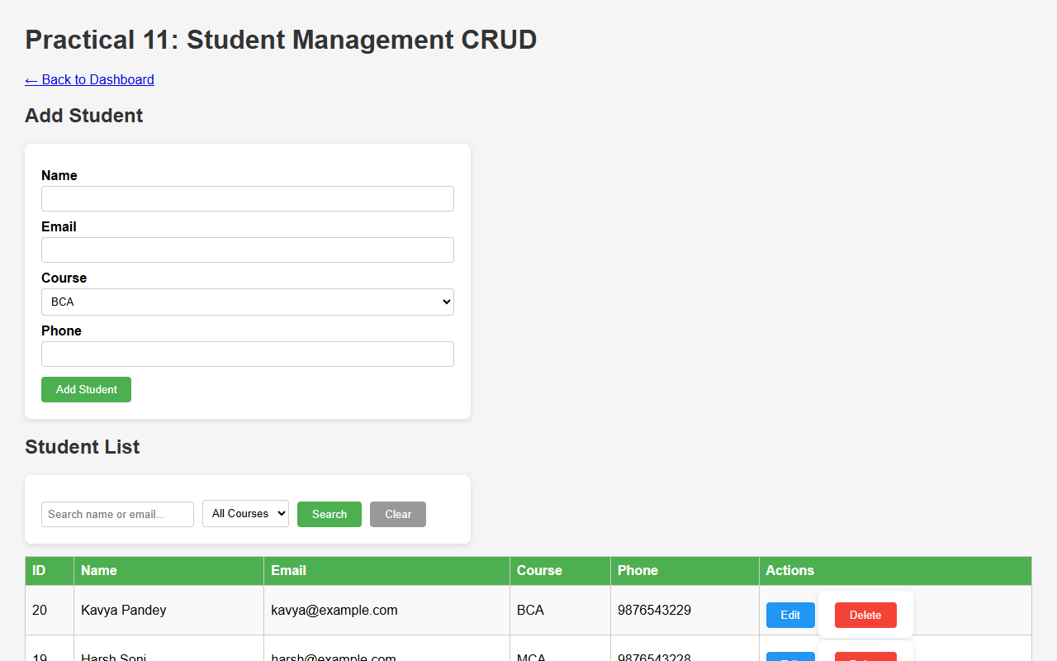
Figure 11.1: Student Management CRUD Dashboard with Seeded Student Records
C. Screenshots
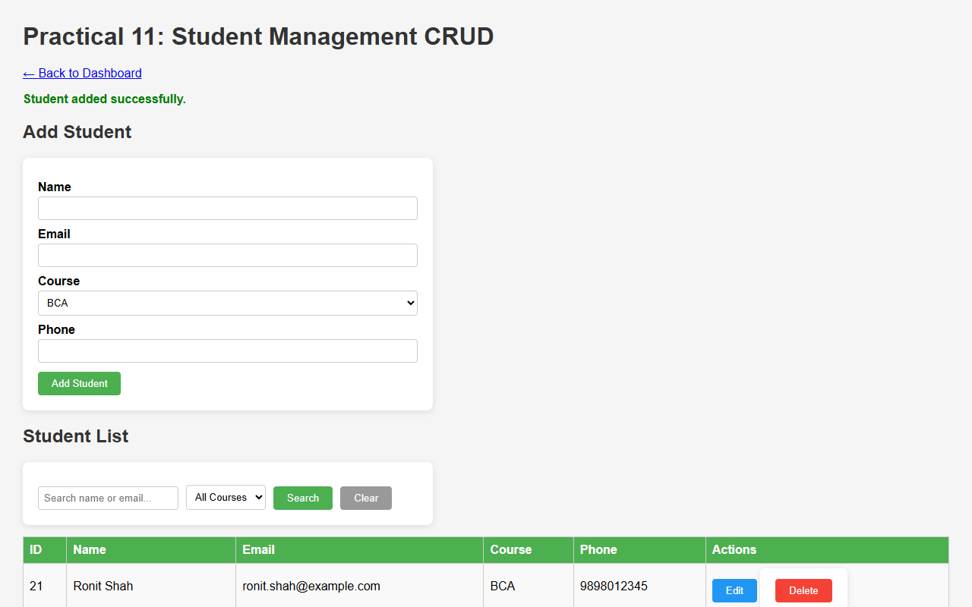
Figure 11.2: Adding New Student Record with Server-side Prepared Insert Operation
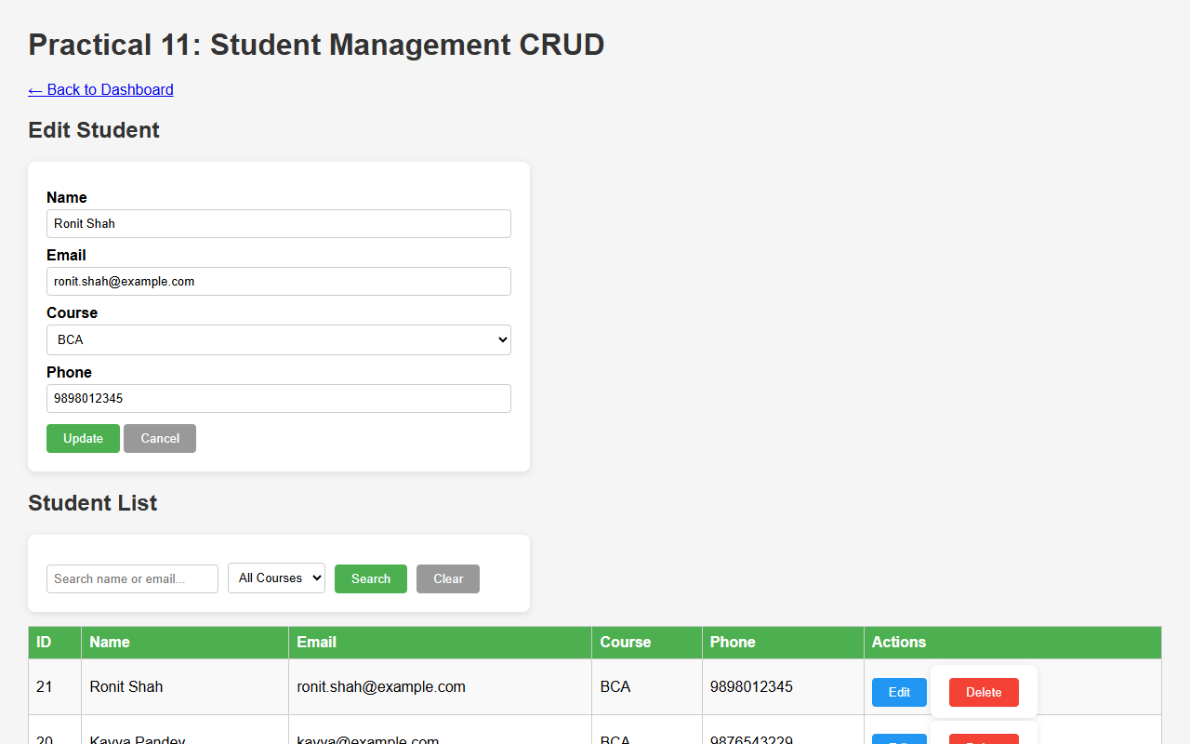
Figure 11.3: Pre-populated Student Edit Form for Updating Existing Records
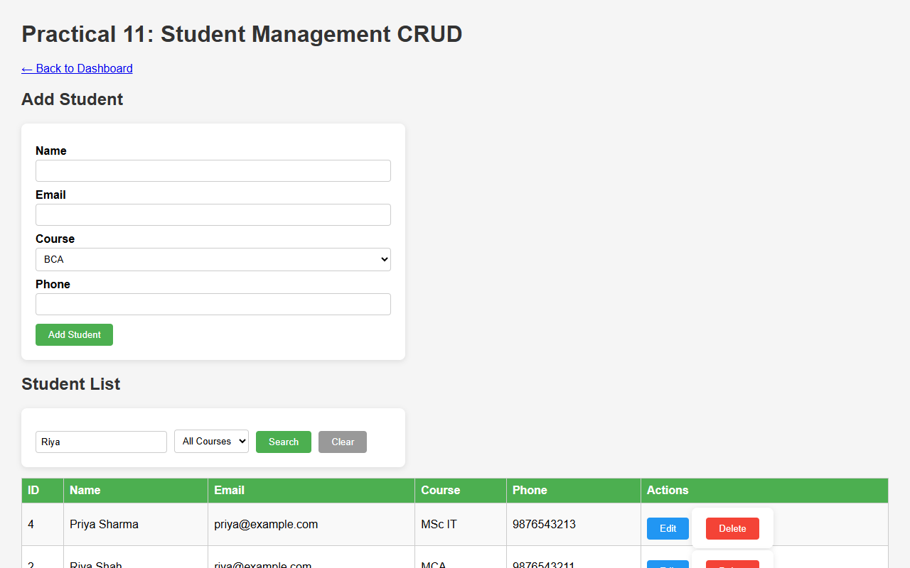
Figure 11.4: Dynamic Student Search Filtered by Name and Email
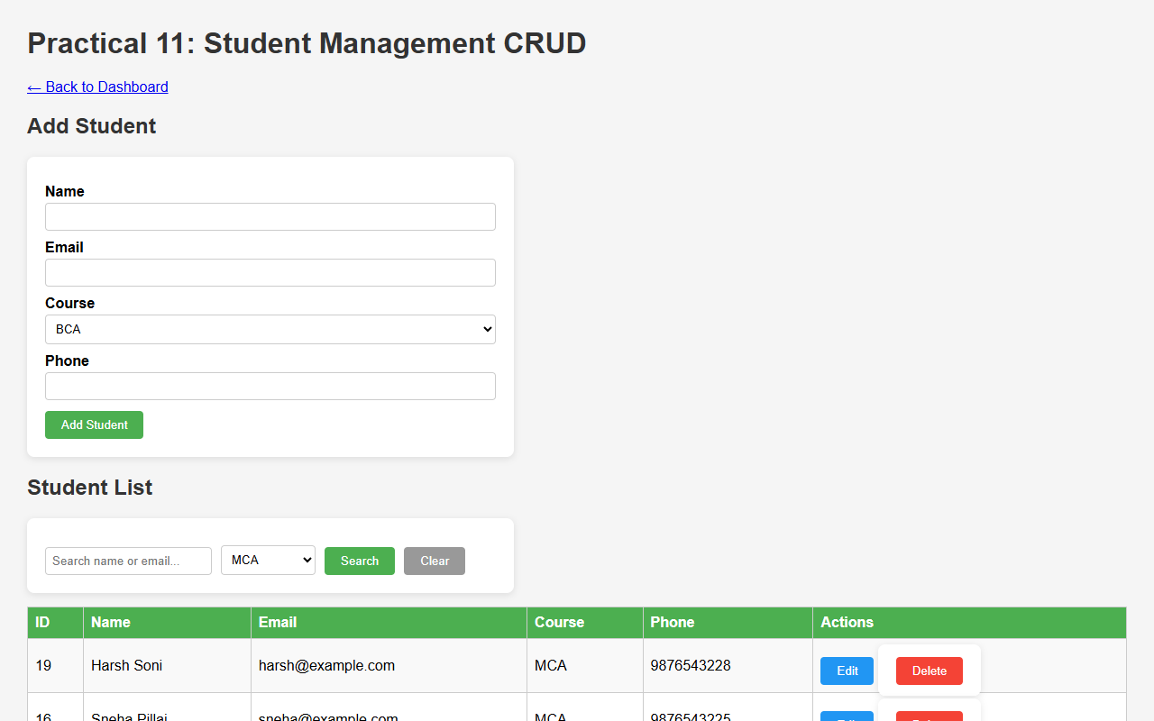
Figure 11.5: Course Filter Restricting Table View to Selected Academic Program
D. GitHub Link
https://github.com/VRAJ-710/studenthub-portal
E. Challenges Faced
- Constructing dynamic SQL queries with flexible parameters and types for combined search terms and course filters.
- Pre-populating the form with existing student data during edit operations without reloading separate pages.
- Generating and streaming CSV exports with correct HTTP headers.
F. Learning Outcomes
- Mastered full CRUD implementation in PHP with MySQLi prepared statements.
- Implemented multi-criteria search and filter queries for efficient data management.
- Learned data export to CSV format directly using PHP output streams.
Faculty Remarks:

