Practical: 12
Practical 12: Event Management CRUD with Poster Upload and File Validation
Problem Definition: Develop event management functionality for admin users. Admin can add, view, update, delete, and upload event posters with file type and file size validation.
A. Theory
1. Are add, update, and delete functionalities implemented correctly?
Yes. Admins can create new events, view existing events in a tabular interface, update event information (with or without updating the poster), and delete events from the database.
2. Is the UI linked with the database correctly?
Yes. The form submits data via POST with multipart/form-data, inserts/updates records in the events table, and reloads the table directly from MySQL with instant status messages.
3. Are poster uploads validated for type and size?
Yes. The handlePoster() function strictly validates uploaded files against allowed MIME types (image/jpeg, image/png, image/gif, image/webp) and enforces a maximum file size limit of 2MB before moving the file to the uploads/ directory.
4. Are success and failure messages displayed?
Yes. Each operation provides clear visual feedback via green success banners or red error banners depending on whether validation and database execution succeeded or failed.
B. Implementation / Output
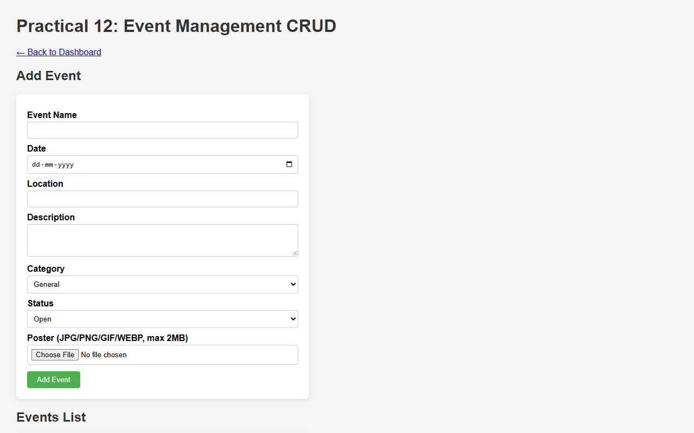
Figure 12.1: Event Management Module Displaying Existing Events and Poster Thumbnails
C. Screenshots
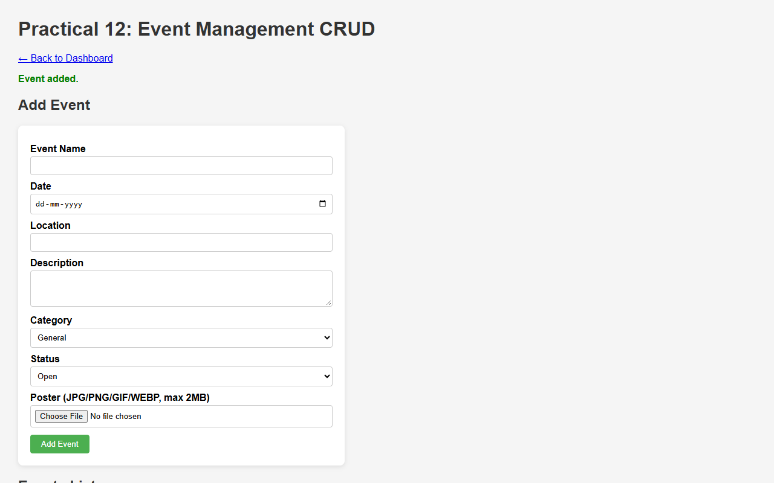
Figure 12.2: Event Registration with Validated Poster Upload and Status Notification
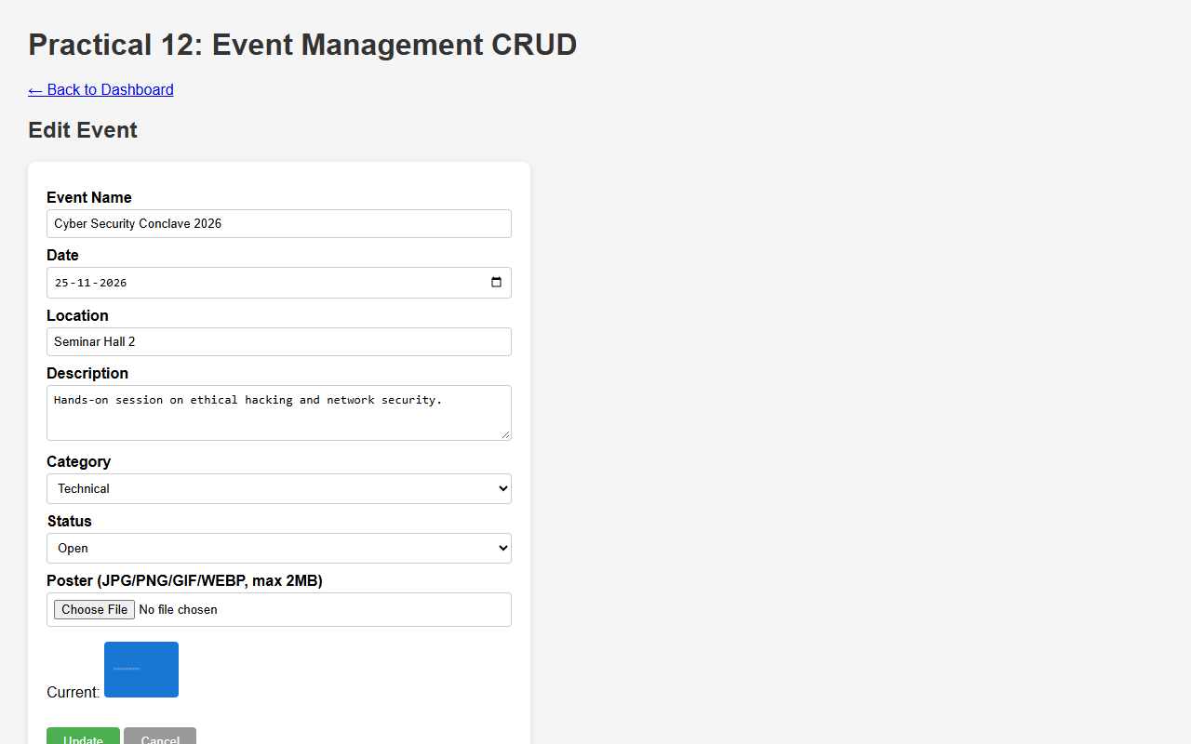
Figure 12.3: Updating Event Metadata and Preserving Existing Uploaded Artwork
Figure 12.4: Event Filtering by Category (Technical) and Open Status
D. GitHub Link
https://github.com/VRAJ-710/studenthub-portal
E. Challenges Faced
- Safely handling file uploads using unique random filenames (uniqid()) to avoid file overwriting and directory traversal issues.
- Ensuring event updates preserve existing posters when an admin updates text details without uploading a new image.
- Validating file MIME types and size constraints on the server side to reject unauthorized file formats.
F. Learning Outcomes
- Developed server-side file upload functionality with strict MIME-type and size validation in PHP.
- Integrated image file storage with database record references.
- Implemented administrative CRUD interfaces with status and category filtering.
Faculty Remarks:

