Practical: 13
Practical 13: PHP JSON API and AJAX/Fetch-Based CRUD without Page Reload
Problem Definition: Create simple PHP JSON API endpoints for events or students and consume them using Fetch API. Perform list, add, update, and delete operations asynchronously without full page reload.
A. Theory
1. Do PHP endpoints return valid JSON responses?
Yes. The backend script api.php sets the response header 'Content-Type: application/json' and serializes all response data into structured JSON objects using json_encode() with consistent status and message keys.
2. Are GET and POST requests handled properly?
Yes. GET requests handle the listing of student records (action=list), while POST requests parse JSON payload bodies (php://input) to handle insert, update, and delete operations.
3. Are loading, success, and error states shown on the frontend?
Yes. The frontend displays a 'Loading...' indicator during asynchronous fetch operations and renders dynamic colored notification banners for 3 seconds upon success or error.
4. Is input validation performed before database operations?
Yes. Both frontend JavaScript (prior to invoking fetch()) and backend PHP (validating parsed JSON inputs) verify that required fields such as student name and email are present and valid before executing database queries.
B. Implementation / Output
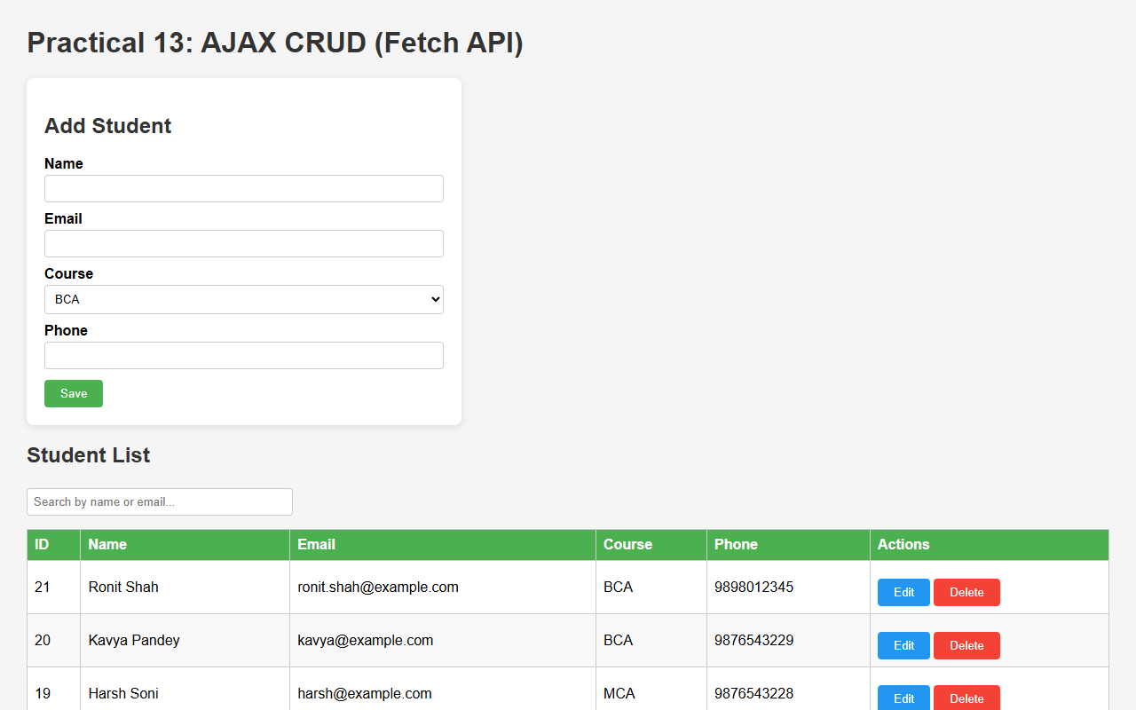
Figure 13.1: Asynchronous Single-Page CRUD Interface Powered by Fetch API
C. Screenshots
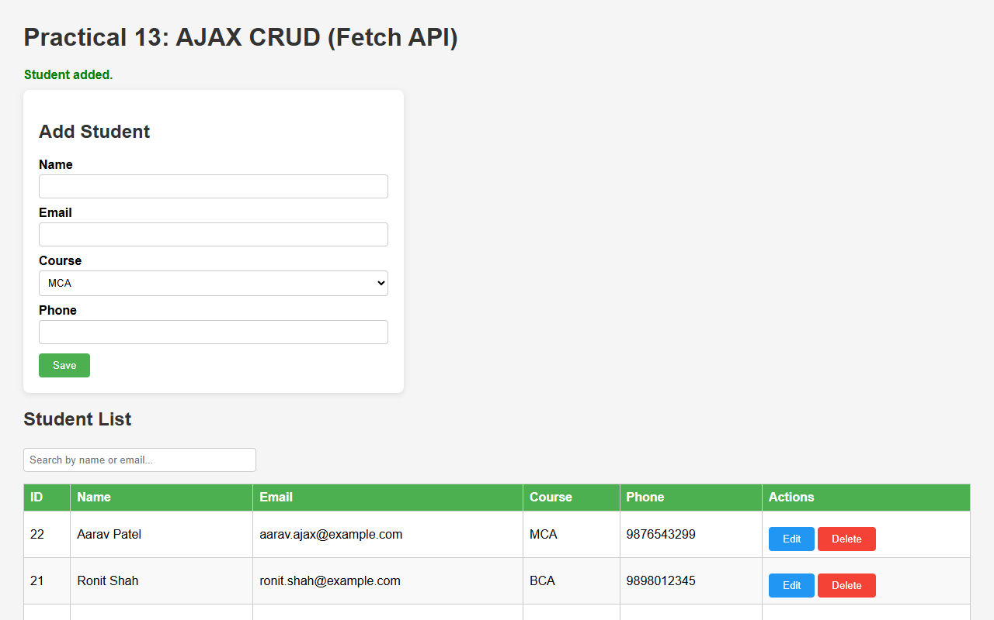
Figure 13.2: Adding a Student Record Asynchronously with Real-time DOM Table Update
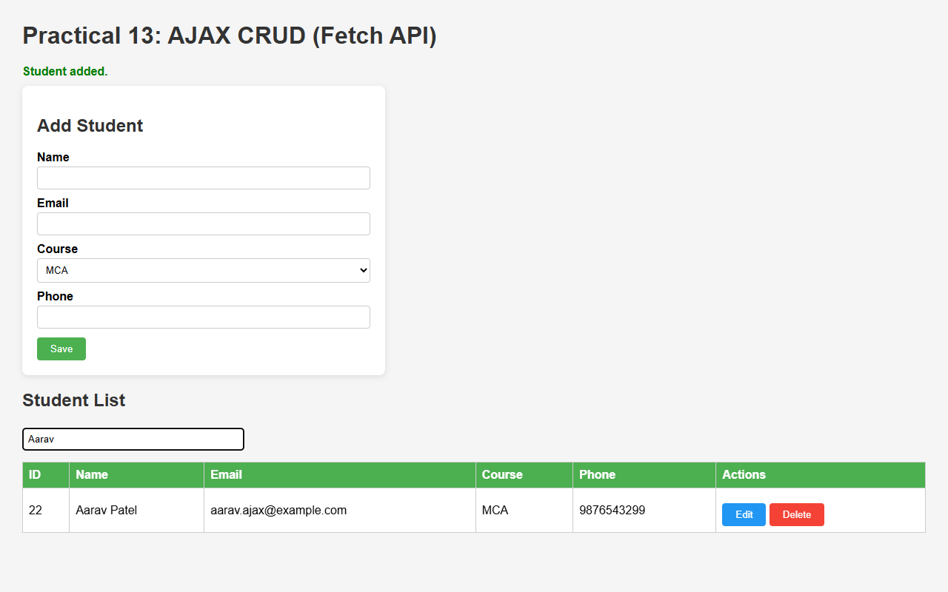
Figure 13.3: Client-side Debounced Real-time Student Search without Full Page Reload
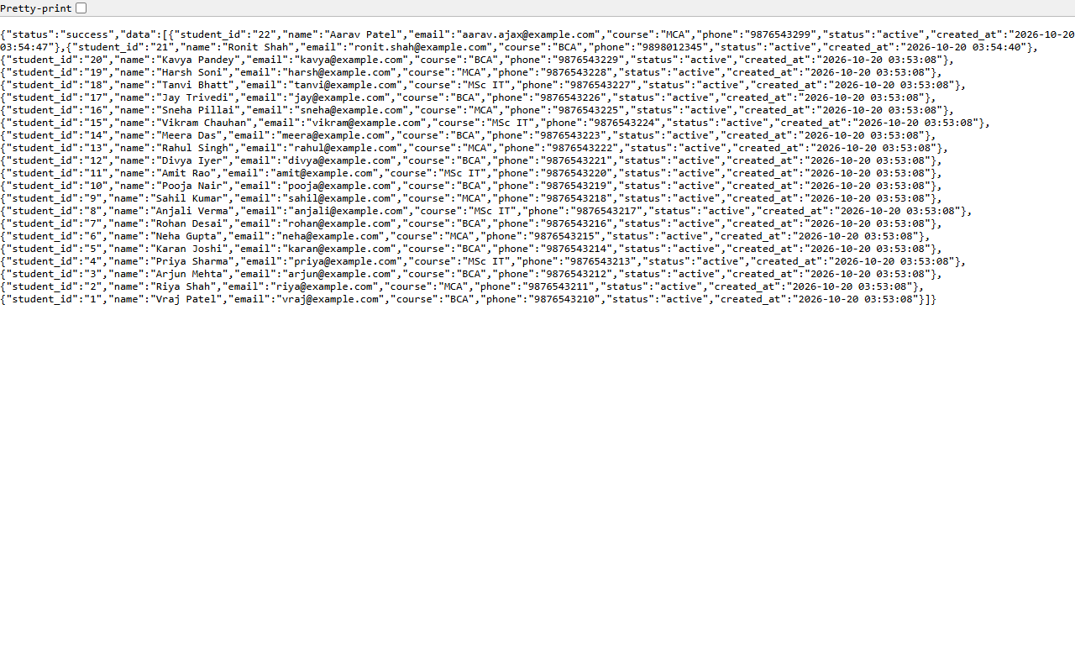
Figure 13.4: PHP JSON API Endpoint Output Returning Serialized Data Structure
D. GitHub Link
https://github.com/VRAJ-710/studenthub-portal
E. Challenges Faced
- Parsing raw JSON request bodies via file_get_contents('php://input') in PHP for incoming POST requests.
- Implementing debouncing on client-side search inputs to prevent excessive API calls.
- Updating DOM tables and managing form states dynamically without requiring full browser page refreshes.
F. Learning Outcomes
- Built RESTful JSON API endpoints in PHP.
- Mastered asynchronous web interactions using the modern JavaScript Fetch API.
- Handled asynchronous request states (loading, success, error) and dynamic DOM updates.
Faculty Remarks:

