Practical: 14
Practical 14: Admin Dashboard with Role-Based Access Control, Dynamic Menu, and Audit Log
Problem Definition: Develop an admin dashboard that displays user statistics, student count, event count and latest registrations. Restrict access to admin users only and show dynamic menu options based on role.
A. Theory
1. Are dashboard values loaded dynamically from the database?
Yes. The dashboard aggregates real-time data using SQL COUNT(*) queries on users, students, events, and registrations tables, displaying updated metrics dynamically.
2. Is access restricted to admin users?
Yes. The dashboard enforces RBAC by checking $_SESSION['role'] === 'admin'. Non-admin users are automatically redirected to student_dashboard.php, preventing unauthorized access.
3. Are role-based menus working?
Yes. The sidebar dynamically renders navigation links based on user role conditions in PHP (if ($role === 'admin')), showing administrative management modules only to verified admins.
4. Are important admin actions recorded in audit_logs?
Yes. High-privilege administrative actions, such as user role toggles, trigger automated INSERT operations into the audit_logs table recording the admin user ID, description of action, and timestamp.
B. Implementation / Output
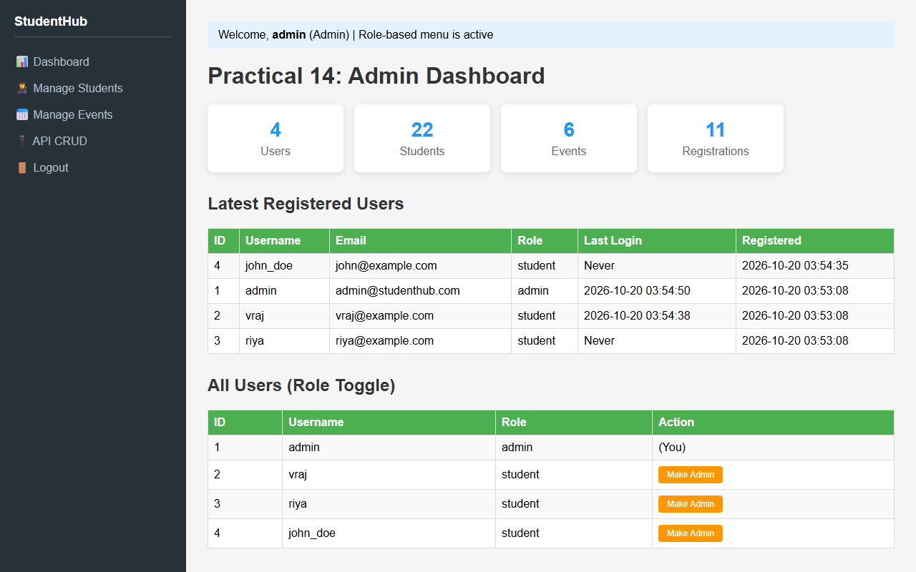
Figure 14.1: Role-Based Admin Dashboard with Real-time Metric Cards and Navigation
C. Screenshots
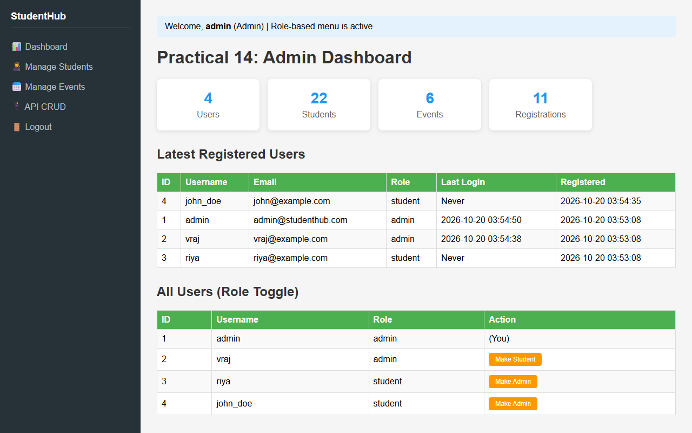
Figure 14.2: Dynamic User Role Management Interface (Admin/Student Toggle)
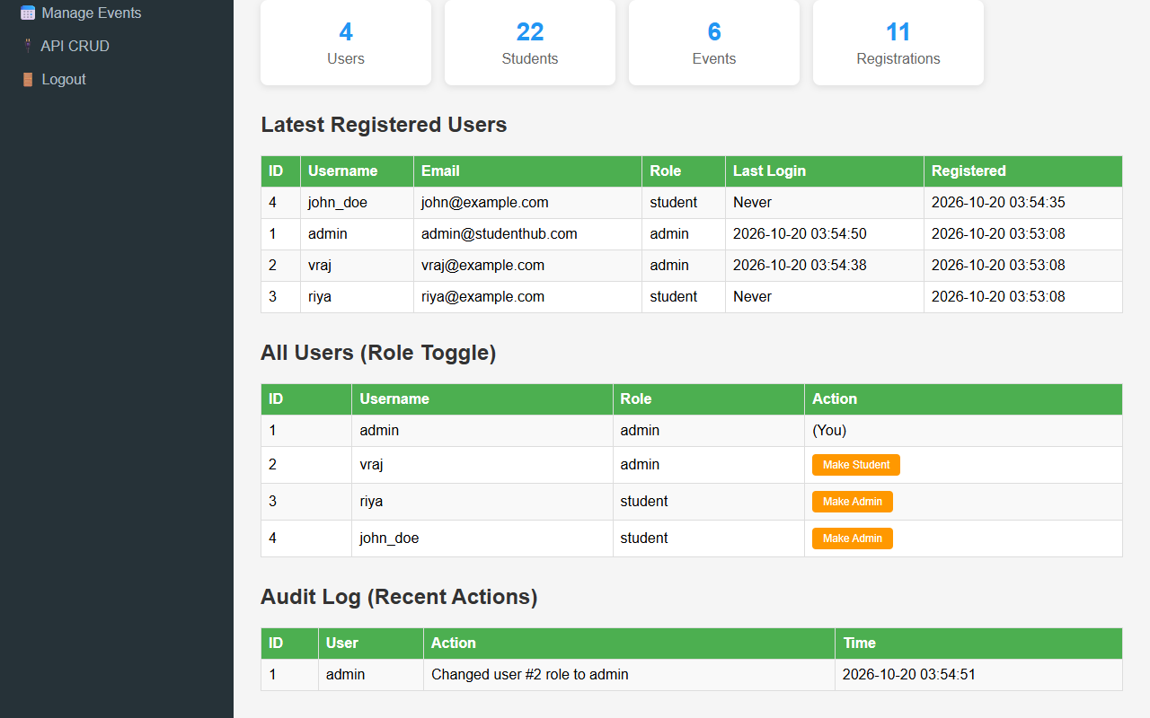
Figure 14.3: Security Audit Log Table Recording Critical Administrative Actions with Timestamps
D. GitHub Link
https://github.com/VRAJ-710/studenthub-portal
E. Challenges Faced
- Structuring responsive multi-column dashboard layouts with summary statistic cards and tabular data.
- Implementing atomic audit logging whenever administrative actions take place.
- Designing a flexible sidebar navigation menu that adapts cleanly according to authenticated session roles.
F. Learning Outcomes
- Designed an administrative control panel with dynamic aggregation metrics and data visualization.
- Implemented Role-Based Access Control (RBAC) with protected administrative routes.
- Created an audit trail system to log security-sensitive operations with timestamps.
Faculty Remarks:

