Budget Report - July 26, 2025

# Summary

This report provides a comprehensive overview of budget allocation and expenditure status. The analysis includes detailed breakdowns of spending across all project components and identifies areas requiring attention.

# Deliverables Progress

Progress on key project deliverables remains on track with established timelines.

* Data collection phase completed successfully
* Analysis framework implemented and tested
* Initial report drafts under review
* Stakeholder feedback sessions scheduled

# Budget

Total Budget: $470,000 | Utilization Rate: 48.3% | Remaining: $243,002

|  |  |  |  |
| --- | --- | --- | --- |
| **Task** | **Budgeted** | **Spent** | **Remaining** |
| 1. Project planning | 20,000 | 15,000 | 5,000 |
| 2. Implementation | 150,000 | 86,499 | 63,501 |
| 3. Monitoring | 50,000 | 10,000 | 40,000 |
| 4. Reporting | 15,000 | 2,000 | 13,000 |
| **TOTALS** | **235,000** | **113,499** | **121,501** |

Summary of budget status:

* Overall budget utilization stands at 48.3%
* Highest utilization: 1. Project planning at 75.0%
* Lowest utilization: 4. Reporting at 13.3%
* Total remaining funds: $243,002

Figure 1 provides a visual comparison of budgeted amounts versus remaining funds for each project component.

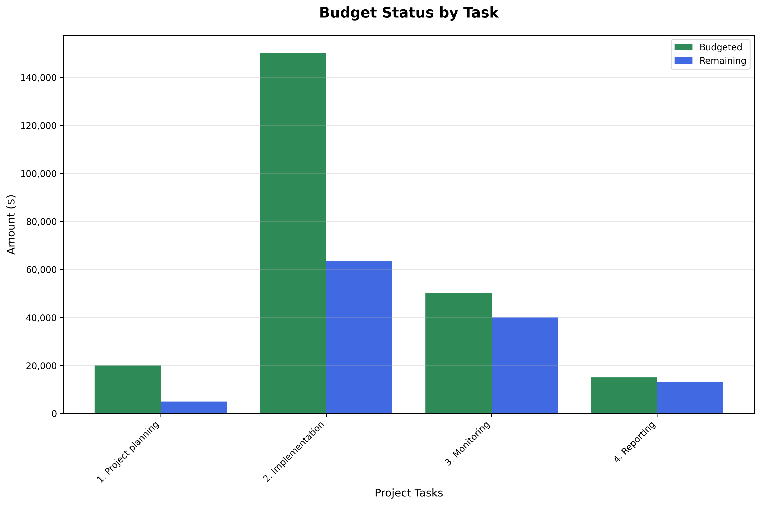

Figure 1: Total amounts budgeted and remaining by project task.

# Challenges

Current challenges and mitigation strategies being implemented:

* Resource allocation requires careful monitoring due to increased material costs
* Timeline adjustments made to accommodate additional quality assurance requirements
* Technical integration challenges resolved through vendor collaboration
* Staff scheduling optimized to maintain project momentum

# Next Period Activities

Planned activities for the upcoming reporting period:

* Complete final data analysis and validation
* Conduct stakeholder review meetings for preliminary findings
* Prepare comprehensive final report documentation
* Initiate knowledge transfer and training sessions
* Plan project closure and evaluation activities