Project Budget Report

Generated on: August 21, 2025

## Executive Summary

This report provides a comprehensive overview of the project budget and financial analysis. The budget has been carefully structured to ensure optimal resource allocation while maintaining project objectives.

## Methodology

The budget analysis methodology includes:

* Comprehensive review of all cost categories
* Analysis of resource requirements and allocation
* Risk assessment and contingency planning
* Alignment with project objectives and timelines

## Budget Overview

|  |  |  |  |
| --- | --- | --- | --- |
| **Task** | **Budgeted** | **Spent** | **Remaining** |
| 1. Project planning | $20,000.00 | $15,000.00 | $5,000.00 |
| 2. Implementation | $150,000.00 | $86,499.00 | $63,501.00 |
| 3. Monitoring | $50,000.00 | $10,000.00 | $40,000.00 |
| 4. Reporting | $15,000.00 | $2,000.00 | $13,000.00 |
| **TOTALS** | **$235,000.00** | **$113,499.00** | **$121,501.00** |

## Key Findings

Based on the budget analysis, the following key findings have been identified:

* Total project budget: $940,000.00
* Highest budget allocation: TOTALS
* Lowest budget allocation: 4. Reporting
* Number of budget categories: 5

The budget distribution shows a strategic allocation of resources across different project components.

## Budget Visualization

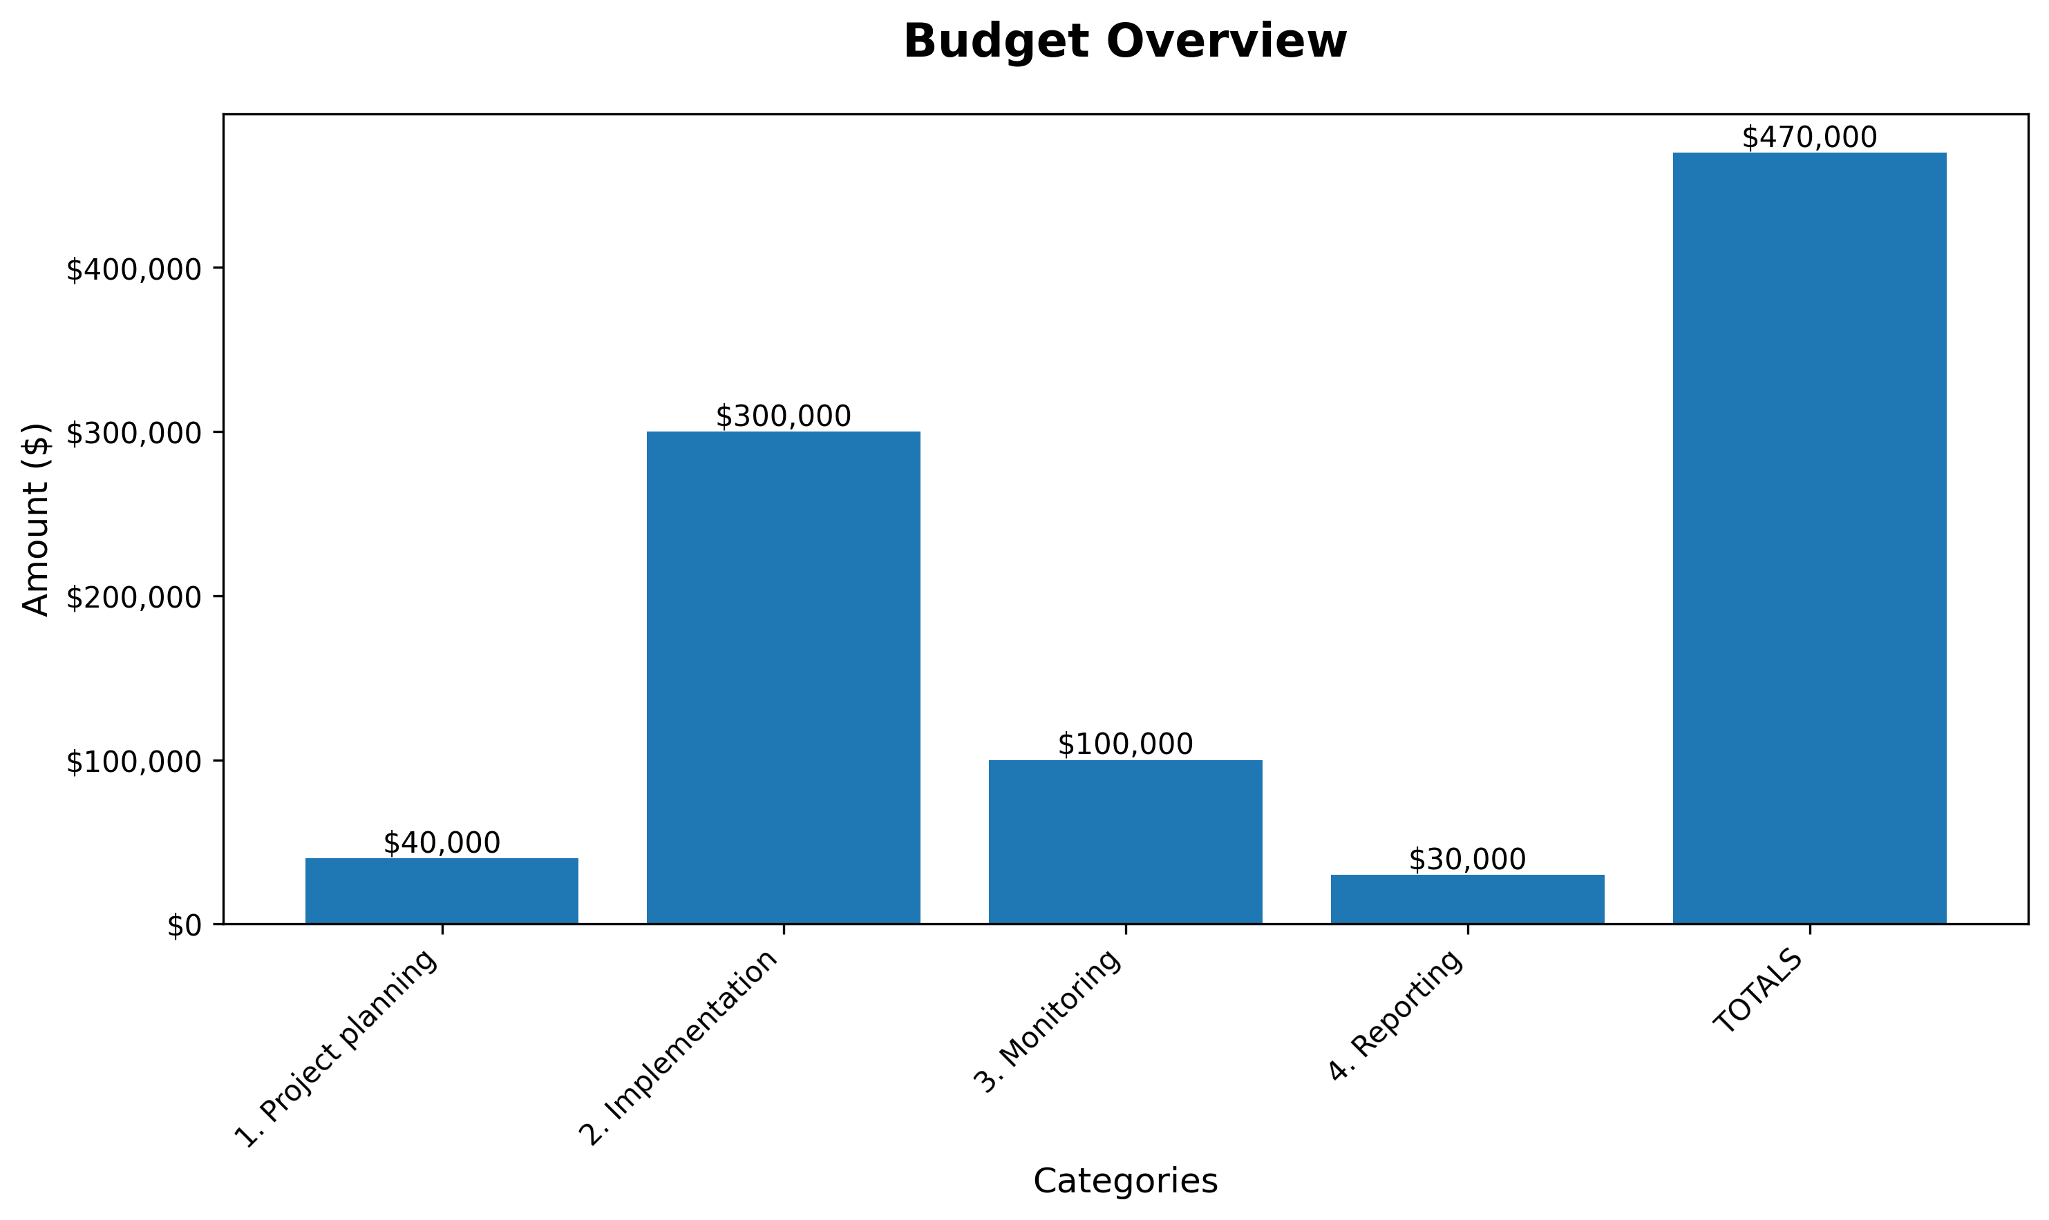

The budget visualization chart provides a clear overview of resource allocation across different project categories. This visual representation helps stakeholders understand the distribution of funds and identify key investment areas.

## Recommendations

Based on the budget analysis, the following recommendations are proposed:

* Continue monitoring budget performance against established benchmarks
* Implement regular review cycles to ensure optimal resource utilization
* Consider potential cost optimization opportunities
* Maintain flexibility for adjustments based on project evolution
* Establish clear reporting mechanisms for budget tracking

## Challenges and Mitigation

Potential challenges and mitigation strategies include:

* Budget variance management through regular monitoring
* Resource availability through strategic planning
* Market fluctuations through contingency planning

## Next Steps

Recommended next steps include:

* Implementation of budget monitoring systems
* Regular stakeholder communication and reporting
* Periodic review and adjustment processes
* Development of contingency planning protocols

## Conclusion

This budget analysis provides a comprehensive foundation for informed decision-making. The structured approach to resource allocation supports project success while maintaining fiscal responsibility. Regular monitoring and adjustment will ensure optimal outcomes.

# Table: budget

Data summary: 5 rows, 4 columns

|  |  |  |  |
| --- | --- | --- | --- |
| **Task** | **Budgeted** | **Spent** | **Remaining** |
| 1. Project planning | 20,000 | 15,000 | 5,000 |
| 2. Implementation | 150,000 | 86,499 | 63,501 |
| 3. Monitoring | 50,000 | 10,000 | 40,000 |
| 4. Reporting | 15,000 | 2,000 | 13,000 |
| TOTALS | 235,000 | 113,499 | 121,501 |

# Summary

This report provides a comprehensive overview of budget allocation and expenditure status. The analysis includes detailed breakdowns of spending across all project components and identifies areas requiring attention.

# Deliverables Progress

Progress on key project deliverables remains on track with established timelines.

* Data collection phase completed successfully
* Analysis framework implemented and tested
* Initial report drafts under review
* Stakeholder feedback sessions scheduled

# Challenges

Current challenges and mitigation strategies being implemented:

* Resource allocation requires careful monitoring due to increased material costs
* Timeline adjustments made to accommodate additional quality assurance requirements
* Technical integration challenges resolved through vendor collaboration
* Staff scheduling optimized to maintain project momentum

# Next Period Activities

Planned activities for the upcoming reporting period:

* Complete final data analysis and validation
* Conduct stakeholder review meetings for preliminary findings
* Prepare comprehensive final report documentation
* Initiate knowledge transfer and training sessions
* Plan project closure and evaluation activities

# Project Notes

## Equipment Overview

This section contains details about the equipment needed for the project.

## Budget Considerations

* Total budget allocated: $50,000
* Equipment costs: 60%
* Labor costs: 30%
* Contingency: 10%

## Timeline

The project is expected to complete within 3 months with the following milestones:

1. Equipment procurement - Month 1
2. Installation and setup - Month 2
3. Testing and validation - Month 3

## Recommendations

* Prioritize equipment quality over cost savings
* Establish regular progress reviews
* Maintain adequate contingency reserves