Forest Biomass Solutions

Vance Russell, Joshua Harrison

Takeaways
- The issue at hand is whether active forest management is ecologically legitimate under novel climate conditions. We believe ecological forest management that follows guidelines outlined in GTR-220 coupled with prescribed fire maintenance will create more resilient forests and reduce fire risks (North et al., 2009).
- Biomass utilization is a downstream process of forest health treatments. It is not a driver of logging. In mitigating wildfire, we need to make the distinction between 1. sawtimber; 2. unavoidable treatment residues; and 3. ‘waste’ streams that exist whether or not there’s an energy market.
- Continued business as usual will mean that California’s forests continue being a net emitter of carbon. Biomass utilization is not free of greenhouse gas emissions, however, it is part of a solution to greatly reduce massive emissions from uncontrolled wildfires.
- Economics
- Policies that focus on reducing emissions from biomass while integrating forest health solutions with climate change are critical to the long-term biodiversity and human health throughout California and the West.

Background
In December 2025, Shaye Wolf published a commentary claiming biomass is a money pit that won’t solve California’s energy or wildfire problems. The piece cited research from authors whose work has been discredited or debunked by a majority of climate and forest scientists. It also made several claims that were neither cited nor accurate. Shortly afterward, Matt Dias of the California Forestry Association responded, arguing that biomass utilization isn’t primarily about renewable energy production—rather, the real issue is confronting the wildfire crisis. We now have a perspective from an environmental group and a response from industry.
This article examines the need for forest health treatments that produce biomass and debunks common myths around its utilization. We then proceed to broader wildfire disinformation, discuss impacts of forest health on biodiversity, and provide broad solutions.

Biomass
Biomass utilization is neither an energy silver bullet, nor unending consumer of timber and spewer of wood smoke from giant burning plants. Biomass utilization is one solution of many for California’s wildfire crisis as the century long suppression of fires has created unnatural conditions in most forests making them more susceptible to disease, fire, and other threats related to climate change.

THE disagreement
The debate isn’t really about biomass. It’s about whether active forest management is ecologically legitimate under novel climate conditions. CBD’s position implicitly says restraint and retreat are the answer; yours says intervention, done carefully, is unavoidable. Surfacing that philosophical split would make the argument clearer and more honest.

Waste streams
Biomass utilization is a crtical downstream process of forest health treatments. It is not a driver of logging. In mitigating wildfire, we need to make the distinction between 1. sawtimber; 2. unavoidable treatment residues; and 3. ‘waste’ streams that exist whether or not there’s an energy market. We also need to make it clear that sawtimber, clearcutting, or excessive forest harvesting cannot be conflated with forest health or wildfire mitigation.

Burning & air quality
public health and air quality angle deserves a bit more attention than it currently gets. CBD gains moral leverage by focusing on localized pollution, and while I agree that wildfire smoke dwarfs regulated point sources, that comparison needs to be made explicitly. It would help to acknowledge that older biomass plants were dirty, then draw a clear distinction with modern controls and siting, and finally compare those impacts to pile burns and wildfire smoke, which are largely unregulated and episodic but massively more harmful.

Energy vs. material flow
We needs to separate “biomass as energy” from “biomass as material flow management.” Wolf collapses everything into burning trees for electricity. We argue something broader: managing unavoidable residues across multiple uses (materials, combined heat and power, heat, and biochar) as part of landscape risk reduction system.

Economics
Increased forest management, through the use of either hand/mechanical treatments or prescribed fire, can reduce fire suppression costs relative to recent practices by more than US$400,000 per year (Holland et al., 2022).
Figure 1 shows the cost benefits of treatments with an estimated cost of reaching the 1 million acres treated/year goal of $3 billion with a benefit of$7.9/yr (Brown, 2024). A maximized net benfit $22.2 billion/yr would be reached if 3.9 million acres/yr are treated at a cost of$10.5. These numbers seem astronomical but indicate the sheer scale of the problem of truly reducing wildfire risk after a century of fire suppression. Even if the state reaches the million acre annual treatment goal, all of the biomass produced, has to go somewhere as piling, masticating, and spreading it in place will only shift wildfire risk or destroy forest understory. That somewhere can be a mix of wood utilization that maximizes carbon sequestration benefits, such as mass timber.
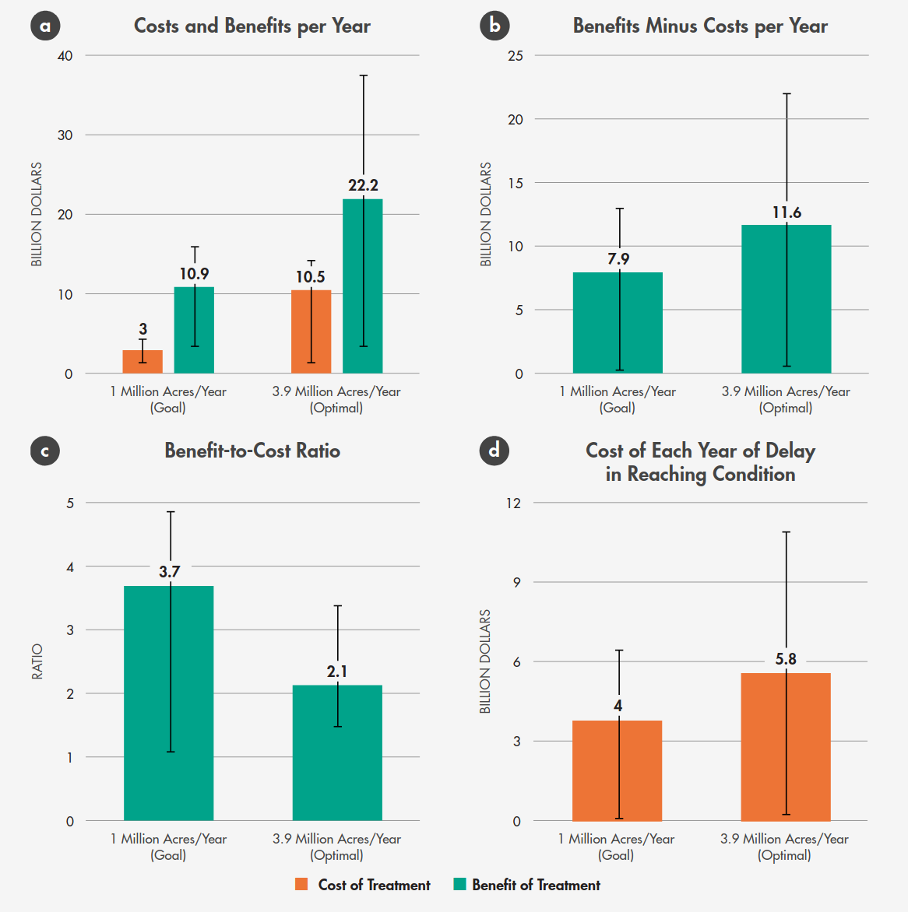
Figure 1: Costs/benefits of California fuel reduction at the goal of 1 million acres vs. 3.9 million acres—the rate that maximizes net benefits (Brown, 2024).
Additional studies estimate a return on investment of treatments of $3.42 for every $1 invested (Strabo et al., 2025) simlar and a benefit cost ratio of 4 (Turner, 2023).

BIOMASS FAQs
In addition to wildfire and climate disinformation, there are several recurring themes touted by some environmentalists that deserve debunking and nuance.
- Downstream process. Wolf mentions leaving thinned biomass in place rather than using it as biomass. However, this practice has led to suppression of important undergrowth and, in worst-case scenarios, started or exacerbated some of the largest fires in California’s history. For example, it’s widely acknowledged that the Dixie Fire, which burned more than 1 million acres across the Plumas National Forest, was spread by a log deck and by thinned fuel piles left in place after thinning operations.
- Carbon accounting. Biomass utilization is not zero carbon, even with newer technologies reducing carbon emissions. However, in fire-prone forests, the alternative is large wildfires releasing immense amounts of carbon in an uncontrolled fashion, often negatively impacting communities downwind of fires for weeks to months. Due to fires, California forests have been a net source of carbon emissions since 2015 (Delyser et al., 2025). Even leaving biomass in place from thinning projects is not a solution since it shifts wildfire risk or creates unnatural conditions from excessive wood chippings spread on the forest floor. Another element of carbon accounting is sequestration. With thinned forests, carbon sequestration increase and large trees grow larger. In a recent simulation Elias et al. (2025) found a treated forest scenario with 6% more carbon despite a decrease of 74% trees/acre.
- Feeding the beast. A fear among opponents of biomass utilization is that feeding plants from pristine forests to support the biomass industry with dubious climate benefits, e.g., as in North Carolina or Europe (Frisch and Uden 2023). However, as the same authors argue, the situation is very different in the American West, where biomass results from wildfire mitigation treatments and 90% of forest land is owned by the public and small-scale landowners.
- Biomass is an energy silver bullet. Biomass energy will not replace renewable energy sources such as solar and wind. It is meant to be a local utilization process that is far superior to and less polluting than letting forests burn. The real issue at hand is addressing California’s wildfire emergency and not biomass vs. other renewables (Dias 2025).
- Policy-based incentives. The Bioenergy Market Adjusting Tariff Program (BIOMAT), which the CPUC sadly decided not to renew, required utilities to buy power from small local projects that convert forest and other organic waste to energy. Creating a successor program that could get facilities across the line to function or re-idle facilities like Loyalton that aren’t currently operating is critical to processing biomass from forest health projects.

Wildfire disinformation
Similar to climate misinformation, untruths about wildfire, forests, and logging have multiplied in the media, political discourse, and across organizations (Jones et al., 2022). Likewise, overexposure of wildfire and biomass contrarians in the media to give ‘balanced’ views can result in public confusion and weakened support for interventions as well as undermine scientific consensus (Cook, 2020). A perfect example from the CalMatters article is the claim that ‘Most of California’s destructive wildfires...have burned in shrublands and grasslands...’ The citation is for a study that concludes that destructive wildfires in the continental US have occurred mostly in these habitats. In reality, the most destructive California wildfires have taken place in a mixture of forests and shrublands.

Fire-adapted forests
Another misconception mentioned is that thinning makes cool, moist forests hotter, drier, and more wind-prone, where the author cites Hagmann et al. (2021). Several authors from this article are cited in Peery et al. (2019) as engaging in agenda-driven pseudoscience, such as the selective use of data, mixing science and litigation without declaring conflicts of interest, and harassing scientists publishing competing studies. Yet there’s widespread scientific consensus that fire was more frequent in western forests (Stephens et al., 2007), trees were bigger and forest stands were more ‘park like’ (North et al., 2009), and due to loss of moderate fires due to decades of fire suppression make current conditions in nearly all forests more vulnerable to drought and fire, particularly in a warming climate (Hagmann et al., 2021). Current needs assessments show more than 11.2 million forested acres in need of treatment to reduce future wildfire risk and severity (Delyser et al., 2025). The same study shows that conducting rapid initial treatmens will restore resilience before climate change will cause wildfire intensification.

Fire suppression
Quite possibly the biggest miss of the Calmatter’s article is not acknowledging the degree of ecological departure from ‘natural’ conditions due to a century of wildfire suppression (Collins et al., 2017; Peery et al., 2019). This human-induced forest condition has led to increasingly large, more frequent fires that destroy ecosystems and communities alike. Prichard et al. (2021) found that the effects of fire exclusion are not overstated, and intentional management adapting to current forest conditions is needed. Utilizing biomass from projects intended to return forest stands to natural fire regimes will be needed in the short term until prescribed fire or fires allowed to burn can allow the forest to catch up to pre-Columbian conditions.

Biodiversity
Curiously, despite the author’s organizational mission, biodiversity wasn’t mentioned at all in the opinion piece. For instance, it is well known that the indigenous burning as a part of historic fire regimes enhanced biodiversity (Hoffman et al., 2021). Measuring the impact of thinning, prescribed fire, and other forest health projects should be a feature of any publicly funded projects.
The science advisory panel of the Wildfire Task Force has done a superb job ensuring biodiversity and listed species data are available for all regions in the state, but more can be done to measure project impacts on vulnerable or threatened species and overall impacts on species over time. There is some evidence that a combination of thinning and prescribed fire significantly increases plant diversity in mixed or dry conifer forests (Dodson et al., 2008). However, California is very diverse, and what works in one ecosystem may not work in others, especially in chaparral or mesic systems, where burn frequency is generally too high and thinning or prescribed fire are not applicable treatments.
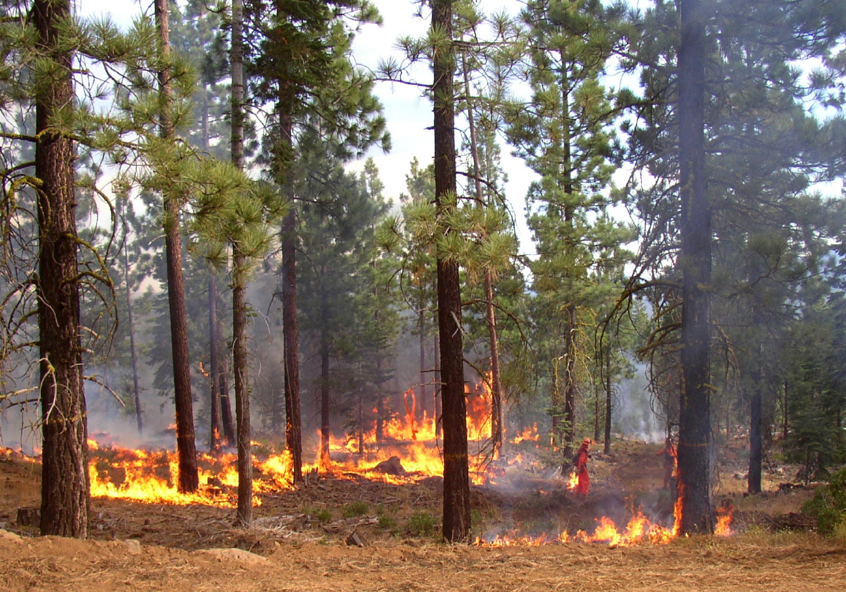

Solutions
Ms. Wolf did get two things right in her op-ed: prioritize thinning in the wildland urban interface and limit development in fire-prone areas. These solutions, however, fail to address the current problem of excessive biomass in forests, resulting from a century of fire suppression.
“The choice is not between profit and responsibility. It is between managed transition and unmanaged failure.” Harrison (2025)
Removing many small-diameter trees followed by prescribed fire will not only reduce wildfire risk in priority areas (note Caldor fire burn deflected by Caples Lake prescribed fire), but it will reduce excessive competition, causing chronic stress across forest stands, reducing disease, insect invasions, allowing large trees to grow larger, and making forest stands more resilient (North et al., 2022). Either/or solutions are not needed; both/and, integrated solutions with all hands on deck to mitigate wildfire threats to forests and communities. Some of these include
- Climate change and biomass. It is clear that rapid scaling of forest health treaments that include thinning and prescribed fire are critical to resilient forests in the face of climate change (Delyser et al., 2025). Creating policies that integrate treatments and biomass utilization to climate goals and greenhouse gas reduction allows for mitigation of wildfire risk and incorporating utilization infrastructure regulations into the same solutions.
- Mobile modular technology. Processing biomass is a temporary solution to the amount of biomass built up over a century of fire suppression. Creating biomass infrastructure should not create a feed the beast situation, as has happened in the Southeast US or parts of Europe. Rather, processing biomass in places of need may be needed over time to not just prioritize utilization locally, but also the transport of biomass and products from the utilization of that biomass.
- Pro-active disaster insurance. It is clear that repeated wildfire at large scales will make California and other regions of the world uninsurable and possibly uninhabitable. Creating economic incentives to treat prevention will reduce losses, stabilize premium costs, and lower overall impacts to the public (Harrison, 2025). Disaster should not form a growth economy, rather policy and market incentives can provide carrot and stick approaches to ensure change at the scale that climate and resulting wildfires pose.
- Jobs in the woods. Biomass production and processing can create valuable jobs in the woods in rural, often disadvantaged communities that are threatened by wildfire and also experiencing a constant state of brain drain and loss of capacity due to residents leaving to look for jobs elsewhere (when jobs don’t exist in their communities). Creating whole system stewards could be a component of this job creation process.
- Biodiversity. Biodiversity isn’t a solution to biomass utilization, per se, but it should be included in every conversation about forest health, e.g., what is the impact on biodiversity of thinning, prescribed fire, and biomass utilization? Taking all the snags out of the forest to reduce fire risk is going to have a negative impact on biodiversity. Indiscriminate thinning, instead of creating gaps and clumps, and ecological-based forest management will reduce biodiversity and may not even work to create resilient forest health stands.

Authors
Vance Russell has nearly 40 years of experience working in forest science & management, rewilding, biodiversity conservation, agricultural landscapes, restoration, and natural resources management. He is the owner of 3point.xyz where he works for various non-profit, state/federal agencies, and private businesses. Vance is the former Board Chair of Groundswell International, is a trustee for the South Downs National Park Trust, and serves on the Rewilding Leadership Council for the Rewilding Institute.
Joshua Harrison is Director of the Center for the Study of the Force Majeure at the University of California, Santa Cruz, where he leads interdisciplinary teams designing regenerative systems in response to climate disruption. His work bridges art, science, and policy: from immersive installations on ocean collapse to circular-economy models for wildfire-damaged forests and allyship with tribal groups bringing back cultural burning.

References
Brown, P. (2024). Cost-effectiveness of large-scale fuel reduction for wildfire mitigation in California. JSTOR. https://www.jstor.org/stable/resrep60733?seq=22
Collins, B. M., Fry, D. L., Lydersen, J. M., Everett, R., & Stephens, S. L. (2017). Impacts of different land management histories on forest change. Ecological Applications, 27(8), 2475–2486. 10.1002/eap.1622
Cook, J. (2020). Deconstructing climate science denial. In Research Handbook on Communicating Climate Change. Edward Elgar Publishing. 10.4337/9781789900408.00014
Delyser, K., Tase, N., Clay, K., Magnan, M., Evans, S., Keithley, C., Bartowitz, K., Gadoth-Goodman, D., Papa, C., Ontl, T., & Cooper, L. (2025). Effects of Forest Management & Wood Utilization on Carbon Sequestration & Storage in California. CAL FIRE. https://d3f9k0n15ckvhe.cloudfront.net/wp-content/uploads/2025/02/CBM_CA_report_FINAL.pdf
Dodson, E. K., Peterson, D. W., & Harrod, R. J. (2008). Understory vegetation response to thinning and burning restoration treatments in dry conifer forests of the eastern Cascades, USA. Forest Ecology and Management, 255(8–9), 3130–3140. 10.1016/j.foreco.2008.01.026
Elias, M., Yackulic, E., Duffy, K., Saksa, P., Sanchez, D. L., Pevzner, N., Plumb, S., Dyszynski, J., & Bracer, C. (2025). Carbon finance for forest resilience in California. Frontiers in Forests and Global Change, 7, 1507554. 10.3389/ffgc.2024.1507554
Hagmann, R. K., Hessburg, P. F., Prichard, S. J., Povak, N. A., Brown, P. M., Fulé, P. Z., Keane, R. E., Knapp, E. E., Lydersen, J. M., Metlen, K. L., Reilly, M. J., Sánchez Meador, A. J., Stephens, S. L., Stevens, J. T., Taylor, A. H., Yocom, L. L., Battaglia, M. A., Churchill, D. J., Daniels, L. D., … Waltz, A. E. M. (2021). Evidence for widespread changes in the structure, composition, and fire regimes of western North American forests. Ecological Applications, 31(8). 10.1002/eap.2431
Harrison, J. (2025). Avoiding an uninsurable future. Medium. https://medium.com/@joshuaharrison_97833/avoiding-an-uninsurable-future-78d525e8ded6
Hoffman, K. M., Davis, E. L., Wickham, S. B., Schang, K., Johnson, A., Larking, T., Lauriault, P. N., Quynh Le, N., Swerdfager, E., & Trant, A. J. (2021). Conservation of Earth’s biodiversity is embedded in Indigenous fire stewardship. Proceedings of the National Academy of Sciences, 118(32). 10.1073/pnas.2105073118
Holland, T., Evans, S., Long, J., Maxwell, C., Scheller, R., & Potts, M. (2022). The management costs of alternative forest management strategies in the Lake Tahoe Basin. Ecology and Society. 27 (4): 43, 27(4). 10.5751/ES-13481-270443
Jones, G. M., Vraga, E. K., Hessburg, P. F., Hurteau, M. D., Allen, C. D., Keane, R. E., Spies, T. A., North, M. P., Collins, B. M., Finney, M. A., Lydersen, J. M., & Westerling, A. L. (2022). Counteracting wildfire misinformation. Frontiers in Ecology and the Environment, 20(7), 392–393. 10.1002/fee.2553
North, M. P., Tompkins, R. E., Bernal, A. A., Collins, B. M., Stephens, S. L., & York, R. A. (2022). Operational resilience in western US frequent-fire forests. Forest Ecology and Management, 507, 120004. 10.1016/j.foreco.2021.120004
North, M., Stine, P., O’Hara, K., Zielinski, W., & Stephens, S. (2009). An ecosystem management strategy for Sierran mixed-conifer forests. U.S. Department of Agriculture, Forest Service, Pacific Southwest Research Station. 10.2737/PSW-GTR-220
Oreskes, N., & Conway, E. M. (2011). Merchants of doubt: How a handful of scientists obscured the truth on issues from tobacco smoke to global warming. Bloomsbury Publishing USA.Peery, M. Z., Jones, G. M., Gutiérrez, R., Redpath, S. M., Franklin, A. B., Simberloff, D., Turner, M. G., Radeloff, V. C., & White, G. C. (2019). The conundrum of agendadriven science in conservation. Frontiers in Ecology and the Environment, 17(2), 80–82. 10.1002/fee.2006
Prichard, S. J., Hessburg, P. F., Hagmann, R. K., Povak, N. A., Dobrowski, S. Z., Hurteau, M. D., Kane, V. R., Keane, R. E., Kobziar, L. N., Kolden, C. A., North, M., Parks, S. A., Safford, H. D., Stevens, J. T., Yocom, L. L., Churchill, D. J., Gray, R. W., Huffman, D. W., Lake, F. K., & KhatriChhetri, P. (2021). Adapting western North American forests to climate change and wildfires: 10 common questions. Ecological Applications, 31(8). 10.1002/eap.2433
Stephens, S. L., Martin, R. E., & Clinton, N. E. (2007). Prehistoric fire area and emissions from California’s forests, woodlands, shrublands, and grasslands. Forest Ecology and Management, 251(3), 205–216. 10.1016/j.foreco.2007.06.005Strabo, F., Bryan, C., & Reimer, M. (2025). Wildfire Damages and the Cost-Effective Role of Forest Fuel Treatments. SSRN. 10.2139/ssrn.5337929
Turner, E. (2023). The Potential for Hazardous Fuel Reduction Treatments to Produce Net Economic Benefits in California [Phdthesis, Johns Hopkins University]. https://jscholarship.library.jhu.edu/server/api/core/bitstreams/f8447761-4375-48d4-a2ba-82bc5bef6318/content

Ironically some environmentalists are using a Merchants of Doubt type of approach to their wildfire disinformation campaigns cf (Oreskes & Conway, 2011).

