Predicting 2026 Wildfires

Vance Russell

Take-aways
- Enabling condition. Climate, wildfire, and forest service restructuring are combining to make 2026 a potentially bad year for wildfires.
- Pockets of infrequently burned and high crown fire probability may point to where especially damaging fires may occur.
- Continuing to increase the pace and scale of forest health restoration will increase forest resilience and resistance to disturbance, especially wildfire.

Background
“Wildfire season is fast approaching, and with low snowpack, dry conditions, and soaring temperatures across the U.S., experts are warning that 2026 may be one of the worst on record. Combine those extreme conditions with massive restructuring at the U.S. Forest Service (USFS), and the result is a powder keg for federal wildland firefighters.” Clarke (2026)
The 2026 wildfire season is shaping up to be one of the most severe in recent U.S. history, driven by a convergence of extreme climatic and institutional factors. A record-low snowpack across the West — California’s measuring just 14–18% of average — combined with early-season heat and drought across 61% of the continental U.S. has created abundant, desiccated fuels primed to burn (Becker, 2026; Spanger-Siegfried, 2026). Already through April, over 1.8 million acres have burned (194% above the 10-year average), and AccuWeather projects 5.5 to 8 million acres could burn by year’s end (Clarke, 2026; Lada, 2026).
Compounding the environmental conditions, the U.S. Forest Service lost 16% of its workforce in 2025 and is undergoing a major restructuring that critics warn erodes firefighting support capacity (Simlot, 2026; Clarke, 2026). Meanwhile, the newly formed U.S. Wildland Fire Service is racing to bring on aircraft and crews early, though experts caution that the administration’s focus on suppression over prevention may leave the country underprepared (Larson, 2026). Together, these factors point to a “fire year” rather than a seasonal threat, demanding urgent policy and operational responses (KPBS, 2026).
But then again every year seems to get a dire wildfire prediction. Is this media hype, climate reality, or does the data help sort out science from fiction? Let’s take a closer look.

Predictive mapping
Generally, examining wildfire probability or history datasets of California, it can be hard to decipher the dominant oranges or reds from anything else. Figure 1 shows all wildfires greater than 5,000 acres (2,023 hectares) since 2010 (FRAP, 2025). Again, the map mostly looks orange, but if we zoom into key areas where forest occur, there are some spot where there haven’t been large fires since 2010 such as northwestern Shasta County or Nevada and Sierra Counties.
There is an especially large donut hole where there have not been large fires in the Sierra/Nevada and NE corner of Yuba county region for some time, really the only spot in the Sierra like this, except for Yosemite National Park where there’s been a strong forest health and prescribed fire program for some time.
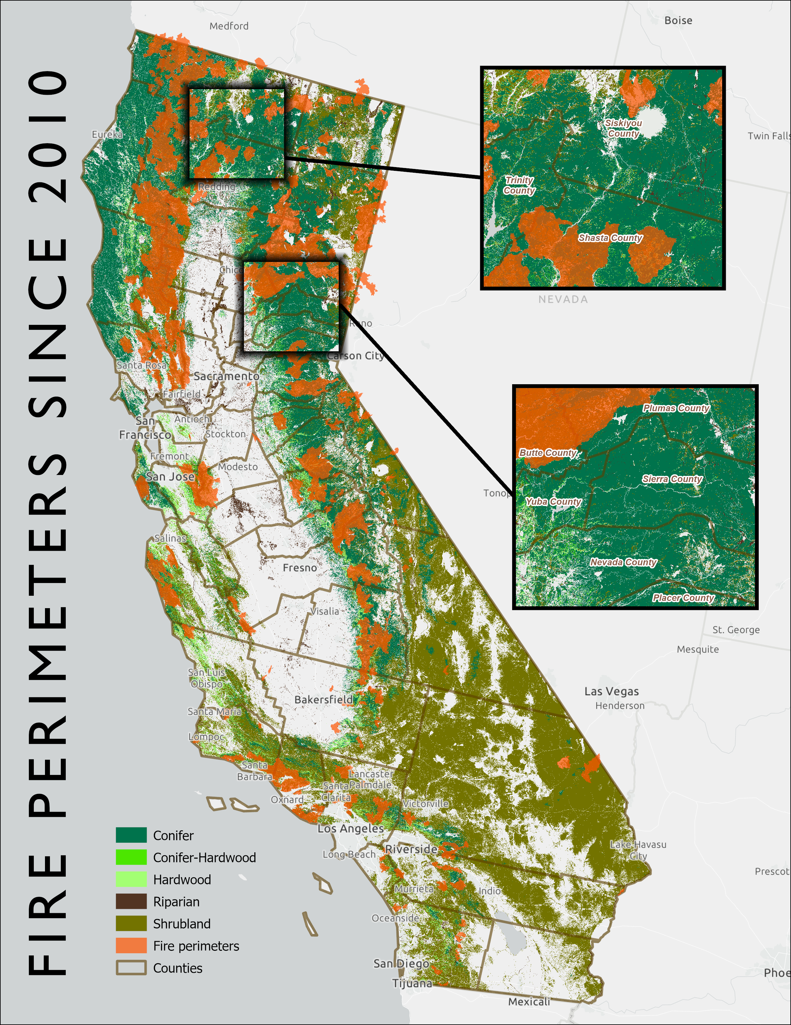
Figure 1: Fire perimeters >5,000 acres since 2010 showing insets for Shasta County (above) and Sierra/Nevada Counties (below) where fewer large wildfires have occurred (FRAP, 2025; Landfire, 2023). Map by 3point.xyz.
We then looked at the probability of fires occurring in these areas. Figure 2 shows the mean crown fire probability (Pyrologix, 2025). The values represent the likelihood of experiencing group torching (mid- to high-grade passive crown fire) or sustained canopy spread or active crown fire if a wildfire occurs. The data was joined to transverse hexagons 4,000 hectares (9,884 acres) in size and calculating the mean probability within each hexagon.
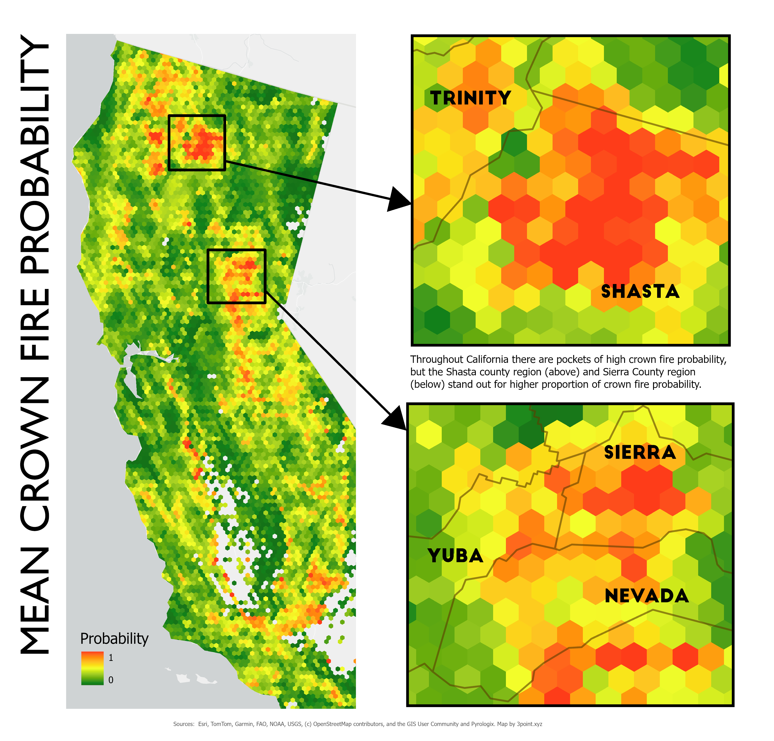
Figure 2: Mean crown fire probability showing inset closeups in the Shasta and Sierra/Nevada County areas where high concentrations of wildfire probablity exist (Pyrologix, 2025). Map by 3point.xyz.
Although there are areas of high probability for severe wildfire scattered throughout California, the two areas that lit up were in the Shasta and Sierra/Nevada County regions where multiple polygons of high probability conncted. This doesn't mean that wildfires will take place in these areas, but it does mean the likelihood is higher. In the Nevada County area, there have been concerted efforts to thin forest and create fuel breaks throughout the County. However, there are pockets, particularly in private land holdings where thinning has not taken place and many houses in the wildland urban interface have not created defensible space nor cleared pine leaves from roofs and yards.
# Biodiversity & Old-growth
Biodiversity not as high as old growth but looks like there is some in lower elevation NV County
For old-growth there does look like more of which a relationship. Zonal stats or a regression to sum this and see if it is more than anecdotal.
What happens when we examine old-growth and species diversity with fire?
# Solutions
Moving forward, several integrated solution sets can support forest health and reduced fire risk:
1. **Treat more forested acres**. Through thinning and prescribed projects. California has been ramping up acres treated for some time now, but the pace and scale still needs to be accelerated. An element that is currently missing is infrastructure to treat biomass responsibly and sustainably.
2. **Climate adaptation and biomass integration**. Rapid scaling of forest health treatments, including thinning and prescribed fire, is critical to maintaining forest resilience in a warming climate [@delyser]. Policies that align forest treatments, biomass utilization, climate goals, and greenhouse gas reduction can reduce wildfire risk while ensuring that utilization infrastructure supports, rather than distorts, restoration outcomes [@biomass].
3. **Biomass aggregation**. A major hurdle for treating more forest acres is long-term feedstock supply agreements. Creating joint powers authoritiies to manage agreements between public landowners and wood product businesses, could greatly increase forest acres treated, but also utilize the wood in a manner that sequesters carbon and increases biodiversity [@jpa].
# Conclusion
While predicting the precise location of any given wildfire remains inherently uncertain, the convergence of historical fire patterns, crown fire probability modeling, and this year's extreme climatic conditions points to areas like Shasta and Nevada/Sierra Counties as particularly vulnerable. The data-driven approach underscores that it is not alarmism but empirical analysis that should guide preparedness, even as wildfire misinformation continues to muddy public debate. Addressing this crisis requires moving beyond suppression toward a sustained, landscape-scale program of thinning and prescribed fire, paired with infrastructure that can responsibly utilize the resulting biomass. Success will depend on policies that align forest restoration with climate goals, carbon sequestration, and economic viability through mechanisms like joint powers authorities for long-term feedstock agreements. Ultimately, the question is not whether severe fires will come, but whether we will have done enough to make our forests and communities resilient when they do.

References
Becker, R. (2026). What California’s awful snowpack means for fire season. CalMatters. https://calmatters.org/environment/wildfires/2026/04/california-snow-early-fire-season/
California now faces a “fire year.” How is the state preparing? (2026). KPBS. https://www.kpbs.org/news/public-safety/2026/05/15/california-now-faces-a-fire-year-how-is-the-state-preparing
Clarke, O. (2026). Why 2026 could be one of the worst wildfire seasons in recent U.S. history. https://www.outsideonline.com/outdoor-adventure/environment/outdoor-adventure-environment-2026-wildfire-season-forecast-usfs-restructuring/?scope=initial
FRAP. (2025). CALFIRE Fire and Resource Assessment Program Fire Perimeters. https://www.fire.ca.gov/what-we-do/fire-resource-assessment-program/fire-perimeters
Lada, B. (2026). Wildfire forecast 2026: Fires likely to burn over 5.5 million acres as drought intensifies. AccuWeather. https://www.accuweather.com/en/weather-forecasts/wildfire-forecast-2026-fires-likely-to-burn-over-5-5-million-acres-as-drought-intensifies/1881897
Landfire. (2023). Landfire existing vegetation type. https://landfire.gov/vegetation/evt
Larson, H. (2026). “We’re dry:” The new U.S. Wildland Fire Service prepares for extreme fire season. NPR. https://www.npr.org/2026/05/09/nx-s1-5804693/prevention-wildfires-firefighters-vegetation-wildland-fire-service
Pyrologix. (2025). Crown fire probability. https://www.vpdatacommons.org/datasets/crown-fire-probability
Simlot, V. (2026). Concerns about Trump cuts to US Forest Service abound as wildfire season comes. The Hill. https://thehill.com/homenews/administration/5879172-trump-forest-service-cuts-wildfire-season-concerns/
Spanger-Siegfried, E. (2026). Danger Season Is Here Again, with Triple the Danger for 2026. Union of Concerned Scientists. https://blog.ucs.org/erika-spanger-siegfried/danger-season-is-here-again-with-triple-the-danger-for-2026/

