DRAFT FBA Review

Forest Business Alliance

Takeaways
Table 1 summarizes the pluses (what went well) and deltas (what we would change) for FBA Phase I. Technical assistance was well-received and helped participants, and workshop turnout and participation were high, especially for funding and finance topics. The peer learning network was greatly appreciated for networking opportunities, but the participant numbers for live webinars fluctuated widely. Table 2 provides a summary of project achievements according to metrics. Highlights include 136% of bdt treated, 107% successful proposals, and more than 100% for the total number of workshops and participants.
Table 1: Summary of pluses (what went well) and deltas (what we would change) for FBA Phase I. Current pluses/deltas listed are for illustrative purposes only and will be updated following a more detailed review.
PLUSES | DELTAS
Technical Assistance
🟢 Providing direct TA to BWD program applicants | 🟡 More targeted TA
🟢 Tribal TA | 🟡 Funding gap
🟢 Funding and finance options | 🟡 Office hours sparsely attended
🟢 Useful resource/reference tools | 🟡 Expand to new statewide programs
🟢 Geospatial and contact databases
Workshops
🟢 Tribal workshops | 🟡 Varied attendance
🟢 Funding & finance best attended | 🟡 Best turnouts during grant rounds
Peer Learning Network
🟢 Created network | 🟡 Need to better connect businesses
🟢 Tribal PLN | 🟡 Change to sector-specific sessions
🟢 High participation around grand deadlines | 🟡 Increase on-ground presence
🟢 Sierra Institute field trip | 🟡 Increased field visits

Background
The Forest Business Alliance provides technical assistance, delivers workshops, and facilitates a peer-learning network to increase local and regional capacity for applicants to CAL FIRE’s Business and Workforce Development Program. Funding for the Forest Business Alliance is provided by the CAL FIRE Business and Workforce Development Grant Program. Past funders include the Yuba Water Agency and the USDA Forest Service.
The design of the Forest Business Alliance is intentionally structured to deliver three core components to participating businesses and nonprofits: technical assistance, workshops, and a peer learning network. This three-pronged approach combines bottom-up and top-down assistance strategies to build organizational capacity across the sector. The model enables the program to get critical information to organizations in need quickly and efficiently while fostering long-term sustainability and collaboration.

Metrics
Table 2 provides a summary of FBA accomplishments by category for Phase I. The numbers are for projects that FBA provided technical assistance to and were funded through the Business and Workforce Development Program. Successfully funded projects were a mix of wood processing facilities and workforce development initiatives. Many of the business development projects FBA has assisted with are not yet processing wood, so the BDT for solid wood processing will continue to increase as grant recipients implement and scale their work.
Table 2: Summary of key metrics and accomplishments for FBA Phase I. CALFIRE Business and Workforce Development Metrics, along with FBA-developed technical assistance and capacity-oriented metrics tracked during FBA Phase I. Percent achieved amounts are from proposed targets.
Category/Metric | Amount | % Achieved
CALFIRE Metrics
B. Biomass Treated or Generation Capacity (BDT) | 13,595 | 136
C. Forest Sector Jobs Created | 573 | 76
F. Forest-Sector Workers Trained | 195 | 78
G. Certifications Earned | 273 | 91
Implementation Metrics
Contacts made | 774 | 155
Proposals submitted | 48 | 96
Successful proposals | 17 | 113
Workshops | 39 | 195
Workshop participants | 559 | 112
PLN meetings | 29 | 116
PLN participants | 587 | 1468
**List-serv members **
Peer Learning Network | 45 | n/a
Forest Business Alliance | 157 | n/a

Review
We conducted a review of the Forest Business Alliance through internal and external processes to assess program effectiveness and inform future directions. External review consisted of personal communications and surveys distributed to FBA participants to gather feedback on their experiences and outcomes. Internal review took the form of a facilitated staff meeting that systematically examined the pluses and deltas of each program component and carefully considered next steps for program development.

Startup Progression
Throughout Phase I of FBA, we tracked stages of contacts from initial identification to funded proposal status (Figure 1). Other stages for collaborators, such as source and participation, were included to account for other types of network participation. Identified, participating, and source category numbers were high at the beginning of the project, and technical assistance was steady but increased dramatically in 2025 as more applicants became aware of the Alliance and contacted us for assistance.
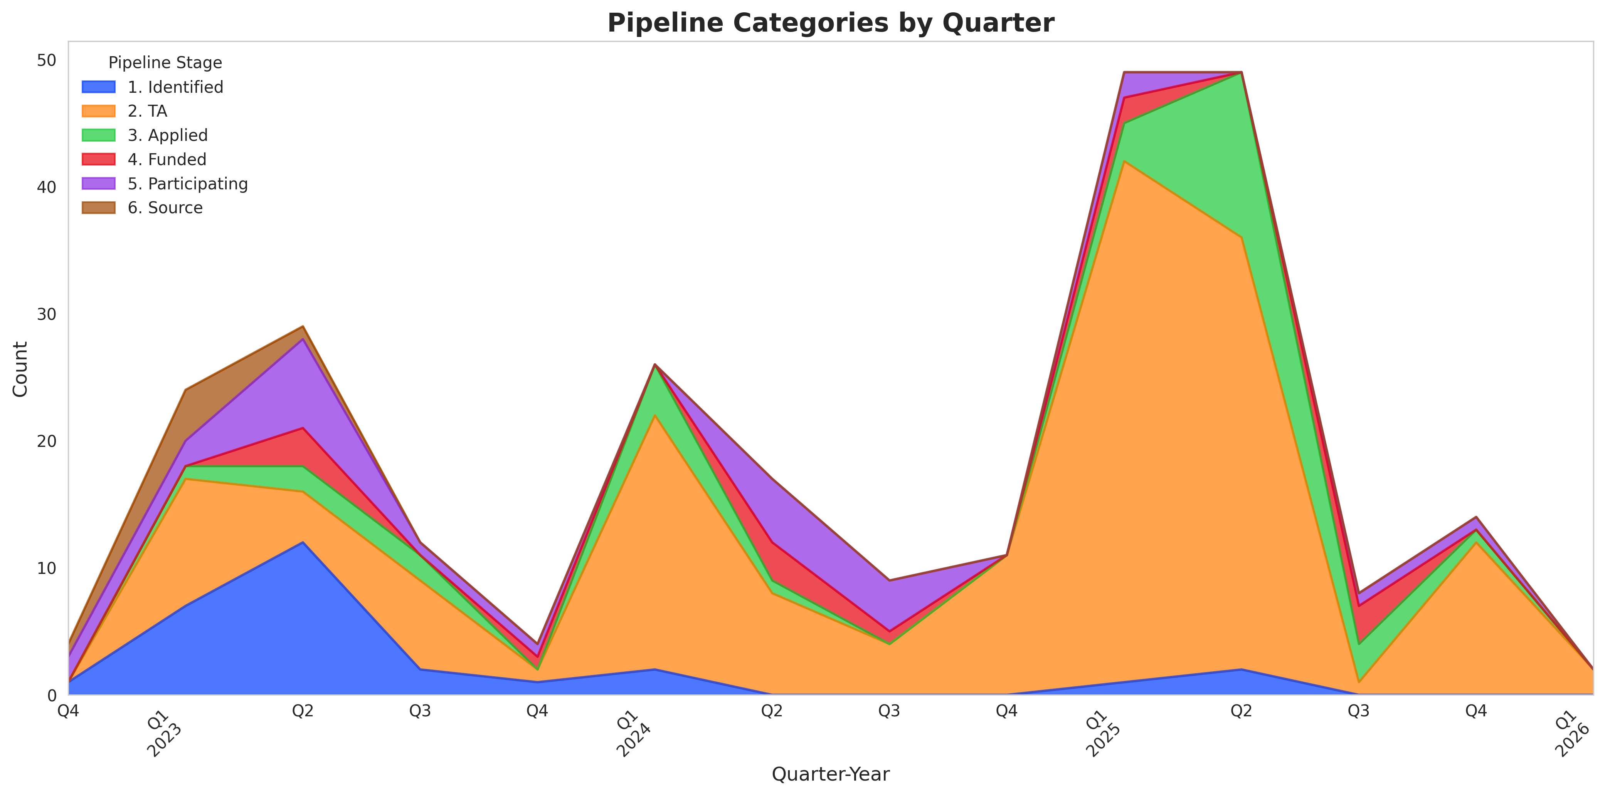
Figure 1: Progression of pipeline technical assistance from FBA startup to present.
Examined in a different manner, cumulative technical assistance rises dramatically over time, while numbers for other pipeline stages roughly stay the same Figure 2.
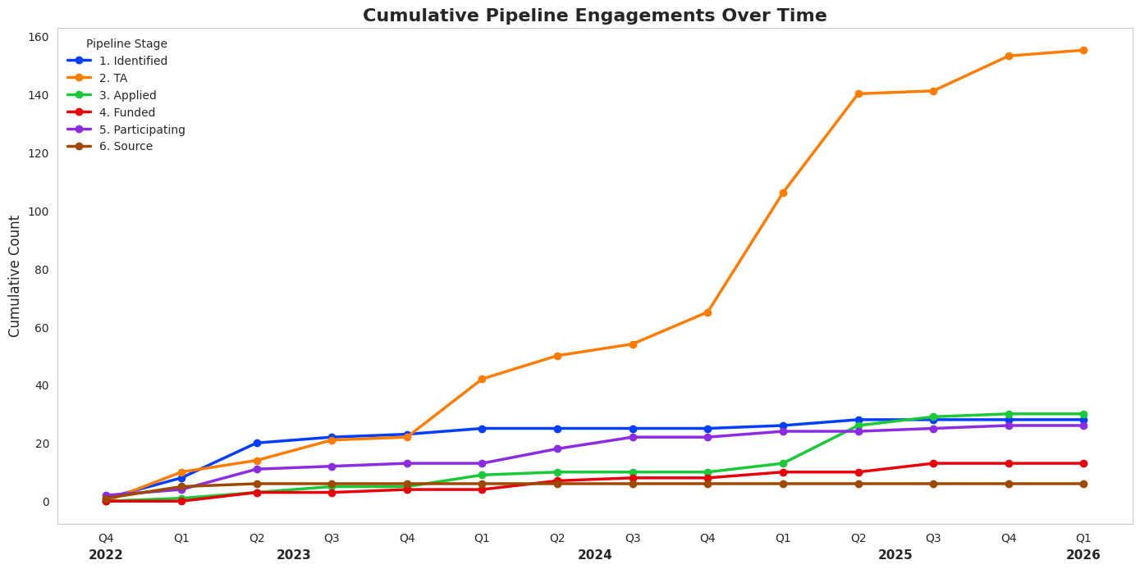
Figure 2: Cumulative pipeline engagement over time.

Technical Assistance
Technical assistance proved to be a core strength of FBA Phase I, with direct support to BWD applicants, specialized Tribal TA, and comprehensive resources, including funding and finance options, and geospatial/contact databases for wood products businesses, helping to build sector capacity. However, several opportunities for improvement emerged: TA delivery needs to be more strategically targeted, a funding gap was identified, office hours saw sparse attendance, and expansion into additional statewide programs is needed. These deltas suggest that while the foundation of TA provision is solid, the program should refine its delivery mechanisms and extend its reach to maximize engagement and impact.

Workshops
FBA delivered 39 workshops to 559 participants, exceeding the target by 195% and total participants by 112%, with tribal workshops and funding & finance sessions drawing the strongest attendance. Participation varied significantly across workshop types and timing, reflecting inconsistent interest or scheduling challenges. Workshops tied to grant deadlines consistently saw the best turnout, suggesting participants prioritized sessions when facing immediate funding deadlines. Funding & finance workshops resonated most because applicants needed specific knowledge to complete proposals for entities with money. Phase II should anchor the workshop schedule to grant cycles and continue emphasizing tribal and funding-focused offerings.

Peer Learning Network
“I left the Peer Learning Network meetings feeling inspried and made contact with many members afterwards.” Mika Cook, Sustainable Rural Forest Community Strategist, Humboldt
Good participation around CalFire grant deadlines—this probably indicates that PLN was perceived as a strong CalFire support group specializing in grant funding. The in-person PLN meeting at Sierra Institute was well attended, and participants developed strong peer-to-peer and organizational connections (though qualitative, hard to document). Funding for in-person field trips is limited. Change to business-specific network, e.g., mills or biomass only sessions.
“The amount of experience in the wood products industry to lend ad hoc expertise is limited. I really appreciated the speakers, fieldtrips, and networking provided by the Network.” Temra Costa, Regenerative Forest Solutions

Next Steps
It is clear there is a need for capacity building and technical assistance for businesses and nonprofits in the wood products sector. In particular, needs are highest around organizational structure/mission, business planning, proposal writing, funding, finance, and grant administration. The following steps are based on feedback from businesses and nonprofits that FBA is assisting, as well as our collective experience over the initial project term. The following are the highest priority items:
- Focus on technical assistance & key workshops. Direct technical assistance was one of the most effective forms of support FBA provided. The challenge was connecting with new and existing organizations, but this has greatly improved over time. Workshops were best attended during grant rounds and when they focused on proposal development or funding, especially funding/finance from entities with money (agencies, banks, foundations, private investors).
- Reconfigure the Peer Learning Network or focus on specific topics with similar businesses. Tribal PLN was well attended, key reasons why? PLN was well attended at grant rounds or with key speakers (e.g., River City Bank). But attendance was low in the latter half of Phase I. Focusing on a network of businesses that need it, or creating ad hoc networks when the need arises, might be a better approach.
- Continue funding Tribal Workshops. These have been very well attended and in high demand for a variety of topics. Creating additional or follow-up resources with the workshops could supplement capacity building.
- Increase connection to unsuccessful grant applicants. Last year, FBA reached out to more previously unsuccessful grant applicants and helped several secure funding through key adjustments to their program design and grant-writing approaches.
- Continue communications & outreach. Each year, more people know about FBA and reach out, either unsolicited or at the advice of CALFIRE staff, for technical assistance. Having outreach materials such as the guide, website, and webinar/workshop recordings is not just an incredible learning resource but also a library for providing assistance.
Additional review of the difference in Peer Learning Network participation between the general PLN and the Tribal PLN would be helpful. Systematic outreach to new startups and nonprofit programs is a feature of the technical assistance that should continue, especially in regions with fewer applicants or lower capacity to apply.

