Proposals

Christopher Sacco, Vance Russell

1.1 Workflow
The project and proposal development workflow is iterative, like program design, similar to the budget process described in the budget section. In general, we suggest the following workflow to develop projects or a proposal:
- Brief. Create a 1-2 page brief with the following sections:
  - Executive summary. Three to five sentences max outlining the reason for the project, tasks, outcomes, timeline, and high-level budget.
  - Project goals. The project links to the programmatic theory of change and goals, followed by project goals/objectives.
  - Tasks. These could be listed under project objectives and also called interventions or activities.
Don’t worry about fleshing out these sections in detail. When drafting the brief, get the ideas down, and the details can be developed later.

Tip
Nest your goals, objectives, and tasks similar to an outline:
- Goal 1
A. Objective 1
  - Task 1
B. Objective 2
  - Task 1
  - Task 2
- Goal 2
A. Objective 1

- Budget. Create a back-of-the-envelope budget broken down by objectives and tasks. You can rough out the costs of tasks by staff, equipment, materials, and other key/generic items. Again, don’t worry about details; make some rough estimates. Napkins and a pen at a restaurant are good tools of the trade! Capture your proposal ideas and get rolling.
- Scope. Draft the proposal narrative or scope of work with a detailed description of tasks and activities by objective, using the brief from step one as a guide. At this point, it is worth adding a GANTT chart as a project timeline to show the project workflow and check if you’ve stacked too many activities at certain times or if your schedule is too aggressive.

1.1.1 Scope
Use the brief to flesh out a more detailed project scope and description. Don’t be afraid to write and then rewrite various sections. Give each a rest for a few days, then return after working on other sections. Create a checklist from the proposal RFP solicitation package to ensure you don’t forget anything. The Forest Business Alliance has a template checklist that may be useful.
Send your proposed ideas to colleagues for review or try to develop them across an interdisciplinary team or collaboratively if working with multiple partners.

1.2 Budget
Identifying and reviewing a proposal’s requirements and other set project parameters early will help focus project design efforts and keep expectations in line with reality. One key parameter is the amount of money available for direct program implementation. Starting with a rough estimate of the required fieldwork will help you make realistic project scope and scale decisions.
Say you’re developing a $1 mn budget project, dividing it into broad categories using a budget calculator (Table 1.1). In this simplified example, salaries (35%) include benefits and contracted labor. Implementation (50%) is for all non-salary project costs, such as supplies, equipment, and travel. Indirect (15%) is for an organization’s operating costs, e.g., rent, utilities, and fees. This immediately informs the project team how to allocate resources to the budget and project as they develop the proposal or project.
Table 1.1: Back-of-the-envelope budget calculator.
Item | Amount
Salaries | 350,000
Implementation | 500,000
Indirect | 150,000
Total | 1,000,000

The calculator will give you rough amounts for each broad category. You could also break it down by your objectives and tasks from step 1 and the rough budget.

Warning
Critical: include inflationary increases in your budget, especially for salaries and material costs that will increase over the project lifetime (at least 4%/yr). If an application only allows one number per item, calculate costs in your budget spreadsheet over the number of years of the project.

1.2.1 Budget process
The project budget is the core engine of the project. Developing it with defensible numbers is critical to project success.
- Tasks. Create draft objectives and tasks.
- Budget rough draft. Draft a back-of-the-envelope budget by project category or deliverable, roughing out the approximate costs with rules that divide out salary implementation.
- Narrative. From the draft tasks and budget, write a proposal narrative.
- Timeline. Create a project GANTT chart with deliverables from the budget and narrative.
- Refined budget. Return to the budget and refine numbers—test assumptions about estimates for each line item. Increase amounts as necessary. You may need to factor in inflation, salary raises, or increases in material purchase amounts that may fluctuate with changing markets. Adjust the total budget to reflect what you think is a reasonable ask to the funder. This may require factoring some estimates down.

Tip
Creating budgets by scratch using a spreadsheet can be tedious, especially when you may need to submit multiple budgets in different formats. If you use Excel, create a table with your budget details. Select the rows/columns in the table, then Styles>Format as Table, and choose the table format colors you like. Here’s an example:
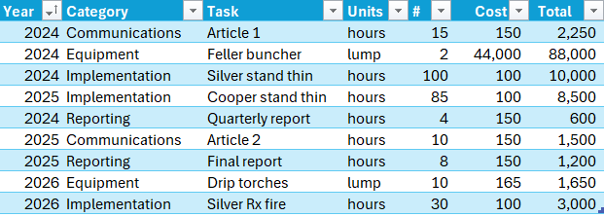
Then, with your cursor in one of the table cells, select Insert>PivotTable>OK. Click in the pivot table report field and, in this case, click and drag Category and Task to the Rows field, Year to the Columns field, and Total to the Σ Values field (with some number formatting and dragging Communications and Reporting to the bottom):
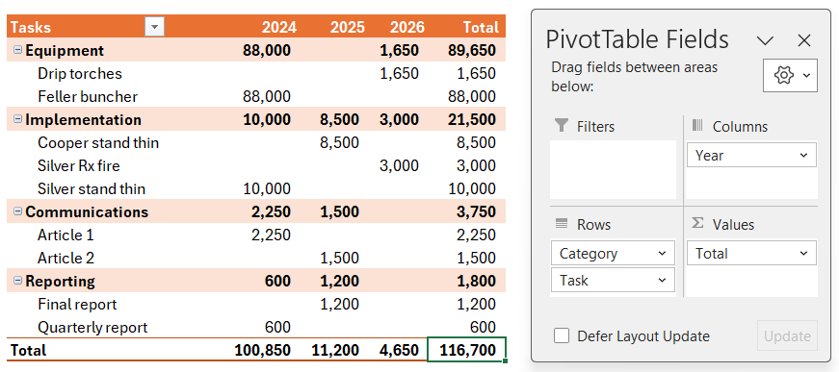
To build out your budget, add more rows to the detail sheet, repeating activities by year. After adding new rows, always click Data>Refresh All to update the summary table(s).

1.3 Finalize
Put together your project design and share it. For both proposals and projects, copyedit your final version and then copyedit it again. Look at it in different formats and, ideally, let the proposal rest for a few days, then copyedit again. Printing out the key written components and editing with a red pen can also help catch additional mistakes or grammatical errors. This might seem like a paper waste, but it can be effective for editing.
The FBA can also review projects and proposals, with our staff writers’ years of experience with proposal development and successful funding track records. However, we ask that you send them early, e.g., months before the due date or during the conceptual phase. Please get in touch with us if you’re interested in a review.
Good luck!

1.4 Resources
The project design chapter is a very brief look at how to develop projects and proposals. You’ll want to dive deeper to develop your project and proposal craft. Here are a few additional resources to get going:
- Forest Business Alliance. Templates upcoming workshops to prepare you for proposals and past workshop recordings on various aspects of program, project, and proposal development.
- Grammarly. Paying for a better grammar/spell checker (than those available in Word or Docs) may help improve your writing.
- Sierra Nevada Conservancy Grant Resources. SNC offers a grants newsletter and regular grant writing workshops. If you’re in the Sierra, contact your local Area Representative to learn more.
- North Coast Resource Partnership. NCRP offers technical assistance for proposals and project development and currently offers weekly office hours for real-time assistance. See the no-registration Zoom link on their What’s New page to join.

